**Academic Year: 2022-23 Name of Student:**

**Semester: VI Student ID:**

**Class / Branch/ Div: TE- IT A/ B Roll No.**

**Subject: MAD & PWA Lab Date of Submission:**

**Name of Instructor: Yaminee Patil**

**Experiment No.:5**

**Aim:** Write a program using arrow function to display Fibonacci series.

**Software Used:** Visual Studio code

**Prerequisites:** HTML, CSS

**Code & Output:**

1. **Index.html**

<Html>

<head>

<title>

JavaScript Function

</title>

<script type="text/javascript">

var fun = fibo => {

var pop = prompt("Enter the count of values in the series", " ");

var var1 = 0, var2 = 1;

document.write("Here is the fibonacci series : ");

document.write("", var1, " ");

document.write("", var2, " ");

var counter, sum;

for (counter = 2; counter < pop; counter++) {

sum = var1 + var2;

document.write("", sum, " ");

var1 = var2;

var2 = sum;

}

}

fun();

</script>

</head>

<body>

</body>

</html>

**Output:**

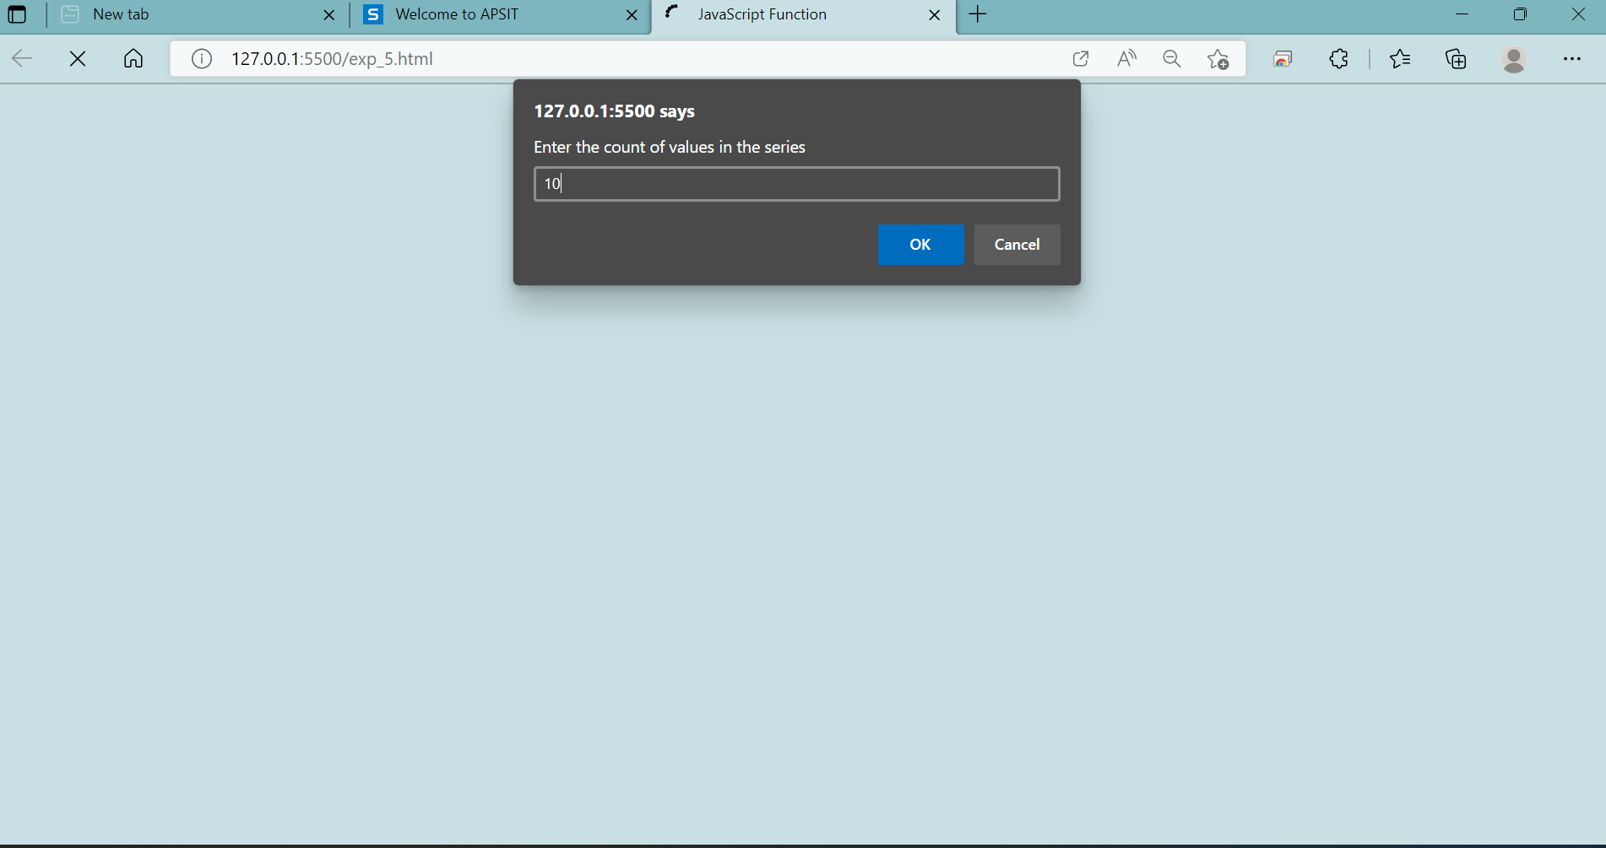

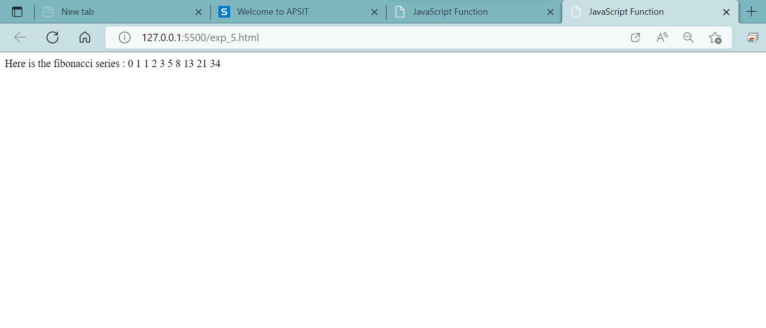

**Conclusion:** In this experiment we have studied and implemented arrow function.