**Department of Information Technology**

**Academic Year: 2022-23 Name of Student:**

**Semester: V Student ID:**

**Class / Branch/ Div: TE- IT A/B Roll No.**

**Subject: IP Lab Date of Submission:**

**Name of Instructor: YP/RS/SA**

**Experiment No.:7**

**Aim:**  Write a program to implement ES6 Iterator & Promises

**Software Used:** Visual Studio Code

**Theory:**

ES6 - Iterator

**Program for iterator**

//user defined iterable

class CustomerList {

constructor(customers){

//adding customer objects to an array

this.customers = [].concat(customers)

}

//implement iterator function

[Symbol.iterator](){

let count=0;

let customers = this.customers

return {

next:function(){

//retrieving a customer object from the array

let customerVal = customers[count];

count+=1;

if(count<=customers.length){

return {

value:customerVal,

done:false

}

}

//return true if all customer objects are iterated

return {done:true}

}

}

}

}

//create customer objects

let c1={

firstName:'Sachin',

lastName:'Tendulkar'

}

let c2={

firstName:'Rahul',

lastName:'Dravid'

}

//define a customer array and initialize it let customers=[c1,c2]

//pass customers to the class' constructor

let customers=[c1,c2]

let customersObj = new CustomerList(customers);

//iterating using for..of

for(let c of customersObj){

console.log(c)

}

//iterating using the next() method

let iter = customersObj[Symbol.iterator]();

console.log(iter.next())

console.log(iter.next())

console.log(iter.next())

**Output:**

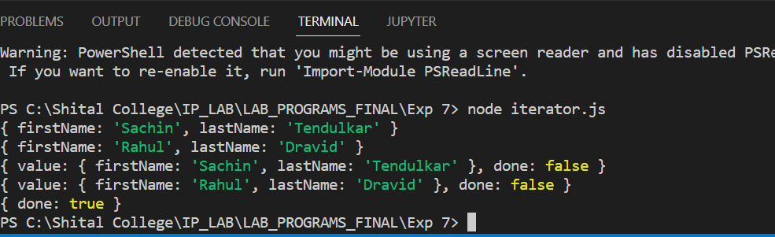

**Program for Promise**

const myPromise = new Promise((resolve, reject) => {

if (Math.random() > 0) {

console.log('resolving the promise ...');

resolve('Hello, Positive :)');

}

reject(new Error('No place for Negative here :('));

});

const Fulfilled = (fulfilledValue) => console.log(fulfilledValue);

const Rejected = (error) => console.log(error);

myPromise.then(Fulfilled, Rejected);

myPromise.then((fulfilledValue) => {

console.log(fulfilledValue);

}).catch(err => console.log(err));

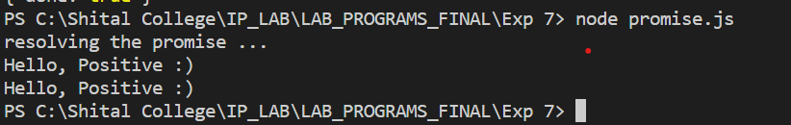

**Conclusion:** In this experiment we have implemented a program to implement ES6 Iterator & Promises.