**Academic Year: 2022-23 Name of Student:**

**Semester: V Student ID:**

**Class / Branch/ Div: TE- IT A/ B Roll No:**

**Subject: IP Lab Date of Submission:**

**Name of Instructor:**

**Experiment No:9**

**Aim:** Write a program to demonstrate Class Component & states using React JS.

**Software Used:** Visual Studio code

**Prerequisites:** HTML, CSS, REACT JS

**Code & Output:**

**Index.js for Class Component:**

import Reactdom from 'react-dom';

import "./index.css";

import Classcomp from './Classcomp';

Reactdom.render(

<Classcomp color='red' />, document.getElementById('root')

);

**Index.css**

body{

background-color: dimgray;

}

.a1{

font-size: 30px;

font-family: Lucida Handwriting;

}

.hh{

border: solid white 30px;

padding: 40px;

text-align: center;

color:#ff00b7;

text-shadow: black 10px 10px 5px;

}

.ll{

display: block;

padding: 5px;

background-color: aqua;

}

.red{

background-color: white;

color:red;

}

.ll{

border: solid green 10px;

padding: 10px;

}

**Classcomp.js**

import { Component } from "react";

import './index.css';

class Classcomp extends Component{

render()

{

return(

<div>

<h1>this is first class component</h1>

<h3>demo of class Component using props</h3>

<h2 className="red">hi I am {this.props.color} coloured CAR</h2>

<ul className="ll">

<li>IP</li>

<li>CNS</li>

<li>EEB</li>

</ul>

</div> )

}

}

export default Classcomp;

**Output of Class component:**

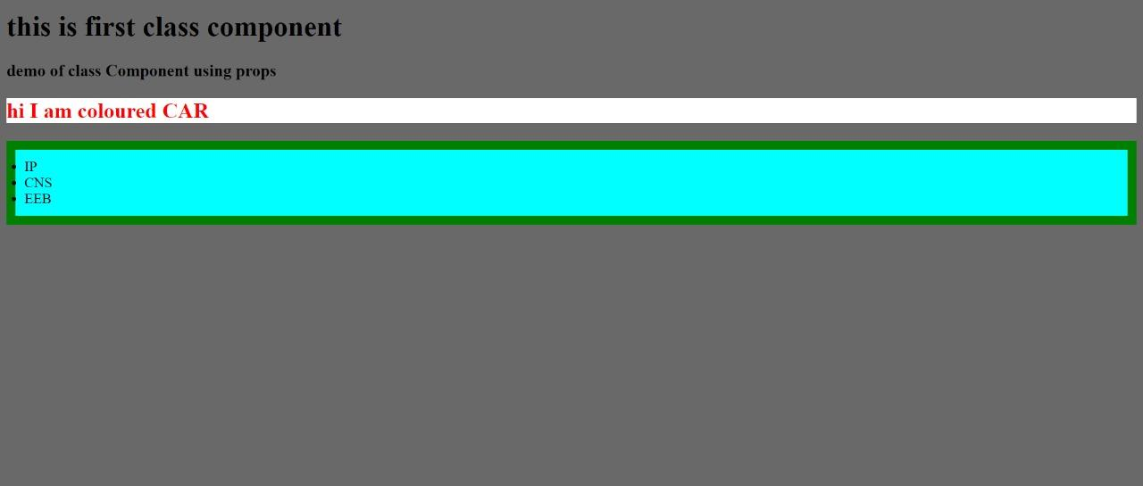

**Conclusion:** Thus, we have studied how to create class component with their syntax. Also learned & implemented ‘States’ in those components to assign properties to them.