This readme file describes how to use the ASPX web application generated for you by Altova StyleVision®.

Introduction

The purpose of the web application is to create an output document and display it in a web browser. The output document contains XML content whose layout you define in advance using a StyleVision stylesheet (SPS file).

You request the output document by browsing to a specific URL in the browser. When you do so, the web application is executed and creates the document on the fly. Internally, the web application performs an XSLT transformation of the XML content and then displays the resulting output document in the browser.

A rendered document’s XML content may originate from XML files, a database, or both. The web application hides this distinction, reading from files and/or a database as necessary to access the required XML content.

How the web application works

StyleVision stores the generated web application in a folder of your choice. For the purposes of this document, we will assume the folder is named C:\MyWebApp and that the web application was generated from an SPS file named OrgChart.sps. In this case, the folder will contain these files (among others):

- Readme.doc (this file)
- OrgChart.aspx
- OrgCharthtml.xslt
- OrgChart.cs

OrgChart.aspx is the URL of the file you browse to in order to view (and implicitly create) the output document. OrgChart.aspx executes C# code stored in the file OrgChart.cs. This C# code reads the XML content (from files or a database as required) and passes it to AltovaXML, together with the OrgCharthtml.xslt file. AltovaXML is Altova’s XSLT transformation engine; it can be downloaded from the Altova website.

AltovaXML performs a transformation of the XML content, using the provided XSLT file. The result is an HTML document, which the web application then displays in the browser.
When the XML content changes, for example because of changes made to the database, browsing to OrgChart.aspx (or refreshing the page in the browser) will automatically fetch the most recent data from the database and render an updated document.

Deploying the Web Application

Once StyleVision has generated the web application, some steps remain to be done in order to deploy the web application on a web server. This section describes how to deploy the web application using IIS, Microsoft’s web server.

Activate IIS

Note: This step is only necessary the first time you deploy a web application.

In Windows, go to “Control Panel | Programs and Features | Turn Windows features on or off”.

Set the “Internet Information Services” checkbox (the tri-state checkbox will change to “partly checked”).

Additionally, set the “Internet Information Services | World Wide Web Services | Application Development Features | ASP.NET” checkbox.

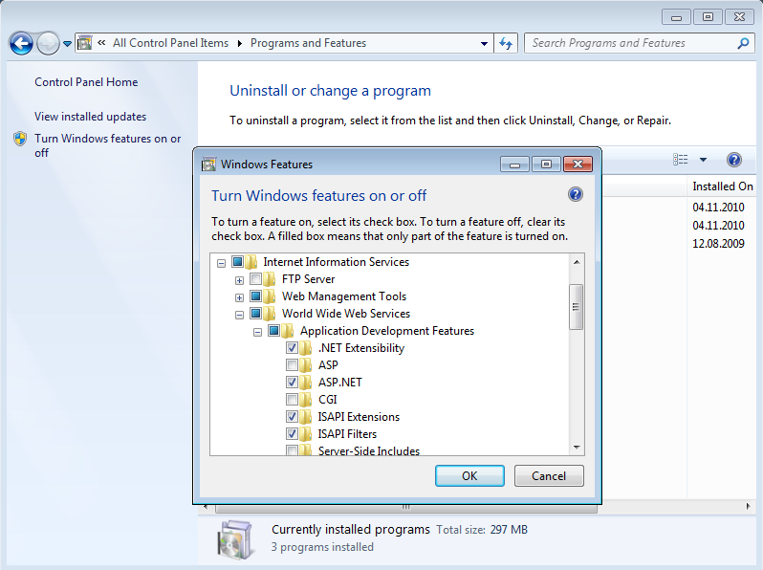

Click OK and wait until the process is complete.

As a test, browse to localhost; this will display the IIS welcome screen.

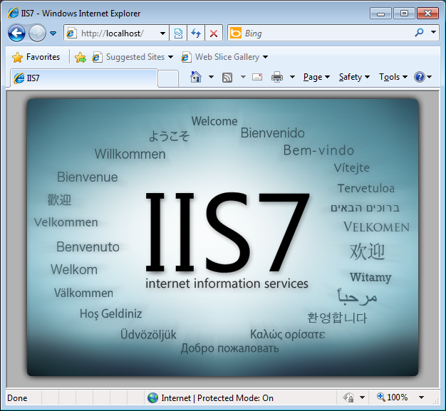

Setup AltovaXML

Note: AltovaXML is required for the transformation to HTML. This step is only necessary the first time you deploy a web application.

Install AltovaXML if it is not already installed.

- Required version: Be sure to install AltovaXML 2011 rel. 2 or later.
- Required edition: If your design contains certain advanced features such as charts, you will need to use the Reporting Edition of AltovaXML. In general though, the Community Edition will suffice.

In Windows, go to “Control Panel | Administrative Tools | Component Services”. If you are logged on to a Windows account that uses standard rights, you will need to run the Component Services as administrator. Otherwise, the security options will not be editable.

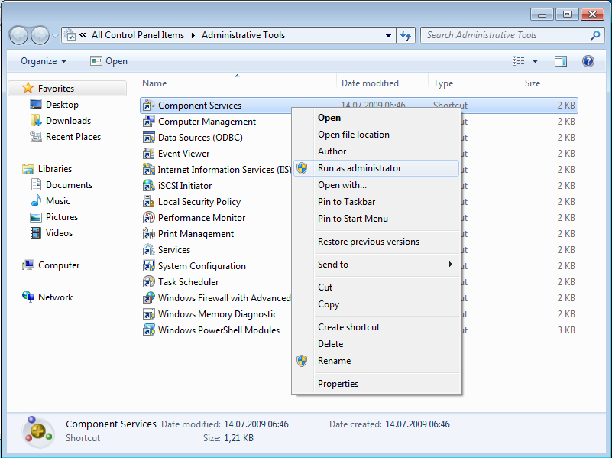

Expand “Component Services | My Computer | DCOM Config”. Open the properties of “AltovaXML Application Class”.

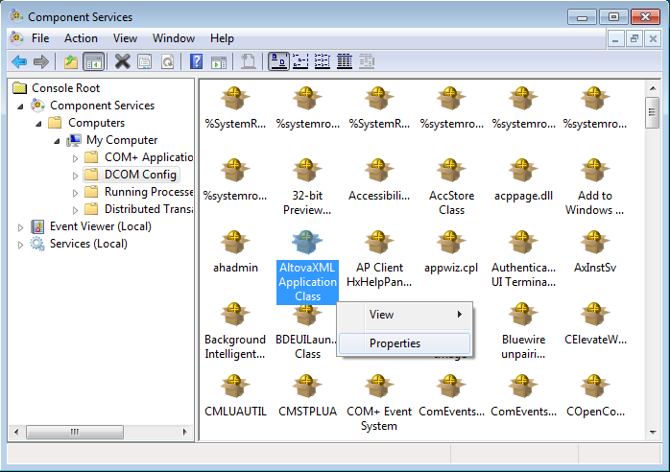

Switch to the Security tab.

For “Launch and Activation Permissions”, choose “Customize”, add IIS_IUSRS and give “Local launch” and “Local Activation” permission.

For “Access Permissions”, choose “Customize”, add IIS_IUSRS and give “Local Access” permission.

Note: In older versions of IIS, the IIS_IUSRS group is called IIS_WPG.

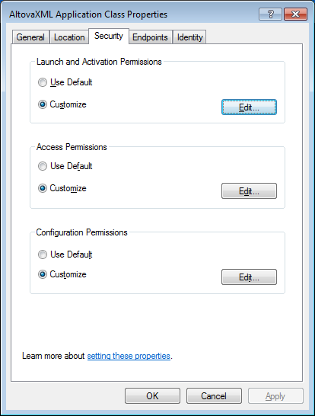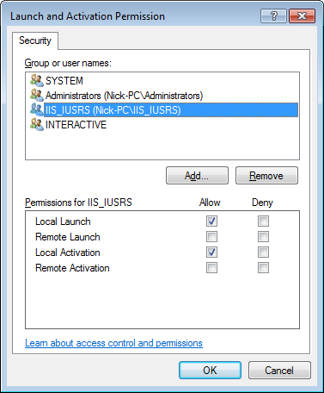

Note: When clicking “Add…” in the “Permission” dialog shown above, Windows opens the “Select Users, Computers, Service Accounts, or Groups” dialog. If the user or group you are looking for is not visible, check the location. You may need to change it to your local machine.

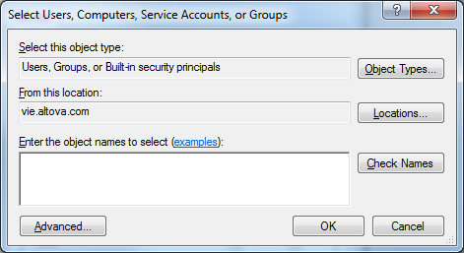

Make ASP.NET aware of the web application

In Windows, go to “Control Panel | Administrative Tools | Internet Information Services (IIS) Manager”.

In the “Connections” panel, expand the tree to display “Default Web Site”. In the context menu for “Default Web Site”, select “Add Application…”.

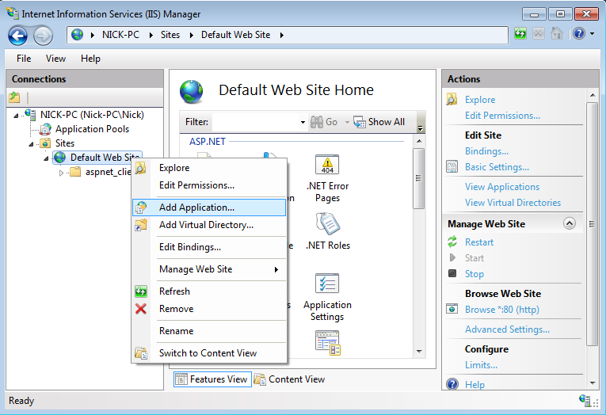

For the alias, enter an arbitrary name, e.g. “MyApp”. For the physical path, enter the folder you saved the application to, e.g. “C:\MyWebApp”.

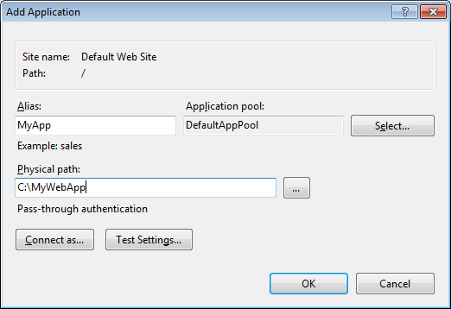

Run the application

In the browser, go to “http://localhost/MyApp/OrgChart.aspx”. The browser will then display the resulting HTML document.

Accessing a database

The example given above (OrgChart.sps) demonstrates a web application that reads its XML data from a file on disk. A web application can also read its XML data from a database, though.

StyleVision includes example SPS designs that retrieve data from a database, such as DB.sps and DBSample.sps. To generate and deploy a web application for these database examples, simply follow the steps given above.

StyleVision’s database examples retrieve data from an Access database. For an SPS design that retrieves data from a different database, additional setup steps may be necessary for the web application to successfully retrieve data from the database. This is due to the fact that the web application runs under ASP.NET. The most common issues are listed below, together with tips how to resolve them.

ODBC data sources

For a client/server database system, a 64-bit database server usually requires a 64-bit client, whereas a 32-bit database server can usually be accessed by a 32-bit or 64-bit client, so care must be taken to define a 32-bit or 64-bit data source as required.

An ODBC data source is defined in the Windows Control Panel. Be aware that there are two versions of the ODBC Administrator tool (odbcad32.exe):

- the 32-bit version of the ODBC Administrator tool (for defining 32-bit data sources) resides in the Windows\SysWow64 folder
- the 64-bit version of the ODBC Administrator tool (for defining 64-bit data sources) resides in the Windows\System32 folder

Also note that if you are using an ODBC User data source, you may have to change the IIS application pool’s Identity property to connect as that user. An ODBC System data source may be preferable.

32-bit and 64-bit database drivers

If access to a database works in StyleVision but fails in the web application, the reason may be the “Enable 32-Bit Applications” setting for the IIS application pool.

To change this setting, go to “Control Panel | Administrative Tools | Internet Information Services (IIS) Manager”.

In the “Connections” panel, expand the tree to display “Application Pools”. In the context menu for “DefaultAppPool”, select “Advanced Settings…” and set the “Enable 32-Bit Applications” setting is set as required.

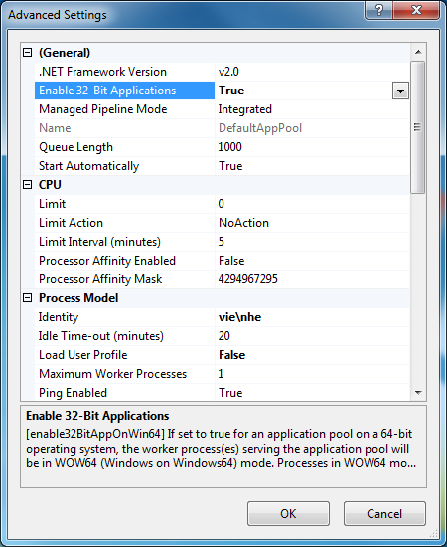

The required setting depends on a number of factors, including the architecture (32-bit or 64-bit) of Windows of the database client. For example, when using 64-bit Windows and 64-bit database drivers, enabling 32-bit applications can cause the connection to fail.

File access permissions

A web application may not arbitrarily access disk files. If connecting to the database fails, ASP.NET may be missing permission to access the folder that contains your database client. In this case, identify the folders in question and assign access to them with Windows Explorer via the Security tab in the Properties dialog.

