Used GPT codex and some info from flagged GPT
PS D:\Suriyan from 2024\College - sem4\HOSPITAL_BANK_MERN> node -e "console.log(require('crypto').randomBytes(64).toString('hex'))"
e63e5c2e056508821e75bec013f847eef29a3be78a9578e4a00e8ad8bd343b0c21c818ec36f5edc67073838154990d288ce525286970becf8165c9ebafa9f687

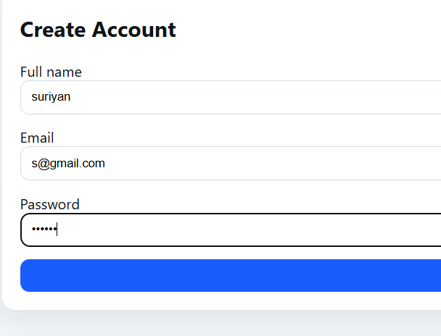
123456
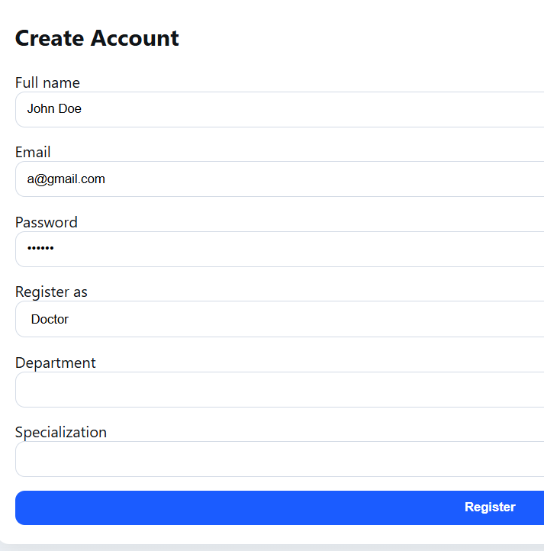
Abcdef
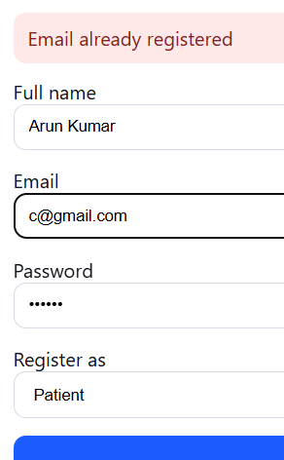pqrstu
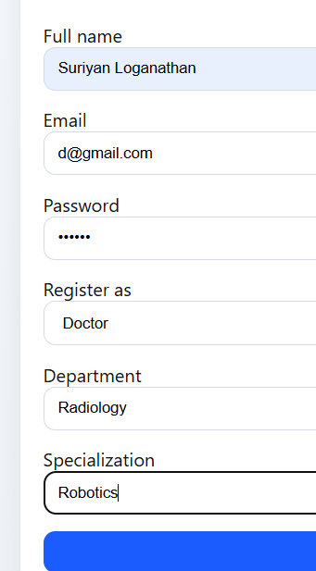123456
Added random meds and docs as seed in db
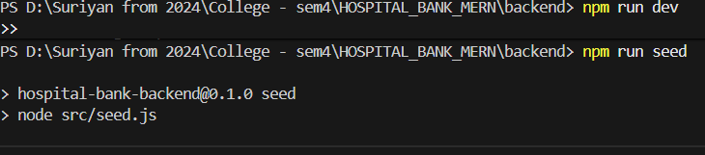
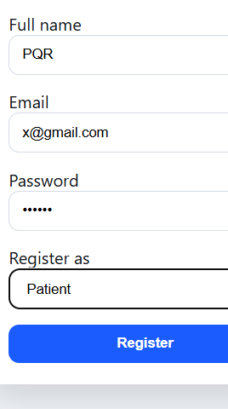123456
y@gmail same doc

Admin1
p@gmail.com
123456

New-
n@gmail.com

