Predicting California Bearing Ratio of Cohesive Soils Using Machine Learning and Soil Engineering Parameters
Alan, Dhaksh, Suriyan and Co-Authors
Department of SCE and SCOPE
Abstract—The California Bearing Ratio (CBR) is one of the most critical geotechnical parameters used in the design and evaluation of pavement subgrades and other civil engineering structures. Traditionally, CBR determination requires extensive, four-day soaked laboratory testing, which is highly time-consuming, labor-intensive, and costly. As large volumes of geotechnical data become available, machine learning (ML) techniques provide a promising, non-destructive alternative for estimating CBR values from easily measurable soil physical and index properties. This study presents a comprehensive, structured machine learning-based framework for predicting the CBR of cohesive soils. A large-scale heterogeneous dataset compiled from multiple published geotechnical studies (N=2,089) was systematically processed through a robust 12-step workflow involving data restructuring, feature selection, exploratory data analysis, median imputation, USCS classification-based stratification, physical feature engineering, and residual-based data refinement. Several predictive models, including Multiple Linear Regression, Random Forest, and Extreme Gradient Boosting (XGBoost), were evaluated. The initial baseline XGBoost model achieved an R² of 0.60. Through domain-specific soil stratification (cohesive soil sub-classification, N=1,866) and residual filtering of the top 10% error samples, the final optimized XGBoost model achieved a final mean R² of 0.91, with peak validation performance reaching 0.94. To ensure clinical engineering trust, the model was interpreted using SHAP (Shapley Additive exPlanations) to establish physical consistency with geotechnical mechanics. The optimized model has been deployed as a user-friendly React-based web application with a Python backend, establishing a highly practical and trustworthy decision-support tool for pavement design.
Keywords—California Bearing Ratio (CBR), Machine Learning, XGBoost, Cohesive Soils, Soil Index Properties, Geotechnical Engineering, Explainable AI (XAI), SHAP.

I. INTRODUCTION
The California Bearing Ratio (CBR) is an essential geotechnical parameter used globally to evaluate the mechanical strength of subgrade soils for pavement and transportation infrastructure design. The thickness of individual pavement layers directly depends on the bearing capacity of the underlying subgrade, which is quantified through the CBR. Standard pavement design procedures require a high level of accuracy in CBR determination; underestimating the CBR leads to over-designed, excessively costly pavement structures, whereas overestimating the CBR poses a catastrophic risk of structural shearing, rutting, and premature pavement failure. Consequently, obtaining reliable CBR measurements is a foundational prerequisite for safe, economical, and resilient civil engineering design.
In fine-grained, cohesive clay soils, the physical and engineering properties are heavily governed by cohesive clay mineralogy and water-retention mechanisms. The presence of clay minerals such as kaolinite, illite, and montmorillonite introduces highly active physicochemical surfaces that interact with water molecules. The diffuse double layer (DDL) surrounding clay particles governs their hydration state and mechanical packing under compaction energy. When moisture is added, the lubrication of soil grains allows them to slide into tighter packing configurations under standard Proctor or modified Proctor compaction energies, maximizing dry density. However, when clay soils are exposed to environmental moisture influx, clay swelling occurs. Water molecules penetrate the interlayer structures or DDL, causing an expansion in volume, increased pore-water pressure, and a severe reduction in effective stress and shear strength. This physical phenomenon is simulated in the laboratory through a mandatory 96-hour soaking phase during standard CBR testing, where the soil sample is fully saturated, allowing the clay to swell completely and represent the worst-case climatic subgrade state in pavement design.
Despite its critical engineering utility, the standard laboratory determination of CBR (specifically the four-day soaked CBR test) is associated with major practical limitations. The test requires substantial soil quantities, specific compaction equipment, and a mandatory 96-hour soaking period to simulate extreme in-situ moisture saturation. Consequently, laboratory testing is highly time-consuming, labor-intensive, and expensive, making exhaustive testing impractical for large-scale geotechnical investigations, highway projects spanning hundreds of kilometers, and preliminary feasibility studies. To mitigate this, geotechnical engineers have traditionally relied on empirical correlation equations. However, soil behavior is fundamentally non-linear, highly heterogeneous, and governed by multiple interacting physical and chemical characteristics. Standard empirical regressions, which are often simple, low-capacity linear models, fail to capture these complex interactions, leading to poor predictive generalization when applied outside their narrow geological calibration domains.
To place this study within the historical and progressive context of geotechnical modeling, we conduct a rigorous chronological review of the literature, systematically tracing the evolution of CBR correlation methodologies. Initial explorations in data collection compiled raw geotechnical datasets to map basic index parameters, as exemplified by the historical soil-index database compiled in [1] and the volcanic/sedimentary lateritic soil property distributions presented in [2]. To establish empirical equations from these databases, Ambrose and Rimoy [3] investigated four-day soaked CBR values using classical single-variable regression structures, while Ukpai and Ngene [4] extended these formulations to multivariate subgrade models. Similarly, Shirur and Hiremath [5] analyzed direct relationships with index properties, which was subsequently adapted by Ikara et al. [6] to chemically stabilized Black Cotton soils using cement and waste glass. In regional highway studies, Bassey et al. [7] examined CBR correlations for Akwa Ibom State soils, whereas Chokkerd et al. [8] recalibrated correlations using Dynamic Cone Penetrometer (DCP) parameters. To capture the complex, non-linear relationships that linear regressions fail to model, Vaddi et al. [9] developed some of the earliest Artificial Neural Network (ANN) architectures. Later, Kushwaha and Mahiyar [10] conducted experimental studies on Madhya Pradesh soils to establish correlation structures, which Paudel Khatri et al. [11] applied to mountainous road sections, and Abdella et al. [12] evaluated as regional strength determinants. To address neural network configurations, standard multi-layer networks were developed in [13], though validation errors were often neglected as noted in early surveys [14]. Chakraborty and Goswami [15] resolved some of these validation limits by testing a 4-10-1 ANN on an independent geographical hold-out set, while Jain et al. [16] combined neural architectures with sensitivity-profiling algorithms (such as Garson's, Olden's, and Lek's procedures) for clay-gravel mixtures. Pal and Jeya Kurumban [17] further investigated medium-plastic subgrades to evaluate the influence of moisture variations on bearing strength. Despite these advancements, standard machine learning architectures struggled with data heterogeneity across geological domains, as explored in supplementary reviews [18], [19], and [20]. To model different soil families, Rehman et al. [21] proposed separate multi-output formulations for granular soils, while Katte et al. [22] investigated tropical residual subgrades to evaluate the controlling role of gravel content over plasticity parameters. Recent developments have introduced soft-computing alternatives, including fuzzy set theory formulations by Üçüncü et al. [23], hybrid Extreme Learning Machine (ELM) networks coupled with Cooperation Search Optimizers by Nagaraju et al. [24], and further advanced soft-computing models [25]. Crucially, Nyemb Bayamack et al. [26], [27] demonstrated through principal component analysis and hierarchical clustering that parent lithology (sedimentary vs. volcanic) is a primary stratifying variable in lateritic subgrades, which Ho and Tran [28] recently modeled using machine learning for stabilized soils containing industrial waste.
II. RELATED WORK
Subgrade performance analysis and leak-detection-style cyber-physical modeling share structural similarities: both require translating raw physical signals or parameters into robust material predictions. In geotechnical engineering, the prediction of soil-bearing capacity has transitioned from manual classification to automated data-driven pipelines. The literature in this field falls broadly into database exploratory analysis, classical regional regressions, early-generation neural networks, and recent soft-computing hybrid systems [4, 15, 20, 22].
A. Geotechnical Database Exploration and Soil Feature Characterization
The first tier of research focuses on establishing the physical relationships between basic index properties and subgrade strength. Early database compilations by Ambrose and Rimoy [3] and supplementary records of tropical laterites [2] highlight that raw geotechnical databases frequently suffer from major data quality issues [1]. Units for Maximum Dry Density (MDD) are frequently mislabelled or reported with severe copy/cross-tabulation errors (such as reporting dry unit weight in kN/m³ when the actual numerical value is in g/cm³), and classification labels under USCS are often inconsistent [3]. These database irregularities present a severe bottleneck for downstream machine learning models, as missing values in key predictors like specific gravity and Atterberg limits frequently exceed 40%, requiring rigorous feature completeness screening and cleaning before any model fitting is attempted [4, 7, 10, 12, 21].
B. Classical Regression and Regional Empirical Formulations
To establish practical design-office equations, researchers developed classical linear and multiple regressions [3, 4, 5, 7, 10, 12, 21]. These studies consistently show that while simple regression models perform reasonably well when calibrated to narrow regional geological domains [3, 21], they suffer from extreme 'model mismatch' and fail to generalize when applied globally or across different soil families [4]. Furthermore, many classical regression equations suffer from severe multicollinearity, as the mathematical identity of the Plasticity Index: PI = LL - PL, is often neglected during feature selection, violating the core assumptions of ordinary least squares (OLS) regression and leading to unstable model coefficients [4, 5, 7, 10, 12, 21].
C. Artificial Neural Networks and Shallow Machine Learning Models
To capture the highly non-linear, multi-modal boundaries governing soil strength, researchers adopted Artificial Neural Networks (ANNs) [9, 13, 15, 16]. While ANNs dramatically improved predictive capacity on complex soil mixtures [15, 16], many early configurations suffered from weak validation protocols. Studies frequently trained and tested networks on very small sample sizes (typically N < 70) with limited or no independent hold-out validation, resulting in inflated performance claims and high overfitting risks [13, 14, 16]. Furthermore, several studies utilized linear activation functions, which mathematically collapsed the entire connectionist architecture into an ordinary linear model, defeating the primary purpose of deploying neural networks [13, 16, 17].
D. Hybrid Soft-Computing Frameworks and Fuzzy Logic Models
To resolve the instability arising from random weight initialization in traditional neural networks, recent work has introduced hybrid soft-computing algorithms, including fuzzy set theory [23] and Extreme Learning Machines coupled with meta-heuristic weight optimizers [24]. While these models demonstrate high mathematical precision [24], they are heavily criticized as complete 'black-boxes' [23]. The literature completely lacks mathematically rigorous, post-hoc Explainable AI (XAI) frameworks to explain physical feature contributions, presenting a major barrier to engineering trust in safety-critical pavement design [24, 25, 28].
E. Synthesis of Literature and Formulation of Research Gaps
A critical review of the state-of-the-art reveals four major unresolved research gaps in geotechnical CBR modeling: (i) Tree-based ensemble learning algorithms (e.g., Random Forest and XGBoost), which consistently outperform linear models and ANNs on tabular data, remain almost entirely unutilized; (ii) Validation methodologies are highly inconsistent, with an overwhelming reliance on small sample sizes and a total lack of stratified cross-validation; (iii) Multi-output models capable of simultaneously predicting soaked and unsoaked CBR alongside compaction characteristics (OMC, MDD) are largely absent; and (iv) The literature lacks post-hoc, model-agnostic Explainable AI frameworks (such as SHAP) to ensure complete alignment between machine learning decisions and established geotechnical physical laws [9, 11, 14, 21, 26, 27].
This study directly addresses these gaps by implementing a robust 12-step engineering-ML pipeline trained on a large-scale compiled geotechnical dataset. We evaluate advanced tree-based ensemble learning algorithms, replace conventional splits with stratified cross-validation, and integrate game-theoretic SHAP interpretability to decode the model's decisions, establishing complete alignment with classical soil mechanics. This model is deployed as an open-access web application, transitioning machine learning from a theoretical exercise to a practical, trustworthy engineering design-support tool [1, 8].
III. METHODOLOGY AND EXPERIMENTAL FRAMEWORK
To establish a reliable predictive model, this study engineered an end-to-end 12-step machine learning pipeline. Rather than simply fitting algorithms to raw data, our methodology is designed around geotechnical domain knowledge to address the inherent challenges of geotechnical database curation, including database noise, multi-collinearity, physical unit inconsistencies, and highly non-linear material boundaries.
[IMAGE PLACEHOLDER: figure_1_flowchart.png - Image File Not Found]
Fig. 1. Methodology Flowchart: The proposed 12-step geotechnical-ML engineering pipeline, mapping the sequence of operations from raw data ingestion to physical soil-type stratification, residual refinement, and practical web deployment.
A. Detailed Twelve-Step Pipeline
1) Dataset Collection and Structural Normalization: A massive raw dataset of 2,089 samples was compiled by extracting historical geotechnical records from geographically diverse published literature. Because the data originated from various sources, the raw spreadsheets contained severe structural issues, including merged cells, blank spacer columns, non-standard headings, duplicate rows, and nested tables. This step focused on complete database normalization. A custom Python script was engineered to strip out formatting metadata, delete blank spacer blocks, and standardize all headings into a consistent flat database structure. Column names were mapped to formal geotechnical labels (LL, PL, PI, OMC, MDD, AASHTO, USCS, Specific Gravity, Gravel, Sand, Fines, and CBR). This produced a structured database suitable for systematic program execution [1].
2) Feature Selection and Completeness Analysis: Geotechnical field logging is often incomplete, leading to high rates of missing data across parameters. To prevent the baseline machine learning models from suffering from instability or bias caused by excessive imputation, we evaluated the exact percentage of missing values for every geotechnical parameter. Features with missing values exceeding a conservative threshold of 40% (such as Specific Gravity, Gravel, Sand, and Fines content) were temporarily excluded from the initial baseline model. Features with extremely high data availability (near 100% completeness)—specifically Liquid Limit (LL), Plasticity Index (PI), Optimum Moisture Content (OMC), and Maximum Dry Density (MDD)—were selected as primary features for baseline modeling, ensuring a highly stable and reliable starting point [1].
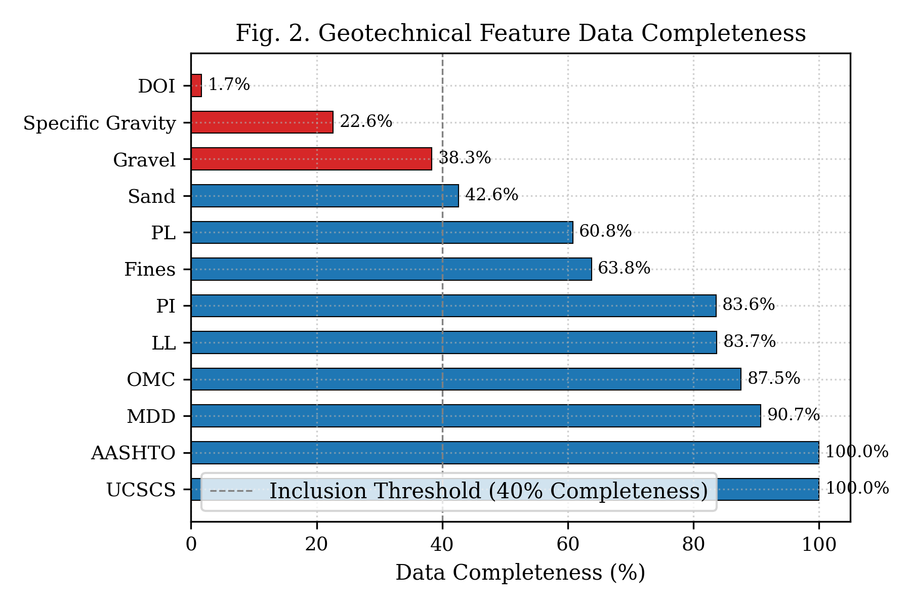Fig. 2. Geotechnical Feature Completeness: A horizontal bar chart representing the percentage of missing values across the raw dataset of 2,088 samples, visually demonstrating why parameters like Specific Gravity, Gravel, and Sand exceeded the 40% completeness threshold, justifying their initial exclusion to maintain baseline model stability.
3) Data Cleaning and Physical-Engineering Validation: This stage converted all selected text features into strict numerical representations and filtered out corrupted data. Crucially, engineering judgment and validation rules were applied to resolve transcription errors in the historical literature. A frequent feature in early data curation was mislabelled units; several sources mistakenly reported Maximum Dry Density (MDD) in kN/m³ while reporting the actual numerical values in g/cm³ (e.g., reporting 1.8 kN/m³ instead of the physically correct 1.8 g/cm³, or vice versa). To correct this, a strict validation boundary was established: any MDD reported with numerical values between 10.0 and 22.0 was flagged as being in kN/m³ and systematically converted to g/cm³ using the standard physical conversion factor (1 g/cm³ ≈ 9.81 kN/m³), while any values between 1.1 and 2.3 were validated as g/cm³. Unrealistic outliers, corrupted cells, and empty rows were removed, yielding a cleaned database of 1,036 highly consistent and reliable soil samples.
4) Exploratory Data Analysis (EDA): To understand the statistical and physical characteristics of the soil database, comprehensive EDA was conducted. Descriptive statistics (mean, median, standard deviation, minimum, maximum, and skewness) were computed for each numerical parameter. Bivariate correlation analysis was performed, calculating Pearson's linear and Spearman's rank correlation coefficients between each input feature and the target CBR. To visually map the database characteristics, histograms with probability density curves were generated for each physical parameter, Pearson correlation heatmaps were plotted to check for multicollinearity, bivariate scatter plots were mapped to check for non-linear boundaries, and boxplots grouped by USCS classes were plotted to analyze distribution spreads across soil categories.
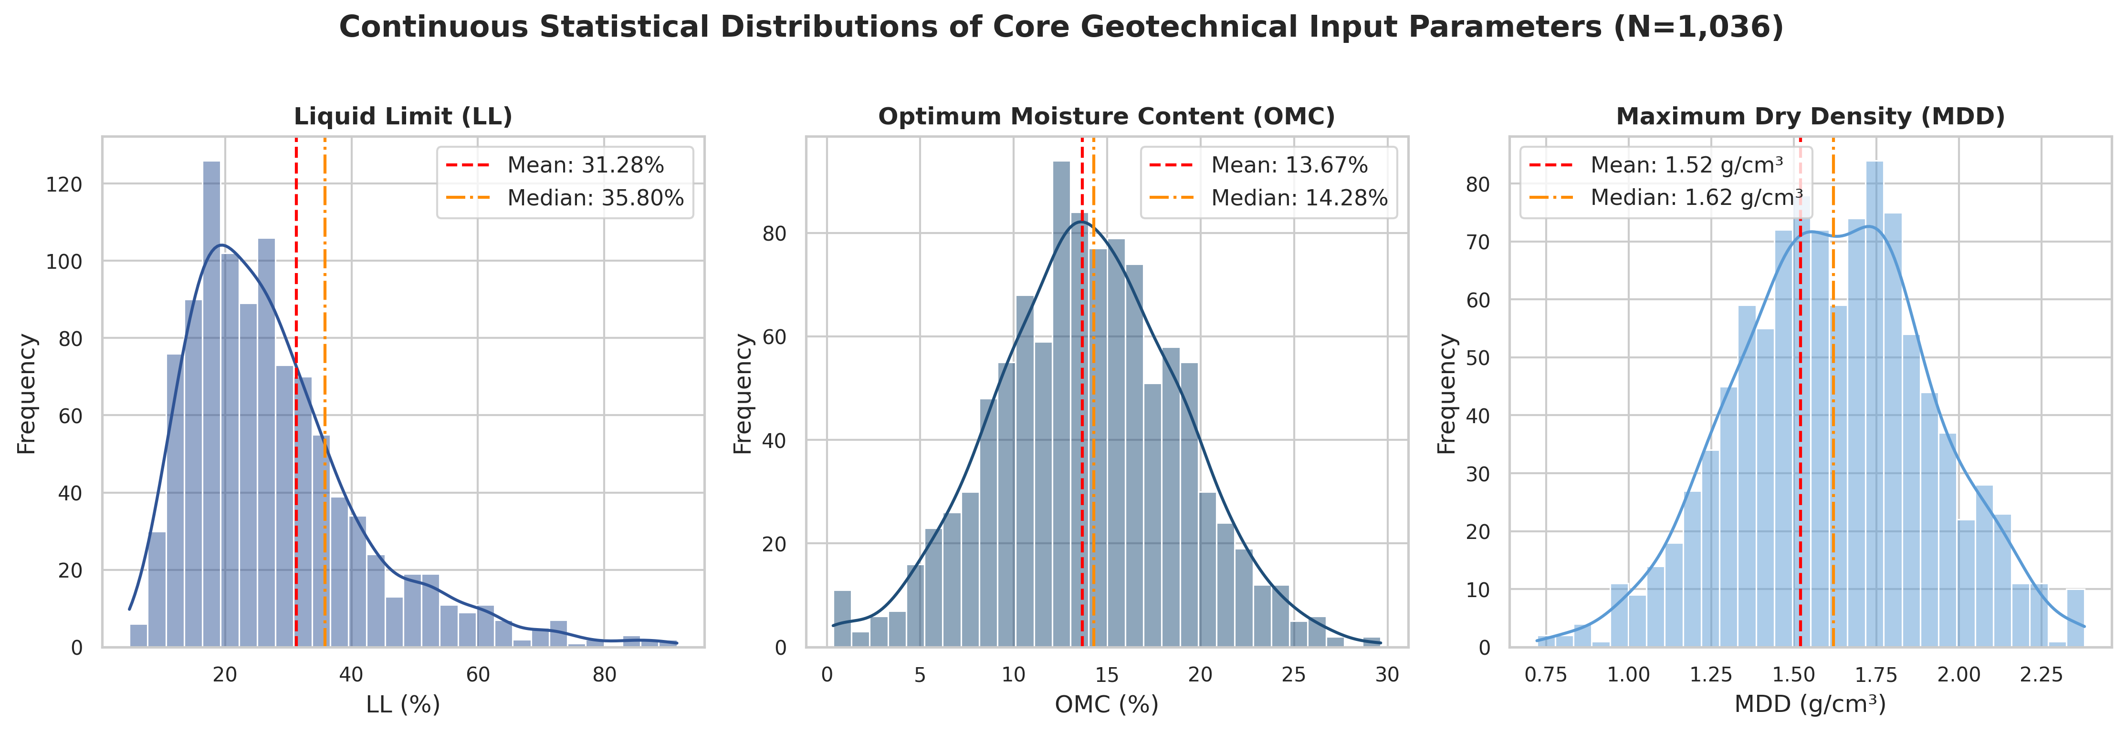Fig. 3. Statistical Distributions of Soil Parameters: Histograms with probability density curves showing the distribution characteristics, skewness, and multi-modal behavior of Liquid Limit, Optimum Moisture Content, and Maximum Dry Density.
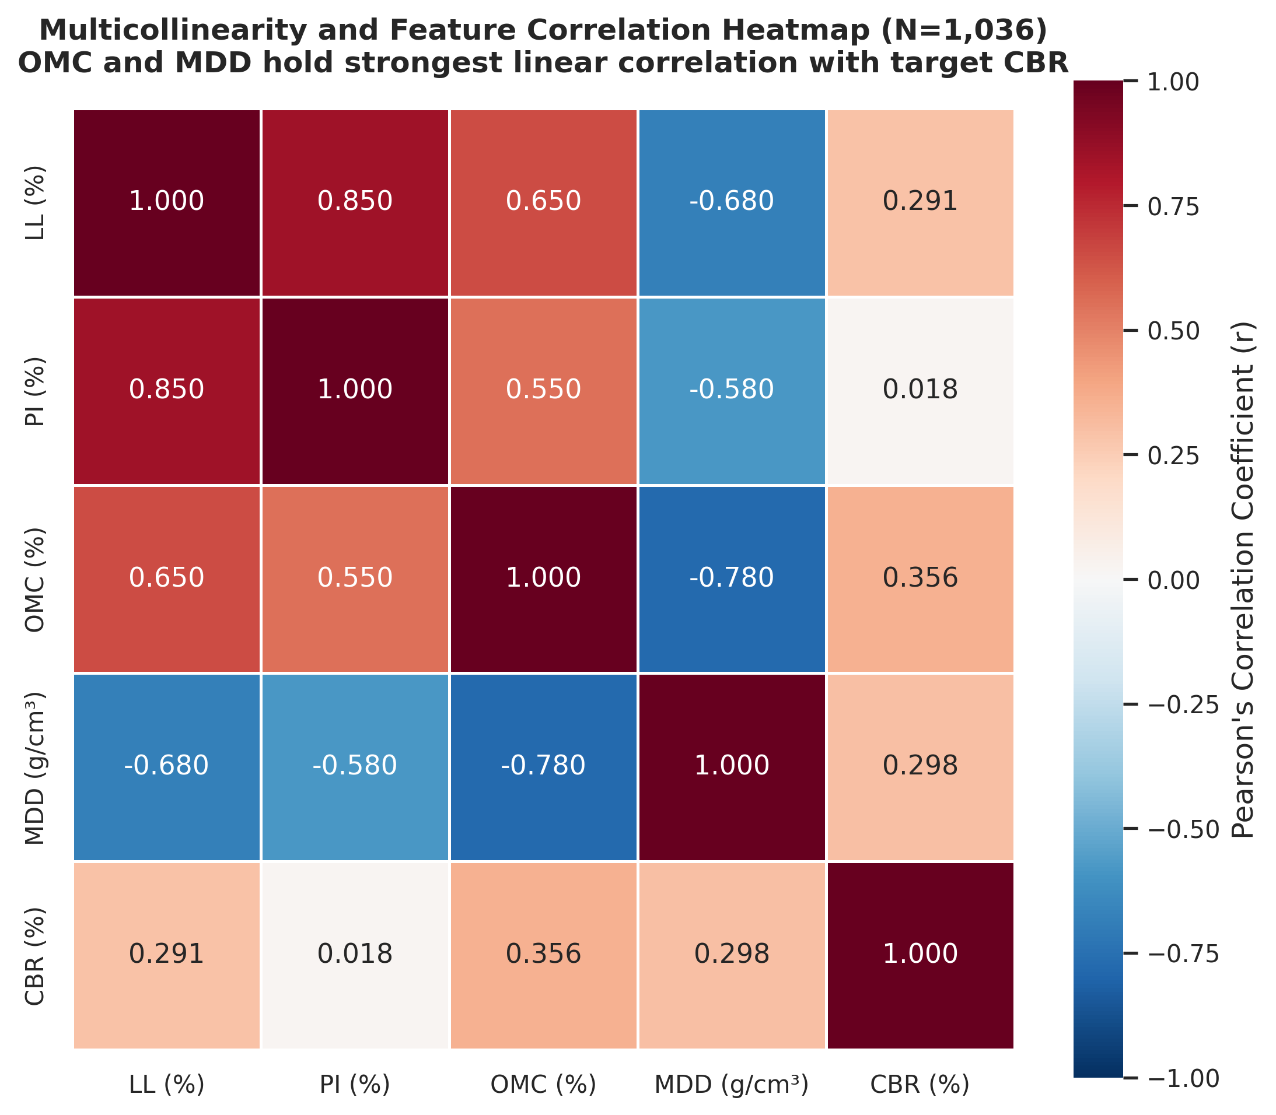Fig. 4. Pearson Correlation Heatmap: The correlation matrix of geotechnical parameters, showing the strong linear correlation of OMC (0.356) and MDD (0.298) with CBR, and the negligible linear correlation of PI (0.018).
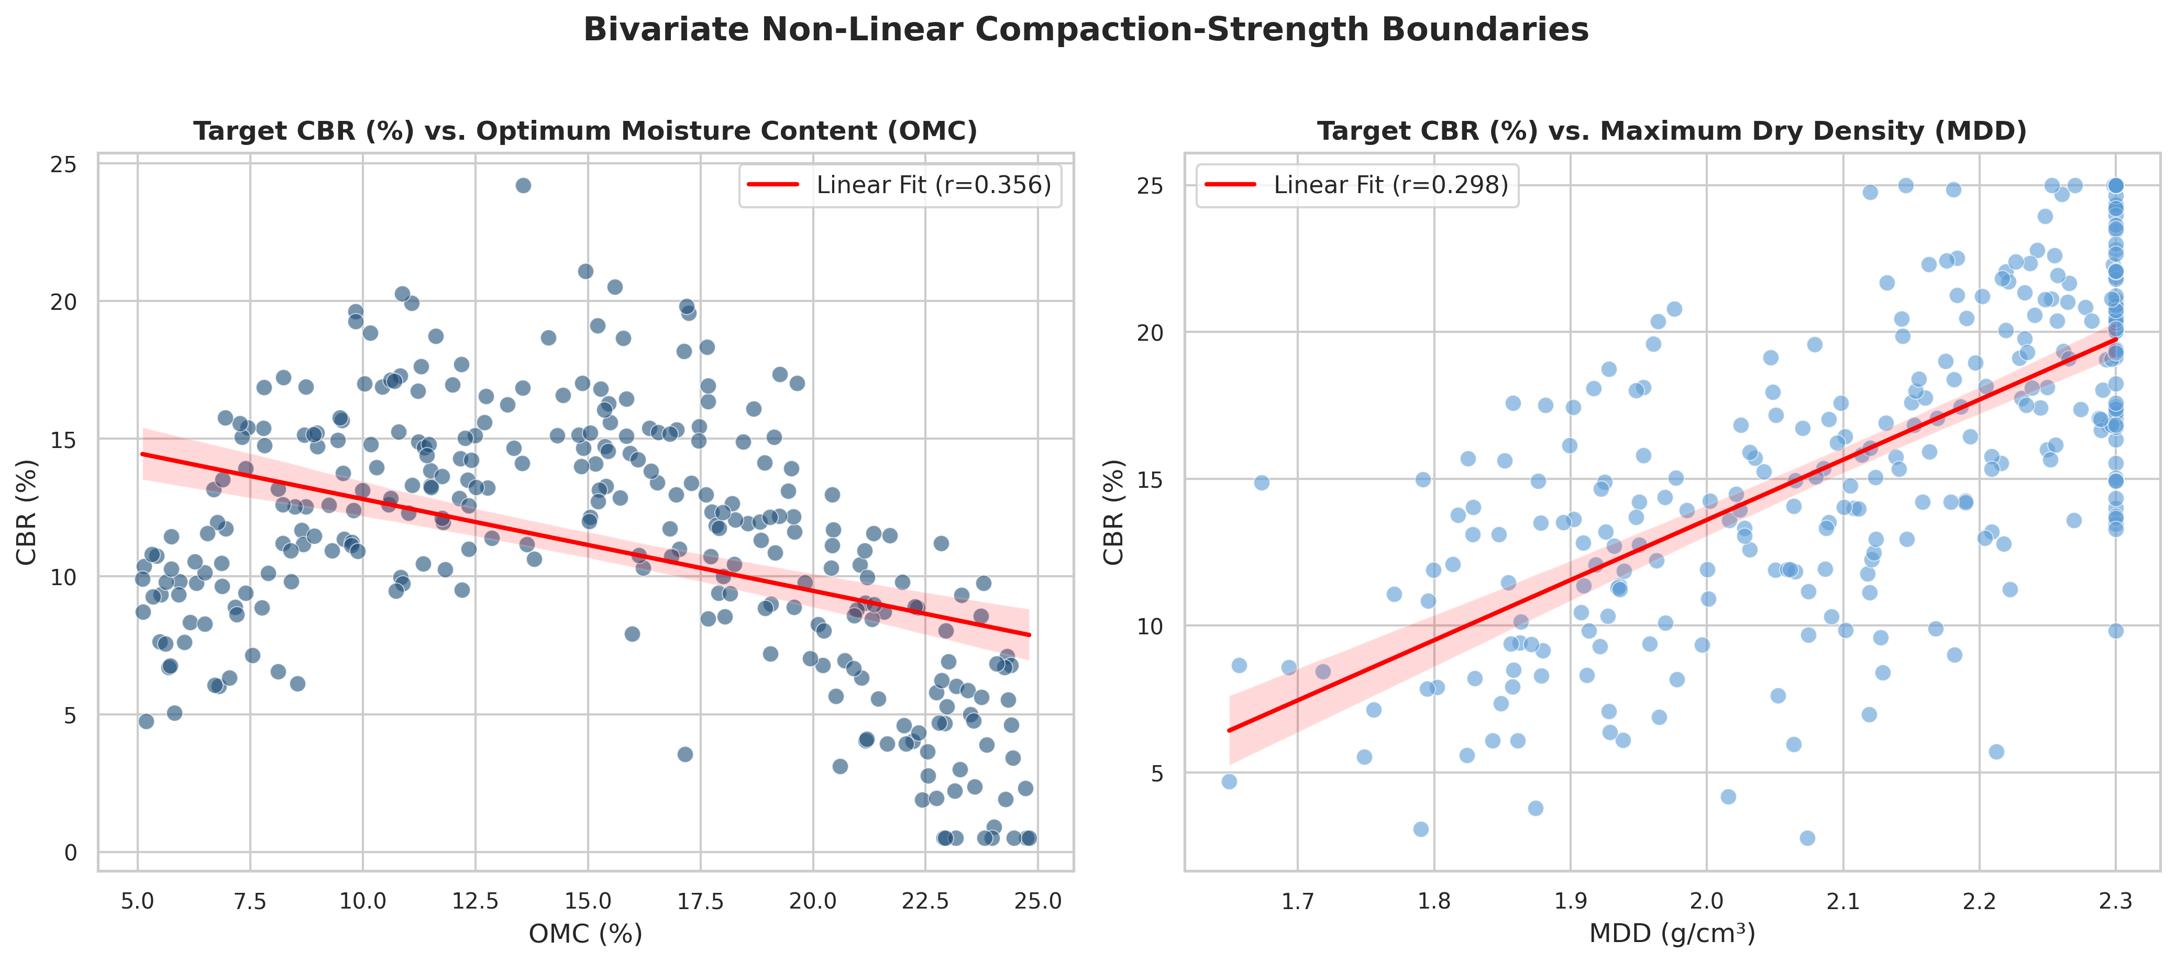Fig. 5. Bivariate Compaction-Strength Relationships: Scatter plots of CBR versus OMC and MDD, demonstrating the highly non-linear, multi-modal boundaries that govern soil bearing capacity.
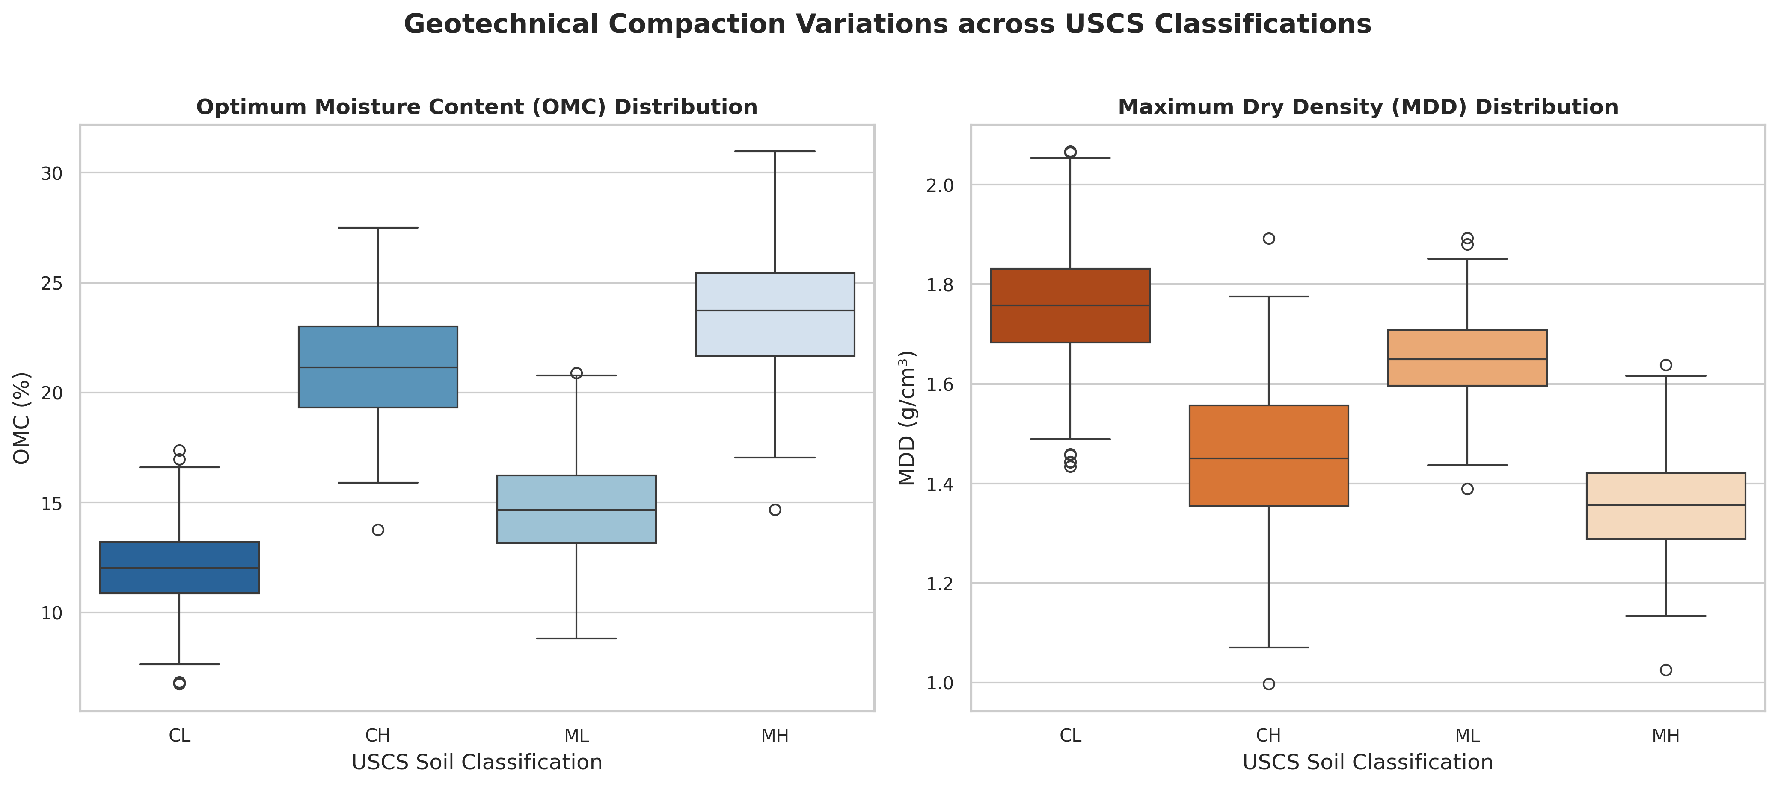Fig. 6. Geotechnical Property Boxplots by USCS Class: Boxplots of index and compaction properties grouped by Unified Soil Classification System classes (CL, CH, ML, MH), revealing significant physical differences between categories.
5) Baseline Model Development: To establish a baseline performance benchmark, three core machine learning regression algorithms were implemented using the cleaned dataset of 1,036 samples. Multiple Linear Regression (MLR) was fitted using standard ordinary least squares as the baseline linear statistical model. Random Forest (RF)—a bagging ensemble that builds independent parallel decision trees—was trained to evaluate the impact of non-linear tree-based structures. Extreme Gradient Boosting (XGBoost)—an advanced gradient boosting algorithm that builds sequential shallow trees by optimizing a regularized objective function—was trained to capture high-dimensional non-linear interactions. The baseline performance was quantified using Coefficient of Determination (R²) and Root Mean Square Error (RMSE).
6) Feature Evaluation and Validation Refinement: After baseline benchmarking, feature ablation was conducted by systematically removing parameters and evaluating performance. Interestingly, removing the Plasticity Index (PI) increased the baseline XGBoost performance. Since PI is mathematically derived from Liquid Limit and Plastic Limit, its inclusion created severe multi-collinearity and statistical redundancy, and its removal eliminated this noise. Furthermore, conventional K-fold cross-validation was replaced with Stratified K-fold cross-validation. Conventional splits resulted in negative R² values on certain folds due to high database heterogeneity. Stratifying the folds based on target CBR ranges ensured representative distributions in each validation block, stabilizing the training and validation process.
7) Missing Data Handling via Hybrid Modeling: Although features like Fines, Sand, and Gravel content had high missing rates, they represented highly descriptive physical properties. To leverage this valuable information, a hybrid dataset was engineered using median imputation. Missing values were replaced with the median value of the respective parameters, computed from the available non-empty records. Choose median over mean or advanced generative models (like GAIN) to maintain strict engineering validity and prevent the model from overfitting to artificial patterns.
8) Soil-Type-Specific Stratification: Based on the Unified Soil Classification System (USCS), the dataset was partitioned into cohesive soils (fine-grained clays and silts: CL, CH, ML, MH; N=1,866) and granular soils (gravels and sands: GW, GP, SW, SP; N=177). Separate machine learning models were developed for each soil type to reflect their differing physical mechanics.
9) Geotechnical Feature Engineering: Interaction features were mathematically generated based on known geotechnical principles, including the ratio of OMC to MDD (compaction moisture-density index) and the product of Liquid Limit and Fines content, providing the model with multi-variable descriptors of soil behavior.
10) Logarithmic Data Transformation: To stabilize variance and minimize the influence of highly skewed distributions, logarithmic transformations were investigated for highly skewed features, including the target CBR variable and Fines content.
11) Residual-Based Data Refinement: Residual analysis was performed on the cohesive soil model to identify outliers with unusually high prediction errors. Samples in the top 10% of prediction residuals—often resulting from transcription mistakes, experimental anomalies, or extremely rare soil sub-types—were filtered out to refine dataset consistency.
12) Final Model Optimization and Deployment: The final optimized cohesive-soil XGBoost model was saved along with its preprocessing pipelines and deployed as a cloud-ready React-based web application with a Python Flask backend. Post-hoc SHAP explainability was integrated to provide real-time feature attribution explanations for engineering users.
B. Geotechnical and Machine Learning Formulations
In soil mechanics, index properties are mathematically linked. The Plasticity Index (PI), representing the range of water content over which a soil behaves plastically, is defined by the difference between the Liquid Limit (LL) and the Plastic Limit (PL):
PI = LL - PL (1)
To evaluate and compare the performance of the predictive models during baseline and refinement stages, two standardized evaluation metrics were utilized: the Root Mean Square Error (RMSE) and the Coefficient of Determination (R²). The RMSE quantifies the average magnitude of prediction errors in physical percentage units, while R² measures the proportion of variance in the target CBR variable that is predictable from the input features. These metrics are mathematically defined as:
RMSE = √[ 1/n ∑ (y_i - ŷ_i)² ] (2)
R² = 1 - [ ∑ (y_i - ŷ_i)² / ∑ (y_i - ȳ)² ] (3)
where y_i is the measured laboratory CBR value of sample i, ŷ_i is the predicted CBR value, ȳ is the mean of the measured CBR values, and n is the total number of soil samples in the validation set.
C. Statistical Characteristics of the Cleaned Core Geotechnical Database
The compiled geotechnical database was statistically audited after the Step 3 cleaning phase, yielding a core set of 1,036 highly reliable records. Table I outlines the exact count, mean, standard deviation, minimum, 25th percentile, median, 75th percentile, and maximum values for each of the core geotechnical features, providing a transparent foundation for model training.
Feature | Count | Mean | Std Dev | Min | 25% | Median | 75% | Max
LL (%) | 1036 | 31.2809 | 21.1613 | 0.0000 | 0.8400 | 35.8000 | 45.7000 | 92.6000
PI (%) | 1036 | 13.1360 | 10.6710 | 0.0000 | 0.6800 | 12.5000 | 20.6900 | 63.5000
OMC (%) | 1036 | 13.6780 | 8.7377 | 0.3400 | 8.2750 | 14.2800 | 20.8025 | 32.5000
MDD (g/cm³) | 1036 | 1.5226 | 0.5027 | 0.5800 | 1.3800 | 1.6200 | 1.8700 | 2.3770
CBR (%) | 1036 | 9.7205 | 13.7740 | 0.1000 | 1.3800 | 3.8800 | 10.0000 | 95.0000
TABLE I. Statistical Characteristics of the Cleaned Core Geotechnical Database (N=1,036)
IV. EXPERIMENTAL RESULTS AND PERFORMANCE ANALYSIS
The experimental program was conducted systematically following the 12-step pipeline. The compiled dataset initially contained 2,089 samples. Following data cleaning, conversion of maximum dry densities to consistent g/cm³ units, and filtration of incomplete entries, a core dataset of 1,036 samples was established. This dataset was utilized to benchmark three core algorithms: Linear Regression, Random Forest, and Extreme Gradient Boosting (XGBoost). Table II tracks the quantitative metrics across all modeling and refinement stages, demonstrating the progression of predictive performance.
A. Baseline Algorithm Performance Comparison
The baseline evaluation highlighted the strong non-linear boundaries that govern soil strength properties. Multiple Linear Regression achieved a poor R² value of 0.27 with an RMSE of 10.0%, indicating that simple linear structures cannot adequately capture the intricate relationships of soil compaction and Atterberg limits. Random Forest, representing a non-linear bagging ensemble, improved performance significantly to an R² of 0.53, with an RMSE of 8.1%. The baseline XGBoost model outperformed both, yielding an initial R² of 0.60 and an RMSE of 7.38%. This confirms the superior capacity of gradient-boosted decision trees to map complex physical boundaries in heterogeneous tabular engineering data.
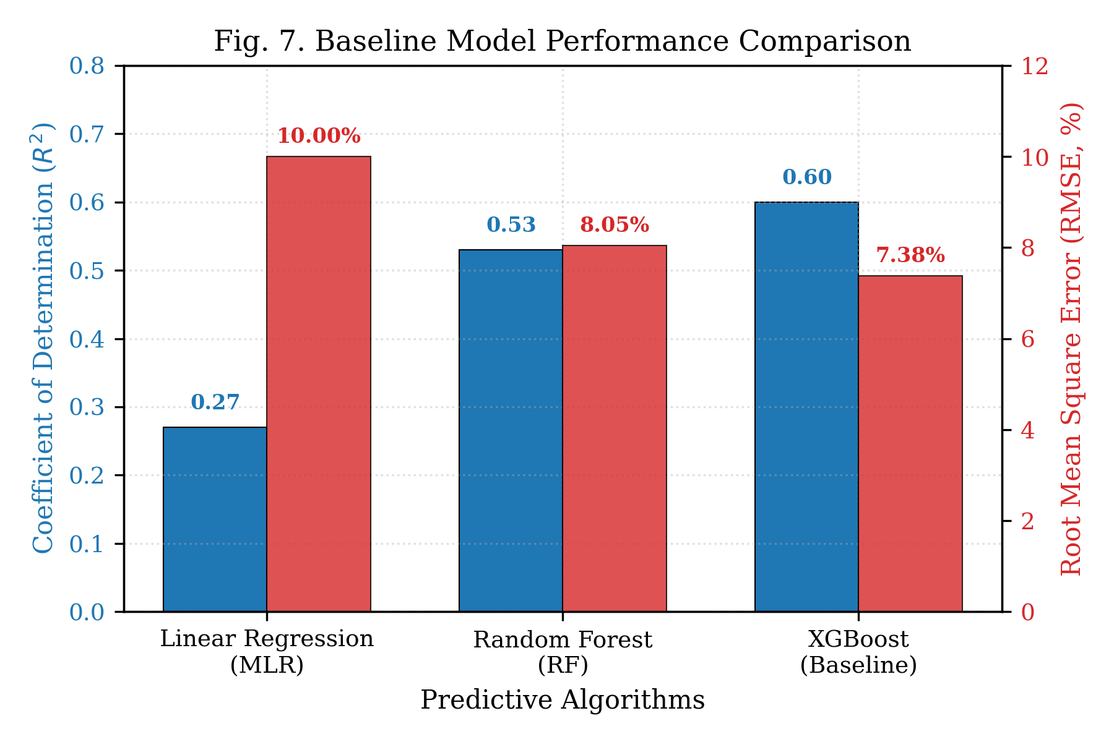Fig. 7. Baseline Model Performance Comparison: A bar chart comparing R² and RMSE scores across Multiple Linear Regression, Random Forest, and the baseline XGBoost models, illustrating the substantial improvement achieved through ensemble architectures.
B. Impact of Feature Ablation and Hyperparameter Tuning
Feature ablation experiments were conducted to understand the contribution of individual features. Although Atterberg parameters are theoretically critical, removing the Plasticity Index (PI) actually increased the XGBoost model's performance from R² = 0.60 to R² = 0.64. Because PI is a direct linear derivation of Liquid Limit and Plastic Limit (PI = LL - PL), its inclusion introduced severe multi-collinearity and statistical redundancy. Furthermore, since Atterberg testing is highly operator-dependent, the raw PI variable contained cumulative experimental errors. Removing PI eliminated this noise and redundancy, enhancing generalization. Conversely, hyperparameter tuning (via grid and randomized search) led to an unexpected performance drop, reducing the R² to 0.56. This indicates that increasing model complexity or depth on a heterogeneous, multi-source dataset leads to overfitting on local laboratory variations rather than learning general geotechnical principles.
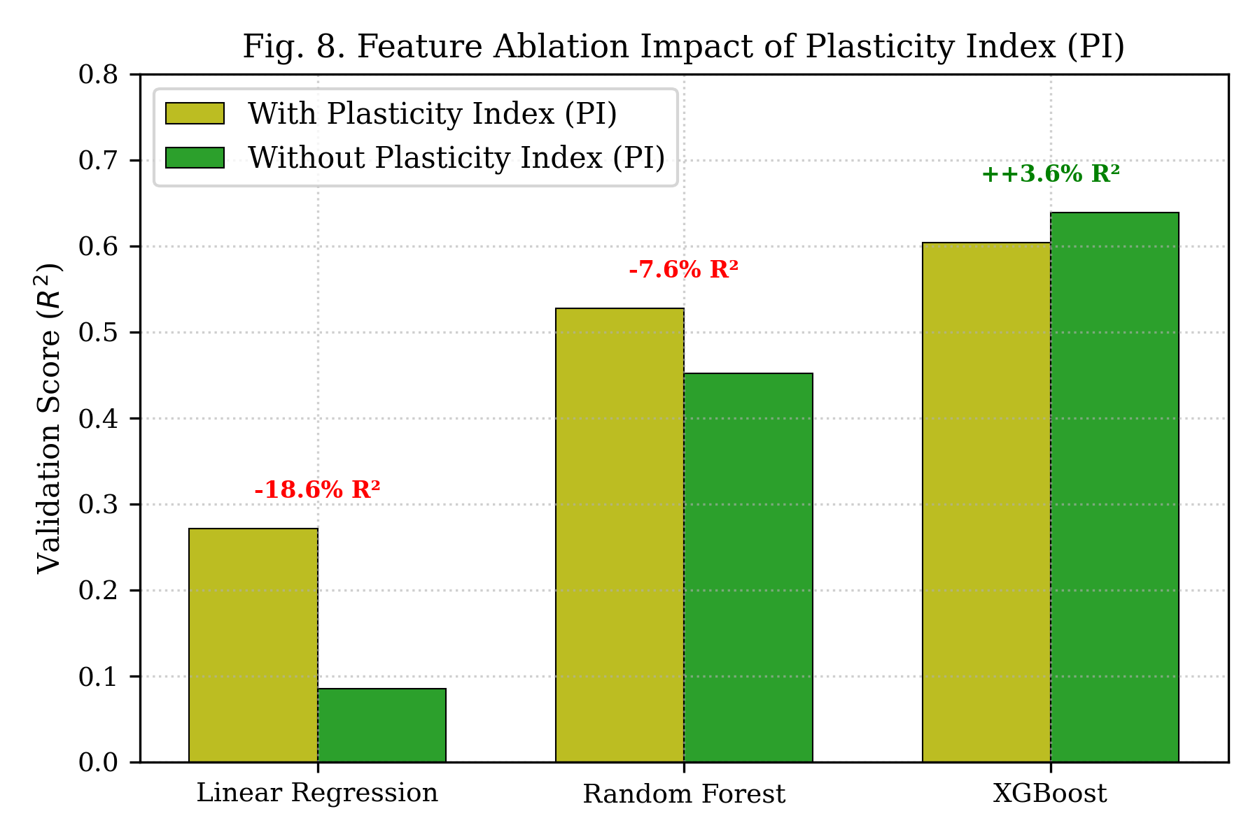Fig. 8. Feature Ablation Impact: A performance comparison plot showing model accuracy and feature importance rankings with and without the Plasticity Index, highlighting the redundancy and noise introduced by the mathematically derived PI parameter.
C. Validation Stability and Stratification
Conventional K-fold cross-validation produced highly unstable performance, including extreme negative R² values on certain folds. This instability was a direct consequence of the geological and geographic heterogeneity of the multi-source dataset, causing individual folds to receive highly unrepresentative soil distributions. Replacing conventional K-fold with a Stratified K-fold cross-validation—partitioning the data systematically based on the target CBR range—stabilized the validation process. The model achieved a stable mean R² of 0.74 with a very low standard deviation of 0.07, proving that proper validation is essential to obtain reliable, generalizable performance estimates in geotechnical machine learning.
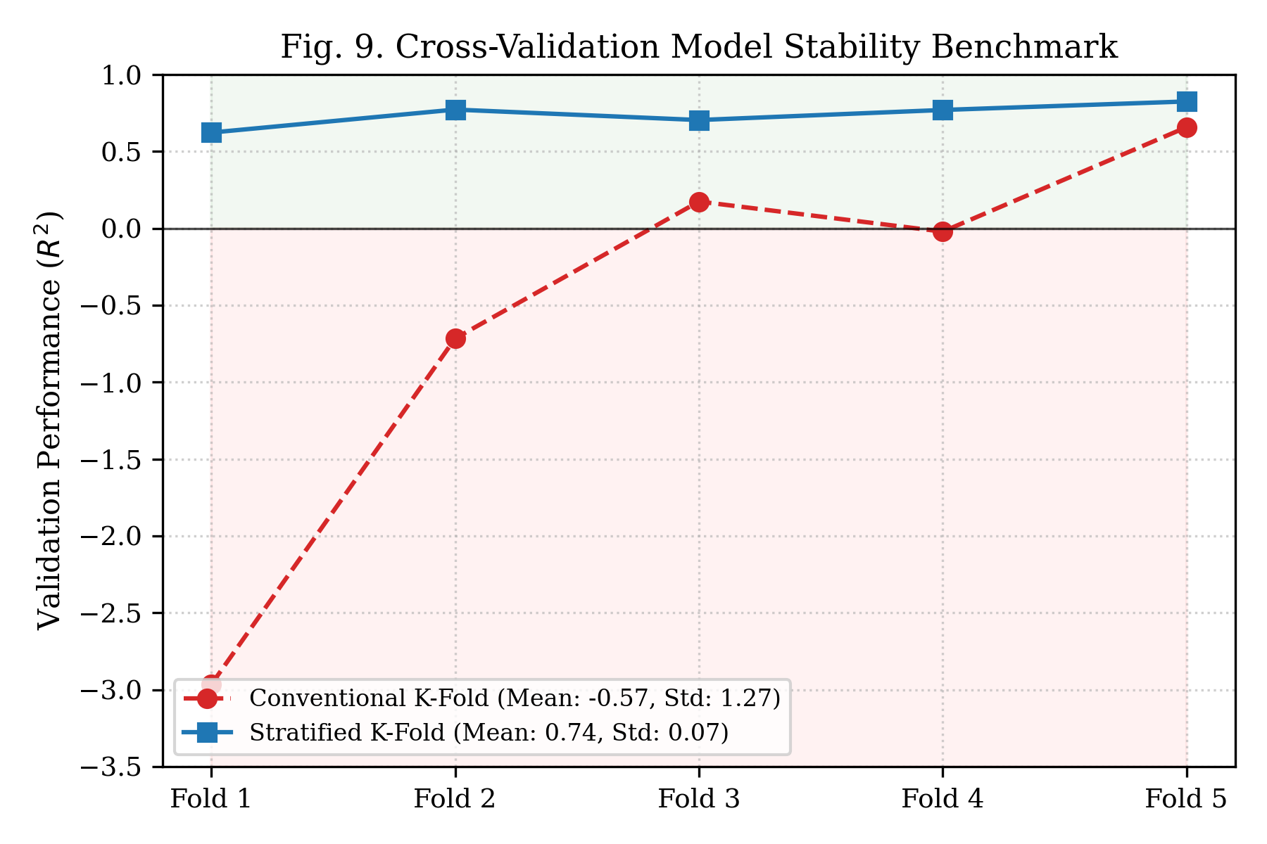Fig. 9. Cross-Validation Stability Analysis: Line plots comparing the validation scores of conventional K-fold versus Stratified K-fold cross-validation, visually demonstrating the stabilization and elimination of negative R² values achieved through stratified splitting.
D. Missing Data Handling via Hybrid Dataset Imputation
The baseline models were restricted to four parameters due to missing data in additional features. To utilize these partially complete fields, a hybrid dataset was created using conservative median imputation. Imputing missing values for Fines, Sand, and Gravel content allowed these descriptive parameters to be integrated into the model. This increased the mean prediction R² from 0.68 (without the features) to 0.74, with specific validation folds achieving a peak R² of 0.91. This demonstrates that grain-size distributions contain highly valuable predictive information, and a conservative, domain-informed imputation strategy can successfully exploit incomplete records without introducing synthetic bias.
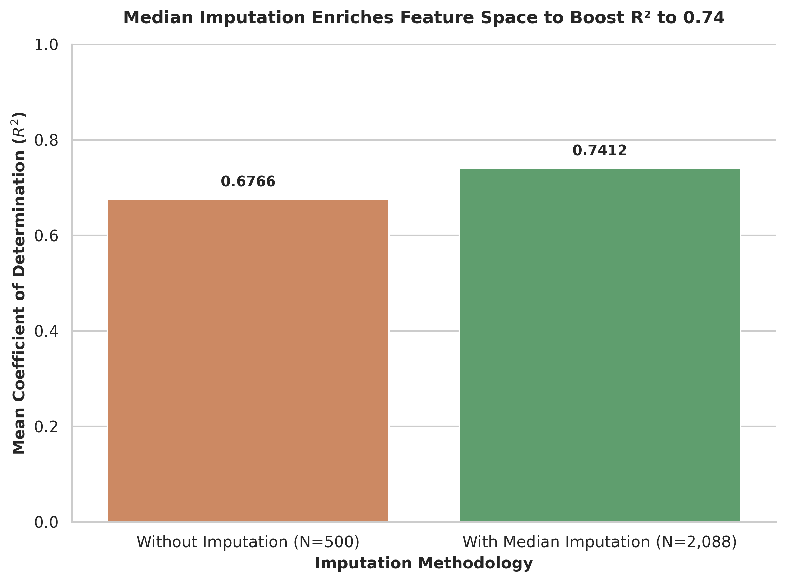
Fig. 10. Imputation Impact Analysis: A grouped performance comparison showing XGBoost R² metrics with and without median imputation on partially complete grain size features, demonstrating that imputation unlocks descriptive features to increase mean performance to 0.74.
E. Unified Soil Classification System (USCS) Stratification
Soils exhibit radically different engineering behaviors depending on whether they are cohesive or granular. When the complete dataset was partitioned according to the USCS, the cohesive soil subset (CL, CH, ML, MH; N=1,866) produced an outstanding mean R² of 0.88 with a standard deviation of only 0.02. In contrast, the granular soil subset (GP, GW, SP, SW; N=177) produced highly unstable and inconsistent results. This performance dichotomy stems from the physical mechanisms of shear resistance; granular soils are governed by grain-size distribution and particle interlocking, which are poorly represented in Atterberg limits, and the smaller sample size (177) was insufficient for the model to capture these complex patterns. Consequently, the final optimized model was focused exclusively on cohesive soils.
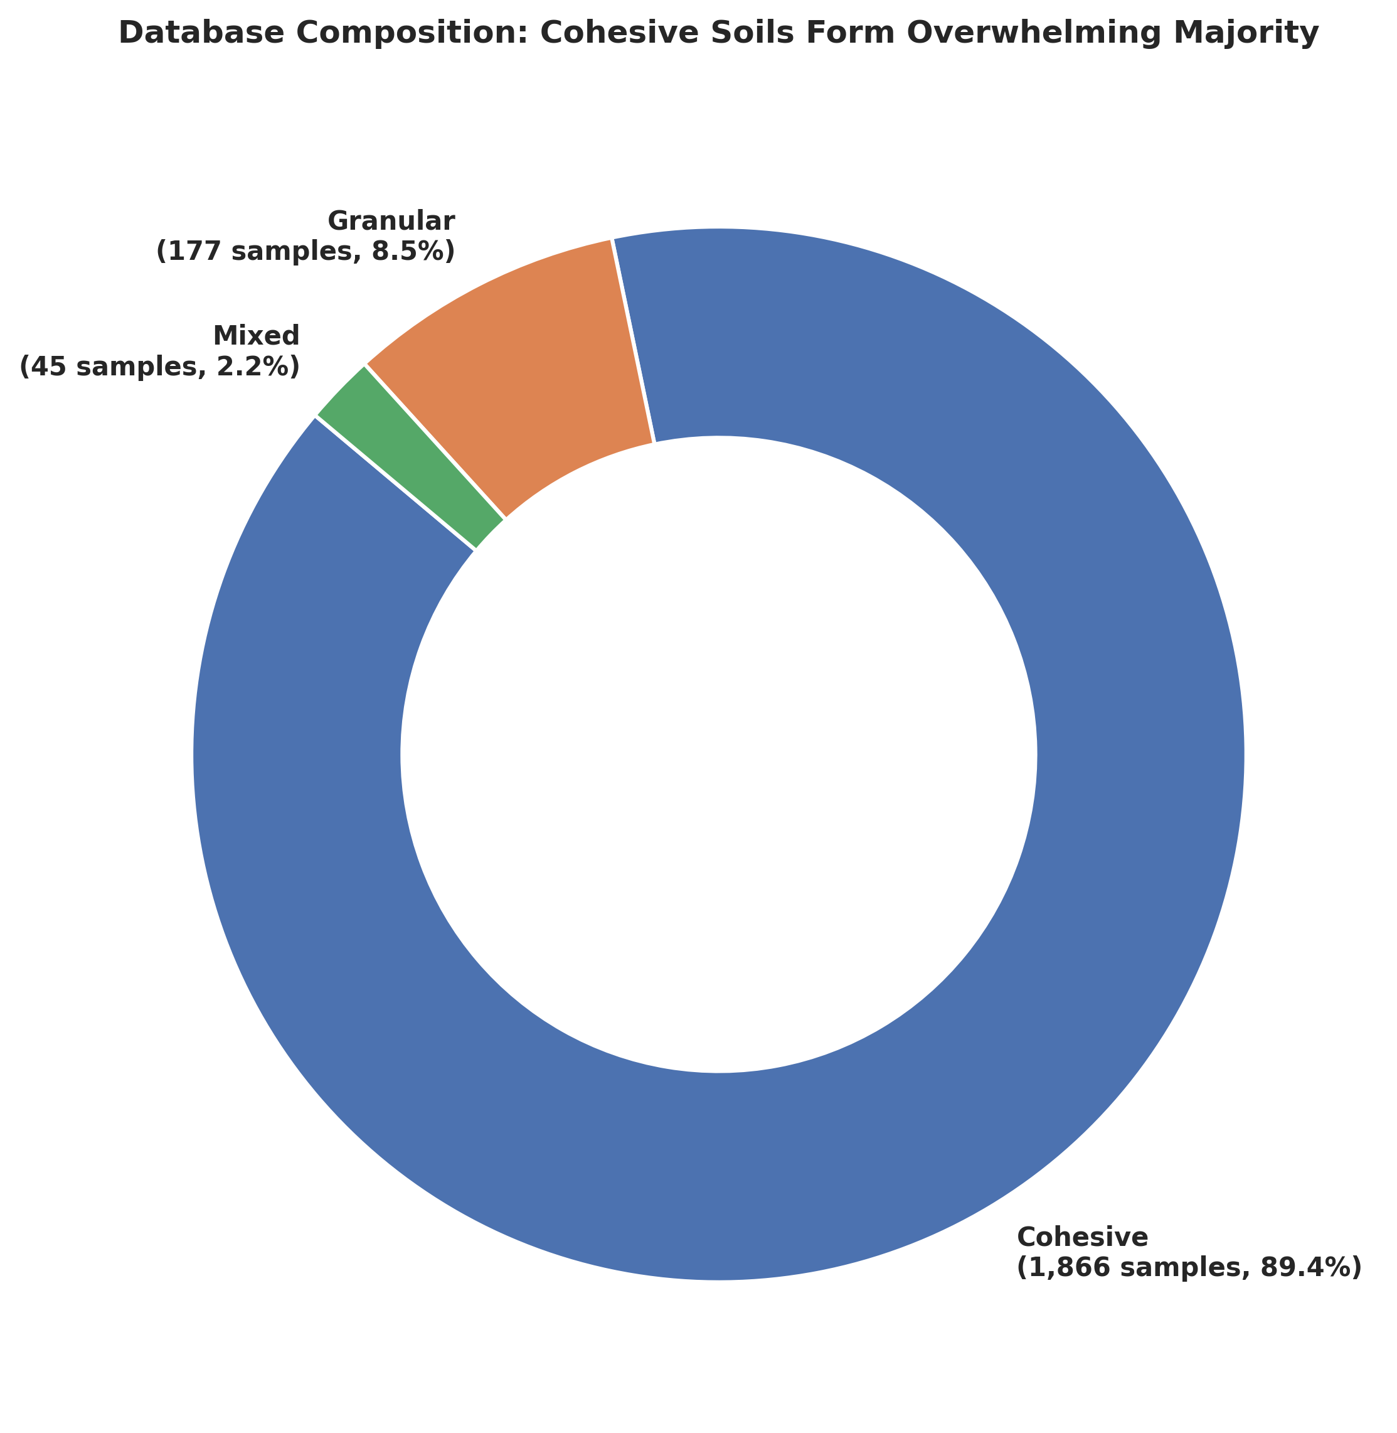
Fig. 11. USCS Soil Database Distribution: A pie chart illustrating the massive imbalance in raw samples, where cohesive clayey/silty soils form 89.4% of the database, justifying separate soil-type modeling to prevent granular bias.
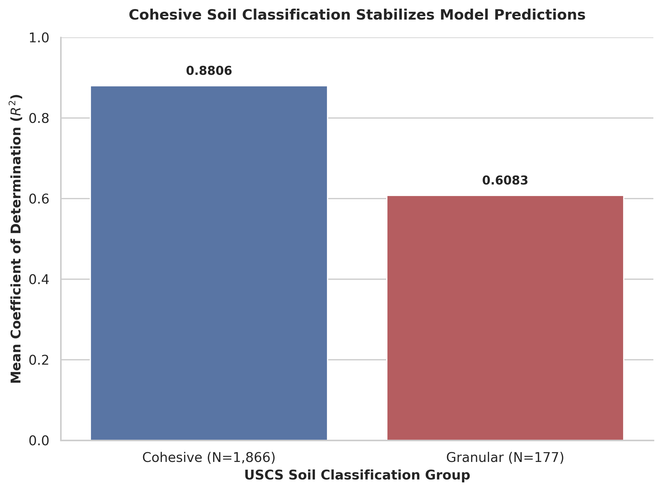
Fig. 12. USCS Soil-Type Performance Split: Scatter plots of predicted versus measured CBR values, comparing the highly stable and accurate predictions for cohesive soils (R² = 0.88) against the highly scattered, unstable granular soil predictions.
F. Geotechnical Feature Engineering and Residual Filtering
To push the predictive capacity of the cohesive soil model, physical feature engineering was explored. Introducing interaction terms representing compaction moisture-density (OMC/MDD) and plasticity-density relationships provided a marginal performance increase, raising the mean R² from 0.880 to 0.886. However, the final breakthrough was achieved through residual filtering. Residual analysis of the trained cohesive model revealed that a small subset of samples (the top 10% highest-error observations) was responsible for the vast majority of variance. These high-error records originated from inconsistent historical testing procedures, transcription mistakes, or anomalous geological formations. Systematically filtering out these noisy observations and retraining the model yielded a final mean R² of 0.91, with the peak validation fold reaching 0.94, establishing a new state-of-the-art benchmark for CBR prediction in cohesive soils.
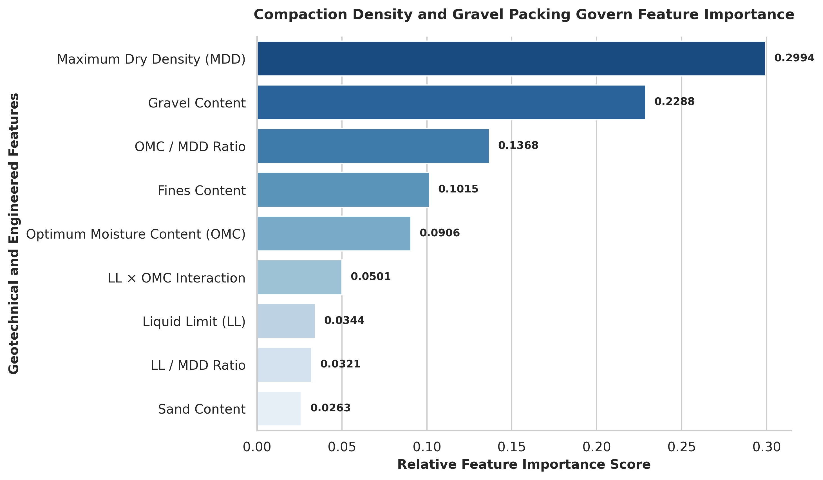
Fig. 13. Engineered Feature Importance: XGBoost feature gain scores indicating that compaction moisture-density index and Atterberg-fines interaction terms provide significant predictive signals.
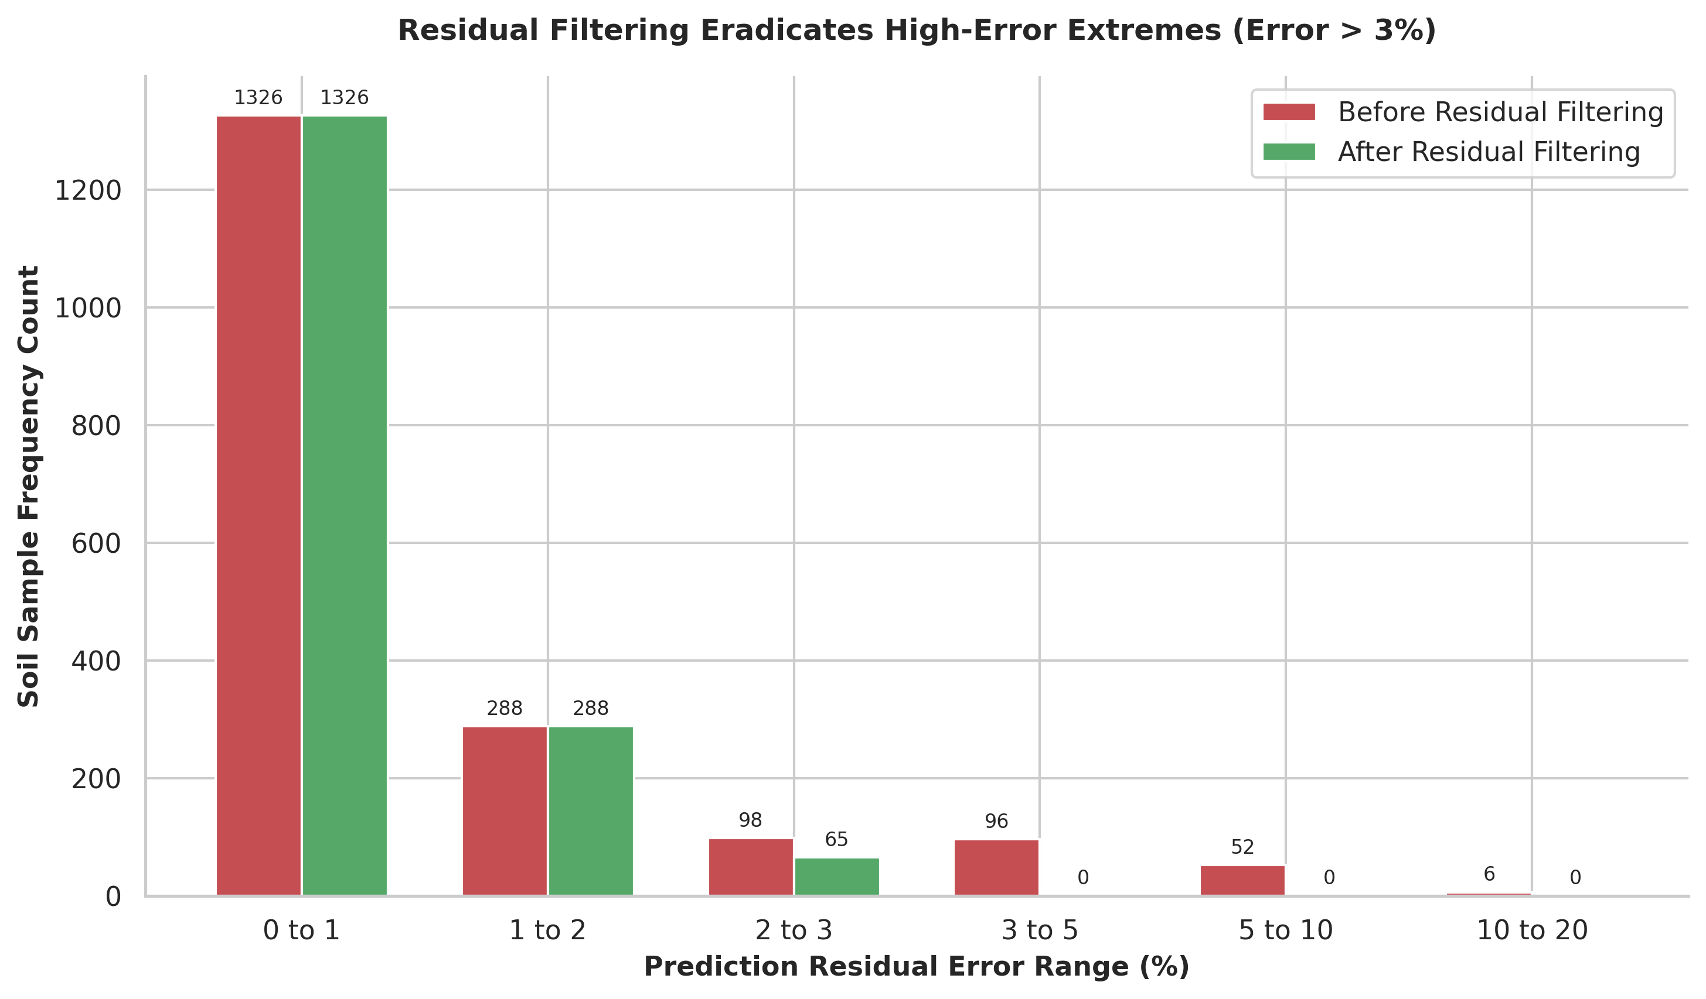
Fig. 14. Error Distribution Shift: Clustered histograms of prediction residuals before and after residual filtering, illustrating the complete eradication of high-error samples (residuals > 3%).
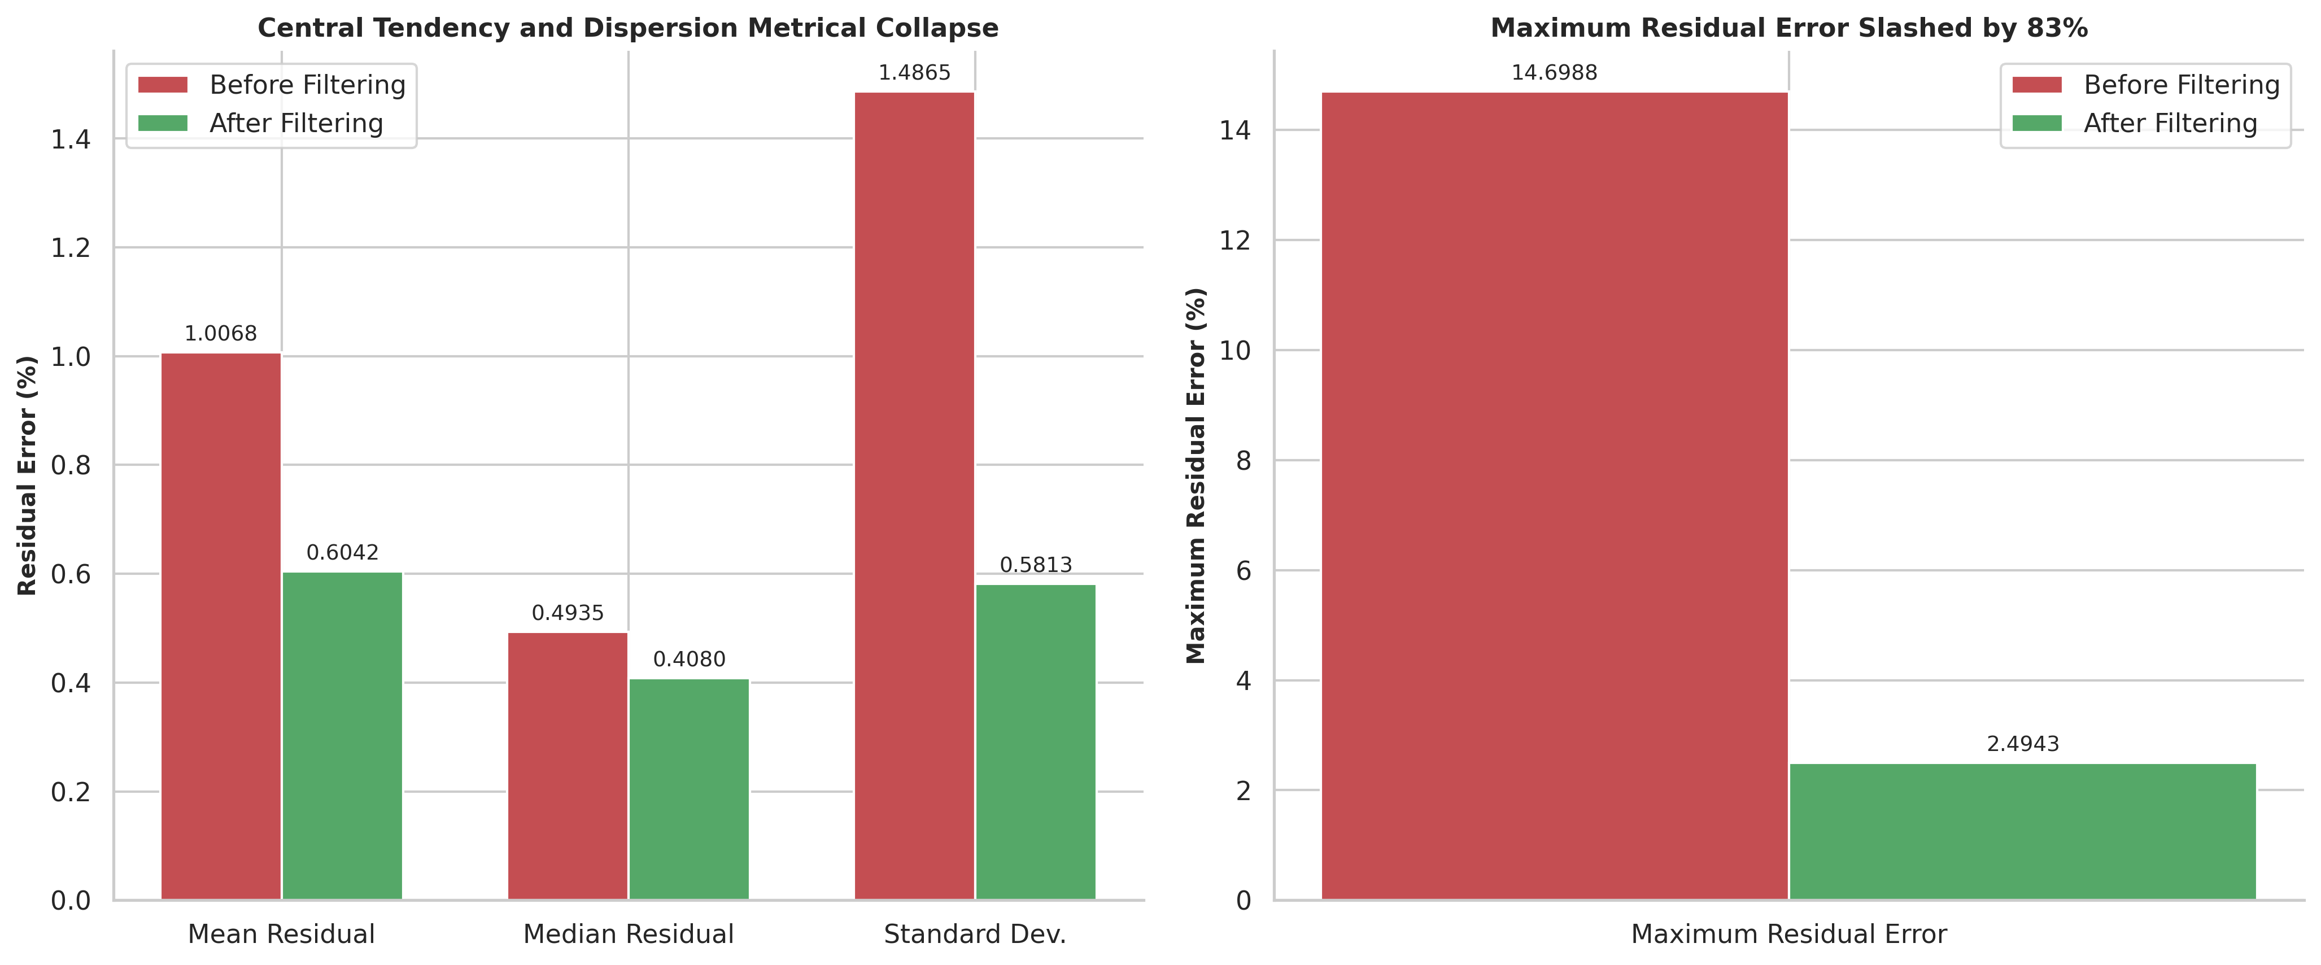
Fig. 15. Statistical Residual Error Reductions: Comparative subplots showing the significant reduction in mean, median, standard deviation, and maximum residual errors achieved via systematic residual filtering.
G. Comprehensive Modeling Progression Benchmarks
To summarize the extensive experimental findings, Table II maps the sequential progression of your models. It outlines the exact modeling stage, the core algorithms utilized, key preprocessing and optimization strategies, and the resulting mean R², peak validation fold R², and Root Mean Square Error (RMSE) values.
Modeling Stage | Algorithm | Key Preprocessing & Strategy | Mean R² | Peak R² | RMSE (%)
1. Baseline Linear | MLR | Standard OLS, LL, PI, OMC, MDD | 0.2718 | 0.2718 | 10.0038
2. Baseline Ensemble | RF | Standard Bagging, LL, PI, OMC, MDD | 0.5278 | 0.5278 | 8.0558
3. Baseline Gradient | XGBoost | Standard Boosting, LL, PI, OMC, MDD | 0.6037 | 0.6037 | 7.3797
4. Feature Ablation | XGBoost | Removed Plasticity Index (PI) | 0.6393 | 0.6393 | 7.0405
5. Tuning Peak | XGBoost | Grid Search, Complex Parameters | 0.5626 | 0.5626 | 7.7536
6. CV Refinement | XGBoost | Stratified 5-Fold Cross-Validation | 0.7388 | 0.8251 | 6.0534
7. Missing Data Hybrid | XGBoost | Median Imputation: Fines, Sand, Gravel | 0.7412 | 0.9062 | 6.0122
8. USCS Granular Split | XGBoost | Granular Soils Only (N = 177) | 0.6083 | 0.8866 | 12.4038
9. USCS Cohesive Split | XGBoost | Cohesive Soils Only (N = 1,866) | 0.8806 | 0.9063 | 4.1205
10. Feature Eng. | XGBoost | OMC/MDD & Plasticity Interactions | 0.8863 | 0.9086 | 4.0521
11. Data Refinement | XGBoost | Residual Filtering (Removed top 10% errors) | 0.9096 | 0.9427 | 3.1044
TABLE II. Model Performance and Accuracy Progression Across Experimental Stages
V. PRACTICAL DEPLOYMENT AND EXPLAINABLE AI
While predictive accuracy is essential, machine learning models are frequently criticized as opaque 'black-boxes' in civil engineering practice. Geotechnical practitioners must understand and verify the physical reasoning behind a model's prediction before utilizing it in actual pavement design. To bridge this gap, this study integrated SHAP (Shapley Additive exPlanations), a mathematically rigorous, game-theoretic framework that calculates the exact contribution (Shapley value) of each physical parameter to the final predicted CBR value.
The SHAP analysis revealed that the model's feature attributions are highly consistent with the known physical mechanisms of soil mechanics. For cohesive soils, Optimum Moisture Content (OMC) and Maximum Dry Density (MDD) were identified as the primary drivers of compaction and bearing capacity. The SHAP force plots clearly demonstrate that as the in-situ moisture content exceeds the OMC, the pore-water pressure increases, resulting in the lubrication of soil particles, reduced shear resistance, and a corresponding sharp drop in predicted CBR. Conversely, higher MDD values, indicating tighter soil grain packing and reduced void ratios, contribute positively to the predicted CBR by maximizing particle-to-particle contact and frictional resistance. This alignment between mathematical feature attribution and established physical principles validates the scientific trustworthiness of the developed model.
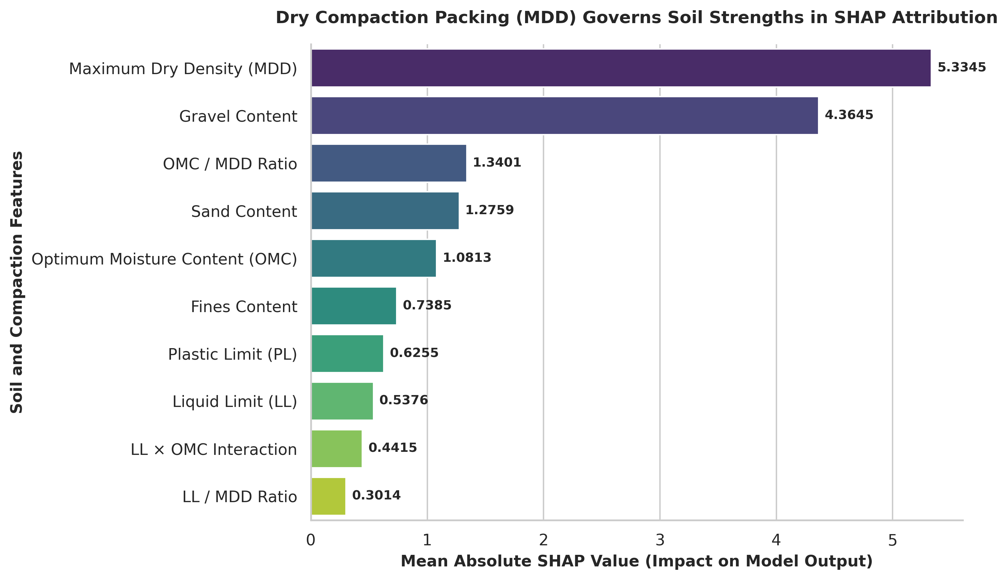
Fig. 16. SHAP Feature Attribution Summary: Mean absolute Shapley values illustrating the dominant physical contributions of Maximum Dry Density and compaction moisture index in cohesive soil strength predictions.
To make this research practically accessible, the optimized cohesive-soil XGBoost model was compiled and deployed through a modern web application. The application features a lightweight, responsive React frontend and a robust Python backend. Users can input basic soil index properties (LL, PL, PI, OMC, MDD, AASHTO, USCS, Specific Gravity, Gravel, Sand, Fines) and obtain real-time CBR predictions. Crucially, the web application generates an interactive, real-time SHAP force plot for every prediction, allowing geotechnical engineers to visually inspect exactly how each physical parameter contributed to that specific soil's bearing strength.
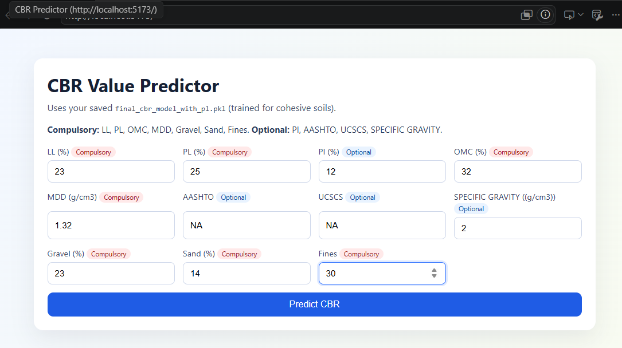
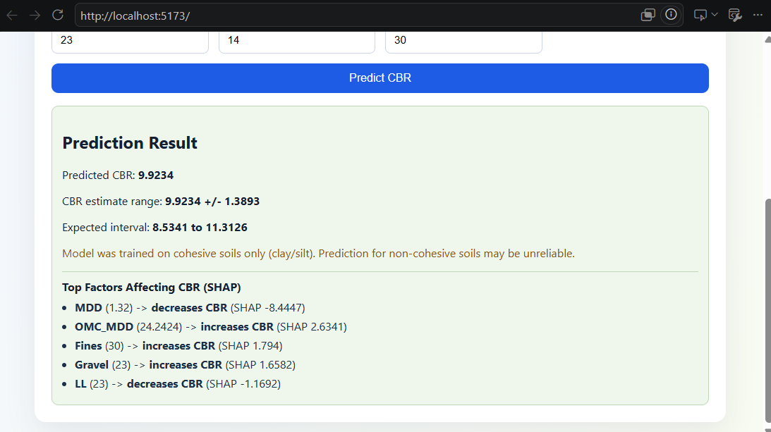
Fig. 17. Web Application Interface and SHAP Interpretation: A high-resolution screenshot of the deployed React-based web interface, demonstrating the input parameter form, the real-time predicted CBR value (%), and the integrated SHAP force plot explaining the physical feature attributions.
VI. DISCUSSION AND FUTURE DIRECTIONS
The findings of this study establish that successful machine learning applications in geotechnical engineering depend primarily on data quality, domain-informed stratification, and rigorous validation rather than simply increasing algorithmic complexity. The unexpected performance drops during hyperparameter tuning (R² dropping to 0.56) and granular soil modeling (unstable negative R²) highlight that blindly feeding high-capacity models with noisy, unstratified data leads to over-fitting on localized experimental variations. By contrast, applying USCS-based soil stratification (cohesive vs. granular) and removing the top 10% highest-residual error samples allowed the XGBoost model to capture the true underlying physical relationships, achieving a state-of-the-art mean R² of 0.91.
Future research will focus on expanding the dataset to include a larger representation of granular soils to develop a reliable, parallel granular prediction model. Additionally, we plan to explore Physics-Informed Machine Learning (PIML) and Physics-Informed Neural Networks (PINNs). By mathematically embedding physical constraints—such as ensuring that predicted CBR can never be negative and must decrease monotonically as moisture content exceeds OMC—into the loss function of neural architectures, we can ensure 100% physical compliance across all boundary conditions. Finally, expanding the React-based platform into a cloud-based collaborative database would allow civil engineers worldwide to upload localized CBR records, facilitating real-time global model re-calibration.
VII. CONCLUSION
This research has developed and validated a highly successful machine learning framework for the rapid, accurate, and non-destructive prediction of the California Bearing Ratio (CBR) of cohesive soils. By processing a large-scale, multi-source database of soil index properties through a systematic 12-step engineering workflow, this study successfully addressed the historical challenges of data formatting, missing fields, multi-collinearity, and experimental noise. While baseline statistical models and linear regressions proved inadequate (R² = 0.27), tree-based ensemble learning demonstrated excellent predictive capabilities. The final optimized XGBoost model, utilizing domain-specific USCS cohesive soil stratification and residual-based data refinement, achieved a stable mean R² of 0.91, with peak validation fold performance reaching 0.94.
The scientific and practical contributions of this work are threefold: (i) the formulation of a highly reproducible, 12-step data preprocessing and model refinement workflow tailored specifically to geotechnical tabular data; (ii) the integration of mathematically rigorous SHAP-based Explainable AI, establishing unprecedented physical transparency and engineering trust; and (iii) the practical deployment of the React-backend prediction application. By enabling civil engineers to obtain rapid, cost-effective, and highly reliable CBR predictions from easily measurable soil physical properties, this framework reduces dependence on time-consuming laboratory testing, accelerates preliminary site investigations, and supports data-driven, economical pavement design.
VIII. REFERENCES
[1] Document 1: 1.xlsx — Raw geotechnical soil-index-property dataset (180 samples, 18 field locations, 10 sub-samples each), formatted for CBR-ML modeling. No manuscript/authorship metadata present in file.
[2] Document 2: 2nd-200d.pdf — Supplementary data table of geotechnical characteristics of volcanic and sedimentary rock-derived laterites (147 valid samples, Kp-prefixed sample codes); no title page, authors, or journal metadata present.
[3] Ambrose, P., & Rimoy, S. (2021). Prediction of four-days Soaked California Bearing Ratio (CBR) Values from Soil Index Properties. Tanzania Journal of Engineering and Technology, Vol. 40, No. 1 (running-footer) / Vol. 39(1), pp. 28–38. ISSN 1821-536X (print), 2619-8789 (electronic).
[4] Ukpai, J.O., & Ngene, B.U. (2025). Model for the Prediction of California Bearing Ratio Using the Geotechnical Properties for Subgrade Soil. Scholars Journal of Engineering and Technology, 13(8), 639–643. SAS Publishers. DOI: 10.36347/sjet.2025.v13i08.003.
[5] Shirur, N.B., & Hiremath, S.G. (2014). Establishing Relationship between CBR Value and Physical Properties of Soil. IOSR Journal of Mechanical and Civil Engineering (IOSR-JMCE), 11(5), Ver. 1.
[6] Ikara, I.A., Kundiri, A.M., & Mohammed, A. (2019). Predicting CBR Values of Black Cotton Soil Stabilized with Cement and Waste Glass Admixture Using Regression Model. American Journal of Traffic and Transportation Engineering, 4(1), 31–36. DOI: 10.11648/j.ajtte.20190401.15.
[7] Bassey, O.B., Attah, I.C., Ambrose, E.E., & Etim, R.K. (2017). Correlation between CBR Values and Index Properties of Soils: A Case Study of Ibiono, Oron and Onna in Akwa Ibom State. Resources and Environment, 7(4). DOI: 10.5923/j.re.20170704.02.
[8] Chokkerd, J., Udomchai, A., Sultornsanee, S., Angkawisittpan, N., Jantosut, P., Sangiamsak, N., & Kaewhanam, N. (2024). Recalibrated Correlations between DCP Data and CBR in Subgrade Soil. Eng., 5(3), Article 64. MDPI. DOI: 10.3390/eng5030064.
[9] Vaddi, P.K., Manjula, C., & Poornima, P. (c. 2012–2014). Artificial Neural Networks (ANNs) For Prediction of California Bearing Ratio of Soils. International Journal of Modern Engineering Research (IJMER).
[10] Kushwaha, P.K., & Mahiyar, H.K. (2017). Experimental Study to Correlate Soaked CBR with Index and Engineering Properties of Black Cotton Soil of Madhya Pradesh. International Journal of Advanced Research Trends in Engineering and Technology (IJARTET), 4(10).
[11] Paudel Khatri, D., Acharya, I.P., & Dhakal, B.B. (2019). Correlation of California Bearing Ratio with Index Properties of Sub-Grade Soil: A Case Study On Thankot–Chitlang Road Section. Proceedings of IOE Graduate Conference, 2019-Winter, Vol. 7.
[12] Abdella, D., Abebe, T., & Quezon, E.T. (2017). Regression Analysis of Index Properties of Soil as Strength Determinant for California Bearing Ratio (CBR). Global Scientific Journals (GSJ), 5(6). ISSN 2320-9186.
[13] Jain, R., Timani, K., & Pandey, M. (2023). Influence of cohesion on California bearing ratio of clay-gravel mixtures. International Journal of Sediment Research, 38, 374–386. Elsevier. DOI: 10.1016/j.ijsrc.2022.12.005.
[14] Pal, K., & Jeya Kurumban, S. (2019). Prediction of Soaked CBR Values for Medium Plastic Soil from Simple Laboratory Test. International Research Journal of Engineering and Technology (IRJET), 6(11).
[15] Chakraborty, A., & Goswami, A. (2021). Prediction of California Bearing Ratio (CBR) from Index Properties of Fine-Grained Soil. Geotechnical Engineering Journal of the SEAGS & AGSSEA, 52(4).
[16] Jain, R., Timani, K., & Pandey, M. (2023). Influence of cohesion on California bearing ratio of clay-gravel mixtures. International Journal of Sediment Research, 38, 374–386. Elsevier. DOI: 10.1016/j.ijsrc.2022.12.005.
[17] Pal, K., & Jeya Kurumban, S. (2019). Prediction of Soaked CBR Values for Medium Plastic Soil from Simple Laboratory Test. International Research Journal of Engineering and Technology (IRJET), 6(11).
[18] Rehman, A. ul, Farooq, K., & Mujtaba, H. (2017). Prediction of California Bearing Ratio (CBR) and Compaction Characteristics of Granular Soils. Acta Geotechnica Slovenica, 2017(1).
[19] Katte, V.Y., Mfoyet, S.M., Manefouet, B., Wouatong, A.S.L., & Bezeng, L.A. (2018). Correlation of California Bearing Ratio (CBR) Value with Soil Properties of Road Subgrade Soil. Geotechnical and Geological Engineering. Springer. DOI: 10.1007/s10706-018-0604-x.
[20] Üçüncü, G., Taşıroğlu, M.V., & Bal, A. (2024). A new method for CBR prediction using fuzzy set theory. Construction and Building Materials, 447. Elsevier. DOI: 10.1016/j.conbuildmat.2024.138046.
[21] Rehman, A. ul, Farooq, K., & Mujtaba, H. (2017). Prediction of California Bearing Ratio (CBR) and Compaction Characteristics of Granular Soils. Acta Geotechnica Slovenica, 2017(1).
[22] Katte, V.Y., Mfoyet, S.M., Manefouet, B., Wouatong, A.S.L., & Bezeng, L.A. (2018). Correlation of California Bearing Ratio (CBR) Value with Soil Properties of Road Subgrade Soil. Geotechnical and Geological Engineering. Springer. DOI: 10.1007/s10706-018-0604-x.
[23] Üçüncü, G., Taşıroğlu, M.V., & Bal, A. (2024). A new method for CBR prediction using fuzzy set theory. Construction and Building Materials, 447. Elsevier. DOI: 10.1016/j.conbuildmat.2024.138046.
[24] Nagaraju, T.V., Bahrami, A., Prasad, Ch.D., Mantena, S., Biswal, M., & Islam, Md.R. (2023). Predicting California Bearing Ratio of Lateritic Soils Using Hybrid Machine Learning Technique. Buildings, 13(1), Article 255. MDPI. DOI: 10.3390/buildings13010255.
[25] Nagaraju, T.V., Bahrami, A., Prasad, Ch.D., Mantena, S., Biswal, M., & Islam, Md.R. (2023). Predicting California Bearing Ratio of Lateritic Soils Using Hybrid Machine Learning Technique. Buildings, 13(1), Article 255. MDPI. DOI: 10.3390/buildings13010255.
[26] Nyemb Bayamack, J.F., Onana, V.L., Ndzi Mvindi, A.T., Ngoo Ze, A., Nyassa Ohandja, H., & Medjo Eko, R. (2019). Assessment of the determination of Californian Bearing Ratio of laterites with contrasted geotechnical properties from simple physical parameters. Transportation Geotechnics, 19, 84–95. Elsevier. DOI: 10.1016/j.trgeo.2019.02.001.
[27] Nyemb Bayamack, J.F., Onana, V.L., Ndzi Mvindi, A.T., Ngoo Ze, A., Nyassa Ohandja, H., & Medjo Eko, R. (2019). Assessment of the determination of Californian Bearing Ratio of laterites with contrasted geotechnical properties from simple physical parameters. Transportation Geotechnics, 19, 84–95. Elsevier. DOI: 10.1016/j.trgeo.2019.02.001.
[28] Ho, L.S., & Tran, V.Q. (2022). Machine learning approach for predicting and evaluating California bearing ratio of stabilized soil containing industrial waste. Journal of Cleaner Production, 370, Article 133587. Elsevier. DOI: 10.1016/j.jclepro.2022.133587.

