MedQuick Project

Software Design Document

Digital Assignment 2 / Review 2
24BRS1009 - Suriyan Loganathan
24BRS1347 - Sairam

Medicine & Emergency Essentials Delivery Platform
Technology Stack:
MongoDB · Express.js · React.js · Node.js
Architecture:
3-Tier Modular Monolith

GitHub Repository:
https://github.com/SuAsPra/MedQuick_MERN_project

Figma Prototype:
https://www.figma.com/design/cVr0YrCWQ9vzvpH7YOpG79/MED_Quick-Pages?node-id=0-1&t=K7QtAcwjEVOsuzCD-1
Refer Architecture and UML diagrams from here -
https://github.com/SuAsPra/MedQuick_MERN_project/tree/main/design

1. Project Overview
MedQuick is a healthcare-focused ecommerce platform designed to enable users to browse and order medicines, first-aid products, emergency supplies, health devices, and other daily healthcare essentials through a centralized web application.
The project is developed using the MERN stack, consisting of a React frontend, Express.js and Node.js backend, and MongoDB database. The application follows a modular architecture where frontend functionality is organized into independent feature modules, while backend functionality is separated into routes, middleware, controllers, and Mongoose models.
The platform provides customer features such as authentication, product browsing, search, cart management, checkout, wishlist, reviews, addresses, and order management. Administrators are provided with centralized functionality for managing products, inventory, customers, and orders.
MedQuick extends a reusable MERN ecommerce foundation toward a healthcare-specific platform. The healthcare design includes 8 product categories, 16 healthcare products, medicine-specific product attributes, prescription-required product indicators, and a planned prescription verification dashboard.

Project Scope

Customer Features
- User registration and authentication
- Browse healthcare products
- Keyword-based product search
- Product details and reviews
- Shopping cart management
- Wishlist management
- Checkout and address management
- Order placement and tracking

Administrative Features
- Product management
- Inventory management
- Order management
- Customer management
- Healthcare product information management
- Prescription verification module (planned)

Project Objectives
The objectives of MedQuick are:
- To provide a centralized platform for ordering medicines and emergency essentials.
- To create a modular and maintainable MERN application.
- To separate customer and administrator responsibilities through role-based functionality.
- To support healthcare-specific product information and future prescription workflows.
- To provide a scalable foundation for future deployment and feature expansion.
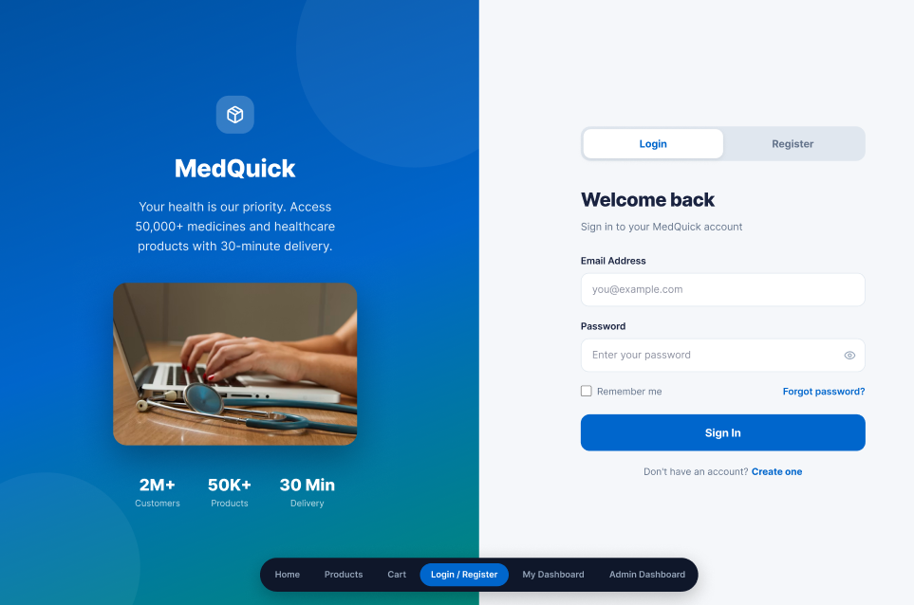
Figure 1: MedQuick Healthcare Delivery Platform – Customer Login Interface

2. Requirements to Design Mapping
The software design of MedQuick was derived from the requirements identified during Digital Assignment 1. User stories, functional requirements, MoSCoW prioritization, and UI wireframes were used as the foundation for designing the application modules.
The requirements were mapped to specific frontend and backend modules to maintain traceability between what users need and how the system is designed. This approach improves maintainability and ensures that major user requirements are represented in the implementation.

2.1 Requirement Traceability
User Requirement | MedQuick Design Module
User registration and login | Authentication Module
Browse healthcare products | Products Module
Search products | Product Listing and Search
View medicine/product details | Product Details Component
Add products to cart | Cart Module
Manage wishlist | Wishlist Module
Manage addresses | Address Module
Checkout and place orders | Checkout and Order Modules
View order history | Order Module
Write product reviews | Review Module
Manage user profile | User Module
Manage products | Admin Product Module
Manage orders | Admin Order Module
Manage categories and brands | Categories and Brands Modules
Identify prescription-required products | Healthcare Product Attributes
Verify prescriptions | Admin Prescription Module (Planned)
The traceability between requirements and modules allows MedQuick to support future changes without redesigning the complete system. For example, a new healthcare feature can be added as an independent module or by extending an existing feature module.

2.2 User Stories as the Basis for Design
MedQuick uses user stories to represent system requirements from the perspective of customers and administrators.
The user stories were created and managed using GitHub Issues, with each issue representing a specific requirement or feature. The issues were then organized using a GitHub Projects Kanban Board to track their development status.
Examples of user requirements include:
- Users should be able to register and securely log in.
- Users should be able to browse medicines and healthcare products.
- Users should be able to add products to a shopping cart.
- Users should be able to place and track orders.
- Administrators should be able to manage products and inventory.
- Administrators should be able to update order status.
- The system should identify products requiring prescriptions.
These user stories directly influenced the feature-based modular structure of the frontend and the route-controller-model organization of the backend.

GitHub User Stories

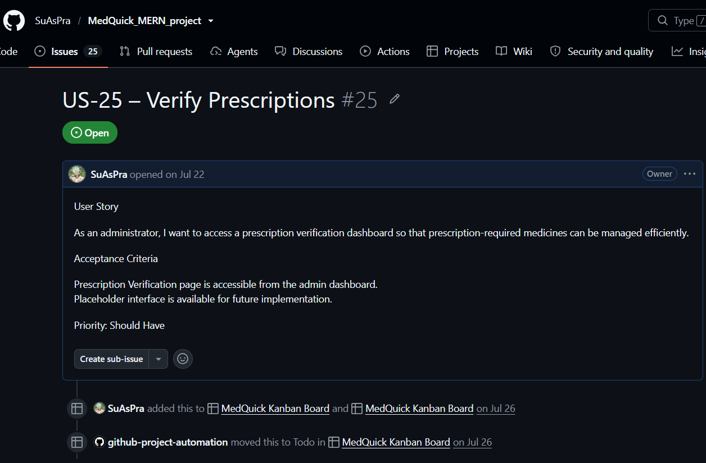Figure 2: MedQuick User Stories Managed Using GitHub Issues
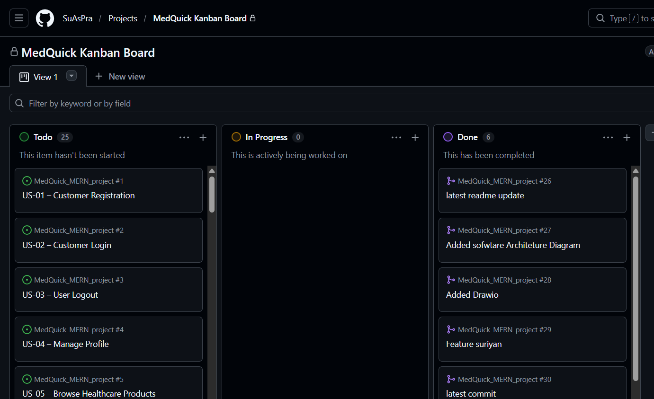
Figure 3: MedQuick User Story Progress Managed Using GitHub Projects

3. Design Principles Applied
The MedQuick system was designed using modularity, abstraction, high cohesion, and low coupling. These principles help organize the application into manageable components and reduce the impact of future changes.
The frontend follows a feature-based modular structure, while the backend separates responsibilities using routes, middleware, controllers, and Mongoose models.

3.1 Modularity
Modularity refers to dividing a software system into independent and manageable modules, where each module focuses on a specific functionality. MedQuick demonstrates strong modularity through its feature-based frontend structure.

Frontend Feature Structure
front/src/features/
├── address
├── admin
├── auth
├── brands
├── cart
├── categories
├── checkout
├── order
├── products
├── review
├── user
└── wishlist
Each feature contains functionality related to a specific business domain. This structure separates product API communication, state management, and user interface components into organized modules.
As a result, changes to one feature have limited impact on unrelated features. For example, modifications to the Cart module do not normally require changes to the Authentication or Wishlist modules.

Benefits of Modularity
- Easier maintenance and debugging
- Clear separation of features
- Independent development of modules
- Better organization of source code
- Easier testing
- Easier addition of future features
The modular structure is particularly useful for MedQuick because future healthcare functionality, such as prescription upload or delivery tracking, can be added as separate modules without redesigning the entire application.
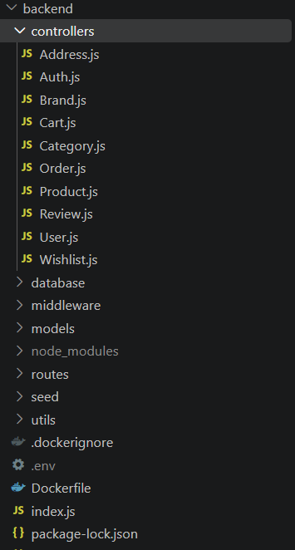
Figure 4: Feature-Based Modular Structure of the MedQuick Backend

3.2 Abstraction
Abstraction is used to hide unnecessary implementation details and provide simplified operations to other parts of the system.
In MedQuick, abstraction is demonstrated through feature-specific API modules.
For example, the Product API module provides operations such as:
fetchProducts(filters)
fetchProductById(id)
addProduct(data)
updateProductById(update)
deleteProductById(id)
The user interface does not need to know how HTTP requests are created or how Axios communicates with the backend.
Instead, API communication is abstracted into a dedicated layer.

Product Data Flow
React Components
↓
Redux / Product Logic
↓
ProductApi.jsx
↓
Axios
↓
Express REST API
This means that React components can focus on displaying information and handling user interaction while the API module handles communication with the backend.
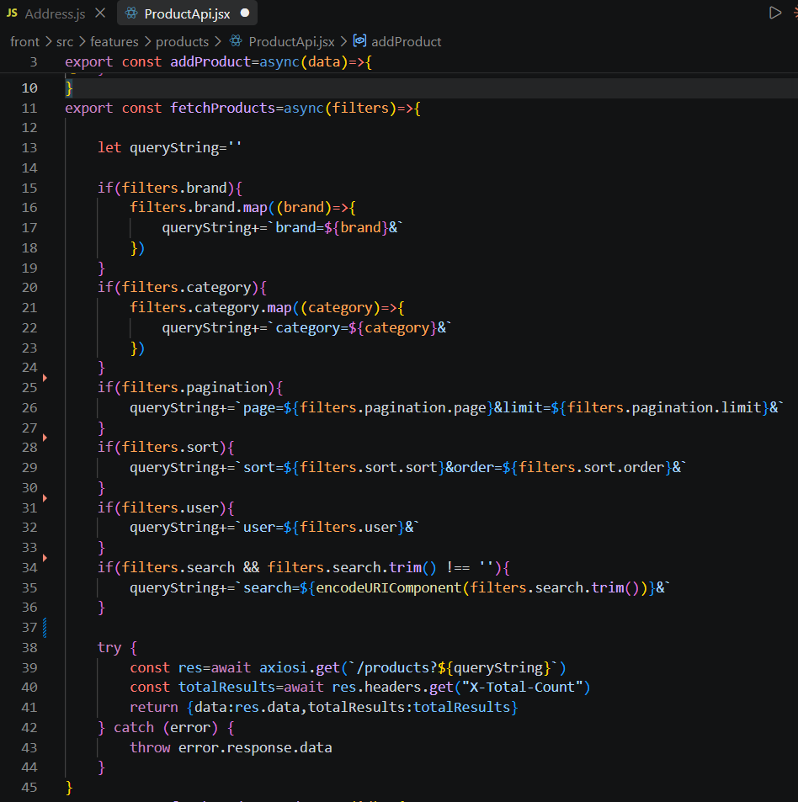
Source: front/src/features/products/ProductApi.jsx

Why This Demonstrates Abstraction
The API implementation details are hidden inside ProductApi.jsx. Other parts of the application interact with product operations through reusable functions rather than directly creating HTTP requests.
This abstraction provides the following benefits:
- UI components remain simpler.
- API logic is centralized.
- HTTP implementation can be modified independently.
- Code duplication is reduced.
- Future backend changes are easier to manage.

3.3 High Cohesion
Cohesion refers to how closely related the responsibilities within a module are. A highly cohesive module focuses on a specific purpose instead of handling many unrelated tasks.
MedQuick demonstrates high cohesion by organizing state management and functionality according to individual business features.
For example, the product state management is grouped within:
front/src/features/products/ProductSlice.jsx
The Product Slice contains product-related functionality such as:
- Product state
- Initial state
- Asynchronous operations
- Reducers
- Extra reducers
- Actions
- Selectors
Each module focuses primarily on its own business domain. This improves code organization and makes the application easier to maintain.

C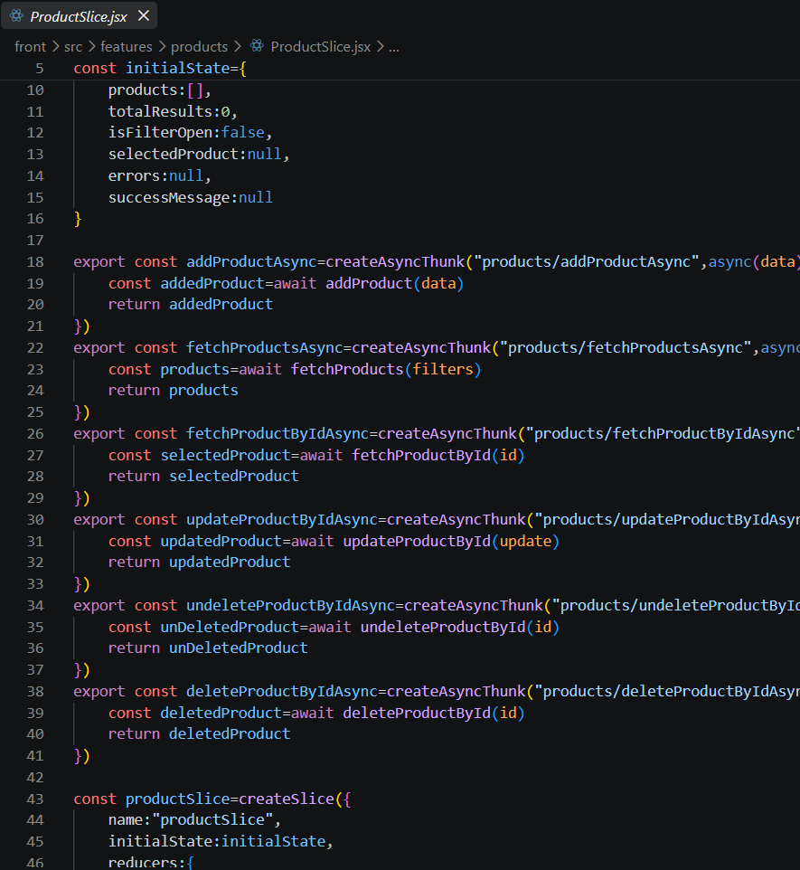

Source:front/src/features/products/ProductSlice.jsx

Why This Demonstrates High Cohesion
All the responsibilities inside the Product Slice are directly related to managing product data and product state.
For example:
ProductSlice
├── Fetch Products
├── Store Products
├── Loading State
├── Error State
└── Product Actions
Unrelated functionality such as authentication, orders, or wishlist management is handled by separate modules.
This demonstrates a high level of cohesion.

3.4 Low Coupling
Low coupling means that individual modules should have minimal dependency on the internal implementation of other modules.
MedQuick separates its application into multiple layers:
React UI Components
↓
Redux Toolkit
↓
Feature API Module
↓
Centralized Axios Client
↓
Express REST API
↓
Routes / Middleware
↓
Controllers
↓
Mongoose Models
↓
MongoDB
Each layer has a specific responsibility and communicates with adjacent layers instead of directly accessing distant layers.
For example, a customer adding a product to the cart follows a flow similar to:
ProductCard
↓
Cart Action
↓
CartSlice
↓
CartApi
↓
Axios
↓
Cart REST Endpoint
The Product UI component does not directly communicate with the database or MongoDB models.
This separation reduces dependencies and makes changes easier to manage.

Code Snippet 3 — Centralized Axios Configuration

Source:front/src/config/axios.js
import axios from 'axios';
export const axiosi = axios.create({
withCredentials: true,
baseURL: process.env.REACT_APP_BASE_URL
});

Why This Demonstrates Low Coupling
Instead of configuring Axios separately in every React component, MedQuick uses a centralized API client.
This means that configuration such as the backend URL can be changed in one location.
Benefits include:
- Reduced code duplication
- Easier configuration changes
- Consistent API communication
- Reduced dependency between UI and HTTP implementation

3.5 Separation of Responsibility
MedQuick also separates authentication logic from business logic through middleware.
JWT verification is handled through: back/middleware/VerifyToken.js
Instead of repeating authentication checks inside every controller, the middleware is responsible for verifying user authentication before protected operations are performed.

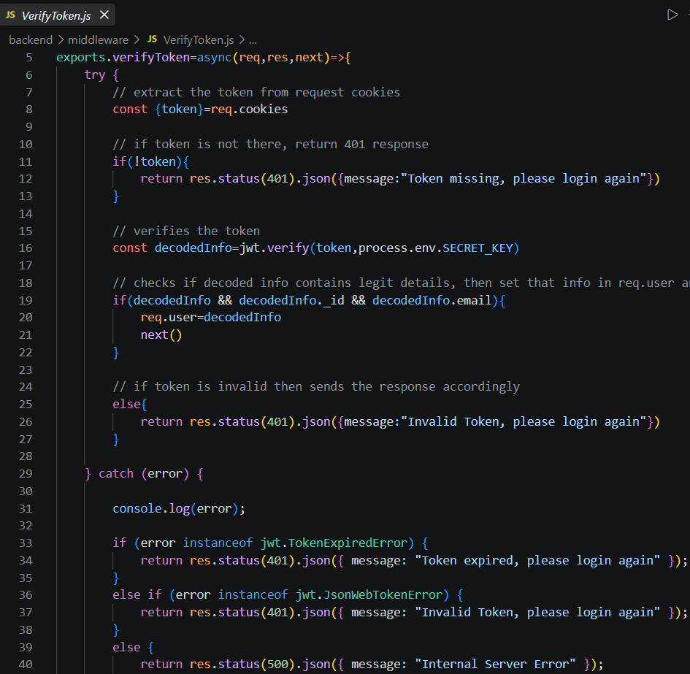Source:back/middleware/VerifyToken.js

Why This Demonstrates Separation of Responsibility
The middleware is responsible for authentication verification, while controllers focus on business operations.
For example:
VerifyToken Middleware
↓
Authentication Verification

Controller
↓
Business Logic

Model
↓
Database Operations
This reduces code duplication and improves maintainability.

3.6 SOLID Principles Evaluation
The SOLID principles were evaluated based on the actual architecture and code structure of MedQuick.
Since MedQuick primarily uses React components, JavaScript modules, Redux Toolkit, and a layered MERN architecture, not every traditional object-oriented SOLID principle is equally applicable.
The project therefore does not claim complete implementation of all five principles.
SOLID Principle | MedQuick Evidence | Assessment
S — Single Responsibility | Feature-specific slices, API modules, middleware and controllers | Strong
O — Open/Closed | Reusable components and extensible feature structure | Partial
L — Liskov Substitution | Limited inheritance/interface usage | Not strongly applicable
I — Interface Segregation | Separate feature-specific API modules | Partial
D — Dependency Inversion | Layer separation and API abstraction | Partial

S — Single Responsibility Principle
The Single Responsibility Principle states that a module should have one primary responsibility.
Examples from MedQuick include:
ProductApi.jsx
→ Product API communication

ProductSlice.jsx
→ Product state management

VerifyToken.js
→ Authentication verification

ProductCard.jsx
→ Product UI presentation
Each module has a clearly defined responsibility.
Assessment: Strongly Demonstrated

O — Open/Closed Principle
MedQuick uses reusable components and modular feature structures that can be extended with new functionality.
For example, new healthcare product attributes or additional product components can be added without redesigning unrelated features.
Assessment: Partially Demonstrated
L — Liskov Substitution Principle
The Liskov Substitution Principle is generally associated with inheritance and substitutable object types.
The current MedQuick implementation does not heavily use classical inheritance or interface hierarchies.
Therefore, this principle is not strongly applicable to the current React and JavaScript architecture.
Assessment: Limited Applicability
I — Interface Segregation Principle
Feature-specific API modules provide operations related to individual business domains.
For example:
ProductApi
CartApi
OrderApi
WishlistApi
Modules use functionality relevant to their own feature rather than depending on one large interface.
Assessment: Partially Demonstrated

D — Dependency Inversion Principle
MedQuick separates high-level UI functionality from lower-level API and database implementation.
For example:
React Component
↓
Redux / API Module
↓
Axios
↓
REST API
The React interface does not directly depend on MongoDB implementation details.
Assessment: Partially Demonstrated

4. High-Level Architecture
MedQuick follows a 3-Tier Client-Server Architecture implemented as a Modular Monolith.
The application is organized into three main logical tiers:
- Presentation Tier — React user interface
- Application Tier — Node.js and Express.js backend
- Data Tier — MongoDB database
Within these tiers, the application is further organized into independent modules and layers to improve maintainability and separation of responsibilities.
The complete system is packaged for local development using Docker and Docker Compose, allowing the frontend, backend, and database services to run in a consistent environment.

4.1 Architecture Style

3-Tier Modular Monolith Architecture
MedQuick was designed as a 3-Tier Modular Monolith.
The system is deployed as a single integrated application rather than being divided into independent microservices. However, the internal code is organized into modular features and layers.

Architecture Tiers

Presentation Tier
The frontend is built using:
- React.js
- Redux Toolkit
- Material UI
- Axios
This layer is responsible for:
- User interface
- Customer interaction
- Admin dashboard interface
- Application state management
- API communication

Application Tier
The backend is built using:
- Node.js
- Express.js
- JWT Authentication
- Middleware
- Controllers
- REST APIs
This layer handles:
- Business logic
- Authentication
- Authorization
- Product operations
- Cart operations
- Order processing
- Administrative operations

Data Tier
The database layer uses:
- MongoDB
- Mongoose ODM
This layer stores:
- Users
- Products
- Categories
- Brands
- Orders
- Reviews
- Cart information
- Addresses
- Wishlist information

4.2 System Data Flow
The main data flow in MedQuick is:
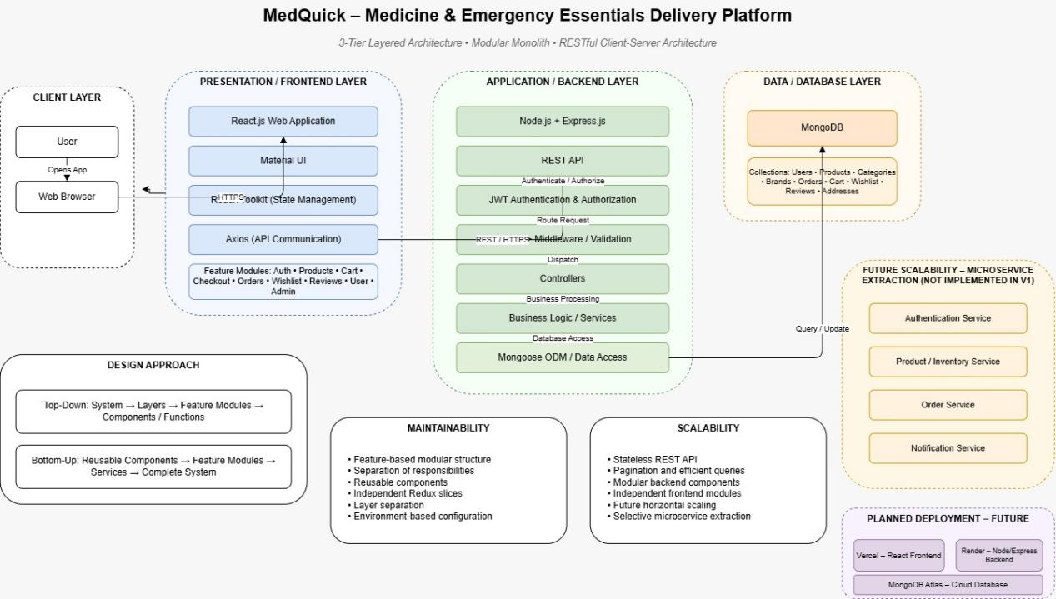
The customer and administrator interfaces communicate with the backend through REST APIs. Authentication and authorization are handled through middleware before protected operations reach the appropriate controllers.
Controllers process business operations and communicate with Mongoose models to store or retrieve data from MongoDB.
This layered flow ensures that user interface components do not directly communicate with the database.
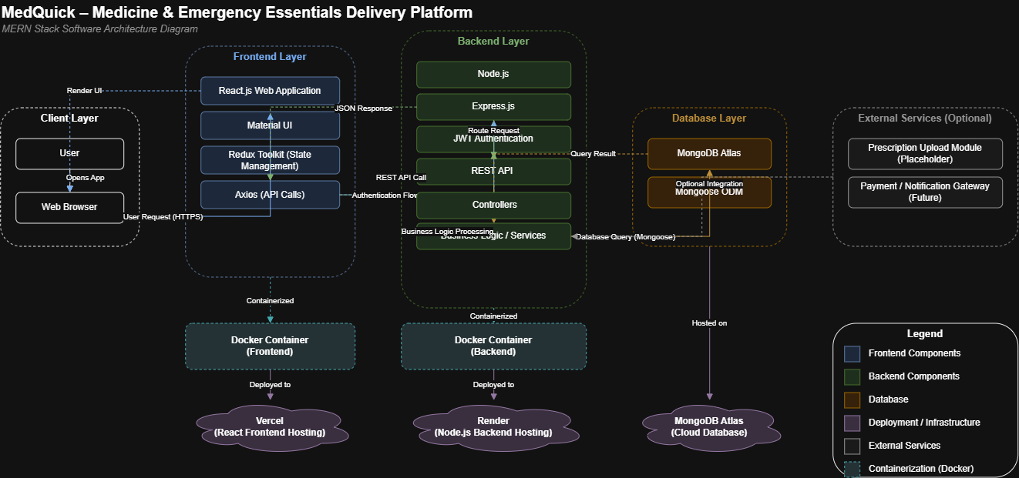

4.3 Why This Architecture Was Chosen
The 3-Tier Modular Monolith architecture was selected because it is suitable for the current size and scope of MedQuick.

Reason 1 — Simplicity
The project is developed by a small team of two student developers. A modular monolith is easier to develop, test, debug, and deploy compared with a distributed microservices architecture.

Reason 2 — Maintainability
The frontend is organized into feature modules such as:
Auth
Products
Cart
Orders
Wishlist
Reviews
Address
Admin
The backend separates responsibilities into:
Routes
Middleware
Controllers
Models
This makes individual features easier to modify without affecting the complete application.

Reason 3 — Clear Separation
The three-tier structure separates:
User Interface
↓
Application Logic
↓
Data Storage
This reduces direct dependencies between the frontend and database.

Reason 4 — Future Scalability
Although MedQuick currently uses a modular monolith architecture, the modular structure provides a foundation for future improvements.
For example, future features such as:
- Prescription verification
- Delivery tracking
- Payment integration
- Notification services
- OCR prescription processing
- Mobile application integration
can be developed as separate modules or potentially extracted into independent services if the system grows significantly.

4.4 Containerization and Deployment
For local development, MedQuick uses:
- Docker
- Dockerfiles
- Docker Compose
Containerization provides a consistent environment for running the application and its dependencies.
The Docker environment can include services such as:
Frontend Container
↓
Backend Container
↓
MongoDB Container
This reduces differences between development environments and makes the project easier to reproduce on another machine.
The architecture also provides a foundation for future cloud deployment.
Possible future deployment options include:
- Frontend deployment service
- Backend cloud server
- Managed MongoDB database
- Container registry
- CI/CD pipeline
These deployment services are considered future extensions and are not claimed as part of the current implementation unless they have actually been configured in your project.

5. User Interface Design
The MedQuick user interface was designed to provide a simple and familiar healthcare shopping experience. The design was initially created using Figma and was based on the functional requirements and user stories developed during Digital Assignment 1.
The interface separates customer-facing functionality from administrative functionality while maintaining consistent navigation, layout, colors, typography, and interaction patterns.
The design focuses on allowing users to quickly find healthcare products and complete common tasks such as browsing, searching, adding products to the cart, and placing orders.

5.1 User-Friendly Design Principles
The following principles were considered while designing the MedQuick interface:

1. Simple Navigation
The navigation structure provides access to major features such as:
- Home
- Products
- Categories
- Cart
- Wishlist
- Orders
- User Profile
This reduces the number of steps required for users to access frequently used functionality.

2. Clear Product Information
Product cards and product detail pages are designed to clearly display important information.
For healthcare-related products, the design can display:
- Product name
- Price
- Category
- Manufacturer
- Dosage
- Medicine type
- Expiry information
- Prescription requirement
This allows users to identify relevant information before adding a product to their cart.

3. Consistent Components
Reusable UI components are used throughout the application.
Examples include:
- Navigation bar
- Product cards
- Buttons
- Forms
- Alerts
- Dialog boxes
Material UI helps maintain consistency in spacing, typography, form elements, and responsive behavior.

4. Clear User Feedback
The interface provides feedback for user actions such as:
- Adding products to the cart
- Updating quantities
- Logging in
- Placing orders
- Updating profile information
This helps users understand whether an action was successfully completed.

SCREEN 1 — HOME PAGE
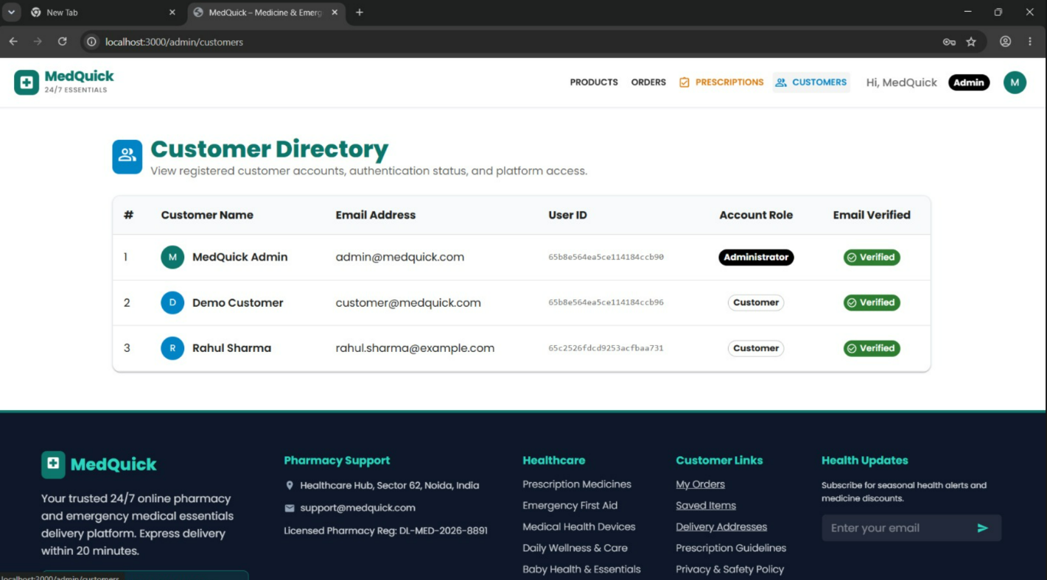Figure 6: MedQuick Home Page Design

Design Explanation
The Home Page provides users with a clear starting point for exploring the platform. Healthcare categories and featured products help users quickly discover relevant products without navigating through multiple pages.
The visual hierarchy uses prominent banners and organized product sections to guide users from general browsing toward specific products.

SCREEN 2 — PRODUCT LISTING / BROWSING
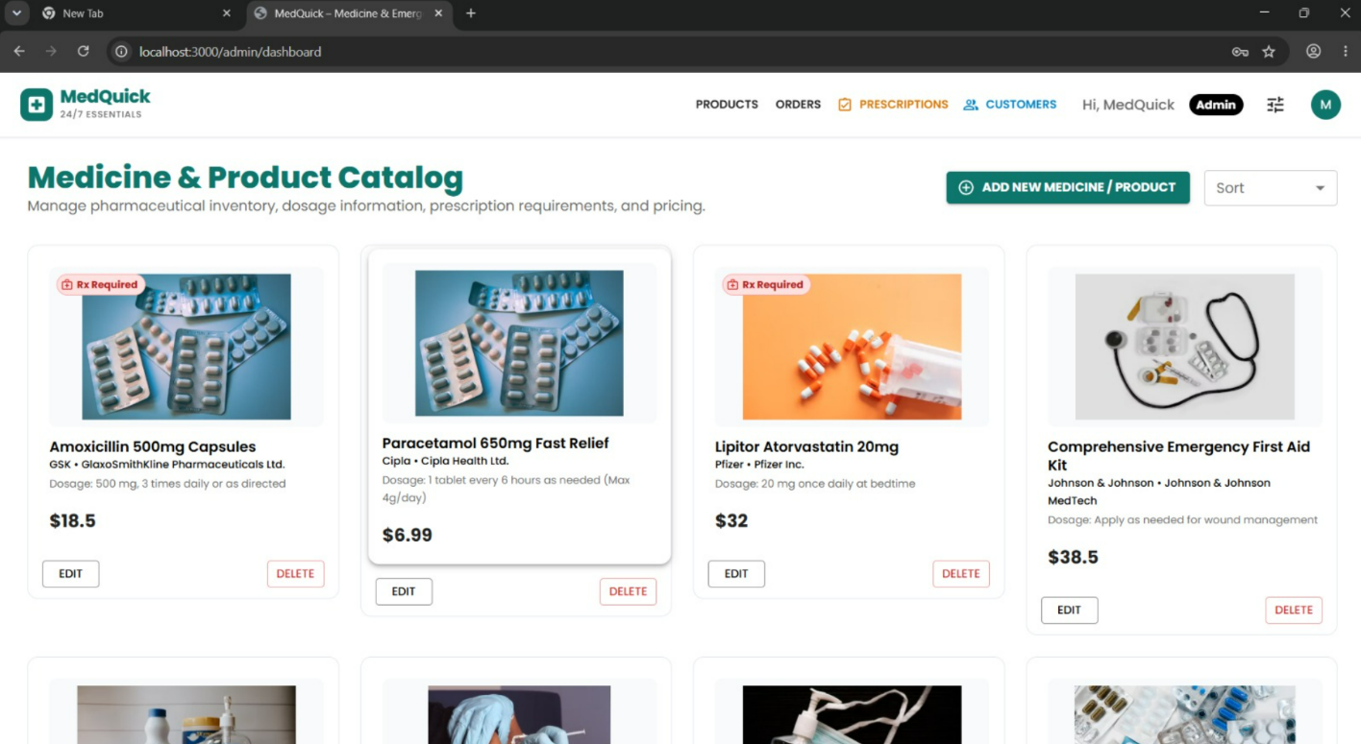Figure 7: Healthcare Product Listing Interface

Design Explanation
The product listing interface is designed to support efficient product discovery. Products are displayed using reusable cards to provide a consistent visual structure.
Search and category filtering reduce the effort required to find specific healthcare products. Prescription-required products are visually identified to provide users with important information before proceeding to purchase.

SCREEN 3 — PRODUCT DETAILS
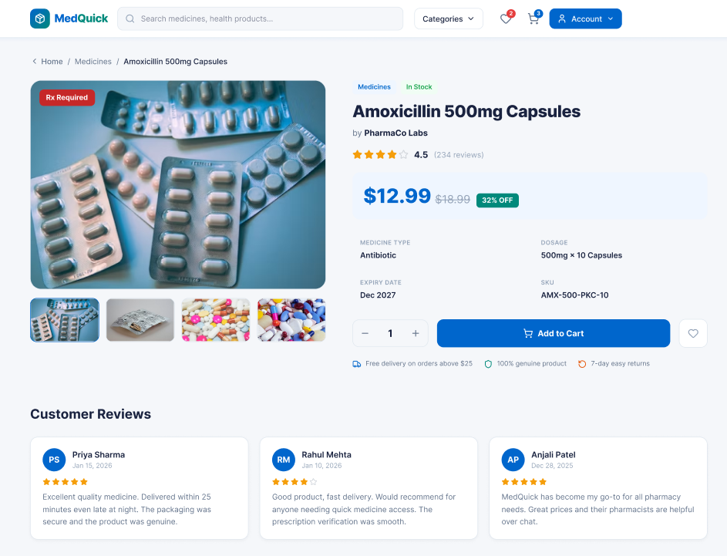Figure 8: Healthcare Product Details Interface

Design Explanation
The Product Details screen provides detailed information before a user makes a purchase decision.
Healthcare-specific information is separated from general product information to improve readability. Important alerts, such as prescription requirements, are displayed prominently to reduce the possibility of users missing critical information.

5.2 Customer and Administrative Interface Design
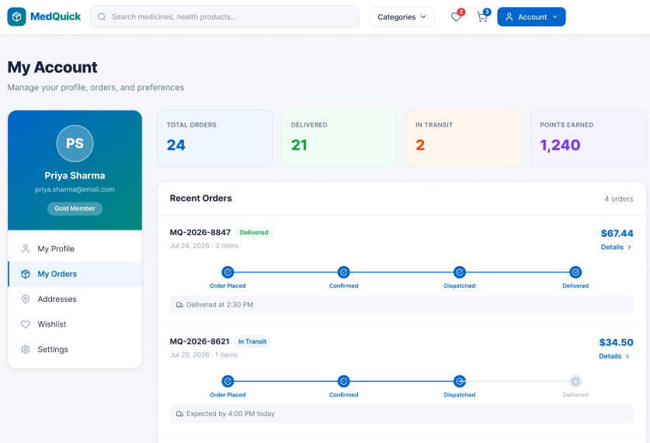
MedQuick has two primary types of users:
- Customers / Patients
- Administrators
Although both users access the same MERN application, they are provided with different functionality based on their role.
The customer interface focuses on browsing and ordering healthcare products, while the administrator interface focuses on managing products, orders, customers, and healthcare-related inventory information.
This role-based separation improves usability because users are only presented with functionality relevant to their tasks.

SCREEN 4 — CART / CHECKOUT
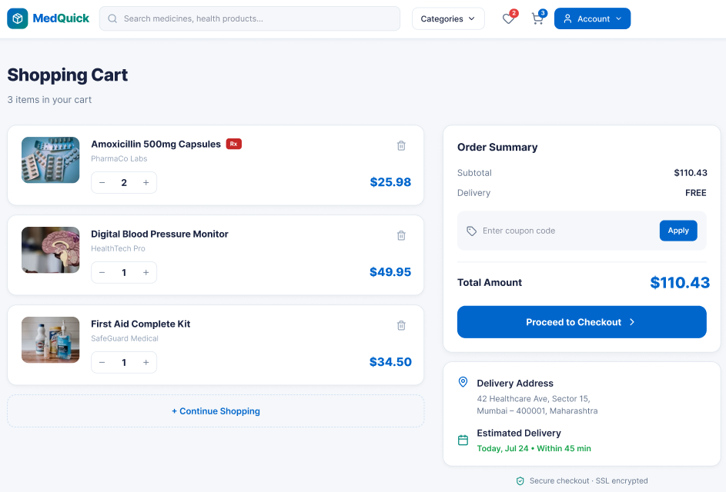Figure 9: MedQuick Cart and Checkout Interface

Design Explanation
The Cart and Checkout interface organizes order information in a clear sequence. Users can review selected products, update quantities, view the total cost, and continue toward order placement.
Keeping the order summary visible helps users understand their purchase before completing the checkout process. The interface reduces unnecessary steps by grouping related checkout information together.

SCREEN 5 — LOGIN / AUTHENTICATION
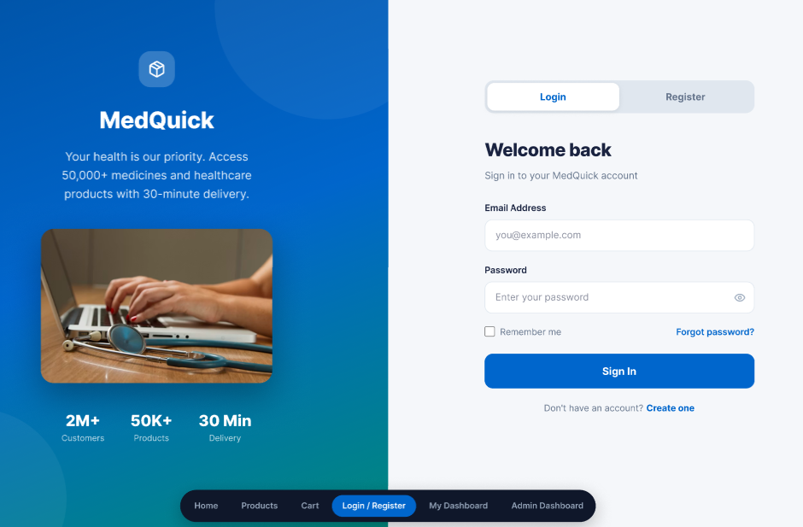
Figure 10: MedQuick User Authentication Interface

Design Explanation
The authentication interface uses a simple form layout with clearly labeled fields and limited distractions.
Authentication-related functionality is separated from shopping and administrative features, allowing users to focus on completing login or registration tasks. Clear validation and feedback messages improve usability when incorrect information is entered.

SCREEN 6 — ADMIN DASHBOARD
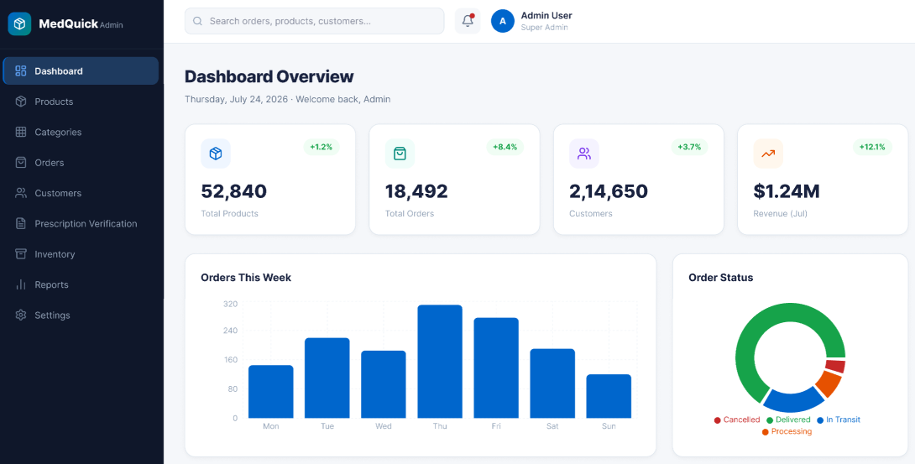Figure 11: MedQuick Administrator Dashboard

Design Explanation
The administrator interface is designed around management tasks rather than product shopping.
Administrative functionality is grouped into clearly separated sections such as:
- Products
- Orders
- Customers
- Categories
- Inventory
- Prescription Verification
This improves usability by allowing administrators to quickly access management operations without navigating through customer-oriented pages.

5.3 Role-Based Interface Separation
The following table shows how the interface differs based on the user role.
Customer Interface | Administrator Interface
Browse products | Manage products
Search products | Update inventory
View product details | Manage orders
Add to cart | Update order status
Manage wishlist | Manage customers
Checkout | Manage categories/brands
View orders | Prescription verification placeholder
Manage profile and addresses | Administrative dashboard
The separation between customer and administrator interfaces also supports better software organization. Role-based access control ensures that administrative operations are not exposed as normal customer features.

5.4 Responsive and Consistent Design
MedQuick uses reusable interface components and Material UI to support a consistent visual design.
Common interface elements include:
- Buttons
- Forms
- Navigation components
- Product cards
- Dialog boxes
- Alerts
- Tables
Reusable components reduce unnecessary duplication and make future UI updates easier.
This supports:
- Consistency
- Maintainability
- Faster development
- Easier UI updates

5.5 Healthcare-Specific UI Decisions
MedQuick adapts a standard ecommerce interface for healthcare product delivery by including healthcare-specific information.
The interface design supports the display of:
- Prescription requirement
- Manufacturer
- Dosage
- Medicine type
- Expiry date
A Prescription Required indicator is designed to be visually prominent so that users can identify products requiring additional verification.
This is an important design decision because healthcare products may require more information than ordinary ecommerce products.

6. Key Design Decisions
The following design decisions were made during the development of MedQuick to improve maintainability, usability, and future extensibility.

6.1 Feature-Based Frontend Architecture

Decision
The React frontend was organized using feature-based modules instead of grouping all components, APIs, and state files by technical type.
Each feature keeps its related components, API communication, and state management close together.
For example:
products/
├── ProductApi.jsx
├── ProductSlice.jsx
└── components/
This makes the code easier to understand and maintain.

Benefit
- High modularity
- Better cohesion
- Easier maintenance
- Easier feature development
- Easier future expansion

6.2 Redux Toolkit for State Management

Decision
MedQuick uses Redux Toolkit for managing shared application state.
Feature-specific slices are used for areas such as:
- Products
- Cart
- Orders
- Authentication
- Wishlist
- Reviews
Ecommerce applications contain data that must be shared across multiple components. Redux Toolkit provides a centralized and structured approach for handling this shared state.

Benefit
- Predictable state management
- Reduced prop drilling
- Better separation of state logic
- Easier debugging
- Reusable asynchronous operations

6.3 3-Tier Modular Monolith Architecture

Decision
MedQuick was implemented as a 3-Tier Modular Monolith.
Presentation Layer
↓
Application Layer
↓
Data Layer
The project is currently developed by a small team of two student developers.
Using microservices would introduce additional complexity such as:
- Multiple deployments
- Inter-service communication
- Distributed debugging
- Additional infrastructure
- More complex testing
A modular monolith provides sufficient structure while remaining easier to develop and maintain. Benefit -
- Simpler development
- Easier debugging
- Lower deployment complexity
- Clear architecture
- Suitable for current project scope

6.4 Role-Based Customer and Admin Design

Decision
MedQuick provides separate functionality for:
- Customers
- Administrators
Customers interact with: Products, profile and carts
Administrators interact with: Brands, categories and orders
Customer and administrative users have different goals. Customers need a simple shopping and ordering experience, while administrators need management tools. Providing both sets of functionality on the same interface would create unnecessary complexity.

Benefit
- Better usability
- Improved security
- Clearer navigation
- Role-based access
- Separation of responsibilities

6.5 Healthcare-Specific Product Schema

Decision
The existing ecommerce product schema was extended with healthcare-specific attributes.
Examples include:
- requiresPrescription
- manufacturer
- expiryDate
- dosage
- medicineType
A standard ecommerce product structure is insufficient for representing healthcare and medicine-related products. MedQuick requires additional information to better describe healthcare products.

6.6 Summary of Design Decisions
Design Decision | Main Reason | Main Benefit
Feature-Based Architecture | Organize related functionality | Maintainability
Redux Toolkit | Manage shared state | Predictability
Modular Monolith | Suitable for project size | Simplicity
Role-Based Design | Different user requirements | Better usability
Healthcare Product Schema | Support medicine information | Domain extensibility

6.7 Current Project Metrics
The following metrics are based on the current MedQuick implementation and project verification records.
Project Metric | Value
Estimated source size | ≈ 9 KLOC
JS/JSX source files | 128
Frontend feature modules | 14+
Architecture | 3-Tier Modular Monolith
Database | MongoDB + Mongoose
Healthcare categories | 8
Seed healthcare products | 16
Order lifecycle states | 6

Product Metrics
Product Metric |  | Value
Authentication |  | JWT + Cookie-based
Search |  | Keyword-based
Soft deletion |  | Implemented
Order snapshot |  | Implemented
Customer feature areas |  | 8+
Admin capabilities |  | Products, Orders, Inventory, Customers, Prescription placeholder

Important Design Observation
The order snapshot design preserves relevant product and address information at the time an order is created. Therefore, future changes to product information do not automatically alter historical order information. This improves the consistency of order records.

7. Maintainability and Future Changes
MedQuick was designed with maintainability in mind. The application separates major responsibilities into independent modules and layers so that changes can be made without requiring modifications throughout the complete system.
The frontend uses feature-based modules, while the backend separates routes, middleware, controllers, and models.
This organization supports easier maintenance, debugging, testing, and future feature development.

7.1 How the Design Supports Maintainability

Feature-Based Frontend
The frontend is divided into independent business features; For example, changes to the Wishlist feature can generally be made within the Wishlist module without modifying the Product or Authentication modules.
This reduces the impact of changes and improves maintainability.

Layered Backend
The backend follows a separation of responsibilities:
Routes
↓
Middleware
↓
Controllers
↓
Mongoose Models
↓
MongoDB
Each layer performs a different responsibility.
Layer | Responsibility
Routes | Define API endpoints
Middleware | Authentication and request processing
Controllers | Business logic
Models | Database structure and operations
MongoDB | Persistent data storage
This structure makes it easier to identify where a change should be implemented.

7.2 Reusable Components and Future Changes
MedQuick uses reusable components and centralized modules where possible.
Examples include:
- Product cards
- Navigation components
- Axios API configuration
- Redux slices
- Feature-specific API modules
- Authentication middleware
This reduces duplication.

7.3 Future Improvements
The current MedQuick implementation provides a foundation for future development.
Potential future improvements include:

1. Real Prescription Upload
The current project includes prescription-related product information and an administrative prescription verification placeholder.

2. OCR Prescription Processing
AI or OCR technology could be integrated to extract medicine information from uploaded prescriptions.
This could assist administrators but should still include human verification for healthcare-related decisions.

3. Real-Time Delivery Tracking
A future delivery system could allow users to track order progress. The current order lifecycle already provides a foundation for this feature.

4. Payment Integration
A future version could integrate a secure payment gateway.
Possible additions:
- Online payments
- Payment verification
- Refund management
- Transaction history

5. Notifications
The system could send notifications for:
- Order confirmation
- Order status updates
- Prescription approval
- Delivery updates
- Low stock alerts

6. Mobile Application
Because the backend provides REST APIs, a future mobile application could communicate with the existing backend. This would allow the existing backend architecture to support additional client applications.

7.4 Effort and Reuse Metric
An estimated effort analysis was also performed for the project.
Development Approach | Estimated Effort
From-scratch development | ≈ 24 person-months
Development with reuse/adaptation | ≈ 7.5 person-months
MedQuick benefits from adapting an existing MERN ecommerce architecture and then extending it for the healthcare domain. This demonstrates the value of software reuse.

7.5 Scheduling and Team Metrics
A 10-week Work Breakdown Structure and project schedule was prepared using project planning tools.
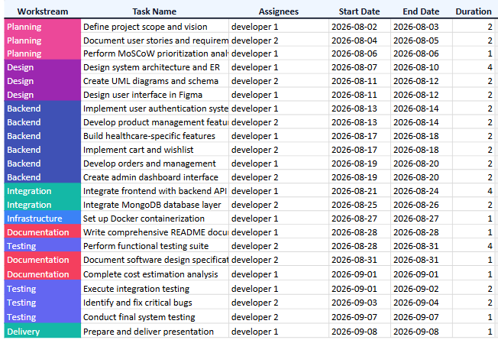
The gantt chart linik -

8. Conclusion
MedQuick was designed as a modular full-stack healthcare and emergency essentials delivery platform using the MERN stack. The software design was developed by transforming the requirements, user stories, and wireframes prepared during Digital Assignment 1 into a structured and maintainable software solution.
The project follows a 3-Tier Modular Monolith Architecture, separating the presentation layer, application logic, and data layer. The frontend uses React, Redux Toolkit, Material UI, and Axios, while the backend uses Node.js, Express.js, middleware, controllers, Mongoose models, and MongoDB.
The design emphasizes important software engineering principles such as modularity, abstraction, high cohesion, low coupling, separation of responsibilities, and maintainability.

8.1 Summary of Design Approach
The main design approach used in MedQuick can be summarized as follows:
Requirements & User Stories
↓
UI Wireframes
↓
Feature-Based Design
↓
Frontend Modules
↓
REST API Backend
↓
MongoDB Data Layer
The user stories were mapped to independent application modules such as:
- Authentication
- Products
- Cart
- Checkout
- Orders
- Wishlist
- Reviews
- Address Management
- User Management
- Administration
This approach helps ensure that the system design remains connected to the original requirements.

8.2 Key Software Engineering Principles Applied
Principle | Application in MedQuick
Modularity | Feature-based frontend modules
Abstraction | API modules and centralized Axios client
High Cohesion | Feature-specific Redux slices
Low Coupling | Separation between UI, API, backend, and database
Single Responsibility | Separate components, middleware, controllers, and models
Maintainability | Modular and layered application structure
Reusability | Reusable UI components and shared API configuration
The project does not attempt to force every SOLID principle into the implementation. Instead, the principles were evaluated based on their actual relevance to the React and MERN architecture.

8.3 Main Design Choices
The most important design decisions were:

1. Feature-Based Frontend
Related functionality is grouped into independent features, improving modularity and maintainability.

2. Redux Toolkit State Management
Shared application state such as authentication, products, cart, and orders is managed in a structured and predictable manner.

3. 3-Tier Modular Monolith Architecture
The architecture provides sufficient separation and scalability while remaining suitable for a two-member college development team.

4. Role-Based Customer and Admin Interfaces
Customers and administrators receive different functionality based on their responsibilities.

5. Healthcare-Specific Product Information
The product structure was extended to support healthcare attributes such as manufacturer, dosage, expiry date, medicine type, and prescription requirements.

8.4 Maintainability and Future Growth
The modular design allows MedQuick to support future changes without requiring a complete redesign of the application.
Potential future improvements include:
- Real prescription upload and verification
- OCR-assisted prescription processing
- Online payment integration
- Real-time delivery tracking
- Order and delivery notifications
- Inventory alerts
- Mobile application integration
- Cloud deployment
- CI/CD automation
The existing REST API and modular structure provide a foundation for these future improvements.

8.5 Final Outcome
MedQuick demonstrates how an existing ecommerce architecture can be systematically adapted into a domain-specific healthcare delivery platform.
The final software design provides:
- A modular frontend structure
- Layered backend organization
- Clear separation of responsibilities
- Role-based functionality
- Healthcare-specific product support
- Docker-based local development
- Maintainable and reusable code organization
The design decisions were selected to balance simplicity, maintainability, usability, and future extensibility, making the system appropriate for the current scope of a college Software Engineering project while providing a foundation for future development.

