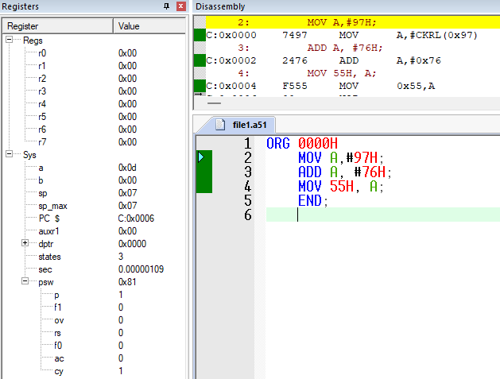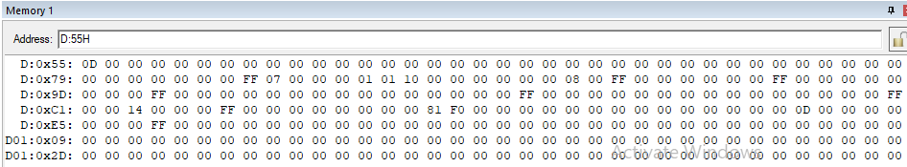
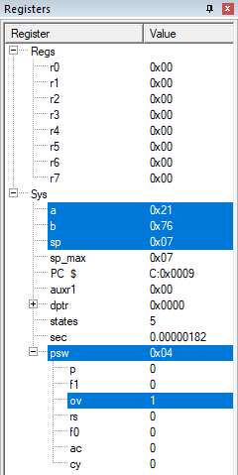
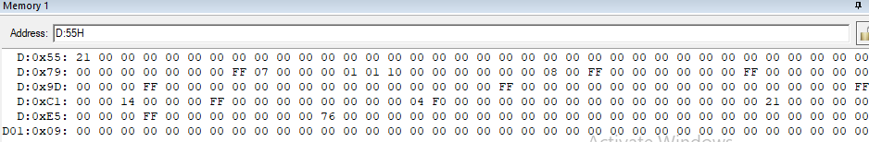

MOV A,#97H;
ADD A, #76H;
MOV 55H, A;
END;

ORG 0000H
MOV A,#97H;
MOV B, #76H;
SUBB A,B;
MOV 55H, A;
END

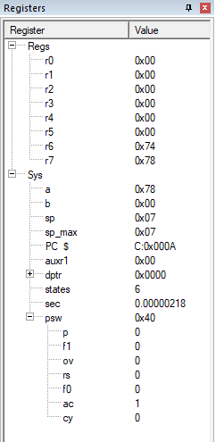
Task 3-
ORG 0000H
MOV A,#0E7H;
ADD A,#8DH;
MOV R6,A;
MOV A,#3CH;
ADDC A,#3BH;
MOV R7,A;
END;

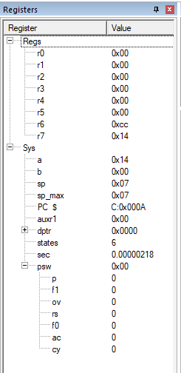
T4-
ORG 0000H
MOV A,#62H;
SUBB A,#96H;
MOV R6,A;
MOV A,#27H;
SUBB A,#12H;
MOV R7,A;
END;
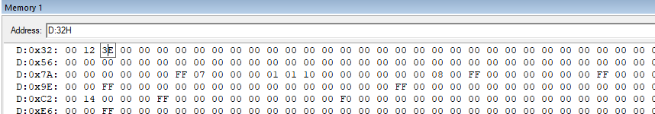

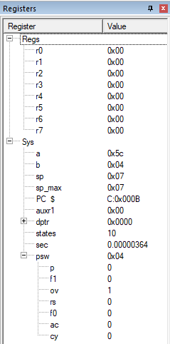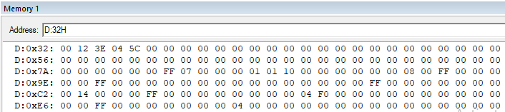
Task 5
ORG 0000H
MOV A, 33H;
MOV B, 34H;
MUL AB
MOV 35H,B
MOV 36H, A;
END

