RANDOM FOREST CLASSIFICATION
clc;
clear;

% Load training data and labels
train_data_x = load('data_train.mat');
train_data_y = load('data_train_labels.mat');

% Extracting the actual data from the loaded variables
train_data_x = train_data_x.data_train;
train_data_y = train_data_y.data_train_labels;

% Define label names
label_names = {'normal', 'roller', 'inner', 'outer', ...
'inner+roller', 'outer+inner', 'outer+inner+roller', 'outer+roller'};

% Use 'data_train_labels' as your target labels
target_labels = train_data_y';

% Define parameters for your dataset (adjust these based on your specifications)
theta = 14.94 * pi / 180; % Convert contact angle from degrees to radians
n = 17;
d = 0.01; % in meters
D = 0.06; % in meters
fi = 800 / 60; % Convert rpm to Hz

% Preallocate feature matrix
num_columns = numel(train_data_x);
num_features = 7; % Including mean, std, rms, skewness, kurtosis, 1st harmonic, 2nd harmonic, crest factor, impulse factor, and clearance factor
time_domain_features = zeros(num_columns, num_features);

% Compute and populate the time domain feature matrix
for col = 1:num_columns
data = train_data_x{col};
mean_value = mean(data);
std_deviation = std(data);
rms_value = rms(data);
skewness_value = skewness(data);
kurtosis_value = kurtosis(data);
fft_data = fft(data);
N = length(data);
fft_normalized = abs(fft_data/N);
first_order_harmonic = fft_normalized(2);
second_order_harmonic = fft_normalized(3);
time_domain_features(col, :) = [mean_value, std_deviation, rms_value, skewness_value, kurtosis_value, first_order_harmonic,second_order_harmonic];
end

% Perform PCA (Optional for Random Forest, included for completeness)
coeff = pca(time_domain_features);
score = time_domain_features * coeff;

% Train Random Forest Classifier
target_labels_str = arrayfun(@(x) label_names{x}, train_data_y, 'UniformOutput', false);
nTrees = 100;
rfModel = TreeBagger(nTrees, time_domain_features, target_labels_str, 'Method', 'classification');

% Load test data and labels
test_data_x = load('data_test.mat');
test_data_y = load('data_test_labels.mat');
test_data_x = test_data_x.data_test;
test_data_y = test_data_y.data_test_labels;

% Preprocess test data to have the same features as training data
num_test_samples = numel(test_data_x);
test_time_domain_features = zeros(num_test_samples, num_features);
for sample = 1:num_test_samples
data = test_data_x{sample};
% Compute features for test data
mean_value = mean(data);
std_deviation = std(data);
rms_value = rms(data);
skewness_value = skewness(data);
kurtosis_value = kurtosis(data);
fft_data = fft(data);
N = length(data);
fft_normalized = abs(fft_data/N);
first_order_harmonic = fft_normalized(2);
second_order_harmonic = fft_normalized(3);
test_time_domain_features(sample, :) = [mean_value, std_deviation, rms_value, skewness_value, kurtosis_value, first_order_harmonic,second_order_harmonic];
end

% Predict the labels of the test data using the trained Random Forest model
[predicted_labels_str, ~] = predict(rfModel, test_time_domain_features);

% Convert predicted labels back to numeric if your test_data_y is numeric
predicted_labels = cellfun(@(x) find(strcmp(x, label_names)), predicted_labels_str);

% Create a confusion matrix chart
confMatChart = confusionchart(test_data_y, predicted_labels);
confMatChart.Title = 'Confusion Matrix for Random Forest Classification';
confMatChart.RowSummary = 'row-normalized';
confMatChart.ColumnSummary = 'column-normalized';

% Calculate and display accuracy
accuracy = sum(diag(confMatChart.NormalizedValues)) / sum(confMatChart.NormalizedValues, 'all');
disp(['Accuracy: ', num2str(accuracy * 100), '%']);
% Convert labels to categorical for easier handling
true_labels_cat = categorical(test_data_y, 1:numel(label_names), label_names);
predicted_labels_cat = categorical(predicted_labels, 1:numel(label_names), label_names);

% Create the confusion matrix
[C, order] = confusionmat(true_labels_cat, predicted_labels_cat);

% Initialize variables to store precision, recall, and F1 scores
numClasses = numel(order);
precision = zeros(numClasses, 1);
recall = zeros(numClasses, 1);
f1Scores = zeros(numClasses, 1);

% Calculate precision, recall, and F1 score for each class
for i = 1:numClasses
truePositives = C(i, i);
falsePositives = sum(C(:, i)) - truePositives;
falseNegatives = sum(C(i, :)) - truePositives;

precision(i) = truePositives / (truePositives + falsePositives);
recall(i) = truePositives / (truePositives + falseNegatives);
f1Scores(i) = 2 * ((precision(i) * recall(i)) / (precision(i) + recall(i)));
end

% Display results
disp('Class | Precision | Recall | F1 Score');
for i = 1:numClasses
fprintf('%s: %.2f | %.2f | %.2f\n', string(order(i)), precision(i), recall(i), f1Scores(i));
end
falsePositives = sum(C(:, i)) - truePositives;
falseNegatives = sum(C(i, :)) - truePositives;

precision(i) = truePositives / (truePositives + falsePositives);
recall(i) = truePositives / (truePositives + falseNegatives);
f1Scores(i) = 2 * ((precision(i) * recall(i)) / (precision(i) + recall(i)));
end

% Display results
disp('Class | Precision | Recall | F1 Score');
for i = 1:numClasses
fprintf('%s: %.2f | %.2f | %.2f\n', string(order(i)), precision(i), recall(i), f1Scores(i));
end

RANDOM FOREST CLASSIFICATION
The code above used 7 features including
- Mean value
- Standard Deviation
- RMS value
- Skewness Value
- Kurtosis Value
- First Order Harmonic
Second Order Harmonic
The range for accuracy becomes 100%
However for using 6 features:
- Mean value
- Standard Deviation
- RMS value
- Skewness Value
- Kurtosis Value
- First Order Harmonic
The accuracy ranges from 99.6 to 100%, where the frequency of getting the accuracy of 100 in not that high.

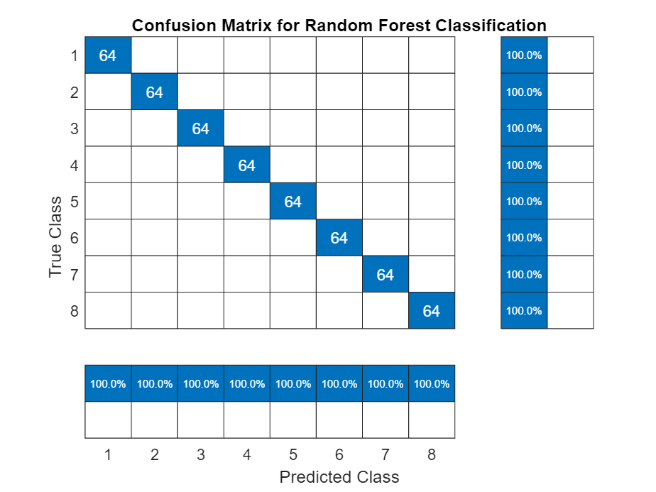
Accuracy: 100%
Class | Precision | Recall | F1 Score
normal: 1.00 | 1.00 | 1.00
roller: 1.00 | 1.00 | 1.00
inner: 1.00 | 1.00 | 1.00
outer: 1.00 | 1.00 | 1.00
inner+roller: 1.00 | 1.00 | 1.00
outer+inner: 1.00 | 1.00 | 1.00
outer+inner+roller: 1.00 | 1.00 | 1.00
outer+roller: 1.00 | 1.00 | 1.00

KNN CLASSIFICATION (K=3)
clc;
clear;

% Load training data and labels
train_data_x = load('data_train.mat');
train_data_y = load('data_train_labels.mat');
% Extracting the actual data from the loaded variables
train_data_x = train_data_x.data_train;
train_data_y = train_data_y.data_train_labels;

% Define label names
label_names = {'normal', 'roller', 'inner', 'outer', ...
'inner+roller', 'outer+inner', 'outer+inner+roller', 'outer+roller'};

% Use 'data_train_labels' as your target labels
target_labels = train_data_y';

% Define parameters for your dataset (adjust these based on your specifications)
theta = 14.94 * pi / 180; % Convert contact angle from degrees to radians
n = 17;
d = 0.01; % in meters
D = 0.06; % in meters
fi = 800 / 60; % Convert rpm to Hz

% Preallocate feature matrix
num_columns = numel(train_data_x);
num_features = 9; % Including mean, std, rms, skewness, kurtosis, 1st harmonic, 2nd harmonic, crest factor, impulse factor, and clearance factor
time_domain_features = zeros(num_columns, num_features);

% Compute and populate the time domain feature matrix
for col = 1:num_columns
data = train_data_x{col};
mean_value = mean(data);
std_deviation = std(data);
rms_value = rms(data);
skewness_value = skewness(data);
kurtosis_value = kurtosis(data);
fft_data = fft(data);
N = length(data);
fft_normalized = abs(fft_data/N);
first_order_harmonic = fft_normalized(2);
second_order_harmonic = fft_normalized(3);
crest_factor = max(data) / rms_value;
impulse_factor = max(data) / mean(abs(data));
time_domain_features(col, :) = [mean_value, std_deviation, rms_value, skewness_value, kurtosis_value, first_order_harmonic, second_order_harmonic, crest_factor,impulse_factor];
end
% Perform PCA (Optional for KNN, included for completeness)
coeff = pca(time_domain_features);
score = time_domain_features * coeff;

% Train K-Nearest Neighbors Classifier
k = 3; % Number of nearest neighbors
knn_model = fitcknn(time_domain_features, label_names(target_labels), 'NumNeighbors', k);

% Load test data and labels
test_data_x = load('data_test.mat');
test_data_y = load('data_test_labels.mat');
test_data_x = test_data_x.data_test;
test_data_y = test_data_y.data_test_labels;

% Preprocess test data to have the same features as training data
num_test_samples = numel(test_data_x);
test_time_domain_features = zeros(num_test_samples, num_features);
for sample = 1:num_test_samples
data = test_data_x{sample};
% Compute features for test data
mean_value = mean(data);
std_deviation = std(data);
rms_value = rms(data);
skewness_value = skewness(data);
kurtosis_value = kurtosis(data);
fft_data = fft(data);
N = length(data);
fft_normalized = abs(fft_data/N);
first_order_harmonic = fft_normalized(2);
second_order_harmonic = fft_normalized(3);
crest_factor = max(data) / rms_value;
impulse_factor = max(data) / mean(abs(data));
%clearance_factor = max(data) / (max(data) - min(data));
test_time_domain_features(sample, :) = [mean_value, std_deviation, rms_value, skewness_value, kurtosis_value, first_order_harmonic, second_order_harmonic, crest_factor, impulse_factor];
%test_time_domain_features(sample, :) = [mean_value, std_deviation, rms_value, skewness_value, kurtosis_value, first_order_harmonic, second_order_harmonic, crest_factor, impulse_factor, clearance_factor];
end

% Predict the labels of the test data using the trained KNN model
predicted_labels = predict(knn_model, test_time_domain_features);

% Convert predicted labels back to numeric if your test_data_y is numeric
predicted_labels_num = cellfun(@(x) find(strcmp(x, label_names)), predicted_labels);

% Create a confusion matrix chart
confMatChart = confusionchart(test_data_y, predicted_labels_num);
confMatChart.Title = 'Confusion Matrix for KNN Classification';
confMatChart.RowSummary = 'row-normalized';
confMatChart.ColumnSummary = 'column-normalized';

% Calculate and display accuracy
accuracy = sum(diag(confMatChart.NormalizedValues)) / sum(confMatChart.NormalizedValues, 'all');
disp(['Accuracy: ', num2str(accuracy * 100), '%']);
true_labels_cat = categorical(test_data_y, 1:numel(label_names), label_names);
predicted_labels_cat = categorical(predicted_labels_num, 1:numel(label_names), label_names);
[C,order] = confusionmat(true_labels_cat, predicted_labels_cat);
% Assuming 'C' is your confusion matrix and 'order' maps to 'label_names'
% Correct definition of numClasses based on the confusion matrix or label_names
numClasses = size(C, 1); % or numel(label_names)

% Initialize metrics
precision = zeros(numClasses, 1);
recall = zeros(numClasses, 1);
f1Scores = zeros(numClasses, 1);

% Calculate metrics for each class
for i = 1:numClasses
TP = C(i, i);
FP = sum(C(:, i)) - TP;
FN = sum(C(i, :)) - TP;

precision(i) = TP / (TP + FP);
recall(i) = TP / (TP + FN);
f1Scores(i) = 2 * (precision(i) * recall(i)) / (precision(i) + recall(i));
end

% Adjust for any NaN values due to division by zero
precision(isnan(precision)) = 0;
recall(isnan(recall)) = 0;
f1Scores(isnan(f1Scores)) = 0;

% Display the results with actual label names
disp('Class | Precision | Recall | F1 Score');
for i = 1:numClasses
% Use 'order' to fetch the corresponding label name if order is used
% or directly use 'label_names' if order is not utilized
label = label_names{i}; % Assuming 'i' aligns with 'label_names' order directly
fprintf('%s: %.2f | %.2f | %.2f\n', label, precision(i), recall(i), f1Scores(i));
end

KNN CLASSIFCATION
The value of K=3,The code above used 9 features including
- Mean value
- Standard Deviation
- RMS value
- Skewness Value
- Kurtosis Value
- First Order Harmonic
- Second Order Harmonic,
- Crest factor
- Impulse factor
Then the code gives the accuracy of 100% repeatedly
However as we increase the value of k from 4 onwards, then the accuracy value starts decreasing from 100 to 99.8 then 99.6… and so on
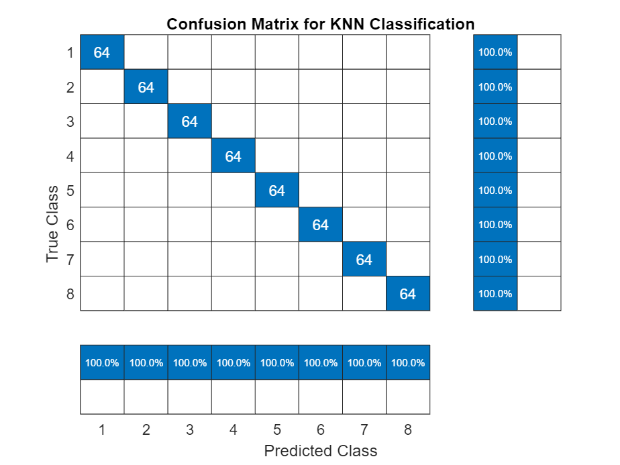
Accuracy: 100%
Class | Precision | Recall | F1 Score
normal: 1.00 | 1.00 | 1.00
roller: 1.00 | 1.00 | 1.00
inner: 1.00 | 1.00 | 1.00
outer: 1.00 | 1.00 | 1.00
inner+roller: 1.00 | 1.00 | 1.00
outer+inner: 1.00 | 1.00 | 1.00
outer+inner+roller: 1.00 | 1.00 | 1.00
outer+roller: 1.00 | 1.00 | 1.00

Accuracy remains 100% at k=3 (k meaning the number of nearest neighbors)
Then from k=4 to k=8, 99.8% then from k=9 to k=11 99.6% then from k=12 to k=22, accuracy remains 99.8% and at k=23, accuracy reduces to 99.2%.

K-Values | Accuracies
3 | 100
4 | 99.8
5 | 99.8
6 | 99.8
7 | 99.8
8 | 99.8
9 | 99.6
10 | 99.6
11 | 99.6
12 | 99.8
13 | 99.8
14 | 99.8
15 | 99.8
16 | 99.6
17 | 99.6
18 | 99.41
19 | 99.41
20 | 99.41
21 | 99.41
22 | 99.2
23 | 99.2

