Homework Four Report
Industrial Artificial Intelligence
ENME 691

Group 4 (Saman, Sudhanshu, Shihao, Venkata)

INTRODUCTION

BACKGROUND

A rotor bearing testbed is a specialized equipment used to stimulate and assess the health condition of the shaft with unbalance defects. It is quite important to understand how the shaft behaves under unbalance effects, and how it affects the performance and reliability of the shaft.
The unbalance effect occurs are induced the screws are added to the disk of the shaft. The testbed, which serves as the experimental platform for conducting such experiments, operates continuously at a constant rotating speed of 20 Hz.

To gather the data, to interpret the effects of such imbalance, accelerometer is attached to the bearing block, so that the vibrations can be measured. The sampling rate of the data collection is 2560 Hz, it means that the accelerometer captures 2560 samples of data (in this case vibration data) each second. If the sample rate is high, that means more data is being captured, which leads to more detailed capturing of vibration signals or data. This helps in better analysis of the data and detection of defects if present.

The number of screws attached to the disk of the shaft determines the severity of the unbalance present on the shaft. These are the three conditions under which the vibration data is collected from, these are:
- 0 or Normal Condition: The number of screws attached here is 0.
- 1 or Unbalanced Level I: The number of screws attached here is 1.
- 2 or Unbalanced Level II: The number of screws attached here are 2.

Figure 1: Normal Condition

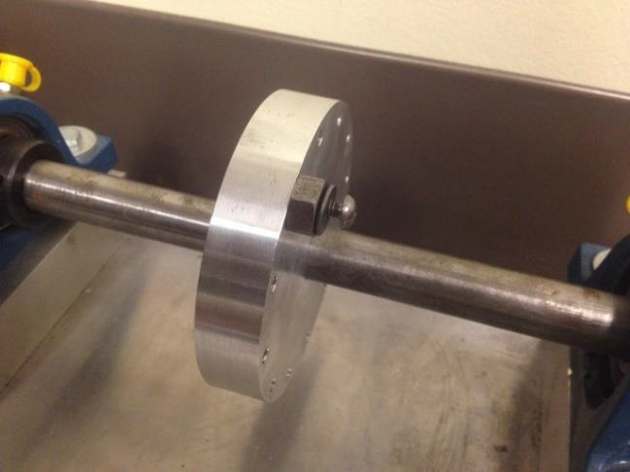
Figure 2: Shaft unbalance: (a) unbalance level 1
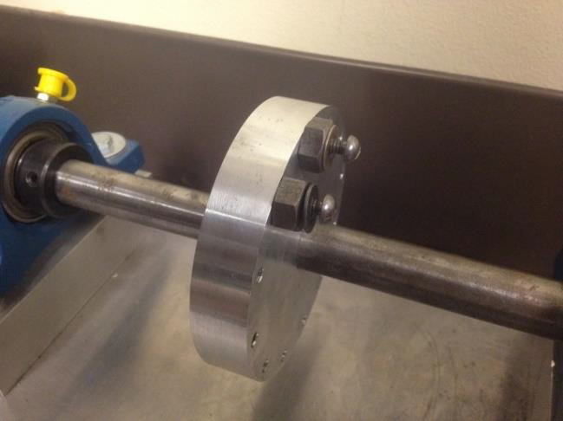
Figure 3: Shaft unbalance: (b) unbalance level 2

To assess the health condition of the shaft using Self-Organizing Maps (SOM) and SOM-MQE (Self-Organizing Map - Mean Quantization Error), we can adapt the approach to unsupervised learning, as these techniques are typically used for clustering and visualization.
Self-Organizing Maps (SOM) are effective tools for assessing vibration data gathered from machines like shafts because they can cluster vibration patterns associated with different operating situations, normal behavior, and probable problems, in this case Unbalance 1 and Unbalance 2.
One can acquire insights into the spatial organization of these patterns by displaying the trained SOM, which makes it easier to comprehend complex vibration data and detect anomalous behavior. This can help in identifying issues such as imbalance or even misalignments.

SOM-MQE assesses the trained SOM's vibration data representation quantitatively using the Mean Quantization Error (MQE). One uses the MQE to assess the SOM's capacity to capture the intrinsic structure and diversity of vibration patterns. A lower MQE suggests a more accurate representation, which implies a better match between the data and the SOM.

DATA DESCRIPTION

To assess the health condition of the shaft, the vibration data is gathered using the accelerometer. There are two types of data, i.e. training and testing data. In training data, the data is divided into healthy and faulty data which be further divided into faulty one and faulty two.

The vibration measurements, includes the data with the positive or negative, these indicate the direction of the acceleration along a specific axis. Here's what each datatype typically represents:

- Positive datapoints (+): A positive acceleration value indicates that the object or system is accelerating in the positive direction along the axis being measured. For example, if the measurements are taken along the X-axis, a positive acceleration value suggests that the object is moving in the positive direction along the X-axis.

- Negative datapoints (-): Similarly, a negative acceleration value indicates that the object or system is accelerating in the negative direction along the axis being measured. Using the same example, if the measurements are taken along the X-axis, a negative acceleration value suggests that the object is moving in the negative direction along the X-axis.
This trend remains the same for all types of data used either for training or testing the model. The data gathered and used for analysis includes:

- Date: The date when the data was gathered.
- Time: The time when the data was gathered.
- Operator: The person responsible for collecting the data.
- Data Type: The data type indicates the type of conditions under which the data was collected, i.e., normal conditions or faulty conditions.
- Acceleration: The data collected as vibration data, that is measured in each assessment, where each data represents the measurement of acceleration along a specific axis, which can be both negative and positive in value.
For health assessment and training of SOM there were 20 observations of healthy, 20 observations of faulty type one, and 20 observations of faulty type two data used. Whereas 30 observations of data were used for testing the validity of the model.

IMPLEMENTED SOLUTION

INTRODUCTION TO THE ANALYTICS PROCESS

Sample Preparation:
Load Data: Data is loaded from given directories comprising both healthy and faulty machine data.
Preprocess the Data: Data is prepared for feature extraction by loading it from files and arranging it for subsequent analysis.

Feature extraction and selection:
Extract Harmonic Features: The data is analyzed using FFT (Fast Fourier Transform) to extract features with an emphasis on harmonic content. Each dataset has harmonic characteristics computed, including the first, second, and third harmonics.

Application of Suggested Algorithms (SOM):
Prepare SOM Data Structure: The retrieved features are used to initialize the SOM data structure.
Train the SOM Model: The SOM model is trained using the prepared data.
Unlabeled neurons in the SOM are labeled depending on their nearest labeled neighbors.
Visualization of SOM: The trained SOM is shown to observe neuron grouping and labeling.

FLOWCHART

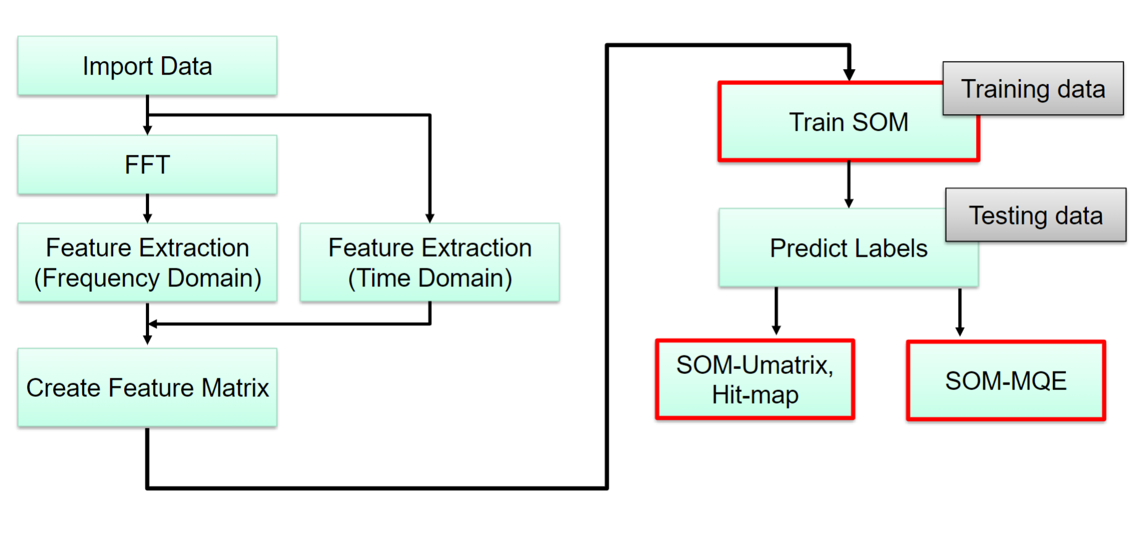
Figure 4:Flowchart of the solution.
A. Load Data:

The code loads the data from specified directories for both healthy and faulty machines. This phase guarantees that the data required for training and testing the SOM model is available in the MATLAB environment.
B. Extract Harmonic Features:

After loading the data, the code analyzes each dataset for harmonic features using FFT. This includes calculating the frequency spectrum of the vibration data and determining the amplitudes of the harmonic components, with a particular emphasis on the first, second, and third harmonics.
Combine Features and Labels:
The features from different machine conditions (healthy, unbalance1, and unbalance2) are concatenated into a single matrix X.
Labels corresponding to each set of features are created ('H' for healthy, 'U1' for unbalance1, and 'U2' for unbalance2) and concatenated into a single vector label.

C. Prepare SOM Data Structure:

After extracting harmonic features, the code creates the Self-Organizing Map (SOM) data structure. This step entails establishing the SOM framework, specifying the input features, and organizing the data for training the SOM model.
Prepare SOM Data Structure:

The SOM data structure sD is initialized using the som_data_struct function. The feature matrix X is assigned to sD. The name of the data set ('Machine Condition Data') and the names of the components (features) are specified ({'First Harmonic', 'Second Harmonic', 'Third Harmonic'}).

Labels are added to the SOM data structure using the som_label function, assigning each data point in X with a label from the labels vector.

D. Train SOM Model:

Prepared data is used to train the SOM model. During training, the SOM method arranges the input data into a low-dimensional grid while maintaining the topological links between the input characteristics. This procedure allows the SOM to generate clusters representing various machine conditions based on the retrieved attributes.

The SOM model sMap is trained using the som_make function. The SOM is trained using the feature matrix and labels provided in the SOM data structure sD.

E. Automatic Labeling of SOM:

After training, the SOM model is labeled automatically based on the training data's majority vote. This phase names the clusters created by the SOM, providing an initial categorization of the machine conditions represented in each cluster.
automatic labeling of the trained SOM (sMap) using the SOM Toolbox's som_autolabel function. In this case, the 'vote' method is used for automatic labeling.

Pairwise distances between all neurons in the SOM are calculated and stored in the matrix neuron_distances using the pdist2 function.
This step computes the Euclidean distance between each pair of neurons in the SOM's codebook (weight matrix) and stores the distances in a matrix for later use.

F. Assign Labels to Unlabeled Neurons:

Automatic labeling may leave some neurons in the SOM grid unmarked. This step assigns labels to unlabeled neurons based on their proximity to identified neurons. This improves the classification of the SOM and ensures that all neurons are correctly classified.

G. Basic Visualization of the Trained SOM:

The trained SOM is visually represented to observe the clustering and labeling of neurons. This image reveals how the SOM grouped the input data and aids in determining the quality of the grouping.

This phase uses the som_show function to see the trained SOM, giving a basic understanding of the neurons' spatial arrangement on the map.

H. U-matrix Visualization with Labels:

A labeled U-matrix visualizes the SOM in detail. This visualization technique displays the distances between neighboring neurons, providing a more complete comprehension of the SOM's structure and cluster interactions.
Neurons are identified using the relevant class labels (e.g., 'H' for healthy, 'U1' for unbalanced1, etc.). And uses, som_show_add, to add labels into the visualization.
I. Testing using SOM:

The trained SOM is applied to test data to classify machine conditions represented by the test samples. This entails preprocessing and feature extraction methods like those used in training, followed by determining the Best Matching Units (BMUs) for the test samples inside the SOM grid.

Identifying the best matching units (BMUs) for test data in the trained SOM using som_bmus, whereas disp was used to show the anticipated label for the test data.

J. Display Testing Results:

Predicted labels for test data are displayed, and classification accuracy is evaluated by comparing them to real labels. This step examines the SOM's ability to classify previously unknown data.

To compare two strings to determine whether they are equal, strcmp was used here the strings were predicted labels and actual labels.
K. Create Confusion Matrix:

Generate a confusion matrix to evaluate classification results in detail. The confusion matrix compares predicted labels to actual labels to assess classification accuracy and identify any misclassifications.
It tells us how many class labels are being misclassified into some other labels.

To convert cell arrays of labels to categorical for confusion matrix computation the keyword: categorical was used.
Whereas to generate the confusion matrix, confusionmat was utilized.
L. Calculate MQE Values:

Mean Quantization Error (MQE) values measure the SOM's confidence in predicting test data. MQE reflects the distance between each test sample and the associated Best Matching Unit (BMU) in the SOM grid, which provides information about the classification results' reliability.

Custom function calculateHarmonics is used to compute the harmonic features from input data.
Whereas norm is used to compute the Euclidean norm of a vector. And finally, to plot the calculated MQE values plot, is used for visualization.

RESULT

Visualizations

Determining map size...
map size [7, 6]
Initialization...
Training using batch algorithm...
Rough training phase...
Training: 0/ 0 s
Finetuning phase...
Training: 0/ 0 s
Final quantization error: 0.000
Final topographic error: 0.333
Final combined error: 0.000

BASIC VISUALIZATION OF TRAINED SOM

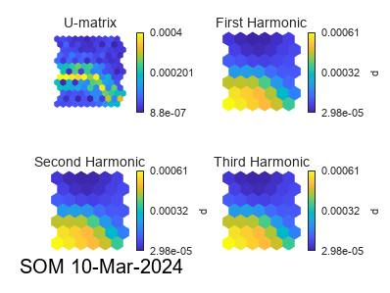

U-MATRIX VISUALIZATION WITH LABELS

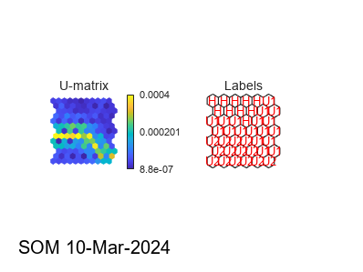

In the figure above, U-matrix visualization is used to interpret the result of SOM. It contains:
Color Intensity:
The intensity of the color indicates the extent of the distance between nearby neurons. Higher intensity often equates to longer distances, whilst lower intensity suggests shorter distances.
Color Gradient:
Different hues or tints are used to depict varying distances. For example, a gradient from blue (low distance) to red (high distance) could be utilized, with intermediate colors representing intermediate distances.
One can use the U-matrix visualization to detect regions of high and low distance, which correlate to dense and sparse data in the input space. This information aids in comprehending the clustering structure and the relationships between the various clusters.

Here, as one can see the key adjacent to the matrix, the color corresponding to the value 0.0004 is more intense because it represents a larger distance between neighboring neurons compared to the color corresponding to the value 0.000201.

The intensity of the color in the U-matrix heatmap increases with the magnitude of the distance between neighboring neurons. Therefore, a larger distance value (0.0004) would result in a more intense color compared to a smaller distance value (0.000201). As encircled in the figure above.

HEALTH ASSESSMENT PLOT
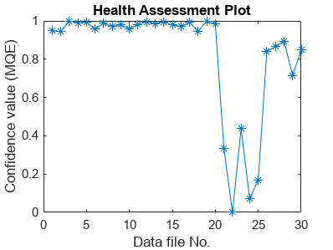

Confusion matrix

Confusion Matrix:
10 0 0
1 9 0
0 0 10
Overall Accuracy: 96.67%= approx. 97%

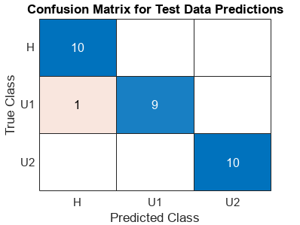

From our results, we got approximately 96.67% accuracy, Data belonging to H labels and U2 labels were classified correctly and 9/10 U1 were classified correctly as well. However, 1/10 U1 label was misclassified as H or Healthy data.

DISCUSSION

Overall Accuracy
The overall accuracy of the model on the test dataset was 96.67%. This indicates that while the model is highly accurate, there are still some instances where it may misclassify the condition of the machinery.

Using just 1X harmonic didn’t provide appropriate results as required, as the accuracy was poor compared to when using three harmonics such as 1X, 2X, and 3X, these features were calculated using FFT, after which they were used as an input to train the Self organizing Map.

"H" labels OR Healthy data are largely clustered together, indicating that instances labeled as "H" are close to each other in the input space, as are the related neurons in the SOM.

The "U1" OR Unbalanced I and "U2" labels OR Unbalanced II are likewise clustered, but they appear to be further away from the "H" cluster, indicating that examples classified as "U1" and "U2" are separated from instances labeled as "H" in the input space.

The fluctuating intensity of colors within each cluster shows the distance between adjacent neurons within that cluster. Darker sections represent shorter distances, and lighter regions indicate longer distances.

However, upon closer inspection the distance between some H and U1 is shorter than expected. according to the visualization. This suggests potential misclassifications between these conditions. Further investigation into these instances may improve the model's performance.

CONCLUSION

The Self-Organizing Map (SOM) visualization demonstrates various clustering patterns among the data points labeled "H" (Healthy), "U1" (Unbalanced I), and "U2" (Unbalanced II). The close closeness of "H" examples suggests a tight clustering in the input space, whereas "U1" and "U2" clusters are more dispersed.

However, differences in distances between specific "H" and "U1" locations indicate to probable misclassifications. These findings highlight the significance of updating the model to improve its accuracy and reliability in categorizing equipment situations.

Appendix – Code

clear;
%% Load Data
folder_path_healthy = 'F:\University of Maryland\Graduate School Reliability Engineering\ENME 691\Project1\Training\Healthy';
folder_path_unbalance1 = 'F:\University of Maryland\Graduate School Reliability Engineering\ENME 691\Homework\HW3\Training\Faulty\Unbalance 1';
folder_path_unbalance2 = 'F:\University of Maryland\Graduate School Reliability Engineering\ENME 691\Homework\HW3\Training\Faulty\Unbalance 2';
folder_path_testing = 'F:\University of Maryland\Graduate School Reliability Engineering\ENME 691\Project1\Testing\Testing';

all_data_healthy = loadDataFromFolder(folder_path_healthy);
all_data_unbalance1 = loadDataFromFolder(folder_path_unbalance1);
all_data_unbalance2 = loadDataFromFolder(folder_path_unbalance2);

%% Extract Harmonic Features
features_healthy = extractFeatures(all_data_healthy);
features_unbalance1 = extractFeatures(all_data_unbalance1);
features_unbalance2 = extractFeatures(all_data_unbalance2);

% Combine features and labels
X = [features_healthy; features_unbalance1; features_unbalance2];
labels = [repmat({'H'}, size(features_healthy, 1), 1);
repmat({'U1'}, size(features_unbalance1, 1), 1);
repmat({'U2'}, size(features_unbalance2, 1), 1)];

%% Prepare SOM data structure
sD = som_data_struct(X, 'name', 'Machine Condition Data', 'comp_names', {'First Harmonic', 'Second Harmonic', 'Third Harmonic'});
sD = som_label(sD, 'add', 1:length(labels), labels);

%% Train SOM Model
sMap = som_make(sD);

%% Calculate pairwise distances between all neurons in the SOM for later use
neuron_distances = pdist2(sMap.codebook, sMap.codebook);

%% Automatic labeling of the SOM
sMap = som_autolabel(sMap, sD, 'vote'); % Using 'vote' method for automatic labeling

%% Assign labels to unlabeled neurons based on nearest labeled neighbor
for i = 1:size(sMap.codebook, 1)
if isempty(sMap.labels{i, 1}) % Check if the neuron is unlabeled
labeledNeighbors = findLabeledNeighbors(i, sMap, neuron_distances);
if ~isempty(labeledNeighbors)
sMap.labels{i, 1} = labeledNeighbors{1}; % Assign the label of the nearest labeled neighbor
end
end
end

%% Basic visualization of the trained SOM
som_show(sMap);

%% U-matrix visualization with labels
figure;
som_show(sMap, 'umat', 'all', 'empty', 'Labels');
som_show_add('label', sMap, 'Textsize', 8, 'TextColor', 'r', 'Subplot', 2);

%% Testing with SOM - Process Similar to Training Data
% Load and process test data - similar structure as training phase
all_data_testing = loadDataFromFolder(folder_path_testing);
features_testing = extractFeatures(all_data_testing);

% Find Best Matching Units for test data
bmus = som_bmus(sMap, features_testing);

%% Display Testing Results
predicted_labels = cell(length(bmus), 1);
for i = 1:length(bmus)
predicted_labels{i} = sMap.labels{bmus(i),1}; % Updated to use labels from sMap
end

disp(predicted_labels);

% Define actual labels for the test data
actual_labels = [repmat({'H'}, 10, 1);
repmat({'U1'}, 10, 1);
repmat({'U2'}, 10, 1)];

% Compare predicted labels with actual labels and calculate accuracy
correct_predictions = 0;
for i = 1:length(predicted_labels)
if strcmp(predicted_labels{i}, actual_labels{i})
correct_predictions = correct_predictions + 1;
end
end

% Calculate the accuracy
accuracy = correct_predictions / length(predicted_labels);
fprintf('Accuracy: %.2f%%\n', accuracy * 100);

%% Generate Confusion Matrix
% Convert cell arrays of labels to categorical for confusion matrix computation
actual_cats = categorical(actual_labels);
predicted_cats = categorical(predicted_labels);

% Generate the confusion matrix
[C, order] = confusionmat(actual_cats, predicted_cats);

% Ensure 'order' is a cell array of strings (for compatibility with all MATLAB versions)
orderStr = cellstr(order); % Convert categorical array to cell array of strings

% Visualize the confusion matrix
figure;
confusionchart(C, orderStr);
title('Confusion Matrix for Test Data Predictions');

%% Calculate the MQE values for the testing data set
numTestSamples = size(features_testing, 1); % Number of testing samples
MQEt = zeros(numTestSamples, 1); % Preallocate array for MQE values

for ii = 1:numTestSamples
% Extract single test sample
singleTestData = features_testing(ii, :);

% Find BMU for the test sample
bmu_index = som_bmus(sMap, singleTestData);
bmu_vector = sMap.codebook(bmu_index, :); % Extract the BMU codebook vector

% Calculate MQE value for each sample
MQEt(ii) = norm(singleTestData - bmu_vector); % Euclidean distance
end

% Normalize MQE
MQEtn = 1 - (MQEt / max(MQEt)); % Normalize MQE

%% Plot the calculated MQE values
% Observe the difference between normal condition and faulty conditions
figure; % Create a new figure window
plot(MQEtn, '-*');
xlabel('Data file No.');
ylabel('Confidence value (MQE)');
title('Health Assessment Plot');

% Supporting Functions

function [all_data] = loadDataFromFolder(folder_path)
file_list = dir(fullfile(folder_path, '*.txt'));
all_data = cell(length(file_list), 1);
for i = 1:length(file_list)
file_path = fullfile(folder_path, file_list(i).name);
all_data{i} = importdata(file_path);
end
return;
end

function features = extractFeatures(all_data)
num_samples = length(all_data);
features = zeros(num_samples, 3); % Assuming three features for simplicity
for i = 1:num_samples
data = all_data{i}.data;
features(i, :) = calculateHarmonics(data);
end
return;
end

function [firstHarmonic, secondHarmonic, thirdHarmonic] = calculateHarmonics(data)
Fs = 2560; % Sampling frequency
Y = fft(data);
N = length(data);
P2 = abs(Y/N);
P1 = P2(1:N/2+1);
P1(2:end-1) = 2*P1(2:end-1);
f = Fs*(0:(N/2))/N;
harmonicFrequencies = [20, 40, 60]; % Example harmonic frequencies
harmonics = zeros(1, length(harmonicFrequencies));
for h = 1:length(harmonicFrequencies)
[~, index] = min(abs(f - harmonicFrequencies(h)));
harmonics(h) = P1(index);
end
firstHarmonic = harmonics(1);
secondHarmonic = harmonics(2);
thirdHarmonic = harmonics(3);
return;
end

function labels = findLabeledNeighbors(index, sMap, neuron_distances)
dists = neuron_distances(index, :);
[~, sortedIndices] = sort(dists, 'ascend');
labels = {};
for j = sortedIndices
if ~isempty(sMap.labels{j, 1})
labels{end+1} = sMap.labels{j, 1};
end
if length(labels) >= 1 % Can adjust how many labeled neighbors to consider
break;
end
end
return;
end

