Homework Three Report
ENME 691

Group 4 (Saman, Sudhanshu, Shihao, Venkata)

INTRODUCTION

BACKGROUND

A rotor bearing testbed is a specialized equipment used to stimulate and assess the health condition of the shaft with unbalance defects. It is quite important to understand how the shaft behaves under unbalance effects, and how it affects the performance and reliability of the shaft.
The unbalance effect occurs are induced the screws are added to the disk of the shaft. The testbed, which serves as the experimental platform for conducting such experiments, operates continuously at a constant rotating speed of 20 Hz.
To gather the data, to interpret the effects of such imbalance, accelerometer is attached to the bearing block, so that the vibrations can be measured. The sampling rate of the data collection is 2560 Hz, it means that the accelerometer captures 2560 samples of data (in this case vibration data) each second. If the sample rate is high, that means more data is being captured, which leads to more detailed capturing of vibration signals or data. This helps in better analysis of the data and detection of defects if present.
The number of screws attached to the disk of the shaft determines the severity of the unbalance present on the shaft. These are the three conditions under which the vibration data is collected from, these are:
- 0 or Normal Condition: The number of screws attached here is 0.
- 1 or Unbalanced Level I: The number of screws attached here is 1.
- 2 or Unbalanced Level II: The number of screws attached here are 2.

Figure 1: Normal Condition

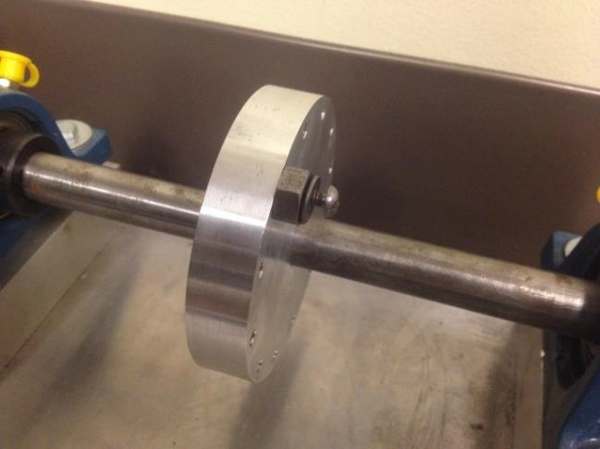
Figure 2: Shaft unbalance: (a) unbalance level 1
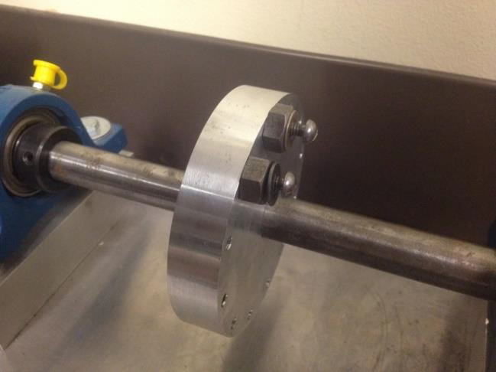
Figure 3: Shaft unbalance: (b) unbalance level 2

To Assess the health condition of the shaft based on the various data, the aim is to use SVM (Support Vector Machine), which is a powerful supervised learning algorithm for classification and regression tasks. It is very popular in the field of machine learning and pattern recognition, especially for classification problems. The main goal of SVM is to find an optimal hyperplane (or hyperplanes, for multi-class classification problems) that can separate different classes of data points at maximum intervals.

DATA DESCRIPTION

To assess the health condition of the shaft, the vibration data is gathered using the accelerometer. There are two types of data, i.e. training and testing data. In training data, the data is divided into healthy and faulty data which be further divided into faulty one and faulty two.

The vibration measurements, includes the data with the positive or negative, these indicate the direction of the acceleration along a specific axis. Here's what each datatype typically represents:
- Positive datapoints (+): A positive acceleration value indicates that the object or system is accelerating in the positive direction along the axis being measured. For example, if the measurements are taken along the X-axis, a positive acceleration value suggests that the object is moving in the positive direction along the X-axis.

- Negative datapoints (-): Similarly, a negative acceleration value indicates that the object or system is accelerating in the negative direction along the axis being measured. Using the same example, if the measurements are taken along the X-axis, a negative acceleration value suggests that the object is moving in the negative direction along the X-axis.
This trend remains the same for all types of data used either for training or testing the model. The data gathered and used for analysis includes:
- Date: The date when the data was gathered.
- Time: The time when the data was gathered.
- Operator: The person responsible for collecting the data.
- Data Type: The data type indicates the type of conditions under which the data was collected, i.e., normal conditions or faulty conditions.
- Acceleration: The data collected as vibration data, that is measured in each assessment, where each data represents the measurement of acceleration along a specific axis, which can be both negative and positive in value.
For health assessment and training of SVM there were 20 observations of healthy, 20 observations of faulty type one, and 20 observations of faulty type two data used. Whereas 30 observations of data were used for testing the validity of the model.

IMPLEMENTED SOLUTION

INTRODUCTION TO THE ANALYTICS PROCESS

Step 1. Loading data:
We used functions to load all training and testing data.

Step 2. Preprocessing the signal and extract features
In this phase, we computed the following time-domain features by traversing the data in each category:
Root mean square (RMS): It's a measure of the average power of a signal. In graphical terms, it's like finding the "average height" of the signal over time.
Mean value: The average value of the signal. In graphical terms, it's the midpoint or central tendency of the signal.
Peak-to-peak value: It's the difference between the highest and lowest points of the signal. Graphically, it's the vertical distance between the highest peak and the lowest valley in the signal.
Standard deviation: It measures the dispersion or spread of the data points around the mean. In a graph, it indicates how widely the signal varies from the average value.

Skewness: It describes the asymmetry of the signal's distribution.
Positive skewness: means the tail on the right side is longer or fatter.
Negative skewness: means the tail on the left side is longer. Graphically, it shows the shape of the signal's distribution.
Kurtosis:
Kurtosis is a statistical measure that describes the shape of the probability distribution of a dataset. It indicates the peak or tail of the distribution relative to a normal distribution.
A high kurtosis value means the dataset has heavy tails and a sharp peak, indicating that it has more outliers or extreme values. Similarly, a low kurtosis value suggests the dataset has light tails and a flatter peak, indicating fewer outliers and less variability in extreme values.
In addition, the first harmonic amplitude in the frequency domain is calculated. These features capture the properties of the vibration signal from different aspects of the data and are useful for distinguishing between different mechanical states.

Step 3. Model training and prediction
We defined a multi-class SVM model that uses an error correction Output code (ECOC) strategy to handle the multi-class classification problem. ECOC is a method for decomposing a multi-class classification problem into multiple two-class classification problems, and then solving the original multi-class problem by training multiple two-class classifiers.
We tried different kernel functions (linear, polynomial, Gaussian, radial basis function (RBF)), and chooses the best kernel function by comparing the performance of these kernel functions. Performance evaluation is done by calculating the accuracy of the model on the training data.

Step 4. Model testing and performance evaluation
A model trained with an optimal kernel function was used to make predictions on the test data set. We also calculated the confusion matrix and some key performance metrics (accuracy, accuracy, recall, F1 score) that help evaluate the model's performance on previously unseen data.

FLOWCHART

RESULT

Feature extraction

Feature extraction is necessary because it helps simplify and enhance the data for machine learning. It reduces the data's complexity by selecting or transforming the most important aspects, making it easier for algorithms to understand. This process improves model accuracy, makes the data easier to interpret, and allows for handling different types of data.

Root mean square (RMS): It's a measure of the average power of a signal. In graphical terms, it's like finding the "average height" of the signal over time.
Mean value: The average value of the signal. In graphical terms, it's the midpoint or central tendency of the signal.
Peak-to-peak value: It's the difference between the highest and lowest points of the signal. Graphically, it's the vertical distance between the highest peak and the lowest valley in the signal.
Standard deviation: It measures the dispersion or spread of the data points around the mean. In a graph, it indicates how widely the signal varies from the average value.

Skewness: It describes the asymmetry of the signal's distribution.
Positive skewness: means the tail on the right side is longer or fatter.
Negative skewness: means the tail on the left side is longer. Graphically, it shows the shape of the signal's distribution.
Kurtosis:
Kurtosis is a statistical measure that describes the shape of the probability distribution of a dataset. It indicates the peak or tail of the distribution relative to a normal distribution.
A high kurtosis value means the dataset has heavy tails and a sharp peak, indicating that it has more outliers or extreme values. Similarly, a low kurtosis value suggests the dataset has light tails and a flatter peak, indicating fewer outliers and less variability in extreme values.
In addition, the first harmonic amplitude in the frequency domain is calculated. These features capture the properties of the vibration signal from different aspects of the data and are useful for distinguishing between different mechanical states.

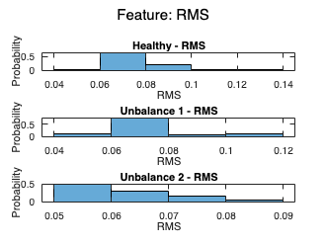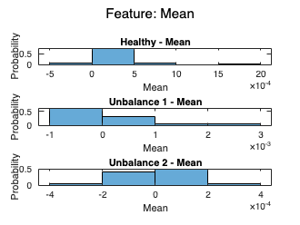

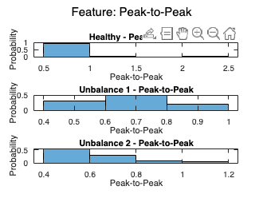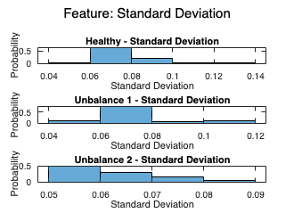
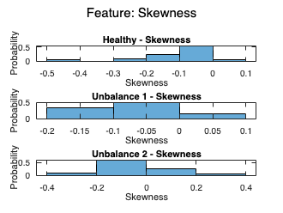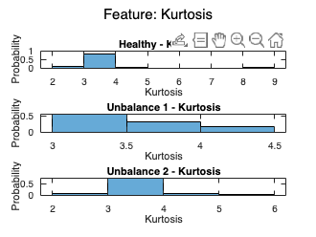
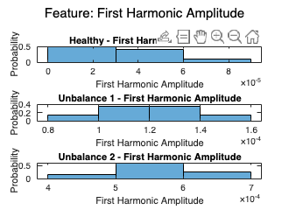
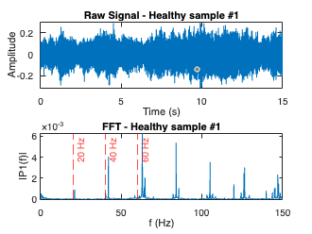
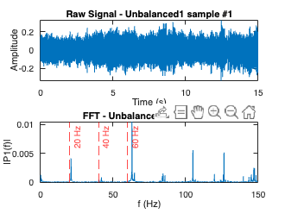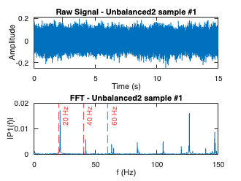

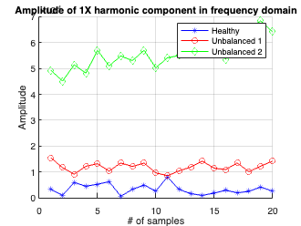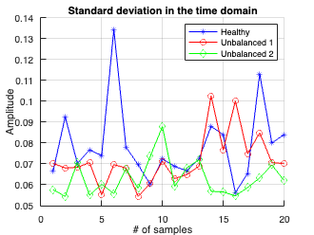

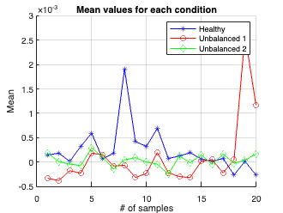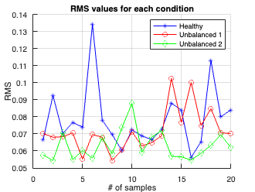
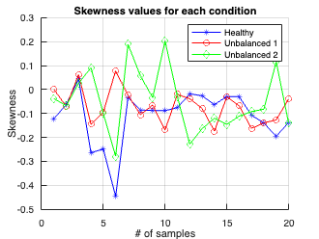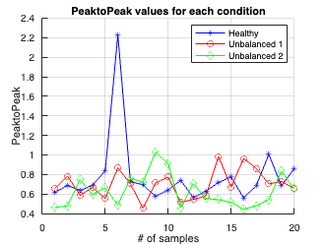

Best performing kernel 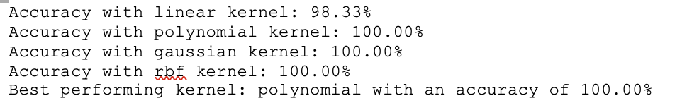

Filenames and Predicted Labels (Best Kernel):
: Predicted Label - Healthy
: Predicted Label - Healthy
: Predicted Label - Healthy
: Predicted Label - Healthy
: Predicted Label - Healthy
: Predicted Label - Healthy
: Predicted Label - Healthy
: Predicted Label - Healthy
: Predicted Label - Healthy
: Predicted Label - Healthy
: Predicted Label - Unbalance 1
: Predicted Label - Unbalance 1
: Predicted Label - Unbalance 1
: Predicted Label - Unbalance 1
: Predicted Label - Unbalance 1
: Predicted Label - Unbalance 1
: Predicted Label - Unbalance 1
: Predicted Label - Unbalance 1
: Predicted Label - Unbalance 1
: Predicted Label - Unbalance 1
: Predicted Label - Unbalance 2
: Predicted Label - Unbalance 2
: Predicted Label - Unbalance 2
: Predicted Label - Unbalance 2
: Predicted Label - Unbalance 2
: Predicted Label - Unbalance 1
: Predicted Label - Unbalance 1
: Predicted Label - Unbalance 2
: Predicted Label - Unbalance 1
: Predicted Label - Unbalance 1
Class Counts for Predicted Labels on Test Data:
Healthy: 10
Unbalance 1: 14
Unbalance 2: 6
Filenames and Predicted Labels:
: Predicted Label - Healthy
: Predicted Label - Healthy
: Predicted Label - Healthy
: Predicted Label - Healthy
: Predicted Label - Healthy
: Predicted Label - Healthy
: Predicted Label - Healthy
: Predicted Label - Healthy
: Predicted Label - Healthy
: Predicted Label - Healthy
: Predicted Label - Unbalance 1
: Predicted Label - Unbalance 1
: Predicted Label - Unbalance 1
: Predicted Label - Unbalance 1
: Predicted Label - Unbalance 1
: Predicted Label - Unbalance 1
: Predicted Label - Unbalance 1
: Predicted Label - Unbalance 1
: Predicted Label - Unbalance 1
: Predicted Label - Unbalance 1
: Predicted Label - Unbalance 2
: Predicted Label - Unbalance 2
: Predicted Label - Unbalance 2
: Predicted Label - Unbalance 2
: Predicted Label - Unbalance 2
: Predicted Label - Unbalance 1
: Predicted Label - Unbalance 1
: Predicted Label - Unbalance 2
: Predicted Label - Unbalance 1
: Predicted Label - Unbalance 1

We tried various kernels and predicted their accuracy, then decided a best kernel by comparing their performance.

Confusion matrix

Confusion Matrix:
10 0 0
0 10 0
0 4 6
Overall Accuracy: 86.67%

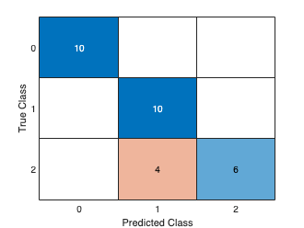

Class 0 - Precision: 1.0000, Recall: 1.0000, F1 Score: 1.0000
Class 1 - Precision: 0.7143, Recall: 1.0000, F1 Score: 0.8333
Class 2 - Precision: 1.0000, Recall: 0.6000, F1 Score: 0.7500

From our results, we did not get 100% accuracy result.

DISCUSSION

- Kernel Performance
The SVM models were tested with four different kernel functions: linear, polynomial, gaussian, and rbf. The polynomial, gaussian, and rbf kernels achieved a perfect accuracy of 100%, while the linear kernel showed slightly lower accuracy at 98.33%. This indicates that for this dataset and feature set, the polynomial, gaussian, and rbf kernels were more effective in capturing the non-linear patterns present in the data, leading to better classification performance.​​

- Overall Accuracy
The overall accuracy of the model on the test dataset was 86.67%. This indicates that while the model is highly accurate, there are still some instances where it may misclassify the condition of the machinery. To locate the problem and improve the accuracy, we tested other two 100% accuracy kernels, and got the results in which showed a lower accuracy than polynomial kernel. This inspired us that this problem may be due to overlaps in the feature space between the different conditions.
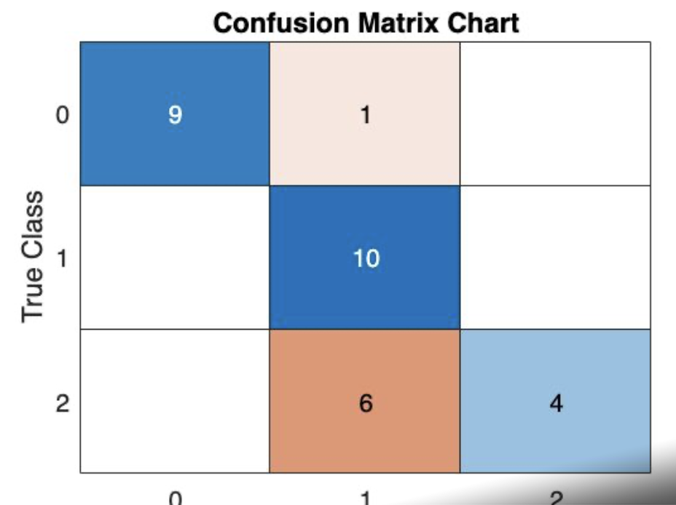
Results of gaussian and rbf kernels

- Precision, Recall, and F1 Score
The precision, recall, and F1 scores for the Healthy class and Unbalance 2 class were high, indicating strong performance in correctly identifying these conditions. However, the precision for Unbalance 1 was lower, suggesting that some of the Unbalance 1 conditions were misclassified as Unbalance 2 or Healthy. This could be due to similarities in the vibration signatures of Unbalance 1 and the other conditions, making it more challenging for the model to distinguish between them.

CONCLUSION

The results from our work show a high accuracy in predicting the condition of the machinery based on the extracted features, with polynomial, gaussian, and rbf kernels achieving a perfect accuracy of 100%. The linear kernel also performed well with 98.33% accuracy. The best performing kernel was identified as polynomial with 100% accuracy. The test data predictions were mostly accurate, with a total class distribution count of 10 Healthy, 14 Unbalance 1, and 6 Unbalance 2. However, for the "Unbalance 2" class, while 6 out of 10 samples were correctly identified, there were 4 instances where samples were misclassified as "Unbalance 1". This suggests that the model encountered challenges in accurately distinguishing between "Unbalance 1" and "Unbalance 2" conditions. Further refinement of the classification algorithm or the inclusion of additional features may help improve the model's ability to differentiate between these classes effectively. Our future work could conduct features to further improve the classification accuracy.

In Comparison to the results that was achieved in the logistic regression model, The difference is that Logistic Regression model achieved the accuracy of 100%, whereas SVM model achieved-86.67%.
The reason for better performance in the LR model maybe because such models work better for binary classification which at that time was classifying the data into Healthy and Faulty labels. However, in the SVM model, the Faulty data gets further classified into Unbalance level 1 and Unbalance level 2, because of which the model was not able to classify ALL the data as accurately as done by its predecessor.

Appendix – Code

clear;
%% Load Data
folder_path_healthy = '/Users/lann/Desktop/UMD/ENME691/HW3/Training/Healthy';
folder_path_unbalance1 = '/Users/lann/Desktop/UMD/ENME691/HW3/Training/Faulty/Unbalance1';
folder_path_unbalance2 = '/Users/lann/Desktop/UMD/ENME691/HW3/Training/Faulty/Unbalance2';
folder_path_testing = '/Users/lann/Desktop/UMD/ENME691/HW3/Testing';

all_data_healthy = loadDataFromFolder(folder_path_healthy);
all_data_unbalance1 = loadDataFromFolder(folder_path_unbalance1);
all_data_unbalance2 = loadDataFromFolder(folder_path_unbalance2);

%% Extract Time Domain and First Harmonic Features

% Initialize feature vectors for healthy data
rms_values_healthy = zeros(length(all_data_healthy), 1);
mean_values_healthy = zeros(length(all_data_healthy), 1);
peak_to_peak_values_healthy = zeros(length(all_data_healthy), 1);
std_values_healthy = zeros(length(all_data_healthy), 1);
skewness_values_healthy = zeros(length(all_data_healthy), 1);
kurtosis_values_healthy = zeros(length(all_data_healthy), 1);
first_harmonic_values_healthy = zeros(length(all_data_healthy), 1); % First harmonic

% Initialize feature vectors for Unbalance 1 data
rms_values_unbalance1 = zeros(length(all_data_unbalance1), 1);
mean_values_unbalance1 = zeros(length(all_data_unbalance1), 1);
peak_to_peak_values_unbalance1 = zeros(length(all_data_unbalance1), 1);
std_values_unbalance1 = zeros(length(all_data_unbalance1), 1);
skewness_values_unbalance1 = zeros(length(all_data_unbalance1), 1);
kurtosis_values_unbalance1 = zeros(length(all_data_unbalance1), 1);
first_harmonic_values_unbalance1 = zeros(length(all_data_unbalance1), 1); % First harmonic

% Initialize feature vectors for Unbalance 2 data
rms_values_unbalance2 = zeros(length(all_data_unbalance2), 1);
mean_values_unbalance2 = zeros(length(all_data_unbalance2), 1);
peak_to_peak_values_unbalance2 = zeros(length(all_data_unbalance2), 1);
std_values_unbalance2 = zeros(length(all_data_unbalance2), 1);
skewness_values_unbalance2 = zeros(length(all_data_unbalance2), 1);
kurtosis_values_unbalance2 = zeros(length(all_data_unbalance2), 1);
first_harmonic_values_unbalance2 = zeros(length(all_data_unbalance2), 1); % First harmonic

% Extract features for healthy data
for i = 1:length(all_data_healthy)
data = all_data_healthy{i}.data;

% Calculate Time Domain Features
rms_values_healthy(i) = rms(data);
mean_values_healthy(i) = mean(data);
peak_to_peak_values_healthy(i) = max(data) - min(data);
std_values_healthy(i) = std(data);
skewness_values_healthy(i) = skewness(data);
kurtosis_values_healthy(i) = kurtosis(data);

% Calculate First Harmonic from Frequency Domain
first_harmonic_values_healthy(i) = calculateFirstHarmonic(data);
end

% Extract features for Unbalance 1 data
for i = 1:length(all_data_unbalance1)
data = all_data_unbalance1{i}.data;

% Calculate Time Domain Features
rms_values_unbalance1(i) = rms(data);
mean_values_unbalance1(i) = mean(data);
peak_to_peak_values_unbalance1(i) = max(data) - min(data);
std_values_unbalance1(i) = std(data);
skewness_values_unbalance1(i) = skewness(data);
kurtosis_values_unbalance1(i) = kurtosis(data);

% Calculate First Harmonic from Frequency Domain
first_harmonic_values_unbalance1(i) = calculateFirstHarmonic(data);
end

% Extract features for Unbalance 2 data
for i = 1:length(all_data_unbalance2)
data = all_data_unbalance2{i}.data;

% Calculate Time Domain Features
rms_values_unbalance2(i) = rms(data);
mean_values_unbalance2(i) = mean(data);
peak_to_peak_values_unbalance2(i) = max(data) - min(data);
std_values_unbalance2(i) = std(data);
skewness_values_unbalance2(i) = skewness(data);
kurtosis_values_unbalance2(i) = kurtosis(data);

% Calculate First Harmonic from Frequency Domain
first_harmonic_values_unbalance2(i) = calculateFirstHarmonic(data);
end

%% Combine Features and Labels

% Combine feature vectors
features_healthy = [rms_values_healthy, mean_values_healthy, peak_to_peak_values_healthy, std_values_healthy, skewness_values_healthy, kurtosis_values_healthy, first_harmonic_values_healthy];
features_unbalance1 = [rms_values_unbalance1, mean_values_unbalance1, peak_to_peak_values_unbalance1, std_values_unbalance1, skewness_values_unbalance1, kurtosis_values_unbalance1, first_harmonic_values_unbalance1];
features_unbalance2 = [rms_values_unbalance2, mean_values_unbalance2, peak_to_peak_values_unbalance2, std_values_unbalance2, skewness_values_unbalance2, kurtosis_values_unbalance2, first_harmonic_values_unbalance2];

% Combine labels
labels_healthy = zeros(length(all_data_healthy), 1); % Label 0 for healthy
labels_unbalance1 = ones(length(all_data_unbalance1), 1); % Label 1 for Unbalance 1
labels_unbalance2 = 2 * ones(length(all_data_unbalance2), 1); % Label 2 for Unbalance 2

% Combine features and labels
X = [features_healthy; features_unbalance1; features_unbalance2];
y = [labels_healthy; labels_unbalance1; labels_unbalance2];

%% Train Multi-Class SVM Model (Using Error Correcting Output Codes - ECOC)

% Define different kernels
kernels = {'linear', 'polynomial', 'gaussian', 'rbf'};

% Initialize a matrix to store accuracies for each kernel
kernelAccuracies = zeros(length(kernels), 1);

for kIndex = 1:length(kernels)
% Set up the SVM template for current kernel
t = templateSVM('KernelFunction', kernels{kIndex}, 'Standardize', true);

% Train the SVM model using ECOC
SVMModel = fitcecoc(X, y, 'Learners', t);

% Predict the labels using the trained model
predicted_labels = predict(SVMModel, X);

% Calculate and store the accuracy
accuracy = sum(predicted_labels == y) / numel(y);
kernelAccuracies(kIndex) = accuracy;

% Display the accuracy for the current kernel
fprintf('Accuracy with %s kernel: %.2f%%\n', kernels{kIndex}, accuracy * 100);
end

% Find the best performing kernel
[bestAccuracy, bestIndex] = max(kernelAccuracies);
fprintf('\nBest performing kernel: %s with an accuracy of %.2f%%\n', kernels{bestIndex}, bestAccuracy * 100);

bestKernel = kernels{bestIndex}; % Get the best kernel

% Set up the SVM template for the best kernel
t_best = templateSVM('KernelFunction', bestKernel, 'Standardize', true);

% Train the SVM model using the best kernel
SVMModel = fitcecoc(X, y, 'Learners', t_best);

%% Load test data from folder
all_data_testing = loadDataFromFolder(folder_path_testing);

% Initialize feature vectors for test data
rms_values_testing = zeros(length(all_data_testing), 1);
mean_values_testing = zeros(length(all_data_testing), 1);
peak_to_peak_values_testing = zeros(length(all_data_testing), 1);
std_values_testing = zeros(length(all_data_testing), 1);
skewness_values_testing = zeros(length(all_data_testing), 1);
kurtosis_values_testing = zeros(length(all_data_testing), 1);
first_harmonic_values_testing = zeros(length(all_data_testing), 1); % First harmonic for test data

% Extract features for test data
for i = 1:length(all_data_testing)
data = all_data_testing{i}.data;

% Calculate Time Domain Features
rms_values_testing(i) = rms(data);
mean_values_testing(i) = mean(data);
peak_to_peak_values_testing(i) = max(data) - min(data);
std_values_testing(i) = std(data);
skewness_values_testing(i) = skewness(data);
kurtosis_values_testing(i) = kurtosis(data);

% Calculate First Harmonic from Frequency Domain
first_harmonic_values_testing(i) = calculateFirstHarmonic(data);
end

% Combine features for test data
features_testing = [rms_values_testing, mean_values_testing, peak_to_peak_values_testing, std_values_testing, skewness_values_testing, kurtosis_values_testing, first_harmonic_values_testing];

% Predict labels for the test data using the trained SVM model
predicted_labels_testing = predict(SVMModel, features_testing);
filenames_testing = cell(length(all_data_testing), 1);
class_labels = {'Healthy', 'Unbalance 1', 'Unbalance 2'};

% Predict the labels for the test data using the trained model
predicted_labels_testing_best = predict(SVMModel, features_testing);

% Display the filenames along with predicted labels for the test data
disp('Filenames and Predicted Labels (Best Kernel):');
for i = 1:length(predicted_labels_testing_best)
fprintf('%s: Predicted Label - %s\n', filenames_testing{i}, class_labels{predicted_labels_testing_best(i) + 1});
end

% Count the occurrences of each predicted class
class_counts = histcounts(predicted_labels_testing, 'BinMethod', 'integers');

% Define class labels

% Display the class counts with labels
disp('Class Counts for Predicted Labels on Test Data:');
for i = 1:length(class_labels)
fprintf('%s: %d\n', class_labels{i}, class_counts(i));
end

% Display filenames along with predicted labels
disp('Filenames and Predicted Labels:');
for i = 1:length(predicted_labels_testing)
fprintf('%s: Predicted Label - %s\n', filenames_testing{i}, class_labels{predicted_labels_testing(i) + 1});
end
% Define True Labels based on the image provided
true_labels = [zeros(10, 1); ones(10, 1); 2*ones(10, 1)]; % 0 for Healthy, 1 for Unbalance Level 1, 2 for Unbalance Level 2

% Generate Confusion Matrix
confMatrix = confusionchart(true_labels, predicted_labels_testing);

% Display the Confusion Matrix
disp('Confusion Matrix:');
disp(confMatrix);

% Calculate and Display Overall Accuracy
correct_predictions = sum(confMatrix.NormalizedValues(logical(eye(size(confMatrix.NormalizedValues))))); % Sum of correct predictions (diagonal elements)
total_predictions = sum(confMatrix.NormalizedValues, 'all'); % Total number of predictions
overallAccuracy = correct_predictions / total_predictions * 100; % Calculate overall accuracy
fprintf('Overall Accuracy: %.2f%%\n', overallAccuracy);

% Calculate and Display Precision, Recall, and F1-Score for Each Class
for i = 1:size(confMatrix.NormalizedValues, 1)
% Precision
precision = confMatrix.NormalizedValues(i, i) / sum(confMatrix.NormalizedValues(:, i));

% Recall
recall = confMatrix.NormalizedValues(i, i) / sum(confMatrix.NormalizedValues(i, :));

% F1-score
f1Score = 2 * (precision * recall) / (precision + recall);

fprintf('Class %d - Precision: %.4f, Recall: %.4f, F1 Score: %.4f\n', i-1, precision, recall, f1Score);
end

%% Plot Time Domain Features for Each Class Separately

% Define feature names
feature_names = {'RMS', 'Mean', 'Peak-to-Peak', 'Standard Deviation', 'Skewness', 'Kurtosis', 'First Harmonic Amplitude'};

% Iterate over each feature
for featureIndex = 1:length(feature_names)
% Create a new figure for each feature
figure;

% Plot healthy data
subplot(3, 1, 1);
histogram(X(y == 0, featureIndex), 'Normalization', 'probability');
title(['Healthy - ' feature_names{featureIndex}]);
xlabel(feature_names{featureIndex});
ylabel('Probability');

% Plot Unbalance 1 data
subplot(3, 1, 2);
histogram(X(y == 1, featureIndex), 'Normalization', 'probability');
title(['Unbalance 1 - ' feature_names{featureIndex}]);
xlabel(feature_names{featureIndex});
ylabel('Probability');

% Plot Unbalance 2 data
subplot(3, 1, 3);
histogram(X(y == 2, featureIndex), 'Normalization', 'probability');
title(['Unbalance 2 - ' feature_names{featureIndex}]);
xlabel(feature_names{featureIndex});
ylabel('Probability');

% Adjust the layout
sgtitle(['Feature: ' feature_names{featureIndex}]);
end

% Example usage
Fs = 2560; % Sampling frequency
data_healthy = all_data_healthy{1}.data; % Assuming your data is stored this way
data_unbalanced1 = all_data_unbalance1{1}.data;
data_unbalanced2 = all_data_unbalance2{1}.data;

figure;
plotSampleAndFFT(data_healthy, Fs, 'Healthy sample #1');

figure;
plotSampleAndFFT(data_unbalanced1, Fs, 'Unbalanced1 sample #1');

figure;
plotSampleAndFFT(data_unbalanced2, Fs, 'Unbalanced2 sample #1');
% Sample indices for plotting
samples = 1:20;

% Plotting the amplitude of 1X harmonic component
figure;
hold on;
plot(samples, first_harmonic_values_healthy(1:20), 'b-*', 'DisplayName', 'Healthy');
plot(samples, first_harmonic_values_unbalance1(1:20), 'r-o', 'DisplayName', 'Unbalanced 1');
plot(samples, first_harmonic_values_unbalance2(1:20), 'g-d', 'DisplayName', 'Unbalanced 2');
hold off;
xlabel('# of samples');
ylabel('Amplitude');
title('Amplitude of 1X harmonic component in frequency domain');
legend('show');
grid on;

% Plotting the standard deviation in the time domain
figure;
hold on;
plot(samples, std_values_healthy(1:20), 'b-*', 'DisplayName', 'Healthy');
plot(samples, std_values_unbalance1(1:20), 'r-o', 'DisplayName', 'Unbalanced 1');
plot(samples, std_values_unbalance2(1:20), 'g-d', 'DisplayName', 'Unbalanced 2');
hold off;
xlabel('# of samples');
ylabel('Amplitude');
title('Standard deviation in the time domain');
legend('show');
grid on;
% Plotting the Mean values
figure;
hold on;
plot(samples, mean_values_healthy(1:20), 'b-*', 'DisplayName', 'Healthy');
plot(samples, mean_values_unbalance1(1:20), 'r-o', 'DisplayName', 'Unbalanced 1');
plot(samples, mean_values_unbalance2(1:20), 'g-d', 'DisplayName', 'Unbalanced 2');
hold off;
xlabel('# of samples');
ylabel('Mean');
title('Mean values for each condition');
legend('show');
grid on;

% Plotting the RMS values
figure;
hold on;
plot(samples, rms_values_healthy(1:20), 'b-*', 'DisplayName', 'Healthy');
plot(samples, rms_values_unbalance1(1:20), 'r-o', 'DisplayName', 'Unbalanced 1');
plot(samples, rms_values_unbalance2(1:20), 'g-d', 'DisplayName', 'Unbalanced 2');
hold off;
xlabel('# of samples');
ylabel('RMS');
title('RMS values for each condition');
legend('show');
grid on;

% Plotting the Skewness values
figure;
hold on;
plot(samples, skewness_values_healthy(1:20), 'b-*', 'DisplayName', 'Healthy');
plot(samples, skewness_values_unbalance1(1:20), 'r-o', 'DisplayName', 'Unbalanced 1');
plot(samples, skewness_values_unbalance2(1:20), 'g-d', 'DisplayName', 'Unbalanced 2');
hold off;
xlabel('# of samples');
ylabel('Skewness');
title('Skewness values for each condition');
legend('show');
grid on;

% Plotting the PeaktoPeak values
figure;
hold on;
plot(samples, peak_to_peak_values_healthy(1:20), 'b-*', 'DisplayName', 'Healthy');
plot(samples, peak_to_peak_values_unbalance1(1:20), 'r-o', 'DisplayName', 'Unbalanced 1');
plot(samples, peak_to_peak_values_unbalance2(1:20), 'g-d', 'DisplayName', 'Unbalanced 2');
hold off;
xlabel('# of samples');
ylabel('PeaktoPeak');
title('PeaktoPeak values for each condition');
legend('show');
grid on;

function [all_data] = loadDataFromFolder(folder_path)
file_list = dir(fullfile(folder_path, '*.txt'));
all_data = cell(length(file_list), 1);
for i = 1:length(file_list)
file_path = fullfile(folder_path, file_list(i).name);
if endsWith(file_list(i).name, '.txt')
all_data{i} = importdata(file_path);
end
end
end

function [firstHarmonicAmplitude] = calculateFirstHarmonic(data)
Fs = 2560;
N = length(data);
Y = fft(data);
P2 = abs(Y/N);
P1 = P2(1:N/2+1);
P1(2:end-1) = 2*P1(2:end-1); % Double-sided spectrum to single-sided spectrum
f = Fs*(0:(N/2))/N; % Frequency range

target_frequency = 20; % Target frequency for the first harmonic in Hz

% Find the closest frequency bin to the target frequency
[~, closestIndex] = min(abs(f - target_frequency));

% Amplitude of the closest frequency to the target first harmonic
firstHarmonicAmplitude = P1(closestIndex);
end
function plotSampleAndFFT(data, Fs, titleText)
% Time-domain plot
subplot(2, 1, 1); % 2 rows, 1 column, first subplot
t = (0:length(data)-1)/Fs; % Time vector
plot(t, data);
xlabel('Time (s)');
ylabel('Amplitude');
title(['Raw Signal - ' titleText]);

% FFT plot
subplot(2, 1, 2); % 2 rows, 1 column, second subplot
N = length(data);
Y = fft(data);
P2 = abs(Y/N);
P1 = P2(1:N/2+1);
P1(2:end-1) = 2*P1(2:end-1); % Double-sided spectrum to single-sided spectrum
f = Fs*(0:(N/2))/N; % Frequency range
plot(f, P1);
xlabel('f (Hz)');
ylabel('|P1(f)|');
title(['FFT - ' titleText]);
xlim([0, 150]); % Adjust as needed to focus on relevant frequency range

% Mark the 20 Hz fundamental harmonic and its 2nd and 3rd harmonics (40 Hz and 60 Hz)
hold on;
xline(20, '--r', '20 Hz');
xline(40, '--r', '40 Hz');
xline(60, '--r', '60 Hz');
hold off;
end

