For KNN, where K=3, Number of Features: 7
Average Accuracy: 99.2678%
Confusion Matrices:
Fold 1
52 0 0 0 0 0 0 0
0 63 0 0 0 0 0 0
0 0 45 0 0 0 0 0
0 0 0 53 0 0 0 0
0 0 0 0 47 0 0 0
0 0 0 0 1 54 0 0
0 0 0 0 0 0 42 0
0 0 0 0 0 0 0 52
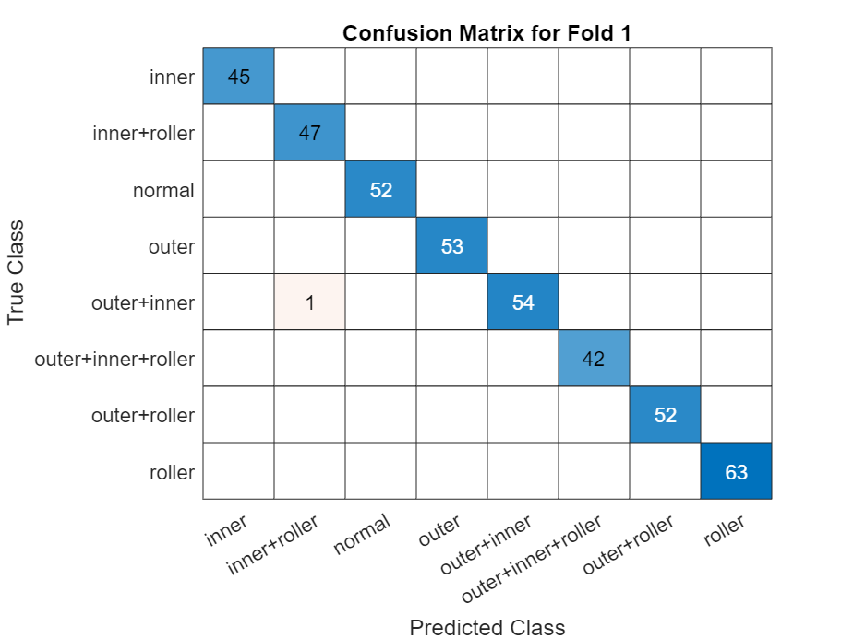

Fold 2
38 0 1 0 0 0 0 0
0 49 0 1 0 0 0 0
0 0 49 0 0 0 0 0
0 0 0 64 0 0 0 0
0 0 0 0 53 1 0 0
0 0 0 0 1 47 0 0
0 0 0 0 0 0 47 0
0 0 0 0 0 0 0 59
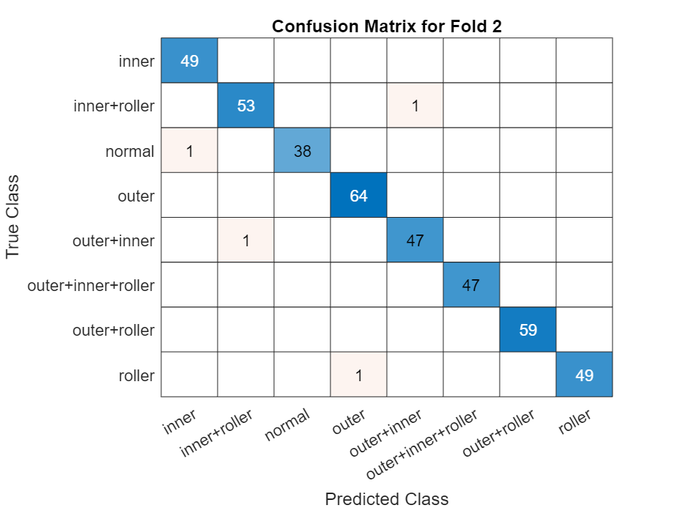

Fold 3
47 0 1 0 0 0 0 0
0 42 0 0 0 0 0 0
0 0 59 0 0 0 0 0
0 0 0 47 0 0 0 0
0 0 0 0 52 2 0 0
0 0 0 0 1 40 0 0
0 0 0 0 0 0 64 0
0 0 0 0 0 0 0 55
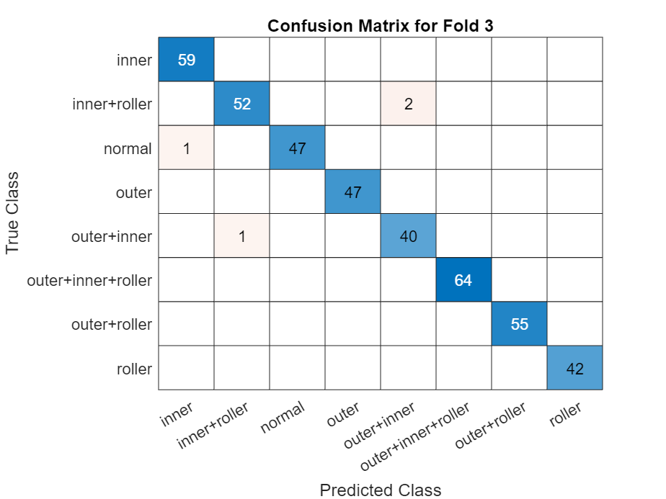

Fold 4
64 0 0 0 0 0 0 0
0 54 0 0 0 0 0 0
0 0 48 0 0 0 0 0
0 0 0 52 0 0 0 0
0 0 0 0 49 1 0 0
0 0 0 0 2 51 0 0
0 0 0 0 0 0 47 0
0 0 0 0 0 0 0 42
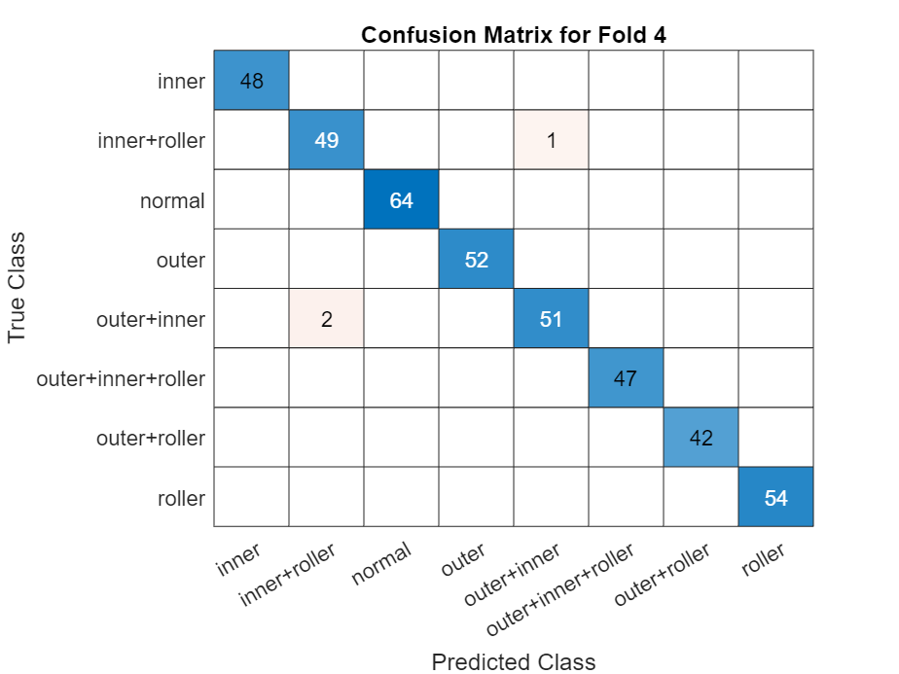

Fold 5
53 0 0 0 0 0 0 0
0 47 0 0 0 0 0 0
0 0 55 0 0 0 0 0
0 0 0 40 0 0 0 0
0 0 0 0 51 0 0 0
0 0 0 0 3 56 0 0
0 0 0 0 0 0 56 0
0 0 0 0 0 0 0 48
