Random Forest (RF) Results:
Average Accuracy: 99.6093%
Average Precision:
1.0000 0.9968 1.0000 1.0000 0.9854 0.9858 1.0000 1.0000
Average Recall:
0.9962 1.0000 1.0000 1.0000 0.9857 0.9882 1.0000 1.0000
Average F1-Score:
0.9981 0.9984 1.0000 1.0000 0.9852 0.9868 1.0000 1.0000

Support Vector Machine (SVM) Results:
Average Accuracy: 99.6582%
Average Precision:
1.0000 1.0000 1.0000 1.0000 0.9819 0.9893 1.0000 1.0000
Average Recall:
1.0000 1.0000 1.0000 1.0000 0.9882 0.9882 0.9962 1.0000
Average F1-Score:
1.0000 1.0000 1.0000 1.0000 0.9847 0.9885 0.9981 1.0000

Confusion Matrices for Random Forest (RF):
Fold 1
50 0 0 0 0 0 0 0
0 47 0 0 0 0 0 0
0 0 51 0 0 0 0 0
0 0 0 42 0 0 0 0
0 0 0 0 61 1 0 0
0 0 0 0 0 51 0 0
0 0 0 0 0 0 48 0
0 0 0 0 0 0 0 58
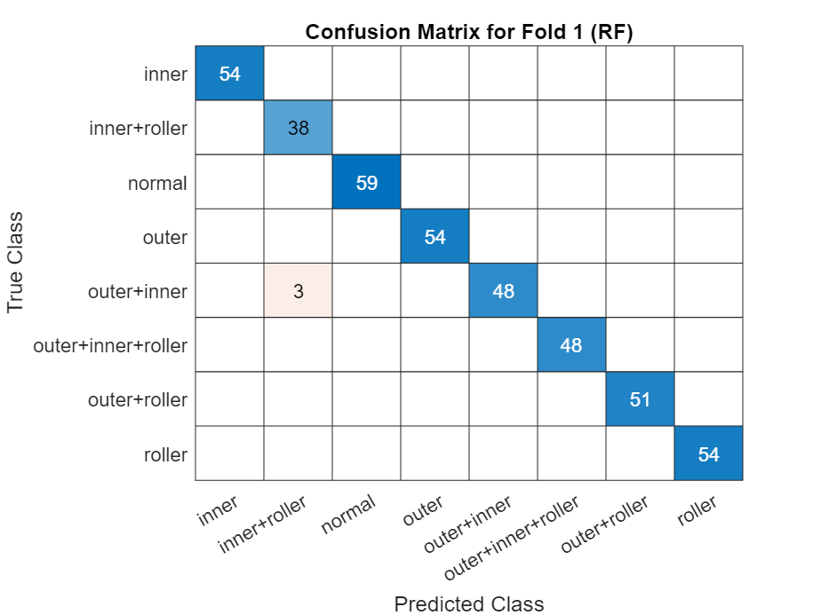

Fold 2
52 1 0 0 0 0 0 0
0 61 0 0 0 0 0 0
0 0 48 0 0 0 0 0
0 0 0 48 0 0 0 0
0 0 0 0 47 1 0 0
0 0 0 0 0 52 0 0
0 0 0 0 0 0 56 0
0 0 0 0 0 0 0 44
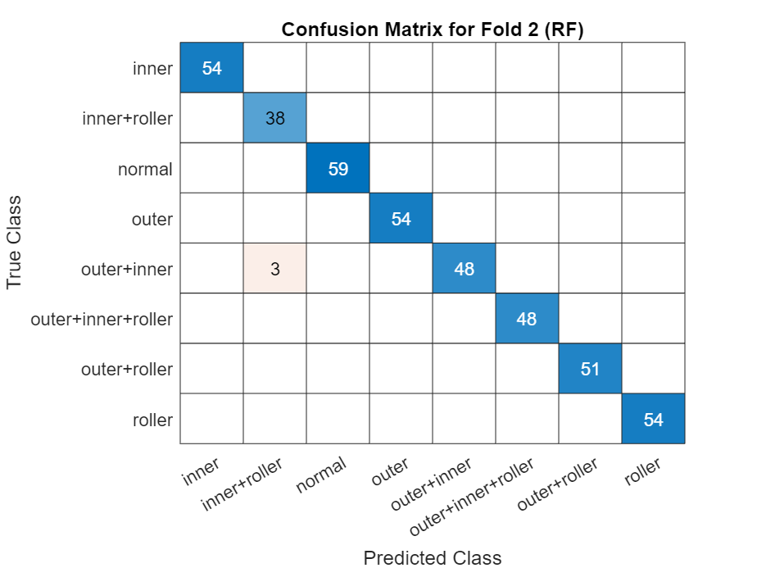

Fold 3
44 0 0 0 0 0 0 0
0 54 0 0 0 0 0 0
0 0 55 0 0 0 0 0
0 0 0 61 0 0 0 0
0 0 0 0 50 0 0 0
0 0 0 0 0 43 0 0
0 0 0 0 0 0 52 0
0 0 0 0 0 0 0 51
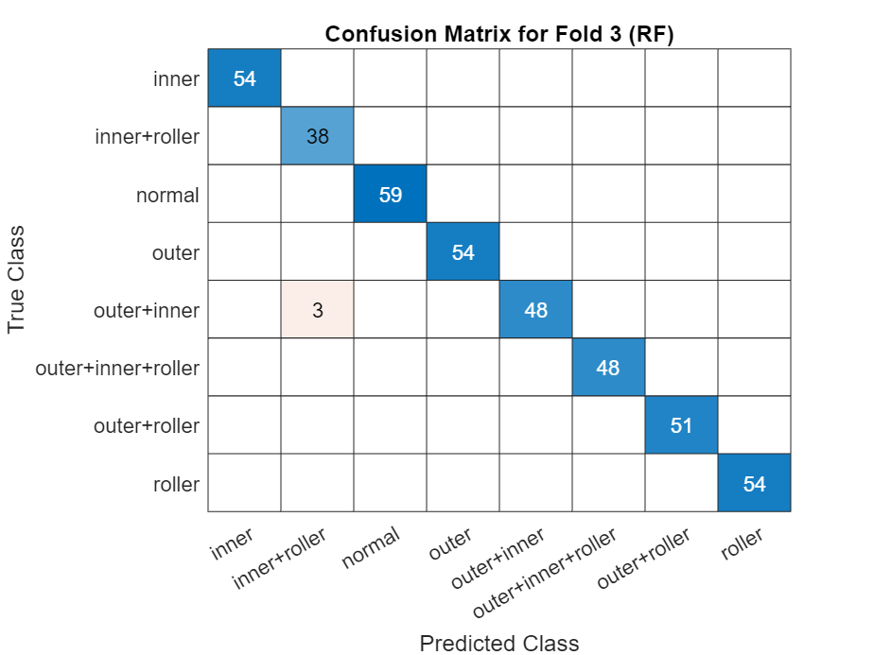

Fold 4
50 0 0 0 0 0 0 0
0 40 0 0 0 0 0 0
0 0 48 0 0 0 0 0
0 0 0 51 0 0 0 0
0 0 0 0 56 2 0 0
0 0 0 0 0 59 0 0
0 0 0 0 0 0 52 0
0 0 0 0 0 0 0 52
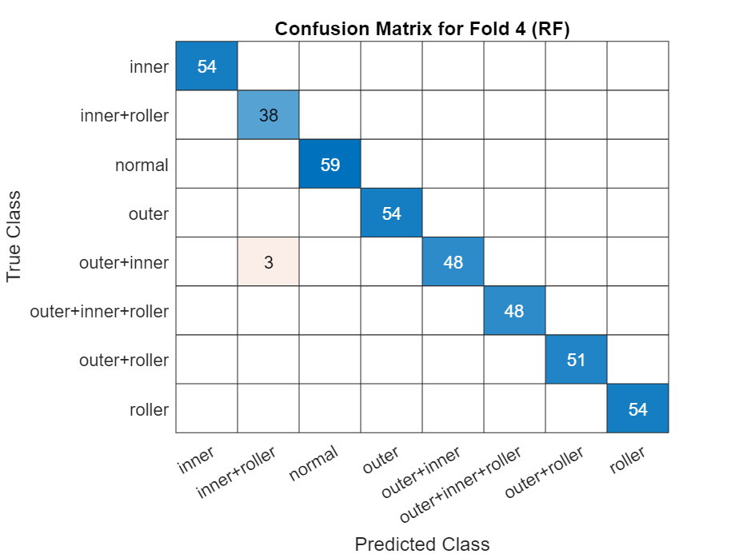

Fold 5
59 0 0 0 0 0 0 0
0 54 0 0 0 0 0 0
0 0 54 0 0 0 0 0
0 0 0 54 0 0 0 0
0 0 0 0 38 0 0 0
0 0 0 0 3 48 0 0
0 0 0 0 0 0 48 0
0 0 0 0 0 0 0 51
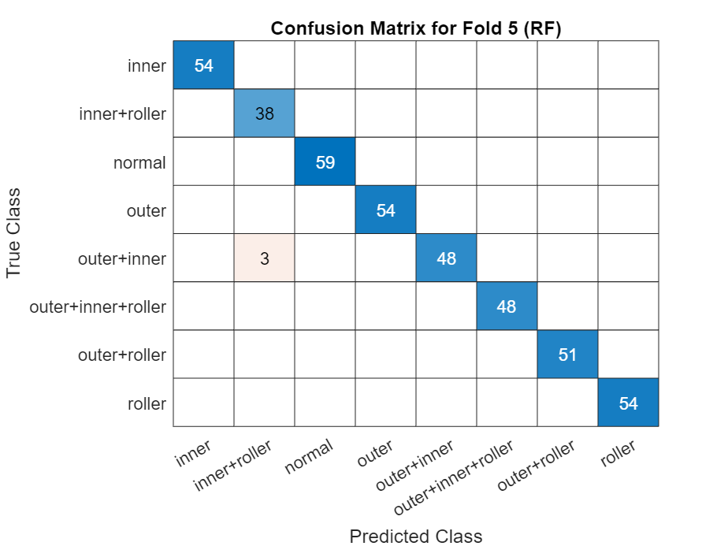

Confusion Matrices for Support Vector Machine (SVM):
Fold 1
50 0 0 0 0 0 0 0
0 47 0 0 0 0 0 0
0 0 51 0 0 0 0 0
0 0 0 42 0 0 0 0
0 0 0 0 62 0 0 0
0 0 0 0 0 51 0 0
0 0 0 0 0 0 48 0
0 0 0 0 0 0 0 58
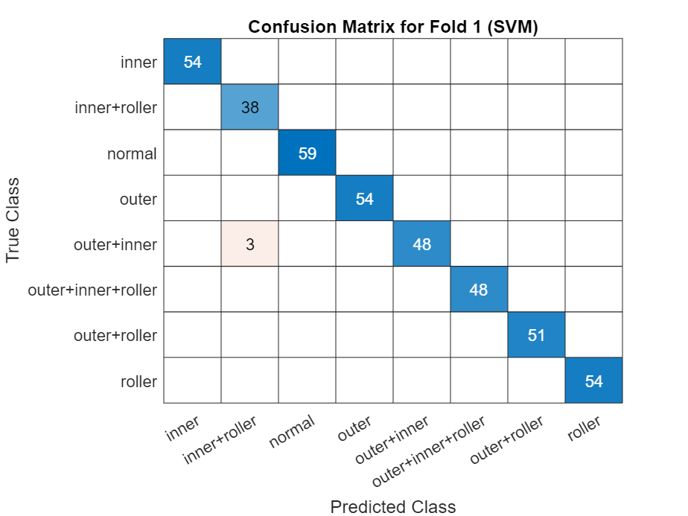

Fold 2
53 0 0 0 0 0 0 0
0 61 0 0 0 0 0 0
0 0 48 0 0 0 0 0
0 0 0 48 0 0 0 0
0 0 0 0 46 2 0 0
0 0 0 0 0 52 0 0
0 0 0 0 0 0 56 0
0 0 0 0 0 0 0 44
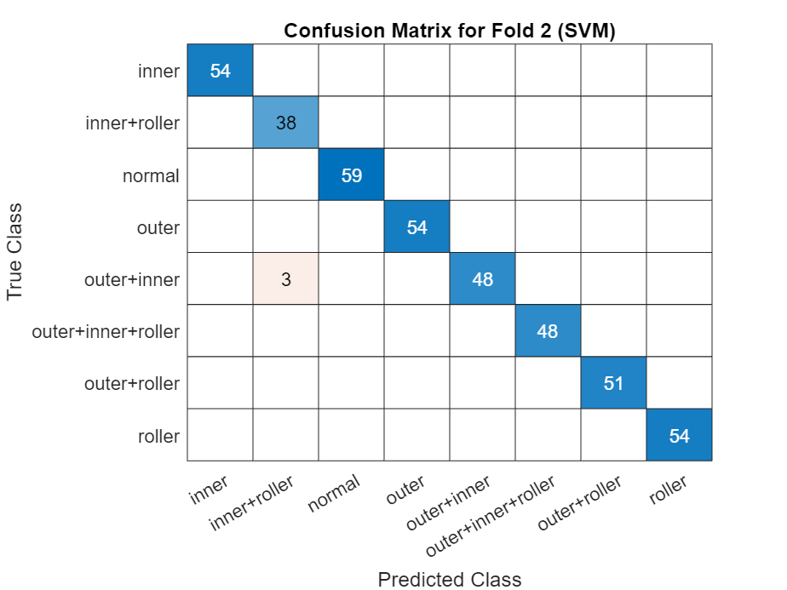

Fold 3
44 0 0 0 0 0 0 0
0 54 0 0 0 0 0 0
0 0 55 0 0 0 0 0
0 0 0 61 0 0 0 0
0 0 0 0 50 0 0 0
0 0 0 0 0 43 0 0
0 0 0 0 0 0 52 0
0 0 0 0 0 0 0 51
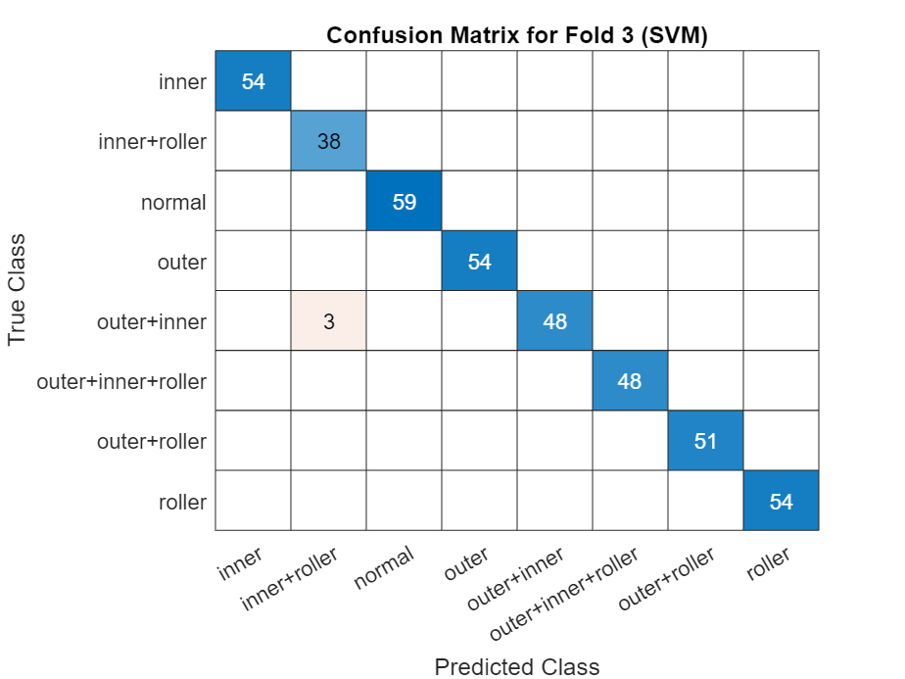

Fold 4
50 0 0 0 0 0 0 0
0 40 0 0 0 0 0 0
0 0 48 0 0 0 0 0
0 0 0 51 0 0 0 0
0 0 0 0 57 1 0 0
0 0 0 0 0 59 0 0
0 0 0 0 1 0 51 0
0 0 0 0 0 0 0 52
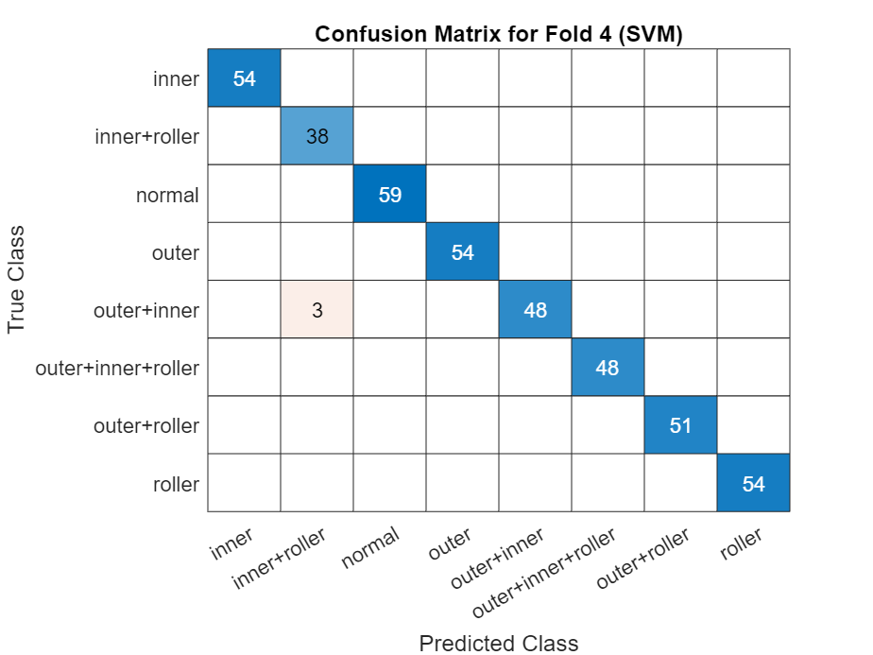

Fold 5
59 0 0 0 0 0 0 0
0 54 0 0 0 0 0 0
0 0 54 0 0 0 0 0
0 0 0 54 0 0 0 0
0 0 0 0 38 0 0 0
0 0 0 0 3 48 0 0
0 0 0 0 0 0 48 0
0 0 0 0 0 0 0 51
