**Assignment – 3**

Sunny

BTech CSE (A) 6th Sem

Roll no – 25526

Subject – Mobile and Wireless Communication

Submitted To: Dr Harkesh Sherawat

DHCP

DHCP stands for Dynamic Host Configuration Protocol, which is a network protocol used to automatically assign IP addresses and other network configuration parameters to devices on a network.

DHCP is a critical component of mobile networks. It enables mobile devices such as smartphones, tablets, and laptops to connect to the network and access resources such as the internet, messaging services, and other network services.

When a device connects to a network, it sends a DHCP request message to the DHCP server, which is typically located on the network. The DHCP server responds with a DHCP offer message that contains network configuration parameters such as an IP address, subnet mask, default gateway, and DNS server address. The device then sends a DHCP request message to request the offered configuration, and the DHCP server responds with a DHCP acknowledgement message that confirms the configuration has been assigned to the device.

DHCP provides a number of benefits in MWC networks. Firstly, it simplifies the process of network configuration by automating the assignment of network configuration parameters, which reduces the need for manual configuration. This is particularly useful in MWC networks where devices are constantly connecting and disconnecting from the network.

Secondly, DHCP enables network administrators to manage IP address allocation centrally, which helps prevent conflicts and ensures efficient use of available IP addresses. This is particularly important in large MWC networks, where there may be thousands or even millions of devices connected to the network at any given time.

Overall, DHCP is an important component of MWC networks, and its ability to automate the assignment of network configuration parameters makes it a critical tool for managing and securing these networks.

**Hierarchical State Routing Protocol(HSR)**is a distributed multi-level hierarchical routing protocol that employs clustering at different levels. Clustering has various advantages in itself. A leader of the cluster is selected at each level of clustering. The benefits of this protocol are:-

* Reduction in routing table size
* Better scalability
* Clustering enhances resource allocation and management

There are different types of clustering in HSR as follows:

**Physical Clustering**

It is between nodes that have physical wireless one-hop links between them. Levels of clusters in physical clustering can be divided into two categories:

* **First Level Cluster-**It is done among the nodes that are reachable in a single wireless hop.
* **Next Higher Level-** It is done among the nodes that have been selected as leaders.

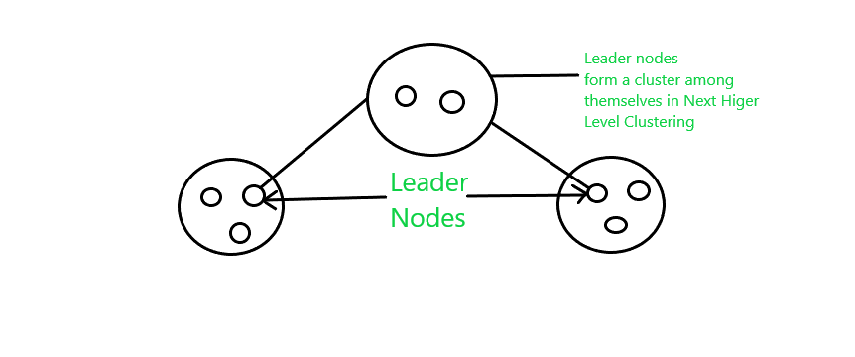

**Logical Clustering**

It is based on certain relations among the nodes rather than geographical positions.

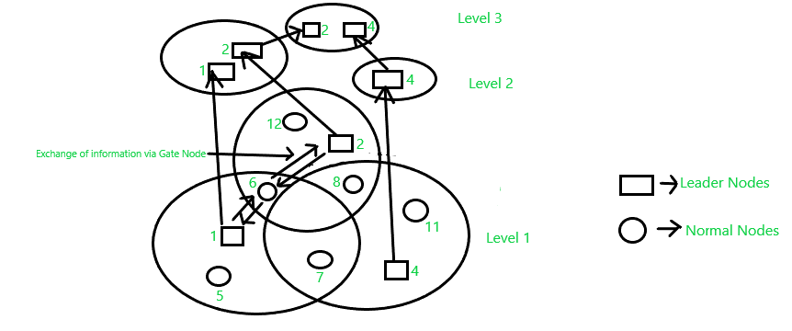

In the above picture, nodes 1,2,4 are the leader of the cluster. Leaders 1 and 2 themselves form a cluster at a higher level as shown in the figure. Node 4 forms a cluster at level 2 by itself. At level 3, nodes 2 and 4 combine to form a cluster. This is the way HSR hierarchically forms a cluster at higher levels. Information is exchanged between the gateway nodes and leader nodes through a path known as**a virtual link**.

**Kinds of Nodes in Cluster**

* **Cluster head**– It acts as a local coordinator of transmissions within the cluster. For example, in the last example as shown in the above picture, nodes 1,4,2 are cluster heads. Properties of cluster heads are allocating slot or frequency or code, call admission control, and most importantly scheduling packet transmission.
* **Gateway node**– These nodes belong to two or more clusters. In the picture, the nodes which are shared by two or more clusters are gateway nodes. For example, nodes 6,7.
* **Internal node**– They belong to a single cluster. It is exactly the opposite of the gateway node. Nodes 5,12,8,11 are internal nodes.

**Disadvantage**

* The process of exchanging information concerning all the levels of the hierarchy as well as the process of leader election in every cluster is time-consuming
* To maintain topology, the hello message needs to be transmitted periodically by the nodes to its neighboring nodes.
* The centralization of routes through the cluster leaders leads to extra taxation of the cluster leader’s power supply.