Early Detection of Parkinson's Disease Using

# Deep Learning and Machine Learning

### Report

Science and Technology Advancement- Assessment Review (STAAR)

# Sushobhan Roy

(Regd. No.- 2101020797)

under the supervision of

Dr. Sukant Kisoro Bisnoy



**Department of Computer Science and Engineering**

**C.V. Raman Global University Bhubaneswar Odisha, 752054, India**

# Abstract

The report presents a study on the early detection of Parkinson's disease (PD) using deep learning and machine learning techniques. The research takes into account a number of markers for Parkinson's disease (PD) detection, such as dopaminergic imaging markers, cerebrospinal fluid (CSF) data, olfactory loss, sleep behavior disorder (RBD), and rapid eye movement (REM). Based on a very small dataset of 401 early-stage Parkinson's disease patients and 183 healthy persons, the authors evaluate the proposed deep learning model with twelve machine learning and ensemble learning techniques for PD detection. The findings demonstrate that, in comparison to the other techniques, the suggested deep learning model detects Parkinson's disease (PD) with the highest average accuracy of 96.45%. Furthermore, the authors offer the feature importance regarding the Boosting method-based PD detection technique. The study demonstrates the promise of machine learning and deep learning methods for early Parkinson's disease (PD) identification, which may assist patients receive disease-modifying treatments and halt the disease's development.

|  |  |  |
| --- | --- | --- |
| Sn. no. | Content | Page no. |
| 1. | Introduction | 1 |
| 2. | Related Work | 2 |
| 3. | Proposed Model | 3-4 |
| 4. | Performance Evaluation and Discussion | 5-7 |
| 5. | Conclusion | 8 |
| 6. | References | 9 |

## Index

## Introduction

## Parkinson's disease (PD) is a progressive neurological ailment affecting millions of people throughout the world. Many motor and non-motor symptoms, including as bradykinesia, stiffness, tremors, and postural instability, are indicative of the condition. Since early detection can greatly slow down the disease's course, it is essential for efficient management and therapy of Parkinson's disease. However, especially in the early stages of the disease, existing PD diagnosis techniques are frequently arbitrary and imprecise.

## The application of machine learning and deep learning methods to the early diagnosis of Parkinson's disease (PD) has attracted increasing attention in recent times. When paired with pertinent clinical, imaging, and genetic data, these methods have the potential to yield more objective and accurate diagnoses. Using information from the Parkinson's Progression Markers Initiative (PPMI), this study created a deep learning model in 2020 for the early identification of Parkinson's disease (PD). The deep learning model outperformed the other twelve machine learning and ensemble learning techniques, with an average accuracy of 96.45% in PD detection.

## The application of machine learning and deep learning methods to the early diagnosis of Parkinson's disease (PD) has attracted increasing attention in recent times. When paired with pertinent clinical, imaging, and genetic data, these methods have the potential to yield more objective and accurate diagnoses. Using information from the Parkinson's Progression Markers Initiative (PPMI), this study created a deep learning model in 2020 for the early identification of Parkinson's disease (PD). The deep learning model outperformed the other twelve machine learning and ensemble learning techniques, with an average accuracy of 96.45% in PD detection.

## 1

## Related Work

**2**

## Proposed Model

The study used data from the Parkinson's Progression Markers Initiative (PPMI) database, which contains 183 healthy people and 401 early-stage Parkinson's disease patients, provided the study's data. Eleven characteristics were taken into account, such as dopaminergic imaging signals, REM sleep behavior problem, olfactory function, and biomarkers in the cerebrospinal fluid.   
With an average accuracy of 96.45% in PD identification, the suggested deep learning model outperformed twelve alternative machine learning and ensemble learning approaches. The deep learning model demonstrated an excellent balance in distinguishing between those with Parkinson's disease (PD) and those who are healthy, with high sensitivity (97.17%) and specificity (94.84%).

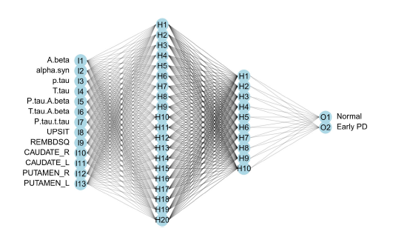

[Figure No.1] **The architecture of the forward neural network model built**.

The feedforward neural network (FNN)(Fig. no. 1) used in the study is a kind of deep learning model made up of several layers of artificial neurons coupled to one another. The incoming data is transformed nonlinearly by each neuron in the network, enabling the network to recognize intricate patterns and correlations.   
The FNN employed in the research comprises two hidden layers: 20 neurons in the first layer and 10 neurons in the second. By capturing both local and global patterns in the data, this architecture enables the network to acquire a reliable representation of the input data. The cross-entropy function is used as the loss function in the stochastic gradient descent (SGD) approach used to train the FNN. The network is trained for 50 epochs, and the algorithm is taught in mini-batches of 16 samples. To avoid overfitting, batch normalization and dropout regularization speed up the training process.

3

Several performance indicators, such as accuracy, sensitivity, specificity, AUC, precision, and F1 score, are used to assess the FNN. The findings demonstrate the FNN's efficacy in differentiating between people with Parkinson's disease and healthy persons, with an average accuracy of 96.68% across 100 data splitting.

In addition, the FNN is contrasted with other machine learning techniques such as logistic regression, discriminant analysis, boosting, random forests, and support vector machines. The outcomes demonstrate how well the FNN performs in comparison to existing techniques in terms of accuracy and other performance measures, suggesting that it has great promise as an early diagnosis tool for Parkinson's disease.

4

Performance Evaluation and Discussion

We begin by presenting the performance evaluation of deep learning methods in distinguishing Parkinson's patients. All deep learning models were trained for 25 and 50 epochs on the training dataset, and the outcomes on the testing data are summarized. The average assessment metrics are detailed in Table 1, while the distribution across 100 splits is visualized in Figure 2. Our analysis reveals the robustness of deep learning models to network structure variations, such as the number of neurons in hidden layers and training epochs. Notably, the accuracy of DEEP1, DEEP2, and DEEP3 ranges from 96.15% to 96.55% for 25 epochs, with marginal changes to 96.43% to 96.53% for 50 epochs. Interestingly, larger networks like DEEP1 do not exhibit higher accuracy in Parkinson's patient discrimination, indicating no signs of overfitting. Furthermore, the ensemble network (DEEP_EN), amalgamating results from DEEP1, DEEP2, and DEEP3, significantly enhances individual network performance, surpassing any single network in all metrics

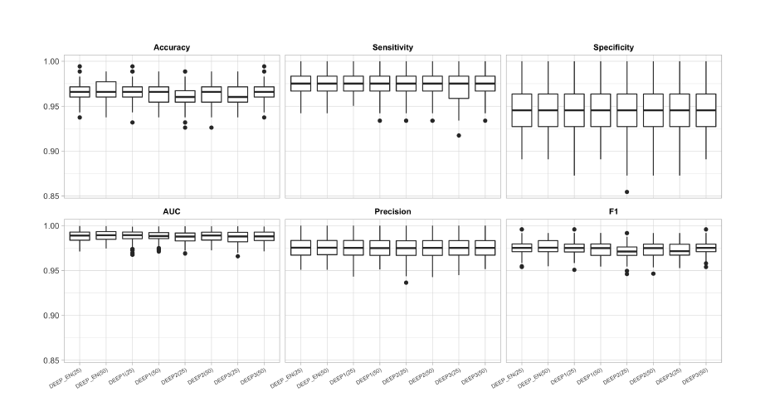

[Figure No.2] The boxplot of performance measures for all the competing methods.

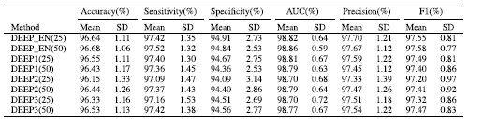

[Table No.1] Performance measures over the testing sets for all the competing methods.

In order to distinguish between Parkinson patients, we compare the deep learning techniques with other machine learning techniques in this section. We only compare the outcomes of deep learning models trained for 50 epochs because these models are insensitive to the number of epochs as previously described. Table 2 provides a summary of the performance metrics used by the rival approaches.

5

Figures 3 show the distribution of F1, AUC, precision, sensitivity, specificity, and accuracy. All in all,

deep learning models outperform conventional machine learning techniques in terms of accuracy when it comes to differentiating between patients with Parkinson's disease and healthy individuals. Among all the approaches, the ensemble network (DEEP_EN) gets the highest accuracy, averaging 96.68% over 100 data splittings. It also has the greatest F1 scores and strikes a superior balance between specificity and sensitivity. The boosting techniques—BOOST_GAM, BOOST_GLM, and BOOST_TREE—all exhibit accuracy levels above 96.2% and closely track Deep learning. The approach of linear discriminate analysis exhibits the highest level of sensitivity, meaning it has the highest probability of accurately identifying a genuine patient. Nevertheless, its sensitivity is modest (91.09%), and it frequently misclassifies persons who are normal. Tree-based techniques with sensitivity above 97.3% include random forest and BOOST_TREE. Deep learning has 97.17% sensitivity. Out of all the competing approaches, BOOST_GLM has the greatest speci_city, averaging 95.31%. The accuracy with which a procedure identifies a true healthy person is measured by its speci_city. The second-largest speci_city 94.84% is attained using deep learning, which is a somewhat lower than BOOST_GLM's. In that they attain the narrowest difference between sensitivity and specificity, BOOST_GLM and Deep learning strike a solid balance between the two. Finally, the AUC of most of the approaches is better than 98%, with the exception of TREE. Figure 4 reports the feature importance and selection frequency computed with the BOOST_GAM (Boosting method with smooth base learners). Out of all the features, the imaging markers of SBR's for the left and right putamen (PUTMEN_L and PUTMEN_R) are the most significant, followed by the UPSIT score. Other features pale in comparison to the significance of the top three features. Dopaminergic imaging has a high value in differentiating Parkinson's disease, as indicated by the varying importance. Figure 8's selection frequency illustrates how frequently features are chosen to serve as the training process' basis learners. During the training process, all significant aspects, such as PUTMEN_L and PUTMEN_R, are regularly chosen.

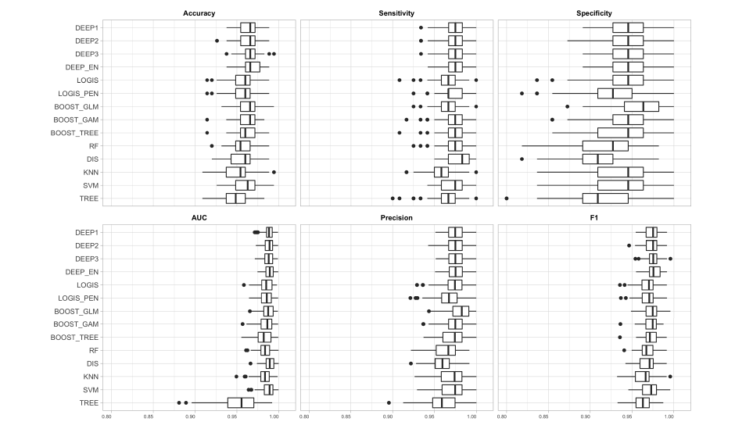

[Figure No. 3] The boxplot of performance measures for all the competing methods.

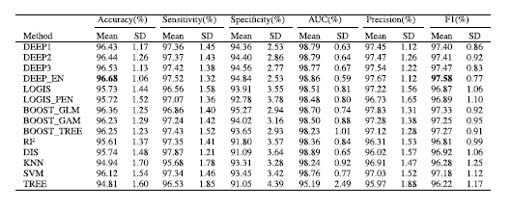

[Table No.2] Performance measures over the testing sets for all the competing methods.

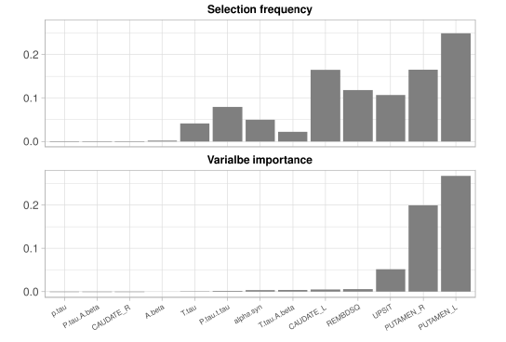

[Figure No. 4] The variable importance and selection frequency calculated using the boosting model with smooth base learners.

7

Conclusion

To better understand the causes of the disease, start therapeutic measures, and facilitate the development of effective medicines, early detection of Parkinson's disease (PD) is crucial. This work suggested a deep learning model to automatically distinguish between healthy people and Parkinson's disease (PD) patients based on premotor characteristics (such as olfactory loss, Rapid Eye Movement (REM) sleep behavior disorder, and sleep behavior disorder). With an accuracy of 96.45%, the deep learning model that was suggested demonstrated a strong capacity for detection. This is mostly because of the deep learning model's advantageous properties, which enable it to extract both linear and nonlinear features from PD data without the need for manual feature extraction. The created deep learning model outperforms the twelve machine learning models under consideration in terms of detection performance when it comes to differentiating between healthy individuals and Parkinson's disease sufferers, according to the findings. Moreover, the boosting techniques offer equivalent results. It is difficult to conclude that deep learning is superior than machine learning models, despite the fact that it performs better than the latter. This is as a result of the deep learning architecture we created utilizing tiny PD data obtained from 584 individuals (401 early PD and 183 healthy). That being said, it is anticipated that deep learning will prove its mettle as the volume and complexity of data increase with time.   
Thus, this work's result might be seen as a promising first step toward the application The created deep learning model outperforms the twelve machine learning models under consideration in terms of detection performance when it comes to differentiating between healthy individuals and Parkinson's disease sufferers, according to the findings. Moreover, the boosting techniques offer equivalent results. It is difficult to conclude that deep learning is superior than machine learning models, despite the fact that it performs better than the latter. This is as a result of the deep learning architecture we created utilizing tiny PD data obtained from 584 individuals (401 early PD and 183 healthy). That being said, it is anticipated that deep learning will prove its mettle as the volume and complexity of data increase with time.   
Thus, this work's result might be seen as a promising first step toward the application of cutting-edge

research for early disease detection.

8

References

* Hoehn, M. M., & Yahr, M. D. (1967). Parkinsonism: onset, progression and mortality. Neurology, 17(5), 427-427.
* Stiasny-Kolster, K., Mayer, G., Schäfer, S., Möller, J. C., Heinzel-Gutenbrunner, M., & Oertel, W. H. (2007). The REM sleep behavior disorder screening questionnaire—a new diagnostic instrument. Movement disorders, 22(16), 2386-2393.
* Doty, R. L. (1995). The smell identification test administration manual. Sensonics.
* Marek, K., Jennings, D., Lasch, S., Siderowf, A., Tanner, C., Simuni, T., ... & Schuff, N. (2011). The Parkinson Progression Marker Initiative (PPMI). Progress in neurobiology, 95(4), 629-635.
* Breiman, L. (2001). Random forests. Machine learning, 45(1), 5-32.

9