Industrial Internship Training Report

" Employee Leave and Attendance Management System"

Submitted by
SUSHOBHAN ROY
(2101020797)
of
8TH SEM Branch : CSE

From
Cognizant Technology Solutions
(Duration:17th March, 2025-17st June, 2025)


Department of Computer Science & Engineering
C. V. RAMAN GLOBAL UNIVERSITY,
BHUBANESWAR, ODISHA
April
2025

Declaration

I hereby declare that the internship report entitled "Employee Leave and Attendance Management System" is my own work and that, to the best of my knowledge and belief, it contains no material previously published or written by another person nor material which to substantial extent has been accepted for the award of any degree of the university or another institute of higher learning.

Name of the Student : SUSHOBHAN ROY

Regn No. : 2101020797

Date : 29/04/2025

i
Department of Computer Science & Engineering

C. V. RAMAN GLOBAL UNIVERSITY

Certificate of Approval

This is to certify that we have examined the training report entitled "Employee Leave and Attendance Management System" submitted by, SUSHOBHAN ROY (Regd No.- 2101020797), CGU, Bhubaneswar. We hereby accord our approval of the training work carried out and presented in a manner required for its acceptance as per the academic regulation, for the partial fulfillment for the 8th Semester in Computer Science & Engineering. This training has fulfilled all the requirements as per the regulations of the university.

Dr. Rojalina Priyadarshini
(H.O.D, CSE)

ii
Internship Joining Letter

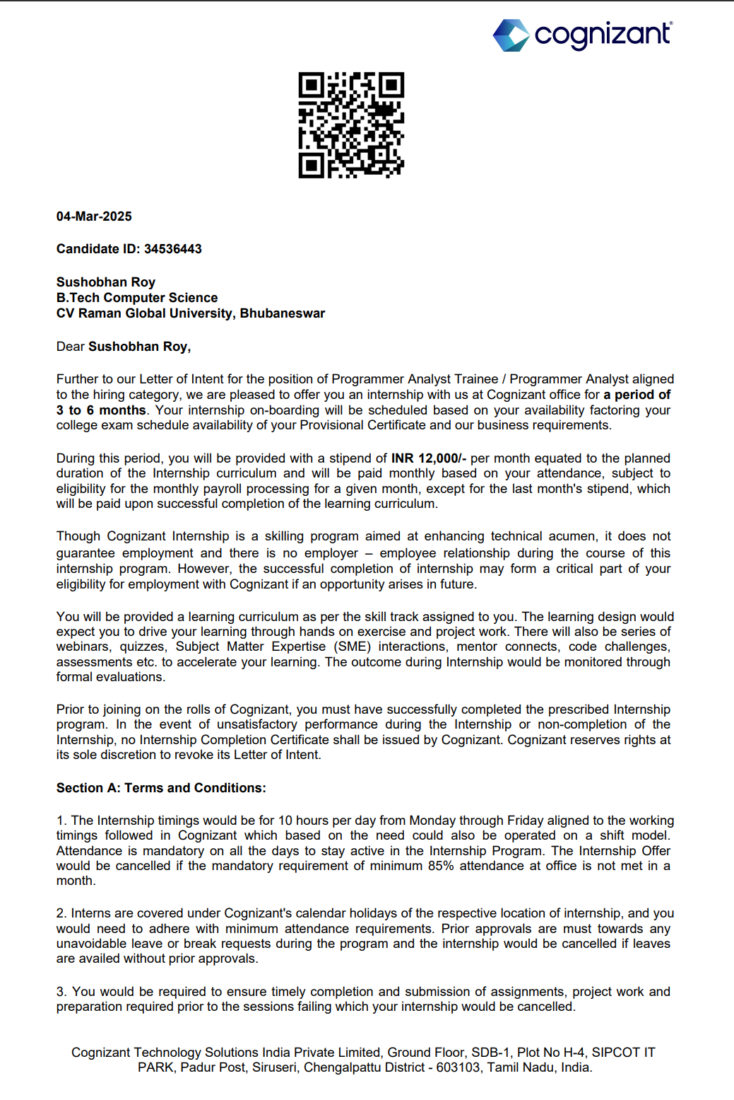
iii
Acknowledgement

It gives me immense pleasure to express my sincere gratitude to Dr. Tusar Kanti Das and Dr. Ashish Ranjan for their immense support during the internship for its success completion.

I extend my sincere thanks to our HOD Dr. R. Priyadarshini for her immeasurable support throughout my internship.

I also like to acknowledge the contribution of other faculty members of the Department of CSE for their cooperation and kind assistance in successful completion of this internship.

SUSHOBHAN ROY (2101020797)
APRIL 2024

iv
Abstract

During my internship in Cognizant Technology Solutions, I gained hands-on experience in the roles and responsibilities of a Java Full-Stack Engineer. I worked on the "Employee Leave and Attendance Management System" project, which automates the process of tracking employee attendance, managing leave requests, and calculating working hours. This system supports Java (Spring Boot) framework for backend development. The project involved designing and implementing various modules such as Employee Attendance, Leave Management, Leave Balance, Shift Management, and Reports and Analytics. This internship strengthened my proficiency in software development, problem-solving, and system design

v

Contents

DECLARATION…………………………………………………………………………………………...i
CERTIFICATE OF APPROVAL………………………………………………………………………...ii
INTERNSHIP CERTIFICATE…………………………………………………………………………..iii
ACKNOWLEDGEMENT...........................................................................................................................iv
ABSTRACT………………………………………………………………………………………………...v
CONTENTS …………………………………………………………………………………………….....vi
WEEKLY OVERVIEW…………………………………………………………………………………...1
INTRODUCTION.........................................................................................................................................2
METHODOLOGY.......................................................................................................................................3
PROJECT DESCRIPTION……………………………………………………………………………….4
RESULT/LEARNING OUTCOME…………………………………………………………………........5
CONCLUSION …………………………………………………………………………………………….6

WEEKLY OVERVIEW OF INTERNSHIP ACTIVITIES

Weeks | Stage | Activity
1-2 | Stage 1 : Onboarding and Brush-up Phase | Activities:  - Corporate Induction  - Asset Allocation  - Core Values Sessions  - Leader Talks  - Brush up of the basic java concepts  Objective: Familiarize interns with the corporate environment and refresh foundational knowledge.
3-6 | Stage 2 : Backend Development Phase | Focus Areas:  - Agile Methodology: Understanding Agile principles and practices.  - SOLID Principles: Learning best practices for software design.  - Spring Core and Maven: Mastering Spring Framework and project management with Maven.  - Test-Driven Development (TDD): Implementing TDD using JUnit and Mockito.  - Code Quality: Maintaining high code standards using tools like SonarQube.  Objective: Build a strong foundation in backend development and best practices.
7-10 | Stage 3 : Frontend Development Phase | Focus Areas:  - Angular (v16): Developing dynamic web applications using Angular.  - Docker Basics: Understanding containerization and Docker.  - Cloud and DevOps Basics: Leveraging GCP for cloud and DevOps practices.  - Application Debugging: Techniques for debugging frontend applications.  Objective: Equip interns with skills to develop and debug frontend applications.
11-12 | Stage 4 : Project Evaluation and Deployment Phase | Interim Evaluation:  - Components: Technical skills assessment and project progress review.  Final Evaluation:  - Components: Comprehensive assessment covering all skills learned.  Objective: Ensure readiness for professional challenges through continuous assessment.

1

Chapter 1

INTRODUCTION

The "Employee Leave and Attendance Management System" project automates tracking employee attendance, managing leave requests, and calculating working hours. This system is essential for organizations to maintain accurate records, manage leave balances efficiently, and ensure compliance with company policies and labour laws.
Objectives
The primary objectives are:
- Automate Attendance Tracking: Implement a system for digital attendance marking.
- Manage Leave Requests: Provide a platform for submitting and managing leave requests.
- Calculate Working Hours: Accurately calculate working hours based on attendance records.
- Generate Reports: Create detailed reports for analysis and decision-making.
Features
Key features include:
- Employee Attendance Module: Clock in/out, view attendance history, track working hours.
- Leave Management Module: Request various types of leave, track request status.
- Leave Balance Module: Maintain and update leave balances.
- Shift Management Module: Assign and manage shifts.
- Reports and Analytics Module: Generate reports on attendance trends, leave usage, and shift coverage.
Technology Stack
The system uses:
- Backend: Java (Spring Boot) .
- Frontend: HTML, CSS, JavaScript.
- Database: MySQL
- APIs: RESTful APIs for integration.

2

Chapter 2

METHODOLOGY

The development of the "Employee Leave and Attendance Management System" followed a systematic and modular approach to ensure efficient implementation and testing. The methodology can be outlined as follows:

Requirement Analysis
- Defined the project scope and objectives, including attendance tracking, leave management, and shift scheduling.
- Identified hardware and software components required for the system.
- Selected appropriate development frameworks and tools.

System Design
- Designed the system architecture, including frontend, backend, and database components.
- Created wireframes and user interface designs for the system.

Implementation
- Developed the Employee Attendance Module, Leave Management Module, Leave Balance Module, Shift Management Module, and Reports and Analytics Module.
- Integrated the modules to ensure seamless interaction and data flow.

Testing and Debugging
- Conducted unit testing for individual modules.
- Performed integration testing to ensure seamless interaction between modules.
- Debugged the system to resolve issues and optimize performance.

Documentation and Finalization
- Documented the code and created a user guide for operating the system.
- Compiled a detailed report on the project methodology, results, and conclusions.
- Presented the project and incorporated feedback for refinement.

3

Chapter 3

PROJECT DESCRIPTION

The "Employee Leave and Attendance Management System" project integrates various modules to provide a comprehensive solution for managing employee attendance, leave requests, and shift schedules. The key features of the system include:

Employee Attendance Module
- Allows employees to mark attendance, view their attendance history, and track daily clock-in and clock-out times.
- Provides managers with a dashboard to monitor attendance records and detect irregularities.

Leave Management Module
- Employees can request different types of leave (sick leave, vacation, etc.) and track the status of leave requests.
- Provides managers with a system for approving or rejecting leave requests.

Leave Balance Module
- Tracks and updates the leave balances for each employee based on the type of leave and the company's leave policies.
- Automatically adjusts leave balances as leaves are approved or rejected.

Shift Management Module
- Allows the assignment of shifts to employees based on company scheduling needs.
- Employees can view and swap shifts based on availability and manager approval.

Reports and Analytics Module
- Generates reports on attendance trends, leave usage, and shift coverage.
- Provides insights into workforce availability and helps in identifying patterns in leave requests or attendance issues.

4

Chapter 4

Results and Learning Outcomes

Results
- Successfully implemented a system for tracking employee attendance, managing leave requests, and scheduling shifts.
- Achieved real-time data processing and reporting for attendance and leave management.
- Developed a user-friendly interface for employees and managers to interact with the system.

Learning Outcomes
- Enhanced understanding of software development processes and system design.
- Gained hands-on experience in developing and integrating various modules in a software system.
- Improved problem-solving and debugging skills.
- Strengthened proficiency in using development frameworks and tools.

5

Chapter 5

CONCLUSION

The "Employee Leave and Attendance Management System" project successfully demonstrated the automation of HR processes, including attendance tracking, leave management, and shift scheduling. The system provides a user-friendly interface for employees and managers, streamlining HR operations and improving efficiency. The project not only achieved its technical objectives but also served as a valuable learning experience, enhancing skills in software development, system design, and problem-solving.

6

