Industrial Internship Training Report

"Menu-Driven LED Control and Waveform Generation via UART and External Interrupts on STM32F446"

Submitted by
SUSHOBHAN ROY
(2101020797)
of
7TH SEM Branch : CSE

Under Supervision of:
MD. Sallahuddin
C.V.RAMAN GLOBAL UNIVERSITY
(Duration:2ND July, 2024-31st July, 2024)


Department of Computer Science & Engineering
C. V. RAMAN GLOBAL UNIVERSITY,
BHUBANESWAR, ODISHA
November
2024

Declaration

I hereby declare that the internship report entitled "Menu-Driven LED Control and Waveform Generation via UART and External Interrupts on STM32F446" is my own work and that, to the best of my knowledge and belief, it contains no material previously published or written by another person nor material which to substantial extent has been accepted for the award of any degree of the university or another institute of higher learning.

Name of the Student : SUSHOBHAN ROY

Regn No. : 2101020797

Date : 21/11/2024

Department of Computer Science & Engineering

C. V. RAMAN GLOBAL UNIVERSITY

Certificate of Approval

This is to certify that we have examined the training report entitled "Menu-Driven LED Control and Waveform Generation via UART and External Interrupts on STM32F446" submitted by, SUSHOBHAN ROY (Regd No.- 2101020797), CGU, Bhubaneswar. We hereby accord our approval of the training work carried out and presented in a manner required for its acceptance as per the academic regulation, for the partial fulfillment for the 7th Semester in Computer Science & Engineering. This training has fulfilled all the requirements as per the regulations of the university.

Dr. Ashish Ranjan Dr. Rojalina Priyadarshini
(Internship Coordinator) (H.O.D, CSE)

INTERNSHIP CERTIFICATE

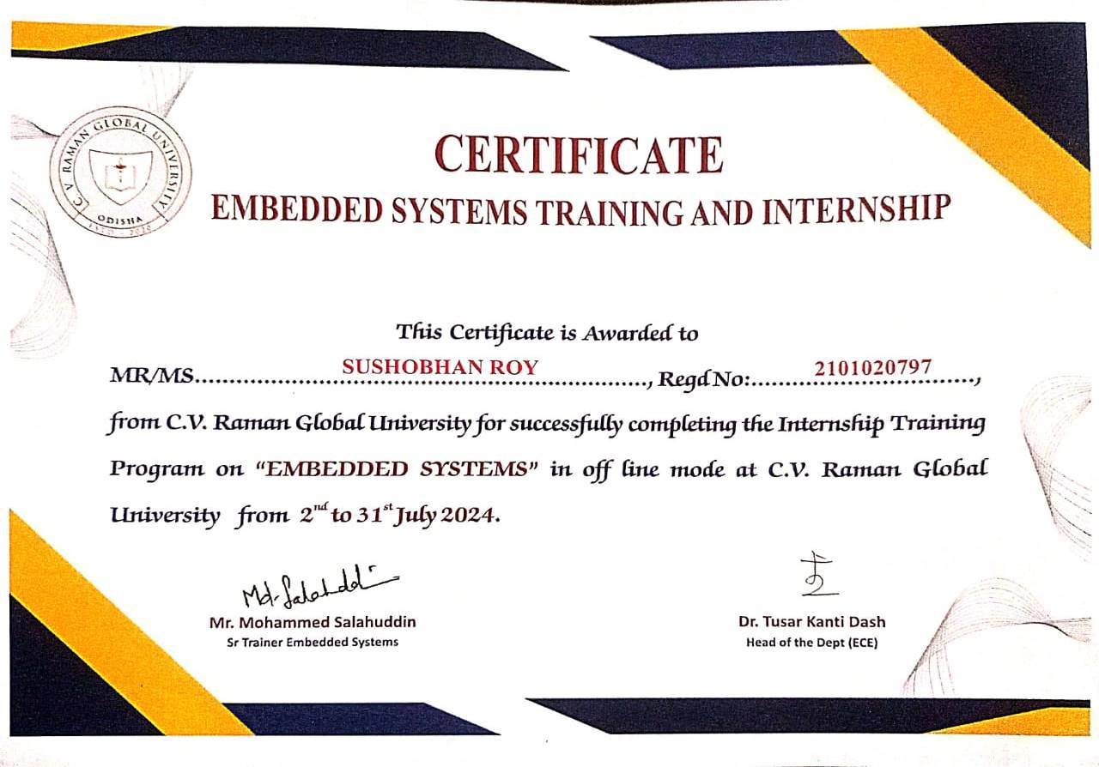

Acknowledgement

It gives me immense pleasure to express my sincere gratitude to our faculty coordinator Dr. Ashish Ranjan for his support and advices to get and complete internship in the above said organization.

I extend my sincere thanks to our HOD Dr. R. Priyadarshini for her immeasurable support throughout my internship.

I also like to acknowledge the contribution of other faculty members of the Department of CSE for their cooperation and kind assistance in successful completion of this internship.

November 2024 SUSHOBHAN ROY (2101020797)

Abstract

During my internship in embedded systems programming, I gained hands-on experience in designing and implementing embedded solutions using microcontrollers such as the STM32F446. My work involved:
- Hardware Programming: Developed and debugged firmware using STM32CubeIDE and C language.
- Peripheral Interfacing: Configured peripherals like UART, GPIO, and timers for communication and control.
- Embedded Application Development: Created menu-driven utilities for real-time applications, including LED control with variable delay and PWM, as well as waveform generation.
- External Interrupt Handling: Implemented interrupt-driven systems for efficient event handling.
- Testing and Debugging: Utilized debugging tools to ensure system reliability and optimized performance.
This internship strengthened my proficiency in embedded systems, problem-solving, and low-level programming. It also enhanced my ability to translate theoretical knowledge into practical applications.

Contents

DECLARATION…………………………………………………………………………………………...i
CERTIFICATE OF APPROVAL………………………………………………………………………...ii
INTERNSHIP CERTIFICATE…………………………………………………………………………..iii
ACKNOWLEDGEMENT...........................................................................................................................iv
ABSTRACT………………………………………………………………………………………………...v
CONTENTS …………………………………………………………………………………………….....vi
WEEKLY OVERVIEW…………………………………………………………………………………...1
INTRODUCTION.........................................................................................................................................2
OVERVIEW...............................
BACKGROUND AND MOTIVATION....................................................................
LEARNING OBJECTIVE…………………………………………………………………………………………………………..
METHODOLOGY.......................................................................................................................................3
PROJECT DESCRIPTION……………………………………………………………………………….4
RESULT/LEARNING OUTCOME…………………………………………………………………........5
CONCLUSION …………………………………………………………………………………………….6

WEEKLY OVERVIEW OF INTERNSHIP ACTIVITIES

Week | Date | Day | Name of the Topic/Module Completed
1st Week |  | Monday | Orientation and Introduction to Embedded Systems
 |  | Tuesday | Setting up STM32CubeIDE and Toolchain Configuration
 |  | Wednesday | Understanding STM32F446 Microcontroller Architecture
 |  | Thursday | GPIO Configuration and Basic LED Blinking Program
 |  | Friday | Using Timers for Delay and PWM Control
 |  | Saturday | Debugging Basics and Project Structure Organization
2nd Week |  | Monday | Introduction to UART Communication
 |  | Tuesday | Writing and Testing Menu-Driven UART Interfaces
 |  | Wednesday | Controlling LED Blinking and PWM via UART
 |  | Thursday | Introduction to External Interrupts and NVIC Configuration
 |  | Friday | Handling Button Presses Using External Interrupts
 |  | Saturday | Integrating UART and Interrupts for Real-Time Control
3rd Week |  | Monday | Waveform Generation Basics: Theory and Practical Implementation
 |  | Tuesday | Generating Square and Sine Waves Using Timers and DAC
 |  | Wednesday | Generating Triangle, Sawtooth, and Ramp Waves
 |  | Thursday | Switching Between Waveforms Using External Interrupts
 |  | Friday | Testing and Optimizing Waveform Generation
 |  | Saturday | Documentation of Waveform Generation Module
4th Week |  | Monday | Integrating All Modules (UART, PWM, Interrupts, Waveforms)
 |  | Tuesday | End-to-End Testing of the Complete System
 |  | Wednesday | Debugging and Code Optimization
 |  | Thursday | Writing Comprehensive Documentation and User Guide
 |  | Friday | Presentation of Project and Feedback
 |  | Saturday | Wrap-Up: Reflections and Final Submission

Chapter 1

INTRODUCTION

The project, "Menu-Driven LED Control and Waveform Generation via UART and External Interrupts on STM32F446", is an embedded systems application designed to demonstrate versatile control over hardware components using microcontroller peripherals.
The primary goal of the project is to develop a menu-driven utility that enables the following features:
- LED Control: Control LED blinking with variable delays and PWM intensity through UART commands.
- Waveform Generation: Generate multiple waveforms, including sine, square, triangle, sawtooth, and ramp, using the STM32F446's DAC and timers.
- External Interrupt Handling: Switch between different waveforms or modes of operation using external interrupts triggered by button presses.
The project leverages the powerful features of the STM32F446 microcontroller, including its UART communication, timer functionalities, and external interrupt capabilities. By integrating these features, the system provides a user-friendly interface for real-time control and demonstrates the practical applications of embedded systems in automation and signal processing.
This project showcases advanced embedded programming techniques, efficient hardware-software interaction, and the practical use of microcontroller peripherals in real-time applications.

Chapter 2

METHODOLOGY

The development of the "Menu-Driven LED Control and Waveform Generation via UART and External Interrupts on STM32F446" project followed a systematic and modular approach to ensure efficient implementation and testing. The methodology can be outlined as follows:

1. Requirement Analysis
- Defined the project scope and objectives, including LED control, PWM intensity adjustment, and waveform generation.
- Identified hardware components (STM32F446 microcontroller, LEDs, push buttons, UART interface, and DAC).
- Selected STM32CubeIDE as the development environment.

2. System Design
- Hardware Configuration:
  - Configured GPIO pins for LEDs and buttons.
  - Set up UART for communication between the microcontroller and a PC terminal.
  - Utilized timers for PWM control and waveform generation.
  - Integrated DAC for analog waveform output.
- Software Architecture:
  - Designed a modular software system with separate functions for UART communication, LED control, PWM generation, and waveform generation.
  - Developed a menu-driven interface for user interaction through UART.
  - Implemented interrupt service routines (ISRs) for handling external interrupts triggered by button presses.

3. Implementation
- UART Communication:
  - Configured UART to send and receive commands.
  - Designed a text-based menu system for selecting LED modes and waveforms.
- LED Control:
  - Implemented basic LED blinking with user-defined delay via UART commands.
  - Used timers to adjust PWM duty cycles for LED intensity control.
- Waveform Generation:
  - Utilized STM32 timers and DAC to generate waveforms (sine, square, triangle, sawtooth, and ramp).
  - Developed algorithms to calculate waveform values dynamically.
- External Interrupts:
  - Configured GPIO pins to trigger interrupts on button presses.
  - Implemented ISRs to switch between waveforms or control modes in real time.

4. Testing and Debugging
- Conducted unit testing for individual modules, including UART communication, PWM, and waveform generation.
- Performed integration testing to ensure seamless interaction between modules.
- Debugged the system using STM32CubeIDE tools to resolve timing issues and optimize performance.

5. Documentation and Finalization
- Documented the code and created a user guide for operating the system.
- Compiled a detailed report on the project methodology, results, and conclusions.
- Presented the project and incorporated feedback for refinement.

Chapter 3

PROJECT DESCRIPTION

The project, "Menu-Driven LED Control and Waveform Generation via UART and External Interrupts on STM32F446", is an embedded systems application that integrates microcontroller peripherals to provide user-controlled LED behaviour and waveform generation. It showcases the practical implementation of real-time systems by combining UART communication, timer-driven PWM, DAC-based waveform generation, and external interrupt handling.

Key Features
- LED Blinking with Variable Delay:
  - The system allows users to control the blinking of an LED by adjusting the delay through UART commands.
  - Timer modules are used to implement precise delays.
- LED Intensity Control via PWM:
  - Users can modify the LED brightness using Pulse Width Modulation (PWM).
  - The duty cycle of the PWM signal is adjustable via the UART menu.
- Waveform Generation:
  - The system generates multiple waveforms, including:
    - Sine Wave
    - Square Wave
    - Triangle Wave
    - Sawtooth Wave
    - Ramp Wave
  - These waveforms are generated using the DAC peripheral of the STM32F446 microcontroller, driven by timer-based algorithms.
- Menu-Driven Interface:
  - A user-friendly text-based menu is displayed on a terminal connected via UART.
  - Users can interact with the system by selecting options to control LED behaviour or switch between waveforms.
- External Interrupt Handling:
  - Push buttons are connected to GPIO pins configured as external interrupt sources.
  - Users can trigger interrupts to switch between waveform modes or modify the operating parameters.

Technical Details
- Hardware Components:
  - STM32F446 microcontroller.
  - LEDs and push buttons.
  - UART interface (PC terminal).
  - DAC for waveform output.
- Software Implementation:
  - Developed using C language in STM32CubeIDE.
  - Modular programming approach for scalability and maintainability.
- User Interaction:
  - The UART menu allows users to:
    - Start or stop LED blinking.
    - Adjust LED intensity and delay.
    - Select and switch between waveforms.
  - Button presses provide real-time waveform switching functionality.

Applications
- Education and Training: Ideal for learning and demonstrating embedded systems concepts.
- Signal Processing: Basic waveform generation for testing and experimentation.
- Prototyping: A foundation for more complex embedded projects requiring real-time control.

Chapter 4

RESULT/LEARNING OUTCOME

Results
- Successfully implemented a menu-driven system via UART for real-time user interaction.
- Achieved precise control over LED blinking with adjustable delays and PWM-based intensity variation.
- Generated multiple waveforms (sine, square, triangle, sawtooth, and ramp) using the STM32F446 microcontroller’s DAC and timers.
- Integrated external interrupt handling to enable seamless switching between waveforms and operating modes via button presses.
- Developed a modular and reusable codebase, ensuring maintainability and scalability for future projects.
- Verified system functionality through thorough unit and integration testing, ensuring reliability under various operating conditions.

Learning Outcomes
- Enhanced Understanding of Microcontroller Peripherals:
  - Gained in-depth knowledge of GPIO, UART, timers, DAC, and external interrupt configuration.
- Hands-On Experience with Real-Time Systems:
  - Learned to handle time-critical tasks and manage concurrency using interrupts and timer-based control.
- Improved Programming Skills:
  - Strengthened proficiency in C programming and embedded software development using STM32CubeIDE libraries.
- Problem-Solving and Debugging:
  - Learned to debug hardware and software issues systematically using tools like STM32CubeIDE’s debugger.
- System Integration:
  - Understood the challenges and solutions involved in integrating multiple peripherals into a single functional system.
- Communication Protocols:
  - Developed an understanding of UART communication and implemented a text-based interface for user interaction.
- Waveform Generation:
  - Acquired knowledge of generating and managing analog and digital waveforms for signal processing applications.
- Project Management Skills:
  - Practiced breaking down a project into manageable tasks, following a structured development approach, and documenting results effectively.

Chapter 5

CONCLUSION

The project, "Menu-Driven LED Control and Waveform Generation via UART and External Interrupts on STM32F446," successfully demonstrated the integration of multiple microcontroller peripherals to build a versatile embedded system. Through the development of a menu-driven interface, real-time control of LED behaviours, and dynamic waveform generation, the project showcased the practical application of embedded programming concepts.
The use of UART communication provided an intuitive user interface, while the external interrupts ensured seamless real-time operation. The implementation of waveform generation further highlighted the capabilities of the STM32F446 microcontroller's DAC and timer peripherals, emphasizing its suitability for signal processing and real-time applications.
This project not only achieved its technical objectives but also served as a valuable learning experience, enhancing skills in microcontroller programming, peripheral integration, debugging, and system design. It lays the foundation for more advanced embedded projects and demonstrates the potential of microcontrollers in automation, signal processing, and user-controlled systems.
The successful execution of this project reinforces the importance of modular design, systematic development, and rigorous testing in creating reliable and efficient embedded solutions.

