Thyroid Disease Detection

***Wireframe Documentation***

|  |  |  |  |
| --- | --- | --- | --- |
| **Date Issued** | **Version** | **Description** | **Author** |
| 21-08-2021 | 1 | Wireframe-V1.0 | Sushant Bisht |
|  |  |  |  |

Homepage

We will have a single-page UI that will facilitate prediction for Thyroid Disease Detection.

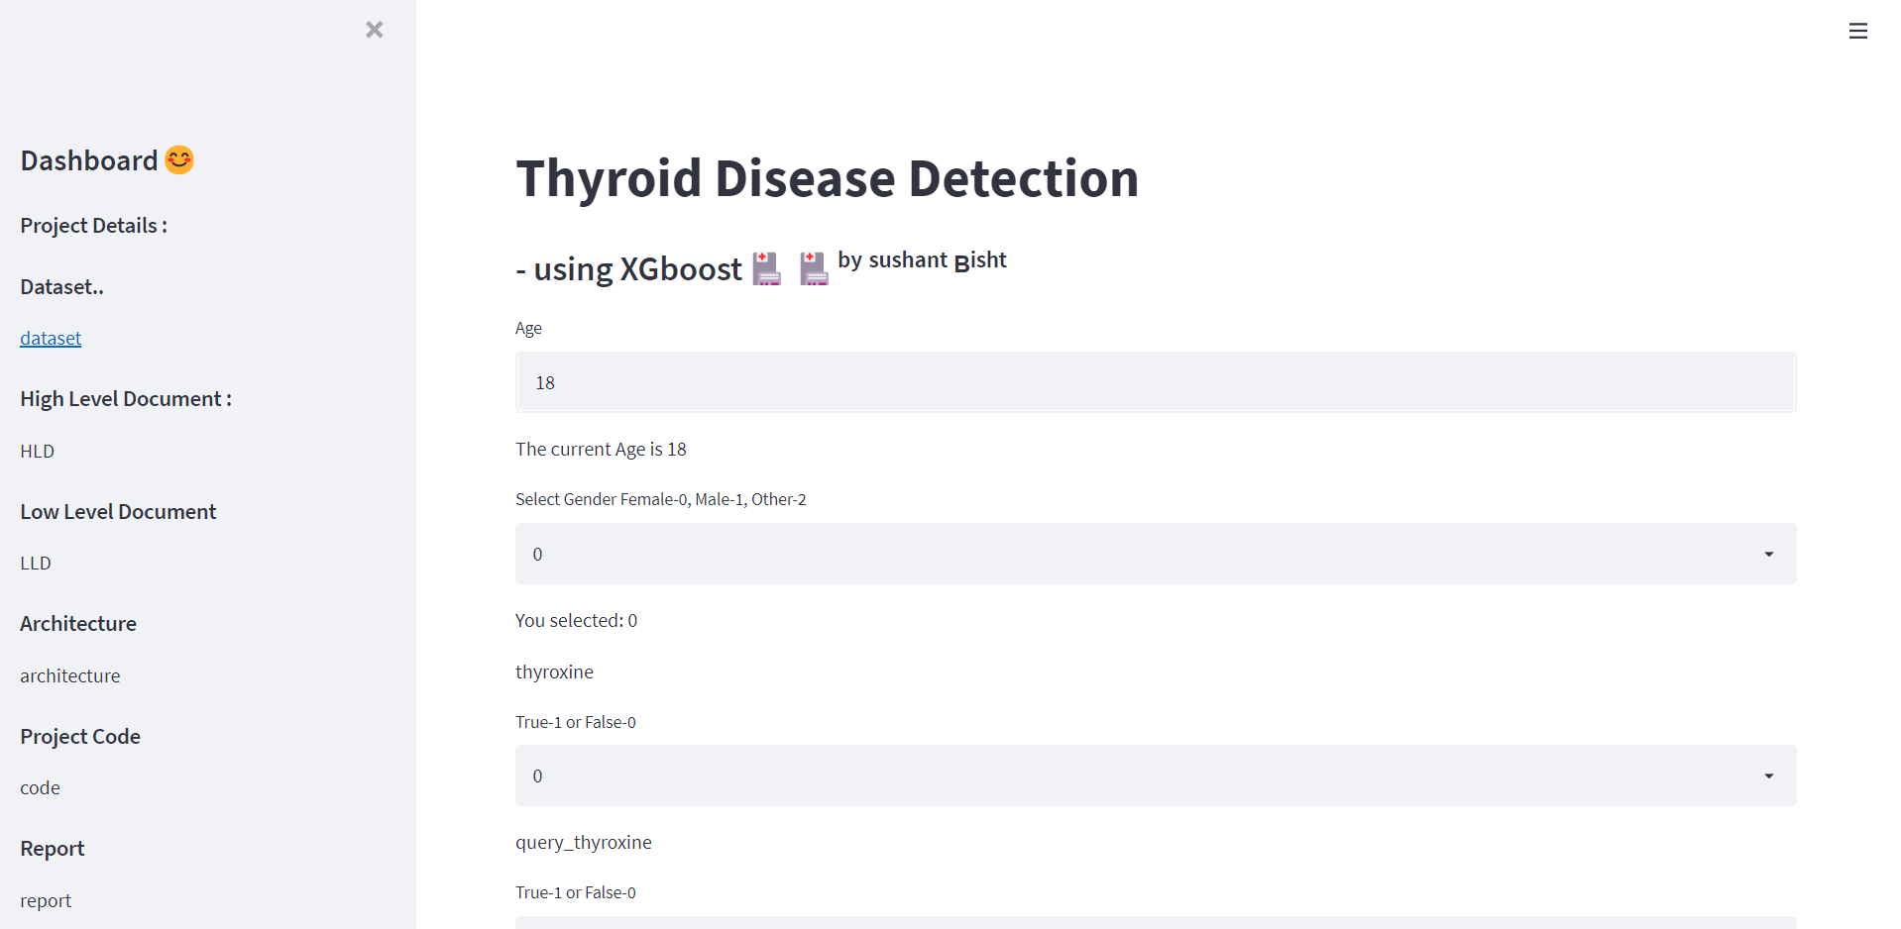

You take custom inputs from the user and predict whether the person has thyroid disease or not.!

