2022

Sushant Bisht

Chandigarh University

11/6/2022

High Level Design



1. **INTRODUCTION**

**Scope of Document**

This document outlines the high-level functional design of Vintage Picture Book Application. It

highlights/refers the high-level flows / Use cases in registration process, design of components, along with

the rationale for the same. It serves as an input to the low-level design documents that would further

elaborate on the application design

1. **Data Requirements**

**Tool Used**

* Flask Web Framework.
* PyCharm will be used as IDE
* HTML, CSS, JavaScript will be used for front end.
* GitHub will be used for version control.
* OpenCV for real-time face detection.

 

 

1. **Modules/Components**

All of these are different type of effect that will give different looks to the images.

1. **Use case scenarios**

Purpose: Scenario that describes the use of Vintage Picture Book.

Equipment: Any computer with a supported browser.

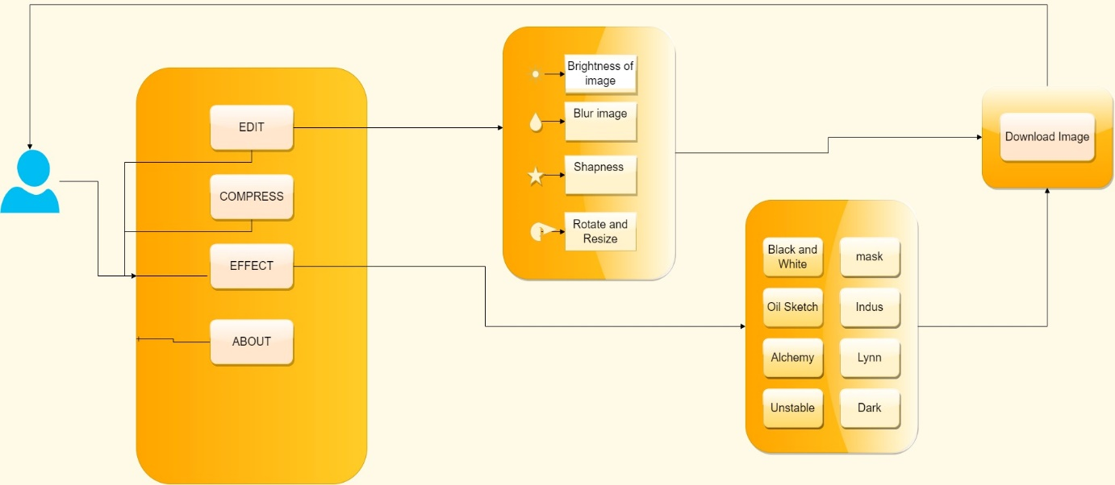

1. **Deployment View**

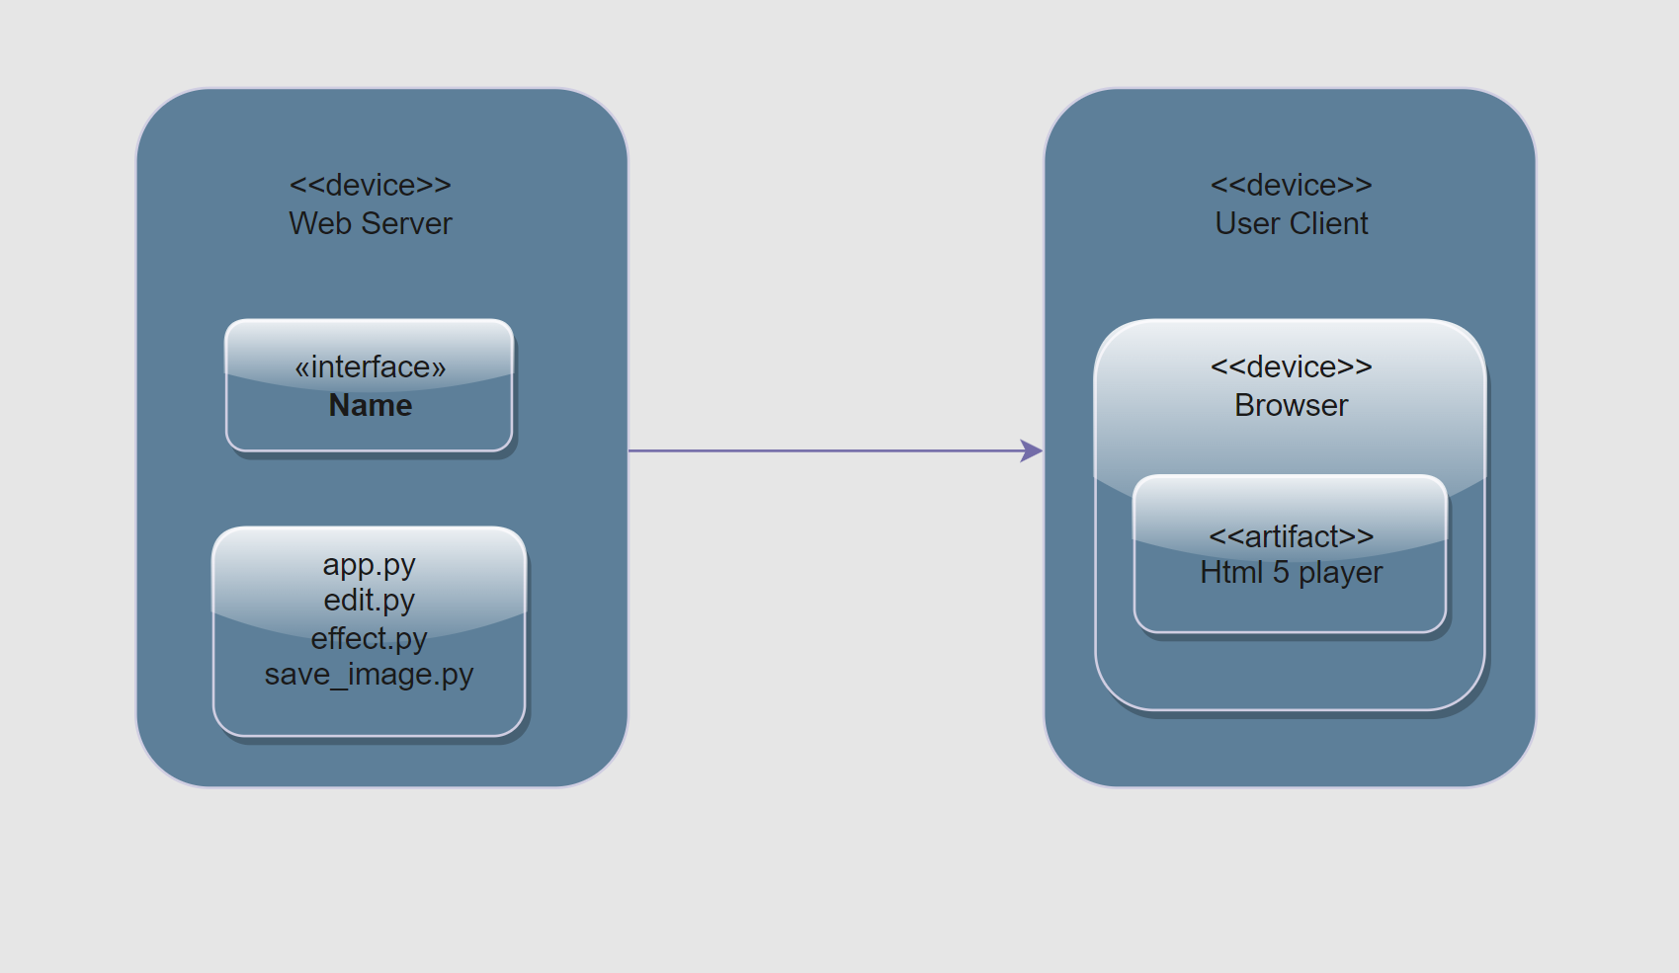

1. **High level sequence diagram**

