2022

Sushant Bisht

Namandeep Singh

Ankit

Anushka

Vaani

Chandigarh University

11/6/2022

Low Level Design



1. **CLASS DIAGRAM**

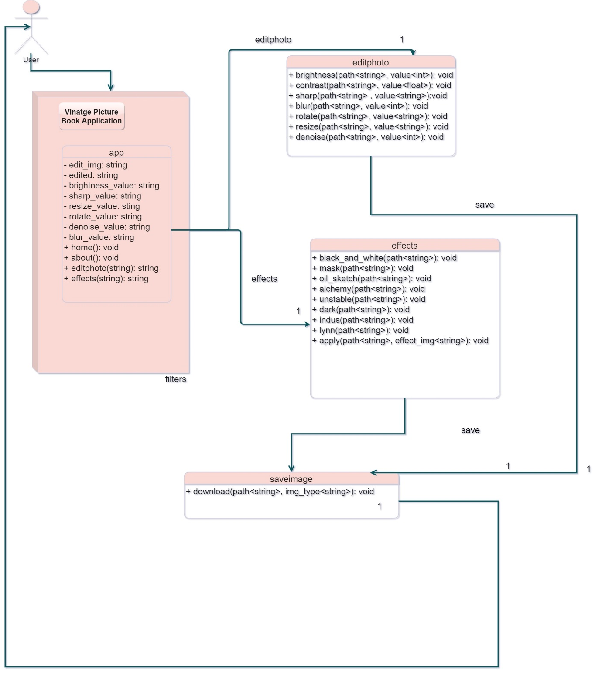

1. **ER Diagram**

