2022

Sushant Bisht

Chandigarh University

11/6/2022

High Level Design



1. **INTRODUCTION**

**Scope of Document**

This document outlines the high-level functional design of Vintage Picture Book Application. It

highlights/refers the high-level flows / Use cases in registration process, design of components, along with

the rationale for the same. It serves as an input to the low-level design documents that would further

elaborate on the application design

1. **Data Requirements**

**Tool Used**

* Flask Web Framework.
* PyCharm will be used as IDE
* HTML, CSS, JavaScript will be used for front end.
* GitHub will be used for version control.
* OpenCV for real-time face detection.

 

 

1. **Modules/Components**

All of these are different type of effect that will give different looks to the images.

Filter module contains different types of facial filter which will use face detection algorithm.

1. **Use case scenarios**

Purpose: Scenario that describes the use of Vintage Picture Book.

Equipment: Any computer with a supported browser.

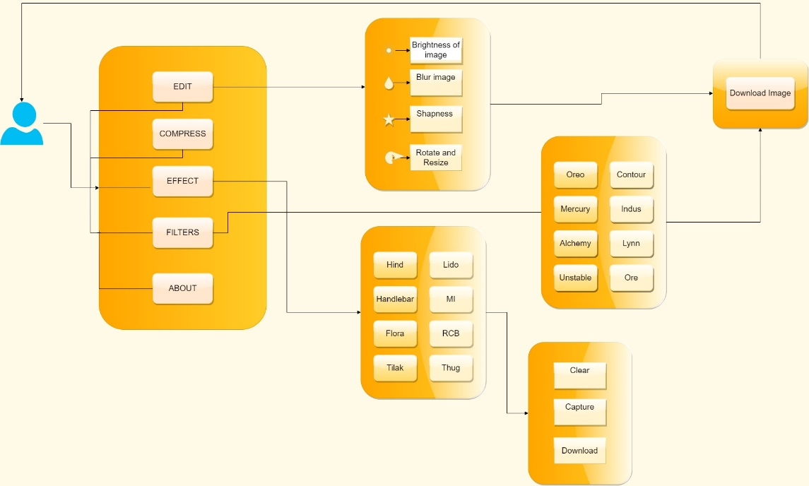

1. **High level sequence diagram**