Pipeline

* Convert original images to a grey-scale images.
* Blur the grey-scale images with Gaussian method.
* Detect edges in blurry images with Canny method.
* Mask some regions that must not be lane lines.
* Detect lane lines with Hough Transform method.

Now most lines of what we have detected are lane lines.

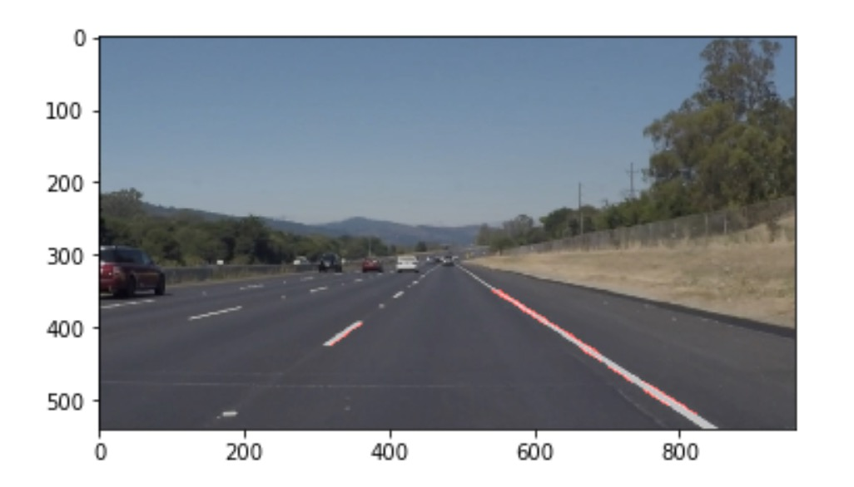

Modify

* Add a function(region_of_ignore) that can mask regions that should be ignored between two lane lines.
* Limit slopes and positions of detected lines. Some wrong lane lines can be deleted. ( draw_lines)
* Calculate average positions and slopes of the left lane line and the right line. ( draw_lines)
* According to last calculation, draw two lane lines in proper positions.

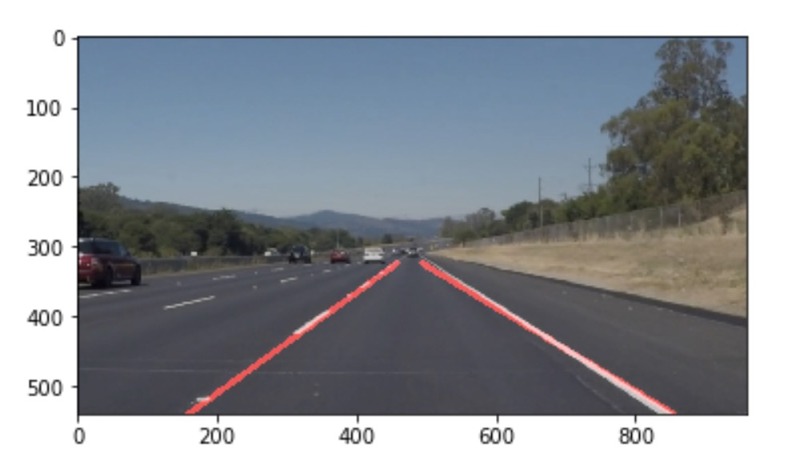

potential shortcomings

* If lane lines have been damaged, detection will be affected deeply.
* If a car is driven in a low contrast environment. Detection will be affected deeply.
* What we detect are edges of lane lines. Therefore, it’s not a direct method to detect them.

potential improvement

* In my opinion, choices of parameters are a kind of trade-off. I don’t know what’s the most proper parameters in Canny detection and Hough Transform.
* We can set more proper mask region so that some noise can be ignored.