Experiment 1: Introduction to Git and Version Control
Level 1: Create and manage Git repositories.
Level 2: Implement branching, merging, and collaborative workflows using Git.

Level 1 — Create and Manage a Local Git Repository

Aim:To create and manage a local Git repository by creating files, tracking changes, staging files, committing versions, and viewing the commit history using Git commands.

Problem Statement: Create a simple Student Management Web Application containing the following 5 HTML pages:
- login.html – Login page
- home.html – Home page
- faculty.html – Faculty page
- student.html – Student page
- hod.html – HOD page
Use Git to maintain different versions of the application.
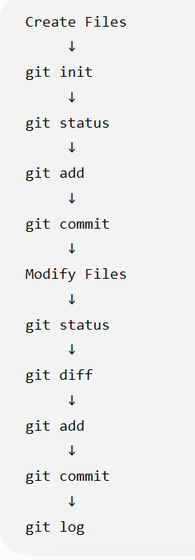
Steps and Flow:
Part A — Create the project
Part B — Create a Git repository
Part C — Track and commit the files
Part D — Modify the project
Part E — View project history

Detailed Procedure:

Part A — Create the project
- Create a folder named: StudentProject
- Create the four HTML files: login.html,home.html faculty.html,student.html hod.html
- Add basic HTML content to each page.

Part B — Create a Git repository
Open Git Bash inside the project folder and execute: git init
Check the repository status: git status

Part C — Track and commit the files
Add the files to the staging area: git add .
Check the status: git status
Create the first version: git commit -m "Initial version of Student Management System"

Part D — Modify the project
Modify student.html
Check the changes: git status
View the exact changes: git diff
Stage and commit the changes: git add student.html
git commit -m "Add student dashboard features"

Part E — View project history
Display the commit history: git log –oneline

Level 2 — Branching, Merging and Collaborative Git Workflow

Aim: To implement branching, merging, remote repository management, and collaborative development using Git and GitHub.

Problem Statement: Continue using the Student Management Web Application created in Exercise 1.Assume that different developers are working on different modules:
- Developer 1: Faculty module
- Developer 2: Student module
Use Git branches and GitHub to allow both developers to work independently and combine their work into the main project.
Work Flow
Part A — Create a GitHub repository

Part B — Create a Faculty branch

Part C — Create a Student branch

Part D — Push branches to GitHub

Part E — Clone the repository

Part F — Merge the branches

Part A — Create a GitHub repository
- Create a GitHub account.
- Create a new GitHub repository named: StudentProject
- Connect the existing local Git repository to GitHub.
git remote add origin <GitHub-repository-URL>
- Push the main/master branch:
git push -u origin master

Part B — Create a Faculty branch
Create a branch for faculty development: git switch -c faculty-feature
Modify faculty.html
Check the changes: git status
Stage and commit: git add faculty.html
git commit -m "Add faculty dashboard features"

Part C — Create a Student branch
Switch back to the main/master branch: git switch master
Create another branch: git switch -c student-feature
Modify student.html
Commit the changes:
git add student.html
git commit -m "Add student dashboard features"

Part D — Push branches to GitHub

Push the faculty branch: git push -u origin faculty-feature

Push the student branch: git push -u origin student-feature

Part E — Clone the repository

Assume Developer 2 does not have the project on their computer.
They can obtain the project using: git clone <GitHub-repository-URL>
Move into the project: cd StudentProject
Check the repository: git status

Part G — Merge the branches
Switch to the main/master branch: git switch master
Merge the faculty development: git merge faculty-feature
Then merge the student development: git merge student-feature
View the complete history: git log --oneline --graph –all

RESULT
The Student Management Web Application was successfully developed and managed using Git. A local Git repository was created, files were tracked and committed, and changes were maintained through different versions. Branching and merging were performed, and the repository was connected with GitHub to demonstrate push, pull, clone, and collaborative development workflows.

