Exp No.1: To study and implement Functions in MySQL.

Functions:

• Functions are declared using the following syntax:

Create function <function-name> (param_spec1, …, param_speck)
returns <return_type>
[not] deterministic
Begin
-- execution code
end;

where param_spec is:
[in | out | in out] <param_name> <param_type>

Example of Functions:
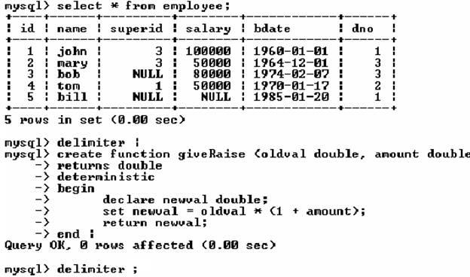
Example of calling function in the SELECT clause:
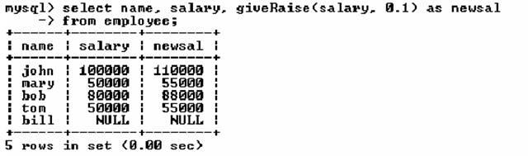

Exp No.2: To study and implement SQL Triggers
To monitor a database and take a corrective action when a condition occurs

Triggers are nothing but the procedures/functions that involve actions and fired/executed automatically whenever an event occurs such as an insert, delete, or update operation or pressing a button or when mouse button is clicked.

Examples:
• Charge $10 overdraft fee if the balance of an account after a withdrawal

transaction is less than $500
• Limit the salary increase of an employee to no more than 5% raise
Syntax:

CREATE TRIGGER trigger-name
trigger-time trigger-event
ON table-name
FOR EACH ROW
trigger-action;
• trigger-time ∈ {BEFORE, AFTER}
• trigger-event ∈ {INSERT, DELETE, UPDATE}

SQL Triggers: An Example

Use employee and department tables created for the previous labsheet.
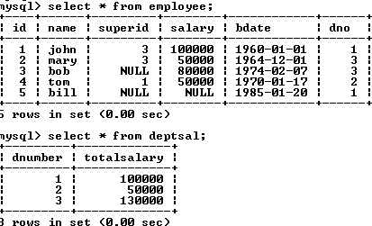

An example: We want to create a trigger to update the total salary of a department when a new employee is hired

Problem Statement:
Create a trigger to update the total salary of a department when a new employee is hired:
Create definer=’root’@’localhost’ trigger update_salary

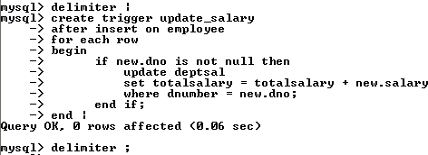

The keyword “new” refers to the new row inserted

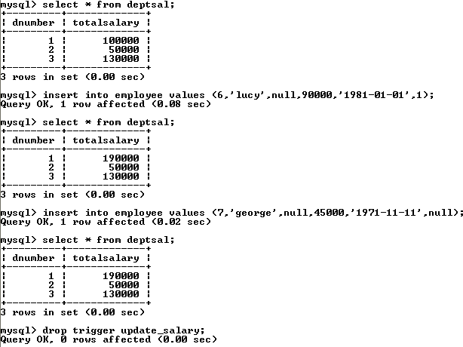

Create a trigger to update the total salary of a department when an employee tuple is modified:

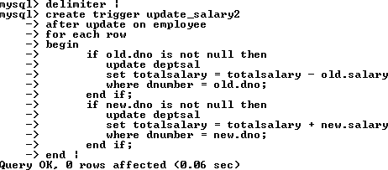

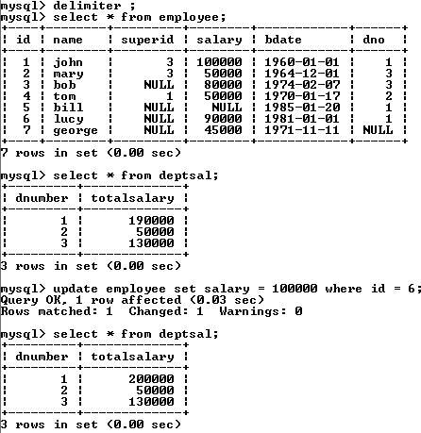

Create a trigger to update the total salary of a department when an employee tuple is deleted:

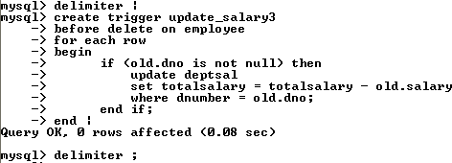

SQL Triggers: An Example

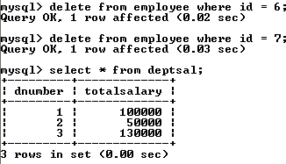
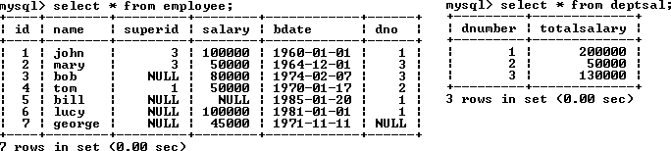

To list all the triggers you have created:
mysql> show triggers;
To drop a trigger or a trigger is no longer required.
mysql> drop trigger trigger_name

