To study and implement Views, and Procedures in MySQL DB.
Exp 1: Implement MySQL Views on Student database.
Views in SQL:
- Views are relations, except that they are not physically stored.
- Views are created for presenting different information to different users
- A view is a “virtual table” or a “stored query” which takes the output of a query and treats it as a table. The table upon which a view is created is called as base table.
- A view is a logical table based on a table or another view. A view contains no data of its own but is like a window through which data from tables can be viewed or changed. The tables on which a view is based are called base tables.
- The view is stored as a SELECT statement in the data dictionary

OBJECTIVE
  - Views Helps to encapsulate complex query and make it reusable.
  - Provides user security on each view - it depends on your data policy security.

SQL COMMANDS

Creating views:
Syntax:
Create view <view name>;
Description:
This command is used to create view by combining two tables.
Viewing single row of table:
Syntax:
Create view<view name> as select from <table name>;
Description:
This command is used to view a single row from a particular table.
Viewing all columns from a single table:
Syntax:
Create view<view name> as select * from <table name>;
Description:
This is used to create view which displays all columns from a single table.
View specified column from a single table:
Syntax:
Create view<view table name> as select column1, column2 from <tablename>;
Description:
This command is used to create view which displays on a specified column from a single
table.
View multiple columns from a table: Syntax:

Create view<view table name> as select column1, column2,….columnn from <table name> where ‘condition’;
Description:
This is used to create view to display specified columns from a table.
View all column from a table:

Syntax:
Create view<view table name> as select * from <table name> where ‘condition’;
Description:
This is used to create view which displays all the columns of a table.
Inserting into views:
Syntax:
Insert into <view name> values <’data1’,’data2’,……>;
Description:
This is used to do inserting of information or data into values.

Updating in view: is done by using query materialization and query modification.

Deleting a view:
Syntax:
Drop view <view name>;

Illustration:
mysql> use studentdb; Database changed
Creates a table with five columns:
mysql> CREATE TABLE STUDENT(
-> SNUM INT PRIMARY KEY,
-> SNAME VARCHAR(20) NOT NULL,
-> MAJOR VARCHAR(5) NOT NULL,
-> DOB DATE
-> SEM INT DEFAULT 4);

Create a simple view named as “Studentdetails”
Solution:
mysql> create view studentdetails as select * from student;
Query OK, 0 rows affected (0.30 sec)

To retrieve all the data in the studentdetails view
Solution:

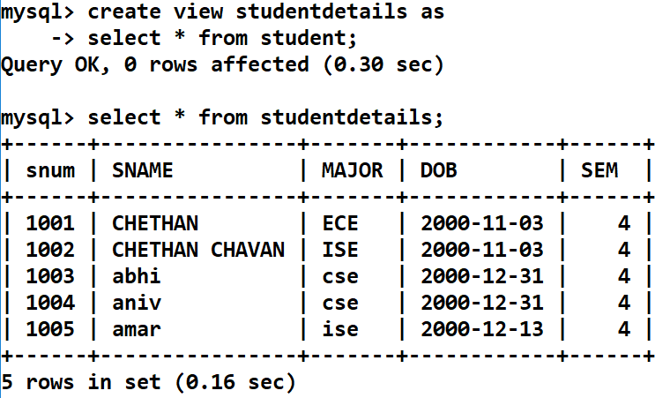
Query on a view.

Retieve the name and id of the student from ‘cse’ department (major).
mysql> select snum, sname from studentdetails where major='cse';
+ + +
| snum | SNAME |
+ + +
| 1003 | abhi |
| 1004 | aniv |
+ + +
2 rows in set (0.11 sec) Complex Views:

Write a Query view for each department retrieve the details like number of students, major of the students.
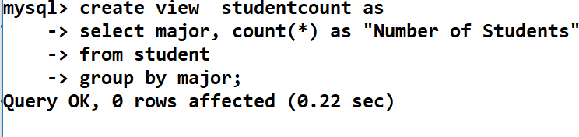

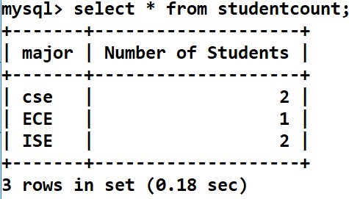

Remove the view called studentdetails and studentcount
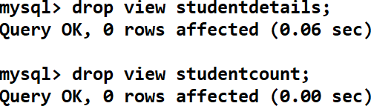

Exp 2: Implement MySQL Procedures on Student database.
A stored procedure contains a sequence of SQL commands stored in the database catalog so that it can be invoked later by a program
  - Stored procedures are declared using the following syntax:
Create Procedure <proc-name>
(param_spec1, param_spec2, …, param_specn )

begin

end;

-- execution code

where each param_spec is of the form:
[in | out | inout] <param_name> <param_type>
- in mode: allows you to pass values into the procedure,
- out mode: allows you to pass value back from procedure to the calling program An example consider the Employee and Department tables which are shown below.
Create two tables employee and (id is the primary key, dno is the foreign key referring to department table) and department (dnumber is the primary key) as per the information given below:
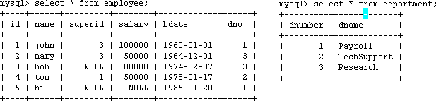

Suppose we want to keep track of the total salaries of employees working for each department
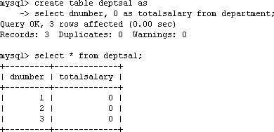

Illustration Example:
Step 1: Change the delimiter (i.e., terminating character) of SQL statement from semicolon (;) to something else (e.g., //) So that you can distinguish between the semicolon of the SQL statements in the procedure and the terminating character of the procedure definition.

Example:

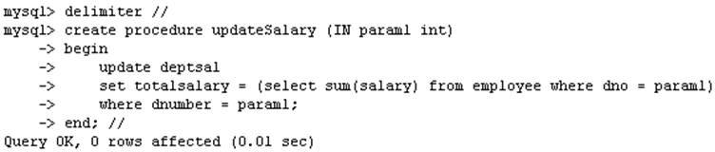

Step 2:
- Define a procedure called updateSalary which takes as input a department number.
- The body of the procedure is an SQL command to update the totalsalary column of the deptsal table.
- Terminate the procedure definition using the delimiter you had defined in step 1 (//)

Example:
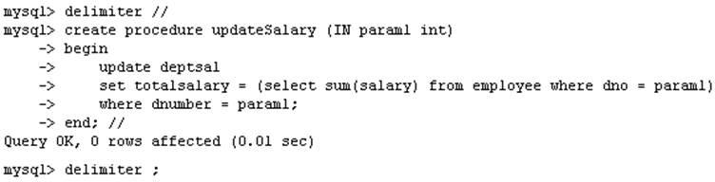

Step 3: Change the delimiter back to semicolon (;)
mysql> delimeter ;

Step 4: Call the procedure to update the totalsalary for each department Example:
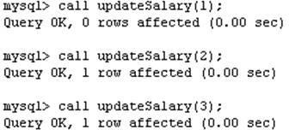

Step 5: Show the updated total salary in the deptsal table

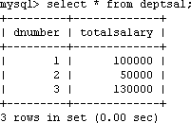

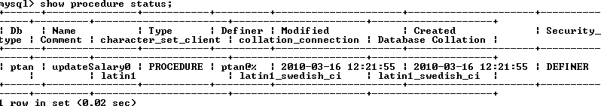
  - Use show procedure status to display the list of stored procedures you have created

Stored Procedures in MySQL:
  - You can declare variables in stored procedures
    - You can use flow control statements (conditional IF-THEN-ELSE or loops such as WHILE and REPEAT)
  - MySQL also supports cursors in stored procedures.
    - A cursor is used to iterate through a set of rows returned by a query so that we can process each individual row.

Example using Cursors:
  - The previous procedure updates one row in deptsal table based on input parameter
  - Suppose we want to update all the rows in deptsal simultaneously

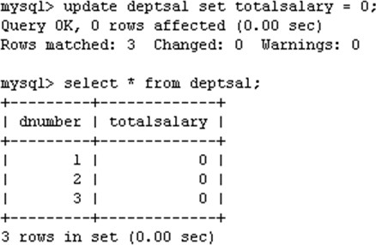
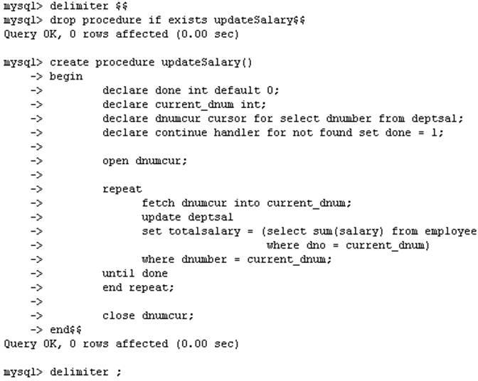
  - First, let’s reset the totalsalary in deptsal to zero

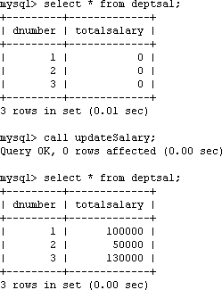

An example illustration:

- Create a stored procedure to give a raise to all employees
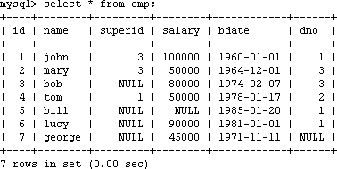

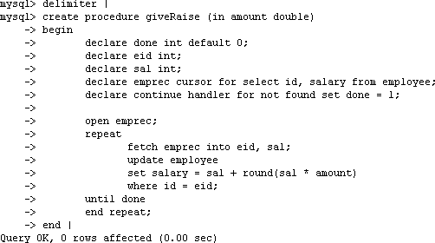
An Example:
