Table of Contents

Table of Contents 1

Overview 2

Assumption 3

Roles and Responsibility 4

User Stories 5

Flow Chart 7

ERD Diagram 8

Sprints Events 8

Sprint-1 8

Backlogs 8

Sprint Planning 10

Burndown chart 17

Sprint-2 18

Sprint Planning 18

Burndown Chart 26

Sprint-3 27

Completed Wireframes 31

Site Map 32

User Manual 33

Testing 46

Test Plan 46

Test Log 49

Overview

The program includes a web-based secure role-based system for collecting student contributions for an annual university magazine for a large university. The university wants marketing manager, coordinator, administrator on the client side and guest, student on the end user side. A guest account can be used to view the selected magazines for each faculty. The marketing manager can oversee the whole process and can download the students’ articles as a zip file. The marketing coordinator can comment on the student magazines and the students have the opportunity to submit one or more articles to the magazines and also high-quality images. The project development method will be the scrum method. The members include database designer, web designer, scrum master, programmer and tester. The steps of the development state are defining project backlogs, identifying sprints and outputting burndown chart every week.

[Keywords: scrum, backlogs, sprints, web-based, role-based, development state]

Aim

The aim of this course work is to get high performance program and get a professional standard documentation.

Assumption

Roles and Responsibility

User Stories

|  |
| --- |
| As **Members/ Students** |
| Students should be able to submit one or more article as word documents to the magazine  Students can upload multiple high-quality images.  Students cannot submit the articles after the closure date.  Students could allow to update their contribution after the closure date.  All students must agree to Terms and Conditions before they can submit. |

|  |
| --- |
| As **Marketing Manager** |
| Marketing Manager can oversea the process.  Marketing Manager can view the selected contributions but cannot edit any.  Marketing manager can zip and download the selected contributions after the closure date |

|  |
| --- |
| As **Marketing Coordinators** |
| Marketing coordinators should get the email notification once the student submits the contribution.  Marketing coordinators should only allow to access contribution by their faculty.  Marketing coordinators interact with the students and with the students in their Faculty in order to edit the contributions and to select those for publication. |

|  |
| --- |
| As **administrators** |
| Admin should maintain to every data in the system.  Admin can see Statistical analysis (e.g. number of contributions per Faculty) needs to be available. |

|  |
| --- |
| As **Guests** |
| A guest account for each Faculty can be used to view the selected reports |

Flow Chart

ERD Diagram

# Sprints Events

## Sprint-1

The first sprint begins at the 24 September 2020 and will be end in 1 October 2020.

### Backlogs

|  |  |  |
| --- | --- | --- |
| ISSUES | PRITORIZATION | VALUE-POINTS |
| Create Member/Student Register Page | VERY HIGH | 10 |
| Create Member Login Page | VERY HIGH | 15 |
| Create Admin Login Page | VERY HIGH | 20 |
| Create Article Upload page by admin | VERY HIGH | 10 |
| Create article upload page by Student | VERY HIGH | 10 |
| Create Edit article page for Student | VERY HIGH | 20 |
| Create Marketing Coordinator Register Page | HIGH­­ | 20 |
| Create Marketing Coordinator Login Page | HIGH | 10 |
| Create marketing Manager Register Page | VERY HIGH | 10 |
| Create Marketing Manager Login Page | VERY HIGH | 20 |
| Create Marketing Coordinator Feedback Form | HIGH | 20 |
| Create Marketing Manager download article function | MEDIUM | 20 |
| Create Student Profile Page | MEDIUM | 20 |
| Create Marketing Manager Profile Page | MEDIUM | 20 |
| Create Tables of magazines, articles, students | Medium | 30 |
| Create View for articles | Medium | 20 |
| Create Authorization rules | MEDIUM | 30 |
| Create approve article function of marketing coordinator | MEDIUM | 10 |
| Create Admin Dashboard with analytical report | LOW | 20 |
| Create Marketing Coordinator Dashboard | LOW | 20 |
| Create E-mail notification function for article submission | LOW | 20 |

### Sprint Planning

Task 1

|  |  |  |  |
| --- | --- | --- | --- |
| Create Member Register Page | | | |
| Status | | TODO | |
| Project | | EWSD_Magazine | |
| Type: | Story | Priority: | Very High |
| Reporter | Arkar | Assignee | Arkar |
| Estimate Time | 5 hour | Remaining Estimate | 0 |

|  |  |  |
| --- | --- | --- |
| Summary | Status | Assignee |
| [Create](https://ewsdmagazine.atlassian.net/browse/EM-38) Repo on Git-Hub | TODO | Arkar |
| Create database Schema | TODO | Sett Wai Aung |
| Create front end | TODO | arkar phyo |
| Implement Backend | TODO | Suan Thiha Nyan |
| Testing | TOD | Zaw Htet Aung |

|  |
| --- |
| **Description**  As a student, the student should allow to register their profile into the system.  **Test Description**   * Show the register form with validation fields. * The member info is saved in the database once registered. |

Task 2

|  |  |  |  |
| --- | --- | --- | --- |
| Create Member/Student Login Page | | | |
| Status | | TODO | |
| Project | | EWSD_Magazine | |
| Type: | Story | Priority: | Very High |
| Reporter | Arkar | Assignee | Arkar |
| Estimate Time | 4 hour | Remaining Estimate | 0 |

|  |  |  |
| --- | --- | --- |
| Summary | Status | Assignee |
| Implement Front End Design | TODO | arkar phyo |
| Implement Validation Rules | TODO | Suan Thiha Nyan |
| Implement Backend | TODO | Suan Thiha Nyan |
| Testing | TOD | Zaw Htet Aung |

|  |
| --- |
| **Description**  As a member/Student of the university, login form should be provided to authenticated by the email and password.  **Test Description**   * Authentication works * Validation Works |

Task-3

|  |  |  |  |
| --- | --- | --- | --- |
| Create Admin Login Page | | | |
| Status | | TODO | |
| Project | | EWSD_Magazine | |
| Type: | Story | Priority: | Very High |
| Reporter | Arkar | Assignee | Arkar |
| Estimate Time | 3 hour | Remaining Estimate | 0 |

|  |  |  |
| --- | --- | --- |
| Summary | Status | Assignee |
| Implement Front End Design | TODO | arkar phyo |
| Implement Backend | TODO | Min Hein Khant |
| Testing | TOD | Zaw Htet Aung |

|  |
| --- |
| **Description**  As admin of the university, admin should be provided with login form with proper validation  **Test Description**   * Authentication works * Validation Works |

Task 4

|  |  |  |  |
| --- | --- | --- | --- |
| Create Article Upload Page by Admin | | | |
| Status | | TODO | |
| Project | | EWSD_Magazine | |
| Type: | Story | Priority: | Very High |
| Reporter | Arkar | Assignee | Arkar |
| Estimate Time | 3 hour | Remaining Estimate | 0 |

|  |  |  |
| --- | --- | --- |
| Summary | Status | Assignee |
| Implement Front End Design | TODO | arkar phyo |
| Implement Backend | TODO | Min Hein Khant |
| Testing | TOD | Zaw Htet Aung |

|  |
| --- |
| **Description**  As admin, the admin should set the magazine tile, end date and final closure date of the magazine.  **Test Description**   * Successful Create of new Magazine * Provide Field for end date and closure date |

Task-5

|  |  |  |  |
| --- | --- | --- | --- |
| Create Article Upload Page by Member/Student | | | |
| Status | | TODO | |
| Project | | EWSD_Magazine | |
| Type: | Story | Priority: | Very High |
| Reporter | Arkar | Assignee | Arkar |
| Estimate Time | 3 hour | Remaining Estimate | 0 |

|  |  |  |
| --- | --- | --- |
| Summary | Status | Assignee |
| Implement Front End Design | TODO | arkar phyo |
| Create Backend Scripts | TODO | Suan Thiha Nyan |
| Testing | TOD | Zaw Htet Aung |

|  |
| --- |
| **Description**  As the member, all students have the opportunity to submit one or more articles as Word documents to the magazine.  All students can also upload high quality images, e.g. photographs.  All students must agree to Terms and Conditions before they can submit.  **Test Description**   * Upload articles as word documents, * Multiple image upload * Provide Field for end date and closure date * Do not allow to submit without agreeing the terms and conditions * Do not allow the submission of new article after end date but edit |

Task-6

|  |  |  |  |
| --- | --- | --- | --- |
| Create Edit Article Functionality Page by Member/Student | | | |
| Status | | TODO | |
| Project | | EWSD_Magazine | |
| Type: | Story | Priority: | Very High |
| Reporter | Arkar | Assignee | Arkar |
| Estimate Time | 3 hour | Remaining Estimate | 0 |

|  |  |  |
| --- | --- | --- |
| Summary | Status | Assignee |
| Implement Front End Design | TODO | arkar phyo |
| Create Backend Scripts | TODO | Suan Thiha Nyan |
| Testing | TOD | Zaw Htet Aung |

|  |
| --- |
| **Description**  As students, the contribution is available to edit after the end data.  Test Description  Contributions after the end date will be defined as late contributions |

### Burndown chart

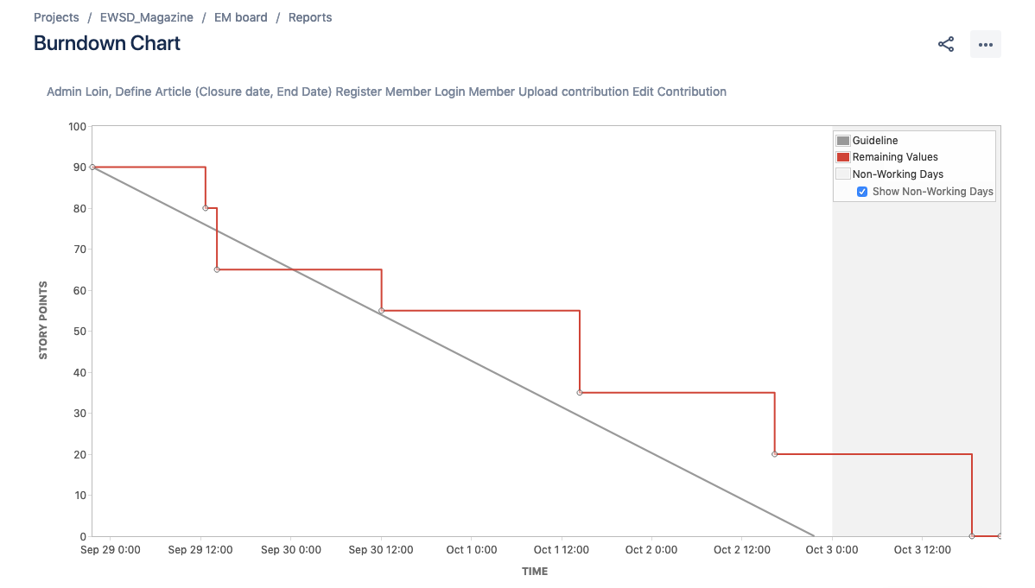

## Sprint-2

The Sprint-2 is planned to begin at and ends at .

### Sprint Planning

Task-1

|  |  |  |  |
| --- | --- | --- | --- |
| Create Marketing Coordinator Register Page | | | |
| Status | | TODO | |
| Project | | EWSD_Magazine | |
| Type: | Story | Priority: | Very High |
| Reporter | Arkar | Assignee | Arkar |
| Estimate Time | 3 hour | Remaining Estimate | 0 |

|  |  |  |
| --- | --- | --- |
| Summary | Status | Assignee |
| Implement Front End Design | TODO | arkar phyo |
| Create Backend Scripts | TODO | Min Hein Khant |
| Testing | TOD | Zaw Htet Aung |

|  |
| --- |
| **Description**  As Admins, the admin should be able to create the marketing manager account.  **Test** **Description**   * Successful registration of marketing coordinator * Validation successful * Deny the duplication of registration |

Task-2

|  |  |  |  |
| --- | --- | --- | --- |
| Create Marketing Coordinator Login Page | | | |
| Status | | TODO | |
| Project | | EWSD_Magazine | |
| Type: | Story | Priority: | Very High |
| Reporter | Arkar | Assignee | Arkar |
| Estimate Time | 2 hour | Remaining Estimate | 0 |

|  |  |  |
| --- | --- | --- |
| Summary | Status | Assignee |
| Implement Front End Design | TODO | arkar phyo |
| Create Backend Scripts | TODO | Min Hein Khant |
| Testing | TOD | Zaw Htet Aung |

|  |
| --- |
| **Description**  As marketing coordinators, coordinator should be able to login with his or her account.  **Test Description**   * Successful Login * Validation works |

Task-3

|  |  |  |  |
| --- | --- | --- | --- |
| Create Marketing Manager Register Page | | | |
| Status | | TODO | |
| Project | | EWSD_Magazine | |
| Type: | Story | Priority: | Very High |
| Reporter | Arkar | Assignee | Arkar |
| Estimate Time | 3 hour | Remaining Estimate | 0 |

|  |  |  |
| --- | --- | --- |
| Summary | Status | Assignee |
| Implement Front End Design | TODO | arkar phyo |
| Create Backend Scripts | TODO | Suan Thiha Nyan |
| Testing | TOD | Zaw Htet Aung |

|  |
| --- |
| **Description**  Admin should be able to create the marketing manager account.  Test Description   * Successful registration * Validation * Do not allow duplication of manager |

Task-4

|  |  |  |  |
| --- | --- | --- | --- |
| Create Marketing Manager Login Page | | | |
| Status | | TODO | |
| Project | | EWSD_Magazine | |
| Type: | Story | Priority: | Very High |
| Reporter | Arkar | Assignee | Arkar |
| Estimate Time | 3 hour | Remaining Estimate | 0 |

|  |  |  |
| --- | --- | --- |
| Summary | Status | Assignee |
| Implement Front End Design | TODO | arkar phyo |
| Create Backend Scripts | TODO | Suan Thiha Nyan |
| Testing | TOD | Zaw Htet Aung |

|  |
| --- |
| **Description**  Marketing should be able to authenticate first when entering to the website.  Test Description   * Successful Login * Validation * Do not allow if login fail |

Task-5

|  |  |  |  |
| --- | --- | --- | --- |
| Create Marketing Coordinator Feedback and Approve Form | | | |
| Status | | TODO | |
| Project | | EWSD_Magazine | |
| Type: | Story | Priority: | Very High |
| Reporter | Arkar | Assignee | Arkar |
| Estimate Time | 3 hour | Remaining Estimate | 0 |

|  |  |  |
| --- | --- | --- |
| Summary | Status | Assignee |
| Implement Front End Design | TODO | arkar phyo |
| Create Backend Scripts | TODO | Suan Thiha Nyan |
| Testing | TOD | Zaw Htet Aung |

|  |
| --- |
| **Description**  Marketing Coordinator should give feedback to the submitted articles according to their faculty.  Test Description   * Successful Comment * Validation * Approve the article |

Task-6

|  |  |  |  |
| --- | --- | --- | --- |
| Create Student Profile Page | | | |
| Status | | TODO | |
| Project | | EWSD_Magazine | |
| Type: | Story | Priority: | Very High |
| Reporter | Arkar | Assignee | Arkar |
| Estimate Time | 3 hour | Remaining Estimate | 0 |

|  |  |  |
| --- | --- | --- |
| Summary | Status | Assignee |
| Implement Front End Design | TODO | arkar phyo |
| Create Backend Scripts | TODO | Suan Thiha Nyan |
| Testing | TOD | Zaw Htet Aung |

|  |
| --- |
| **Description**  Student Should be able to view, edit and deactivate the account if they want to.  **Test Description**   * Can view their particular profile information * Available to edit * Delete or deactivate the their own account |

Task-7

|  |  |  |  |
| --- | --- | --- | --- |
| Create Marketing Coordinator Profile Page | | | |
| Status | | TODO | |
| Project | | EWSD_Magazine | |
| Type: | Story | Priority: | Very High |
| Reporter | Arkar | Assignee | Arkar |
| Estimate Time | 3 hour | Remaining Estimate | 0 |

|  |  |  |
| --- | --- | --- |
| Summary | Status | Assignee |
| Implement Front End Design | TODO | arkar phyo |
| Create Backend Scripts | TODO | Suan Thiha Nyan |
| Testing | TOD | Zaw Htet Aung |

|  |
| --- |
| **Description**  Only admin can view, edit, deactivate the marketing coordinator account.  **Test Description**   * Can view their profile information of marketing coordinator with table * Available to edit * Delete or deactivate the account |

Task-8

|  |  |  |  |
| --- | --- | --- | --- |
| Create Marketing Manager Profile Page | | | |
| Status | | TODO | |
| Project | | EWSD_Magazine | |
| Type: | Story | Priority: | Very High |
| Reporter | Arkar | Assignee | Arkar |
| Estimate Time | 3 hour | Remaining Estimate | 0 |

|  |  |  |
| --- | --- | --- |
| Summary | Status | Assignee |
| Implement Front End Design | TODO | arkar phyo |
| Create Backend Scripts | TODO | Suan Thiha Nyan |
| Testing | TOD | Zaw Htet Aung |

|  |
| --- |
| **Description**  Only admin can view, edit, deactivate the marketing manager account.  **Test Description**   * Can view their profile information of marketing manager with table * Available to edit * Delete or deactivate the account |

## Burndown Chart

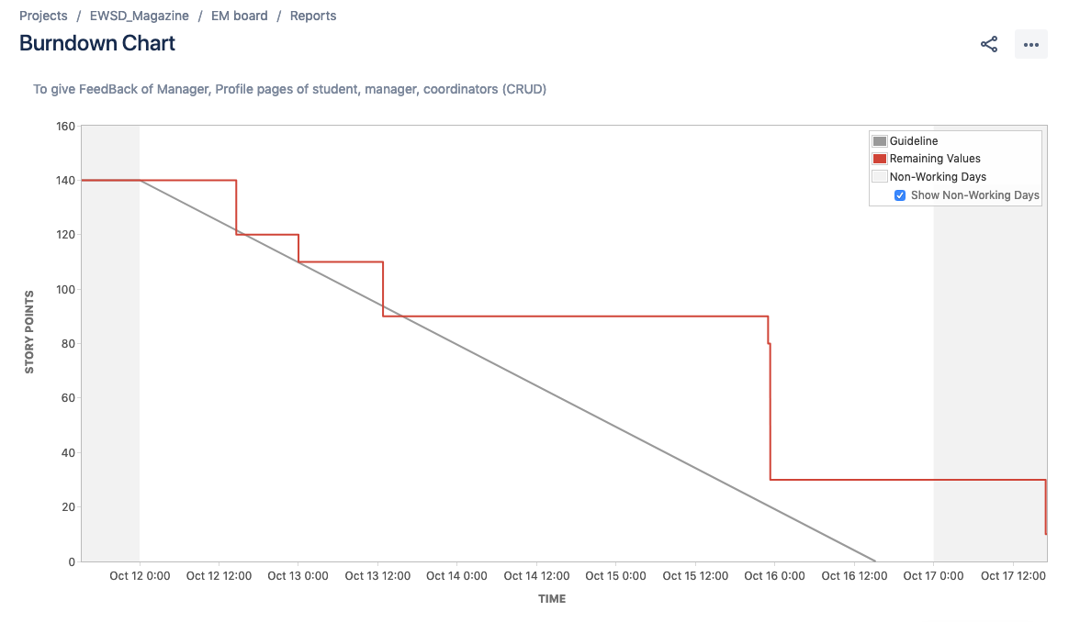

Sprint-3

Task-1

|  |  |  |  |
| --- | --- | --- | --- |
| Create tables of articles, magazine, staffs and students | | | |
| Status | | TODO | |
| Project | | EWSD_Magazine | |
| Type: | Story | Priority: | Very High |
| Reporter | Arkar | Assignee | Arkar |
| Estimate Time | 6 hour | Value Points | 20 |

|  |  |  |
| --- | --- | --- |
| Summary | Status | Assignee |
| Implement backend scripts | TODO | Min Hein Khant |
| Create Backend Scripts | TODO | Suan Thiha Nyan |
| Testing | TOD | Zaw Htet Aung |

|  |
| --- |
| **Description**  As manager, the manager should be able to view all students, articles table.  As coordinator, the coordinators should be able to view the students table within the faculty.  As admin, admin should be able to view all students of the university, article contributions and staffs table.  **Test Description**   * All tables can be searched by their fields. |

Task-2

|  |  |  |  |
| --- | --- | --- | --- |
| Create the total article display view per faculty | | | |
| Status | | TODO | |
| Project | | EWSD_Magazine | |
| Type: | Story | Priority: | Very High |
| Reporter | Arkar | Assignee | Arkar |
| Estimate Time | 2 hours | Value Points | 15 |

|  |  |  |
| --- | --- | --- |
| Summary | Status | Assignee |
| Create the UI of the Page | TODO | Arkar Phyo |
| Create Backend Scripts | TODO | Suan Thiha Nyan |
| Testing | TOD | Zaw Htet Aung |

|  |
| --- |
| **Description**  As manager, coordinator and admin, there should be a page that display the total articles per faculty.  **Test Description**   * Display the correct number of the article according to the article |

Task-3

|  |  |  |  |
| --- | --- | --- | --- |
| Create Authorization and Authentication Rules | | | |
| Status | | TODO | |
| Project | | EWSD_Magazine | |
| Type: | Story | Priority: | Very High |
| Reporter | Arkar | Assignee | Arkar |
| Estimate Time | 3 hour | Value Points | 40 |

|  |  |  |
| --- | --- | --- |
| Summary | Status | Assignee |
| Implement backend scripts | TODO | Min Hein Khant |
| Create Backend Scripts | TODO | Suan Thiha Nyan |
| Testing | TOD | Zaw Htet Aung |

|  |
| --- |
| **Test Description**  All user except guests have to authenticated first before entering the system.  Coordinator cannot edit any contribution made by the students.  Manager or admin can only view and download zip of the contribution approved.  Admin can manage all users of the system. |

Task-4

|  |  |  |  |
| --- | --- | --- | --- |
| Create E-mail function | | | |
| Status | | TODO | |
| Project | | EWSD_Magazine | |
| Type: | Story | Priority: | Very High |
| Reporter | Arkar | Assignee | Arkar |
| Estimate Time | 3 hour | Value Points | 20 |

|  |  |  |
| --- | --- | --- |
| Summary | Status | Assignee |
| Implement backend scripts | TODO | Min Hein Khant/Suan Thiha Aung |
| Testing | TOD | Zaw Htet Aung |

|  |
| --- |
| **Description**  As students, there should be alert notification to the coordinator.  As admin, when creating the account for manager and coordinator, there should be notification system via e-mail.  **Test Description**   * send the actual e-mail to the coordinator email when the student submit the article. * send the actual e-mail to the particular user when the admin creates the account. |

Completed Wireframes

Site Map

Admin Section

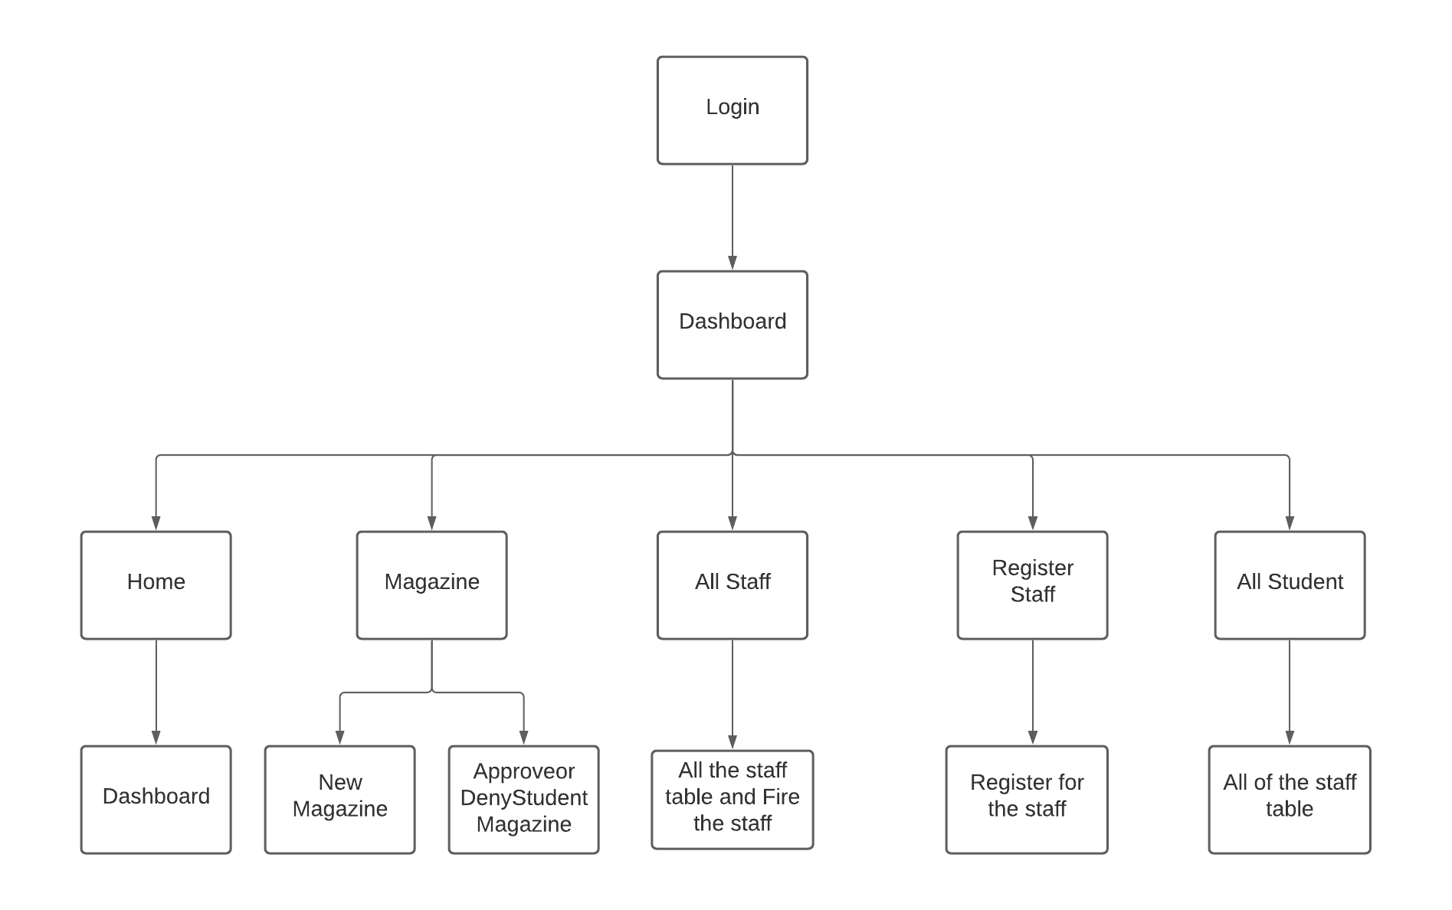

Marketing Coordinator Section

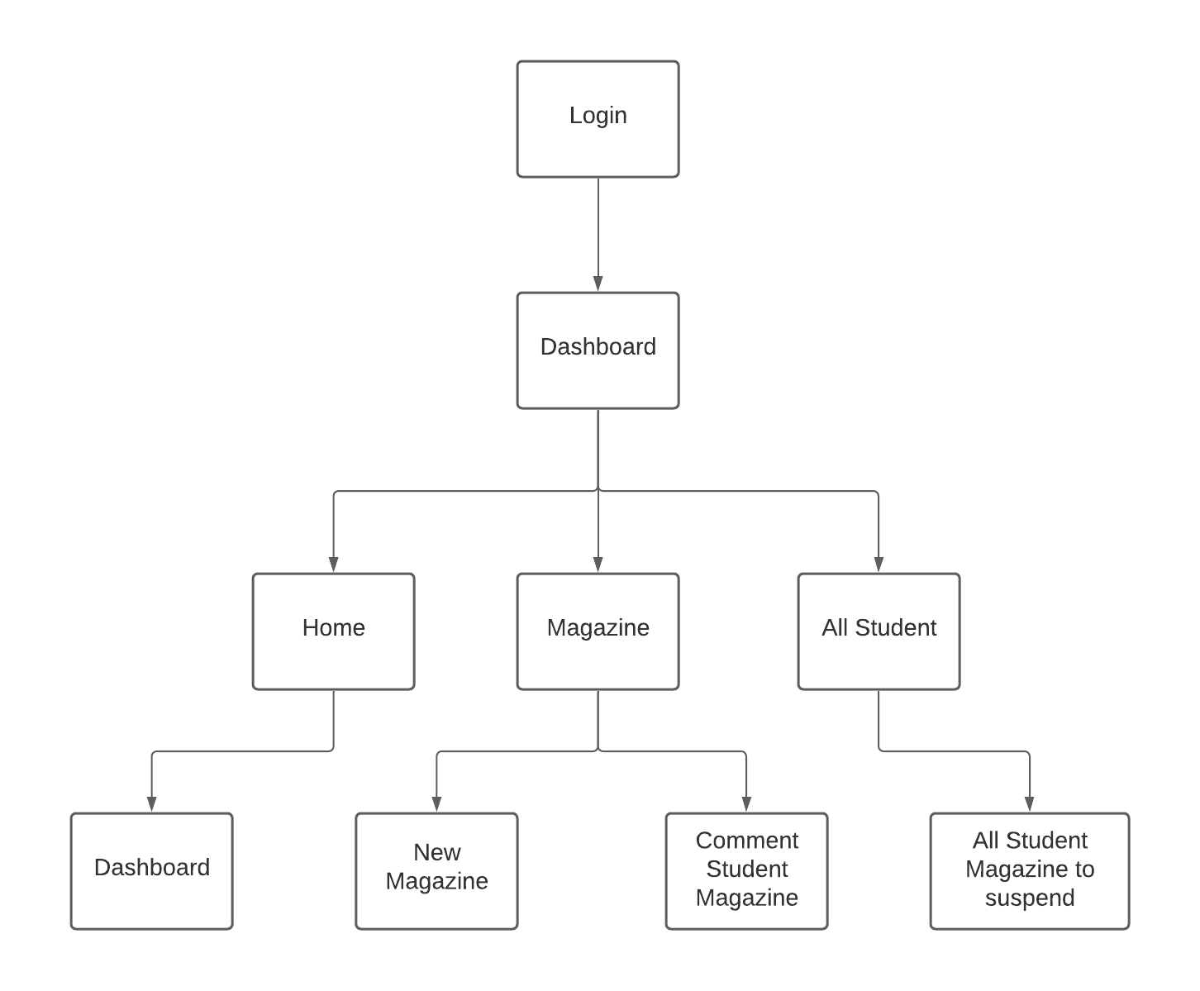

Manager Section

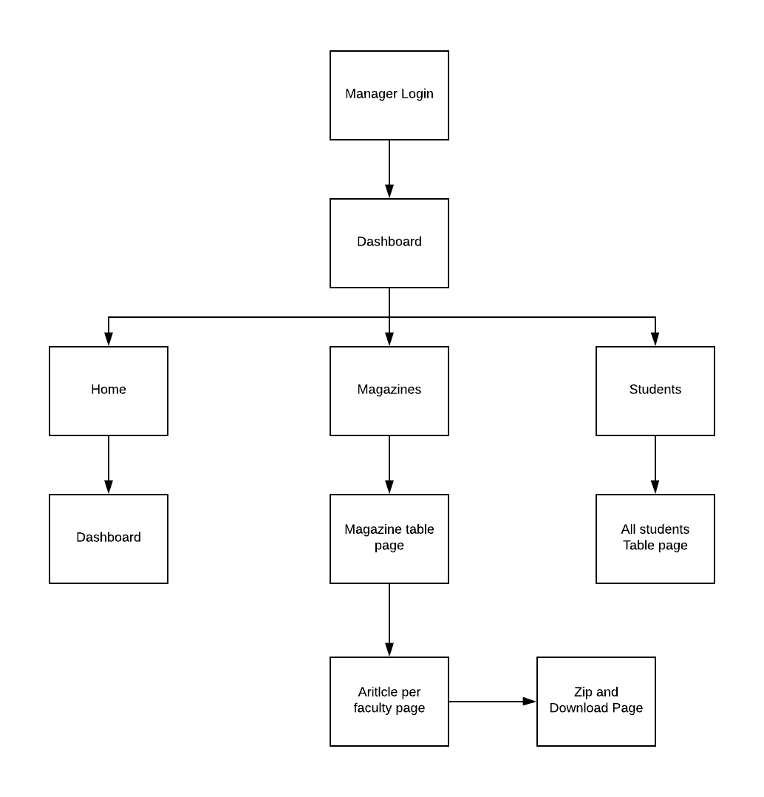

User Manual

Manager View

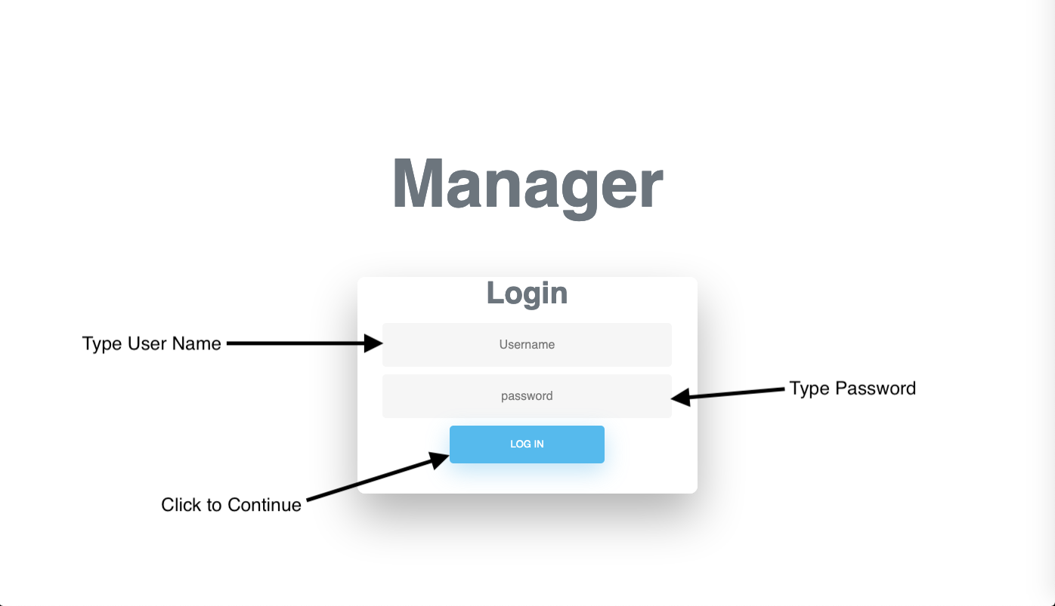

Fig.1

The manager section starts with the login form.

The manager needs to authenticate first before entering the system

The manager must fill the correct credentials that the admin provided.

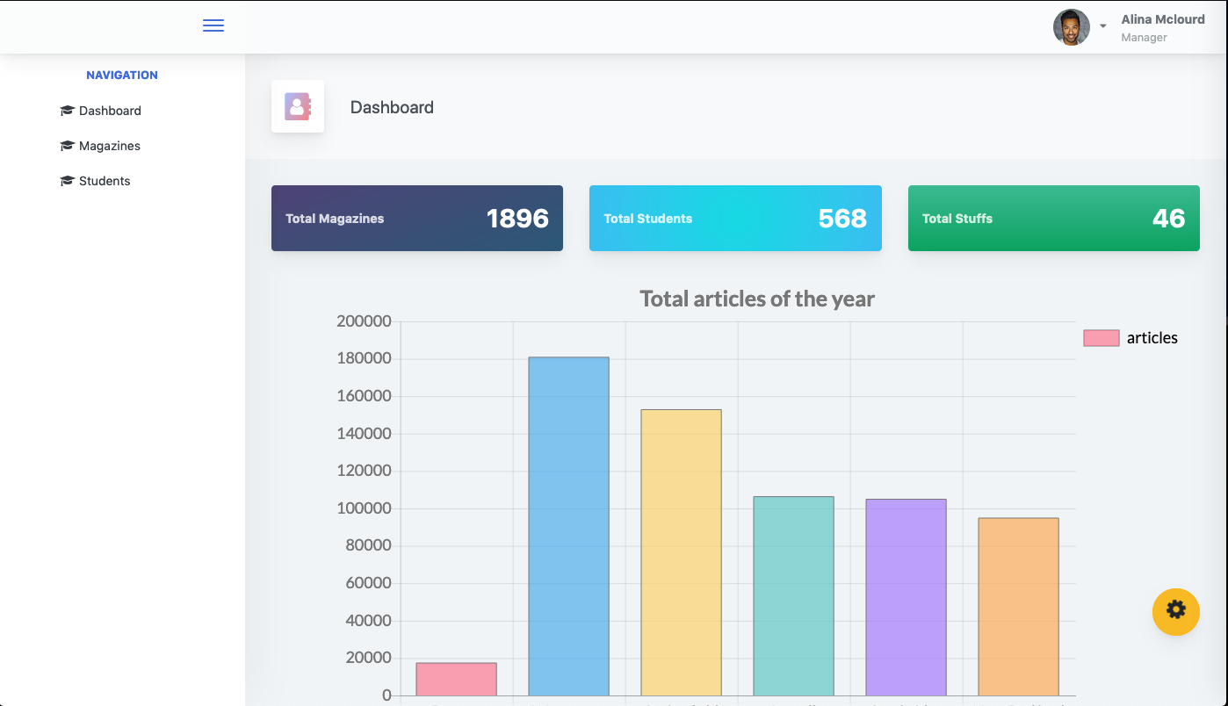

Fig.2

Once login, the manager will see the manager dashboard as shown in the figure.

This page will display the analytical reports of the magazine along with the three-navigation links, Home, Magazine, Students

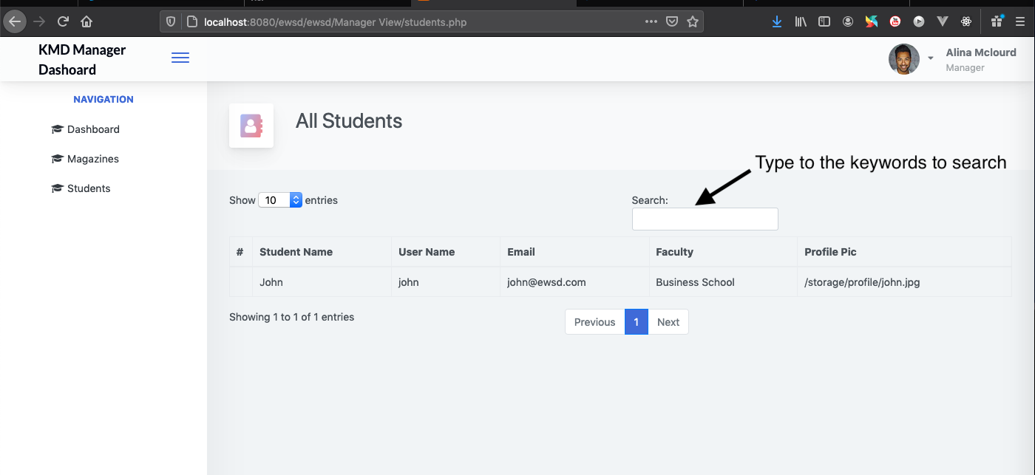

Fig.3

In Student Page, the manager will see all the students of the university. available to search by their name, username, email, faculty but cannot perform any action.

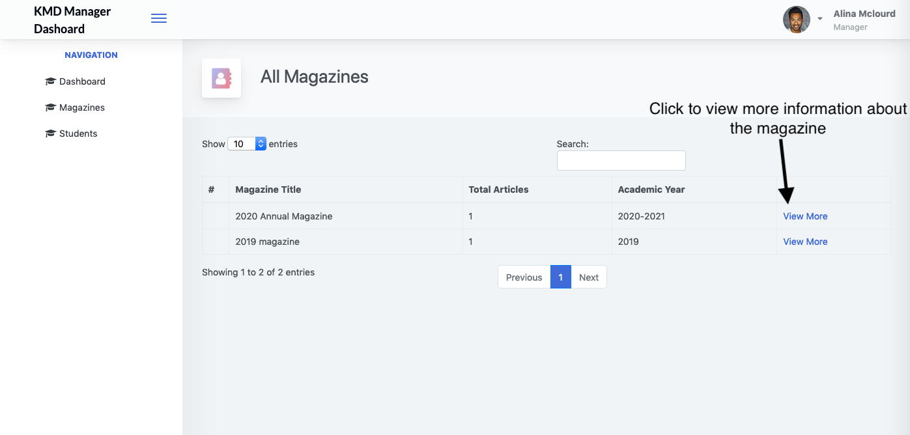

Fig.4

In magazine, the manager will see the table with the information of magazine title and their total contributions from all faculties.

For more information, click the view more button.



Fig.5

This will lead to the page where the number of total articles per faculty is displayed. Then, the manager can select the faculty to view the articles.

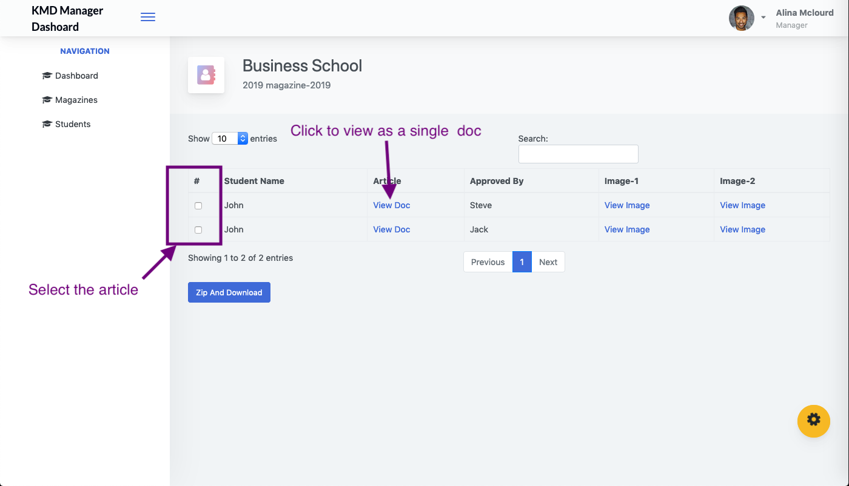

Fig.6

This is the page where manager can zip and download. The only approved article of a particular faculty will be displayed with the checkboxes where the manager can choose and download as zip.

Meeting Minutes Meeting Minutes

|  |  |
| --- | --- |
| **Meeting Number** | 1 |
| **Date**  **Meeting time** | 18 September, 2020.  1 hour 20 minutes. |
| **Absentee** | None. |
| **Discussions**.   * Discuss about the technology to be used in coursework. * Discuss the ERD of the coursework. * Discuss the wireframes * Discuss user Stories. | |
| **Outcomes**   * Decided to use HTML, CSS, BOOTSTRAP, JQUERY, VUE JS * Discuss and Assign the task to database designer * Web-designer starts to implement the wireframes. * Identify and separate the user stories in the coursework scenario according to the user level (Role) | |

|  |  |
| --- | --- |
| **Meeting Number** | 2 (Sprint Planning) |
| **Date**  **Meeting time** | 26 September, 2020.  3 hour. |
| **Absentee** | None. |
| **Discussions**   * Discuss the backlog to priorities * Define the sprint goals. * Discuss about the estimate values of the task * Discuss how to procedure * Discuss about the terms and conditions | |
| **Outcomes**   * Set the sprint goal as Admin Login, Define Article (Closure date, End Date) Register Member Login Member Upload Contribution Edit Contribution. * Set the estimate value points. * Decide to use Gitlab for the development. | |

|  |  |
| --- | --- |
| **Meeting Number** | 4 (Sprint Review) |
| **Date**  **Meeting time** | 5 October, 2020.  1 hour 20 minutes. |
| **Absentee** | None. |
| **Discussions**   * Demonstration of the result. * Review the sprint-1 * Identify the issues occurred | |
| **Outcomes**   * All the tasks completed successfully * Left the encryption functionality of the password. | |

|  |  |
| --- | --- |
| **Meeting Number** | 5 (Sprint Retrospective) |
| **Date**  **Meeting time** | 7 October, 2020.  45 minutes. |
| **Absentee** | None. |
| **Discussions**   * Discuss the wireframes created by the web-designer. * Discuss about how to improve the workshop. | |
| **Outcome**   * Changes made in workflow (consider the admin role as only one person) * Admin can only create the account of marketing coordinator, and manager. * Decide to use the discord during the implementing coding to get more transparency. | |

|  |  |
| --- | --- |
| **Meeting Number** | 6 (Sprint-2 Planning) |
| **Date**  **Meeting time** | 12 October, 2020.  1 hour 20 minutes. |
| **Absentee** | None. |
| **Discussions**   * Define the sprint goal. * Discuss about the estimate values of the task | |
| **Outcomes**   * Set the sprint goal as Feedback of Manager, Profile pages of student, manager, coordinators, Guest Page | |

|  |  |
| --- | --- |
| **Meeting Number** | 7 (Sprint Review and Retrospective) |
| **Date**  **Meeting time** | 17 October, 2020.  1 hour. |
| **Absentee** | None. |
| **Discussions**   * Review the result. * Discuss about the difficulties | |
| **Outcomes**   * All the tasks are completed except the guest display. * The guest will not be implemented as the separate pages. * Implementing authorization rules to the student page will solve the guest display problem | |

|  |  |
| --- | --- |
| **Meeting Number** | 8 |
| **Date**  **Meeting time** | 18 October, 2020.  1 hour 10 minutes. |
| **Absentee** | None. |
| **Discussions**   * Discuss about how to make zip and download feature * Discuss about how to implement the notification system * Make clear statement of authorization rules * Discuses about the user manual | |
| **Outcomes**   * Decided not to store Zip and download record in the database. * Use smtp mail server for the real time e-mail notification system. * Decide the clear rules for each role of the system. * Each role of the use manual is assigned the responsible backend developer. | |

|  |  |
| --- | --- |
| **Meeting Number** | 9 (Sprint Planning) |
| **Date**  **Meeting time** | 19 October, 2020.  1 hour 20 minutes. |
| **Absentee** | None. |
| **Discussions**   * Define the estimate value for the tasks | |

|  |  |
| --- | --- |
| **Meeting Number** | 10 (Sprint Review) |
| **Date**  **Meeting time** | 25 October, 2020.  1 hour 30 minutes. |
| **Absentee** | None. |
| **Discussions**   * Discuss about the process. * Discuss about the difficulties. | |
| **Outcomes**   * The sprint will not be finished in time because it takes time more than expexted in the authorization task. | |

Testing

# Test Plan

|  |  |  |  |
| --- | --- | --- | --- |
| 1 | Member/ Student Register Page | Test the registration info data that are registered to the database and fill the date and click the summit button. | The data of the registration will be showing register save successfully and save the data in database. |
| 2 | Member Login Page | Login form from registration user name and password fill pass and click the summit button. | Show the user account details and can be choose button update my account and update my arts and cannel. |
| 3 | Admin Login Page | Click the create button and drop box from fills the admin details and click the summit button | Show the admin login account creating is successfully and save the data in database |
| 4 | Article Upload page by admin | Click the create article button and fail details and upload | Show the Article upload is complete successfully and save the data in database |
| 5 | Edit Article page for student | Student can article edit for click the article and edit and editing complete click the update button | Show the article edit is successfully and save the data in database |
| 6 | Marketing Coordinator Register Page | Login for registering Marketing Coordinator click the register page and fail the details and click the summit button | Show the complete successfully Marketing Coordinator register and save the data in database |
| 7 | Marketing Coordinator Login Page | Login for click the login page and fill the user name password click the login button. | Login successfully and user can use magazines web and sabe the data in database |
| 8 | Marketing Manager Register Page | Registering for click the register page and fill the user details and click summit button | Show the complete successfully registering and save the data in database |
| 9 | Marketing Manager Login Page | Login for click the Manager login page and fill pass user name and password and click login button | Show the Manager login successfully and manager can use magazines web and save the data in database |
| 10 | Marketing Coordinator Feedback Form | Marketing coordinator feedback form for user watch magazine and leave the page with request feedback and click the feedback form and fill the feedback and ratting and click the summit button | Show the feedback is complete and save the data in database |
| 11 | Marketing Manager download article function | Download article function for choose article and click the download | Show the complete download and save the data in database |
| 12 | Student Profile Page | Student login and user profile in show the user details and can-do upload update and delete | Show the Student profile from used student details |
| 13 | Marketing Manager Profile Page | Manager login and user profile in show the user details and can-do upload update and delete | Show the manger profile from used manager details |
| 14 | Authorization roles | Authorization roles for admin show the web from authorization form and user need comply | Show the Authorization roles from need comply roles show page |
| 15 | approve article function of Marketing Coordinator | User upload articles are marketing coordinator from need approve for upload and click the approve | Show the approve complete articles and save the data in database |
| 16 | admin dashboard with analytical report | Admin dashboard from user articles are show and analytical report | Admin dashboard from user articles upload and edit approve for always sending notification |
| 17 | Marketing Coordinator Dashboard | Marketing Coordinator dashboard from show sending user feedback and ratting | Received user feedback and ratting article notification from Marketing Coordinator Dashboard |
| 18 | E-mails notification for article submission | Emails notification for articles submission is always send request approve from admin team | User received email from articles submission is complete |
| 19 | guest account which can view the selected article | Guest account can visit web with admin selected articles | Guest account which selected articles can read and download |

# Test Log

|  |  |  |  |  |  |  |
| --- | --- | --- | --- | --- | --- | --- |
| Test | What is being tested | How | Expected results | Dates | Actual results | Action taken |
| 1 | Member/ Student Register Page | Test the registration info data that are registered to the database and fill the date and click the summit button. | The data of the registration will be showing register save successfully and save the data in database. | 17.10.2020 | The data of the registration will be showing register save successfully and save the data in database. | none |
| 2 | Member Login Page | Login form from registration user name and password fill pass and click the summit button. | Show the user account details and can be choose button update my account and update my arts and cannel. | 17.10.2020 | Show the user account details and can be choose button update my account and update my arts and cannel. | none |
| 3 | Admin Login Page | Click the create button and drop box from fills the admin details and click the summit button | Show the admin login account creating is successfully and save the data in database | 17.10.2020 | Show the admin login account creating is successfully and save the data in database | none |
| 4 | Article Upload page by admin | Click the create article button and fail details and upload | Show the Article upload is complete successfully and save the data in database | 17.10.2020 | Show the Article upload is complete successfully and save the data in database | none |
| 5 | Edit Article page for student | Student can article edit for click the article and edit and editing complete click the update button | Show the article edit is successfully and save the data in database | 17.10.2020 | Show the article edit is successfully and save the data in database | none |
| 6 | Marketing Coordinator Register Page | Login for registering Marketing Coordinator click the register page and fail the details and click the summit button | Show the complete successfully Marketing Coordinator register and save the data in database | 17.10.2020 | Show the complete successfully Marketing Coordinator register and save the data in database | none |
| 7 | Marketing Coordinator Login Page | Login for click the login page and fill the user name password click the login button. | Login successfully and user can use magazines web and sabe the data in database | 17.10.2020 | Login successfully and user can use magazines web and sabe the data in database | none |
| 8 | Marketing Manager Register Page | Registering for click the register page and fill the user details and click summit button | Show the complete successfully registering and save the data in database | 18.10.2020 | Show the complete successfully registering and save the data in database | none |
| 9 | Marketing Manager Login Page | Login for click the Manager login page and fill pass user name and password and click login button | Show the Manager login successfully and manager can use magazines web and save the data in database | 18.10.2020 | Show the Manager login successfully and manager can use magazines web and save the data in database | none |
| 10 | Marketing Coordinator Feedback Form | Marketing coordinator feedback form for user watch magazine and leave the page with request feedback and click the feedback form and fill the feedback and ratting and click the summit button | Show the feedback is complete and save the data in database | 18.10.2020 | Show the feedback is complete and save the data in database | none |
| 11 | Marketing Manager download article function | Download article function for choose article and click the download | Show the complete download and save the data in database | 18.10.2020 | Show the complete download and save the data in database | none |
| 12 | Student Profile Page | Student login and user profile in show the user details and can-do upload update and delete | Show the Student profile from used student details | 18.10.2020 | Show the Student profile from used student details | none |
| 13 | Marketing Manager Profile Page | Manager login and user profile in show the user details and can-do upload update and delete | Show the manger profile from used manager details | 18.10.2020 | Show the manger profile from used manager details | none |
| 14 | Authorization roles | Authorization roles for admin show the web from authorization form and user need comply | Show the Authorization roles from need comply roles show page | 18.10.2020 | Show the Authorization roles from need comply roles show page | none |
| 15 | approve article function of Marketing Coordinator | User upload articles are marketing coordinator from need approve for upload and click the approve | Show the approve complete articles and save the data in database | 18.10.2020 | Show the approve complete articles and save the data in database | none |
| 16 | admin dashboard with analytical report | Admin dashboard from user articles are show and analytical report | Admin dashboard from user articles upload and edit approve for always sending notification | 18.10.2020 | Admin dashboard from user articles upload and edit approve for always sending notification | none |
| 17 | Marketing Coordinator Dashboard | Marketing Coordinator dashboard from show sending user feedback and ratting | Received user feedback and ratting article notification from Marketing Coordinator Dashboard | 18.10.2020 | Received user feedback and ratting article notification from Marketing Coordinator Dashboard | none |
| 18 | E-mails notification for article submission | Emails notification for articles submission is always send request approve from admin team | User received email from articles submission is complete | 18.10.2020 | User received email from articles submission is complete | none |
| 19 | Guest account which can view the selected article | Guest account can visit web with admin selected articles | Guest account which selected articles can read and download | 18.10.2020 | Guest account which selected articles can read and download | none |