Table of Contents

Table of Contents 1

Overview 2

Assumption 3

Roles and Responsibility 4

User Stories 5

Flow Chart 7

ERD Diagram 8

Sprints Events 8

Sprint-1 8

Backlogs 8

Sprint Planning 10

Sprint review/Sprint Retrospective 17

Burndown chart 17

Sprint-2 21

Completed Wireframes 22

Overview

Assumption

Roles and Responsibility

User Stories

|  |
| --- |
| As **Members/ Students** |
| Students should be able to submit one or more article as word documents to the magazine  Students can upload multiple high-quality images.  Students cannot submit the articles after the closure date.  Students could allow to update their contribution after the closure date.  All students must agree to Terms and Conditions before they can submit. |

|  |
| --- |
| As **Marketing Manager** |
| Marketing Manager can oversea the process.  Marketing Manager can view the selected contributions but cannot edit any.  Marketing manager can zip and download the selected contributions after the closure date |

|  |
| --- |
| As **Marketing Coordinators** |
| Marketing coordinators should get the email notification once the student submits the contribution.  Marketing coordinators should only allow to access contribution by their faculty.  Marketing coordinators interact with the students and with the students in their Faculty in order to edit the contributions and to select those for publication. |

|  |
| --- |
| As **administrators** |
| Admin should maintain to every data in the system.  Admin can see Statistical analysis (e.g. number of contributions per Faculty) needs to be available. |

|  |
| --- |
| As **Guests** |
| A guest account for each Faculty can be used to view the selected reports |

Flow Chart

ERD Diagram

# Sprints Events

## Sprint-1

The first sprint begins at the 24 September 2020 and will be end in 1 October 2020.

### Backlogs

|  |  |  |
| --- | --- | --- |
| ISSUES | PRITORIZATION | VALUE-POINTS |
| Create Member/Student Register Page | VERY HIGH | 10 |
| Create Member Login Page | VERY HIGH | 15 |
| Create Admin Login Page | VERY HIGH | 20 |
| Create Article Upload page by admin | VERY HIGH | 10 |
| Create article upload page by Student | VERY HIGH | 10 |
| Create Edit article page for Student | VERY HIGH | 20 |
| Create Marketing Coordinator Register Page | HIGH­­ | 20 |
| Create Marketing Coordinator Login Page | HIGH | 10 |
| Create marketing Manager Register Page | VERY HIGH | 10 |
| Create Marketing Manager Login Page | VERY HIGH | 20 |
| Create Marketing Coordinator Feedback Form | HIGH | 20 |
|  |  |  |
| Create Marketing Manager download article function | MEDIUM | 20 |
| Create Student Profile Page | MEDIUM | 20 |
| Create Marketing Manager Profile Page | MEDIUM | 20 |
| Create Authorization rules | MEDIUM | 30 |
| Create approve article function of marketing coordinator | MEDIUM | 10 |
| Create Admin Dashboard with analytical report | LOW | 20 |
| Create Marketing Coordinator Dashboard | LOW | 20 |
| Create E-mail notification function for article submission | LOW | 20 |
| Create gust account which can view the selected article | LOW | 20 |

### Sprint Planning

Task 1

|  |  |  |  |
| --- | --- | --- | --- |
| Create Member Register Page | | | |
| Status | | TODO | |
| Project | | EWSD_Magazine | |
| Type: | Story | Priority: | Very High |
| Reporter | Arkar | Assignee | Arkar |
| Estimate Time | 5 hour | Remaining Estimate | 0 |

|  |  |  |
| --- | --- | --- |
| Summary | Status | Assignee |
| [Create](https://ewsdmagazine.atlassian.net/browse/EM-38) Repo on Git-Hub | TODO | Arkar |
| Create database Schema | TODO | Sett Wai Aung |
| Create front end | TODO | arkar phyo |
| Implement Backend | TODO | Suan Thiha Nyan |
| Testing | TOD | Zaw Htet Aung |

|  |
| --- |
| **Description**  As a student, the student should allow to register their profile into the system.  **Test Description**   * Show the register form with validation fields. * The member info is saved in the database once registered. |

Task 2

|  |  |  |  |
| --- | --- | --- | --- |
| Create Member/Student Login Page | | | |
| Status | | TODO | |
| Project | | EWSD_Magazine | |
| Type: | Story | Priority: | Very High |
| Reporter | Arkar | Assignee | Arkar |
| Estimate Time | 4 hour | Remaining Estimate | 0 |

|  |  |  |
| --- | --- | --- |
| Summary | Status | Assignee |
| Implement Front End Design | TODO | arkar phyo |
| Implement Validation Rules | TODO | Suan Thiha Nyan |
| Implement Backend | TODO | Suan Thiha Nyan |
| Testing | TOD | Zaw Htet Aung |

|  |
| --- |
| **Description**  As a member/Student of the university, login form should be provided to authenticated by the email and password.  **Test Description**   * Authentication works * Validation Works |

Task-3

|  |  |  |  |
| --- | --- | --- | --- |
| Create Admin Login Page | | | |
| Status | | TODO | |
| Project | | EWSD_Magazine | |
| Type: | Story | Priority: | Very High |
| Reporter | Arkar | Assignee | Arkar |
| Estimate Time | 3 hour | Remaining Estimate | 0 |

|  |  |  |
| --- | --- | --- |
| Summary | Status | Assignee |
| Implement Front End Design | TODO | arkar phyo |
| Implement Backend | TODO | Min Hein Khant |
| Testing | TOD | Zaw Htet Aung |

|  |
| --- |
| **Description**  As admin of the university, admin should be provided with login form with proper validation  **Test Description**   * Authentication works * Validation Works |

Task 4

|  |  |  |  |
| --- | --- | --- | --- |
| Create Article Upload Page by Admin | | | |
| Status | | TODO | |
| Project | | EWSD_Magazine | |
| Type: | Story | Priority: | Very High |
| Reporter | Arkar | Assignee | Arkar |
| Estimate Time | 3 hour | Remaining Estimate | 0 |

|  |  |  |
| --- | --- | --- |
| Summary | Status | Assignee |
| Implement Front End Design | TODO | arkar phyo |
| Implement Backend | TODO | Min Hein Khant |
| Testing | TOD | Zaw Htet Aung |

|  |
| --- |
| **Description**  As admin, the admin should set the magazine tile, end date and final closure date of the magazine.  **Test Description**   * Successful Create of new Magazine * Provide Field for end date and closure date |

Task-5

|  |  |  |  |
| --- | --- | --- | --- |
| Create Article Upload Page by Member/Student | | | |
| Status | | TODO | |
| Project | | EWSD_Magazine | |
| Type: | Story | Priority: | Very High |
| Reporter | Arkar | Assignee | Arkar |
| Estimate Time | 3 hour | Remaining Estimate | 0 |

|  |  |  |
| --- | --- | --- |
| Summary | Status | Assignee |
| Implement Front End Design | TODO | arkar phyo |
| Create Backend Scripts | TODO | Suan Thiha Nyan |
| Testing | TOD | Zaw Htet Aung |

|  |
| --- |
| **Description**  As the member, all students have the opportunity to submit one or more articles as Word documents to the magazine.  All students can also upload high quality images, e.g. photographs.  All students must agree to Terms and Conditions before they can submit.  **Test Description**   * Upload articles as word documents, * Multiple image upload * Provide Field for end date and closure date * Do not allow to submit without agreeing the terms and conditions * Do not allow the submission of new article after end date but edit |

Task-6

|  |  |  |  |
| --- | --- | --- | --- |
| Create Edit Article Functionality Page by Member/Student | | | |
| Status | | TODO | |
| Project | | EWSD_Magazine | |
| Type: | Story | Priority: | Very High |
| Reporter | Arkar | Assignee | Arkar |
| Estimate Time | 3 hour | Remaining Estimate | 0 |

|  |  |  |
| --- | --- | --- |
| Summary | Status | Assignee |
| Implement Front End Design | TODO | arkar phyo |
| Create Backend Scripts | TODO | Suan Thiha Nyan |
| Testing | TOD | Zaw Htet Aung |

|  |
| --- |
| **Description**  As students, the contribution is available to edit after the end data.  Test Description  Contributions after the end date will be defined as late contributions |

### 

### Burndown chart

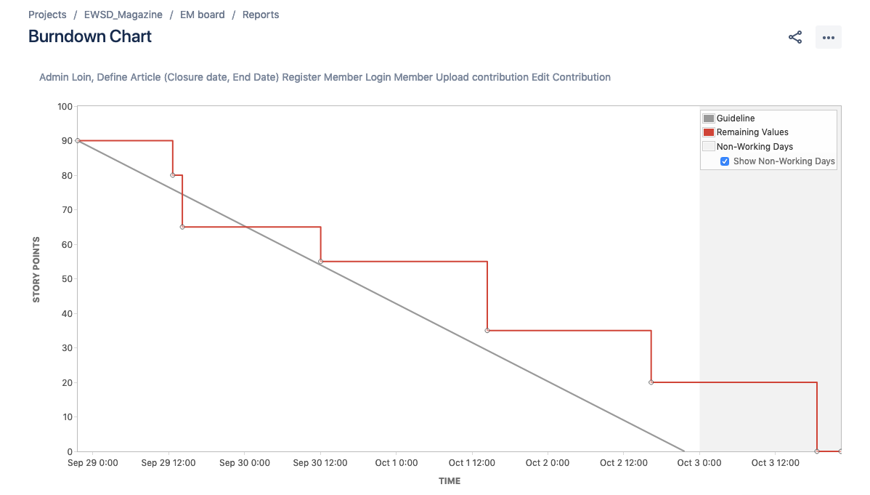

## Sprint-2

### Sprint Planning

Task-1

|  |  |
| --- | --- |
| [EM-84] [Create Marketing Coordinators Register Page](https://ewsdmagazine.atlassian.net/browse/EM-84) **Created: 08/Oct/20  Updated: 09/Oct/20** | |
| **Status:** | To Do |
| **Project:** | [EWSD_Magazine](https://ewsdmagazine.atlassian.net/secure/BrowseProject.jspa?id=10000) |
| **Components:** | None |
| **Affects versions:** | None |
| **Fix versions:** | None |

|  |  |  |  |
| --- | --- | --- | --- |
| **Type:** | Story | **Priority:** | Medium |
| **Reporter:** | [Ar Kar](https://ewsdmagazine.atlassian.net/secure/ViewProfile.jspa?accountId=5f68bb0146a2ed0072e3aec7) | **Assignee:** | [arkar phyo](https://ewsdmagazine.atlassian.net/secure/ViewProfile.jspa?accountId=5f6c784ced55c7006ae84c26) |
| **Resolution:** | Unresolved | **Votes:** | 0 |
| **Labels:** | None | | |

|  |  |  |  |  |  |  |  |  |  |  |  |  |  |  |  |  |  |  |  |  |  |  |  |  |  |  |  |  |  |  |  |
| --- | --- | --- | --- | --- | --- | --- | --- | --- | --- | --- | --- | --- | --- | --- | --- | --- | --- | --- | --- | --- | --- | --- | --- | --- | --- | --- | --- | --- | --- | --- | --- |
| **Sub-tasks:** | |  |  |  |  |  | | --- | --- | --- | --- | --- | | **Key** | **Summary** | **Type** | **Status** | **Assignee** | | [EM-90](https://ewsdmagazine.atlassian.net/browse/EM-90) | [Create WIreFrame](https://ewsdmagazine.atlassian.net/browse/EM-90) | Sub-task | To Do | arkar phyo | | [EM-91](https://ewsdmagazine.atlassian.net/browse/EM-91) | [Create User InterFace](https://ewsdmagazine.atlassian.net/browse/EM-91) | Sub-task | To Do | arkar phyo | | [EM-92](https://ewsdmagazine.atlassian.net/browse/EM-92) | [Provide database query](https://ewsdmagazine.atlassian.net/browse/EM-92) | Sub-task | To Do | Sett Wai Aung | | [EM-93](https://ewsdmagazine.atlassian.net/browse/EM-93) | [Implement backend coding include vali...](https://ewsdmagazine.atlassian.net/browse/EM-93) | Sub-task | To Do | Min Hein Khant | | [EM-94](https://ewsdmagazine.atlassian.net/browse/EM-94) | [Testing](https://ewsdmagazine.atlassian.net/browse/EM-94) | Sub-task | To Do | Zaw Htet Aung | |
| **Sprint:** | Sprint 2 |

|  |  |
| --- | --- |
| **Description** |  |

|  |
| --- |
| **User Stories**  As coordinators can available to create their own account.  **Testing**  Validate the field.  unique email |

Task-2

|  |  |
| --- | --- |
| [EM-85] [Create Marketing Coordinator Login Page](https://ewsdmagazine.atlassian.net/browse/EM-85) **Created: 08/Oct/20  Updated: 10/Oct/20** | |
| **Status:** | To Do |
| **Project:** | [EWSD_Magazine](https://ewsdmagazine.atlassian.net/secure/BrowseProject.jspa?id=10000) |
| **Components:** | None |
| **Affects versions:** | None |
| **Fix versions:** | None |

|  |  |  |  |
| --- | --- | --- | --- |
| **Type:** | Story | **Priority:** | Medium |
| **Reporter:** | [Ar Kar](https://ewsdmagazine.atlassian.net/secure/ViewProfile.jspa?accountId=5f68bb0146a2ed0072e3aec7) | **Assignee:** | [Ar Kar](https://ewsdmagazine.atlassian.net/secure/ViewProfile.jspa?accountId=5f68bb0146a2ed0072e3aec7) |
| **Resolution:** | Unresolved | **Votes:** | 0 |
| **Labels:** | None | | |
| **Σ Remaining Estimate:** | Not Specified | **Remaining Estimate:** | Not Specified |
| **Σ Time Spent:** | Not Specified | **Time Spent:** | Not Specified |
| **Σ Original Estimate:** | Not Specified | **Original Estimate:** | Not Specified |

|  |  |  |  |  |  |  |  |  |  |  |  |  |  |  |  |  |  |  |  |  |  |  |  |  |  |  |  |  |  |  |  |
| --- | --- | --- | --- | --- | --- | --- | --- | --- | --- | --- | --- | --- | --- | --- | --- | --- | --- | --- | --- | --- | --- | --- | --- | --- | --- | --- | --- | --- | --- | --- | --- |
| **Sub-tasks:** | |  |  |  |  |  | | --- | --- | --- | --- | --- | | **Key** | **Summary** | **Type** | **Status** | **Assignee** | | [EM-95](https://ewsdmagazine.atlassian.net/browse/EM-95) | [Create Wire frames](https://ewsdmagazine.atlassian.net/browse/EM-95) | Sub-task | In Progress | arkar phyo | | [EM-96](https://ewsdmagazine.atlassian.net/browse/EM-96) | [Create User Interface](https://ewsdmagazine.atlassian.net/browse/EM-96) | Sub-task | In Progress | arkar phyo | | [EM-97](https://ewsdmagazine.atlassian.net/browse/EM-97) | [Generate sql query](https://ewsdmagazine.atlassian.net/browse/EM-97) | Sub-task | In Progress | Sett Wai Aung | | [EM-98](https://ewsdmagazine.atlassian.net/browse/EM-98) | [Implement Backend coding](https://ewsdmagazine.atlassian.net/browse/EM-98) | Sub-task | In Progress | Min Hein Khant | | [EM-99](https://ewsdmagazine.atlassian.net/browse/EM-99) | [Testing](https://ewsdmagazine.atlassian.net/browse/EM-99) | Sub-task | In Progress | Zaw Htet Aung | |
| **Sprint:** | Sprint 2 |

|  |  |
| --- | --- |
| **Description** |  |

|  |
| --- |
| Description  As coordinator, the coordinator should provide proper register form.  Testing  Provide Login Form with proper validation.  Validate for right user |

Task-3

|  |  |
| --- | --- |
| [EM-82] [Create Marketing Manager Register Page](https://ewsdmagazine.atlassian.net/browse/EM-82) **Created: 08/Oct/20  Updated: 09/Oct/20** | |
| **Status:** | To Do |
| **Project:** | [EWSD_Magazine](https://ewsdmagazine.atlassian.net/secure/BrowseProject.jspa?id=10000) |
| **Components:** | None |
| **Affects versions:** | None |
| **Fix versions:** | None |

|  |  |  |  |
| --- | --- | --- | --- |
| **Type:** | Story | **Priority:** | High |
| **Reporter:** | [Ar Kar](https://ewsdmagazine.atlassian.net/secure/ViewProfile.jspa?accountId=5f68bb0146a2ed0072e3aec7) | **Assignee:** | Unassigned |
| **Resolution:** | Unresolved | **Votes:** | 0 |
| **Labels:** | None | | |
| **Σ Remaining Estimate:** | Not Specified | **Remaining Estimate:** | Not Specified |
| **Σ Time Spent:** | Not Specified | **Time Spent:** | Not Specified |
| **Σ Original Estimate:** | Not Specified | **Original Estimate:** | Not Specified |

|  |  |  |  |  |  |  |  |  |  |  |  |  |  |  |  |  |  |  |  |  |  |  |  |  |  |  |  |  |  |  |  |
| --- | --- | --- | --- | --- | --- | --- | --- | --- | --- | --- | --- | --- | --- | --- | --- | --- | --- | --- | --- | --- | --- | --- | --- | --- | --- | --- | --- | --- | --- | --- | --- |
| **Sub-tasks:** | |  |  |  |  |  | | --- | --- | --- | --- | --- | | **Key** | **Summary** | **Type** | **Status** | **Assignee** | | [EM-100](https://ewsdmagazine.atlassian.net/browse/EM-100) | [Create WireFrame](https://ewsdmagazine.atlassian.net/browse/EM-100) | Sub-task | To Do | arkar phyo | | [EM-101](https://ewsdmagazine.atlassian.net/browse/EM-101) | [Create Front end design](https://ewsdmagazine.atlassian.net/browse/EM-101) | Sub-task | To Do | arkar phyo | | [EM-102](https://ewsdmagazine.atlassian.net/browse/EM-102) | [Generate the necessary sql query](https://ewsdmagazine.atlassian.net/browse/EM-102) | Sub-task | To Do | Sett Wai Aung | | [EM-103](https://ewsdmagazine.atlassian.net/browse/EM-103) | [Implement the backend architecture](https://ewsdmagazine.atlassian.net/browse/EM-103) | Sub-task | To Do | Min Hein Khant | | [EM-104](https://ewsdmagazine.atlassian.net/browse/EM-104) | [Testing](https://ewsdmagazine.atlassian.net/browse/EM-104) | Sub-task | To Do | Zaw Htet Aung | |
| **Sprint:** | Sprint 2 |

Task-4

|  |  |
| --- | --- |
| [EM-83] [Create Login Page (Marketing Manager)](https://ewsdmagazine.atlassian.net/browse/EM-83) **Created: 08/Oct/20  Updated: 10/Oct/20** | |
| **Status:** | To Do |
| **Project:** | [EWSD_Magazine](https://ewsdmagazine.atlassian.net/secure/BrowseProject.jspa?id=10000) |
| **Components:** | None |
| **Affects versions:** | None |
| **Fix versions:** | None |

|  |  |  |  |
| --- | --- | --- | --- |
| **Type:** | Story | **Priority:** | Medium |
| **Reporter:** | [Ar Kar](https://ewsdmagazine.atlassian.net/secure/ViewProfile.jspa?accountId=5f68bb0146a2ed0072e3aec7) | **Assignee:** | Unassigned |
| **Resolution:** | Unresolved | **Votes:** | 0 |
| **Labels:** | None | | |
| **Σ Remaining Estimate:** | Not Specified | **Remaining Estimate:** | Not Specified |
| **Σ Time Spent:** | Not Specified | **Time Spent:** | Not Specified |
| **Σ Original Estimate:** | Not Specified | **Original Estimate:** | Not Specified |

|  |  |  |  |  |  |  |  |  |  |  |  |  |  |  |  |  |  |  |  |  |  |  |  |  |  |  |  |  |  |  |  |
| --- | --- | --- | --- | --- | --- | --- | --- | --- | --- | --- | --- | --- | --- | --- | --- | --- | --- | --- | --- | --- | --- | --- | --- | --- | --- | --- | --- | --- | --- | --- | --- |
| **Sub-tasks:** | |  |  |  |  |  | | --- | --- | --- | --- | --- | | **Key** | **Summary** | **Type** | **Status** | **Assignee** | | [EM-105](https://ewsdmagazine.atlassian.net/browse/EM-105) | [Create WireFrames](https://ewsdmagazine.atlassian.net/browse/EM-105) | Sub-task | To Do | arkar phyo | | [EM-106](https://ewsdmagazine.atlassian.net/browse/EM-106) | [Create Frontend Design](https://ewsdmagazine.atlassian.net/browse/EM-106) | Sub-task | To Do | arkar phyo | | [EM-107](https://ewsdmagazine.atlassian.net/browse/EM-107) | [Generate the sql Query](https://ewsdmagazine.atlassian.net/browse/EM-107) | Sub-task | To Do | Sett Wai Aung | | [EM-108](https://ewsdmagazine.atlassian.net/browse/EM-108) | [Implement Backend](https://ewsdmagazine.atlassian.net/browse/EM-108) | Sub-task | To Do | Min Hein Khant | | [EM-109](https://ewsdmagazine.atlassian.net/browse/EM-109) | [Testing](https://ewsdmagazine.atlassian.net/browse/EM-109) | Sub-task | To Do | Zaw Htet Aung | |
| **Sprint:** | Sprint 2 |

|  |  |
| --- | --- |
| **Description** |  |

|  |
| --- |
| Description  as marketing manager , the manager should be able to login for authentication..  Test Description  Authenticate the marketing coordinator |

Task-5

|  |  |
| --- | --- |
| [EM-86] [Create Marketing Manager Feedback Form](https://ewsdmagazine.atlassian.net/browse/EM-86) **Created: 08/Oct/20  Updated: 15/Oct/20  Resolved: 15/Oct/20** | |
| **Status:** | Done |
| **Project:** | [EWSD_Magazine](https://ewsdmagazine.atlassian.net/secure/BrowseProject.jspa?id=10000) |
| **Components:** | None |
| **Affects versions:** | None |
| **Fix versions:** | None |

|  |  |  |  |
| --- | --- | --- | --- |
| **Type:** | Story | **Priority:** | Medium |
| **Reporter:** | [Ar Kar](https://ewsdmagazine.atlassian.net/secure/ViewProfile.jspa?accountId=5f68bb0146a2ed0072e3aec7) | **Assignee:** | Unassigned |
| **Resolution:** | Done | **Votes:** | 0 |
| **Labels:** | None | | |
| **Σ Remaining Estimate:** | Not Specified | **Remaining Estimate:** | Not Specified |
| **Σ Time Spent:** | Not Specified | **Time Spent:** | Not Specified |
| **Σ Original Estimate:** | Not Specified | **Original Estimate:** | Not Specified |

|  |  |  |  |  |  |  |  |  |  |  |  |  |  |  |  |  |  |  |  |  |  |
| --- | --- | --- | --- | --- | --- | --- | --- | --- | --- | --- | --- | --- | --- | --- | --- | --- | --- | --- | --- | --- | --- |
| **Sub-tasks:** | |  |  |  |  |  | | --- | --- | --- | --- | --- | | **Key** | **Summary** | **Type** | **Status** | **Assignee** | | [EM-111](https://ewsdmagazine.atlassian.net/browse/EM-111) | [Implement Front End](https://ewsdmagazine.atlassian.net/browse/EM-111) | Sub-task | Done | arkar phyo | | [EM-112](https://ewsdmagazine.atlassian.net/browse/EM-112) | [Implement Backend coding](https://ewsdmagazine.atlassian.net/browse/EM-112) | Sub-task | Done | Min Hein Khant | | [EM-113](https://ewsdmagazine.atlassian.net/browse/EM-113) | [Testing](https://ewsdmagazine.atlassian.net/browse/EM-113) | Sub-task | Done | Zaw Htet Aung | |
| **Sprint:** | Sprint 2 |

|  |  |
| --- | --- |
| **Description** |  |

|  |
| --- |
| Description  AS coordinator,  coordinators should give feedbacks to the submitted articles,  Coordinators can approved the article if he wants t.  Test Description  Coordinator can give feedback to the particular student submission.  Coordinator can approve the submitted article. |

Task-6

|  |  |
| --- | --- |
| [EM-87] [Manage Student Profile Page](https://ewsdmagazine.atlassian.net/browse/EM-87) **Created: 09/Oct/20  Updated: 15/Oct/20  Resolved: 15/Oct/20** | |
| **Status:** | Done |
| **Project:** | [EWSD_Magazine](https://ewsdmagazine.atlassian.net/secure/BrowseProject.jspa?id=10000) |
| **Components:** | None |
| **Affects versions:** | None |
| **Fix versions:** | None |

|  |  |  |  |
| --- | --- | --- | --- |
| **Type:** | Story | **Priority:** | Medium |
| **Reporter:** | [Ar Kar](https://ewsdmagazine.atlassian.net/secure/ViewProfile.jspa?accountId=5f68bb0146a2ed0072e3aec7) | **Assignee:** | Unassigned |
| **Resolution:** | Done | **Votes:** | 0 |
| **Labels:** | None | | |
| **Σ Remaining Estimate:** | Not Specified | **Remaining Estimate:** | Not Specified |
| **Σ Time Spent:** | Not Specified | **Time Spent:** | Not Specified |
| **Σ Original Estimate:** | Not Specified | **Original Estimate:** | Not Specified |

|  |  |  |  |  |  |  |  |  |  |  |  |  |  |  |  |  |  |  |  |  |  |  |  |  |  |  |
| --- | --- | --- | --- | --- | --- | --- | --- | --- | --- | --- | --- | --- | --- | --- | --- | --- | --- | --- | --- | --- | --- | --- | --- | --- | --- | --- |
| **Sub-tasks:** | |  |  |  |  |  | | --- | --- | --- | --- | --- | | **Key** | **Summary** | **Type** | **Status** | **Assignee** | | [EM-114](https://ewsdmagazine.atlassian.net/browse/EM-114) | [Create WireFrames](https://ewsdmagazine.atlassian.net/browse/EM-114) | Sub-task | Done | arkar phyo | | [EM-115](https://ewsdmagazine.atlassian.net/browse/EM-115) | [Implement Front End Design](https://ewsdmagazine.atlassian.net/browse/EM-115) | Sub-task | Done | arkar phyo | | [EM-116](https://ewsdmagazine.atlassian.net/browse/EM-116) | [Implement Backend coding](https://ewsdmagazine.atlassian.net/browse/EM-116) | Sub-task | Done | Min Hein Khant | | [EM-117](https://ewsdmagazine.atlassian.net/browse/EM-117) | [Testing](https://ewsdmagazine.atlassian.net/browse/EM-117) | Sub-task | Done | Zaw Htet Aung | |
| **Sprint:** | Sprint 2 |

|  |  |
| --- | --- |
| **Description** |  |

|  |
| --- |
| Description  As students, students should view their own profile, make changes and deactivate if they want to.  Test Description  Students can view their acc.  Students can edit their profile  Student can deactivate or delete their own account. |

Task-7

|  |  |
| --- | --- |
| [EM-88] [Create Coordinator profile page](https://ewsdmagazine.atlassian.net/browse/EM-88) **Created: 09/Oct/20  Updated: 15/Oct/20  Resolved: 15/Oct/20** | |
| **Status:** | Done |
| **Project:** | [EWSD_Magazine](https://ewsdmagazine.atlassian.net/secure/BrowseProject.jspa?id=10000) |
| **Components:** | None |
| **Affects versions:** | None |
| **Fix versions:** | None |

|  |  |  |  |
| --- | --- | --- | --- |
| **Type:** | Story | **Priority:** | Medium |
| **Reporter:** | [Ar Kar](https://ewsdmagazine.atlassian.net/secure/ViewProfile.jspa?accountId=5f68bb0146a2ed0072e3aec7) | **Assignee:** | Unassigned |
| **Resolution:** | Done | **Votes:** | 0 |
| **Labels:** | None | | |
| **Σ Remaining Estimate:** | Not Specified | **Remaining Estimate:** | Not Specified |
| **Σ Time Spent:** | Not Specified | **Time Spent:** | Not Specified |
| **Σ Original Estimate:** | Not Specified | **Original Estimate:** | Not Specified |

|  |  |  |  |  |  |  |  |  |  |  |  |  |  |  |  |  |  |  |  |  |  |  |  |  |  |  |  |  |  |  |  |
| --- | --- | --- | --- | --- | --- | --- | --- | --- | --- | --- | --- | --- | --- | --- | --- | --- | --- | --- | --- | --- | --- | --- | --- | --- | --- | --- | --- | --- | --- | --- | --- |
| **Sub-tasks:** | |  |  |  |  |  | | --- | --- | --- | --- | --- | | **Key** | **Summary** | **Type** | **Status** | **Assignee** | | [EM-118](https://ewsdmagazine.atlassian.net/browse/EM-118) | [Create Wire Frames](https://ewsdmagazine.atlassian.net/browse/EM-118) | Sub-task | Done |  | | [EM-119](https://ewsdmagazine.atlassian.net/browse/EM-119) | [Implement Front end Design](https://ewsdmagazine.atlassian.net/browse/EM-119) | Sub-task | Done |  | | [EM-120](https://ewsdmagazine.atlassian.net/browse/EM-120) | [Implement Database design](https://ewsdmagazine.atlassian.net/browse/EM-120) | Sub-task | Done |  | | [EM-121](https://ewsdmagazine.atlassian.net/browse/EM-121) | [Implement backend design](https://ewsdmagazine.atlassian.net/browse/EM-121) | Sub-task | Done |  | | [EM-122](https://ewsdmagazine.atlassian.net/browse/EM-122) | [Testing](https://ewsdmagazine.atlassian.net/browse/EM-122) | Sub-task | Done |  | |
| **Sprint:** | Sprint 2 |

|  |  |
| --- | --- |
| **Description** |  |

|  |
| --- |
| Description  As coordinators , coordinator needs to view their page, edit , or deactivate their account.  Test Description  Show the profile information  Edit the profile  Delete the account |

Task-8

|  |  |
| --- | --- |
| [EM-89] [Create Manager Profile Page](https://ewsdmagazine.atlassian.net/browse/EM-89) **Created: 09/Oct/20  Updated: 17/Oct/20  Resolved: 17/Oct/20** | |
| **Status:** | Done |
| **Project:** | [EWSD_Magazine](https://ewsdmagazine.atlassian.net/secure/BrowseProject.jspa?id=10000) |
| **Components:** | None |
| **Affects versions:** | None |
| **Fix versions:** | None |

|  |  |  |  |
| --- | --- | --- | --- |
| **Type:** | Story | **Priority:** | Medium |
| **Reporter:** | [Ar Kar](https://ewsdmagazine.atlassian.net/secure/ViewProfile.jspa?accountId=5f68bb0146a2ed0072e3aec7) | **Assignee:** | Unassigned |
| **Resolution:** | Done | **Votes:** | 0 |
| **Labels:** | None | | |
| **Σ Remaining Estimate:** | Not Specified | **Remaining Estimate:** | Not Specified |
| **Σ Time Spent:** | Not Specified | **Time Spent:** | Not Specified |
| **Σ Original Estimate:** | Not Specified | **Original Estimate:** | Not Specified |

|  |  |  |  |  |  |  |  |  |  |  |  |  |  |  |  |  |  |  |  |  |  |  |  |  |  |  |
| --- | --- | --- | --- | --- | --- | --- | --- | --- | --- | --- | --- | --- | --- | --- | --- | --- | --- | --- | --- | --- | --- | --- | --- | --- | --- | --- |
| **Sub-tasks:** | |  |  |  |  |  | | --- | --- | --- | --- | --- | | **Key** | **Summary** | **Type** | **Status** | **Assignee** | | [EM-123](https://ewsdmagazine.atlassian.net/browse/EM-123) | [Create Wireframes](https://ewsdmagazine.atlassian.net/browse/EM-123) | Sub-task | Done |  | | [EM-124](https://ewsdmagazine.atlassian.net/browse/EM-124) | [Create frontend design](https://ewsdmagazine.atlassian.net/browse/EM-124) | Sub-task | Done |  | | [EM-125](https://ewsdmagazine.atlassian.net/browse/EM-125) | [Implement the backend design](https://ewsdmagazine.atlassian.net/browse/EM-125) | Sub-task | Done |  | | [EM-126](https://ewsdmagazine.atlassian.net/browse/EM-126) | [Testing](https://ewsdmagazine.atlassian.net/browse/EM-126) | Sub-task | Done |  | |
| **Sprint:** | Sprint 2 |

|  |  |
| --- | --- |
| **Description** |  |

|  |
| --- |
| Description  As manager, manager should be able to view their profile, edit and deactivate if they want to.  Test Description  View the profile.  Available to edit their profile  delete the account |

## Burndown Chart

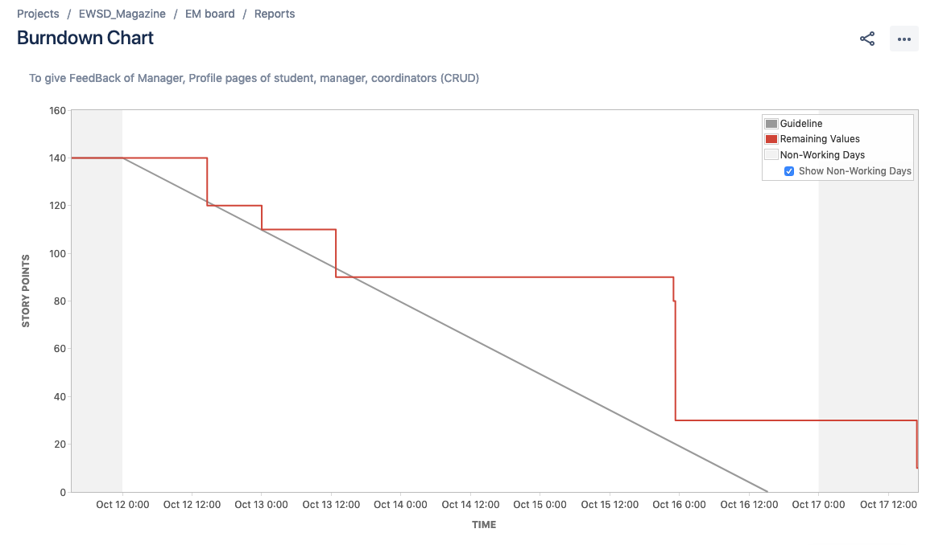

Completed Wireframes