PD Action Configuration Index.

Contents
1 Action,OutComes,Step & Step attributes Configuration 2-15
2.1 Action Configuration 2-6
2.1.1 Steps 7-9
2.1.1.1 Outcomes………………….…………………………………………………………………………………10-12
2.1.1.2 Attributes………………….…………………………………………………………………………………13-15

Action, Steps, Attributes & Outcomes Configuration
This Section will describe the PD configuration of Action, Steps, Attributes & Outcomes Configuration. It will describe how to create an Action and configure the Standard Action, View Action and Action Macro.

Action Configuration:
Standard Actions Overview and Examples
Definition : Standard Actions work within a context that includes the whole quote or transaction. They concern themselves with all of the occurrences in the transaction rather than any single specific one.
Ex: genInvoiceConfig, runExtPaymentMonitor, postAccount.
View Actions Overview and Examples.
Definition : View Actions work within a context that includes only a single occurrence, and within that occurrence only the Questions present in the active View. They work within the View and do not directly impact any other occurrences
Ex: allocateAdjustmentPT, unAllocateFWAdj, unAllocateAdjustment

Action Macro Overview and Examples
Definition : Action macro’s will be called from Standard Actions. It can be considered as a recursive function.
Calling a Action from another Action.
If Standard Actions can is JAVA class then Action Macro can be called as a JAVA method.
Ex: runPayPlanChangeMAC, uploadICInvoiceMACRO

Step 1: - Select the Product group in which you want to create a new action
For example, this could be ‘Businessowners’,’account’, ‘remittance’ etc.
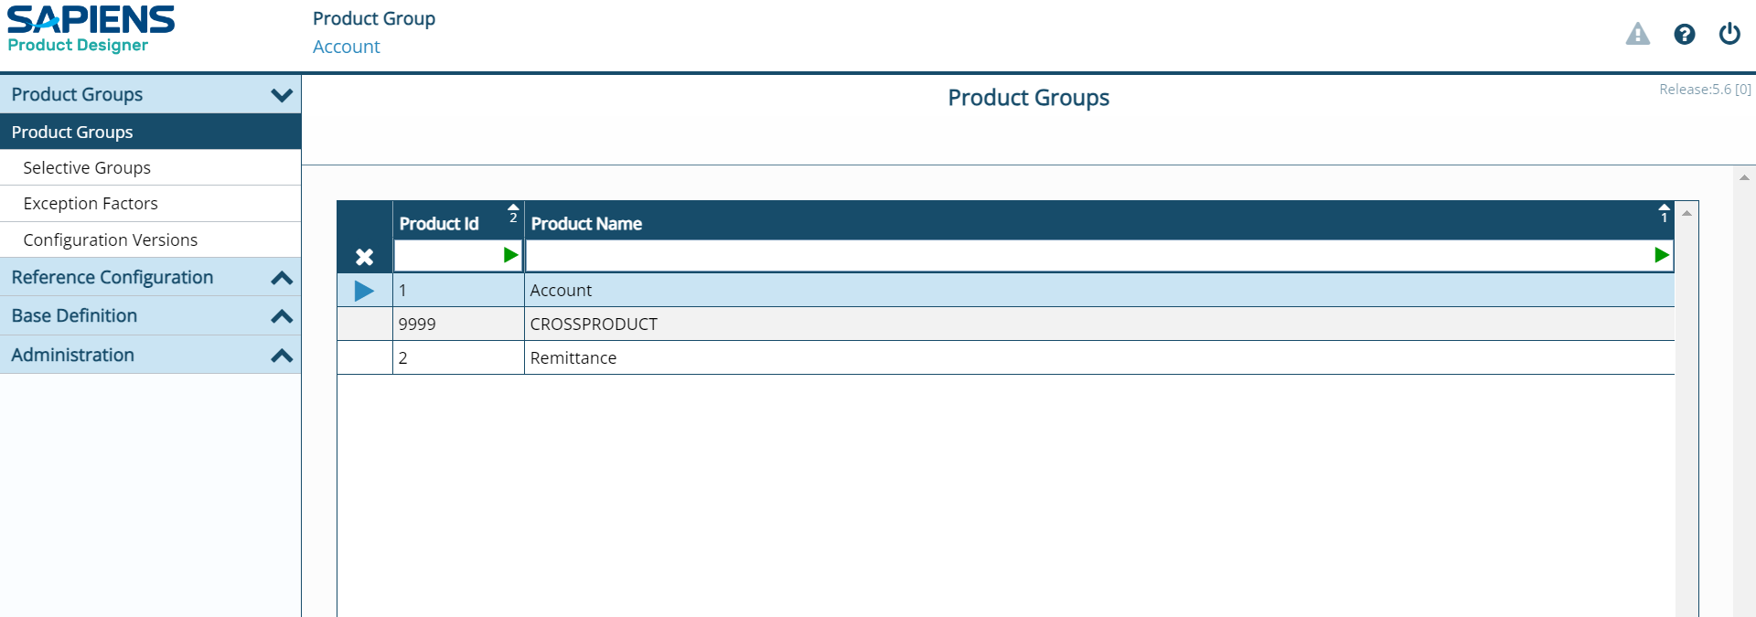

Step 2: - Click on Configuration Versions and select the appropriate configuration version.
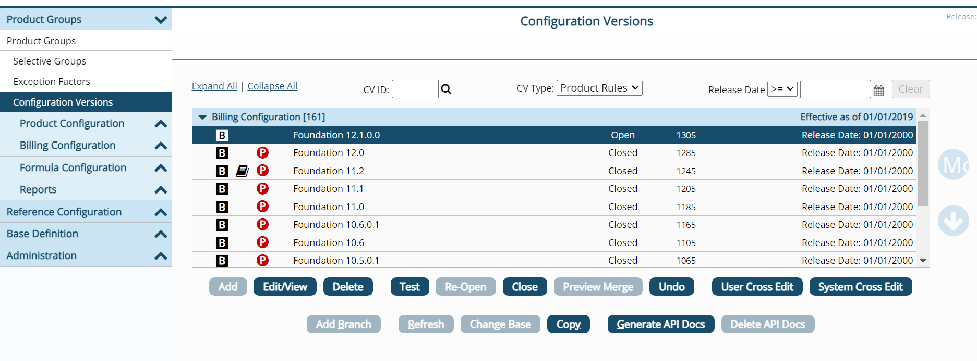

Step 3: - Once you click on 'Configuration Versions,' multiple tabs will appear, such as Product Configuration, Billing Configuration, and Formula Configuration.
Billing Configuration will be available under Billing Pro, Policy Configuration under Policy Pro, and similarly, each component will have its respective configuration available.
Expand the Billing Configuration tab.
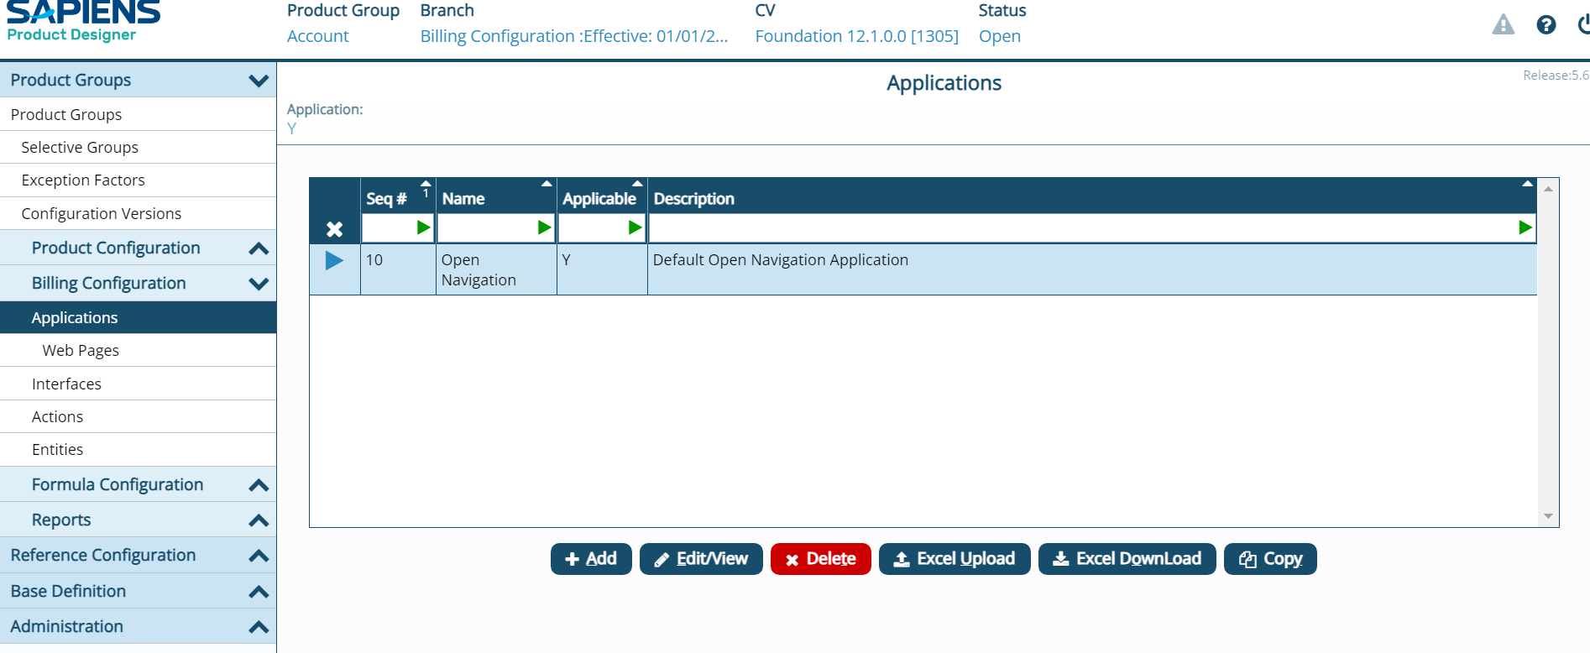

Step 4: - Click on the Actions.
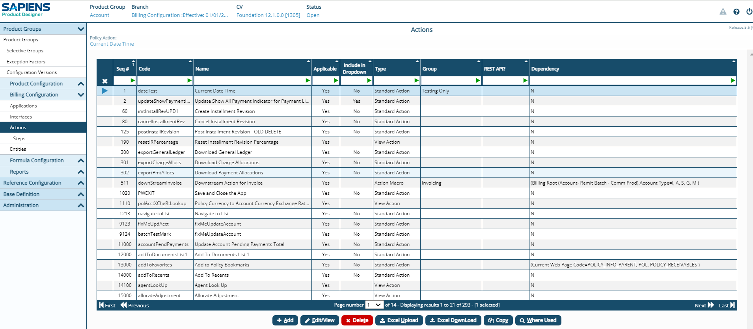

Step 5: - Click on the +Add button. Product Action box appears.
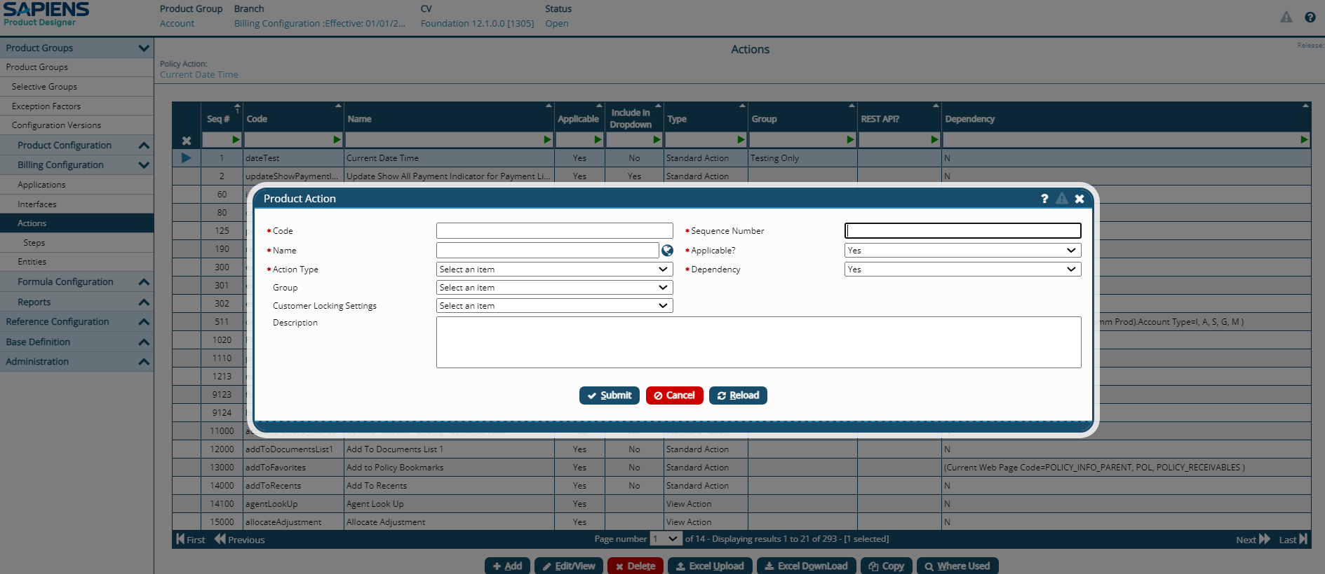

Step 6: - Provide the required information.
- Specify the unique action name under “code”, and specify the name of the action under “Name” box.
- Specify the action such as Standard Action, Action Macro , View action etc under Action type.
- Specify the sequence number of the action and make sure the sequence number should be unique by considering other added actions.
- We can toggle the action to “Yes”(On) or “No”(off) in “Applicable” section.
- Specify if the action is dependent on some other parameters to perform its operation.
- If it is a standard action , please specify if it has to be included in dropdown under application dashboard.
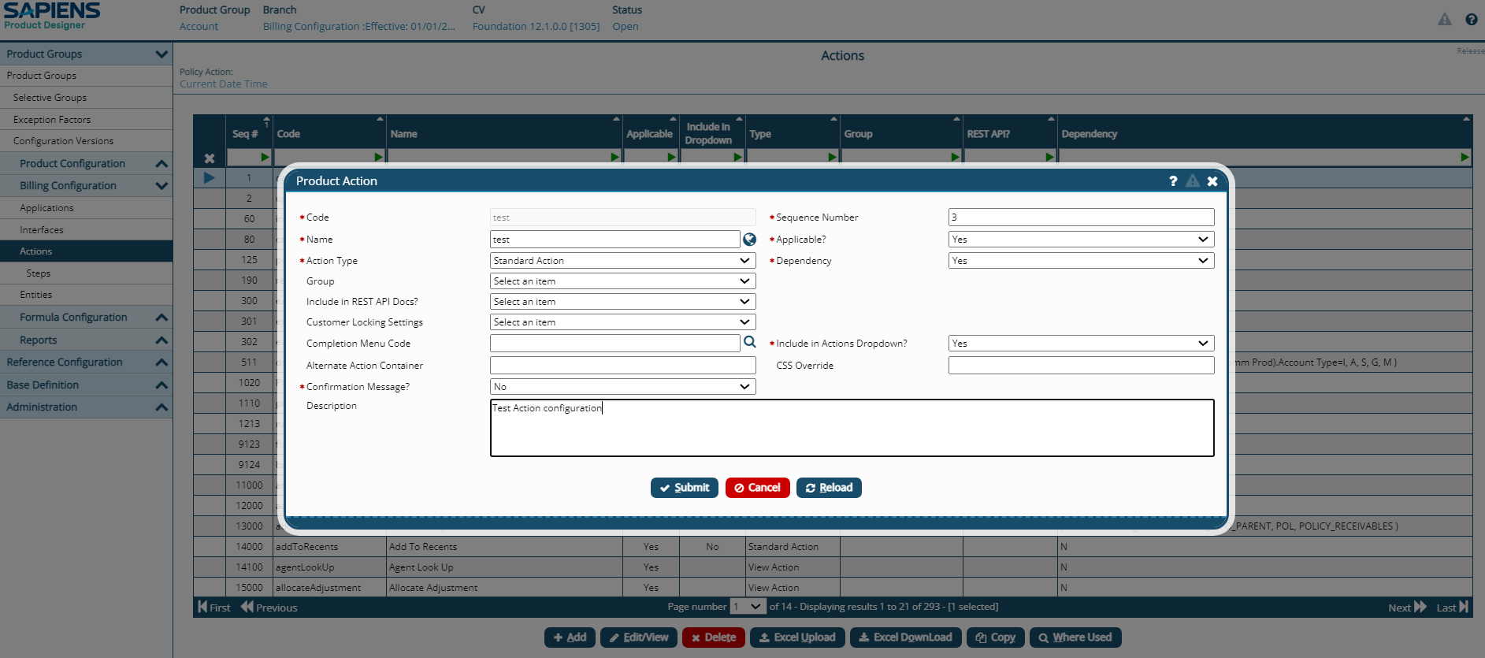

Step 7: -Click on Submit button.
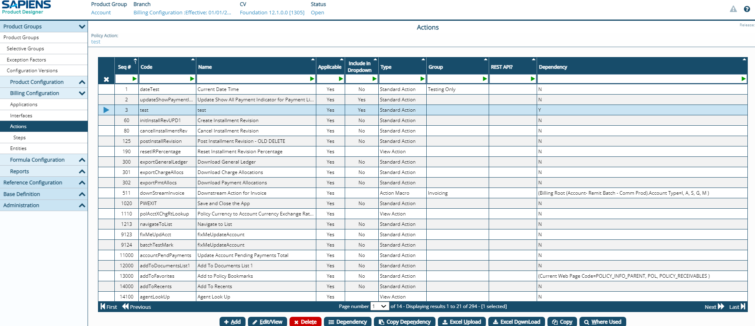
Action added successfully.

Steps Configuration:
Each Action consists of one or more Steps, a distinct unit of work to be done within the Action. Action Steps are discrete units of work within an Action that execute Billing - provided methods, run custom code (XSL’s, etc.) or call external systems
- Actions steps often reference an internal Billing method (see appendix for full list of Internal Methods)
- Action steps can call a Web Service – URL, Web Service – Java Bean, etc.
- Each step can have multiple potential Outcomes & Attributes
- Dependencies control Step applicability
Each Action Step provides the ability to:
- Optionally use input XML (Generated from DB, or reused)
- Optionally apply an XSLT to transform the input XML
- Allows translation between Billing XML and outside vocabularies
- Call a service (Web Service – URL, Web Service, or an billing Internal Method)
- Optionally apply an XSLT to transform any XML returned
- Allows translation between outside vocabularies and billing XML
- Transformed XML is available for processing by a subsequent Step

Step 1: -Click on the step in the navigation bar which appears under action tab.
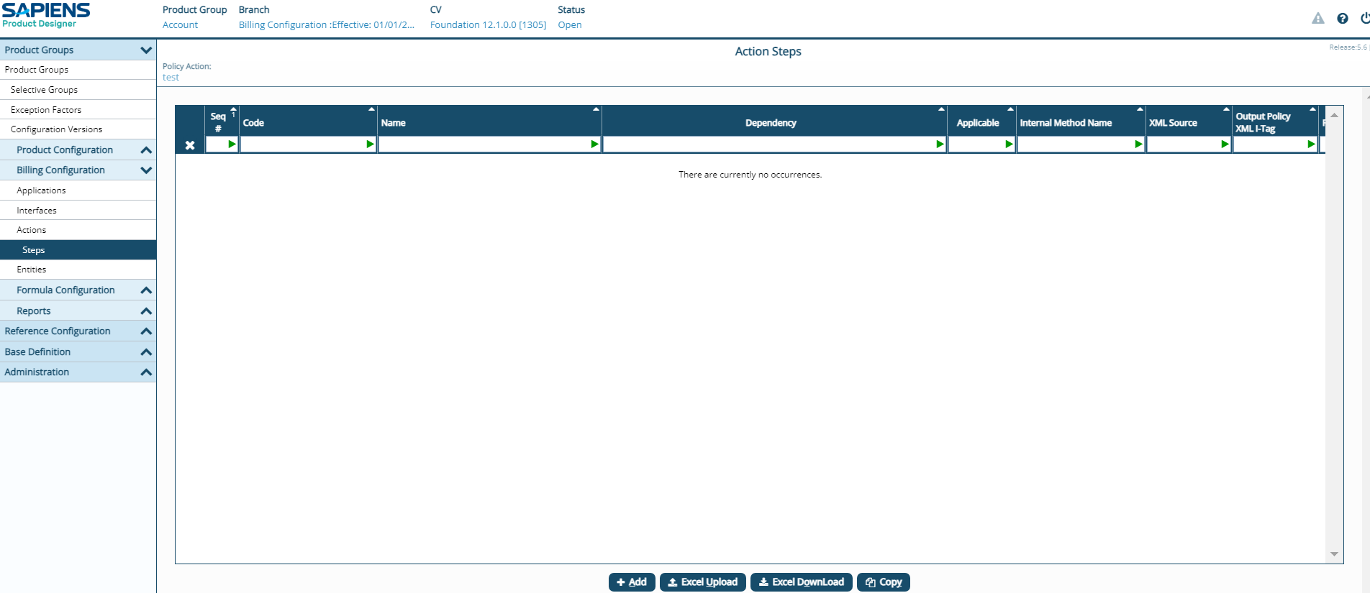

Step 2: -Click on the +Add button
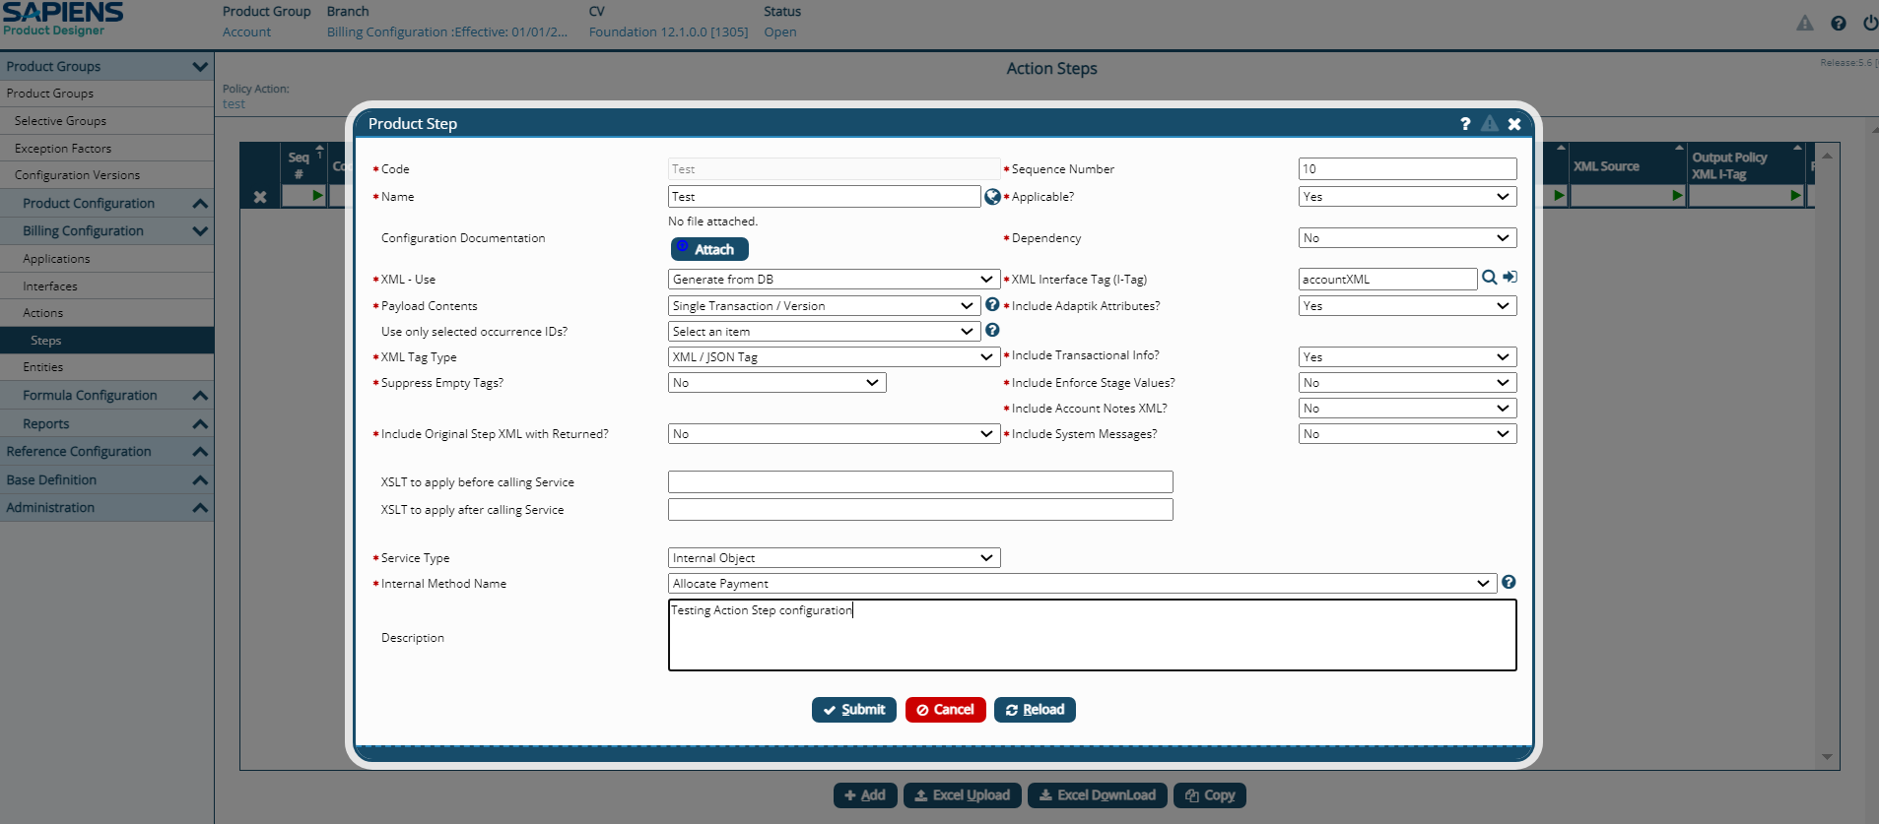

Step 3: - Provide the required information.
- Specify unique code for Step of action under “code”.
- Specify the unique sequence number for the step of action.
- Give suitable name for the Step under “Name” Section.
- Specify if the step is dependent on other parameters, if “YES” give the required dependants.
- Specify whether the step purpose is to “generate from DB” or “Upload XML” etc for XML related operations.
- Specify the interface name which will be used while processing the step under “XML Interface Tag(I-Tag).
- Specify the Payload transaction.
- Specify the Service type, such as “Internal Object” which can call “internal method” to perform the required operation.
- After adding all other mandatory parameters click on submit.


Step 4: - Click on Submit button.
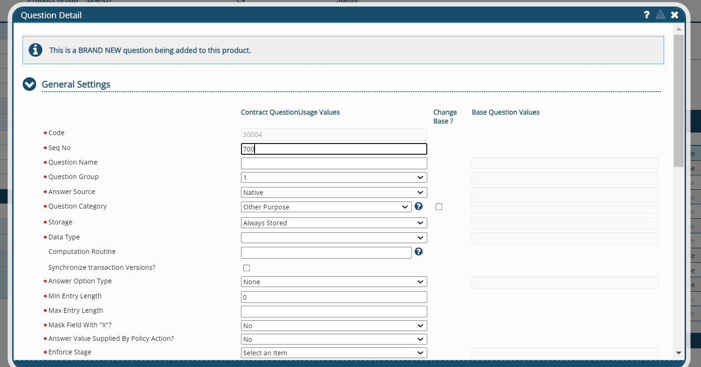
Step added successfully.

OutComes Configuration:
Outcomes specify return status information, navigation (Standard Actions only), and any specified Error Message for the Step.
- The Outcome will determine whether or not
the next Step in the Action should be invoked
by setting the Continue Process Code
- The Outcome can indicate that the Step succeeded
or failed to both the billing code and external
systems
- Outcomes are not required to successfully implement a Billing Action
- If a Step does not have an Outcome specified, then the next Step will be executed (success is assumed)
- Dependencies are used to determine which Outcome to use
- The first applicable Outcome will be selected (order matters)
- Outcome configuration on a Step SHOULD include a catch-all Outcome for unexpected errors
Ex : SUCCESS, FAILURE, UNSPECIFIED etc

Step 1: - Click on Outcome in the navigation which appears under Step.
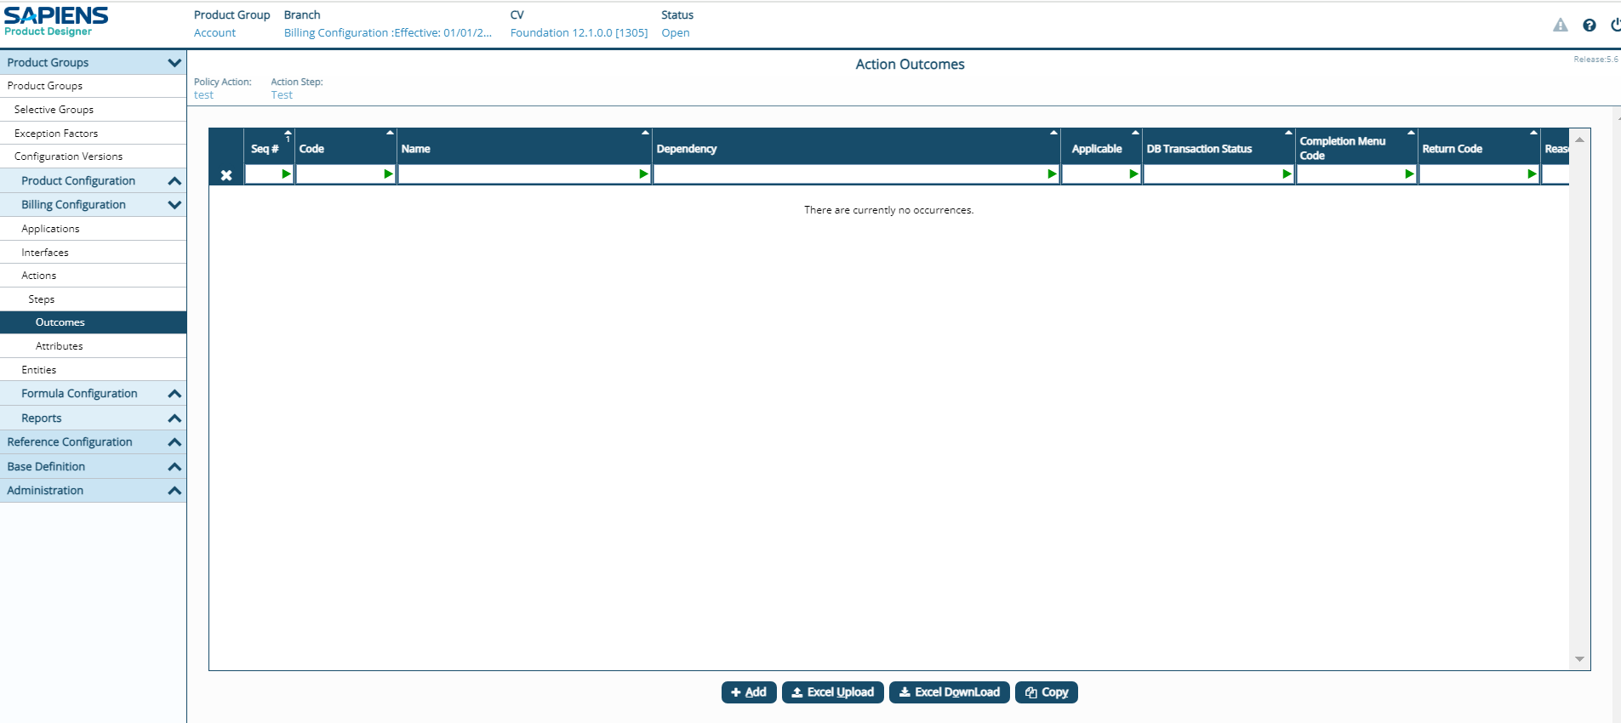

Step 2: - Click on +Add button.
Step 3: - Provide the necessary information.
- As each step contains necessary outcomes, we need to configure the outcomes whether it has to proceed further or not.
- Specify the OUTCOME code alone with unique Sequence number Ex: SUCCESS,FAILURE
- Specify if the outcome is applicable or not by giving “YES” or “NO” under applicable tag.
- Specify outcomes dependency by selecting “YES” or “NO” under dependency section.
- Whether with current outcome specify whether it has continue the process or not , under “Continue process” Section.
- Specify if this outcome indicates failure or not under “Does this outcome indicate failure?”

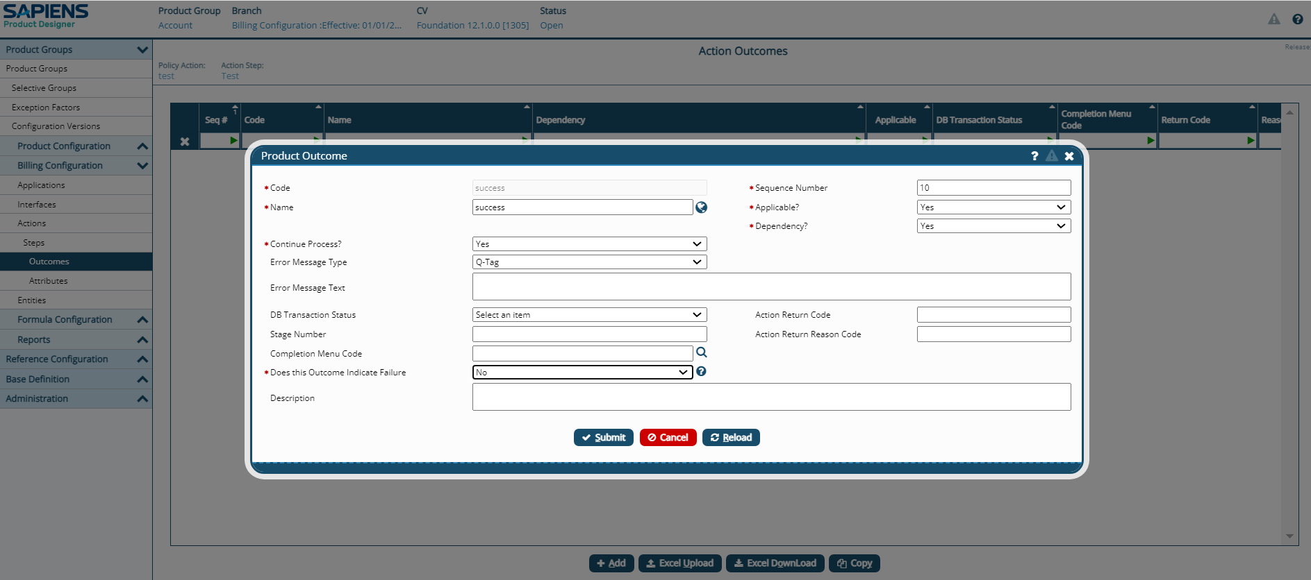

Step 4: - Click Submit.
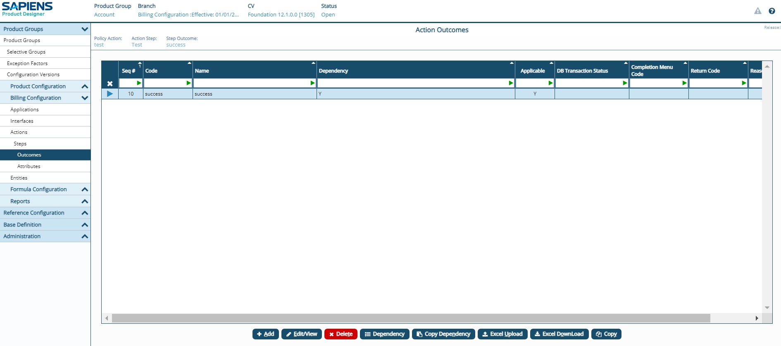
Outcome added successfully.

Step attributes Configuration.
Attributes are parameters that are used to guide the Step by indicating the object upon which the Step will operate, or what values to apply.
- Attributes are often needed for Internal Method calls
- Parameters are processed in the order
specified so the Attributes must be in the
order required by the Internal Method
- Attributes can also be used for external
service calls as needed
- Dependency processing is not available
for Attributes
- Only the needed Attributes should be
specified in the Action Step
Examples : Step : genRecInstallmentsA -> Step attributes : INVOICE_LEAD_DAYS, DUE_DAY_IND

Step 1: - Click on the Attribute on the navigation which appears under Steps.
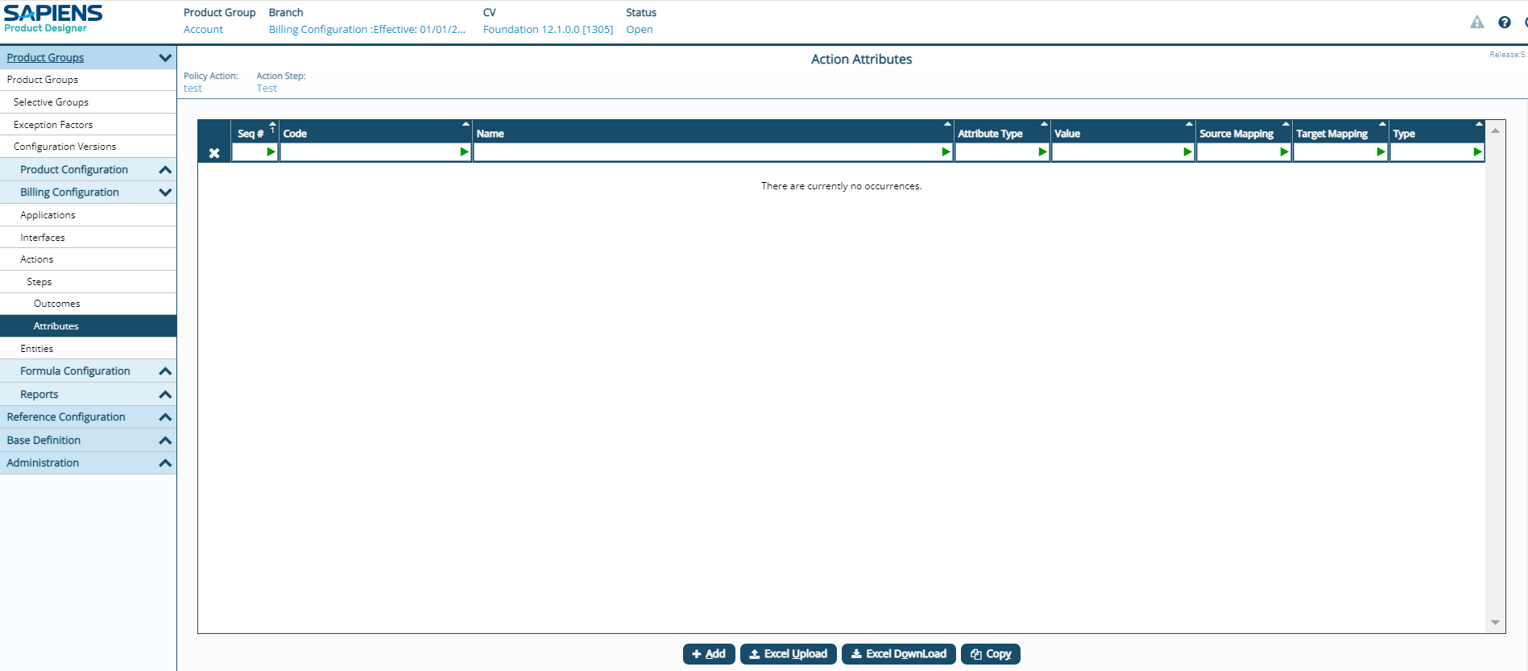
Step 2: - Click on the +Add Button.
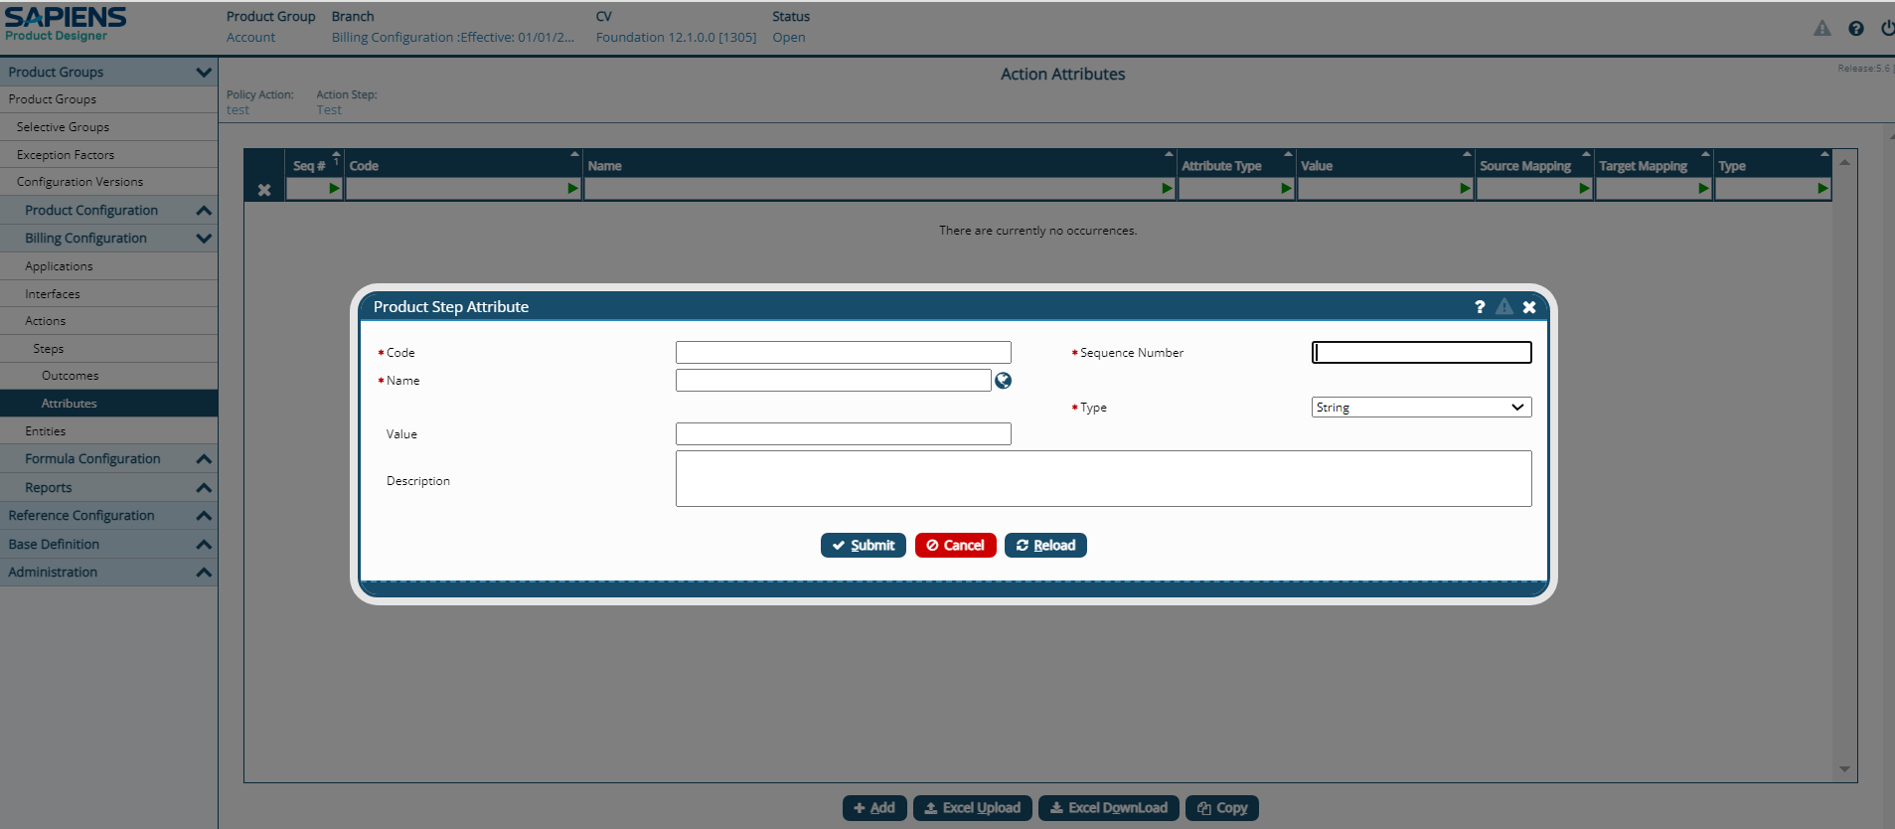
Step 3: - Provide the necessary information.
- Provide the Code of the step attributes which can match Q-tag or which supposed to match DB column under “Code” Section.
- Provide unique sequence number for step attributes.
- Give the “Name” and “Type” of step attribute such as “String, Integer,Date etc” .
- Give the “value” of the step attribute which supposed to contain its value and then submit.
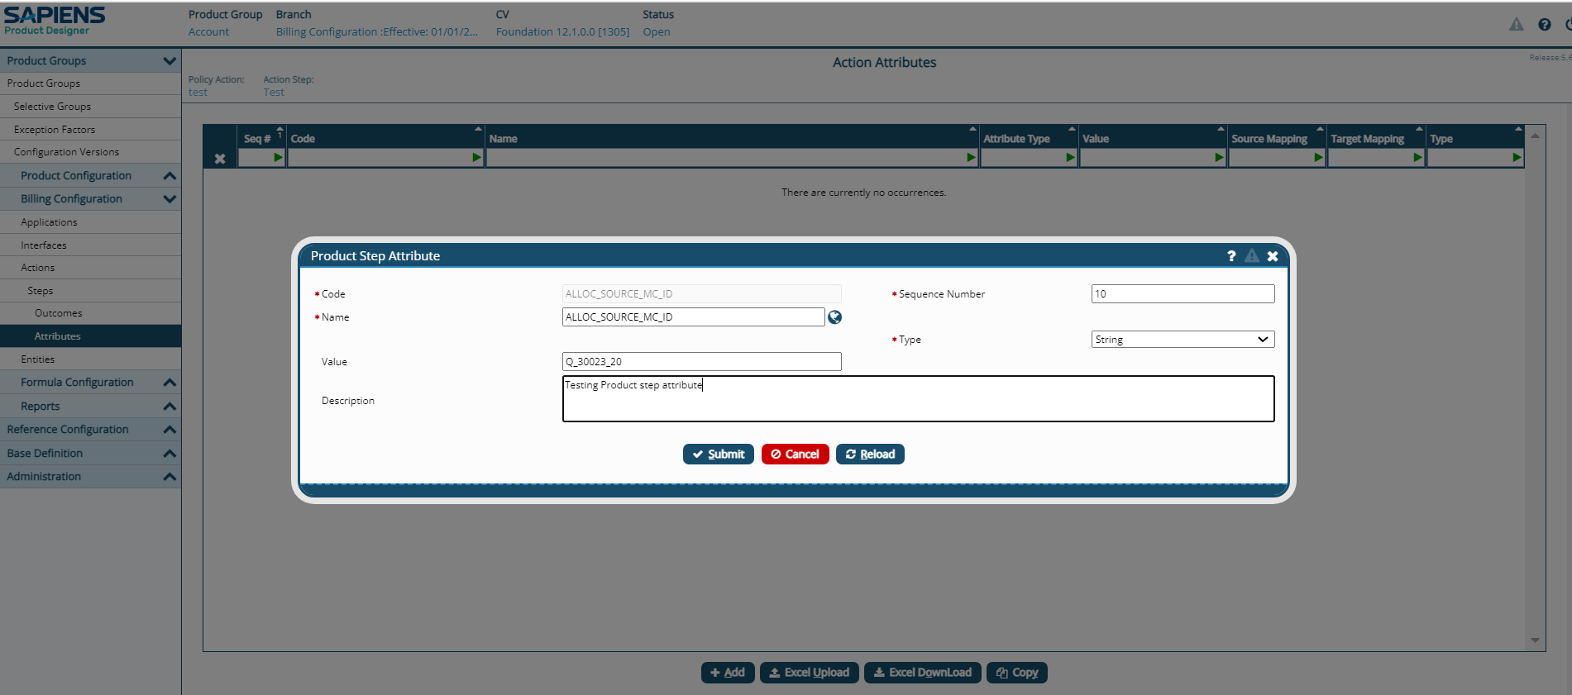
Step 4: - Click Submit.

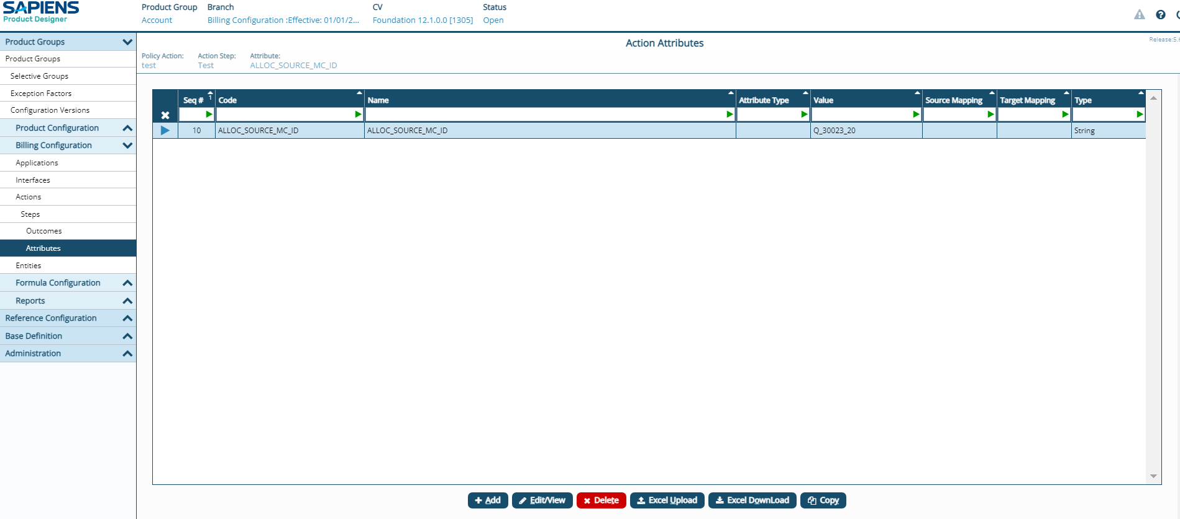
Attribute added successfully.

