PD-Action_Configuration

ACTION
Step 1: - Select the Product group in which you want to create a new action
For example, this could be ‘Businessowners’,’account’, ‘remittance’ etc.
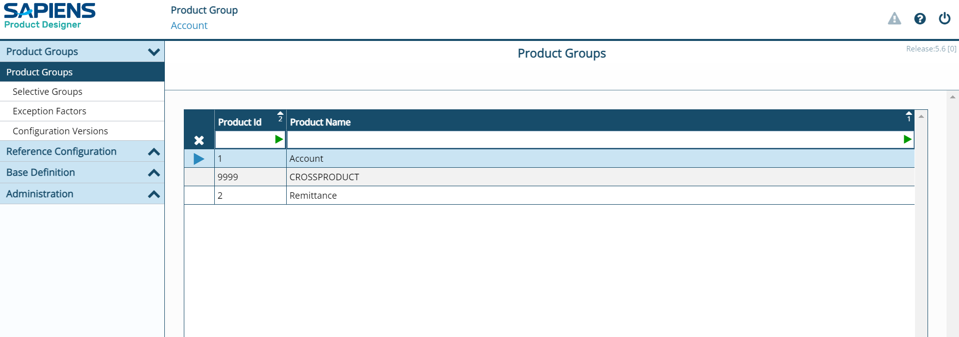
Step 2: - Click on Configuration Versions and select the appropriate configuration version.
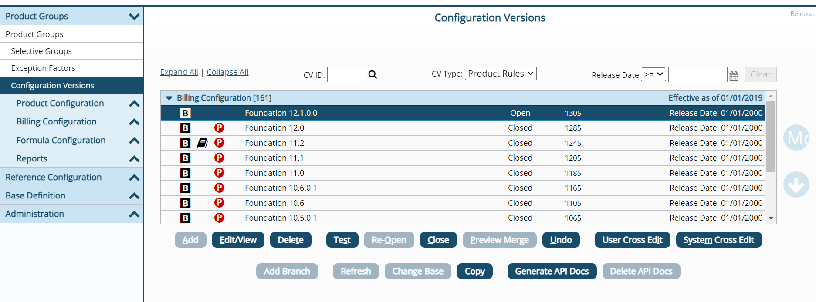
Step 3: - Once you click on 'Configuration Versions,' multiple tabs will appear, such as Product Configuration, Billing Configuration, and Formula Configuration.
Billing Configuration will be available under Billing Pro, Policy Configuration under Policy Pro, and similarly, each component will have its respective configuration available.
Expand the Billing Configuration tab.
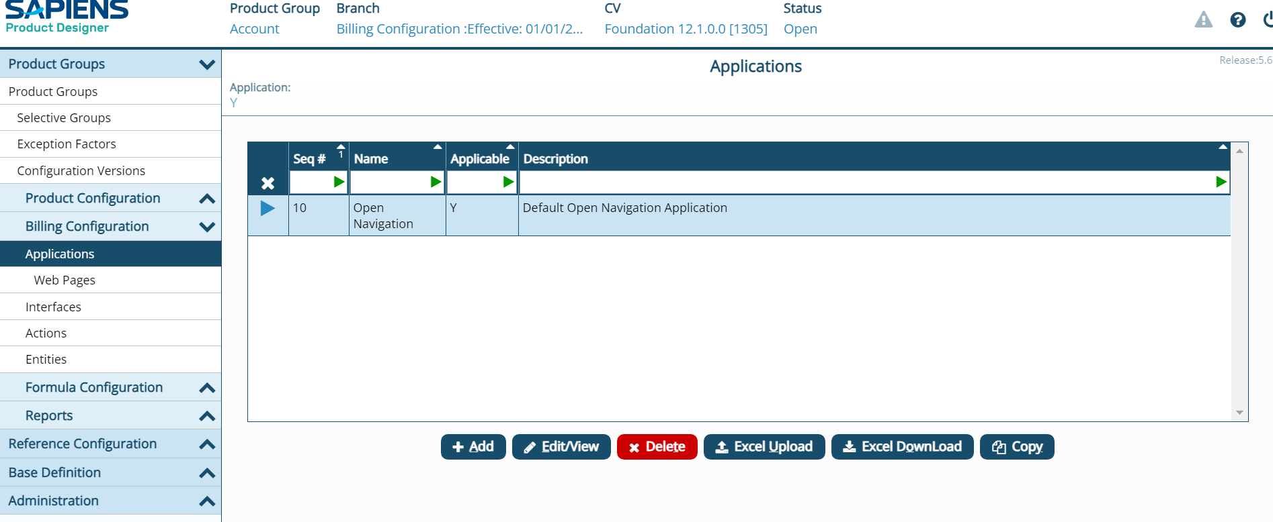
Step 4: - Click on the Actions.
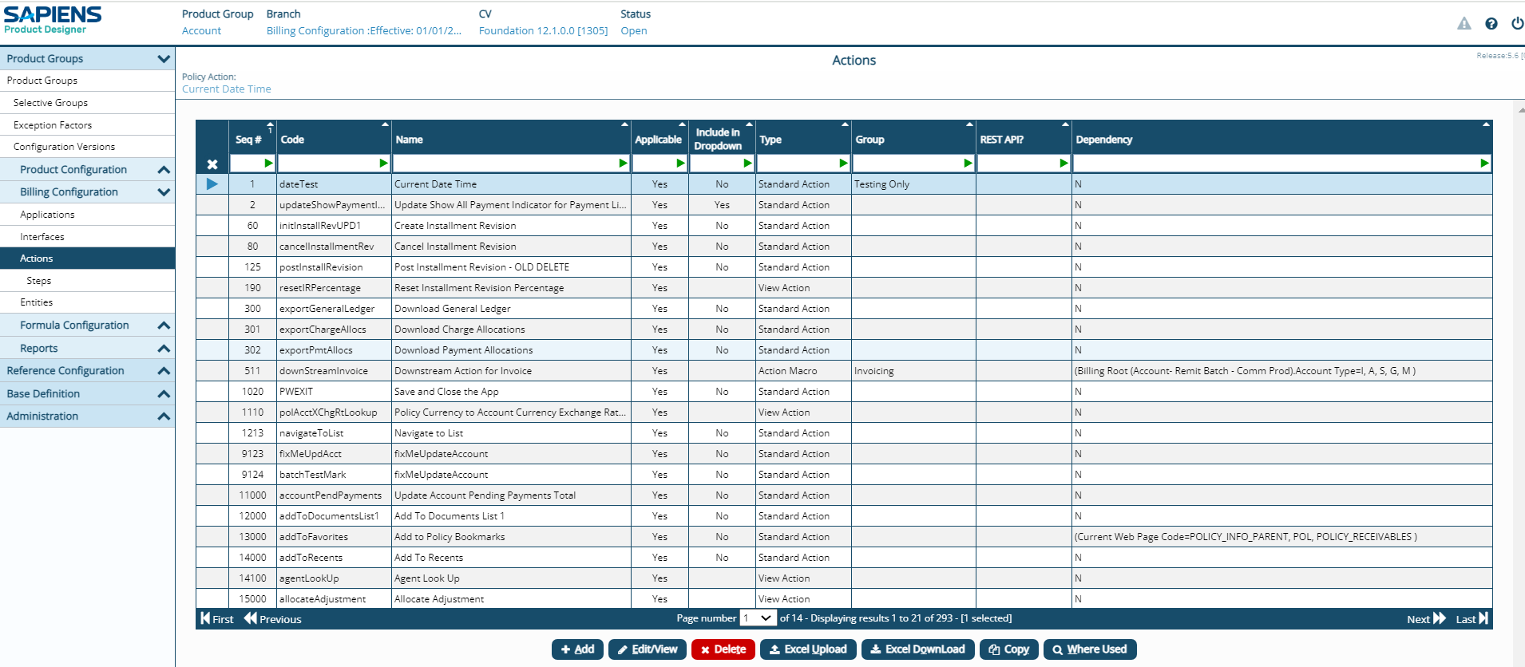
Step 5: - Click on the +Add button. Product Action box appears.
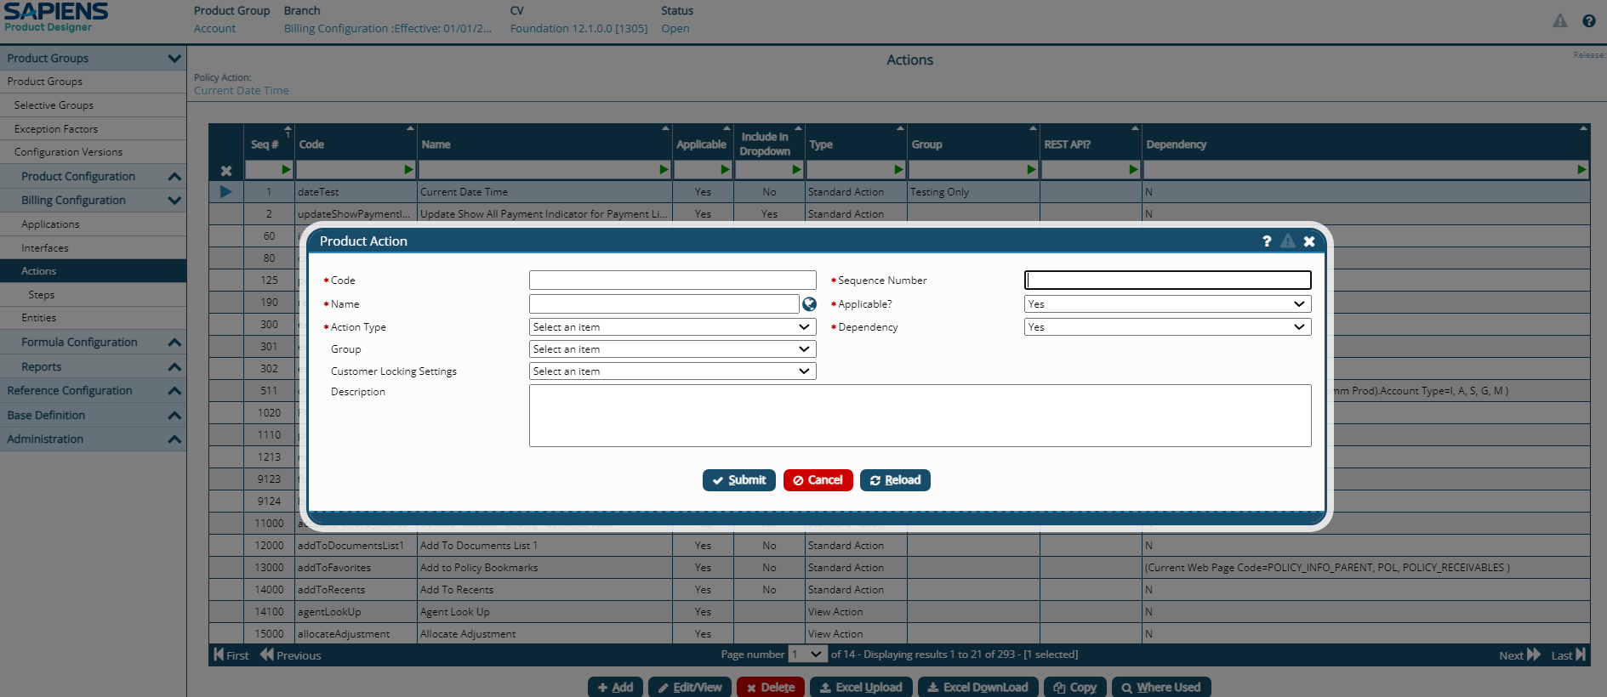
Step 6: - Provide the required information.
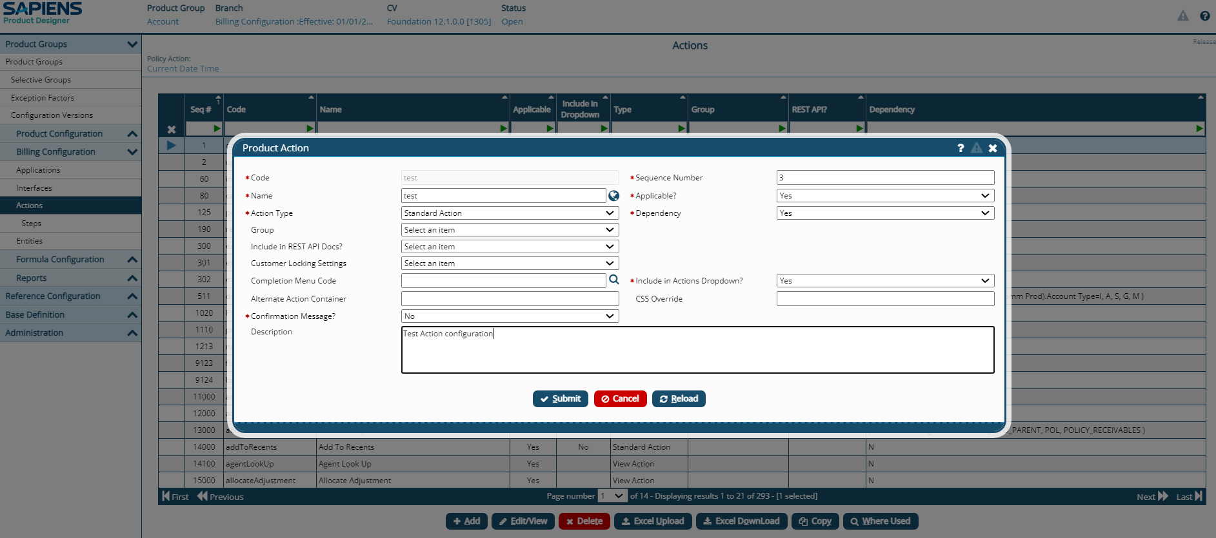
Step 7: -Click on Submit button.
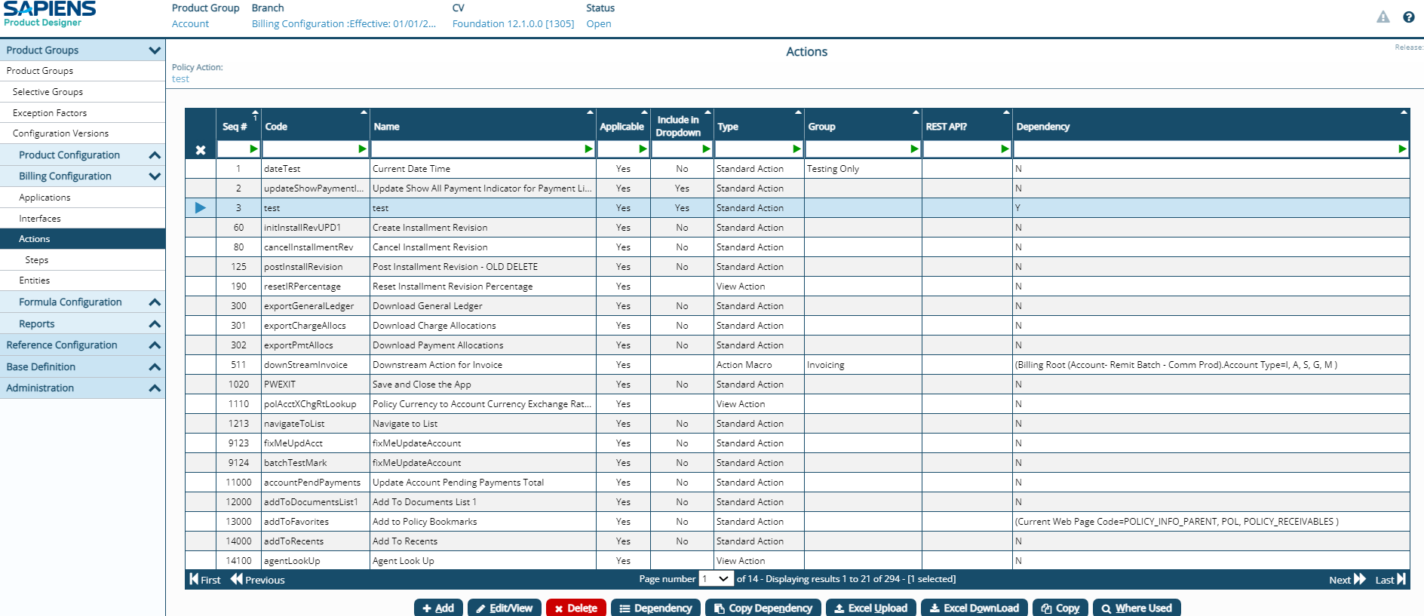
Action added successfully.

ACTION STEP

Step 8: -Click on the step in the navigation bar
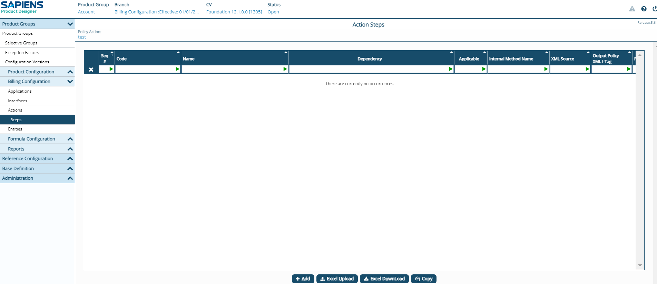
Step 9: -Click on the +Add button
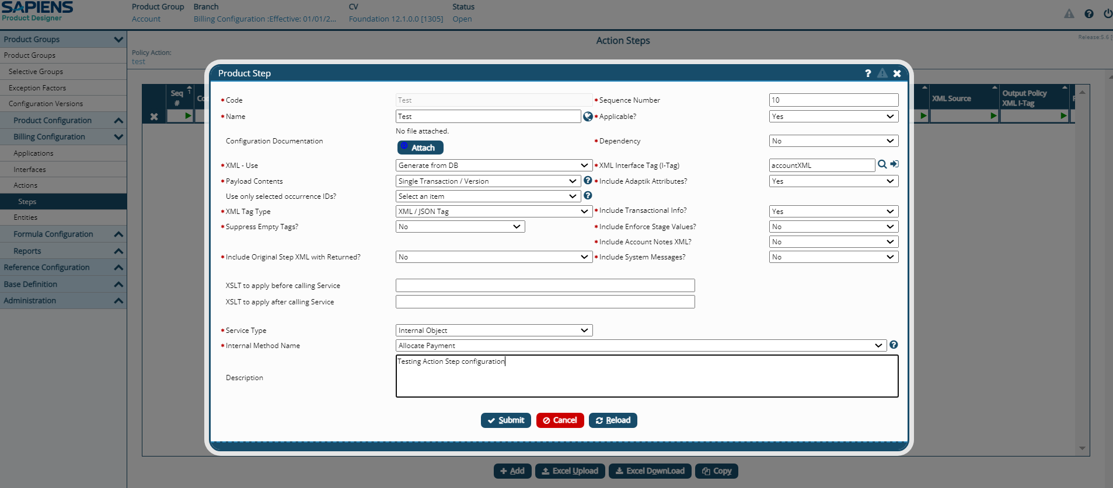

Step 10: - Provide the required information.

Step 11: - Click on Submit button.
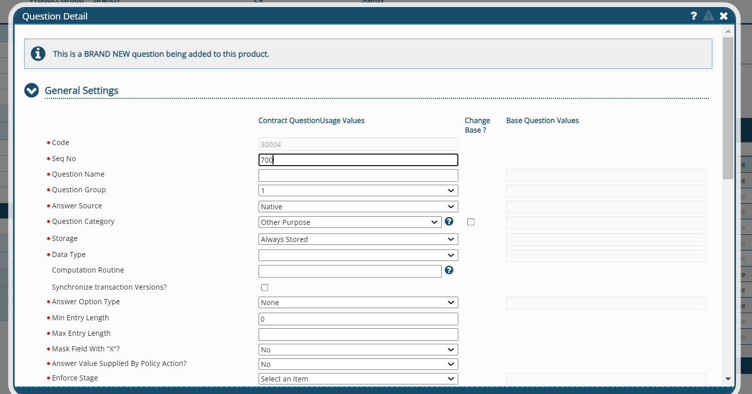
Step added successfully.

ACTION STEP OUTCOME

Step 12: - Click on Outcome in the navigation.
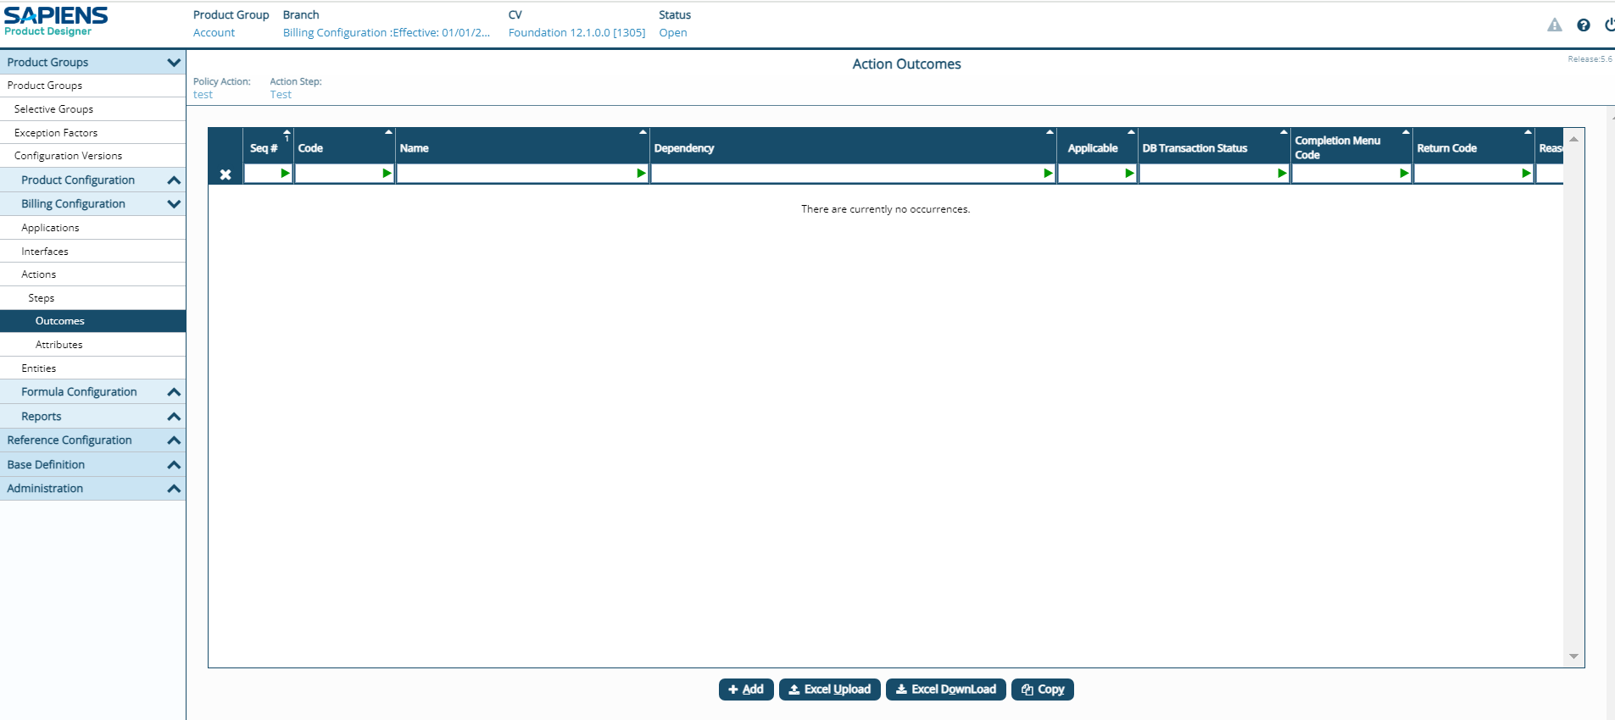
Step 13: - Click on +Add button.
Step 14: - Provide the necessary information.

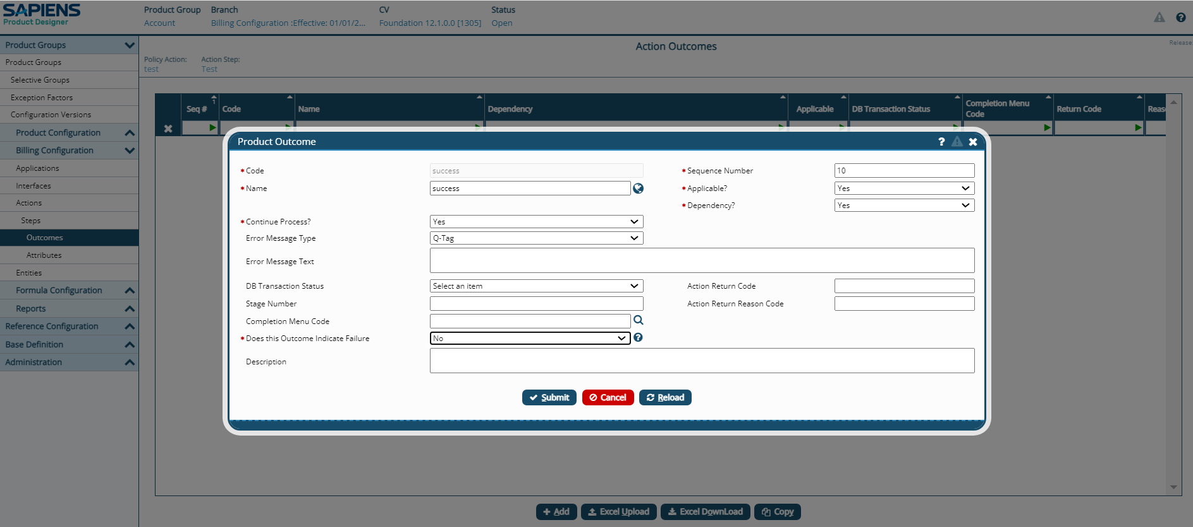
Step 15: - Click Submit.
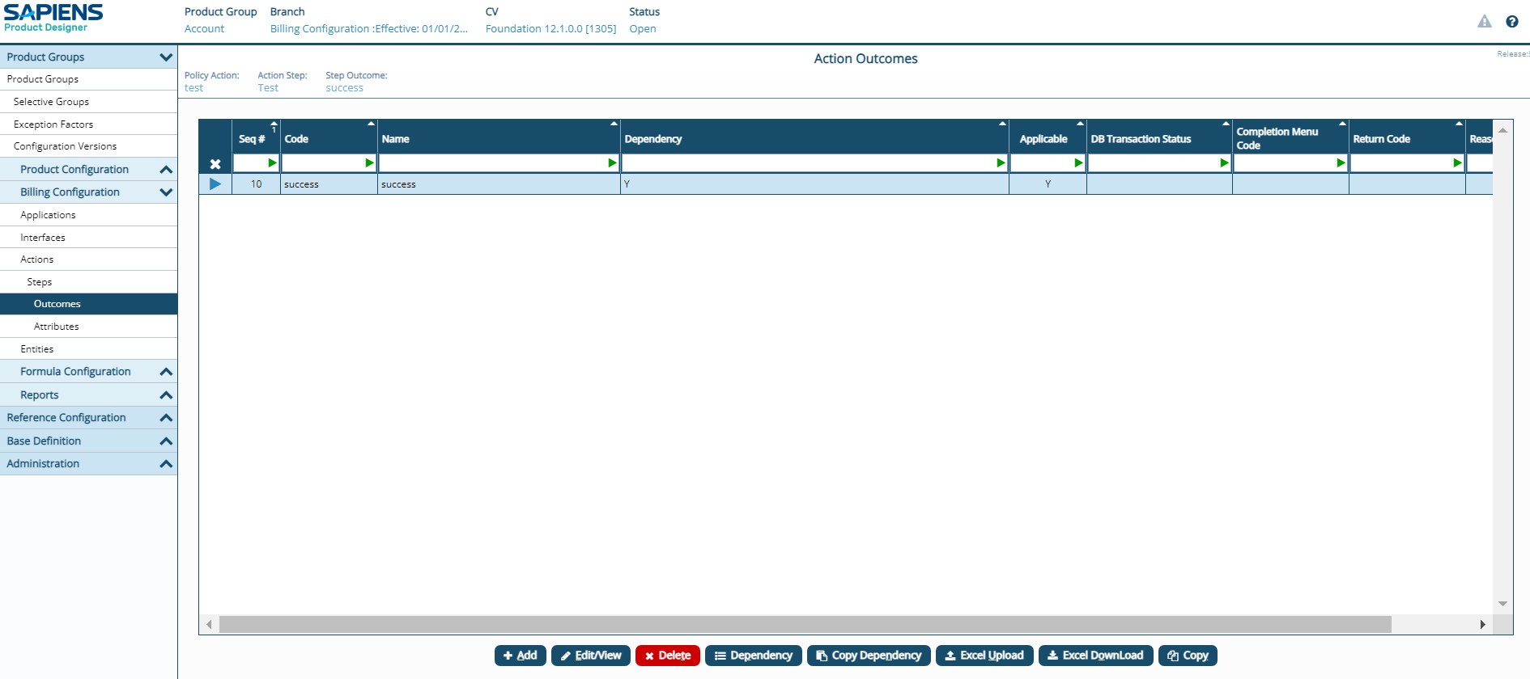
Outcome added successfully.

ACTION STEP ATTRIBUTE

Step 15: - Click on the Attribute on the navigation.
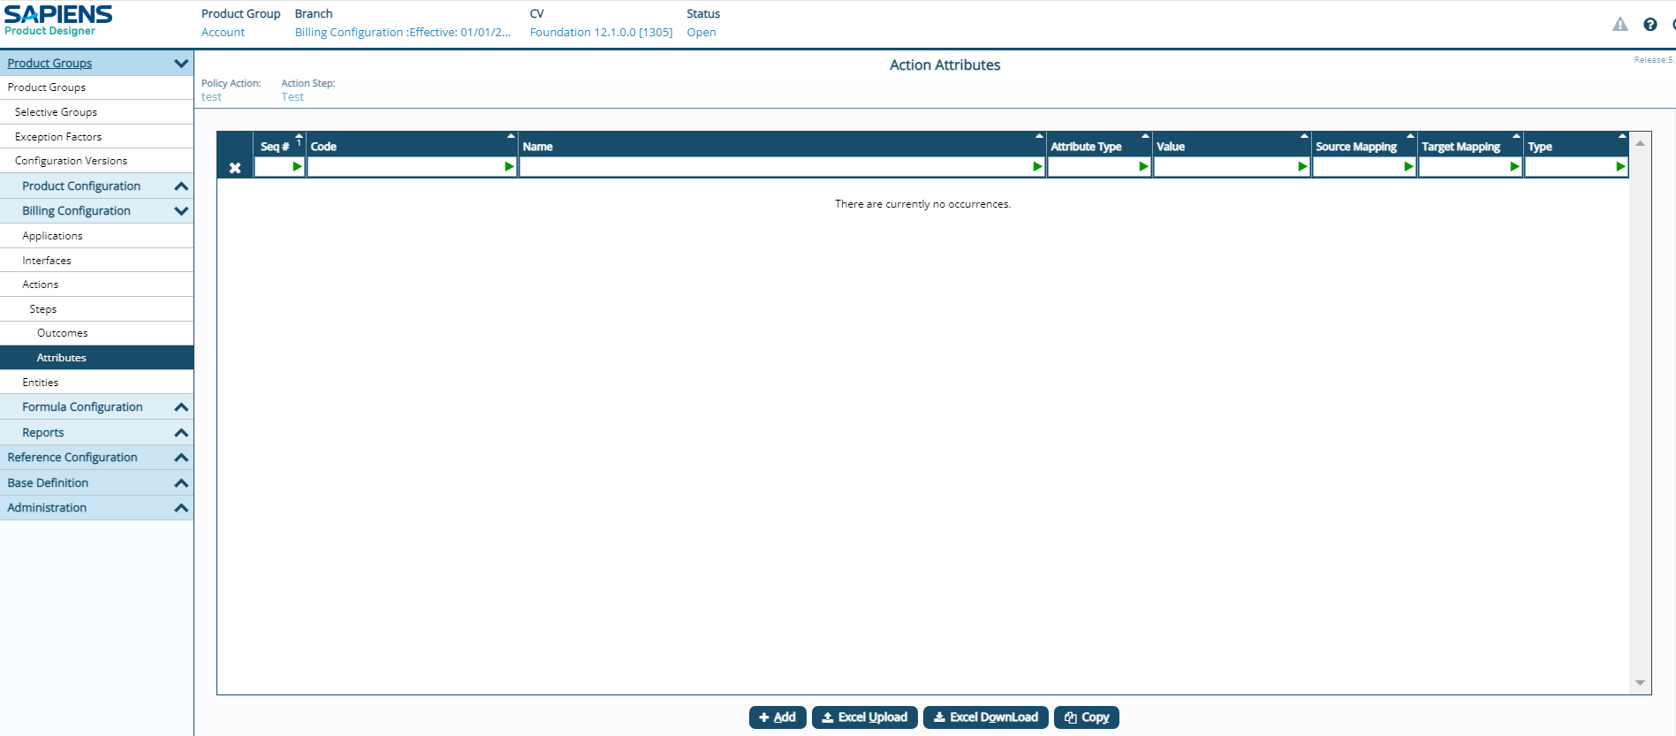
Step 16: - Click on the +Add Button.
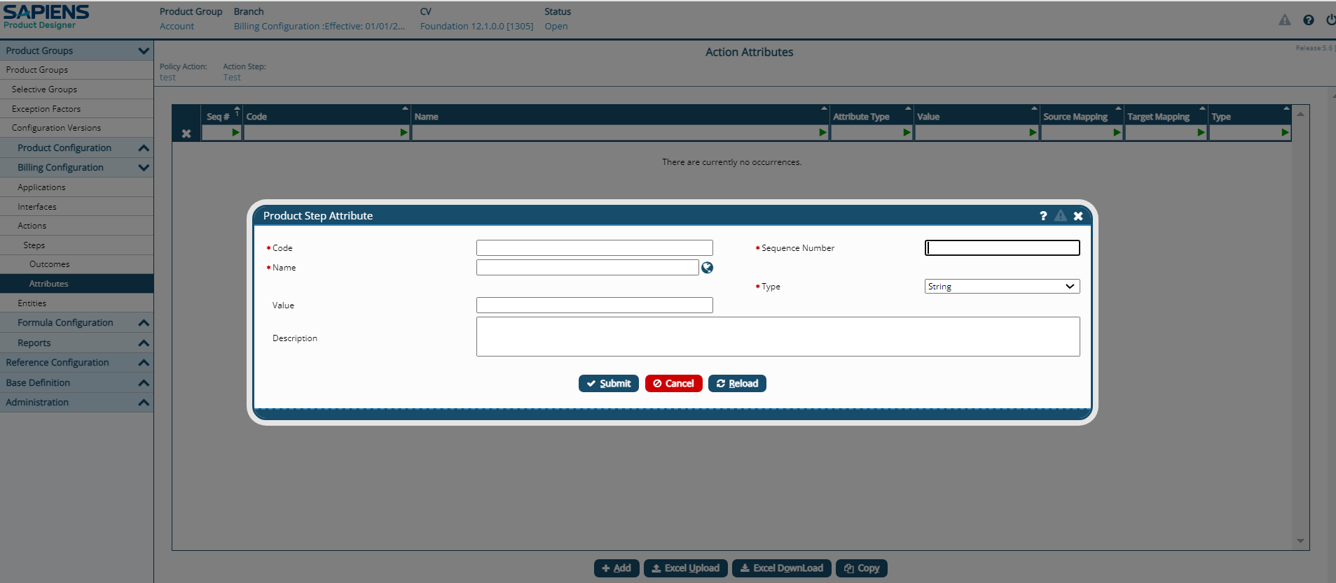
Step 17: - Provide the necessary information.
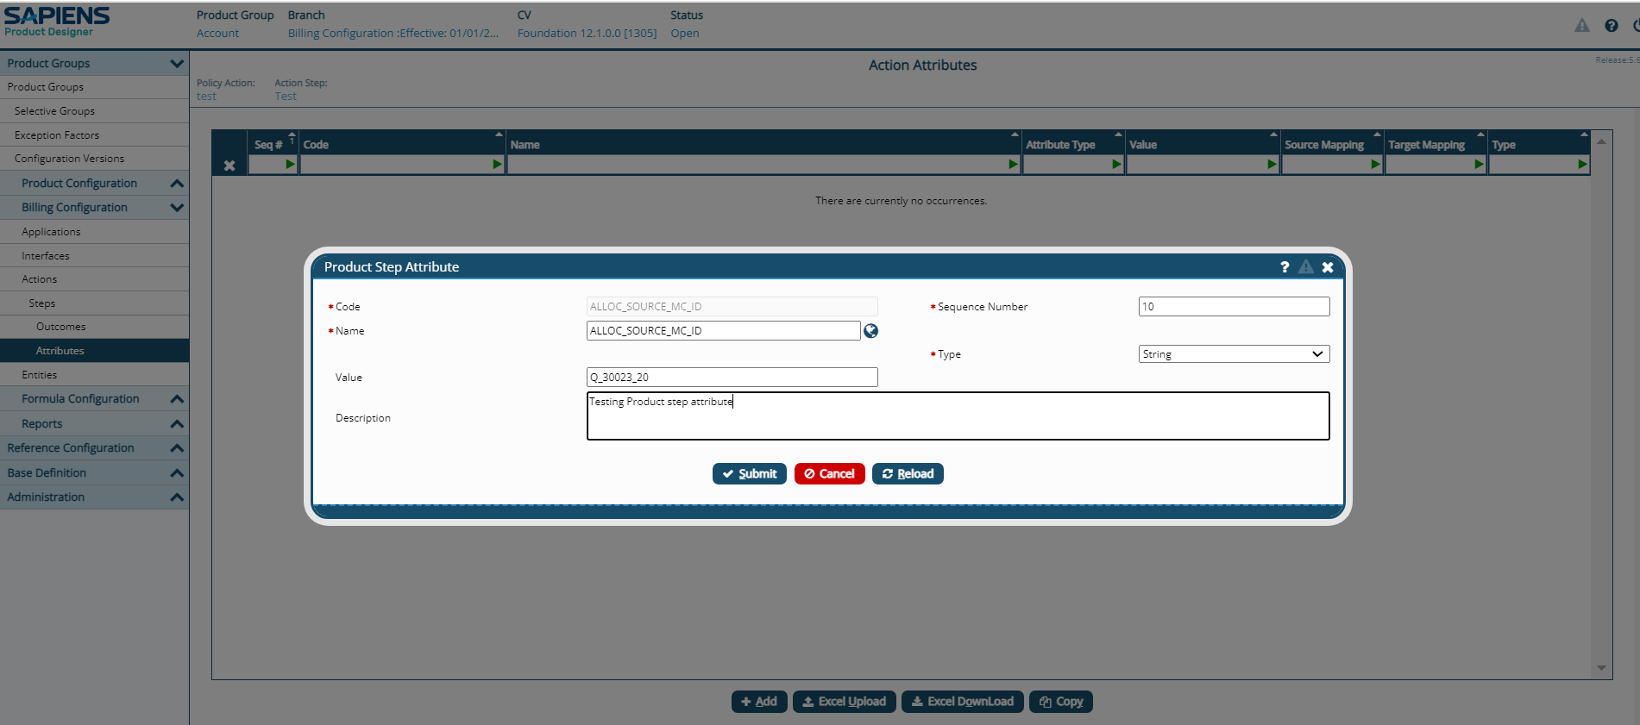
Step 15: - Click Submit.

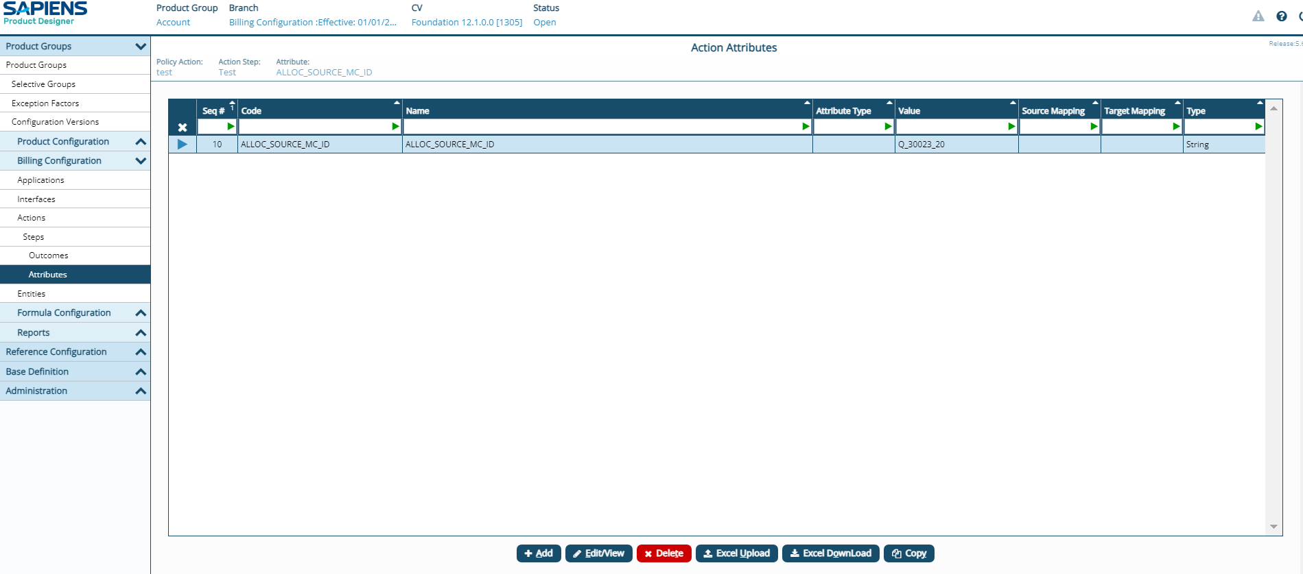
Attribute added successfully.

