ASSIGNMENT

NAME: SAFIYA TABASSUM
- Create tomcat , wordpress , nginx , Jenkins container with hosted volume

docker pull tomcat
docker run -it -v/home/ec2-user/mydata:/var/www/html --name webserver1 tomcat /bin/bash

docker pull wordpress
docker run -it -v/home/ec2-user/mydata:/var/www/html --name webserver2 wordpress /bin/bash

docker pull nginx
docker run -it -v/home/ec2-user/mydata:/var/www/html --name webserver3 nginx /bin/bash

docker pull jenkins/jenkins
docker run -it -v/home/ec2-user/mydata:/var/www/html --name webserver4 jenkins/jenkins /bin/bash

docker images

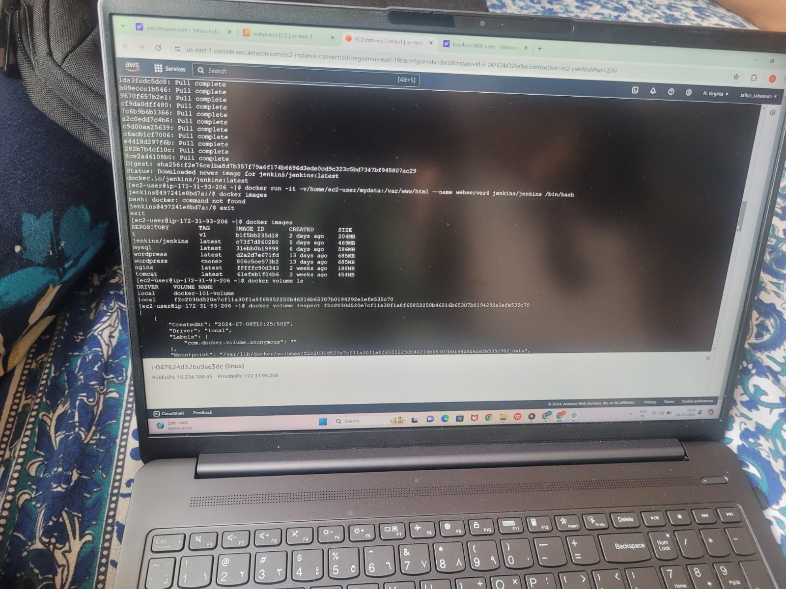

Created tomcat, WordPress, nginx, jenkins container with hosted volume
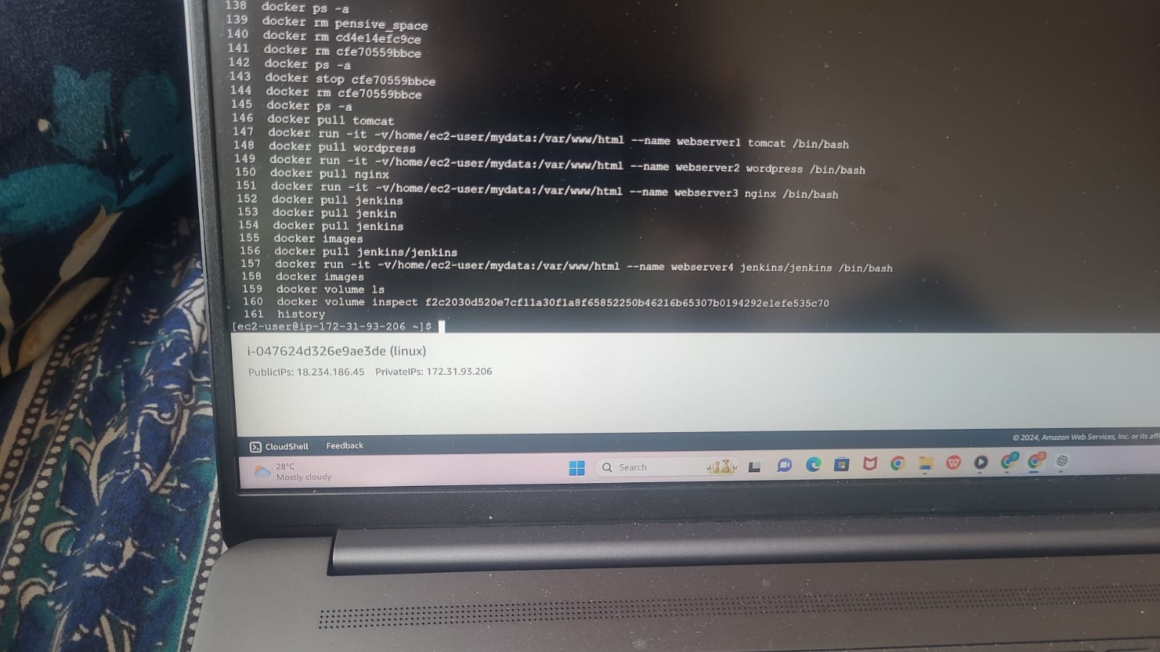

Docker hosted volume commands used

- Push nginx image to dockerhub.

docker ps -a
docker commit webserver4 newweb
docker tag newweb:latest safiyatabassum/safiya
docker login
User name:XXXX
Password:XXXX
docker push safiyatabassum/safiya:newweb
docker push safiyatabassum/safiya
Go to dockerhub & check the repository.

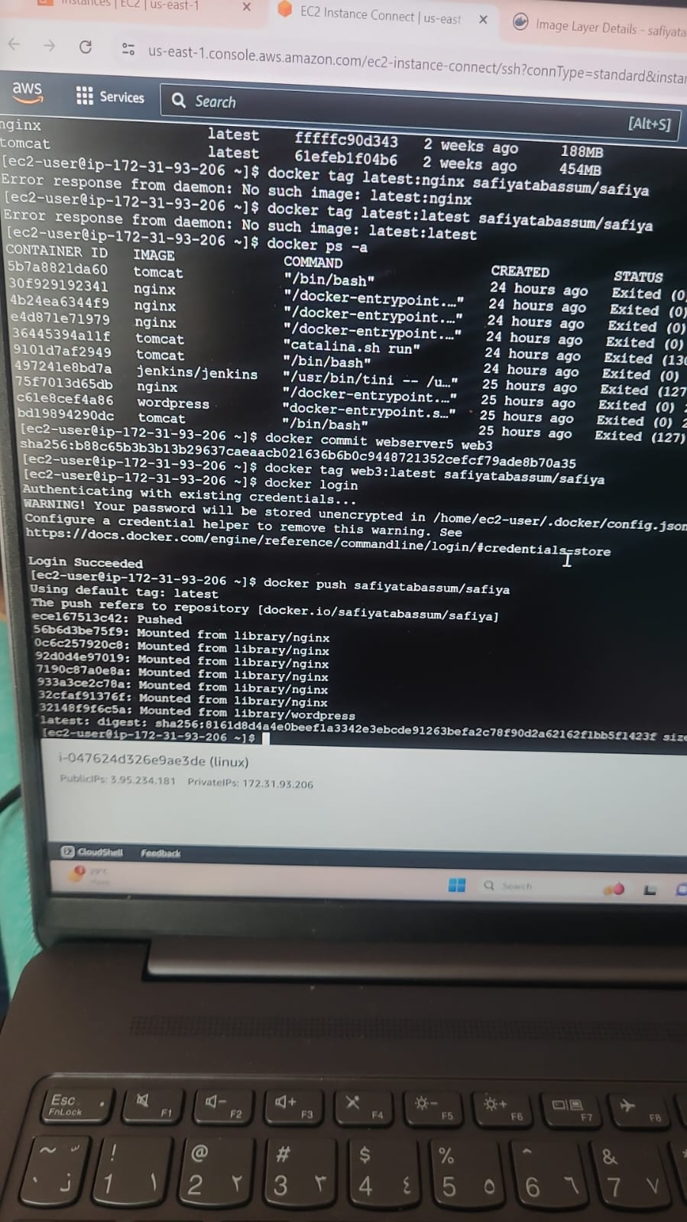
Pushed nginx image to dockerhub
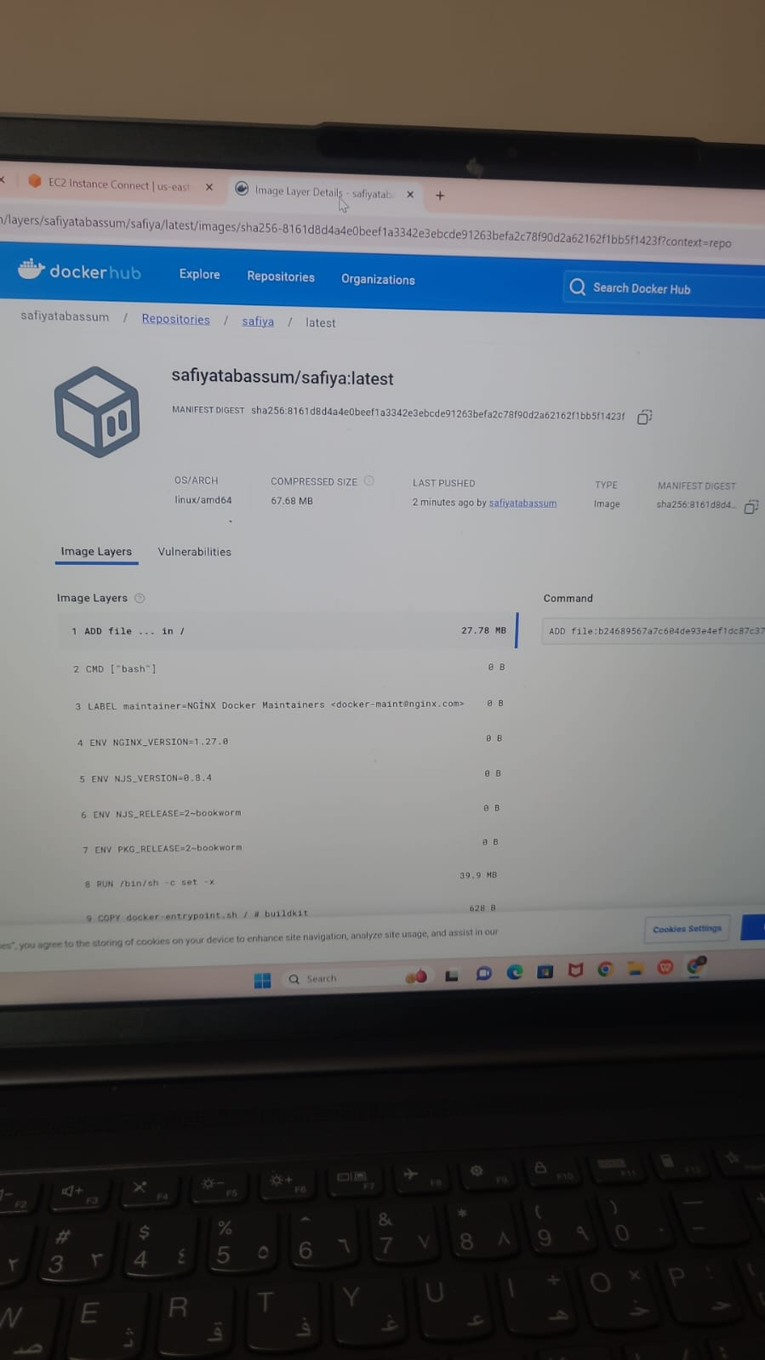
Pushed image on dockerhub repository

- Push Jenkins custom image to docker hub and github.
docker ps -a
docker commit webserver5 web3
docker tag web3:latest safiyatabassum/safiya
docker login
docker push safiyatabassum/safiya
User name:XXXX
Password:XXXX
docker push safiyatabassum/safiya:web3
docker push safiyatabassum/safiya
Go to dockerhub & check the repository.
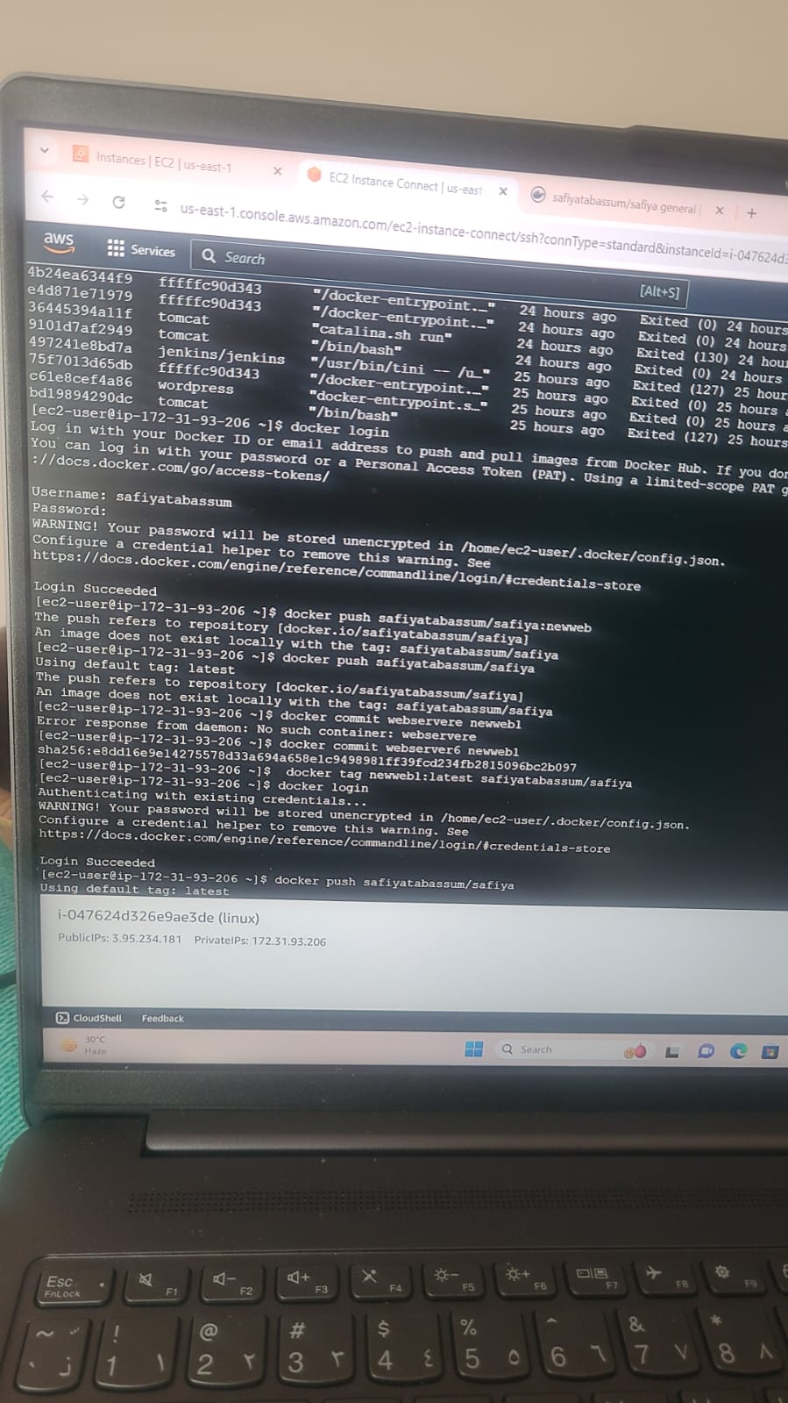
Pushed jenkins image to dockerhub
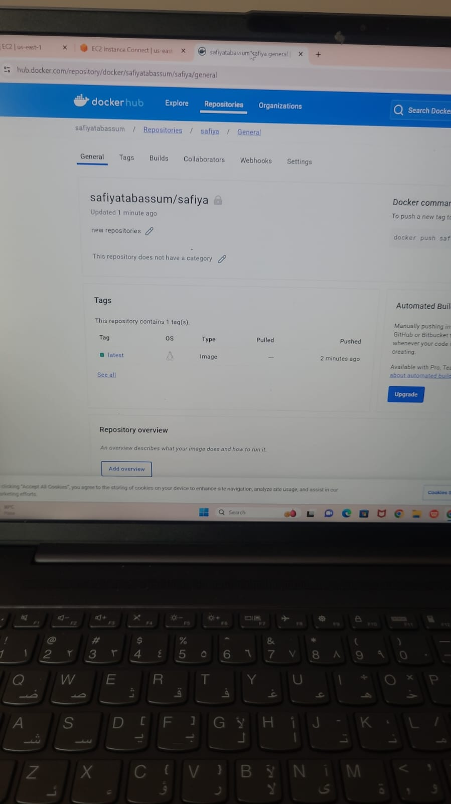
Pushed jenkins image and attached as a tag in the repository
FOR GITHUB:
- For pushing in a github, we need to convert the file into .tar
docker export -o webserver4.tar webserver4
docker import webserver4.tar myimportedimage:v1
docker run -it myimportedimage:v1 sh
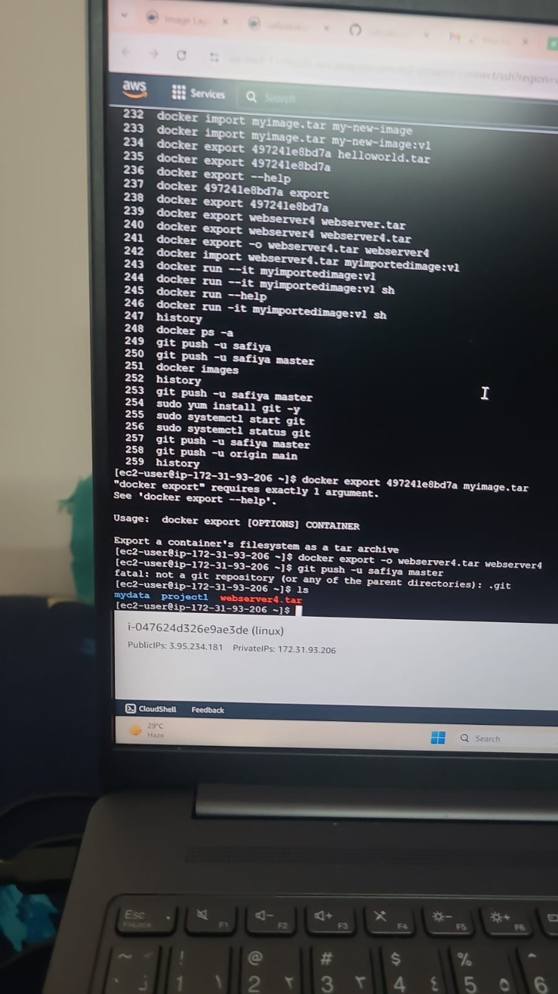
.tar file created which is shown in red colour

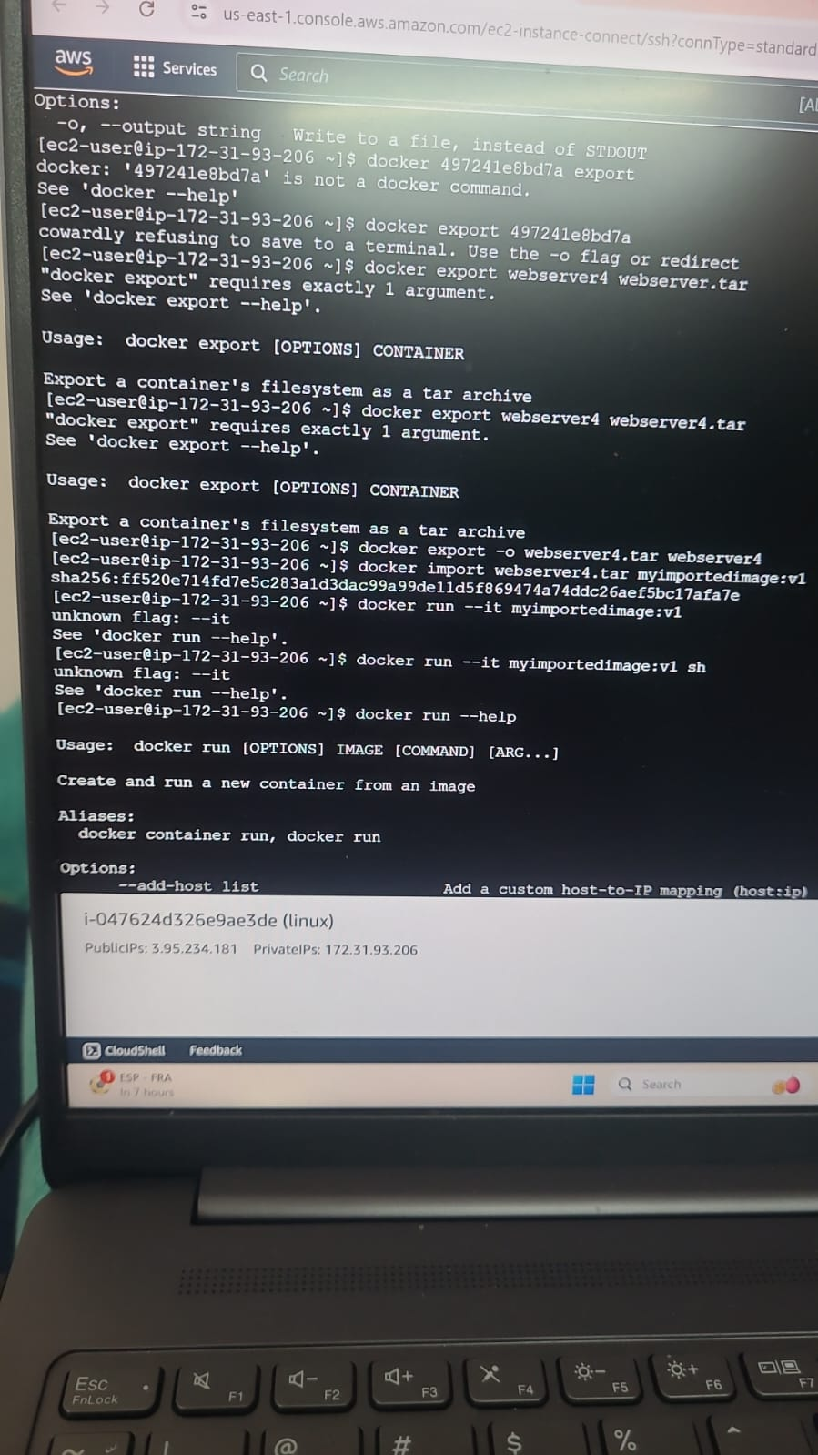
Export and import command is used
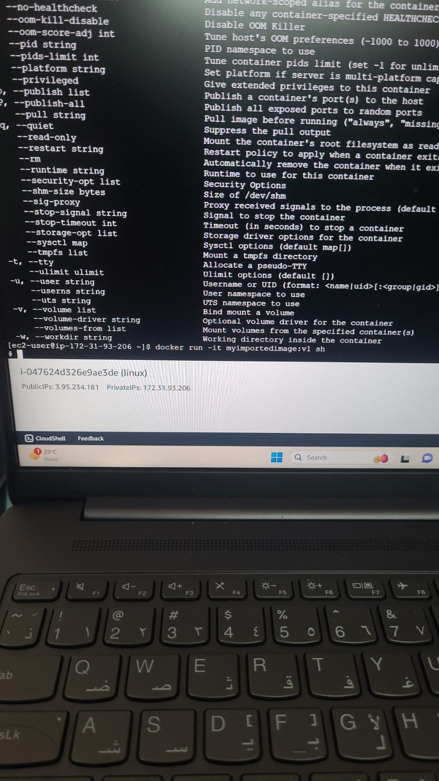
Verified by creating container using created image

- Create sonarqube container.
docker run -it --name web7 sonarqube /bin/bash
docker pull sonarqube
docker ps -a
docker start sonarqube
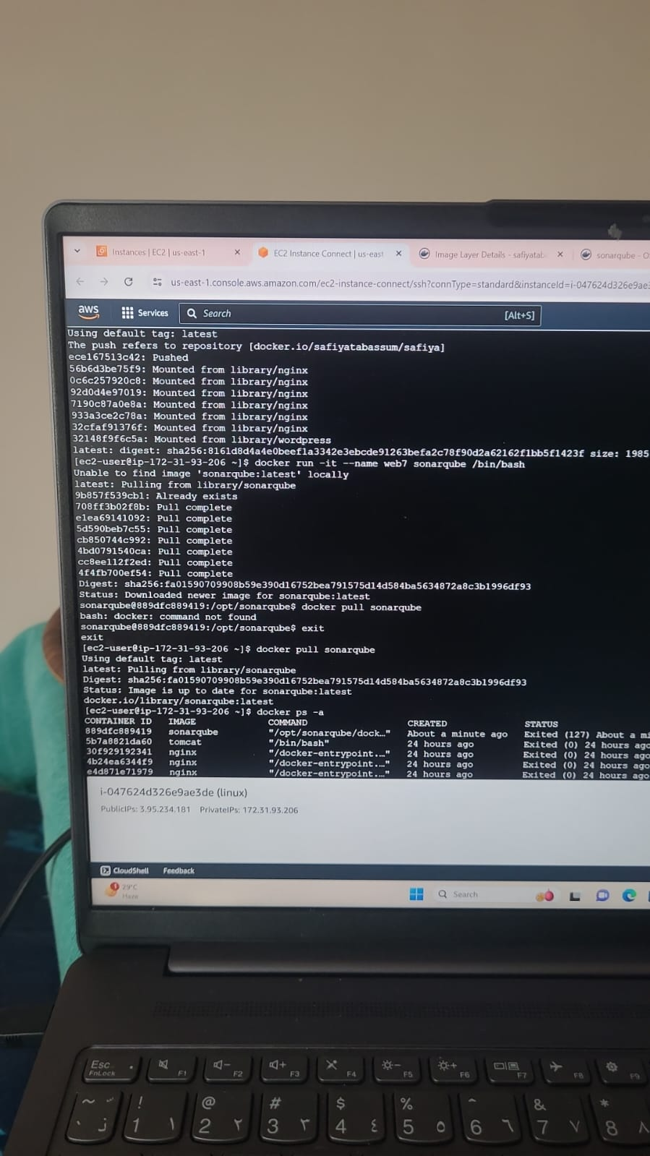
Created sonarqube container

