**AUSTRALIA:**

**JAN – MARCH:**

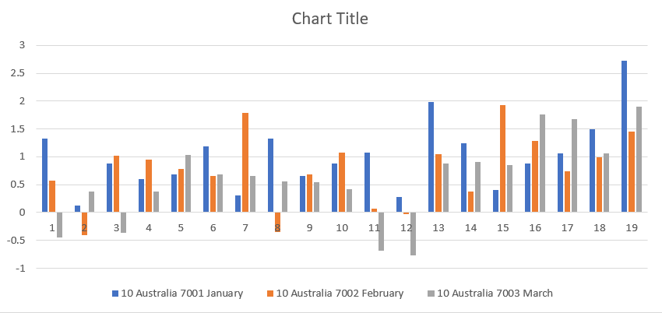

**APRIL – JUNE :**

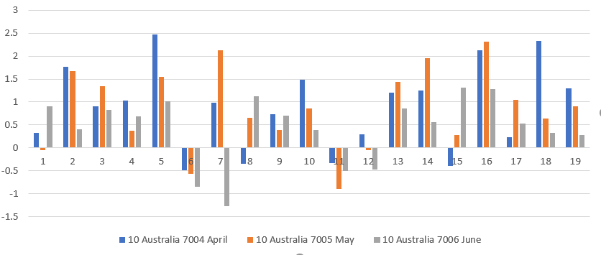

**JULY – SEPTEMBER:**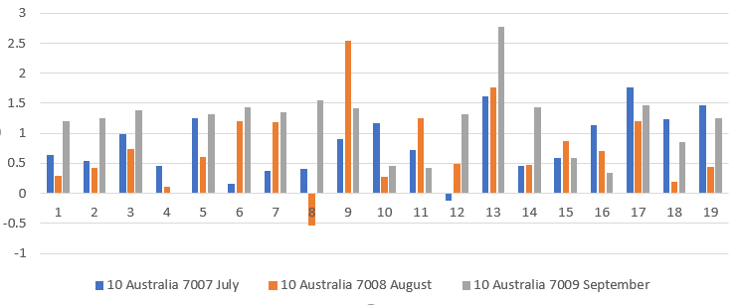

**OCTOBER – DECEMBER:**

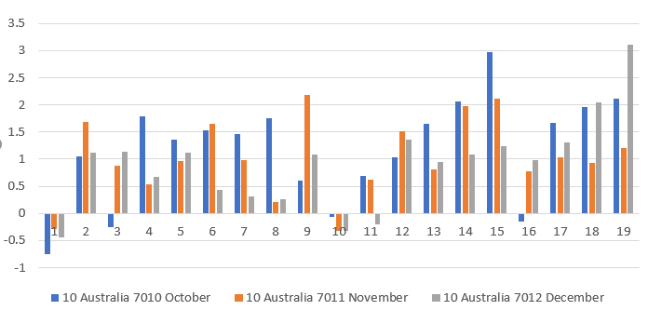

**METEOROLOGICAL YEAR:**

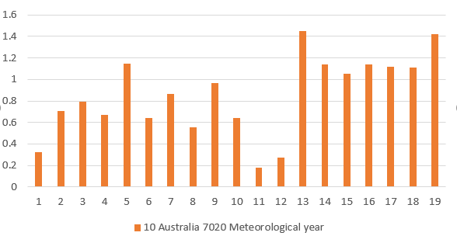

**PIE CHART:**

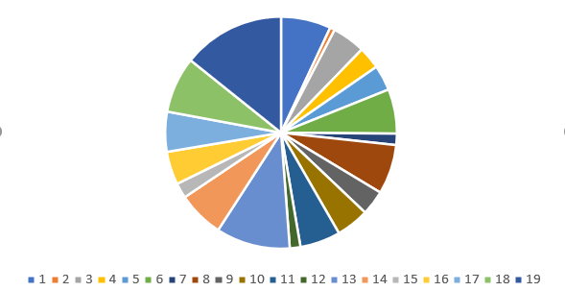

**CANADA:**

**JAN – MARCH:**

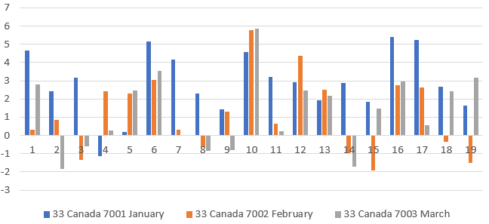

**APRIL – JUNE:**

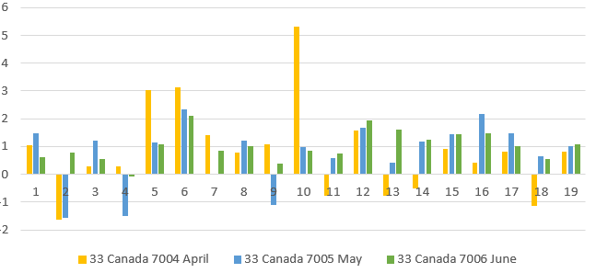

**JULY – SEPTEMBER:**

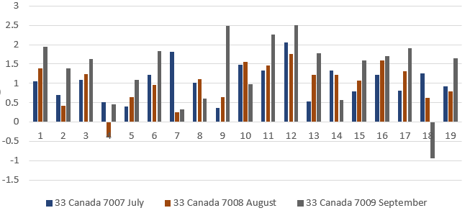

**OCTOBER – DECEMBER:**

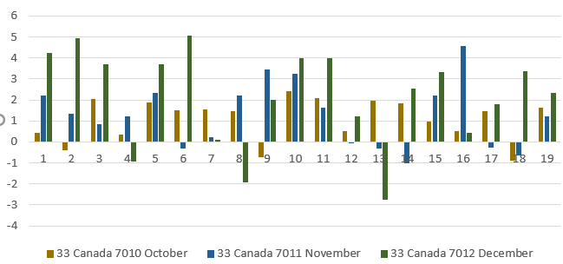

**METEOROLOGICAL YEAR:**

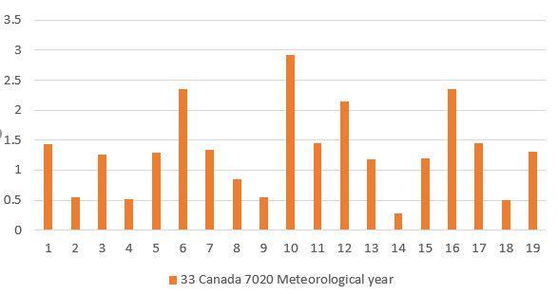

**PIE CHART:**

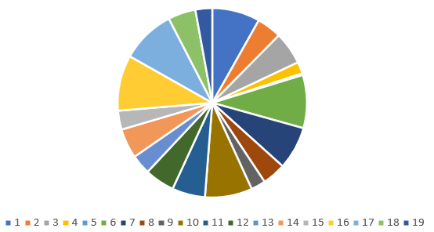

**INDIA:**

**JAN – MARCH:**

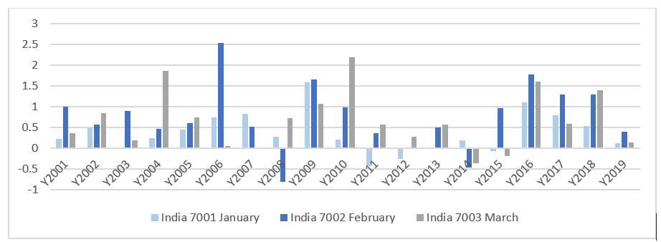

**APRIL – JUNE:**

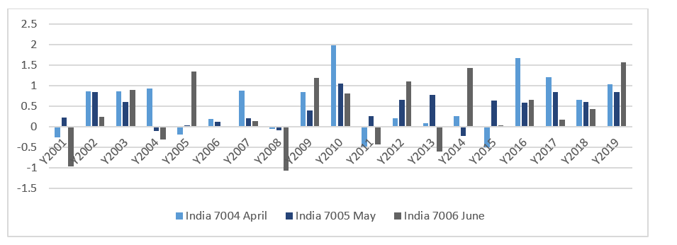

**JULY – SEPTEMBER:**

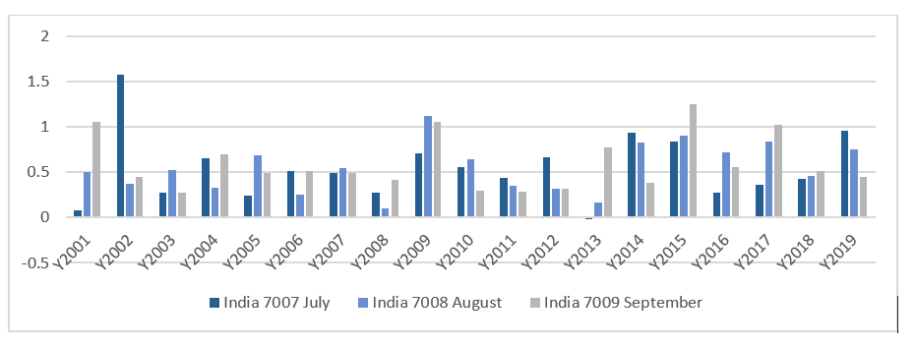

**OCTOBER – DECEMBER:**

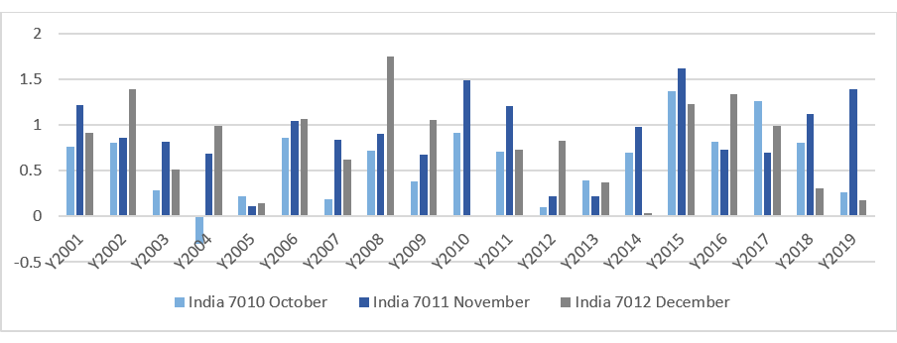

**METEOROLOGICAL YEAR:**

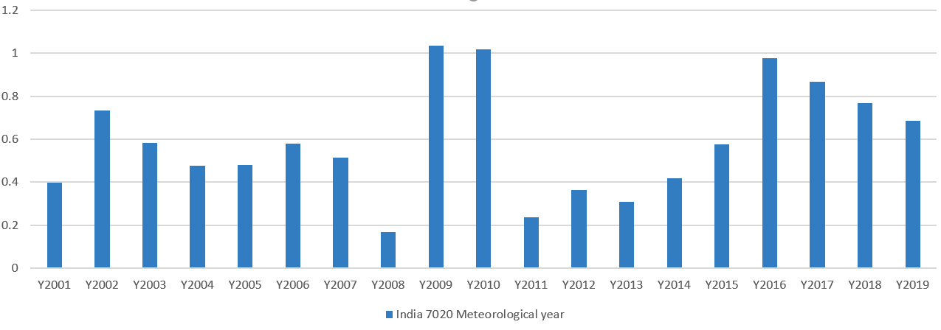

**PIE CHART:**

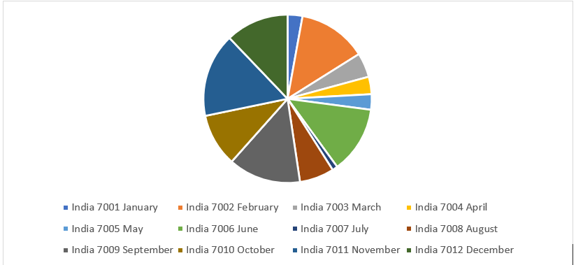

**NETHERLANDS:**

**JAN – MARCH:**

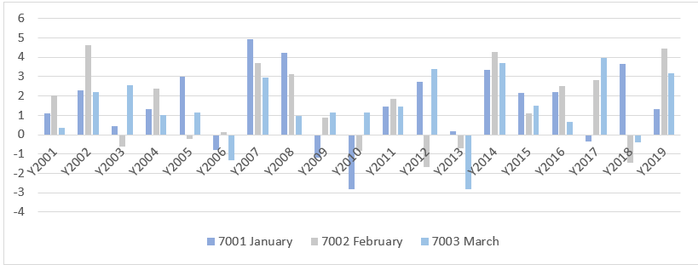

**APRIL – JUNE:**

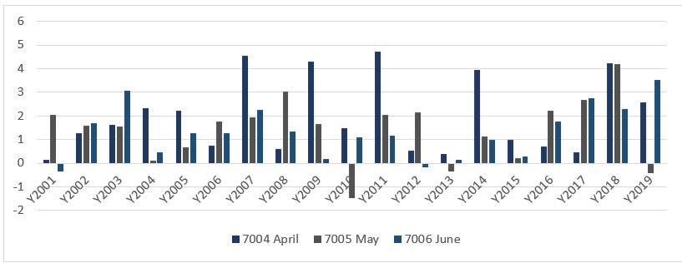

**JULY – SEPTEMBER:**

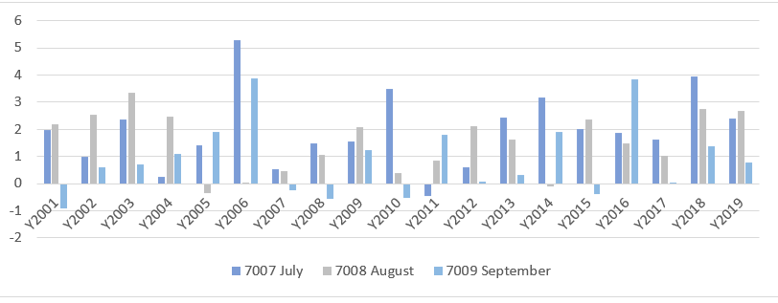

**OCTOBER – DECEMBER:**

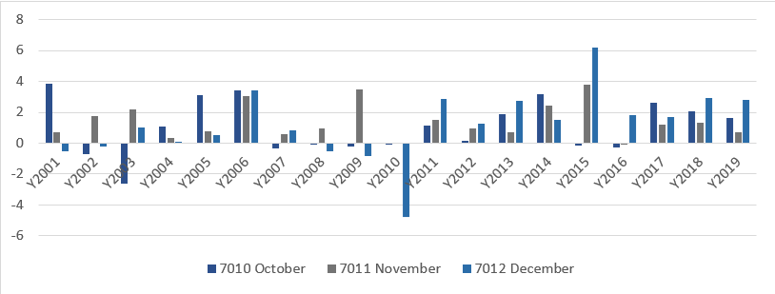

**METEOROLOGICAL YEAR:**

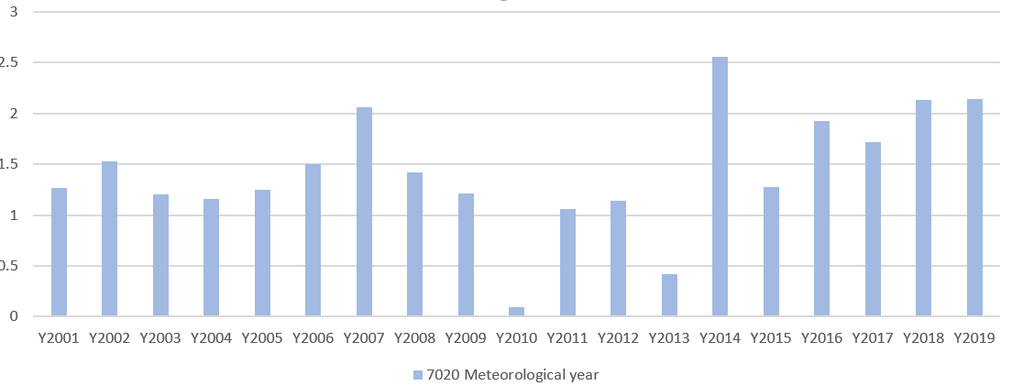

**PIE CHART:**

