**Querying the database**

Individual queries and the corresponding queries.

All the queries are also attached in the file Queries.sql.

1. **List of all arrived orders**
   1. Give the total number of arrived orders in a Point of Sale.

**Query:**

select COUNT(1) from migrate.parcel_tracker as parcel

where parcel.date_pos_status is not NULL;

**output:**

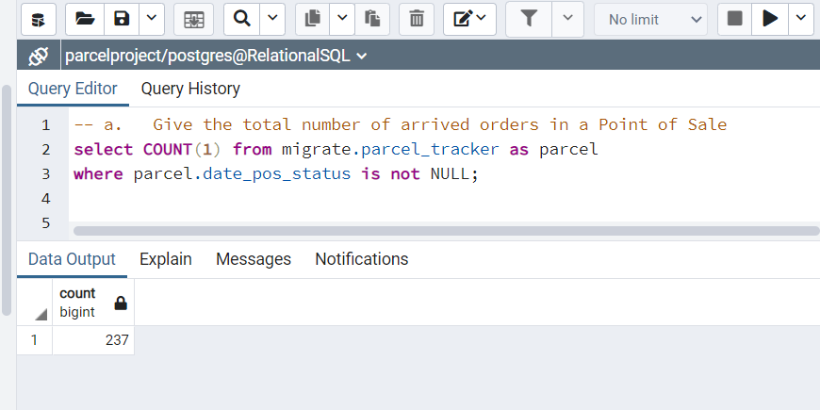

* 1. Give the total number of arrived orders for one specific customer.

**Query:**

select migrate.orders.customer_name, COUNT(1) from migrate.parcel_tracker

INNER JOIN migrate.parcel

on migrate.parcel_tracker.parcel_id = migrate.parcel.parcel_id

and migrate.parcel_tracker.date_pos_status is not NULL

INNER JOIN migrate.orders

on migrate.parcel.order_id = migrate.orders.order_id

and migrate.orders.customer_name = 'MR PATR'

GROUP BY migrate.orders.customer_name;

**Output:**

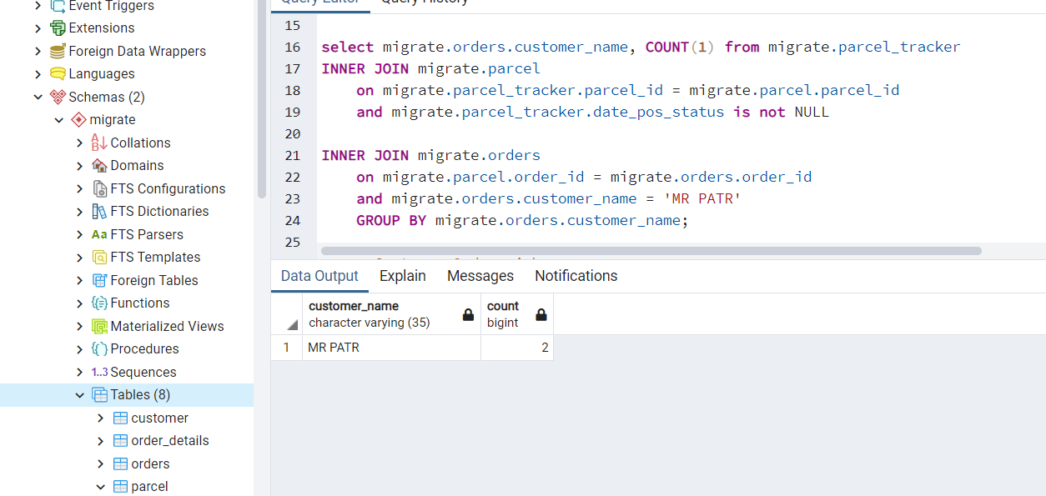

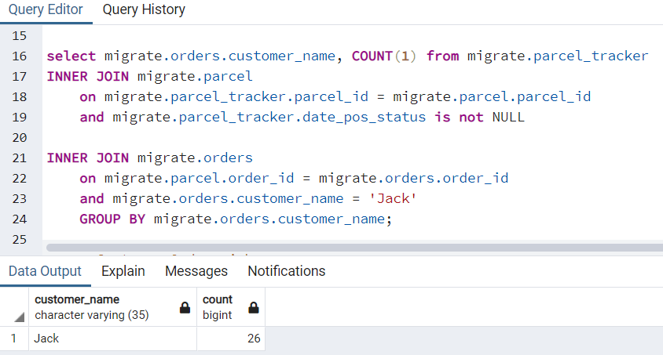

1. **Customer Order Pickup**
   1. Build a search query that will be able to look for customer orders by date, name, or article.

**Query:**

**Name:**

select * from migrate.Orders

where migrate.orders.customer_name = 'MR PATR';

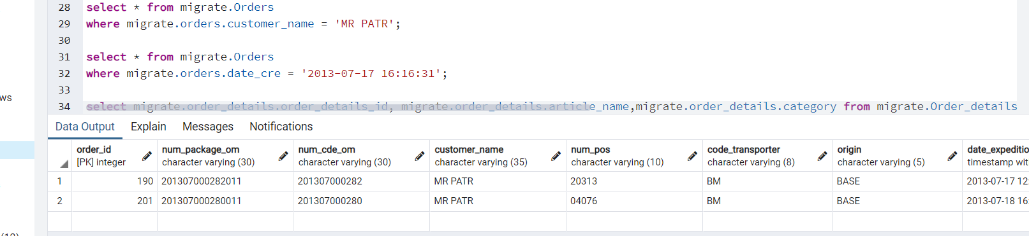

**Date:**

select * from migrate.Orders

where migrate.orders.date_cre = '2013-07-17 16:16:31';

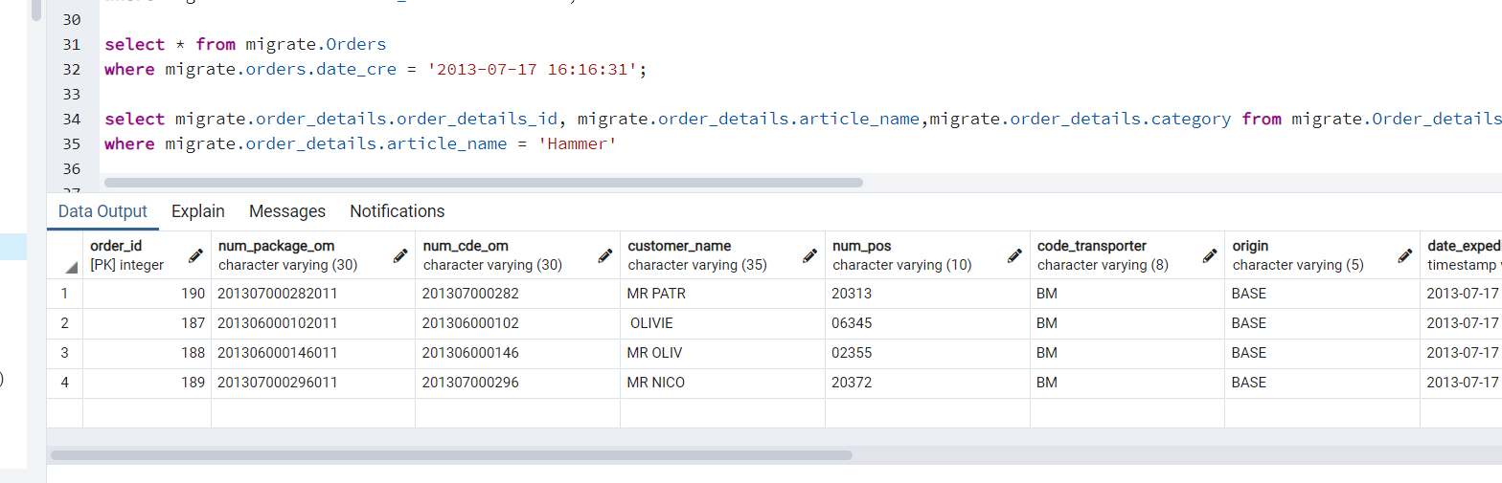

**Article:**

Select migrate.order_details.order_details_id,migrate.order_details.article_name,migrate.order_details.category from migrate.Order_details

where migrate.order_details.article_name = 'Hammer';

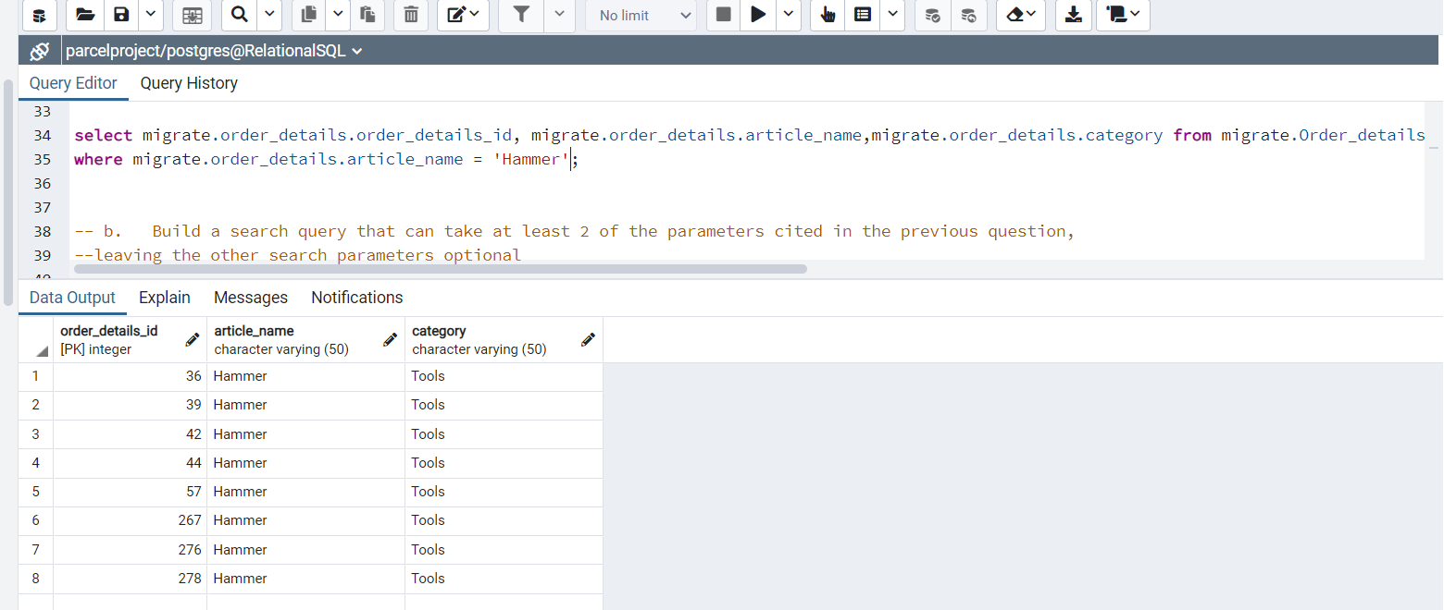

* 1. Build a search query that can take at least 2 of the parameters cited in the previous question, leaving the other search parameters optional

**Query:** Name and Date

select * from migrate.Orders

where migrate.orders.date_cre = '2013-07-17 16:16:31'

and migrate.orders.customer_name = 'MR PATR'

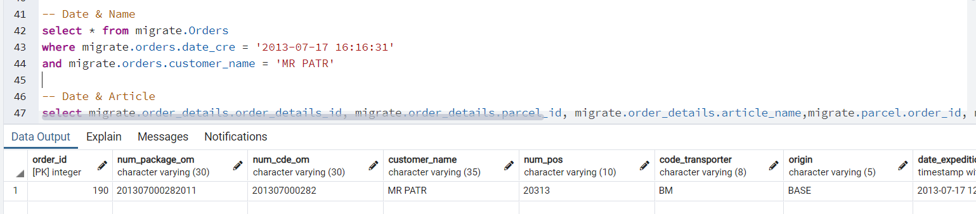

**Article and Date**

select migrate.order_details.order_details_id, migrate.order_details.parcel_id, migrate.order_details.article_name,migrate.parcel.order_id, migrate.Orders.order_id, migrate.Orders.customer_name, migrate.Orders.date_cre from migrate.Order_details

INNER JOIN migrate.parcel on migrate.order_details.parcel_id = migrate.parcel.parcel_id

and migrate.order_details.article_name = 'Cement'

INNER JOIN migrate.Orders on migrate.parcel.order_id = migrate.Orders.order_id

and migrate.Orders.date_cre = '2013-06-25 19:20:04';

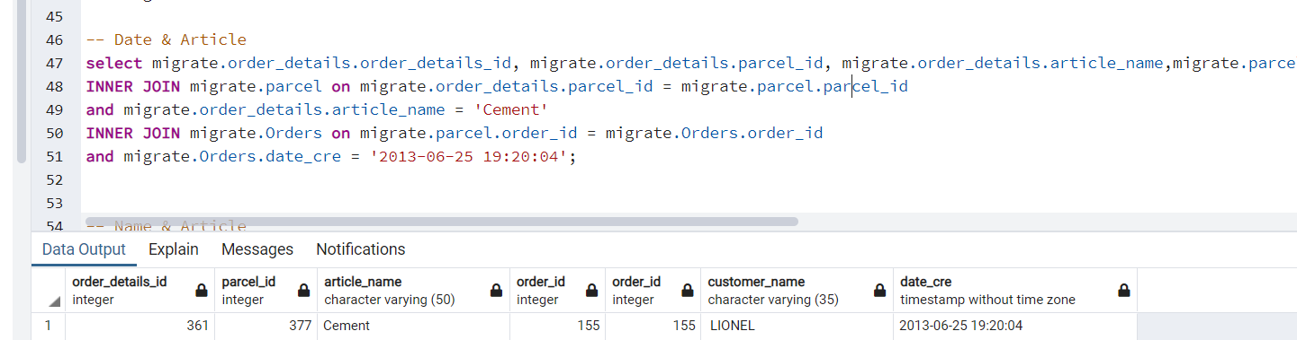

**Name and Article**

select migrate.order_details.order_details_id, migrate.order_details.parcel_id, migrate.order_details.article_name,migrate.parcel.order_id, migrate.Orders.order_id, migrate.Orders.customer_name, migrate.Orders.date_cre from migrate.Order_details

INNER JOIN migrate.parcel on migrate.order_details.parcel_id = migrate.parcel.parcel_id

and migrate.order_details.article_name = 'Hammer'

INNER JOIN migrate.Orders on migrate.parcel.order_id = migrate.Orders.order_id

and migrate.Orders.customer_name = ' BRICOM';

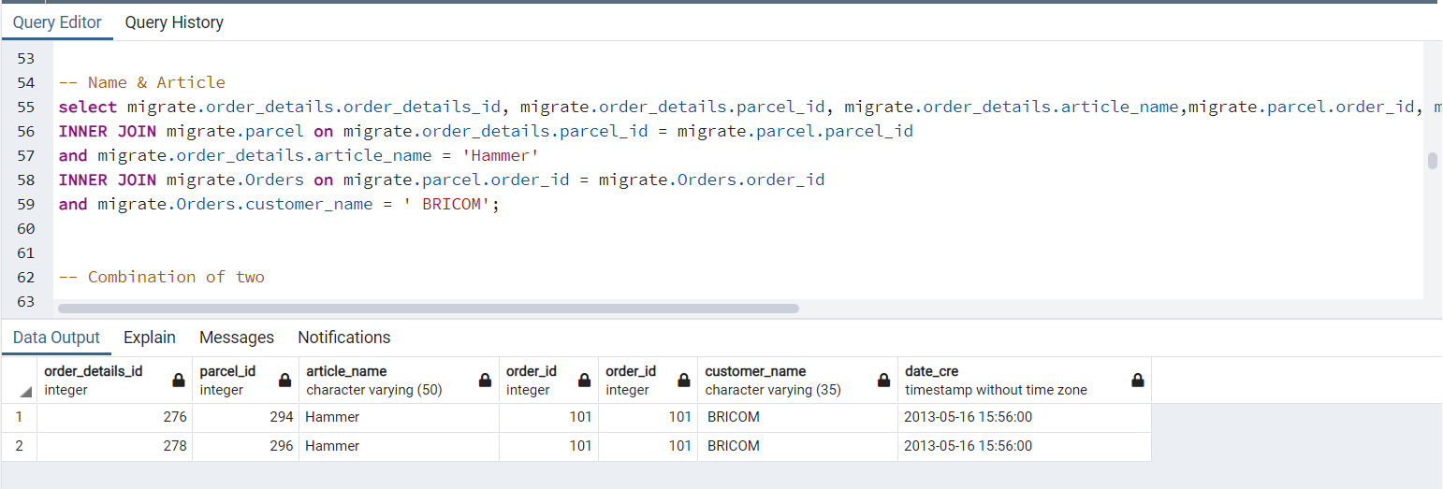

**Combined:**

select migrate.order_details.order_details_id, migrate.order_details.parcel_id, migrate.order_details.article_name,migrate.parcel.order_id, migrate.Orders.order_id, migrate.Orders.customer_name, migrate.Orders.date_cre from migrate.Order_details

INNER JOIN migrate.parcel on migrate.order_details.parcel_id = migrate.parcel.parcel_id

INNER JOIN migrate.Orders on migrate.parcel.order_id = migrate.Orders.order_id

where (migrate.order_details.article_name = 'Hammer')

and (migrate.Orders.date_cre = '2013-05-16 15:56:00')

and (migrate.Orders.customer_name = ' BRICOM');

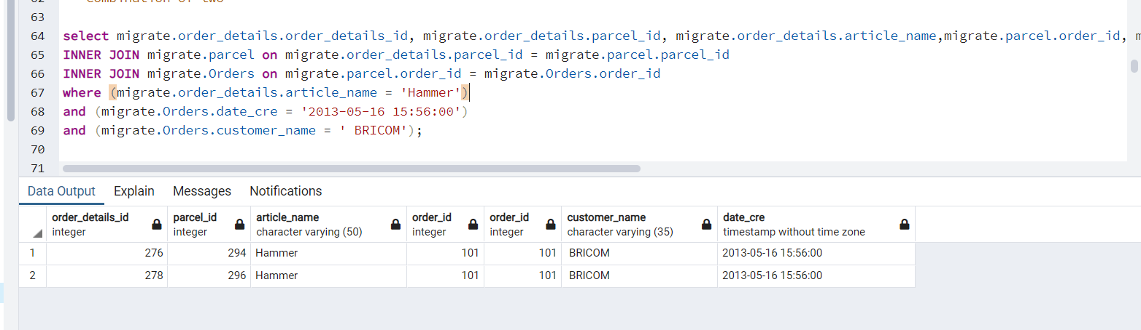

* 1. For a specific customer, display the list of orders with the following information :
     + Parcel number
     + Order number
     + Customer name
     + Last Status Date (arrival date)
     + Parcel Status

**Query:**

select migrate.parcel.n_tracking_um , migrate.Orders.order_id,migrate.Orders.num_cde_om, migrate.Orders.customer_name,migrate.status_manager.status, migrate.orders.date_delivery_expected from migrate.parcel_tracker as pt

INNER JOIN migrate.status_manager on pt.code_status_ref = status_manager.status_id

INNER JOIN migrate.parcel on pt.parcel_id = migrate.parcel.parcel_id

INNER JOIN migrate.Orders on migrate.parcel.order_id = migrate.Orders.order_id

and migrate.orders.customer_name = ' BRICOM';

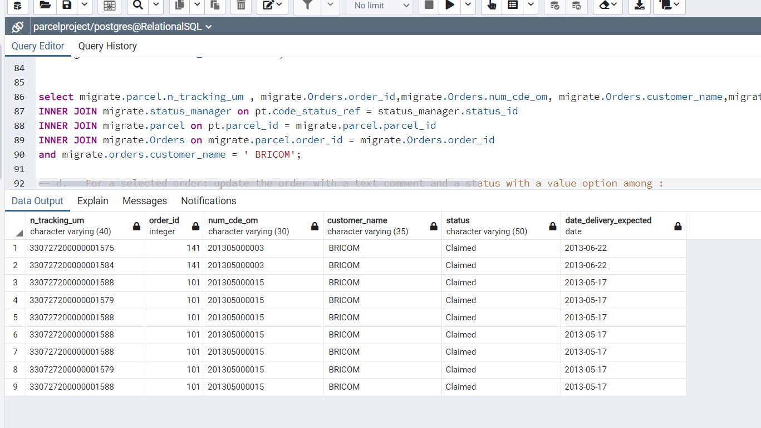

* 1. For a selected order: update the order with a text comment and a status with a value option among :
     + Delivered to customer.
     + Not delivered, to customer wants an item exchange.
     + Not delivered, the customer wants a refund.

**Query:**

select migrate.parcel.order_id, migrate.status_manager.delivery_comments, migrate.status_manager.status from migrate.parcel_tracker as pt

INNER JOIN migrate.status_manager on pt.code_status_ref = status_manager.status_id

INNER JOIN migrate.parcel on pt.parcel_id = migrate.parcel.parcel_id

and migrate.parcel.order_id = 9;

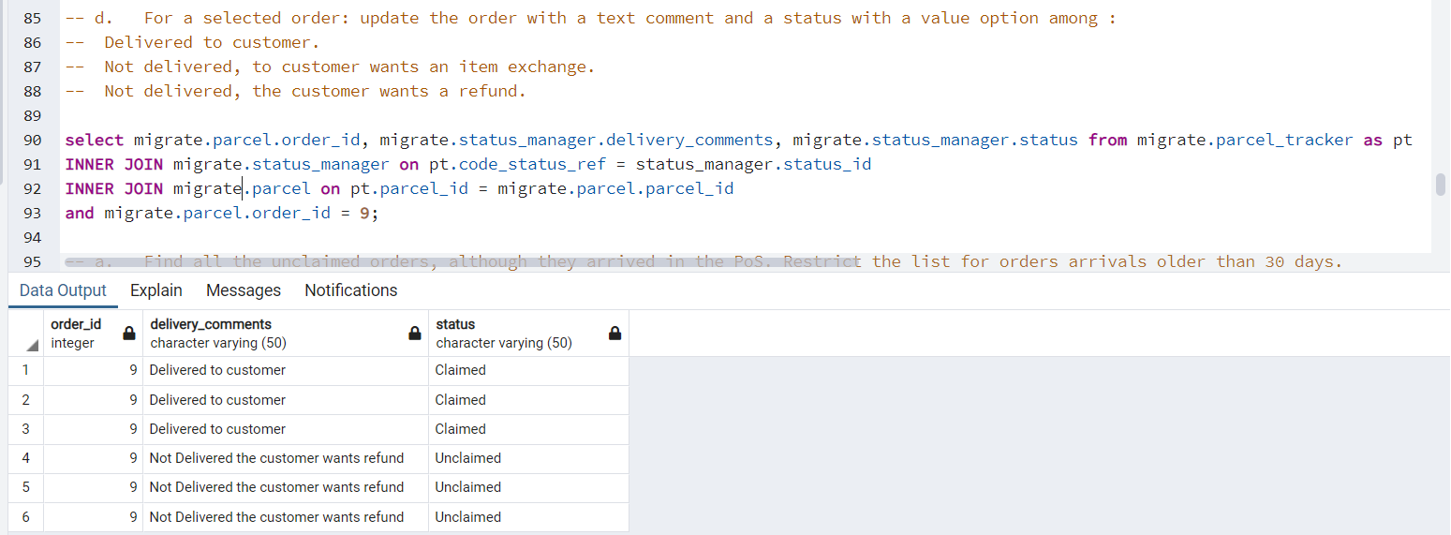

1. **Orders that have not been picked up**
   1. Find all the unclaimed orders, although they arrived in the PoS. Restrict the list for orders arrivals older than 30 days.

**Query:**

select * from migrate.parcel_tracker as parcel

LEFT JOIN migrate.order_details on migrate.order_details.parcel_id = parcel.parcel_id

where DATE(migrate.order_details.date_cre) is not null

and DATE(parcel.date_pos_status) - DATE(migrate.order_details.date_cre) >= 30;

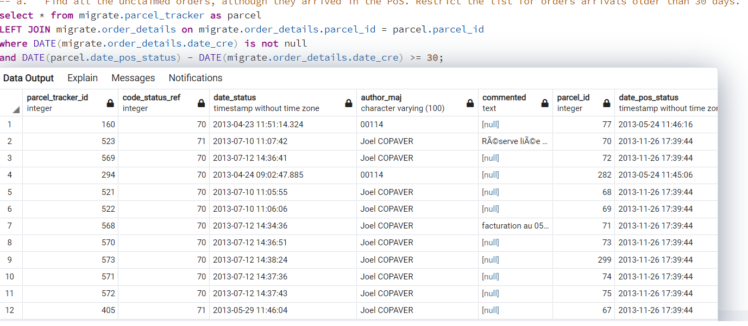

* 1. Calculate the 3 categories the most affected by unclaimed orders

**Query:**

select COUNT(migrate.order_details.category), migrate.order_details.category from migrate.parcel_tracker as pt

INNER JOIN migrate.order_details on pt.parcel_id = migrate.order_details.parcel_id

INNER JOIN migrate.status_manager on pt.code_status_ref = migrate.status_manager.status_id

and migrate.status_manager.status = 'Unclaimed'

GROUP BY migrate.order_details.category

ORDER BY COUNT DESC

limit 3;

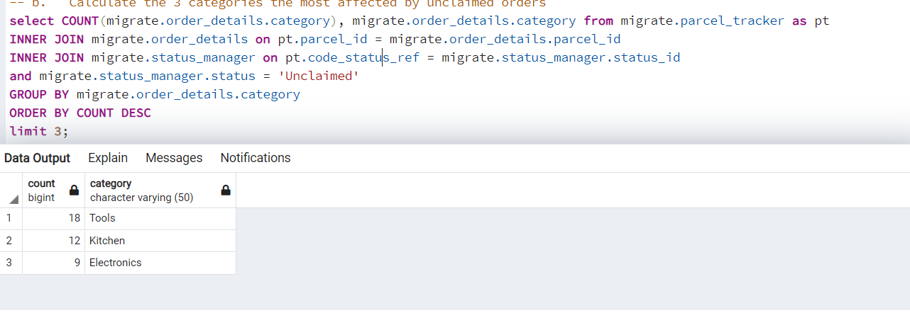

* 1. Calculate the overall cost of unclaimed orders

**Query:**

select sum(migrate.order_details.total_price) from migrate.parcel_tracker as pt

INNER JOIN migrate.order_details on pt.parcel_id = migrate.order_details.parcel_id

INNER JOIN migrate.status_manager on pt.code_status_ref = migrate.status_manager.status_id

and migrate.status_manager.status = 'Unclaimed';

