**Robot Project:**

This is a python robot project where two teams of robot fight agains each other to win the game.

**Requirements and Installation:**

**•** Juputer notebook or any python IDE

• Download the .ipynb or .py file.

• Tkinter library, time, sys, random

**Description:**

**•** There are two teams blue and red.

• Deactivated robots are in grey color.

• Teleporting changes deactivated to neutral robots (green color)

• Dead robots are black when a red or blue robot moves it gets 1 HP.

• The red and blue team cannot attack neutral robots whereas neutral robots can.

• The game ends when all robots in one team are dead.

**Running the program:**

• Run all the cells in the file before executing the main function.

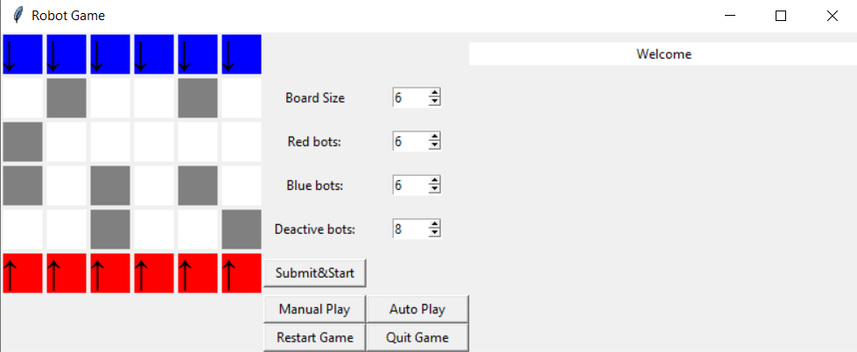

This is the first screen which you can see.

• **Board size (row x column):** The values can be increased or decreased

• **Red bots, Blue bots:** Number of robots in each team this field can also be increased or decreased. To increase the number of red/blue robots value first increase board size submit it and again increase the number.

**• Deactive bots :** The number of grey bots that are obstacles which later convert into neutral bots.

• **Submit and Start:** Once you make changes in the value to apply it press this button.

**Example 1:**

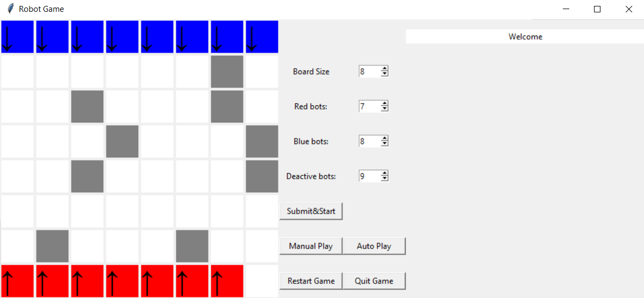

**Example 2:**

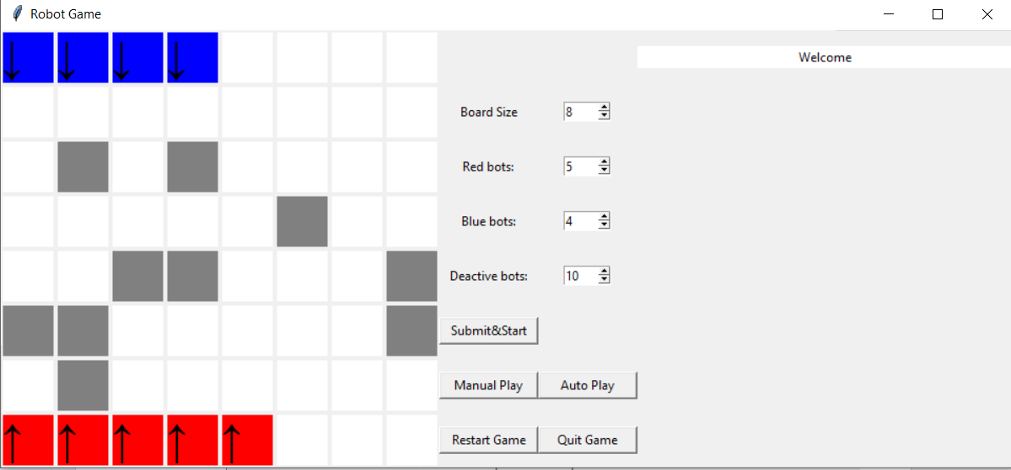

Here, we can see after clicking submit and start with new values we get a updated game with the corresponding values.

• **Manual Play –** To manually play the next turn.

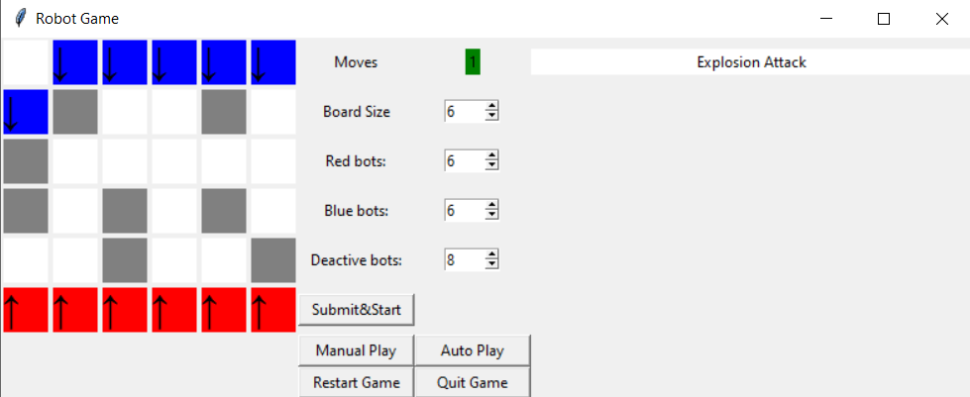

Once clicked a robot moves and shows the attack done and whether it’s successful or not.

**• Moves:** The number of moves completed is shown here. This includes the moves of neutral robots also.

**• Auto-Play:** The auto play does the next 50 turns on its own.

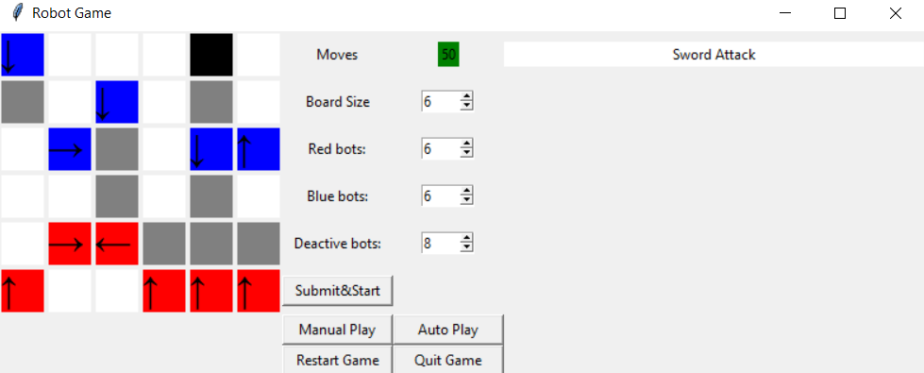

Here, we can see the first fifty moves was done on its own and we see one robot dead.

• **Quit Game:** Closes the window and quits the game.

• **Restart Game:** Restarts the whole game with default values.

**Example:**

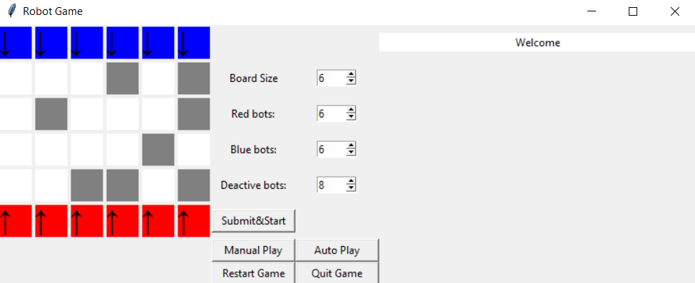

This is how it looks after reset.

**Playing a game till the end:**

1. **Starting a new game.**



1. **Manually playing some turns**

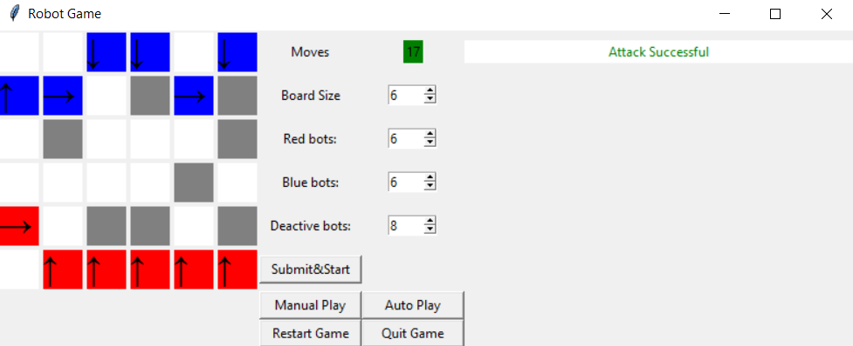

1. **Auto Playing the next 50 Turns**

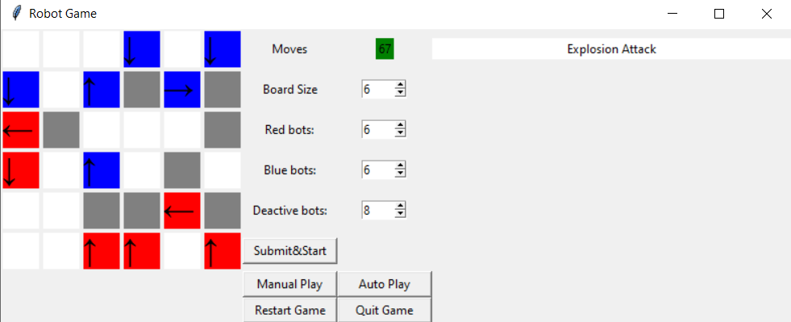

1. **Teleporting activated after 80 moves and a robot is converted**

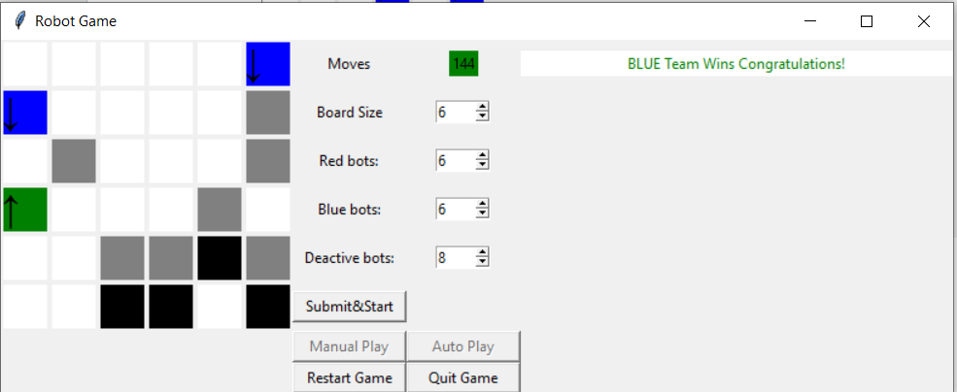

1. **Winner is displayed**

After some time we see the winner is displayed after that till we start the new game the Manual play and Autoplay buttons are disabled.

**Author**

Subaandh