Owl-M: A Material Design Study App

1.INTRODUCTION :

OVERVIEW: The Application Skill based on the learning purpose of student’s skill then material studyapp , A project that demonstrates the use of Android Jetpack Compose to build a UI for a Owl-M: a material design study  app. Owl-M app is a sample project built using the Android Compose UI toolkit. A Compose implementation of the Owl Material study.

Purpose:

The skill based on the student’s Learning ,the project

2.Problem Definition & Design Thinking

Empathy Map:

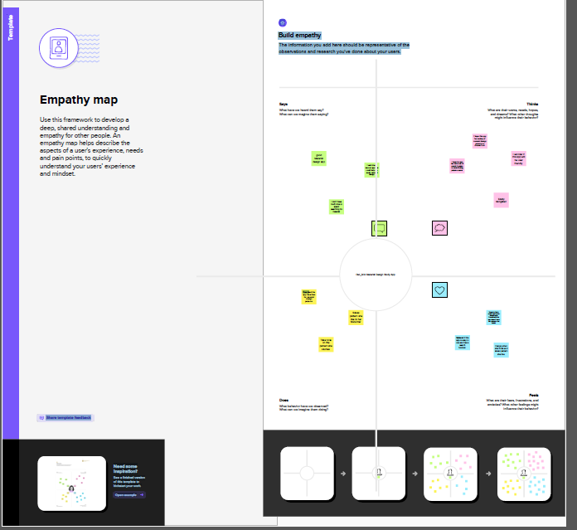

Ideation & Brinstorming Map: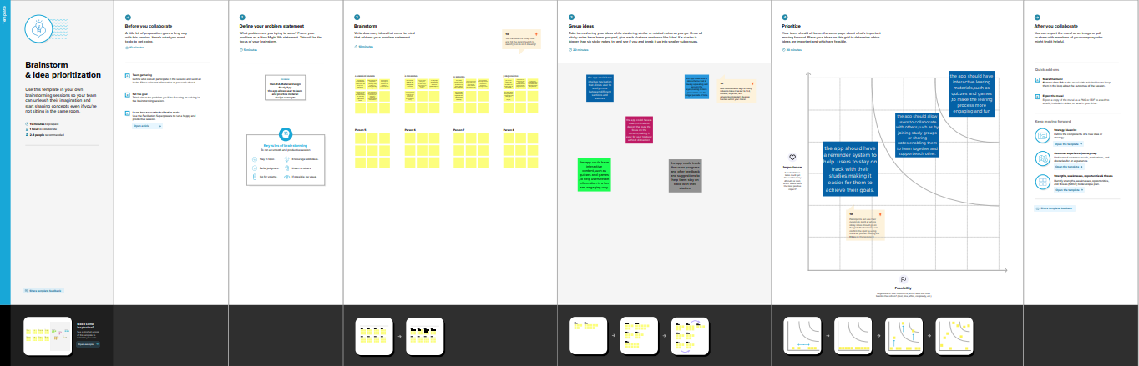

3.RESULT :

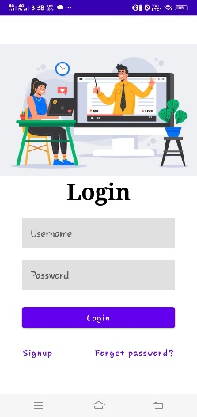 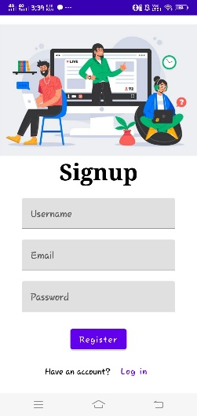 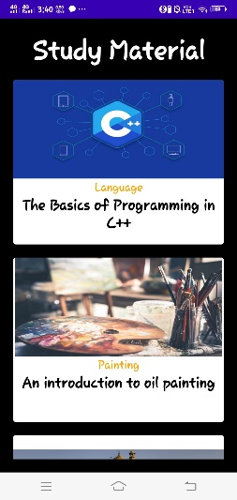 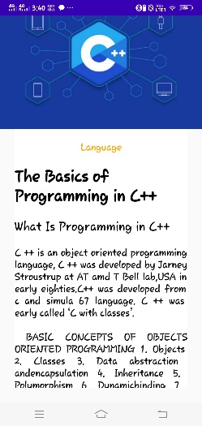

4.Advantage & DisAdvantage :

More granular advantages for Material Design include things like **subtle skeuomorphism**, which sets it apart from flat design and makes it more intuitive for many users

* Distraction. Technology is good, but it is also distractive. ...
* Emotional development. ...
* Overstimulation due to excessive screen time. ...
* Decreased social interaction. ...
* Reduced emphasis on traditional teaching and learning skills.

5.Applications :

There application applied Android Studio in Kotlin Programming Language in My application

* Virtual Implementation Training (a prerequisite to receiving access to the lessons)
* Digital Teachers Guide PDF
* Digital Teacher Presentation Online Tool
* Student Reading Playgrounds
* Digital Guided Student Practice Book PDF

6.Conclusion :

The Application can be used student’s learning purpose of build the skill base application an there using material desig study app, then the main documentation of there learning basic If you’re a student, regardless of your age, solid studying habits can help you succeed. While your studying strategies may evolve as you progress in your educational career, here are basic tips and advice to help you get the most out of your study sessions.

7.Future Scope :

One of the effective ways to make the most out of your study sessions is to have it set up properly. Keeping a tidy desk means that you’ll have enough space to lay out all the papers and books you need, without dealing with distractions or clutter from other classes or assignments. Also, it’s advisable to prepare basic snacks and water so you can stay nourished while you study. And most of all, turn off your phone and avoid using the internet for unrelated tasks to maintain your focus.