CLASS EXERCISE1:

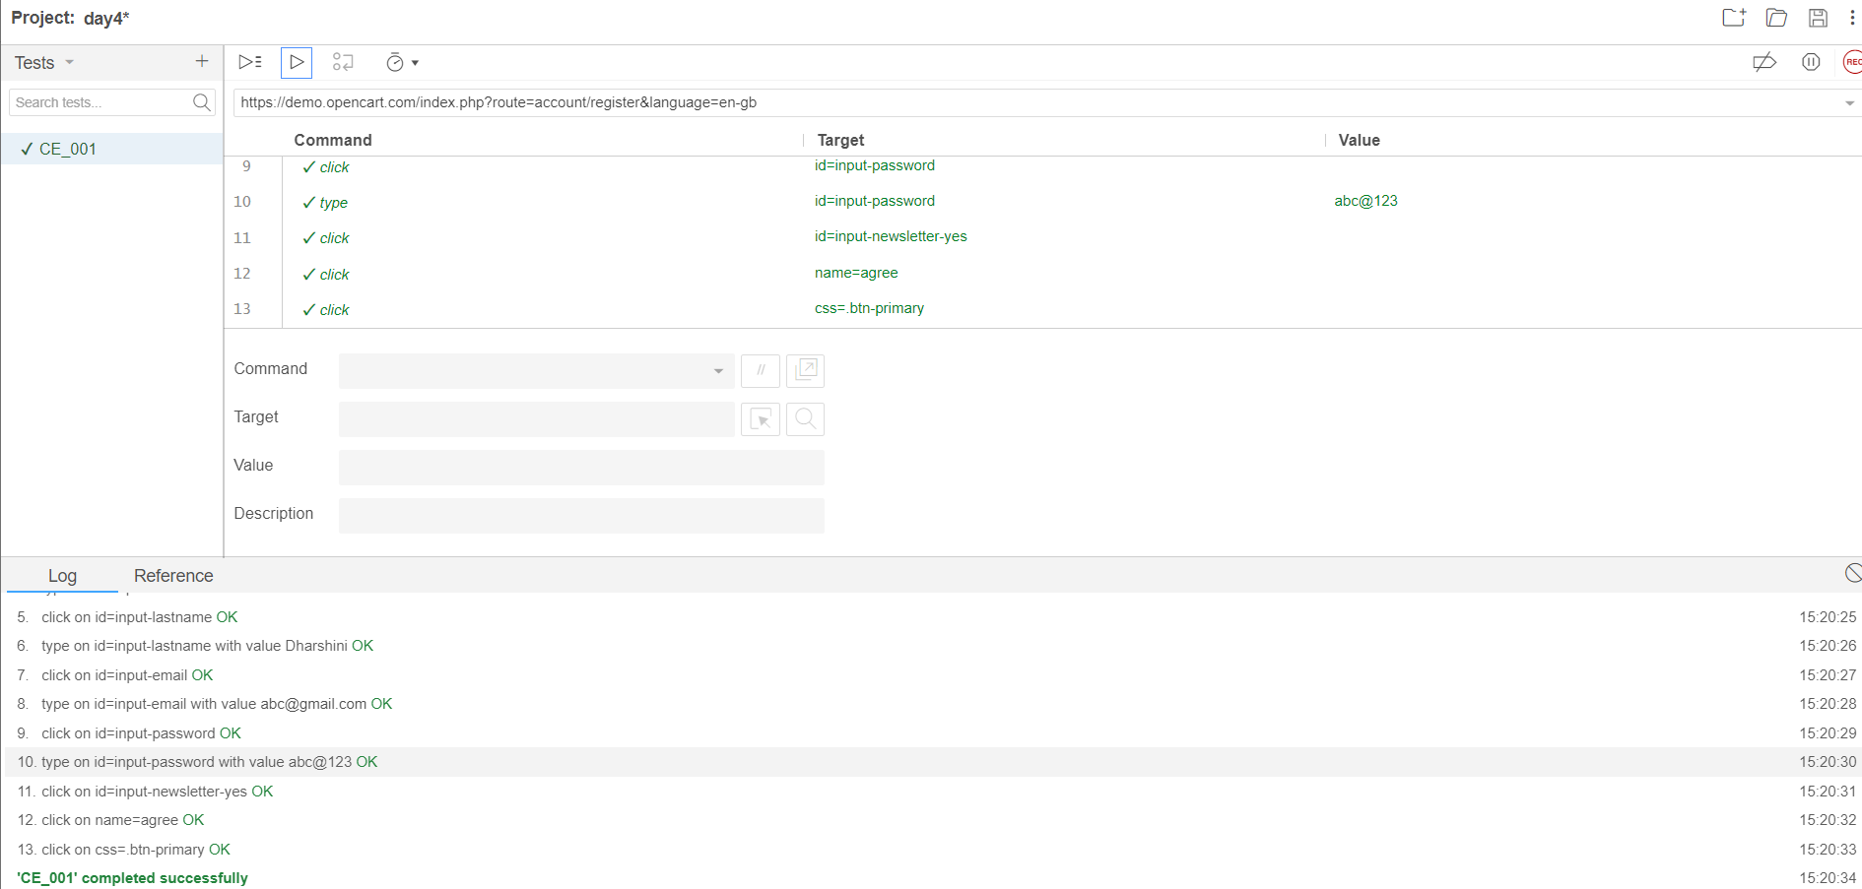

CLASS EXERCISE2:

**package** com.Test.Test;

**import** org.openqa.selenium.By;

**import** org.openqa.selenium.JavascriptExecutor;

**import** org.openqa.selenium.WebDriver;

**import** org.openqa.selenium.WebElement;

**import** org.openqa.selenium.chrome.ChromeDriver;

**import** org.openqa.selenium.chrome.ChromeOptions;

**import** io.github.bonigarcia.wdm.WebDriverManager;

**public** **class** App

{

**public** **static** **void** main( String[] args ) **throws** InterruptedException

{

ChromeOptions co=**new** ChromeOptions();

co.addArguments("--remote-allow-origins=*");

WebDriverManager.*chromedriver*().setup();

WebDriver d=**new** ChromeDriver(co);

d.get("https://demo.opencart.com/index.php?route=account/register&language=en-gb");

d.manage().window().maximize();

d.findElement(By.*id*("input-firstname")).sendKeys("suba");

d.findElement(By.*xpath*("//input[@id=\"input-lastname\"]")).sendKeys("harini");

d.findElement(By.*cssSelector*("input#input-email")).sendKeys("suba@gmail.com");

d.findElement(By.*id*("input-password")).sendKeys("suba@123");

JavascriptExecutor js=(JavascriptExecutor) d;

js.executeScript("window.scrollBy(0,500)","" );

Thread.*sleep*(3000);

WebElement subs=d.findElement(By.*xpath*("//*[@id=\"input-newsletter-yes\"]"));

subs.click();

Thread.*sleep*(3000);

d.findElement(By.*xpath*("//*[@id=\"form-register\"]/div/div/div/input")).click();

Thread.*sleep*(3000);

d.findElement(By.*xpath*("//*[@id=\"form-register\"]/div/div/button")).click();

}

}

CLASS EXERCISE3:

**package** com.Test.Test;

**import** org.openqa.selenium.By;

**import** org.openqa.selenium.JavascriptExecutor;

**import** org.openqa.selenium.WebDriver;

**import** org.openqa.selenium.chrome.ChromeDriver;

**import** org.openqa.selenium.chrome.ChromeOptions;

**import** io.github.bonigarcia.wdm.WebDriverManager;

**public** **class** d43 {

**public** **static** **void** main( String[] args ) **throws** InterruptedException

{

ChromeOptions co=**new** ChromeOptions();

co.addArguments("--remote-allow-origins=*");

WebDriverManager.*chromedriver*().setup();

WebDriver d=**new** ChromeDriver(co);

d.get("https://demo.opencart.com/index.php?route=checkout/voucher&language=en-gb");

d.manage().window().maximize();

d.findElement(By.*xpath*("//input[@id=\"input-to-name\"]")).sendKeys("suba");

d.findElement(By.*xpath*("//input[@id=\"input-to-email\"]")).sendKeys("abc@gmail.com");

d.findElement(By.*xpath*("//input[@id=\"input-from-name\"]")).sendKeys("harini");

d.findElement(By.*xpath*("//input[@id=\"input-from-email\"]")).sendKeys("def@gmail.com");

JavascriptExecutor js=(JavascriptExecutor) d;

js.executeScript("window.scrollBy(0,500)","" );

Thread.*sleep*(3000);

d.findElement(By.*xpath*("//input[@id=\"input-theme-7\"]")).click();

d.findElement(By.*xpath*("//textarea[@id=\"input-message\"]")).sendKeys("Happy Birthday !!!");

Thread.*sleep*(3000);

d.findElement(By.*xpath*("//input[@name=\"agree\"]")).click();

d.findElement(By.*xpath*("//button[@class=\"btn btn-primary\"]")).click();

}

}

CLASS EXERCISE4:

**package** com.Test.Test;

**import** org.openqa.selenium.By;

**import** org.openqa.selenium.WebDriver;

**import** org.openqa.selenium.chrome.ChromeDriver;

**import** org.openqa.selenium.chrome.ChromeOptions;

**import** io.github.bonigarcia.wdm.WebDriverManager;

**public** **class** d44 {

**public** **static** **void** main( String[] args )

{

ChromeOptions co=**new** ChromeOptions();

co.addArguments("--remote-allow-origins=*");

WebDriverManager.*chromedriver*().setup();

WebDriver d=**new** ChromeDriver(co);

d.navigate().to("https://j2store.net/free/");

d.manage().window().maximize();

d.findElement(By.*xpath*("//*[@id=\"Mod112\"]/div/div/ul/li[1]/h4/a")).click();

d.navigate().back();

d.navigate().forward();

d.navigate().refresh();

d.close();

}

}

CLASS EXERCISE5(1):

**package** com.Test.Test;

**import** org.openqa.selenium.By;

**import** org.openqa.selenium.JavascriptExecutor;

**import** org.openqa.selenium.WebDriver;

**import** org.openqa.selenium.chrome.ChromeDriver;

**import** org.openqa.selenium.chrome.ChromeOptions;

**import** io.github.bonigarcia.wdm.WebDriverManager;

**public** **class** d45 {

**public** **static** **void** main( String[] args ) **throws** InterruptedException

{

ChromeOptions co=**new** ChromeOptions();

co.addArguments("--remote-allow-origins=*");

WebDriverManager.*chromedriver*().setup();

WebDriver d=**new** ChromeDriver(co);

d.get("https://j2store.net/free/");

d.manage().window().maximize();

String currentUrl=d.getCurrentUrl();

String expectedUrl="https://j2store.net/free/";

**if**(currentUrl.equals(expectedUrl)) {

System.***out***.println("URL MATCHED");

}

**else** {

System.***out***.println("URL NOT MATCHED");

}

Thread.*sleep*(3000);

d.findElement(By.*xpath*("//*[@id=\"Mod112\"]/div/div/ul/li[1]/h4/a")).click();

String curl=d.getCurrentUrl();

String exurl="https://j2store.net/free/index.php/shop?filter_catid=11";

**if**(curl.equals(exurl)) {

System.***out***.println("URL MATCHED");

}

**else** {

System.***out***.println("URL NOT MATCHED");

}

}

}

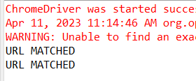

CLASS EXERCISE5(2):

**package** com.Test.Test;

**import** java.util.List;

**import** org.openqa.selenium.By;

**import** org.openqa.selenium.JavascriptExecutor;

**import** org.openqa.selenium.WebDriver;

**import** org.openqa.selenium.WebElement;

**import** org.openqa.selenium.chrome.ChromeDriver;

**import** org.openqa.selenium.chrome.ChromeOptions;

**import** io.github.bonigarcia.wdm.WebDriverManager;

**public** **class** d452 {

**public** **static** **void** main( String[] args ) **throws** InterruptedException

{

ChromeOptions co=**new** ChromeOptions();

co.addArguments("--remote-allow-origins=*");

WebDriverManager.*chromedriver*().setup();

WebDriver d=**new** ChromeDriver(co);

d.get("https://j2store.net/free/");

d.manage().window().maximize();

JavascriptExecutor js=(JavascriptExecutor) d;

js.executeScript("window.scrollBy(0,500)","" );

Thread.*sleep*(3000);

d.findElement(By.*xpath*("//*[@id=\"Mod112\"]/div/div/ul/li[1]/h4/a")).click();

List<WebElement>li=d.findElements(By.*xpath*("//h2[@itemprop=\"name\"]"));

**for**(WebElement link:li) {

System.***out***.println(link.getText());

}

}

}

