**DAY 7**

**TASK 1:**

**package** com.test.ClassExercise;

**import** org.openqa.selenium.WebDriver;

**import** org.openqa.selenium.chrome.ChromeDriver;

**import** org.openqa.selenium.chrome.ChromeOptions;

**import** org.testng.Assert;

**import** org.testng.annotations.Test;

**import** io.github.bonigarcia.wdm.WebDriverManager;

**public** **class** CE1 {

@Test

**public** **void** titleCheck() {

WebDriverManager.*chromedriver*().setup();

ChromeOptions co=**new** ChromeOptions();

co.addArguments("--remote-allow-origins=*");

WebDriver driver=**new** ChromeDriver(co);

driver.get("https://demo.wpeverest.com/user-registration/guest-registration-form/");

driver.manage().window().maximize();

String actual=driver.getTitle();

String expected="Guest Registration Form – User Registration";

Assert.*assertEquals*(actual,expected);

}

}

**OUTPUT:**

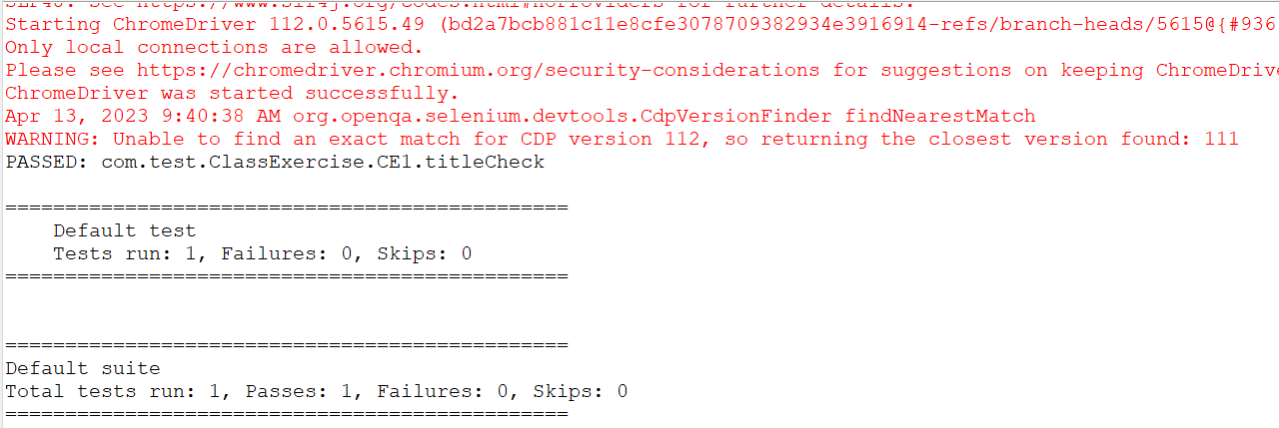

**TASK 2:**

**package** com.test.ClassExercise;

**import** org.testng.Assert;

**import** org.testng.annotations.Test;

**public** **class** CE2 {

@Test(priority=2)

**public** **void** add() {

**int** a=4;

**int** b=5;

**int** c=a+b;

**int** d=9;

System.***out***.println(c);

Assert.*assertEquals*(c,d);

}

@Test(priority=4)

**public** **void** subtract() {

**int** a=10;

**int** b=5;

**int** c=a-b;

**int** d=5;

System.***out***.println(c);

Assert.*assertEquals*(c,d);

}

@Test(priority=3)

**public** **void** multiply() {

**int** a=4;

**int** b=5;

**int** c=a*b;

**int** d=20;

System.***out***.println(c);

Assert.*assertEquals*(c,d);

}

@Test(priority=1)

**public** **void** divide() {

**int** a=10;

**int** b=2;

**int** c=a/b;

**int** d=5;

System.***out***.println(c);

Assert.*assertEquals*(c,d);

}

}

**OUTPUT:**

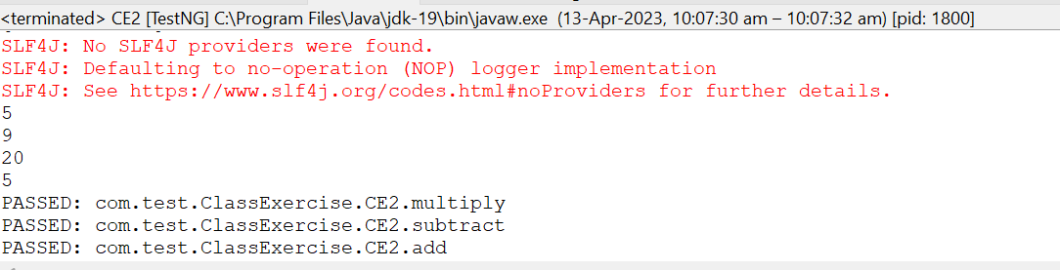

**TASK 3:**

**package** com.test.ClassExercise;

**import** org.testng.annotations.Test;

**import** io.github.bonigarcia.wdm.WebDriverManager;

**import** org.testng.annotations.BeforeMethod;

**import** org.openqa.selenium.By;

**import** org.openqa.selenium.WebDriver;

**import** org.openqa.selenium.WebElement;

**import** org.openqa.selenium.chrome.ChromeDriver;

**import** org.openqa.selenium.chrome.ChromeOptions;

**import** org.testng.Assert;

**import** org.testng.annotations.AfterMethod;

**public** **class** CE3 {

WebDriver driver;

@Test

**public** **void** max_wid() {

WebElement from=driver.findElement(By.*xpath*("//*[@id=\"app\"]/div[1]/div/div[1]/div/div[2]/div[2]/form/div[1]/div/div[2]/input"));

from.sendKeys("Admin");

WebElement to=driver.findElement(By.*xpath*("//*[@id=\"app\"]/div[1]/div/div[1]/div/div[2]/div[2]/form/div[2]/div/div[2]/input"));

to.sendKeys("admin123");

WebElement submitBtn=driver.findElement(By.*xpath*("//*[@id=\"app\"]/div[1]/div/div[1]/div/div[2]/div[2]/form/div[3]/button"));

submitBtn.click();

String CurrentUrl=driver.getCurrentUrl();

String ExpectedUrl="https://opensource-demo.orangehrmlive.com/web/index.php/dashboard/index";

Assert.*assertEquals*(CurrentUrl, ExpectedUrl);

}

@BeforeMethod

**public** **void** beforeMethod() **throws** InterruptedException {

WebDriverManager.*chromedriver*().setup();

ChromeOptions co=**new** ChromeOptions();

co.addArguments("--remote-allow-origins=*");

driver=**new** ChromeDriver(co);

driver.get("https://opensource-demo.orangehrmlive.com/web/index.php/auth/login");

driver.manage().window().maximize();

Thread.*sleep*(3000);

}

@AfterMethod

**public** **void** afterMethod() {

driver.close();

}

}

**OUTPUT:**

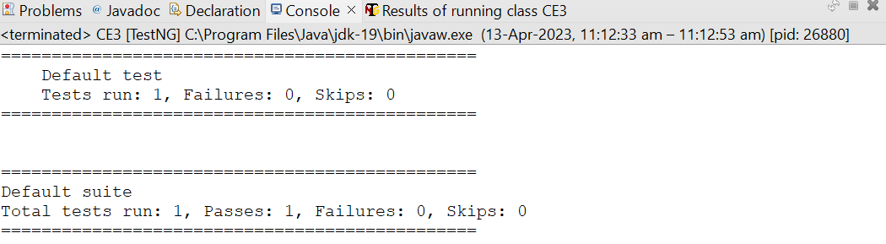

**TASK 4:**

package com.Demo.Demo;

import org.openqa.selenium.By;

import org.openqa.selenium.WebDriver;

import org.openqa.selenium.chrome.ChromeDriver;

import org.openqa.selenium.chrome.ChromeOptions;

import org.testng.Assert;

import org.testng.annotations.Test;

import io.github.bonigarcia.wdm.WebDriverManager;

public class d74 {

WebDriver d;

@Test

public void login() throws InterruptedException {

ChromeOptions co=new ChromeOptions();

co.addArguments("--remote-allow-origins=*");

WebDriverManager.chromedriver().setup();

d=new ChromeDriver(co);

d.get("https://opensource-demo.orangehrmlive.com/web/index.php/auth/login");

d.manage().window().maximize();

Thread.sleep(3000);

d.findElement(By.xpath("//*[@id=\"app\"]/div[1]/div/div[1]/div/div[2]/div[2]/form/div[1]/div/div[2]/input")).sendKeys("Admin");

d.findElement(By.xpath("//*[@id=\"app\"]/div[1]/div/div[1]/div/div[2]/div[2]/form/div[2]/div/div[2]/input")).sendKeys("admin123");

d.findElement(By.xpath("//*[@id=\"app\"]/div[1]/div/div[1]/div/div[2]/div[2]/form/div[3]/button")).click();

String et="Dashboard";

System.out.println(et);

Thread.sleep(3000);

String ct=d.findElement(By.xpath("//*[@id=\"app\"]/div[1]/div[1]/header/div[1]/div[1]/span/h6")).getText();

System.out.println(ct);

Assert.assertEquals(et, ct);

System.out.println("Logged in");

}

@Test(dependsOnMethods="login")

public void logut() throws InterruptedException {

d.findElement(By.xpath("//*[@id=\"app\"]/div[1]/div[1]/header/div[1]/div[2]/ul/li/span")).click();

d.findElement(By.xpath("//*[@id=\"app\"]/div[1]/div[1]/header/div[1]/div[2]/ul/li/ul/li[4]/a")).click();

String et="Login";

System.out.println(et);

Thread.sleep(2000);

String ct=d.findElement(By.xpath("//*[@id=\"app\"]/div[1]/div/div[1]/div/div[2]/h5")).getText();

System.out.println(ct);

Assert.assertEquals(et, ct);

System.out.println("Logged out successfully");

}

}

**OUTPUT:**

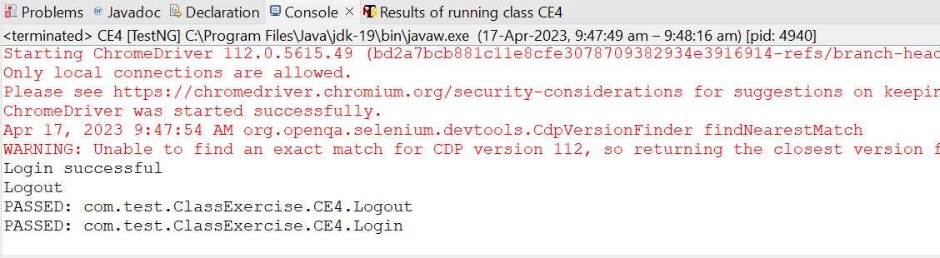

**TASK 5:**

package com.Demo.Demo;

import org.testng.annotations.Test;

import io.github.bonigarcia.wdm.WebDriverManager;

import org.testng.annotations.BeforeMethod;

import java.util.concurrent.TimeUnit;

import org.openqa.selenium.By;

import org.openqa.selenium.WebDriver;

import org.openqa.selenium.chrome.ChromeDriver;

import org.openqa.selenium.chrome.ChromeOptions;

import org.testng.Assert;

import org.testng.annotations.AfterMethod;

public class d75

{

WebDriver d;

@Test(groups="Smoke Test")

public void t1()

{

String eurl="https://www.godaddy.com/en-in";

String curl=d.getCurrentUrl();

Assert.assertEquals(eurl,curl);

String etitle="Domain Names, Websites, Hosting & Online Marketing Tools - GoDaddy IN";

String ctitle=d.getTitle();

Assert.assertEquals(etitle,ctitle);

}

@Test(groups="Regression Test")

public void t2()

{

d.manage().timeouts().implicitlyWait(10,TimeUnit.SECONDS);

d.findElement(By.xpath("//*[@id=\"id-631b049a-e9c0-4d24-8710-c504745206dd\"]/div[2]/div[1]/ul/li[1]/button")).click();

d.findElement(By.xpath("//*[@id=\"id-631b049a-e9c0-4d24-8710-c504745206dd\"]/div[2]/div[1]/ul/li[1]/div/div[2]/div[1]/ul/li[2]/a")).click();

}

@Test(groups="Regression Test")

public void t3()

{

d.manage().timeouts().implicitlyWait(10,TimeUnit.SECONDS);

d.findElement(By.xpath("//*[@id=\"id-631b049a-e9c0-4d24-8710-c504745206dd\"]/div[2]/div[1]/ul/li[1]/button")).click();

d.findElement(By.xpath("//*[@id=\"id-631b049a-e9c0-4d24-8710-c504745206dd\"]/div[2]/div[1]/ul/li[1]/div/div[2]/div[1]/ul/li[2]/a")).click();

String ctitle=d.getTitle();

String etitle="GoDaddy Domain Search - Buy and Register Available Domain Names";

System.out.println(ctitle);

Assert.assertEquals(etitle, ctitle);

}

@BeforeMethod

public void beforeMethod()

{

ChromeOptions co=new ChromeOptions();

co.addArguments("--remote-allow-origins=*");

WebDriverManager.chromedriver().setup();

d=new ChromeDriver(co);

d.get("https://www.godaddy.com/en-in");

d.manage().window().maximize();

}

@AfterMethod

public void afterMethod()

{

d.close();

}

}

**OUTPUT:**

