Smart Temperature Monitor and Alert System Using Thermal Imaging

Subar Mahdi

Summary
This project presents the design and testing of a low-cost temperature monitoring system combining a DS18B20 sensor with an AMG8833 thermal camera. The system was developed in two stages to compare point-based measurement with spatial heat detection. Experimental results showed that while the DS18B20 provided stable threshold-based alerts, the thermal camera enabled improved classification and visualisation of thermal conditions. Distance testing further highlighted limitations in detection range due to sensor resolution.

Supervised by Dr Saeed Jahdi Supported by Xiangyu Wang
Foundation Project for Science, Engineering and Mathematics
2026

Abstract
Temperature monitoring is used across areas such as industrial, environmental, and scientific applications because overheating and abnormal thermal behavior can be an indicator of unsafe operating conditions, instability, or failures [1]. Many low-cost temperature monitoring systems use a single sensor and a fixed alarm threshold. This system is simple but only accounts for a single point and does not show how localised the heat is.
This dissertation investigates a low-cost multi-sensor system that combines a point source temperature sensor (DS18B20) with a low-resolution thermal camera (AMG8833, 8x8 infrared array), on an Arduino platform. The system reports on integrated LEDs, LCD display, and a laptop based heatmap. The system triggers a warning when the sensors report a temperature in excess of a defined value, 30°C was used in the baseline system. Early evaluations of the system show correct threshold triggers and responses, and stable ambient readings of approximately 22.31°C with a range of 0.50°C. Improvements in useability were made by the addition of the display and spatial temperature sensing. The limitations of the system are low thermal resolution and reliability.
The results show that combining point source sensors with low resolution thermal cameras increases the interpretability of the data while remaining low cost, although performance is limited by the sensor resolution and overall reliability.

Introduction

Temperature monitoring is used in a range of applications where overheating can indicate a problem. In industrial systems, temperature sensors are used to monitor high temperature processes and manufacturing environments, where accurate readings can improve consistency and safety [1]. In environmental monitoring, microcontroller based systems have been used to track weather and pollution conditions by combining multiple sensors into a single system [2]. Similarly low-cost monitoring approached have also been applied in areas such as water level measurement and infrastructure monitoring where continuous data is important but system cost and reliability are key limitations [3]. Because temperature is often one of the first indicators of a problem, it is widely used as a simple but effective way of monitoring system behavior.
In many low-cost and embedded systems, this is done using a single temperature sensor and a fixed threshold. When the temperature exceeds a set value, a warning is triggered. This works well as a simple system and can give clear and early warnings, but it only measures temperature at one point and does not show how heat is destituted or where it is coming from. In practice overheating is often localised rather that spread out evenly, so a

hotspot may exist away from the sensor. This means the system might not detect the most important change until later, which reduces how useful the data is, especially when the aim is to identify the source of heating rather than just detect that a threshold has been exceeded.
More advance monitoring systems try to deal with this by collecting and analysing more data. In industrial applications, this is often done using networks of sensors that continuously record temperature and respond automatically when conditions change [1]. While this can improve consistency and provide more reliable monitoring, it also increases system complexity and cost, which is not always practical for smaller or low-cost applications. Microcontroller platforms offer a simpler alternative by allowing more flexible systems to be built without significantly increasing cost. Arduino based systems are commonly used for this as they make it possible to combine sensors, processing and outputs in a modular way. This means the system can be adapted depending on what is needed, rather that relying on a single measurement [2] [3] [4].
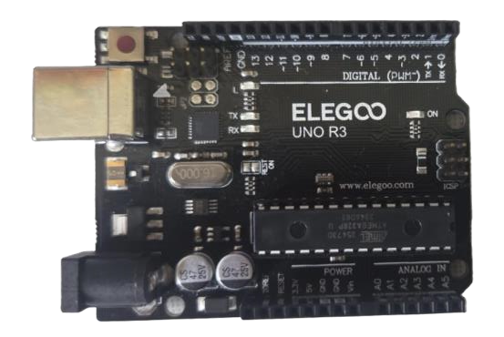
Figure 1. ELEGOO UNO R3 micro controller

Different temperature sensing methods provide different types of information. Contact based sensor provide readings at a specific point, while thermal imaging sensors estimate temperature over an area by detecting infrared radiation [5]. In low-cost systems digital sensors are often preferred because they are simple to use and provide stable readings that can be used directly without calibration or significant setup [6]. These are well suited to threshold based monitoring where the goal is to detect when a temperature limit has been exceeded.

This project uses a DS18B20 as the point temperature sensor. The sensor is a reliable and simple sensor that outputs a digital temperature value over 1-wire, making it practical basic monitoring and threshold systems [7]. The warning trigger temperature was set as 30°C, with the systems taking readings every second. A fixed threshold warning is clear and simple, but it is limited in that it indicated that one specific region has exceeded 30°C but not how localised the heat is or identify the hottest area. Additionally, if the heating is not located

near the sensor then the sensor could continue to remain close to ambient conditions even when the hot region has exceeded the threshold. This is a serious downside in many applications where users often need to locate the cause of heating.
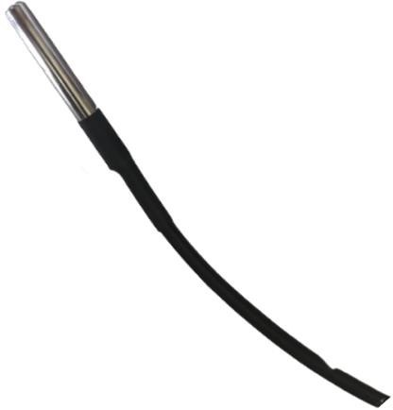

Figure 2. DS18B20, point source temperature sensor

Thermal Imagine, however, can provide a way to address this by adding special context. Instead of measuring temperature at a tingle point infrared sensors detect infrared radiation across a field of view, allowing temperature difference to be observed across an area. Traditional thermal cameras can be expensive leaving room for low-cost modular infrared sensors that can integrate with microcontrollers. Although these low-cost sensors do not produce detailed images they can still show general patterns, such as the location of hotspots or colder regions. Previous work suggests that this type of low resolution thermal imaging can still be useful as long as it is used to provide context rather that precise measurements. This project therefore adds an AMG8833, 8x8 infrared thermal array that provides 64 temperature values across its field of view [9]. The 8x8 format sets a defined boundary, the system can show rough hotspot patterns and approximate location but not detailed thermal imagery.
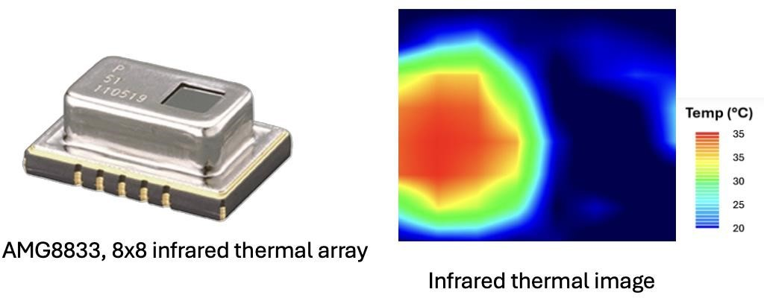

Figure 3. Infrared thermal array including thermal image.

The main idea behind this project is to combine these two approaches. The DS18B20 provides a stable and reliable point measurement which works well for threshold detection. The thermal array provides spatial information, showing how temperature is distributed across an area. By using both together it becomes possible to compare a simple threshold based system with one that also includes special context.
Therefore the research question is: To decide what extent does combining a DS18B20 point sensor and a AMG8833 8x8 thermal array improve the interpretability of thermal conditions compared with a simple point source threshold system?
To investigate this, a low cost monitoring system was developed using an Arduino microcontroller. The system combines a DS18B20 temperature sensor with an AMG8833 8x8 thermal array into the same microcontroller. The system aims to reporting back critical data. LEDs provide a clear and simple safe/warning signal but does not distinguish between temperatures just over or under the boundary or far away. A 16x2 LCD improves usability by displaying the temperature and warning state directly on the device. The data from the AMG8833 is displayed on a laptop to give special context to the user.
The main aim of this project is not just to measure temperature but to investigate whether adding special information makes the system more useful. In this system a simple threshold can show when the temperature exceeds 30°C, but does not explain where the heat is coming from or how it is distributed. In many situations, being able to identify the location of a hotspot is just as important as detecting that a threshold has bee reached, particularly when trying to understand the cause of heating or respond to it effectively.

The system is designed as a low cost prototype using a point sensor and a low resolution thermal array. Therefore there are clear limitations: the thermal sensor only provides an 8x8 grid, meaning it can show general patterns but not detailed images, and the overall system is limited by sensor accuracy and reliability. However, this is part of the investigation, as the aim is not to match high end systems but to see whether combining these simple components still gives more useful information than a basic threshold system on its own.

Overall, this project focuses on whether adding special context to a simple temperature monitoring system makes it easier to interpret what is happening. Rather than just detecting that something is wrong, the system aims to give clearer idea of where the heat is and how it behaves, which could make it more useful in practical situation.

Methodology

The experimental work was designed to compare a simple point-temperature alert system with an extended thermal monitoring system capable of producing spatial information. The build was therefore separated into two linked stages. First, a baseline Arduino system was constructed using a DS18B20 digital temperature sensor and light-emitting diode (LED) indicators. Secondly, the system was extended using an AMG8833 8x8 infrared thermal sensor array to test whether spatial heat detection could improve the usefulness of the system for identifying different thermal conditions.
System overview. The baseline setup used a single DS18B20 sensor to measure temperature at one point. The Arduino Uno was programmed to compare the measured temperature with a 30 °C warning threshold. Temperatures below the threshold produced a normal state, indicated by a green LED, while temperatures above the threshold produced a warning state, indicated by a red LED. This stage was used to test whether the sensor could provide stable measurements and a simple threshold-based alert output.
The extension build retained the DS18B20 sensor but added the AMG8833 thermal camera. The AMG8833 was connected using inter-integrated circuit communication and provided an 8x8 grid of infrared temperature readings. Processing software was used to convert these readings into a live thermal heatmap and to log numerical data to commaseparated value (CSV) files. The final extended system recorded the DS18B20 reading, the peak thermal camera reading, the average thermal camera reading, and a classified state such as room temperature, human heat, hot object, or cold object.

Table 1. Main hardware and software components used in the temperature monitoring system. The DS18B20 provided stable point-temperature data, while the AMG8833 provided spatial thermal information for the extension stage.

Component | Role in system | Key output
Arduino Uno | Microcontroller used to collect  sensor data and control outputs | Serial data stream and LED/LCD  output
DS18B20 temperature sensor | Single-point digital temperature  measurement | Ambient or local temperature  (°C)
Red/green LEDs | Visual warning indicators for  threshold response | Normal or warning state
AMG8833 8x8 IR thermal camera | Spatial infrared temperature  detection | 64 pixel temperature values,  peak and average values
Processing software | Visualisation and logging of  thermal data | Heatmap images and CSV data  files

Baseline testing procedure.

For the initial build, temperature was sampled atapproximately 1 s intervals. Two baseline tests were carried out. In the threshold-response test, a heat source was introduced close to the DS18B20 sensor until the reading exceeded the 30 °C warning threshold, after which the heat source was removed, and the cooling response was recorded. In the stability test, the sensor was left under room conditions for approximately 9 min while the temperature reading was recorded. The stability test was used to determine whether fluctuations were small enough for the DS18B20 to act as a reliable baseline sensor.

Thermal camera testing procedure.

For the extension stage, four thermal conditions were tested: room temperature, human heat, hot object, and cold object. Each condition was presented to the thermal camera for a fixed period before being removed. The Processing interface displayed the heatmap and stored the peak thermal reading and average thermal reading. The colour scale was used as a qualitative guide, where cooler regions appeared blue and warmer regions appeared green, yellow, orange, or red.
Distance testing procedure.

A separate distance test was carried out to estimate the practical sensitivity of the thermal camera. A hand was held at 3 cm, 6 cm, and 9 cm from the camera, and five readings were recorded for each distance. The mean peak thermal reading and mean average thermal reading were then calculated. These distances were selected because early testing showed that the low-resolution thermal camera struggled to produce reliable human-heat classification at larger distances.
System refinement and data quality control.

Initial testing revealed inconsistencies in temperature classification, particularly between room temperature and human heat conditions. This was caused by threshold values being set too close to ambient temperature, resulting in unstable state changes and occasional misclassification. To resolve this, the threshold logic was adjusted to create clearer separation between temperature ranges, improving classification reliability.
Further issues were observed in the form of fluctuating sensor readings immediately after introducing a heat source. This was due to measurements being recorded before the system reached a stable state. A stabilisation period was therefore introduced prior to data

collection, ensuring that both the DS18B20 sensor and thermal camera readings had settled before recording.
Data recording during early trials was performed manually, which led to minor inconsistencies and increased the risk of transcription errors. This was addressed by implementing automated CSV logging, allowing for consistent, time-stamped data collection and improved accuracy across repeated tests.

Results

The results were analysed to determine whether the final system could move beyond simple point-temperature measurement and provide useful information about thermal state and spatial heat distribution. The discussion is organised around the four main datasets: threshold response, DS18B20 stability, thermal camera condition classification, and distance sensitivity.
Baseline threshold response.
The threshold-response test showed that the DS18B20 system responded clearly to heating and cooling (Figure 3). The measured temperature increased from approximately 23°C to a peak of about 31.3°C. The 30°C threshold was crossed after roughly 20 s, which would activate the warning state in the Arduino program. After the heat source was removed, the temperature gradually decreased and fell below 30°C after approximately 27s.
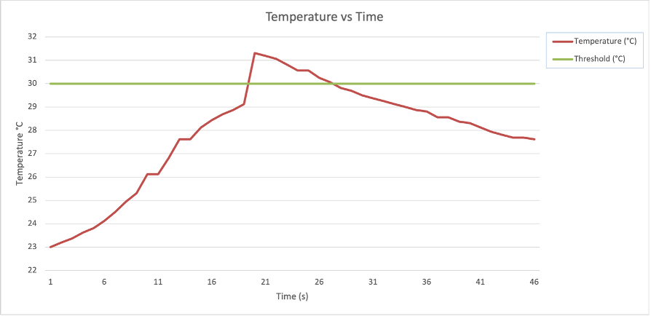
Figure 4. Threshold response of the DS18B20 temperature sensor during heating and cooling. The green horizontal line represents the 30 °C alert threshold, while the red curve shows the measured temperature. The

sensor exceeded the threshold at approximately 20s and returned below the threshold during the cooling phase.

This result indicates that the baseline system achieved its original purpose: it detected a temperature rise and produced a measurable transition across the warning threshold. The gradual cooling phase also shows that the system did not simply switch randomly between states but followed the expected physical behaviour of heat loss after the heat source was removed.
Sensor stability.

The stability test showed that the DS18B20 reading remained within a narrow temperature range during ambient testing (Figure 4). The recorded values decreased gradually from approximately 22.6-22.7°C to approximately 22.2°C over the test period, with the mean temperature close to 22.3°C. The small step-like changes are consistent with the digital resolution of the DS18B20 sensor and normal environmental drift rather than large random noise.

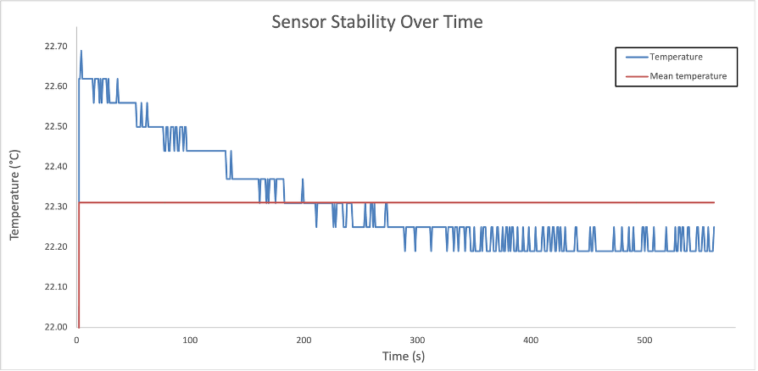
Figure 5. Stability of the DS18B20 sensor under room conditions. The blue line shows the measured sensor temperature, and the red line shows the mean temperature. The gradual drift remained small, indicating that the sensor was suitable for use as a baseline point-temperature measurement device.

Thermal camera response to controlled conditions.

The extended system produced clearer separation between different thermal conditions than the DS18B20-only setup (Figure 5). During room-temperature periods, the peak and

average thermal readings remained close to 25 °C. Human heat produced a moderate increase, with values around 34-36 °C. The hot object produced the largest increase, with peak values above 50 °C, while the cold object produced the lowest readings, falling to approximately 14-16 °C. The sequence of rises and falls in Figure 5 therefore corresponds to the object placed in front of the thermal camera at each stage of the test.
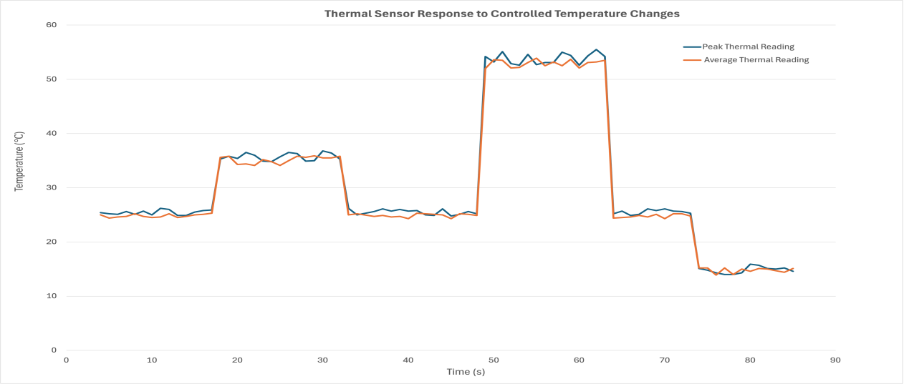
Figure 6. Thermal camera response to controlled temperature changes. The blue curve shows peak temperature, and the orange curve shows average temperature. Each condition was applied for 10 s, with data recorded every 2 s. The peaks correspond to human heat and a hot object, while the final decrease corresponds to a cold object. Return to room temperature between stages indicates repeatable baseline recovery.

The difference between the peak and average readings reflects how heat is distributed across the sensor array. The peak value represents the hottest region within the 8×8 grid, while the average value represents the overall thermal field across all pixels. For localised heat sources, such as a hand or small hot object, only a portion of the sensor is exposed to elevated temperatures, resulting in a stronger increase in the peak value compared to the average.

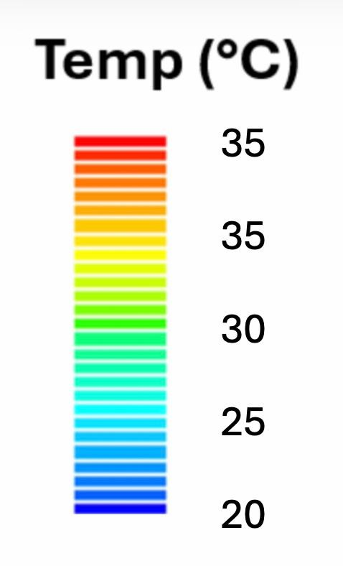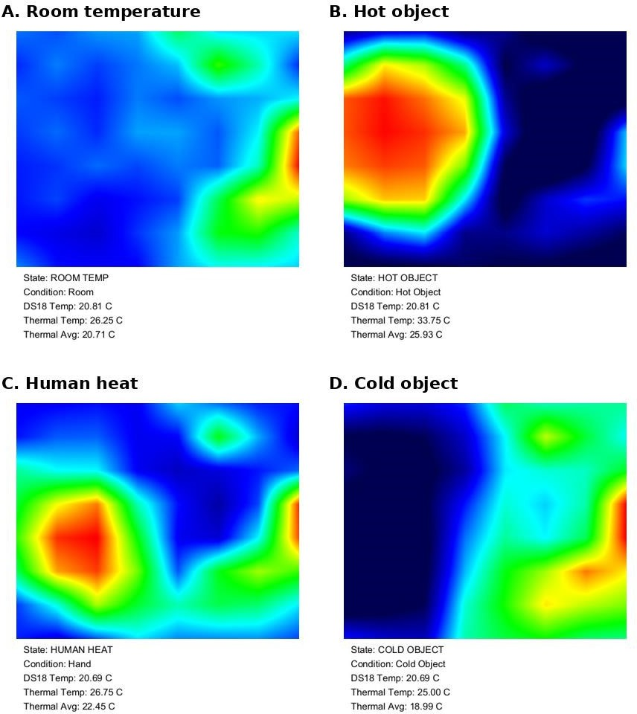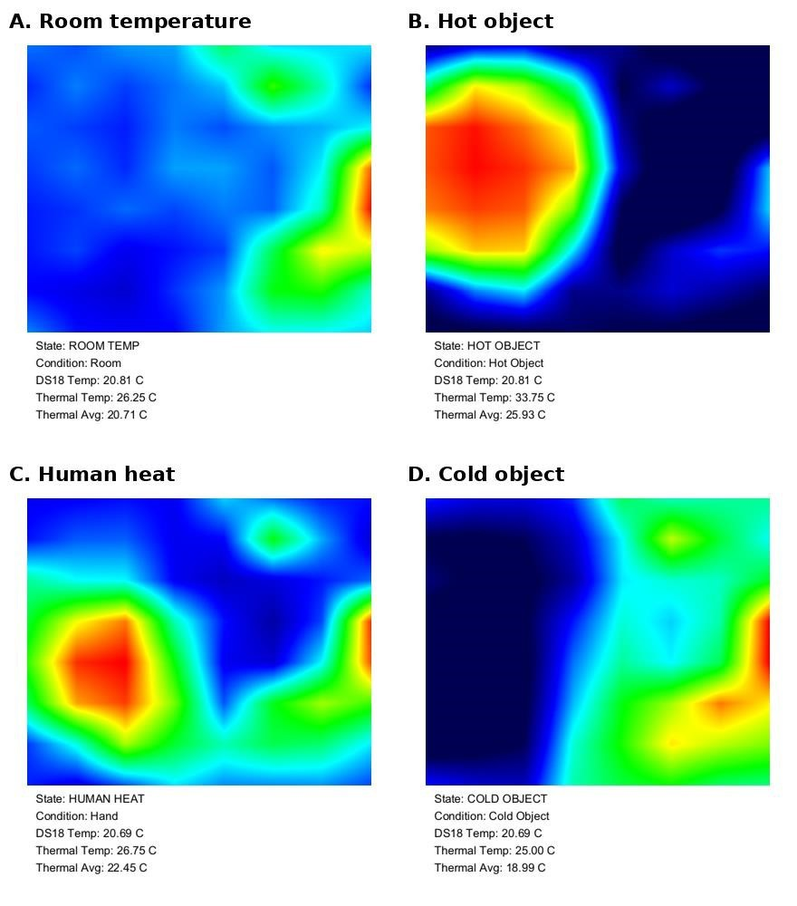

Figure 7. Thermal heatmap images generated using Processing for four conditions: A) room temperature, B) hot object, C) human heat, and D) cold object. The images show that the AMG8833 sensor produced distinguishable thermal patterns, although the 8x8 resolution caused the heatmaps to appear blurred rather than sharply defined.

The heatmap images in Figure 7 provide a visual explanation of the numerical data by showing how temperature is distributed across the sensor field. Under room-temperature conditions, the image is dominated by cooler blue and green regions, indicating a relatively uniform thermal background. In contrast, the hot object produces a concentrated red/orange region, showing a strong localised increase in temperature. Human heat produces a smaller and less intense warm region, while the cold object introduces a clearly defined cooler area.

The condition comparison is summarised in Table 2. The DS18B20 reading remained close to 20.6-20.8 °C across all conditions because the tested objects were placed in front of the thermal camera rather than directly on the DS18B20 sensor.

Table 2. Summary of sensor readings under di`erent thermal conditions. The DS18B20 value remained close to room temperature because it measured a fixed point, while the thermal camera changed clearly when di`erent objects were placed in its field of view.

Condition | DS18B20 temperature (°C) | Peak thermal reading (°C) | Average thermal reading (°C)
Room temperature | 20.44 | 25.4 | 25.0
Human heat | 20.69 | 36.0 | 34.1
Hot object | 20.69 | 55.1 | 53.5
Cold object | 20.62 | 14.6 | 15.1

Distance sensitivity.

The distance test showed that the thermal response decreased as the heat source was moved further away from the AMG8833 sensor (Figure 8). The mean peak thermal reading decreased from 27.1 °C at 3 cm to 26.4 °C at 6 cm and 25.9 °C at 9 cm.

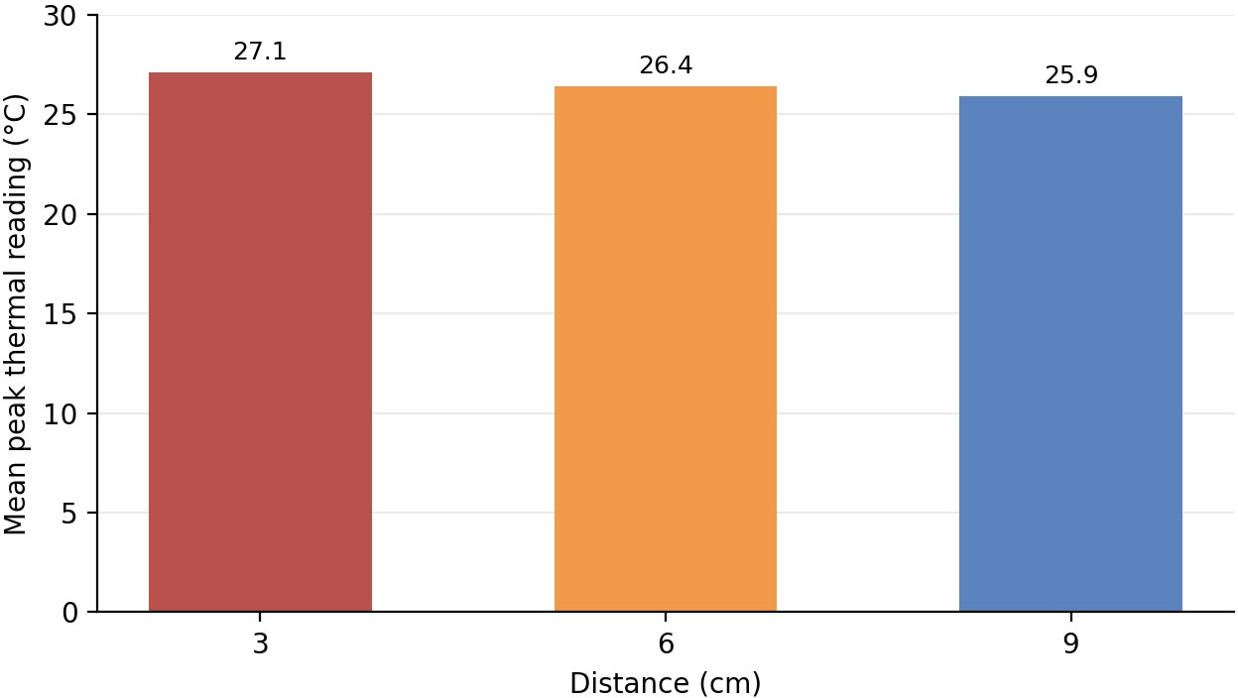

Figure 8. Mean peak thermal reading measured at 3 cm, 6 cm, and 9 cm from a human heat source. The decrease in measured temperature with increasing distance shows reduced detection strength at larger separations.

Table 3. Distance sensitivity results for the thermal camera. The highest response was measured at 3 cm and the weakest response was measured at 9 cm, showing that distance reduces detection strength.

Distance (cm) | Mean peak thermal reading (°C) | Mean average thermal reading (°C) | Dominant classification
3 | 27.1 | 22.3 | Human heat
6 | 26.4 | 21.8 | Human heat
9 | 25.9 | 21.3 | Weak / mixed

Discussion

The DS18B20 stability test in figure 5 showed that the temperature probe was reasonably consistent under controlled and steady conditions. The temperature stayed within a narrow range of about 0.5°C and had a mean value of approximately 22.3°C, meeting the specification listed by the manufacturer [7]. This shows that the sensor was suitable for basic ambient temperature monitoring. However, the graph also showed a gradual downward trend from around 22.6°C to around 22.2°C, which suggests that small environmental changes or sensor settling can affect the readings. Therefore, the temperature probe was useful for simple monitoring, but it should not be treated as a fully calibrated scientific measurement system without further testing. The threshold test in figure 4 showed that the warning function worked correctly. The measured temperature increased from around 23°C, crossed the 30°C threshold, peaked at approximately 31.3°C, and then dropped below the threshold again once the probe was taken out of hot water.
This demonstrated that the system could detect a temperature rise, identify when the warning point had been reached, and show the cooling trend afterwards. This confirmed that the basic alert system functioned as intended.

The thermal sensor response test in figure 6 showed that the Thermal array could detect controlled temperature changes. The sensor readings increased to around 34–36°C during the first heating stage caused by a human hand, it then rose further to approximately 52–55°C during the stronger heating stage where hot water was introduced and dropped to around 14–16°C during the cold stage. The peak and average thermal readings followed the same similar pattern, showing that the thermal array was responding to real changes in the general environment. The peak value was useful for identifying the hottest point, while the average value gave a broader indication of the whole scene.

The heatmap results in figure 7 showed the main benefit of extending the project. In the hot object test, the temperature probe measured only 20.8°C, while the thermal array detected a temperature of 33.7°C and an average of 25.9°C. This showed that the temperature probe did not detect the hotspot because it was not measuring the region that was hot. The thermal array, however, was able to identify the warmer area visually and numerically. This was the clearest evidence that the thermal array improved the system. The cold object and human heat tests also supported this. In the cold object test achieved with cold water, the thermal average dropped to 18.9°C, showing that the thermal array could detect a colder region in the field of view. In the human heat test, the thermal peak reached 26.7°C and the thermal average increased to 22.4°C, even though the temperature probe stayed close to room temperature at 20.6°C. These results show that the thermal array could identify warmer or cooler areas that the point sensor alone did not capture.

Figure 8 provided a great example of thermal intensity over a given distance. As the heat source occupies a smaller proportion of the sensor field when at greater distance away, therefore contributing a smaller thermal radiation footprint on the sensor. This is a great example of how distance can affect the data we collected and something that needs to be considered when taking measurements to not introduce unwanted error. Although the trend was consistent, the total change between 3 cm and 9 cm was only about 1.2 °C. This indicates that the Thermal array could detect a distance-related change, but its sensitivity over this short range was limited.

Several issues were encountered during development, particularly in relation to data interpretation and system responsiveness. Early versions of the Processing visualisation were slow and produced heatmaps that were difficult to interpret due to rapid fluctuations in colour mapping. This was improved by simplifying the visual output and focusing on peak and average thermal readings, which provided clearer numerical indicators of system behaviour. In addition, the classification system initially produced unstable outputs when threshold values were too close to ambient conditions, causing rapid switching between states. This was resolved by refining the threshold ranges and applying consistent, repeatable test conditions, ensuring that each thermal state produced a distinct and stable response.

Hardware reliability was another issue. The LCD and thermal camera required many jumper-wire connections, making loose wiring a possible source of intermittent failure. The build was reorganized so that the thermal camera and sensor connections were more stable before the final dataset was recorded. These refinements meant that the final data were not simply a record of early trial-and-error, but the result of an improved and repeatable experimental setup.

Future development should focus on improving accuracy, resolution, and reliability. A higher-resolution thermal sensor would allow for more detailed hotspot detection. More rigorous accuracy testing would help to pinpoint weaknesses in design or equipment.
Wireless alerts or data logging would make the system more useful for long-term monitoring, and a stronger physical build would also make the prototype more suitable for practical use.

Wireless alerts would also make the system more practical. In the current prototype, the user needs to be near the LED, LCD, or laptop heatmap. In real use, a user may not constantly watch the display. A wireless version could send a warning by Bluetooth, Wi-Fi, email or app notification when a threshold is crossed. This would make the system more useful for monitoring equipment, storage spaces, or small enclosures.

Calibration is another important improvement. The temperature probe and thermal array measure temperature differently. The temperature probe measures one physical point, while the thermal array senses infrared radiation across an area. Infrared readings can be affected by distance, angle, surface material, reflectivity, and airflow. This means the system should not be treated as fully accurate without calibration against a known thermometer or professional thermal camera.

The heatmap display is useful, but the 8×8 resolution is the main limitation of the thermal array. It only provides 64 temperature values, so it can show broad hot and cold regions but not detailed thermal images. The heatmaps show this clearly, as the hot and cold areas appear as colored blobs rather than sharp shapes. This is enough for approximate hotspot detection, but not for detailed diagnostics. A future version could use a higher-resolution thermal sensor to improve hotspot location and image detail.

Conclusion

The project successfully developed a low-cost smart temperature sensor and alert system using an Arduino Uno, a DS18B20 temperature probe, and an AMG8833 8×8 thermal array. The system was able to achieve its main aim of measuring temperature, displaying live readings, and giving a warning when temperature exceeded a particular threshold set by the user. The project also showed that adding a thermal array improved the usefulness of the system by giving it some basic spatial information about heat distribution.

This matters because in real-world temperature monitoring, the location of heat can be just as important as the temperature value. In electrical systems, battery packs, motors, or

mechanical components, overheating can just be localized. A loose connection, damaged wire, overloaded component or failing part may create a hotspot that a single temperature probe would not be the appropriate device to use as it might not be placed directly on the hot area. The hot object test demonstrated this clearly. The temperature probe measured only 20.8°C, while the thermal array detected a peak temperature of 33.7°C. This shows that the temperature probe stayed close to room temperature while the thermal array detected a hotter region elsewhere in its field of view.

The room temperature test showed that the two sensors could agree reasonably well when no strong hot or cold object was present. The temperature probe measured 20.8°C, while the thermal array was 20.7°C. This suggests that under stable room conditions, the thermal array can give a similar general reading to the temperature probe. However, when an object was introduced, the readings became very different. This shows why the two sensors are more useful together.

The physical build would also need improvement before real-world use. As a prototype, the system may be affected by loose wires, sensor movement, and inconsistent positioning. A practical version would need a fixed case, secure sensor mounting, better cable management and protection from dust, moisture and knocks. The display could also be improved with clearer warning messages, color-coded risk levels, maximum and minimum readings, and automatic hotspot location.

In conclusion, the project showed that a low-cost smart temperature monitoring system can be made more useful by combining a temperature probe with a low-resolution thermal array. The final system was not a replacement for professional thermal imaging equipment, but it successfully demonstrated the value of adding visual data to a basic threshold warning system. Overall, the project shows that the usefulness of a temperature monitor depends not only on detecting that a limit has been exceeded, but also on helping the user understand where the heat source is coming from and how that heat is distributed.
However, the system still has limitations. The thermal array has only an 8×8 resolution, so it can only show rough thermal patterns rather than detailed thermal images. The prototype is also limited by sensor accuracy, calibration, wiring, build quality, and reliability.

References

- Chang V, Martin C. An industrial IoT sensor system for high-temperature measurement. Computers and Electrical Engineering [Internet]. 2021;95. Available from: http://dx.doi.org/10.1016/j.compeleceng.2021.107439
- Akinwumi SA, Okey-Amadi O, Ayara WA, Akinwumi OA. Eco-friendly Weather Monitoring Device using Arduino Mega and Sensor Integration. IOP Conference Series: Earth and Environmental Science [Internet]. 2024;1428(1). Available from: http://dx.doi.org/10.1088/1755-1315/1428/1/012006
- Pearce RH, Chadwick MA, Main B, Chan K, Sayer CD, Patmore IR. LowCost Approach to an Instream Water Depth Sensor Construction Using Differential Pressure Sensors and Arduino Microcontrollers. Sensors (Basel, Switzerland) [Internet]. 2024;24(8). Available from:
https://doi.org/10.3390/s24082488

- Barroca N, Borges LM, Velez FJ, Monteiro F, Górski M, Castro-Gomes J. Wireless sensor networks for temperature and humidity monitoring within concrete structures. Construction and Building Materials [Internet]. 2013;40:1156–66. Available from: http://dx.doi.org/10.1016/j.conbuildmat.2012.11.087
- Dedyulin S, Ahmed Z, Machin G. Emerging technologies in the field of thermometry. Measurement Science and Technology [Internet]. 2022;33(9). Available from: http://dx.doi.org/10.1088/1361-6501/ac75b1
- John Kinchin. Using an Arduino and cheap thermistor to make a simple temperature sensor. Physics Education [Internet]. 2018;53(6). Available from: http://dx.doi.org/10.1088/1361-6552/aae34a
- Analog Devices Inc. DS18B20 programmable resolution 1-wire digital thermometer datasheet [Internet]. 2019 [cited 2026 Apr 15]; [20]. Available from: https://www.analog.com/media/en/technicaldocumentation/data-sheets/DS18B20.pdf

- Soong R, Jenne A, Biswas RG, Adamo A, Simpson A. Exploring the Maker Culture in Chemistry: Making an Affordable Thermal Imaging System for Reaction Visualization. Journal of Chemical Education [Internet].
2020;97(10):3887–91. Available from: https://dx.doi.org/10.1021/acs.jchemed.0c00516
- Panasonic Corporation. ADI8000C66 datasheet [Internet]. 2023 [cited 2026 Apr 15]; [9 screens]. Available from: https://industrial.panasonic.com/cdbs/wwwdata/pdf/ADI8000/ADI8000C66.pdf

