**Lab-1 Assignment**

**Submitted by:**

**SUBARNA POUDEL  
Student ID: 23002412**

**Submitted to:**

**Professor: Nawaz Chowdhury**

**Subject: Web Development 2**

**Course code: CSD213**

Honesty Statement: “I declare that this submission is my own work in compliance with Sault College Academic Policies.”

**Due date: September 11, 2024**

**Table of Content**

**Assignment Steps** 3

**Assignment Steps-1** 3

**Assignment Steps-2** 4

**Assignment Step-2** 5

# 

# **Assignment Steps**

## **Assignment Steps-1**

Here is my code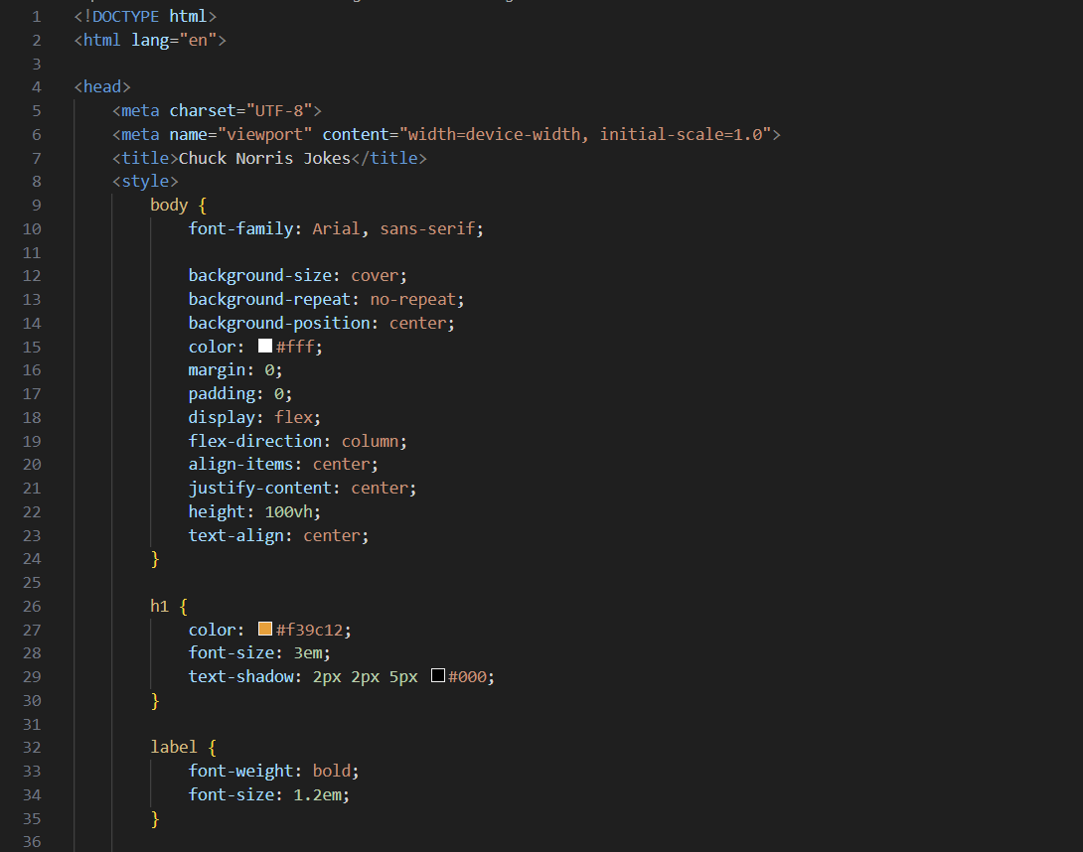

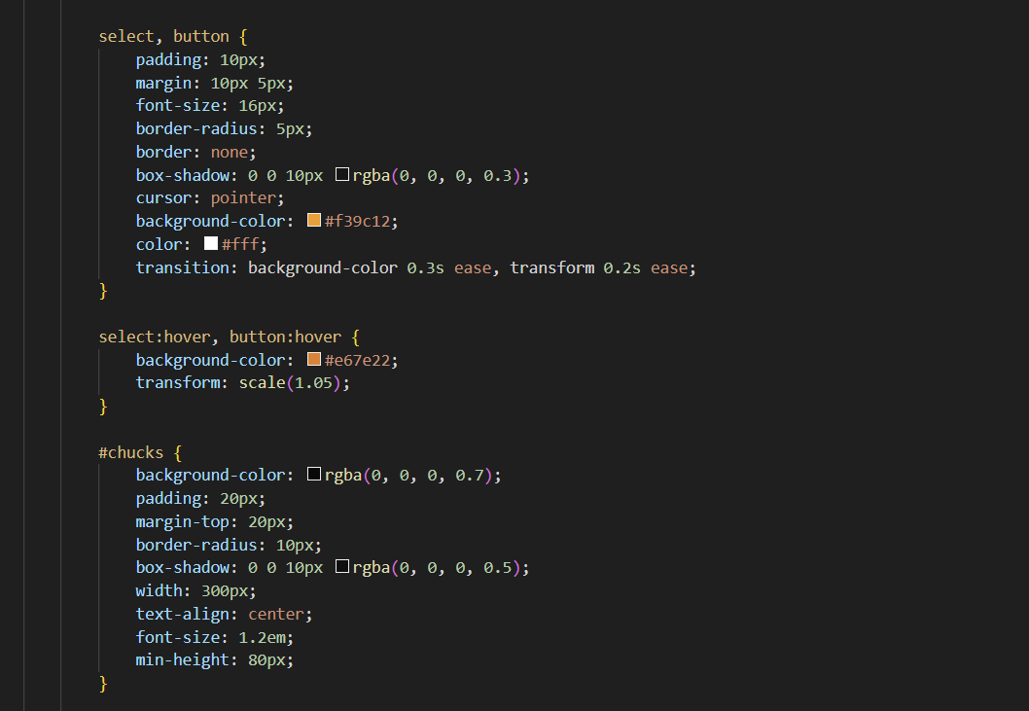

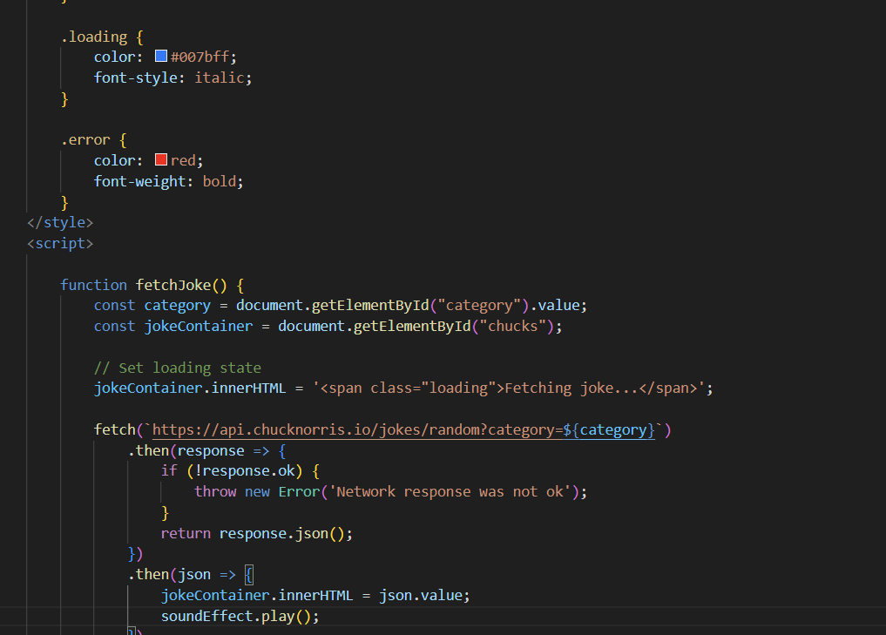

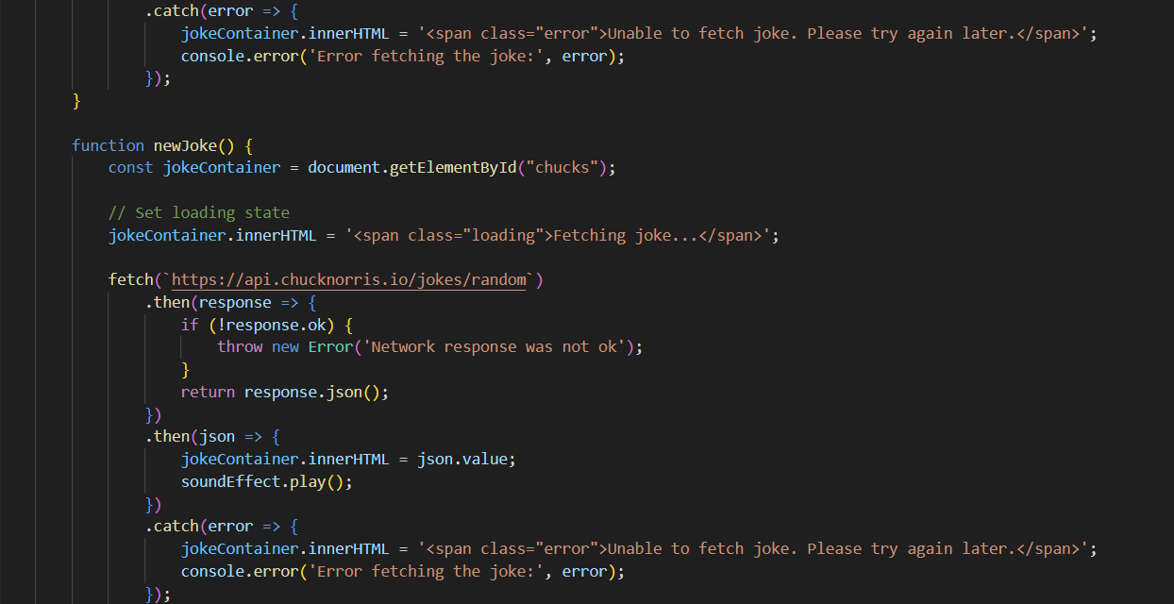

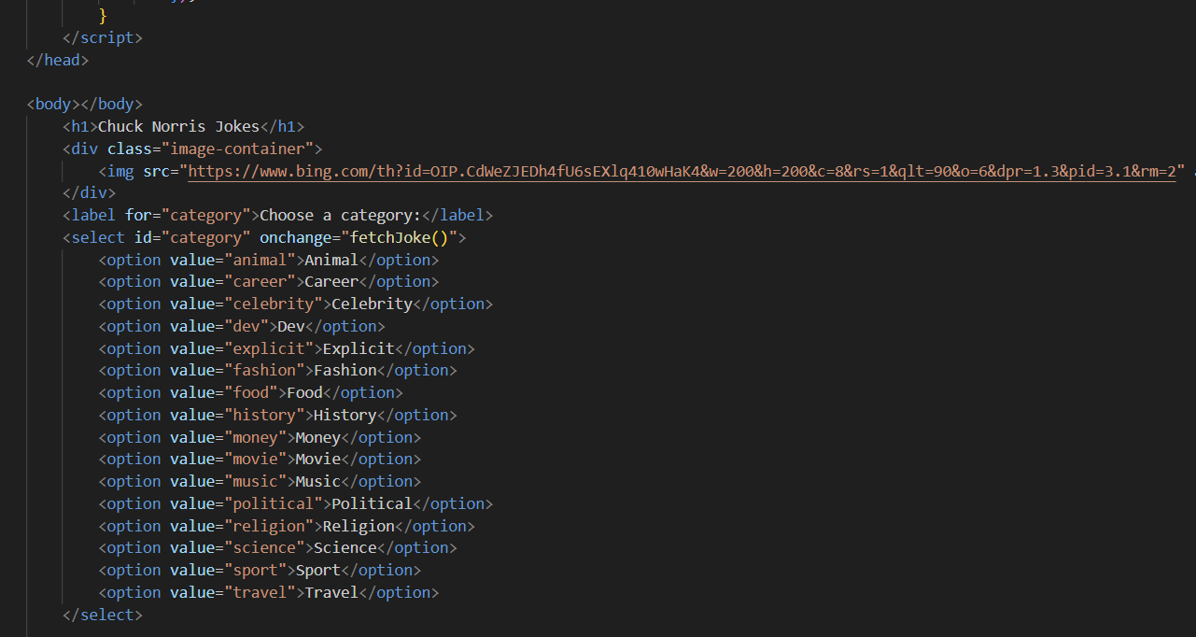

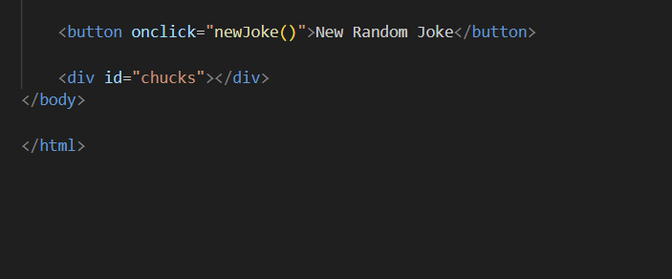

## **Assignment Steps-2**

Here is my output

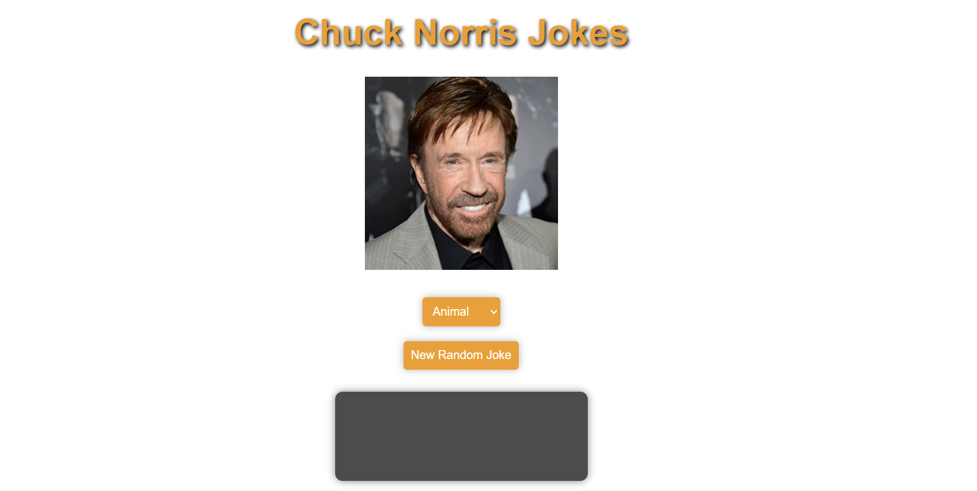

**Thank you.**