Title: Reports on Cars4U
Module Name: Database System
Student Name: Raj DC
Student id: 77263649

Task 1. Application Builder Report

Query 1.
SELECT CUSTOMER_ADDRESS, CUSTOMER_NAME, CHARGE_ID, CHARGE_AMOUNT
FROM CUSTOMER, CHARGE
WHERE CUSTOMER.CUSTOMER_ID = CHARGE.FK1_CUSTOMER_ID
AND CHARGE_AMOUNT>5000;

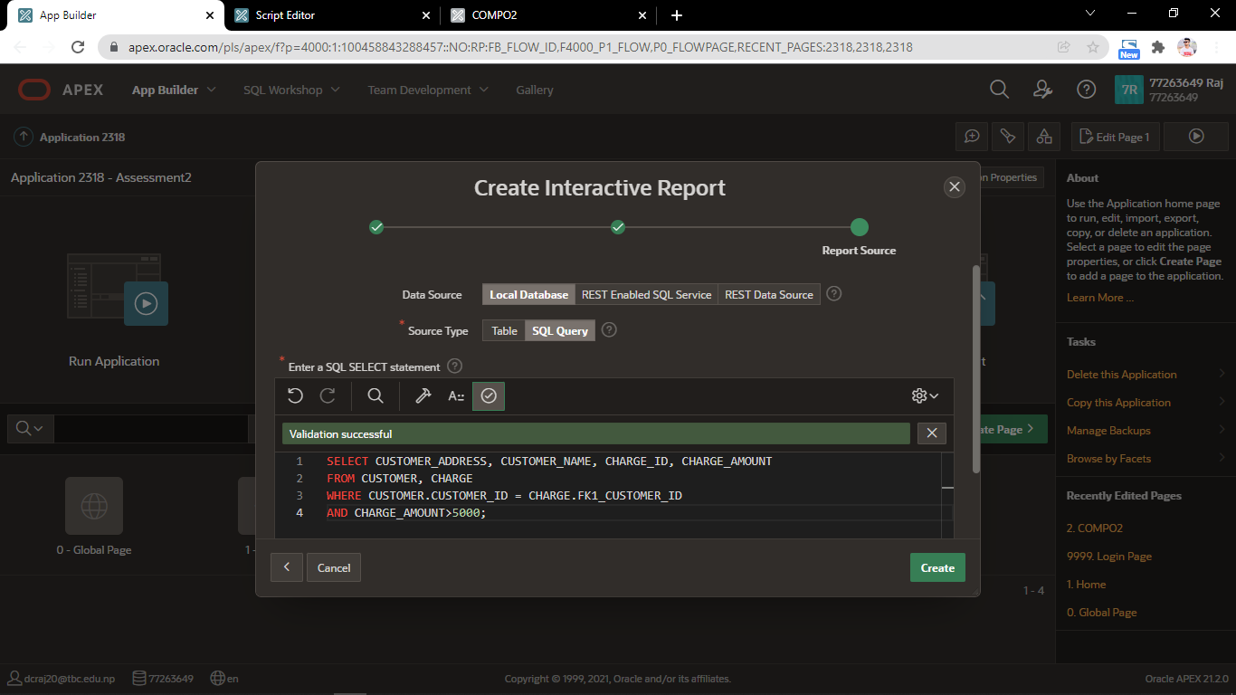

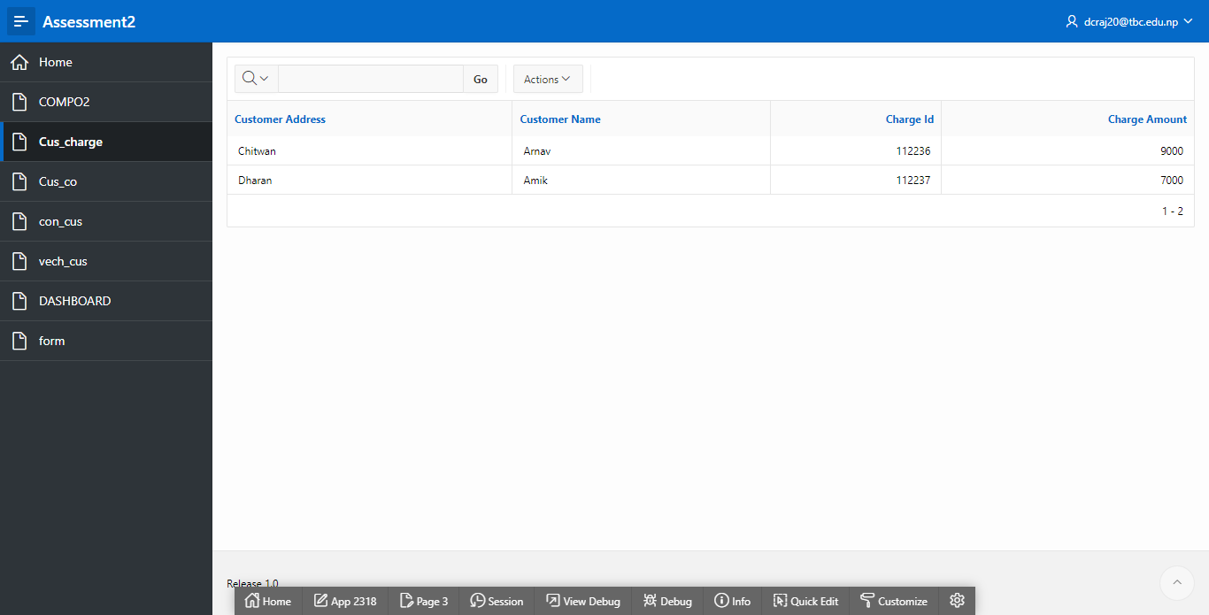

Query 2.
SELECT MEMBERSHIP_TYPE, CUSTOMER.CUSTOMER_ID
FROM CUSTOMER, CORPORATE
WHERE CUSTOMER.CUSTOMER_ID = CORPORATE.CUSTOMER_ID
AND MEMBERSHIP_TYPE = 'Gold';
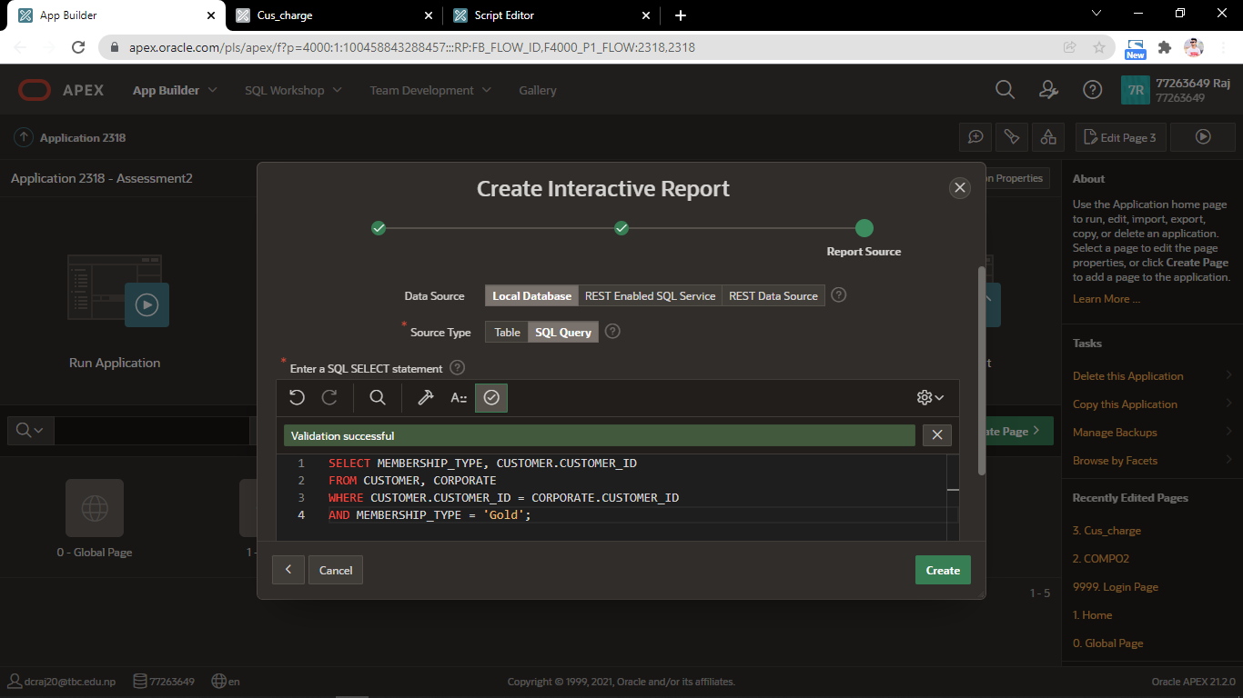
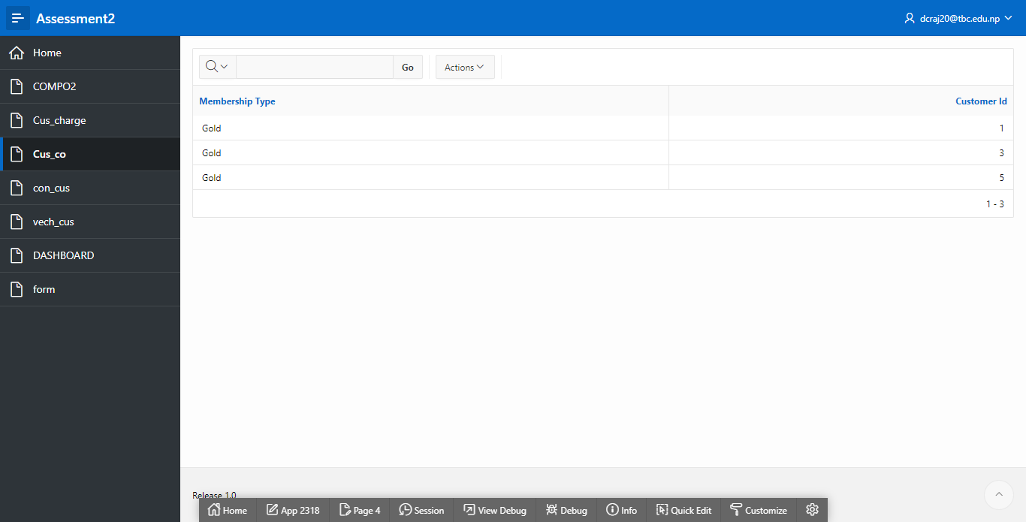

Query 3.

SELECT FREUENCY, CUSTOMER_ADDRESS, CUSTOMER_NAME
FROM CONTRACT, CUSTOMER
WHERE CONTRACT.FK1_CUSTOMER_ID = CUSTOMER.CUSTOMER_ID
AND FREUENCY = 10
AND CUSTOMER_ADDRESS ='Butwal';
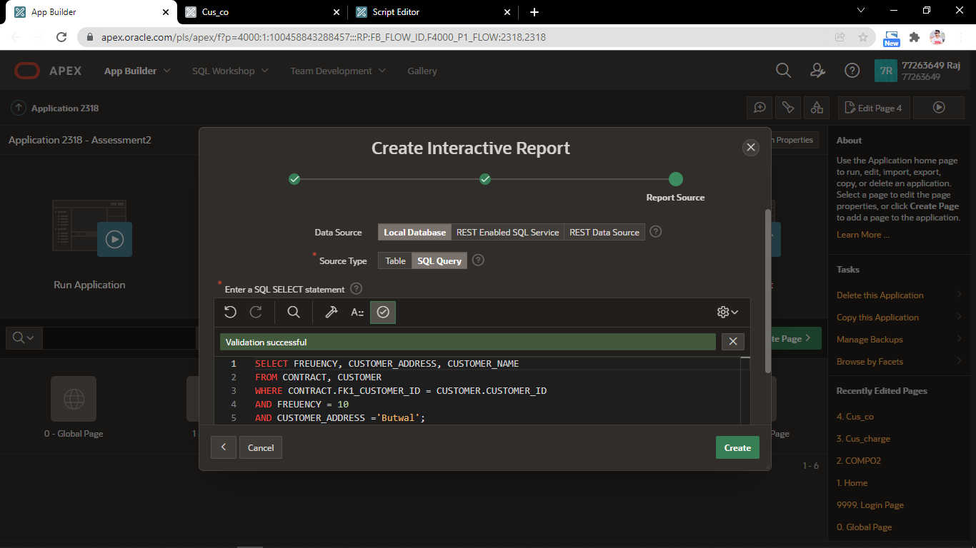
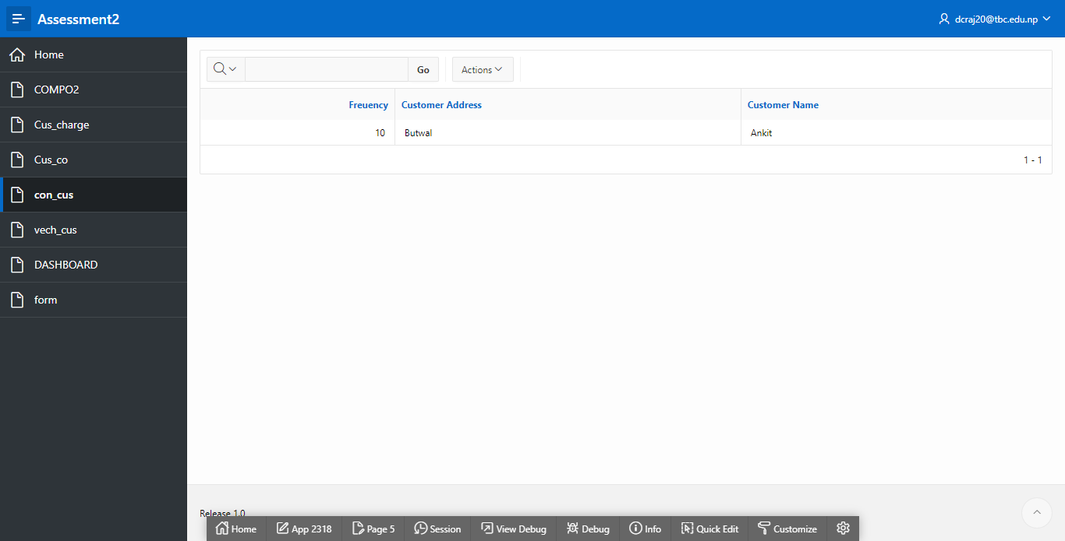

Query 4.
SELECT VEHICLE_NAME, VEHICLE_TYPE, CUSTOMER_ADDRESS, CUSTOMER.CUSTOMER_ID
FROM VEHICLE, CUSTOMER
WHERE VEHICLE.FK1_CUSTOMER_ID = CUSTOMER.CUSTOMER_ID
AND VEHICLE_TYPE = 'HATCHBACK';
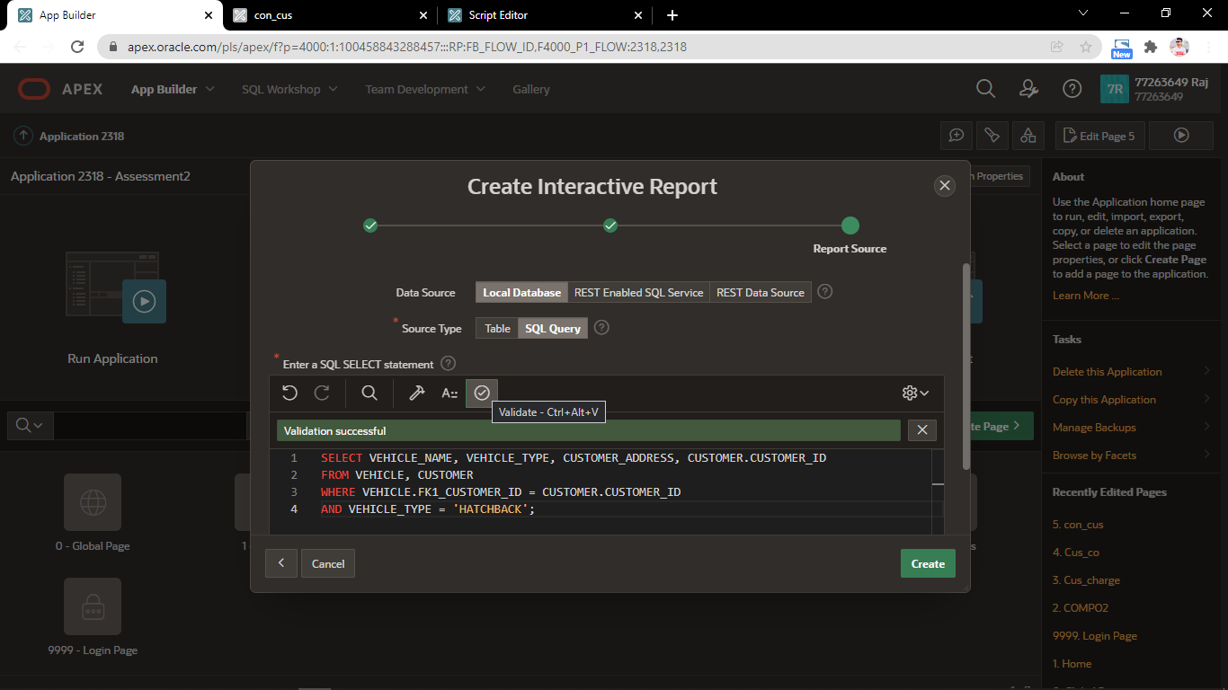
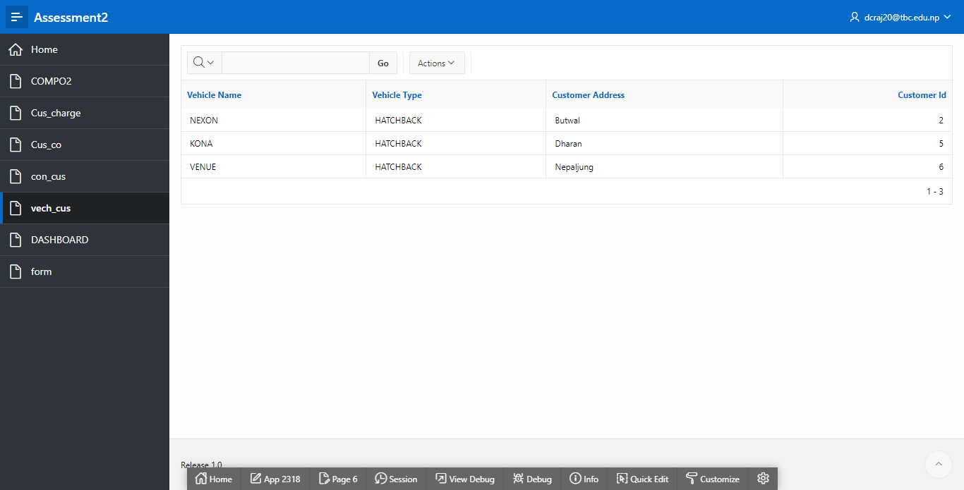

MASTER DETAILS.

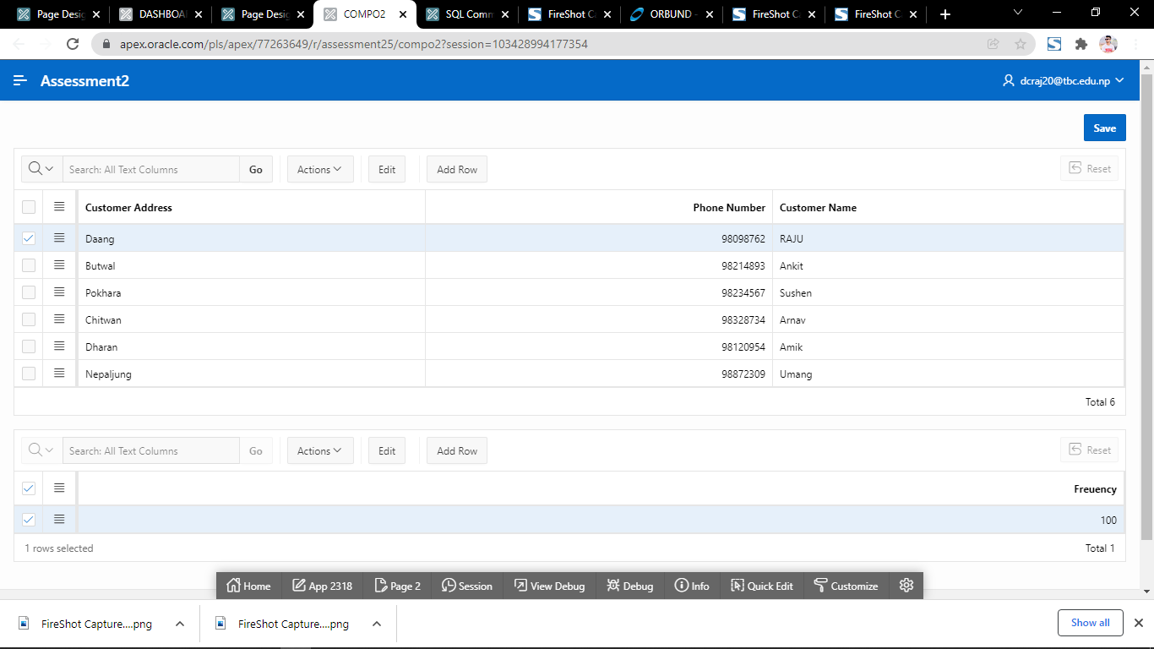

INSERT.
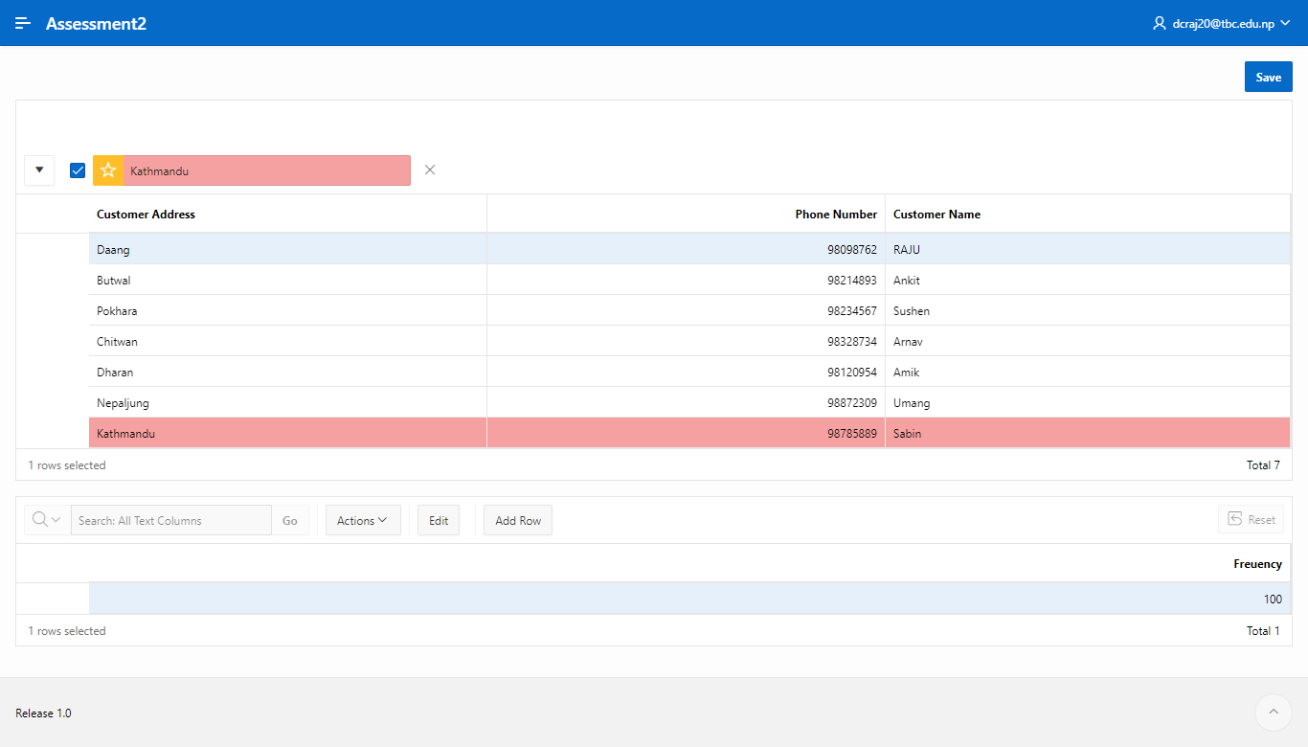

DELETE.

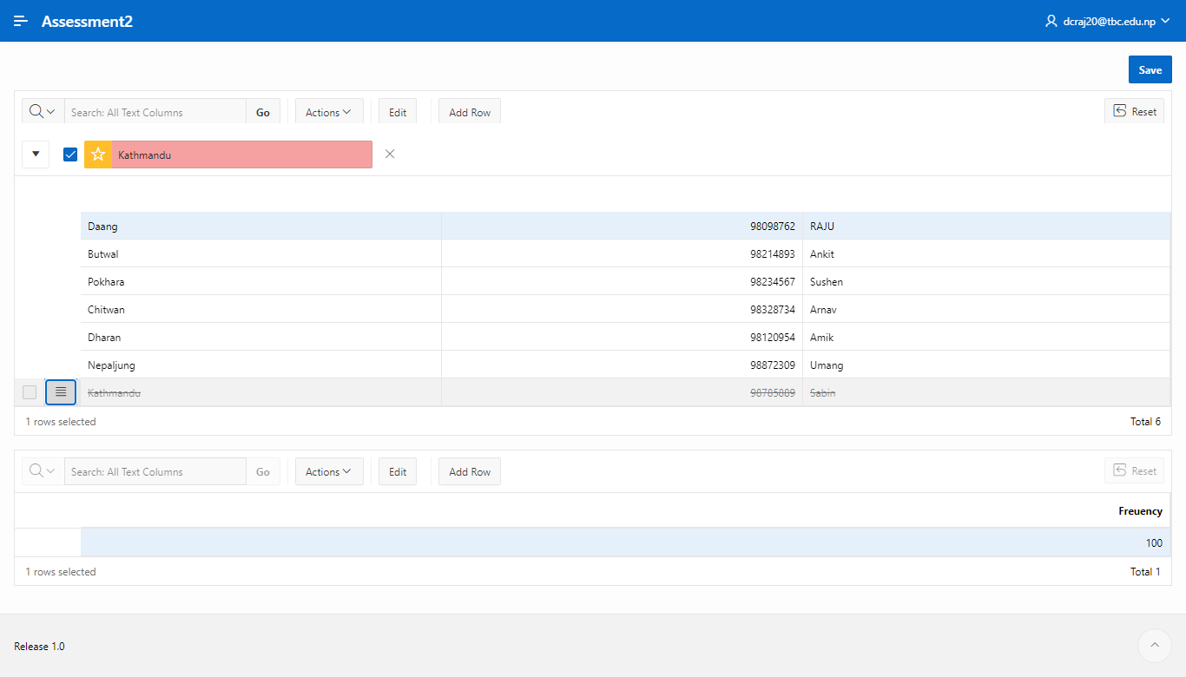
The Master Detail for the Customer and Contract tables, where data is entered and deleted, is shown above.
FORM.
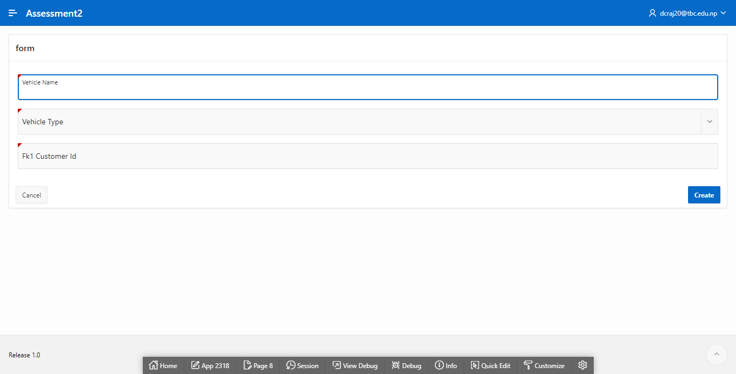

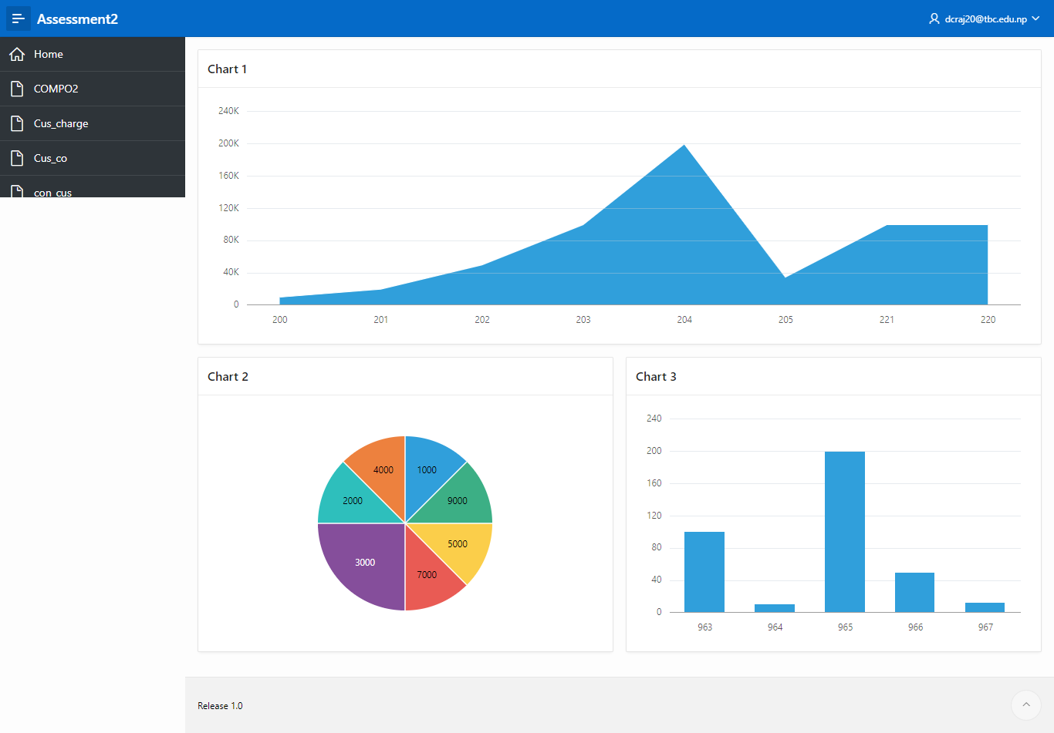
A graph data between H CHARGE and H ID is shown in the figure chart 1. The pie chart of HARGE DESCRIPTION and CHARGE AMOUNT is shown in Chart 2. The FREQUENCY, contract bar graph is shown in Chart 3.

TRIGGERS.
Trigger 1.
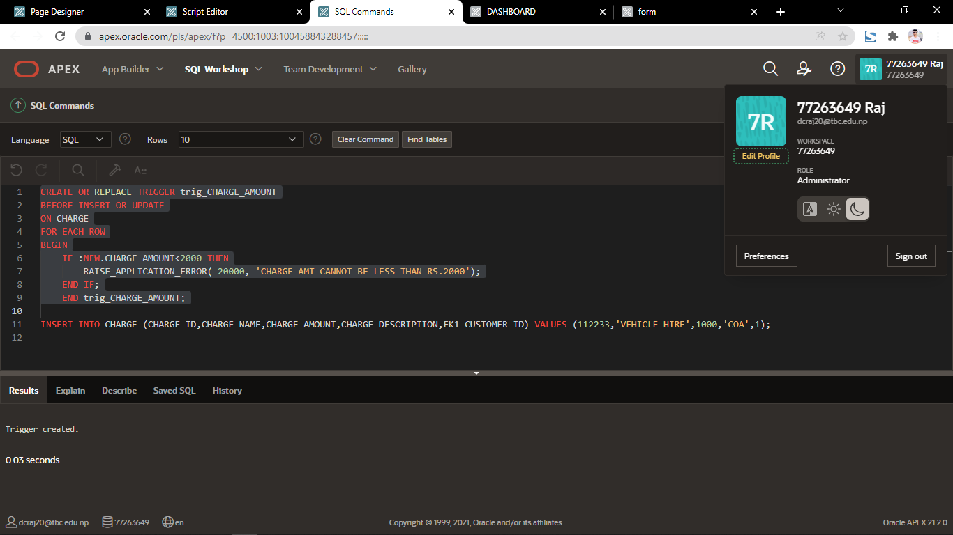

Trigger Firing.

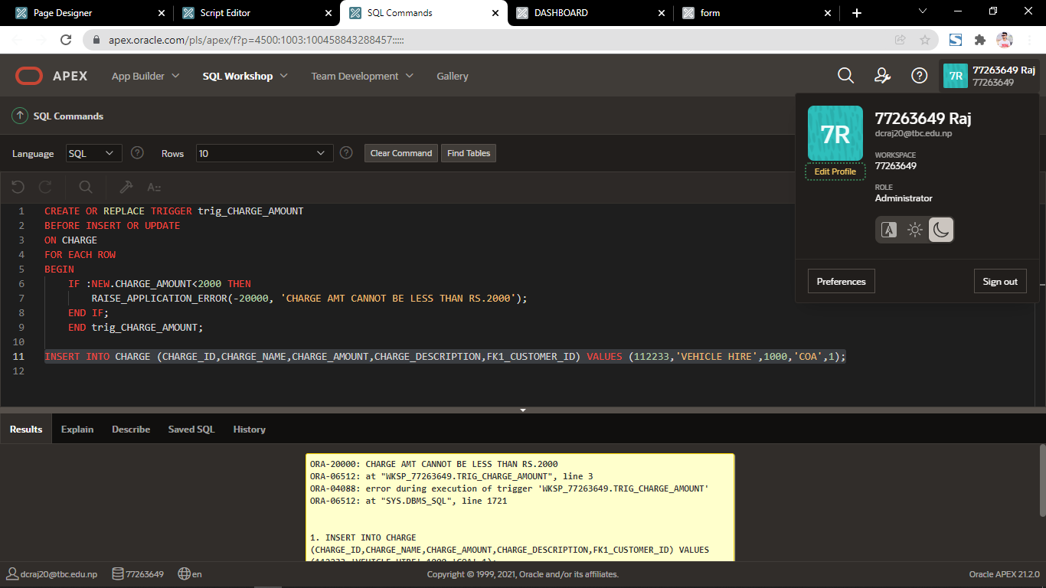

Trigger Not Firing.

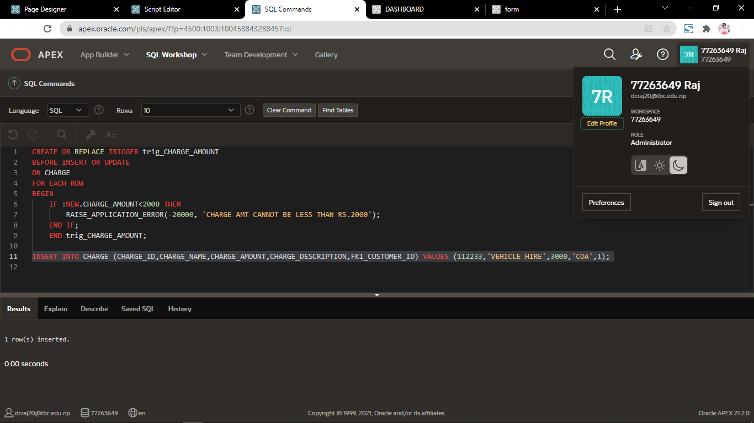

Trigger 2.
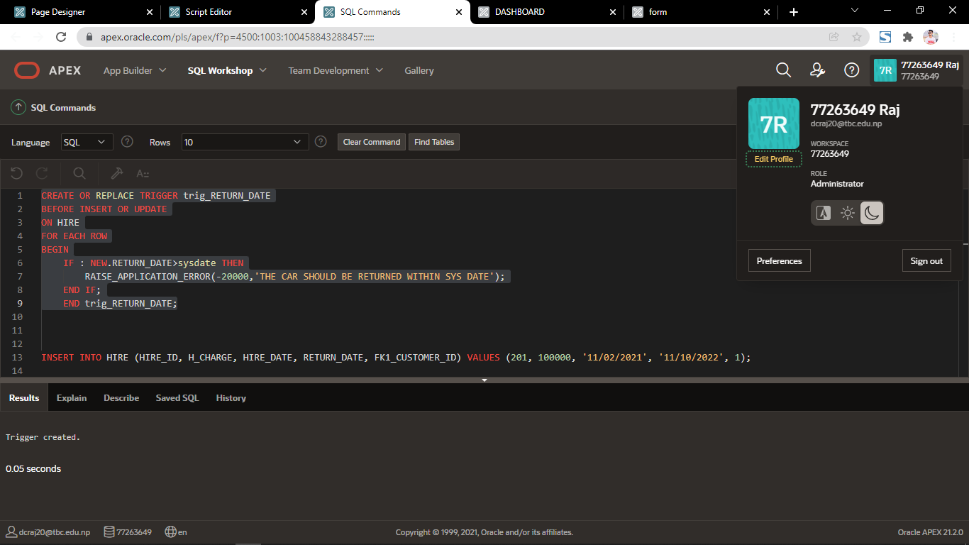

Tigger Firing.

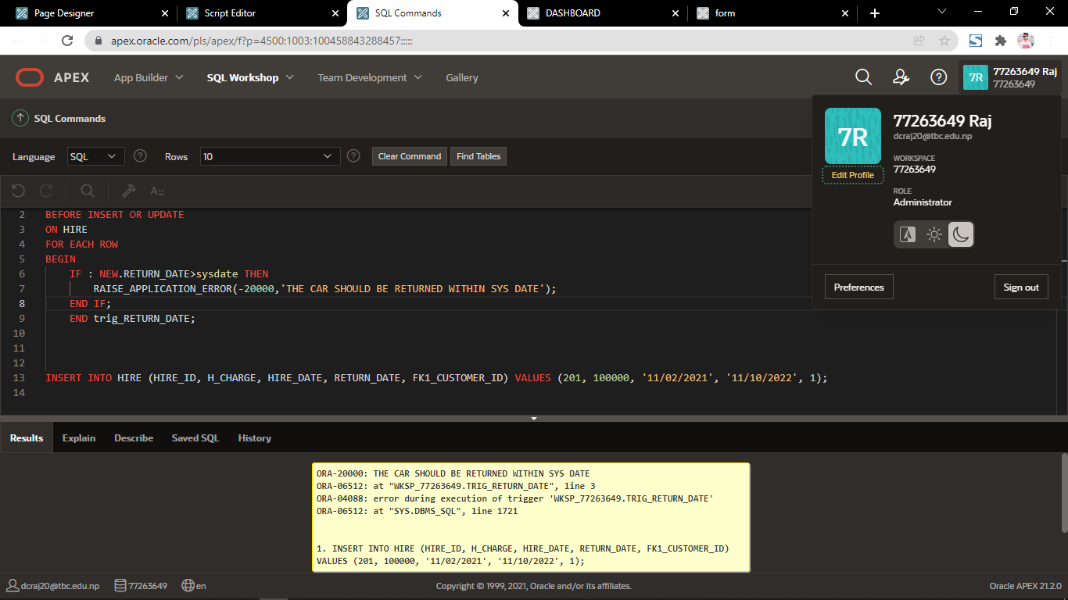

Trigger Not Firing.

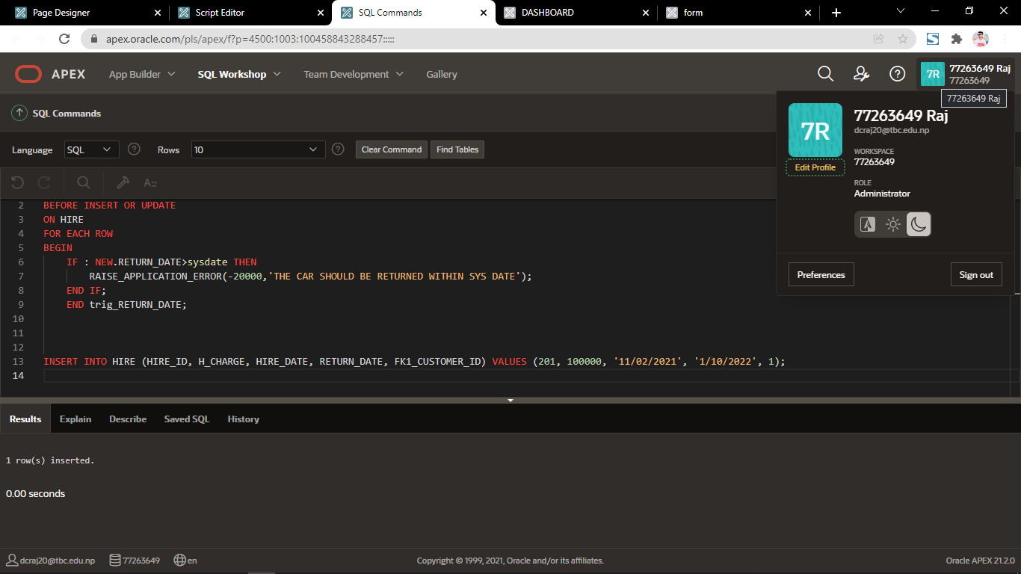

Trigger 3.

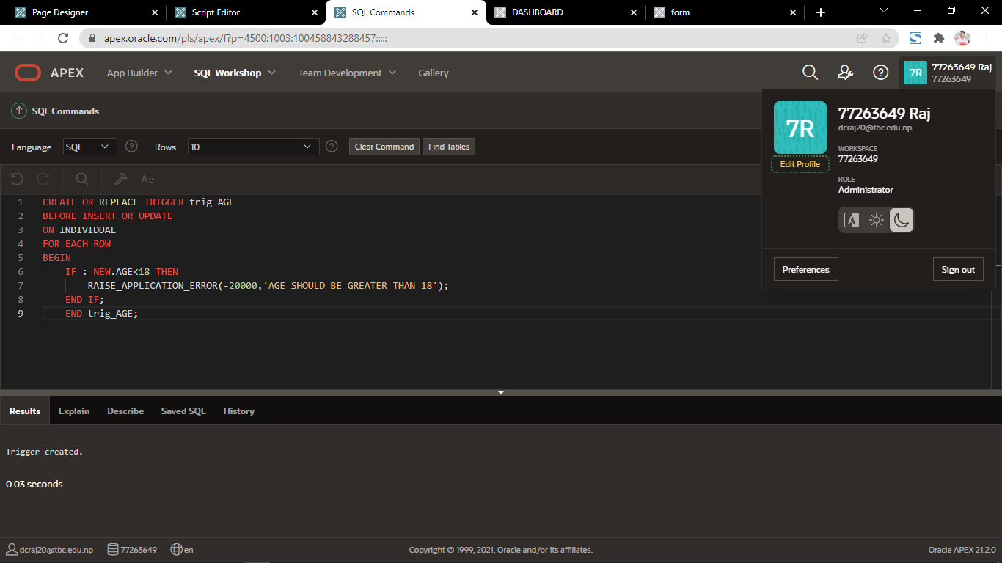

Trigger Firing.

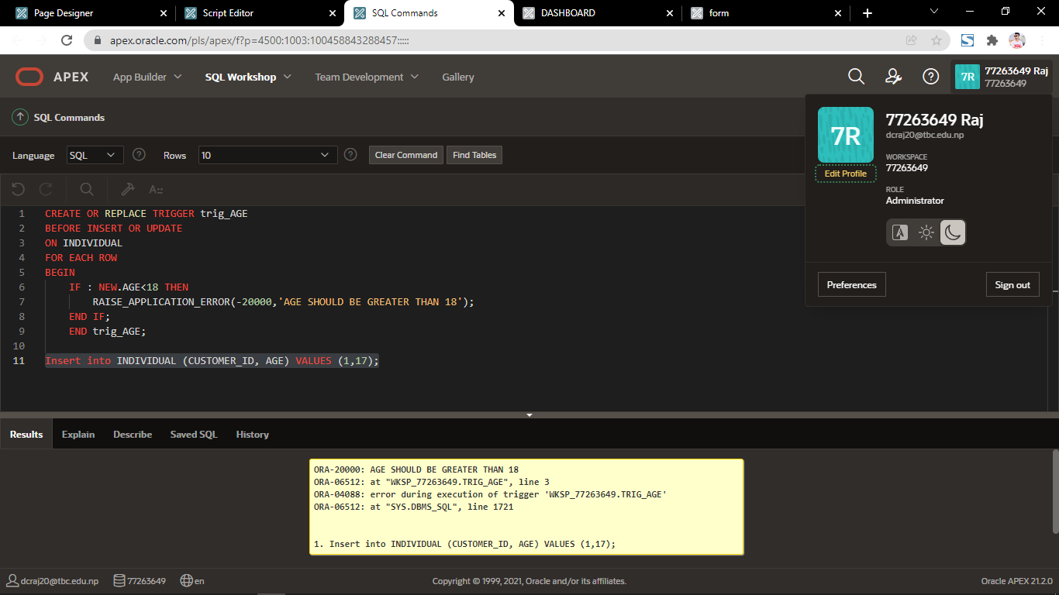

Trigger Not Firing.

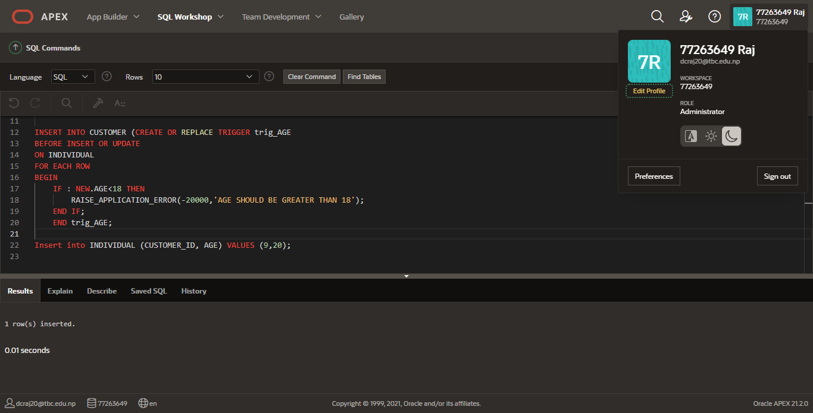

DROP TABLE QUIZ_QUESTIONS;
DROP TABLE DEPT CASCADE CONSTRAINTS ;
DROP TABLE EMP CASCADE CONSTRAINTS ;
DROP TABLE SALGRADE CASCADE CONSTRAINTS ;

--commands to create tables
CREATE TABLE DEPT (
DEPTNO NUMBER (2) ,
DNAME VARCHAR2 (14),
LOC VARCHAR2 (13),
CONSTRAINT PK_DEPT5 PRIMARY KEY ( DEPTNO ));

CREATE TABLE EMP (
EMPNO NUMBER (4) ,
ENAME VARCHAR2 (10),
JOB VARCHAR2 (9),
MGR NUMBER (4),
HIREDATE DATE,
SAL NUMBER (7,2),
COMM NUMBER (7,2),
DEPTNO NUMBER (2) REFERENCES dept (DEPTNO),
CONSTRAINT PK_EMP5 PRIMARY KEY ( EMPNO ));

CREATE TABLE SALGRADE (
GRADE NUMBER,
LOSAL NUMBER,
HISAL NUMBER);

-- insert data into dept, emp and salgrade, note salgrade is not linked to emp and dept, however dept is a FK in emp

INSERT INTO DEPT (DEPTNO, DNAME, LOC) VALUES (10, 'ACCOUNTING', 'NEW YORK');
INSERT INTO DEPT (DEPTNO, DNAME, LOC) VALUES (20, 'RESEARCH', 'DALLAS');
INSERT INTO DEPT (DEPTNO, DNAME, LOC) VALUES (30,'SALES', 'CHICAGO');
INSERT INTO DEPT (DEPTNO, DNAME, LOC) VALUES (40,'OPERATIONS', 'BOSTON');

INSERT INTO EMP (EMPNO, ENAME, JOB, MGR, HIREDATE, SAL, COMM, DEPTNO) VALUES (7369, 'SMITH', 'CLERK ', 7902, '12/17/80', 800, null, 20);
INSERT INTO EMP (EMPNO, ENAME, JOB, MGR, HIREDATE, SAL, COMM, DEPTNO) VALUES (7499, 'ALLEN', 'SALESMAN', 7698, '02/20/81',1600, 300, 30);
INSERT INTO EMP (EMPNO, ENAME, JOB, MGR, HIREDATE, SAL, COMM, DEPTNO) VALUES (7521, 'WARD', 'SALESMAN', 7698, '02/22/81', 1250, 500, 30);
INSERT INTO EMP (EMPNO, ENAME, JOB, MGR, HIREDATE, SAL, COMM, DEPTNO) VALUES (7566, 'JONES', 'MANAGER', 7839, '04/02/81', 2975, null, 20);
INSERT INTO EMP (EMPNO, ENAME, JOB, MGR, HIREDATE, SAL, COMM, DEPTNO) VALUES ( 7654, 'MARTIN','SALESMAN', 7698, '09/28/81', 1250, 1400, 30);
INSERT INTO EMP (EMPNO, ENAME, JOB, MGR, HIREDATE, SAL, COMM, DEPTNO) VALUES ( 7698, 'BLAKE', 'MANAGER', 7839, '05/01/81', 2850, null, 30);
INSERT INTO EMP (EMPNO, ENAME, JOB, MGR, HIREDATE, SAL, COMM, DEPTNO) VALUES (7782, 'CLARK', 'MANAGER', 7839, '06/09/81', 2450, null, 10);
INSERT INTO EMP (EMPNO, ENAME, JOB, MGR, HIREDATE, SAL, COMM, DEPTNO) VALUES (7788, 'SCOTT', 'ANALYST', 7566, '04/19/87', 3000, null, 20);
INSERT INTO EMP (EMPNO, ENAME, JOB, MGR, HIREDATE, SAL, COMM, DEPTNO) VALUES ( 7839, 'KING', 'PRESIDENT', null, '11/17/81', 5000, null, 10);
INSERT INTO EMP (EMPNO, ENAME, JOB, MGR, HIREDATE, SAL, COMM, DEPTNO) VALUES ( 7844, 'TURNER','SALESMAN', 7698, '09/08/81', 1500, 0, 30);
INSERT INTO EMP (EMPNO, ENAME, JOB, MGR, HIREDATE, SAL, COMM, DEPTNO) VALUES ( 7876, 'ADAMS', 'CLERK', 7788, '05/23/87', 1100, null, 20);
INSERT INTO EMP (EMPNO, ENAME, JOB, MGR, HIREDATE, SAL, COMM, DEPTNO) VALUES ( 7900, 'JAMES', 'CLERK', 7698, '12/03/81', 950, null, 30);
INSERT INTO EMP (EMPNO, ENAME, JOB, MGR, HIREDATE, SAL, COMM, DEPTNO) VALUES ( 7902, 'FORD', 'ANALYST', 7566, '12/03/81', 3000, null, 20);
INSERT INTO EMP (EMPNO, ENAME, JOB, MGR, HIREDATE, SAL, COMM, DEPTNO) VALUES ( 7934, 'MILLER','CLERK', 7782, '01/03/82', 1300 , null, 10);

INSERT INTO salgrade(GRADE, LOSAL,HISAL) VALUES (1, 700, 1200);
INSERT INTO salgrade(GRADE, LOSAL,HISAL) VALUES (2, 1201, 1400);
INSERT INTO salgrade(GRADE, LOSAL,HISAL) VALUES (3, 1401, 2000);
INSERT INTO salgrade(GRADE, LOSAL,HISAL) VALUES (4, 2001, 3000);
INSERT INTO salgrade(GRADE, LOSAL,HISAL) VALUES (5, 3001, 9999);

-- this command will add FK constraint to emp table, based on the recursive relationship
ALTER TABLE emp ADD CONSTRAINT fk_manager FOREIGN KEY (mgr)REFERENCES emp(empno);

-- this command is to create and drop sequences for PK columns in emp and dept tables
DROP sequence dept_seq;
CREATE sequence dept_seq start with 50;
DROP sequence emp_seq;
CREATE sequence emp_seq start with 8000;

COMMIT;
create or replace trigger emp_T1
BEFORE insert on emp
for each row
begin
IF :NEW.empno IS NULL THEN
SELECT emp_SEQ.NEXTVAL INTO :NEW.empno FROM SYS.DUAL;
END IF;
end;
/
commit;

create or replace trigger dept_T1
BEFORE
insert on dept
for each row
begin
if :NEW.deptno is null then
select dept_SEQ.nextval into :NEW.deptno from sys.dual;
end if;
end;
/
commit;

/

CREATE TABLE QUIZ_QUESTIONS (
question_no NUMBER(10) PRIMARY KEY,
q_type VARCHAR2(200),
challenge VARCHAR2(1000),
sugg_solution VARCHAR2(1000)
);
COMMIT;

REM INSERTING into QUIZ_QUESTIONS

-- SECTION 1 Basic and Intermediate SQL

Insert into QUIZ_QUESTIONS (QUESTION_NO,Q_TYPE,CHALLENGE,SUGG_SOLUTION) values (1,'Basic','Select all the information from the salgrade table','SELECT * FROM salgrade;');
Insert into QUIZ_QUESTIONS (QUESTION_NO,Q_TYPE,CHALLENGE,SUGG_SOLUTION) values (2,'Basic','Select all information from the emp table','select * from emp;');
Insert into QUIZ_QUESTIONS (QUESTION_NO,Q_TYPE,CHALLENGE,SUGG_SOLUTION) values (3,'Basic','List all employees who have a salary between 1000 and 2000.','SELECT ename, deptno, sal FROM emp WHERE sal between 1000 and 2000;');
Insert into QUIZ_QUESTIONS (QUESTION_NO,Q_TYPE,CHALLENGE,SUGG_SOLUTION) values (4,'Basic','List department numbers and names in department name order','select deptno, dname
from dept order by dname;');
Insert into QUIZ_QUESTIONS (QUESTION_NO,Q_TYPE,CHALLENGE,SUGG_SOLUTION) values (5,'Basic','Display all different job types','select distinct job from emp;');
Insert into QUIZ_QUESTIONS (QUESTION_NO,Q_TYPE,CHALLENGE,SUGG_SOLUTION) values (6,'Intermediate','List the details of the employees in departments 10 and 20 in alphabetical order of name','select * from emp where deptno in (10,20) order by ename;');
Insert into QUIZ_QUESTIONS (QUESTION_NO,Q_TYPE,CHALLENGE,SUGG_SOLUTION) values (7,'Basic','List names and jobs of all clerks in department 20','select ename, job
from emp
where job = ''CLERK''
and deptno = 20;');
Insert into QUIZ_QUESTIONS (QUESTION_NO,Q_TYPE,CHALLENGE,SUGG_SOLUTION) values (8,'Intermediate','Display all employees names which have TH or LL in them','select ename
from emp
where ename like ''%TH%''
or ename like ''%LL%'';');
Insert into QUIZ_QUESTIONS (QUESTION_NO,Q_TYPE,CHALLENGE,SUGG_SOLUTION) values (9,'Intermediate','List the employee name, job and salary for all employees who have a manager','select ename, job, sal
from emp
where mgr is not null;');

Insert into QUIZ_QUESTIONS (QUESTION_NO,Q_TYPE,CHALLENGE,SUGG_SOLUTION) values (10,'Intermediate','Display all employees who were hired during 1981.','select ename, hiredate from emp where hiredate like ''%81'';');
Insert into QUIZ_QUESTIONS (QUESTION_NO,Q_TYPE,CHALLENGE,SUGG_SOLUTION) values (11,'Intermediate','Display name, annual salary and commission of all salesmen whose monthly salary is greater than their commission. The output should be ordered by salary, highest first, and then if two or more employees have the same salary, by employee name.','select ename, sal*12 annual_sal, comm
from emp
where sal> comm
order by sal desc, ename;');

Insert into QUIZ_QUESTIONS (QUESTION_NO,Q_TYPE,CHALLENGE,SUGG_SOLUTION) values (12,'Basic','Select the employee name and job as one column, like SMITHCLERK ...','select ename||job as employee_job from emp;');

--Challenge your skills with these:

Insert into QUIZ_QUESTIONS (QUESTION_NO,Q_TYPE,CHALLENGE,SUGG_SOLUTION) values (13,'Intermediate','Select data so that the output for all employees reads like SMITH has held the position of CLERK in DEPT 20 since 13-JUN-83
','select ename||
'' has held the position of ''||
job ||
'' in dept ''||
deptno||
'' since ''||
hiredate "who,what and when"
from emp;');
Insert into QUIZ_QUESTIONS (QUESTION_NO,Q_TYPE,CHALLENGE,SUGG_SOLUTION) values (14,'Intermediate','Display all employee information in ascending order of manager number. King must be last.','select *
from emp
order by nvl(mgr,9999);');

-- SECTION 2 Simple Joins
Insert into QUIZ_QUESTIONS (QUESTION_NO,Q_TYPE,CHALLENGE,SUGG_SOLUTION) values (15,'Basic-Simple Joins','Display all employee names and their department name','select ename, dname
from emp, dept
where emp.deptno = dept.deptno;');
Insert into QUIZ_QUESTIONS (QUESTION_NO,Q_TYPE,CHALLENGE,SUGG_SOLUTION) values (16,'Basic-Simple Joins','Display all employee names, department number and name.','select ename, e.deptno, dname
from emp e, dept d
where e.deptno = d.deptno;');
Insert into QUIZ_QUESTIONS (QUESTION_NO,Q_TYPE,CHALLENGE,SUGG_SOLUTION) values (17,'Basic-Simple Joins','Display employee names, location and department whose salary is more than 1500 a month.','select ename, loc location, dname
from emp, dept
where emp.deptno = dept.deptno
and sal >1500;');
Insert into QUIZ_QUESTIONS (QUESTION_NO,Q_TYPE,CHALLENGE,SUGG_SOLUTION) values (18,'Intermediate-Simple Joins','Produce a list showing employees salary grades.
','select ename, job, sal, grade
from emp, salgrade
where sal between losal and hisal;');
Insert into QUIZ_QUESTIONS (QUESTION_NO,Q_TYPE,CHALLENGE,SUGG_SOLUTION) values (19,'Intermediate-Simple Joins','Show only employees on Grade 3.','select ename, job, sal, grade
from emp, salgrade
where sal between losal and hisal
and grade = 3;');
Insert into QUIZ_QUESTIONS (QUESTION_NO,Q_TYPE,CHALLENGE,SUGG_SOLUTION) values (20,'Basic-Simple Joins','Show all employees in Dallas.','select ename, sal, loc location
from emp, dept
where emp.deptno = dept.deptno
and loc = ''DALLAS'';');
Insert into QUIZ_QUESTIONS (QUESTION_NO,Q_TYPE,CHALLENGE,SUGG_SOLUTION) values (21,'Intermediate-Simple Joins','List employee name, job, salary, grade and department name for everyone in the company except clerks, sort on salary highest first.','select ename, job, sal, grade, dname
from emp, salgrade, dept
where emp.deptno = dept.deptno
and sal between losal and hisal
and job != ''CLERK''
order by sal desc;');

-- SECTION 3 Group Functions

Insert into QUIZ_QUESTIONS (QUESTION_NO,Q_TYPE,CHALLENGE,SUGG_SOLUTION) values (22,'Intermediate-Group Functions','Find the minimum salary of all employees','select min(sal) minimum
from emp;');
Insert into QUIZ_QUESTIONS (QUESTION_NO,Q_TYPE,CHALLENGE,SUGG_SOLUTION) values (23,'Intermediate-Group Functions','Find the minimum, maximum, and average salaries of all employees','select max(sal), min(sal), avg(sal)
from emp;');
Insert into QUIZ_QUESTIONS (QUESTION_NO,Q_TYPE,CHALLENGE,SUGG_SOLUTION) values (24,'Intermediate-Group Functions','List the minimum and maximum salary for each job type.','select job,
max(sal) maximum,
min(sal) minimum
from emp
group by job;');
Insert into QUIZ_QUESTIONS (QUESTION_NO,Q_TYPE,CHALLENGE,SUGG_SOLUTION) values (25,'Intermediate-Group Functions','Find out how many managers there are without listing them.','select count(*) empno from emp where job= ''MANAGER'';');
Insert into QUIZ_QUESTIONS (QUESTION_NO,Q_TYPE,CHALLENGE,SUGG_SOLUTION) values (26,'Advanced-Group Functions','Find the average salary and average total remuneration for each job type. Remember salesmen earn commission.','select job,
avg(sal) avsal,
avg(sal*12+nvl(comm,0)) avcomp
from emp
group by job;');
Insert into QUIZ_QUESTIONS (QUESTION_NO,Q_TYPE,CHALLENGE,SUGG_SOLUTION) values (27,'Intermediate-Group Functions','Find the difference between the highest and lowest salaries.','select max(sal) - min(sal) difference
from emp;');
Insert into QUIZ_QUESTIONS (QUESTION_NO,Q_TYPE,CHALLENGE,SUGG_SOLUTION) values (28,'Advanced-Group Functions','Find all departments which have more than 3 employees.','select deptno, count(*)
from emp
group by deptno
having count(*) > 3;');
Insert into QUIZ_QUESTIONS (QUESTION_NO,Q_TYPE,CHALLENGE,SUGG_SOLUTION) values (29,'Advanced-Group Functions','Check whether all employee numbers are indeed unique.','select empno
from emp
group by empno
having count(*) > 0;');
Insert into QUIZ_QUESTIONS (QUESTION_NO,Q_TYPE,CHALLENGE,SUGG_SOLUTION) values (30,'Advanced-Group Functions','List lowest paid employees working for each manager. Exclude any groups where the salary is less than 1000. Sort the output by salary.','select mgr, min(sal)
from emp
group by mgr
having min(sal) > 1000
order by min(sal);');

-- SECTION 4 SQL using Functions

Insert into QUIZ_QUESTIONS (QUESTION_NO,Q_TYPE,CHALLENGE,SUGG_SOLUTION) values (31,'Advanced','Display name and total remuneration of all employees','select ename, sal*12+nvl(comm,0) remuneration from emp;');
Insert into QUIZ_QUESTIONS (QUESTION_NO,Q_TYPE,CHALLENGE,SUGG_SOLUTION) values (32,'Intermediate-Using Functions','List the employee name and salary increased by 15% and expressed as a whole number.','select deptno, ename, round(sal*1.15) pctsal
from emp;');
Insert into QUIZ_QUESTIONS (QUESTION_NO,Q_TYPE,CHALLENGE,SUGG_SOLUTION) values (33,'Advanced-Using Functions','Display employee name with hiredate, and their salary reviewdate. Assume that the review date is one year after the hiredate.
','select ename, hiredate,add_months(hiredate,12) review from emp
order by add_months(hiredate,12);');
Insert into QUIZ_QUESTIONS (QUESTION_NO,Q_TYPE,CHALLENGE,SUGG_SOLUTION) values (34,'Advanced-Using Functions','Display a list of all employees with an identifier which is a composite of the first two characters of their job, the middle two digits of their employee number and soundex code of their name.i.e.
SMITH CL36S530
ALLEN SA49A450
','select ename name,
substr(job,1,2)||
substr(empno,2,2)||
soundex(ename) code
from emp;');

-- SECTION 5 Other Join Methods
-- no question 35 :)

Insert into QUIZ_QUESTIONS (QUESTION_NO,Q_TYPE,CHALLENGE,SUGG_SOLUTION) values (36,'Intermediate-Other Join Methods','Display the department that has no employees
','select d.deptno, dname
from emp e, dept d
where e.deptno(+) = d.deptno
and e.empno is null;');
Insert into QUIZ_QUESTIONS (QUESTION_NO,Q_TYPE,CHALLENGE,SUGG_SOLUTION) values (37,'Intermediate-Other Join Methods','List all employees by name and number along with their manager''s name and number.','select emps.empno,
emps.ename,
mgrs.empno mgrno,
mgrs.ename mgr_name
from emp emps, emp mgrs
where emps.mgr = mgrs.empno;');
Insert into QUIZ_QUESTIONS (QUESTION_NO,Q_TYPE,CHALLENGE,SUGG_SOLUTION) values (38,'Intermediate-Other Join Methods', 'Modify previous solution to the question to display KING who has no manager.
','select emps.empno,
emps.ename,
mgrs.empno mgrno,
mgrs.ename mgr_name
from emp emps, emp mgrs
where emps.mgr = mgrs.empno(+);');
Insert into QUIZ_QUESTIONS (QUESTION_NO,Q_TYPE,CHALLENGE,SUGG_SOLUTION) values (39,'Intermediate-Other Join Methods','Find any jobs that were filled in the first half of 1981 and were also filled during the same period 1984.','select job
from emp
where hiredate between ''01-jan-81'' and ''30-jun-81''
union
select job
from emp
where hiredate between ''01-Jan-84'' and ''30-JUN-84'';');
Insert into QUIZ_QUESTIONS (QUESTION_NO,Q_TYPE,CHALLENGE,SUGG_SOLUTION) values (40,'Intermediate-Other Join Methods','Find all employees who joined the company before their manager.','select e.ename employee,
e.hiredate,
m.ename manager,
m.hiredate
from emp e, emp m
where e.mgr = m.empno
and e.hiredate < m.hiredate;');
Insert into QUIZ_QUESTIONS (QUESTION_NO,Q_TYPE,CHALLENGE,SUGG_SOLUTION) values (41,'Intermediate-Other Join Methods','Display those who manage employees in either department 10 or 20. Order by manager number.','select mgr
from emp
where deptno = 10
union
select mgr
from emp
where deptno = 20
order by 1;');
Insert into QUIZ_QUESTIONS (QUESTION_NO,Q_TYPE,CHALLENGE,SUGG_SOLUTION) values (42,'Intermediate-Other Join Methods','Find another query method to display the department that has no employees.','select deptno, dname
from dept
minus
select emp.deptno, dname
from emp, dept
where emp.deptno = dept.deptno;');
Insert into QUIZ_QUESTIONS (QUESTION_NO,Q_TYPE,CHALLENGE,SUGG_SOLUTION) values (43,'Intermediate-Other Join Methods','Find the names of those who manage employees of grade 1,2 and 3 only.
','select m.ename
from emp w,emp m,salgrade
where w.mgr = m.empno
and w.sal between losal and hisal
and grade = 1
intersect
select m.ename
from emp w, emp m, salgrade
where w.mgr = m.empno
and w.sal between losal and hisal
and grade = 2
intersect
select m.ename
from emp w, emp m, salgrade
where w.mgr = m.empno
and w.sal between losal and hisal
and grade = 3
minus
select m.ename
from emp w, emp m, salgrade
where w.mgr = m.empno
and w.sal between losal and hisal
and grade in (4,5);');

-- SECTION 6 Advance Query Techniques

Insert into QUIZ_QUESTIONS (QUESTION_NO,Q_TYPE,CHALLENGE,SUGG_SOLUTION) values (44,'Advance Query Techniques','Find the employee(s) who earn the highest salary in each job type.
','select job, ename, sal
from emp
where sal in ( select max(sal)
from emp
group by job)
order by sal desc;');
Insert into QUIZ_QUESTIONS (QUESTION_NO,Q_TYPE,CHALLENGE,SUGG_SOLUTION) values (45,'Advance Query Techniques','Find the employees who earn the minimum salary for their job. Display the result in ascending order of salary','select ename, job, sal
from emp
where sal in (select min(sal)
from emp
group by job)
order by sal desc;');
Insert into QUIZ_QUESTIONS (QUESTION_NO,Q_TYPE,CHALLENGE,SUGG_SOLUTION) values (46,'Advance Query Techniques','Find the most recently hired employees in each department.
','select deptno, ename, hiredate
from emp
where (hiredate, deptno) in
(select max(hiredate), deptno from emp
group by deptno);');
Insert into QUIZ_QUESTIONS (QUESTION_NO,Q_TYPE,CHALLENGE,SUGG_SOLUTION) values (47,'Advance Query Techniques','Show the following details for any employee who earns a salary greater than the average for their department:

employee name, salary, department no.
','select ename, sal salary, deptno
from emp e
where sal > (select avg(sal)
from emp
where deptno = e.deptno);');
Insert into QUIZ_QUESTIONS (QUESTION_NO,Q_TYPE,CHALLENGE,SUGG_SOLUTION) values (48,'Advance Query Techniques','List all the departments where there are no employees (using a subquery this time).','select deptno, dname
from dept
where deptno not in
(select deptno from emp);');
Insert into QUIZ_QUESTIONS (QUESTION_NO,Q_TYPE,CHALLENGE,SUGG_SOLUTION) values (49,'Advance Query Techniques','Who works for the Sales Department, but is not a SALESMAN?
','select ename, job, sal
from emp
where job != ''SALESMAN''
and deptno in ( select deptno
from dept
where dname = ''SALES'');');
Insert into QUIZ_QUESTIONS (QUESTION_NO,Q_TYPE,CHALLENGE,SUGG_SOLUTION) values (50,'Advance Query Techniques','Who are the top three earners in the company? Display their names and salaries','select ename, sal
from emp e
where 3 > (select count(*)
from emp
where e.sal < sal );');

DROP SEQUENCE seq_customer_id;
CREATE SEQUENCE seq_customer_id
START WITH 1
INCREMENT BY 1;

DROP TRIGGER trig_generate_pk;
CREATE OR REPLACE TRIGGER trig_generate_pk
BEFORE INSERT ON Customer
FOR EACH ROW
BEGIN
SELECT seq_customer_id.NEXTVAL INTO :NEW.customer_id from sys.dual;
END;
/

INSERT INTO CUSTOMER (CUSTOMER_ID, CUSTOMER_ADDRESS, PHONE_NUMBER, CUSTOMER_NAME) VALUES (1,'Daang',98098762,'RAJU');
INSERT INTO CUSTOMER (CUSTOMER_ID, CUSTOMER_ADDRESS, PHONE_NUMBER, CUSTOMER_NAME) VALUES (2,'Butwal',98214893,'Ankit');
INSERT INTO CUSTOMER (CUSTOMER_ID, CUSTOMER_ADDRESS, PHONE_NUMBER, CUSTOMER_NAME) VALUES (3,'Pokhara',98234567,'Sushen');
INSERT INTO CUSTOMER (CUSTOMER_ID, CUSTOMER_ADDRESS, PHONE_NUMBER, CUSTOMER_NAME) VALUES (4,'Chitwan',98328734,'Arnav');
INSERT INTO CUSTOMER (CUSTOMER_ID, CUSTOMER_ADDRESS, PHONE_NUMBER, CUSTOMER_NAME) VALUES (5,'Dharan',98120954,'Amik');
INSERT INTO CUSTOMER (CUSTOMER_ID, CUSTOMER_ADDRESS, PHONE_NUMBER, CUSTOMER_NAME) VALUES (6,'Nepaljung',98872309,'Umang');

Insert into INDIVIDUAL (CUSTOMER_ID, AGE) VALUES (1,24);
Insert into INDIVIDUAL (CUSTOMER_ID, AGE) VALUES (2,19);
Insert into INDIVIDUAL (CUSTOMER_ID, AGE) VALUES (3,30);
Insert into INDIVIDUAL (CUSTOMER_ID, AGE) VALUES (4,45);
Insert into INDIVIDUAL (CUSTOMER_ID, AGE) VALUES (5,54);
Insert into INDIVIDUAL (CUSTOMER_ID, AGE) VALUES (6,30);

INSERT INTO CORPORATE (CUSTOMER_ID,MEMBERSHIP_TYPE) VALUES (1,'Gold');
INSERT INTO CORPORATE (CUSTOMER_ID,MEMBERSHIP_TYPE) VALUES (2,'Bronze');
INSERT INTO CORPORATE (CUSTOMER_ID,MEMBERSHIP_TYPE) VALUES (3,'Gold');
INSERT INTO CORPORATE (CUSTOMER_ID,MEMBERSHIP_TYPE) VALUES (4,'Silver');
INSERT INTO CORPORATE (CUSTOMER_ID,MEMBERSHIP_TYPE) VALUES (5,'Gold');
INSERT INTO CORPORATE (CUSTOMER_ID,MEMBERSHIP_TYPE) VALUES (6,'Bronze');

DROP SEQUENCE seq_charge_id;
CREATE SEQUENCE seq_charge_id
START WITH 112233
INCREMENT BY 1;

DROP TRIGGER trig_generate_pk2;
CREATE OR REPLACE TRIGGER trig_generate_pk2
BEFORE INSERT ON charge
FOR EACH ROW
BEGIN
SELECT seq_charge_id.NEXTVAL INTO :NEW.charge_id from sys.dual;
END;
/

INSERT INTO CHARGE (CHARGE_ID,CHARGE_NAME,CHARGE_AMOUNT,CHARGE_DESCRIPTION,FK1_CUSTOMER_ID) VALUES (112233,'VEHICLE HIRE',5000,'CASH ON DELIVERY',1);
INSERT INTO CHARGE (CHARGE_ID,CHARGE_NAME,CHARGE_AMOUNT,CHARGE_DESCRIPTION,FK1_CUSTOMER_ID) VALUES (112234,'INSURANCE',2000,'PAYMENT IN ADVANCE',2);
INSERT INTO CHARGE (CHARGE_ID,CHARGE_NAME,CHARGE_AMOUNT,CHARGE_DESCRIPTION,FK1_CUSTOMER_ID) VALUES (112235,'VEHICLE HIRE',4000,'CASH ON ADVANCE',3);
INSERT INTO CHARGE (CHARGE_ID,CHARGE_NAME,CHARGE_AMOUNT,CHARGE_DESCRIPTION,FK1_CUSTOMER_ID) VALUES (112236,'VEHICLE HIRE',9000,'CASH ON HAND',4);
INSERT INTO CHARGE (CHARGE_ID,CHARGE_NAME,CHARGE_AMOUNT,CHARGE_DESCRIPTION,FK1_CUSTOMER_ID) VALUES (112237,'VEHICLE HIRE',7000,'CASH ON DELIVERY',5);
INSERT INTO CHARGE (CHARGE_ID,CHARGE_NAME,CHARGE_AMOUNT,CHARGE_DESCRIPTION,FK1_CUSTOMER_ID) VALUES (112238,'VEHICLE HIRE',1000,'CASH ON HAND',6);

DROP SEQUENCE seq_vehicle_id;
CREATE SEQUENCE seq_vehicle_id
START WITH 1000
INCREMENT BY 1;

DROP TRIGGER trig_generate_pk3;
CREATE OR REPLACE TRIGGER trig_generate_pk3
BEFORE INSERT ON vehicle
FOR EACH ROW
BEGIN
SELECT seq_vehicle_id.NEXTVAL INTO :NEW.vehicle_id from sys.dual;
END;
/

INSERT INTO VEHICLE (VEHICLE_ID, VEHICLE_NAME, VEHICLE_TYPE, FK1_CUSTOMER_ID) VALUES (1001, 'GLC 300 4MATIC', 'LUXURY', 1);
INSERT INTO VEHICLE (VEHICLE_ID, VEHICLE_NAME, VEHICLE_TYPE, FK1_CUSTOMER_ID) VALUES (1002, 'NEXON', 'HATCHBACK', 2);
INSERT INTO VEHICLE (VEHICLE_ID, VEHICLE_NAME, VEHICLE_TYPE, FK1_CUSTOMER_ID) VALUES (1003, 'MACAN', 'SPORTS', 3);
INSERT INTO VEHICLE (VEHICLE_ID, VEHICLE_NAME, VEHICLE_TYPE, FK1_CUSTOMER_ID) VALUES (1004, 'GALLARADO', 'LUXURY', 4);
INSERT INTO VEHICLE (VEHICLE_ID, VEHICLE_NAME, VEHICLE_TYPE, FK1_CUSTOMER_ID) VALUES (1005, 'KONA', 'HATCHBACK', 5);
INSERT INTO VEHICLE (VEHICLE_ID, VEHICLE_NAME, VEHICLE_TYPE, FK1_CUSTOMER_ID) VALUES (1006, 'VENUE', 'HATCHBACK', 6);

DROP SEQUENCE seq_hire_id;
CREATE SEQUENCE seq_hire_id
START WITH 200
INCREMENT BY 1;

DROP TRIGGER trig_generate_pk4;
CREATE OR REPLACE TRIGGER trig_generate_pk4
BEFORE INSERT ON hire
FOR EACH ROW
BEGIN
SELECT seq_hire_id.NEXTVAL INTO :NEW.hire_id from sys.dual;
END;
/

INSERT INTO HIRE (HIRE_ID, H_CHARGE, HIRE_DATE, RETURN_DATE, FK1_CUSTOMER_ID) VALUES (201, 10000, '11/02/2021', '11/10/2021', 1);
INSERT INTO HIRE (HIRE_ID, H_CHARGE, HIRE_DATE, RETURN_DATE, FK1_CUSTOMER_ID) VALUES (202, 20000, '01/01/2021', '02/02/2021', 2);
INSERT INTO HIRE (HIRE_ID, H_CHARGE, HIRE_DATE, RETURN_DATE, FK1_CUSTOMER_ID) VALUES (203, 50000, '03/03/2021', '04/04/2021', 3);
INSERT INTO HIRE (HIRE_ID, H_CHARGE, HIRE_DATE, RETURN_DATE, FK1_CUSTOMER_ID) VALUES (204, 100000, '05/05/2021', '06/06/2021', 4);
INSERT INTO HIRE (HIRE_ID, H_CHARGE, HIRE_DATE, RETURN_DATE, FK1_CUSTOMER_ID) VALUES (205, 200000, '07/07/2021', '08/08/2021', 5);
INSERT INTO HIRE (HIRE_ID, H_CHARGE, HIRE_DATE, RETURN_DATE, FK1_CUSTOMER_ID) VALUES (206, 35000, '07/07/2021', '08/08/2021', 6);

DROP SEQUENCE seq_model_id;
CREATE SEQUENCE seq_model_id
START WITH 90
INCREMENT BY 1;

DROP TRIGGER trig_generate_pk5;
CREATE OR REPLACE TRIGGER trig_generate_pk5
BEFORE INSERT ON model
FOR EACH ROW
BEGIN
SELECT seq_model_id.NEXTVAL INTO :NEW.model_id from sys.dual;
END;
/

INSERT INTO MODEL (MODEL_ID,MODEL_NAME,MODEL_COST,FK1_VEHICLE_ID) VALUES (90,'MERCEDES','80000','1001');
INSERT INTO MODEL (MODEL_ID,MODEL_NAME,MODEL_COST,FK1_VEHICLE_ID) VALUES (91,'TATA','90000','1001');
INSERT INTO MODEL (MODEL_ID,MODEL_NAME,MODEL_COST,FK1_VEHICLE_ID) VALUES (92,'PORSCHE','70000','1001');
INSERT INTO MODEL (MODEL_ID,MODEL_NAME,MODEL_COST,FK1_VEHICLE_ID) VALUES (93,'LAMBORGINI','50000','1001');
INSERT INTO MODEL (MODEL_ID,MODEL_NAME,MODEL_COST,FK1_VEHICLE_ID) VALUES (94,'HUNDAI','60000','1001');
INSERT INTO MODEL (MODEL_ID,MODEL_NAME,MODEL_COST,FK1_VEHICLE_ID) VALUES (95,'HUNDAI','10000','1001');

DROP SEQUENCE seq_contract;
CREATE SEQUENCE seq_contract
START WITH 963
INCREMENT BY 1;

DROP TRIGGER trig_generate_pk6;
CREATE OR REPLACE TRIGGER trig_generate_pk6
BEFORE INSERT ON Contract
FOR EACH ROW
BEGIN
SELECT seq_contract.NEXTVAL INTO :NEW.contract from sys.dual;
END;
/

INSERT INTO CONTRACT(CONTRACT,FREUENCY,FK1_CUSTOMER_ID) VALUES (963,100,1);
INSERT INTO CONTRACT(CONTRACT,FREUENCY,FK1_CUSTOMER_ID) VALUES (964,10,2);
INSERT INTO CONTRACT(CONTRACT,FREUENCY,FK1_CUSTOMER_ID) VALUES (965,200,3);
INSERT INTO CONTRACT(CONTRACT,FREUENCY,FK1_CUSTOMER_ID) VALUES (966,50,4);
INSERT INTO CONTRACT(CONTRACT,FREUENCY,FK1_CUSTOMER_ID) VALUES (967,12,5);

DROP SEQUENCE seq_centre_id;
CREATE SEQUENCE seq_centre_id
START WITH 991
INCREMENT BY 1;

DROP TRIGGER trig_generate_pk7;
CREATE OR REPLACE TRIGGER trig_generate_pk7
BEFORE INSERT ON centre
FOR EACH ROW
BEGIN
SELECT seq_centre_id.NEXTVAL INTO :NEW.centre_id from sys.dual;
END;
/
INSERT INTO CENTRE(CENTRE_ID, C_ADDRESS, fk1_VEHICLE_ID) VALUES (991, 'BANESHWOR', 1001);
INSERT INTO CENTRE(CENTRE_ID, C_ADDRESS, fk1_VEHICLE_ID) VALUES (992, 'DALLU', 1002);
INSERT INTO CENTRE(CENTRE_ID, C_ADDRESS, fk1_VEHICLE_ID) VALUES (993, 'PEPSICOLA', 1003);
INSERT INTO CENTRE(CENTRE_ID, C_ADDRESS, fk1_VEHICLE_ID) VALUES (994, 'SANEPA', 1004);
INSERT INTO CENTRE(CENTRE_ID, C_ADDRESS, fk1_VEHICLE_ID) VALUES (995, 'KUPANDOLE', 1005);

--CHARGE TRIGGER
CREATE OR REPLACE TRIGGER trig_CHARGE_AMOUNT
BEFORE INSERT OR UPDATE
ON CHARGE
FOR EACH ROW
BEGIN
IF :NEW.CHARGE_AMOUNT<2000 THEN
RAISE_APPLICATION_ERROR(-20000, 'CHARGE AMT CANNOT BE LESS THAN RS.2000');
END IF;
END trig_CHARGE_AMOUNT;

INSERT INTO CHARGE (CHARGE_ID,CHARGE_NAME,CHARGE_AMOUNT,CHARGE_DESCRIPTION,FK1_CUSTOMER_ID) VALUES (112233,'VEHICLE HIRE',1000,'COA',1);

--HIRE TRIGGER
CREATE OR REPLACE TRIGGER trig_RETURN_DATE
BEFORE INSERT OR UPDATE
ON HIRE
FOR EACH ROW
BEGIN
IF : NEW.RETURN_DATE>sysdate THEN
RAISE_APPLICATION_ERROR(-20000,'THE CAR SHOULD BE RETURNED WITHIN SYS DATE');
END IF;
END trig_RETURN_DATE;

INSERT INTO HIRE (HIRE_ID, H_CHARGE, HIRE_DATE, RETURN_DATE, FK1_CUSTOMER_ID) VALUES (201, 100000, '11/02/2021', '11/10/2022', 1);

--INDIVIDUAL TRIGGER
CREATE OR REPLACE TRIGGER trig_AGE
BEFORE INSERT OR UPDATE
ON INDIVIDUAL
FOR EACH ROW
BEGIN
IF : NEW.AGE<18 THEN
RAISE_APPLICATION_ERROR(-20000,'AGE SHOULD BE GREATER THAN 18');
END IF;
END trig_AGE;

Insert into INDIVIDUAL (CUSTOMER_ID, AGE) VALUES (1,17);

