CI/CD Pipeline with Jenkins and SonarCloud for DevSecOps Security Automation

Project Title: Design and Implementation of a Complete CI/CD Pipeline using Jenkins with SonarCloud Integration
Application Used: Diabetes Prognosticator Web Application
Platform Used: DigitalOcean Droplet (Ubuntu Linux)

1. Objective
The objective of this project is to design and implement a complete CI/CD pipeline using Jenkins integrated with SonarCloud for continuous code quality and security analysis. The pipeline automatically triggers on every Git commit, performs SAST scanning, executes automated unit testing with coverage validation, enforces Quality Gates, builds Docker images, and deploys the application only if all security and quality conditions pass.

2. Technologies Used
- Jenkins
- SonarCloud / SonarQube
- GitHub
- Python Flask
- Docker
- Pytest
- Coverage.py
- DigitalOcean
- Ubuntu Linux
- Java 21
- Python 3.8

3. Architecture Overview
The developer pushes code changes to GitHub. Jenkins automatically pulls the latest code and executes pipeline stages including dependency installation, testing, code coverage analysis, SonarCloud scanning, Quality Gate validation, Docker image creation, and deployment to the staging environment.

4. Jenkins Setup
Jenkins was installed on an Ubuntu-based DigitalOcean droplet. Required plugins such as SonarQube Scanner, Git, Docker Pipeline, and Pipeline plugins were configured. Credentials such as SonarCloud authentication tokens were securely stored inside Jenkins Credentials Manager.

5. SonarCloud Integration
SonarCloud was integrated with Jenkins using the SonarScanner plugin. The pipeline performs static code analysis to identify vulnerabilities such as:
- SQL Injection
- Cross-Site Scripting (XSS)
- Hardcoded credentials
- Unsafe deserialization
- Code smells
- Maintainability issues
- Dependency security warnings

6. Unit Testing and Coverage
Pytest and Coverage.py were used to execute automated unit tests and generate coverage reports. The pipeline validates that code coverage remains above the required threshold before deployment.

7. Quality Gate Enforcement
The Jenkins pipeline waits for SonarCloud Quality Gate results. If critical or blocker vulnerabilities are detected, the pipeline automatically blocks deployment. This demonstrates automated DevSecOps security gating.

8. Docker Deployment
After successful code analysis and Quality Gate validation, the application is containerized using Docker and deployed to the staging server hosted on DigitalOcean.

9. DevSecOps Security Controls
SAST (Static Application Security Testing):
SonarCloud continuously scans source code for security vulnerabilities and insecure coding patterns.
Secret Scanning:
SonarCloud identifies potential hardcoded credentials, unsafe dependency usage, and security-sensitive configurations.
Automated Security Gating:
Quality Gates automatically stop deployment if the application violates defined security or maintainability conditions.
Coverage Enforcement:
The pipeline validates minimum test coverage before allowing deployment.

10. Pipeline Stages
1. Clone Repository
2. Setup Python Environment
3. Install Dependencies
4. Run Unit Tests
5. Generate Coverage Report
6. SonarCloud Analysis
7. Quality Gate Validation
8. Build Docker Image
9. Deploy Application

11. Conclusion
The project successfully implemented a secure and automated DevSecOps CI/CD pipeline using Jenkins and SonarCloud. The pipeline improved software quality, automated vulnerability detection, enforced security policies, and automated deployment using Docker containers.

12. Screenshot Placeholders

Jenkins up and running
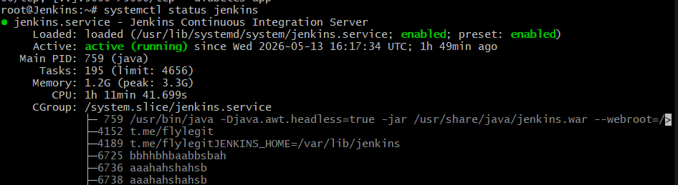
Docker up and running
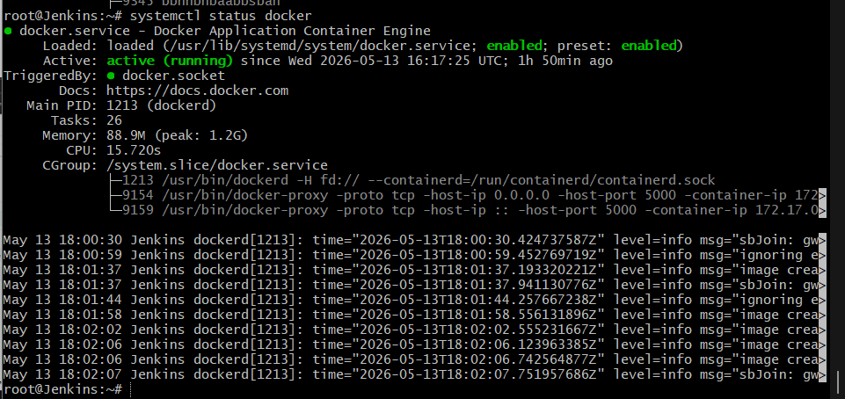
SonarCloud Project Dashboard
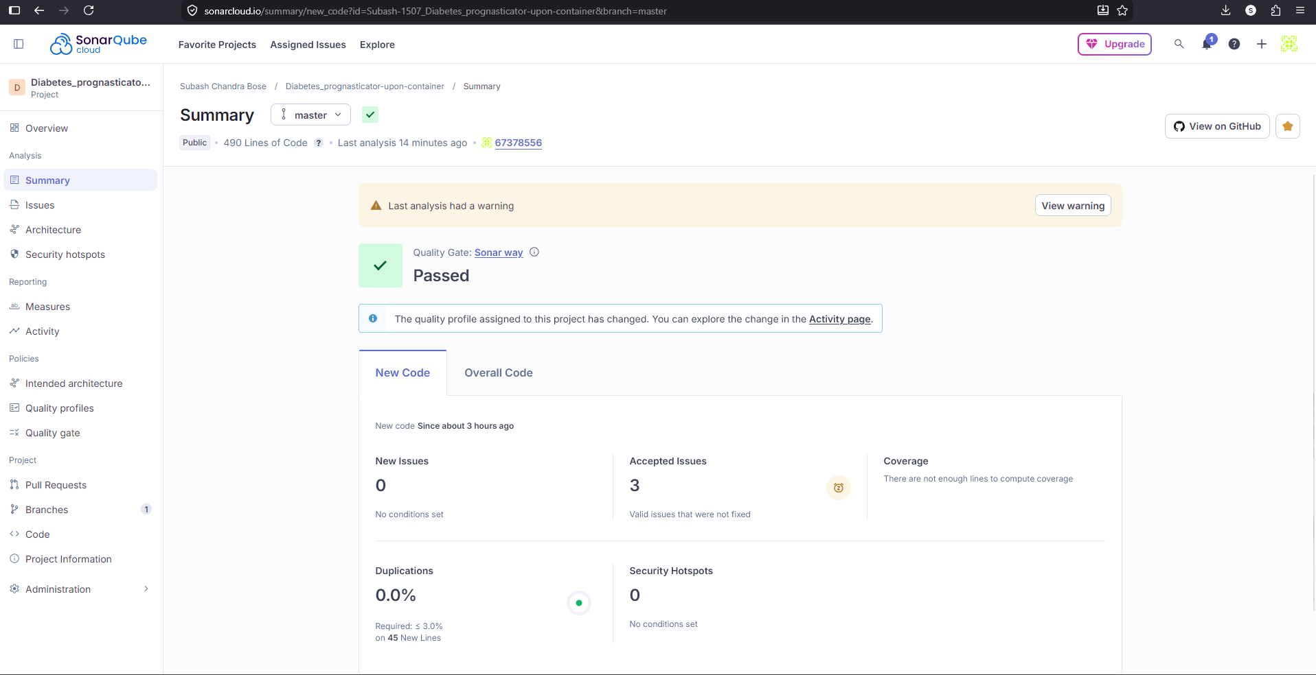
Pipeline Build Stages
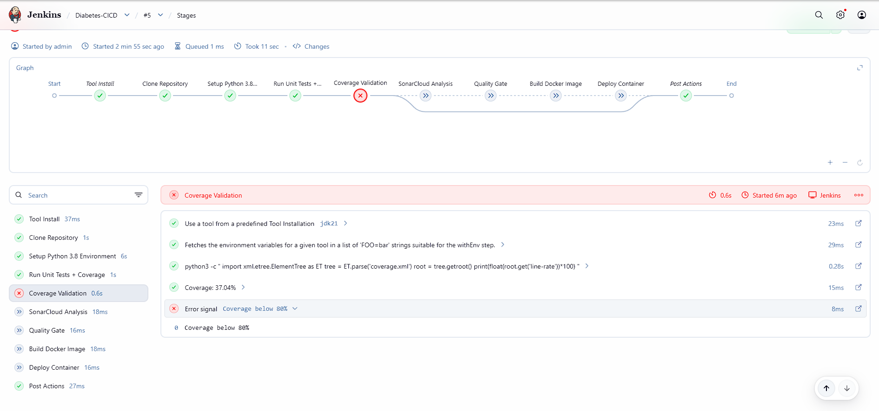
Coverage Validation Output
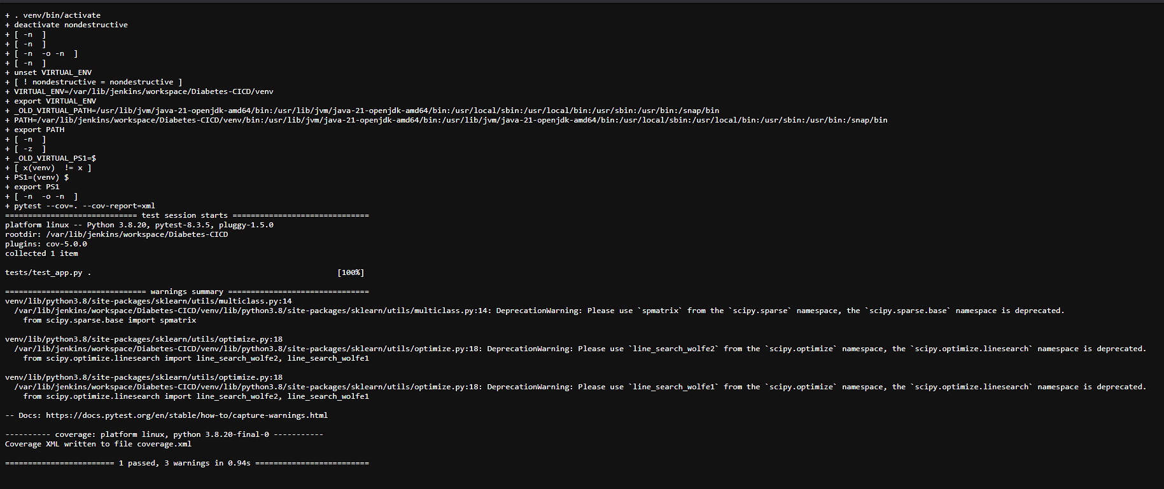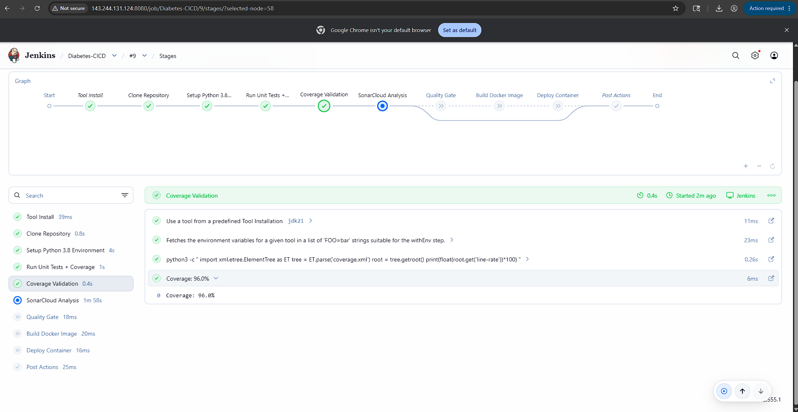
SonarCloud Issues
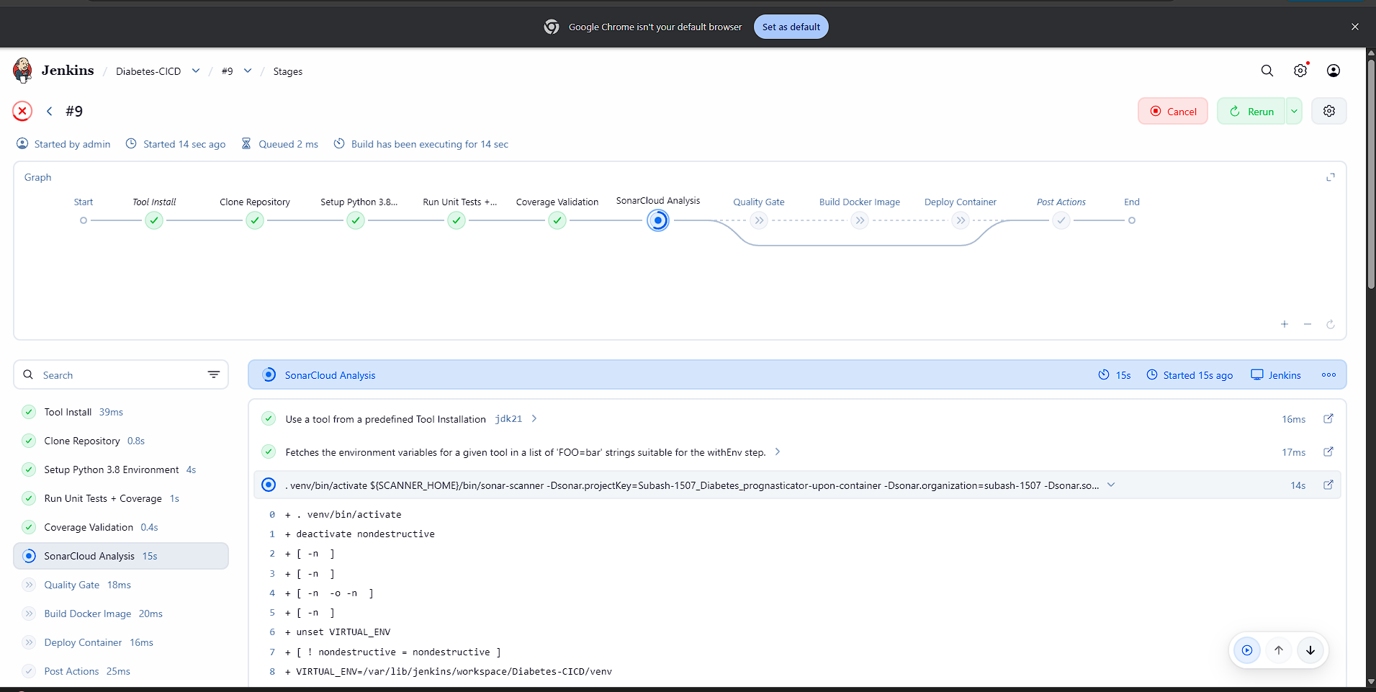
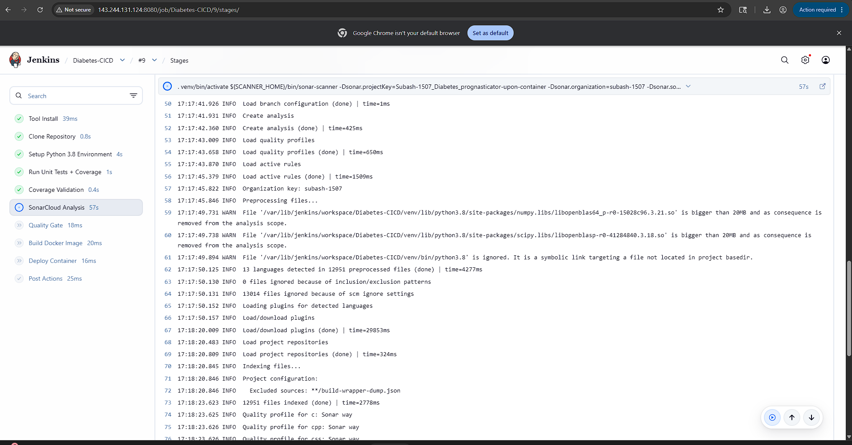
Quality Gate Failure Screenshot
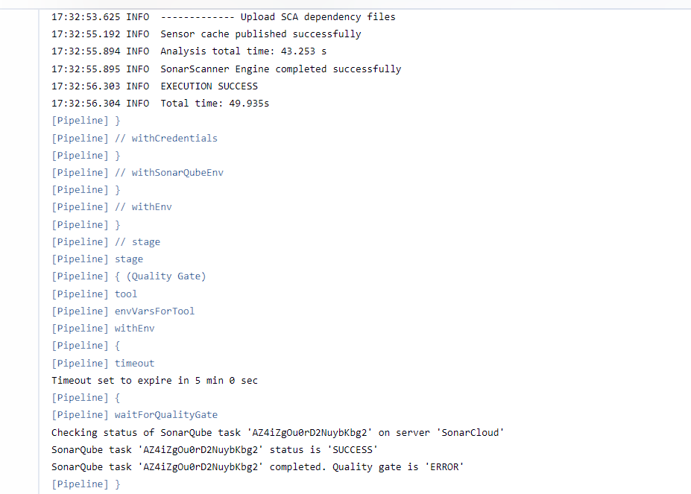
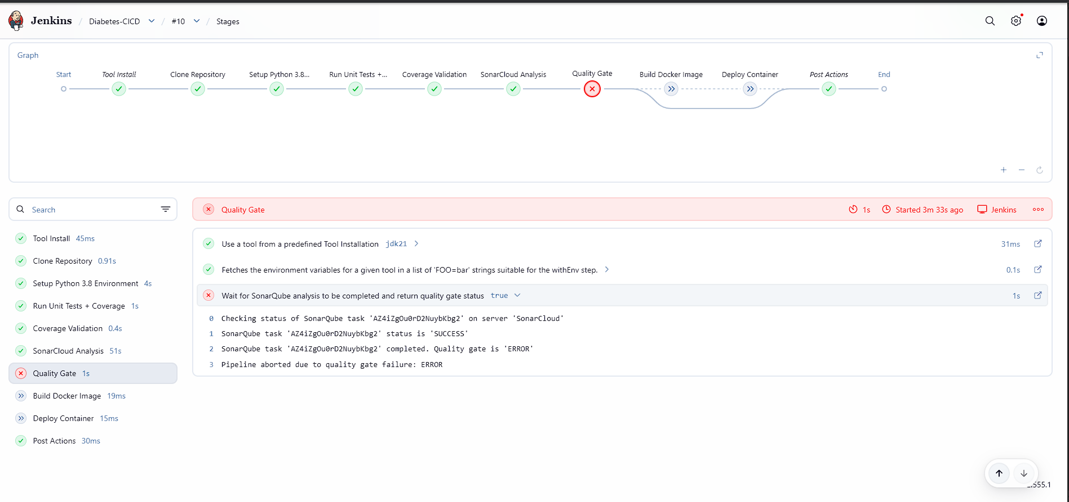
Successful Pipeline Execution
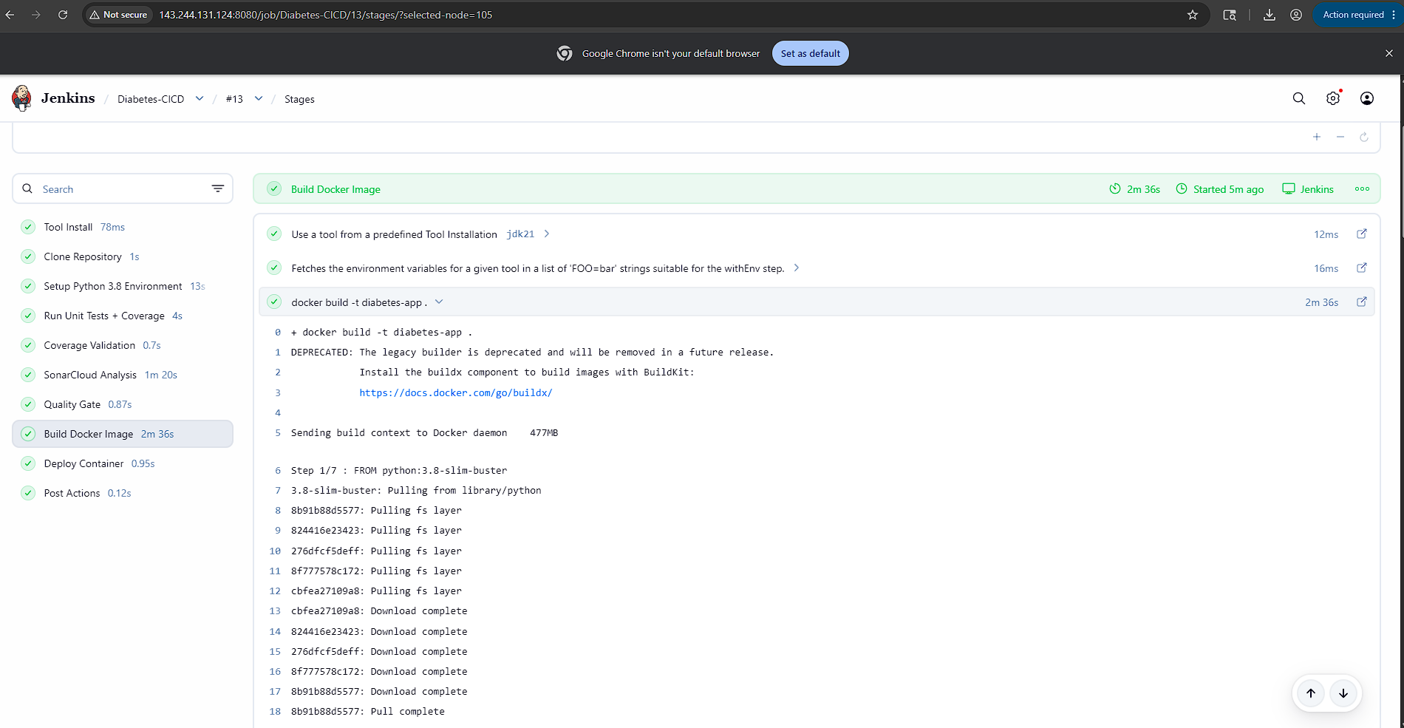
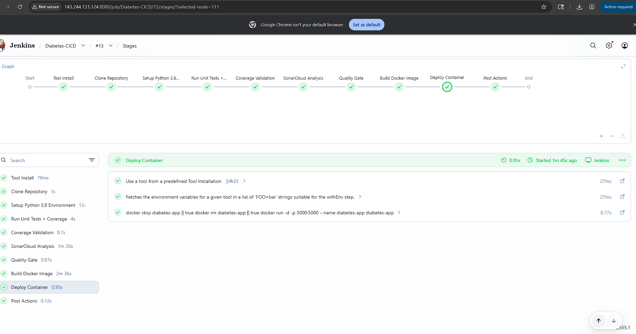

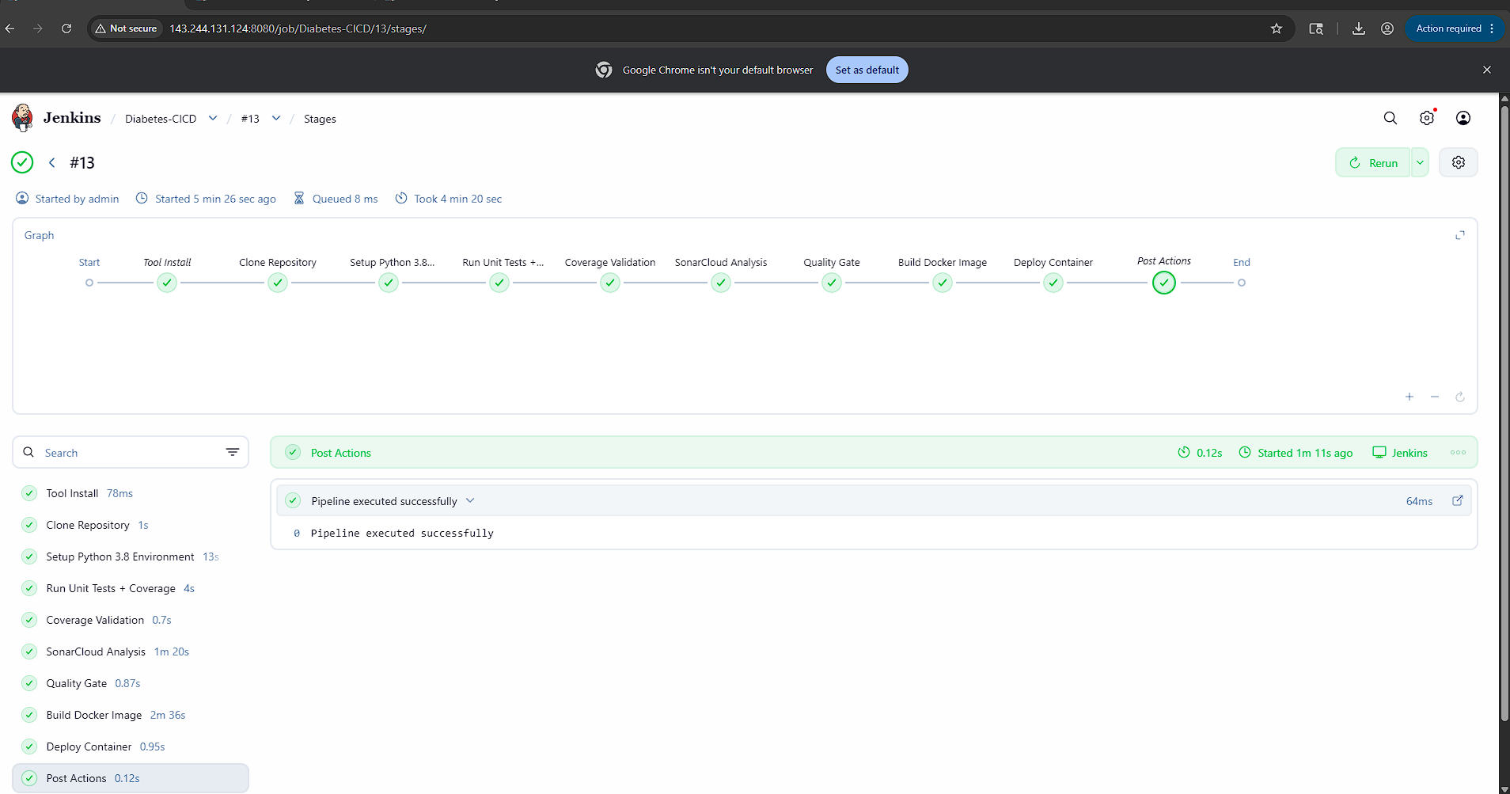
Docker Deployment Output
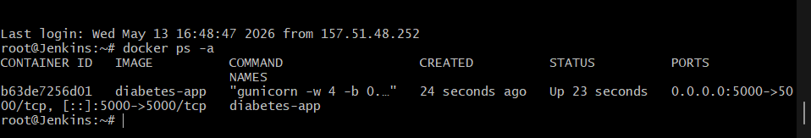
Application Running in Browser
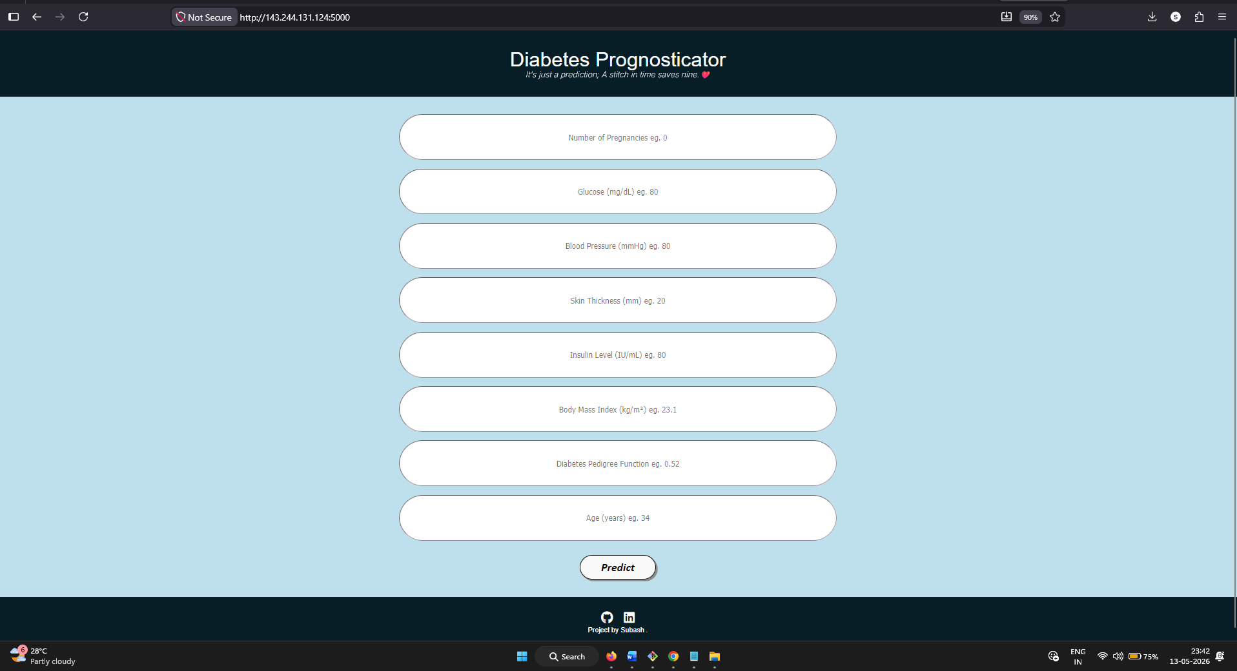

13. Jenkins Pipeline
pipeline {
agent any

tools {
jdk 'jdk21'
}

environment {
SCANNER_HOME = tool 'SonarScanner'
}

stages {

stage('Clone Repository') {
steps {
git branch: 'main',
url: 'https://github.com/Subash-1507/Diabetes_prognasticator-upon-container.git'
}
}

stage('Setup Python 3.8 Environment') {
steps {
sh '''
python3.8 -m venv venv

. venv/bin/activate

pip install --upgrade pip

pip install -r requirements.txt

pip install pytest pytest-cov coverage
'''
}
}

stage('Run Unit Tests + Coverage') {
steps {
sh '''
. venv/bin/activate

pytest --cov=. --cov-report=xml
'''
}
}

stage('Coverage Validation') {
steps {
script {

def coverage = sh(
script: """
python3 -c "
import xml.etree.ElementTree as ET
tree = ET.parse('coverage.xml')
root = tree.getroot()
print(float(root.get('line-rate'))*100)
"
""",
returnStdout: true
).trim()

echo "Coverage: ${coverage}%"

if (coverage.toFloat() < 80) {
error("Coverage below 80%")
}
}
}
}

stage('SonarCloud Analysis') {
steps {
withSonarQubeEnv('SonarCloud') {

withCredentials([
string(credentialsId: 'sonar-token', variable: 'SONAR_TOKEN')
]) {

sh '''
. venv/bin/activate

${SCANNER_HOME}/bin/sonar-scanner \
-Dsonar.projectKey=Subash-1507_Diabetes_prognasticator-upon-container \
-Dsonar.organization=subash-1507 \
-Dsonar.sources=. \
-Dsonar.python.coverage.reportPaths=coverage.xml \
-Dsonar.host.url=https://sonarcloud.io \
-Dsonar.token=$SONAR_TOKEN
'''
}
}
}
}

stage('Quality Gate') {
steps {
timeout(time: 5, unit: 'MINUTES') {
waitForQualityGate abortPipeline: true
}
}
}

stage('Build Docker Image') {
steps {
sh '''
docker build -t diabetes-app .
'''
}
}

stage('Deploy Container') {
steps {
sh '''
docker stop diabetes-app || true

docker rm diabetes-app || true

docker run -d -p 5000:5000 \
--name diabetes-app diabetes-app
'''
}
}
}

post {

success {
echo 'Pipeline executed successfully'
}

failure {
echo 'Pipeline failed'
}
}
}

