Stored xss:
Procedure
- Navigated to DVWA → XSS (Stored).
- Entered malicious script input into the message/comment field.
- Submitted the input, which was stored in the backend database.
- When the page was revisited, the script executed automatically.
Observation
- The payload persisted in the application.
- Script execution occurred for every user visiting the page.
Splunk Logs
- HTTP POST requests recorded.
- Repeated GET requests triggering script execution.
- Apache access logs indexed in Splunk.

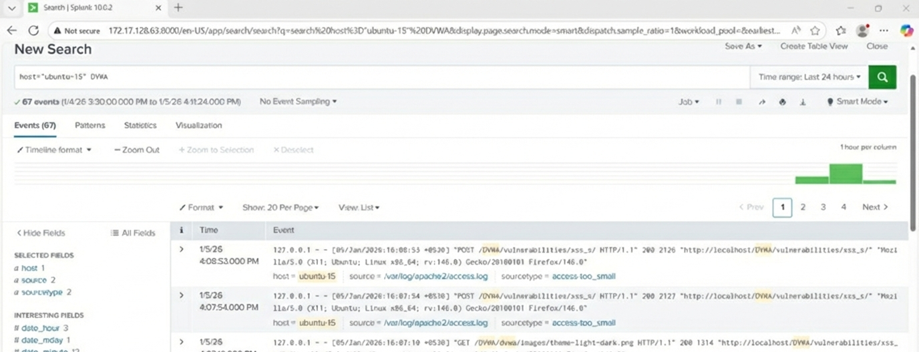

Csrf
Procedure
- Navigated to DVWA → CSRF.
- Observed password change functionality without CSRF token validation.
- Crafted a forged request that triggered an unauthorized action.
Observation
- Password changed without user confirmation.
- No CSRF protection mechanisms implemented.
Splunk Logs
- Unauthorized POST requests logged.
- No authentication validation in request flow.

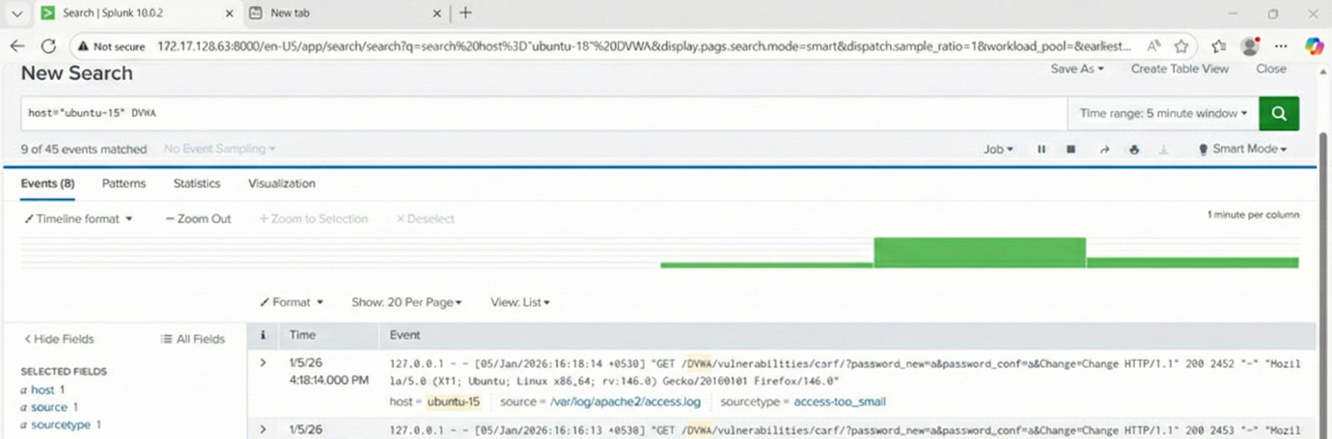

File Upload Vulnerability
Procedure
- Navigated to DVWA → File Upload.
- Uploaded a malicious file disguised as a normal file.
- Accessed the uploaded file via browser.
Observation
- Server failed to validate file type.
- Uploaded file executed on the server.
Splunk Logs
- File upload POST requests logged.
- File access requests captured.
- Server execution traces visible.

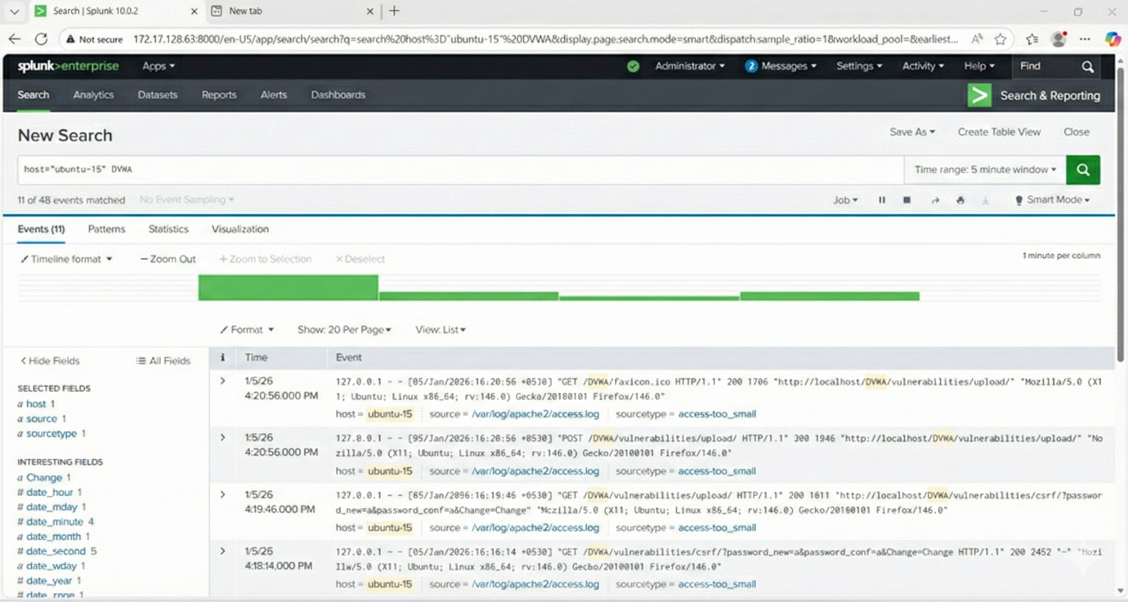

DOM-Based XSS
Procedure
- Navigated to DVWA → XSS (DOM).
- Manipulated URL fragment parameters processed by client-side JavaScript.
- Script executed entirely in the browser.
Observation
- No server-side filtering.
- Execution occurred without server response modification.
Splunk Logs
- URL access recorded.
- Minimal server interaction (client-side execution).
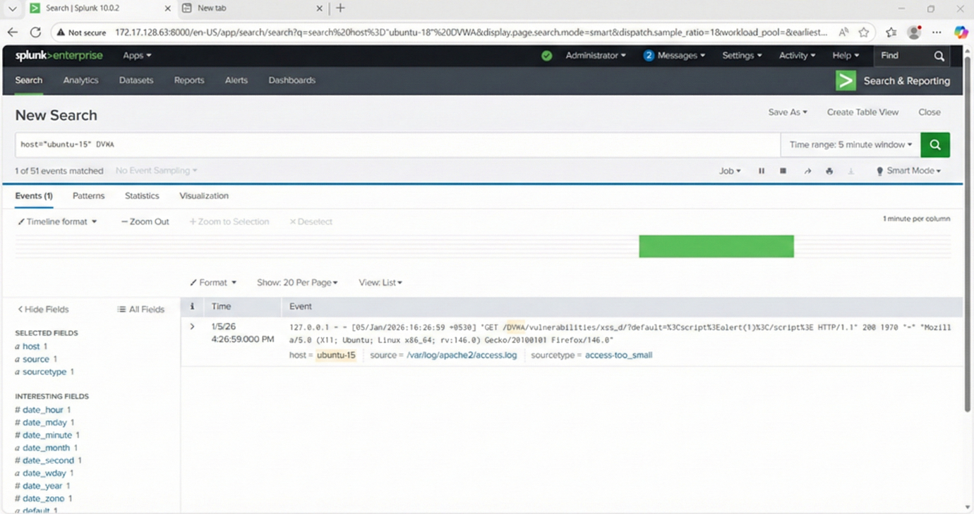

Reflected XSS
Procedure
- Navigated to DVWA → XSS (Reflected).
- Injected script input via the URL/form parameter.
- Submitted the request.
Observation
- Script executed immediately in the response.
- Payload was not stored.
Splunk Logs
- Single HTTP request with malicious parameters.
- Reflected input visible in request logs.

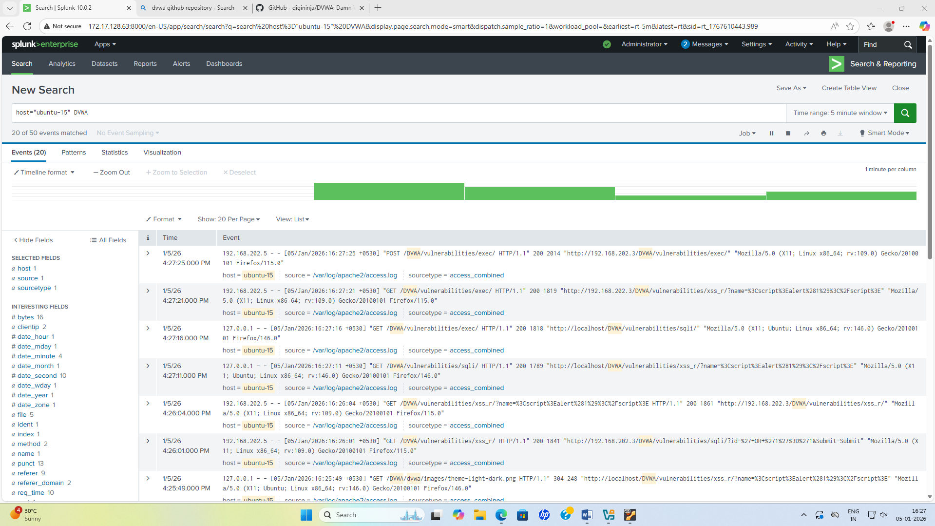

SQL Injection Attack
Procedure
- Navigated to DVWA → SQL Injection.
- Provided crafted input in the User ID field.
- Manipulated backend SQL query logic.
Observation
- Retrieved unauthorized database records.
- Backend queries were directly affected by user input.
Splunk Logs
- Suspicious query patterns logged.
- Multiple failed and successful query attempts visible.
