HOME PAGE
<!DOCTYPE html>
<html lang="en">
<head>
<title>XYZ Travel Agency</title>
</head>
<body>
<hr>
<nav>login | Home </nav>
<hr>
<main>
<article>
<h1>xyz travels</h1>
<p>explore the world with us ,with our very affordable packages,hotel bookings,flight reservations and many more.....</p>
<h2>our services</h2>
<ul>
<li>Domestic Tours</li>
<li>International Tours</li>
<li>Flight Booking</li>
<li>Hotel Reservation</li>
</ul>
</article>
<aside>
<h2>Popular Destinations</h2>
<ol>
<li>Goa</li><li>Kerala</li>
<li>Manali</li><li>Dubai</li>
<li>Paris</li>
</ol>
</aside>
</main><hr>
<footer>
<address> XYZ Travel Agency<br>
Hyderabad, Telangana<br>
Email: XYZtravel@gmail.com<br>
Phone: +91 123456789
</address>
</footer>
</html>
OUTPUT
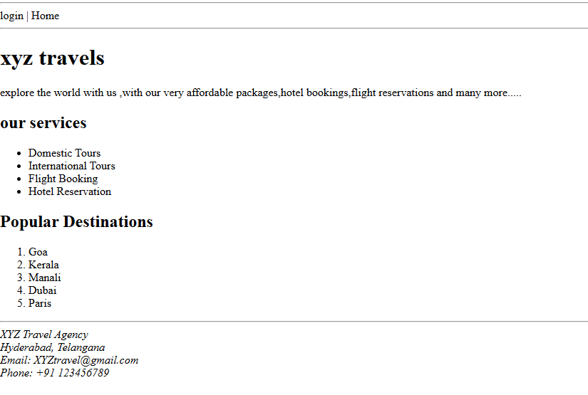

LOGIN PAGE
<!DOCTYPE html>
<html lang="en">

<head>
<title>Login page:</title>
</head>
<body>
<center>
<form>
<fieldset>
<legend>Login details</legend>
<label> Username:</label>
<input type="text"><br><br>
<label>Password:</label>
<input type="password"><br><br>
<input type="submit">
<input type="reset">
</fieldset>
</form>
</center>
</html>

OUTPUT
