1.Why are functions advantageous to have in your programs?

**Ans: Functions are very affordable to programmers why because it reduces the greater number of lines of code also its reusable or callable everywhere, so this the major advantageous.**

2.When does the code in a function run: when it's specified or when it's called?

**Ans: The code which is defined inside the function it will run only when the function has been called in the runtime.**

3.What statement creates a function?

**Ans:** **A function is a block of organized, reusable code that is used to perform a single, related action. Functions provide better modularity for your application and a high degree of code reusing. Mainly def function name () statement will create the function in python.**

4.What is the difference between a function and a function call?

**Ans:**

**1.Function: Function is block of code which will give the result as per the given code**

**2.Function call: Function call is helping to function to achieve its tasks.**

5. How many global scopes are there in a Python program? How many local scopes?

**Ans:**

**Global** -**There's only one global Python scope per program execution. This scope remains in existence until the program terminates and all its names are forgotten. Otherwise, the next time you were to run the program, the names would remember their values from the previous run.**

**Local-For the local scope we can only use the local variable inside the function where we have declared the variable**

**Ex: def local ():**

**x = 45**

**y=32**

**print (x + y)**

**Note: Here we have declared x, y values inside the function, so we can use it whenever we want inside this function only it can’t b used in another functions, that’s why it’s called local scope.**

6. What happens to variables in a local scope when the function call returns?

**Ans: Function return will destroy the local variables when the function has been called out.**

7. What is the concept of a return value? Is it possible to have a return value in an expression?

**Ans:** **A return values concept is it will give the output of the function when the function was called. A return value can be any one of the four variable types: handle, integer, object, or string.**

8. If a function does not have a return statement, what is the return value of a call to that function?

**Ans: If a function does not have a return statement it will search for any print statements it that also not available inside the function then ‘None’ will return while calling the functions.**

9. How do you make a function variable refer to the global variable?

**Ans: if any of the variable was declared outside the function it’s called Global variable and if we want to refer the variable inside the function, we can refer it by using the global variable keyword which has been declared outside the function.**

10. What is the data type of None?

**Ans: Data type of ‘None’ is NoneType**

11. What does the sentence import areallyourpetsnamederic do?

**Ans: while using the keyword import it will search for a package name which we’ve given**

**inside the installed packages in locals, if there no packages or modules was found then it’ll return the ‘No module named 'areallyourpetsnamederic' error message.** 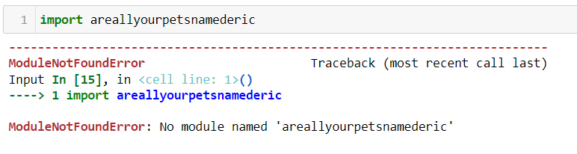

12. If you had a bacon () feature in a spam module, what would you call it after importing spam?

**Ans: By using the parent function name. child function name we can easily access the function.**

**Import spam**

**spam.bacon()**

13. What can you do to save a programme from crashing if it encounters an error?

**Ans: if the programme may give error then I will use it inside the try except block to reduce the error of it.**

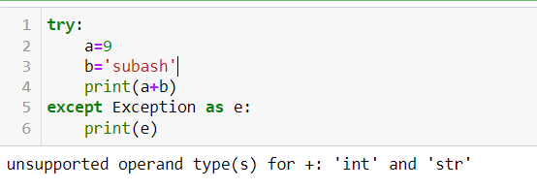

14. What is the purpose of the try clause? What is the purpose of the except clause?

**Ans:**

**Try: The try clause will try to execute the piece of code which we have given inside the try block but it’ll not through any kind of error even though the given code is having issue. simply says try clause will test the code.**

**Except: The except clause will give the exception message of the try block if we have a issues or errors in the codes. simply says Except clause will handle the code errors.**

