1. What exactly is []?

**Ans: Generally [] is called as list and also it called as array in python. We can store the elements inside the [] it’s called as list.**

2. In a list of values stored in a variable called spam, how would you assign the value 'hello' as the third value? (Assume [2, 4, 6, 8, 10] are in spam.)

**Ans**:

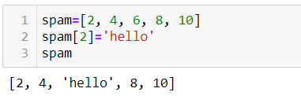

Let's pretend the spam includes the list ['a', 'b', 'c', 'd'] for the next three queries.

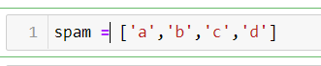

3. What is the value of spam [int(int('3' * 2) / 11)]?

**Ans:**

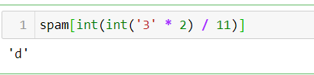

4. What is the value of spam[-1]?

**Ans:**

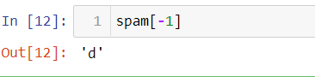

5. What is the value of spam[:2]?

**Ans:**

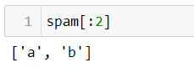

Let's pretend bacon has the list [3.14, 'cat,' 11, 'cat,' True] for the next three questions. 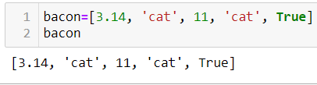

6. What is the value of bacon.index('cat')?

**Ans:**

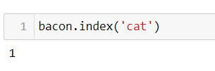

7. How does bacon.append(99) change the look of the list value in bacon?

**Ans:**

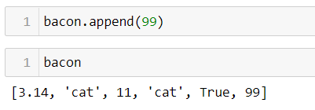

8. How does bacon.remove('cat') change the look of the list in bacon?

**Ans:  
 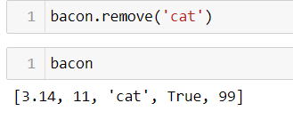**

9. What are the list concatenation and list replication operators?

**Ans: What are the operators for list concatenation and list replication? The operator for list concatenation is +, while the operator for replication is *.**

10. What is difference between the list methods append() and insert()?

**Ans**:

**Append: The append function can add the element at last index of the list**

**Insert: insert function can add the element in particular index of the list**

11. What are the two methods for removing items from a list?

**Ans:**

**Remove ()-remove function will remove the particular element in the list.**

**Pop ()-pop function will remove the last element of the list by default and we can remove the specific element by using pop function as well.**

**Clear ()-Clear function will remove all the present elements from the list and it will return the empty list.**

12. Describe how list values and string values are identical.

**Ans**: **List values are stored in [] it can be any values including string values which chr values are stored inside ‘single’ or “double” quotes and list is mutable object and string was immutable object.**

13. What's the difference between tuples and lists?

**Ans:**

**1.List is mutable and tuple is immutable**

**2.List can accept the duplicates values and tuple can’t accept the duplicate elements.**

**3.List was stored inside []**

**4.Tuple was stored inside ()**

14. How do you type a tuple value that only contains the integer 42?

**Ans:** **(42,) (The trailing comma is mandatory.)**

15. How do you get a list value's tuple form? How do you get a tuple value's list form?

**Ans:** The tuple () and list () functions, respectively

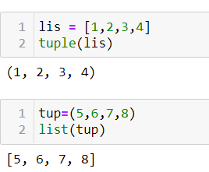

16. Variables that "contain" list values are not necessarily lists themselves. Instead, what do they contain?

**Ans:** **They contain references to list values**.

17. How do you distinguish between copy.copy() and copy.deepcopy()?

**Ans** **The copy.copy () function will do a shallow copy of a list, while the copy.deepcopy () function will do a deep copy of a list. That is, only copy.deepcopy () will duplicate any lists inside the list.**