1. What does an empty dictionary's code look like?

**Ans: Dictionary is declared inside the curly brackets d = {} or d=dict ()**

2. What is the value of a dictionary value with the key 'foo' and the value 42?

**Ans: {‘foo’:42}**

3. What is the most significant distinction between a dictionary and a list?

**Ans:** **The list is an ordered collection of data, whereas the dictionaries store the data in the form of key-value pairs using the hashtable structure.**

4. What happens if you try to access spam['foo'] if spam is {'bar': 100}?

**Ans:** 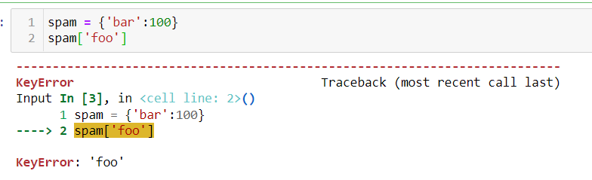

5. If a dictionary is stored in spam, what is the difference between the expressions 'cat' in spam and 'cat' in spam.keys()?

**Ans: There is no difference. The in operator checks whether a value exists as a key in the dictionary**

6. If a dictionary is stored in spam, what is the difference between the expression’s 'cat' in spam and 'cat' in spam.values()?

**Ans: 'cat' in spam checks whether there is a 'cat' key in the dictionary, while 'cat' in spam. values() checks whether there is a value 'cat' for one of the keys in spam.**

7. What is a shortcut for the following code?

if 'color' not in spam:

spam['color'] = 'black'

**Ans:** **spam.setdefault('color', 'black')**

8. How do you "pretty print" dictionary values using which module and function?

**Ans: pprint.pprint ()**