1. What are escape characters, and how do you use them?

**Ans: In Python strings, the backslash "\" is a special character, also called the "escape" character. It is used in representing certain whitespace characters: "\t" is a tab, "\n" is a newline, and "\r" is a carriage return. Conversely, prefixing a special character with "\" turns it into an ordinary character.**

2. What do the escape characters n and t stand for?

**Ans:**

**n-New line**

**t-tab**

3. What is the way to include backslash characters in a string?

**Ans:**

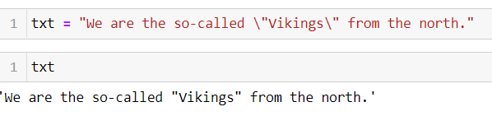

4. The string "Howl's Moving Castle" is a correct value. Why isn't the single quote character in the word Howl's not escaped a problem?

**Ans: The string has been declared inside the double quotes so its not make any issue while using the single quotes inside it.**

5. How do you write a string of newlines if you don't want to use the n character?

**Ans: by using the multiline quotes its allow us to write the string in next line without using the ‘n’**

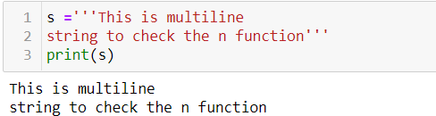

6. What are the values of the given expressions?

'Hello, world!'[1] -- **‘e’**

'Hello, world!'[0:5] — **‘Hello’**

'Hello, world!'[:5] – **‘Hello’**

'Hello, world!'[3:] – **'lo, world!'**

7. What are the values of the following expressions?

'Hello'.upper() – ‘HELLO’

'Hello'.upper().isupper() – ‘True’

'Hello'.upper().lower() – ‘hello’

8. What are the values of the following expressions?

'Remember, remember, the fifth of July.'.split()

'-'.join('There can only one.'.split())

**Ans:**

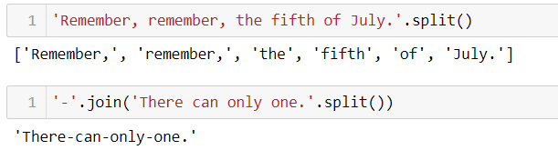

9. What are the methods for right-justifying, left-justifying, and centering a string?

**Ans: rjust (), ljust (), center () these are the methods to justifying the string.**

10. What is the best way to remove whitespace characters from the start or end?

**Ans: trim () will remove all the whitespace from the starting to end of the string**