1. List the month name and number of employees hired in each month and ignore the

year factor

Note: Two different years but the same month's hired employee count should be

summed together to get the total of employees hired in the respective month.

with t1 as (select Month(HireDate)AS Month from [HumanResources].[Employee])

select Month, Count(*) as Employees from t1

group by Month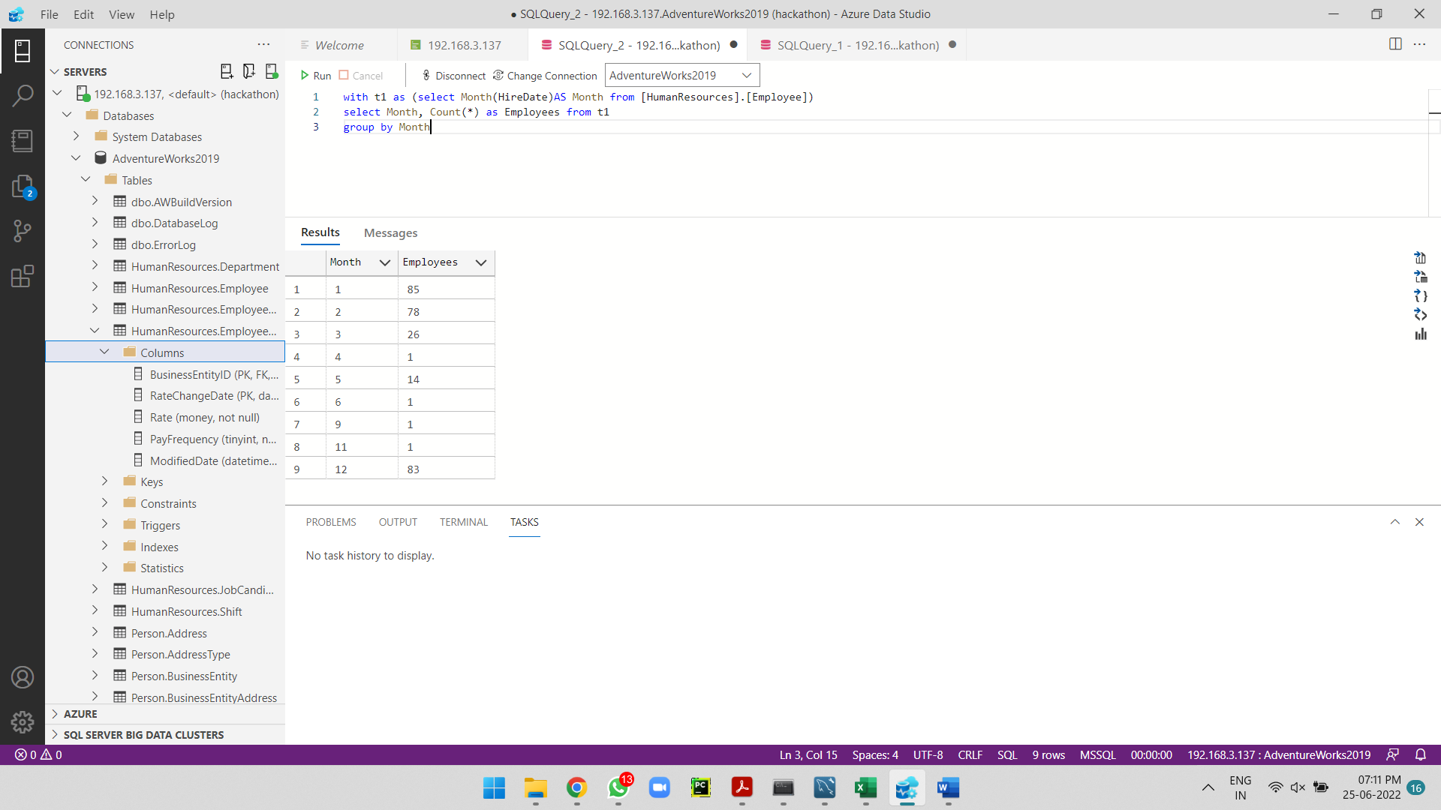

2. List department name, and the number of employees hired in each department

year-wise.

select count(1) as Employee_count, Name, year from (select a.Name, Year(HireDate)as year from HumanResources.Department as a

join [HumanResources].[EmployeeDepartmentHistory] as b

on a.[DepartmentID] = b.[DepartmentID]

join [HumanResources].[Employee] as c

on b.[BusinessEntityID] = c.BusinessEntityID)as a

group by a.Name, year

order by year

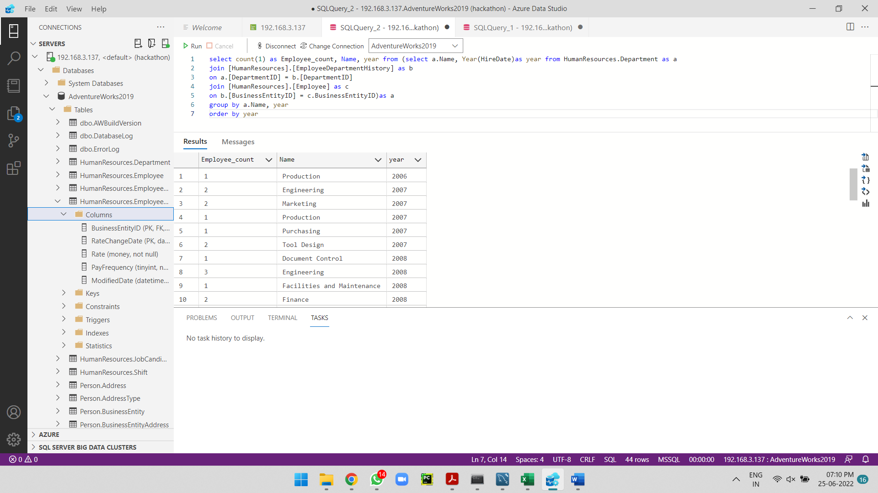

3. List the person and their country region name who is not an employee and their

name starts with the character “S”.

with t1 as (select a.FirstName, a.BusinessEntityID from [Person].[Person] a left join

[HumanResources].[Employee] b on a.BusinessEntityID= b.BusinessEntityID

where FirstName LIKE 'S%' and LoginID is Null)

select distinct a.FirstName, e.Name from t1 a

join [Person].[BusinessEntityAddress]as b on a.BusinessEntityID = b.BusinessEntityID

join [Person].[Address] c on b.AddressID = c.AddressID

join [Person].[StateProvince] d on c.[StateProvinceID] = d.[StateProvinceID]

join [Person].[CountryRegion] e on d.[CountryRegionCode] = e.CountryRegionCode