Cloud & Containers Skill test1
https://github.com/Subash023/Cloud-Containers.git
Task 1
1. Created the Flask Application (app.py)
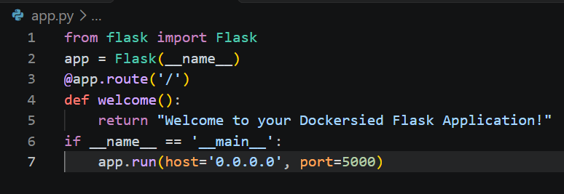
2. Created requirement.txt file for Flask
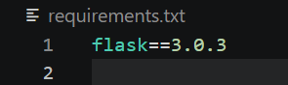
3. Created the Dockerfile (Dockerfile)
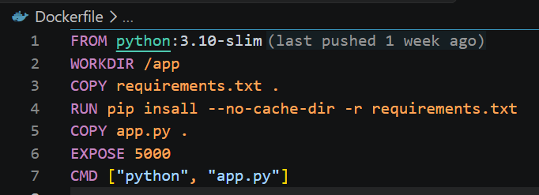
Terminal Commands
1. Build the Docker Image
docker build -t flask-welcome-app
2. Run the Docker Container
docker run -p 5000:5000 flask-welcome-app
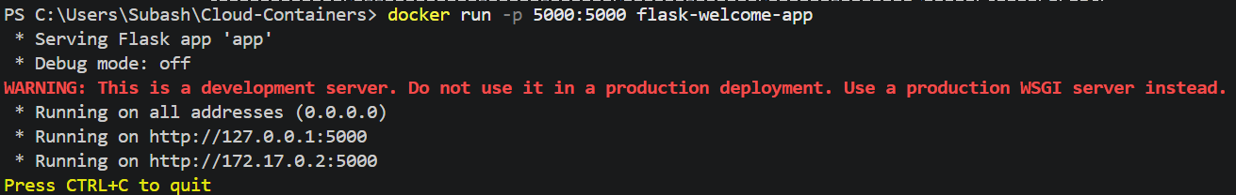
Testing the Application
- Navigated to http://localhost:5000.

- Verify that the webpage displays the text: "Welcome to your Dockerised Flask Application!"
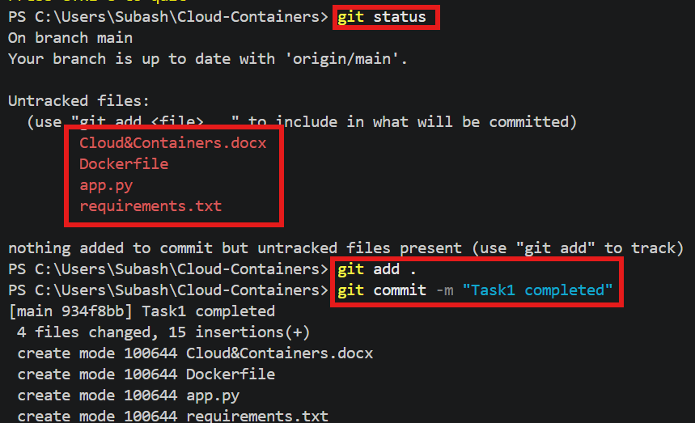
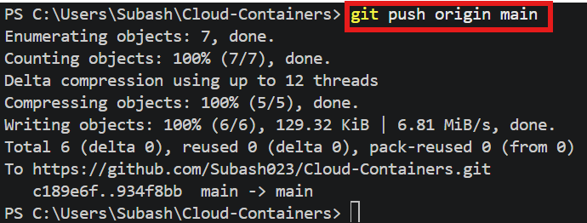

Task 2
1. app.py (Flask Application)
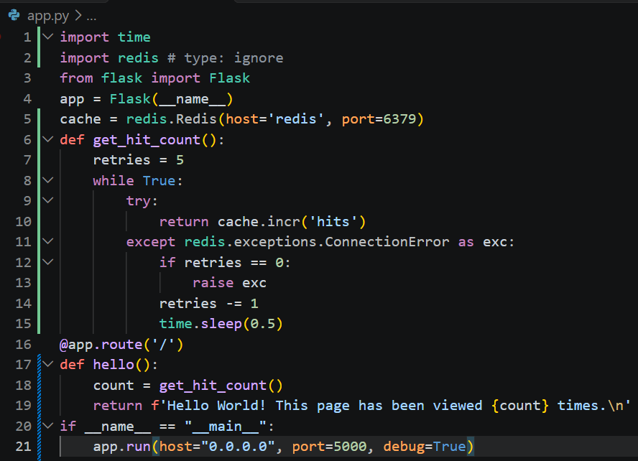
2. requirements.txt (Python Dependencies)
flask & redis
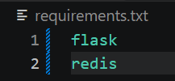
3. Dockerfile (Containerizing the Flask App)

4. compose.yaml (Defining the Services)
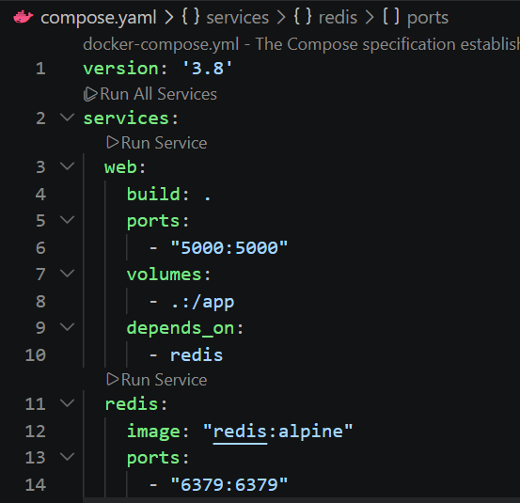

5. Test and Run the Application
- Start the containers:
docker-compose up –build
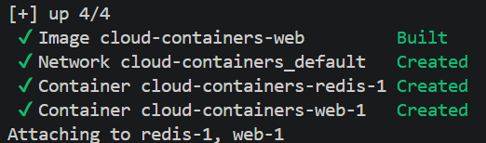
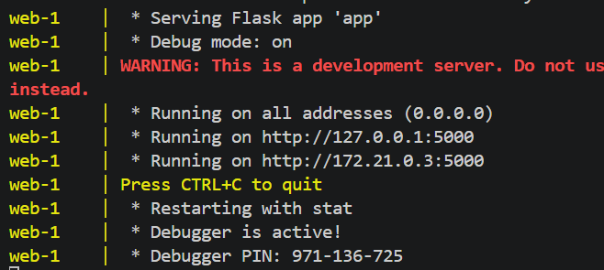

- Verify it works: Open your web browser and navigate to http://127.0.0.1:5000.
- Test the counter: it’s saying “Hello World! This page has been viewed 1 times.”
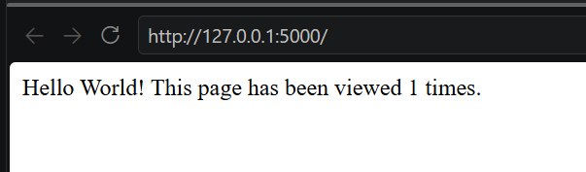
- Refresh the page a few times to confirm that the counter increments properly.

- Stop the app: To stop the containers, press Ctrl + C in your terminal, or run docker-compose down
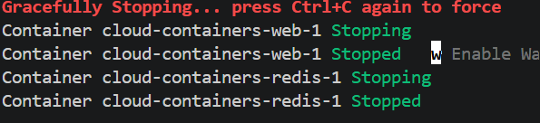
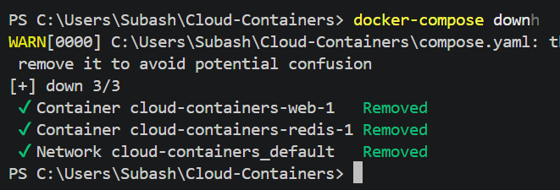
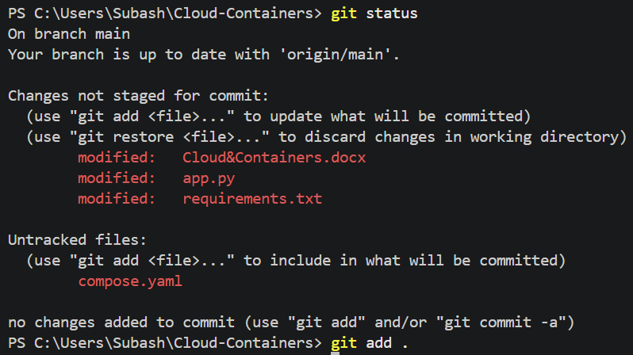
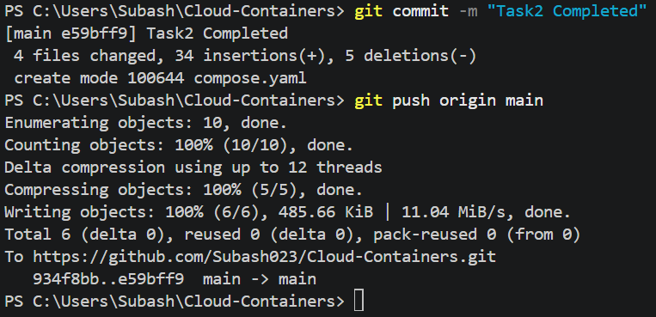

Task 3
1. Create MySQL Container & 2. Create a Docker Volume
Executed the following command in the terminal to create the volume:
(Verify it exists by running docker volume ls.)
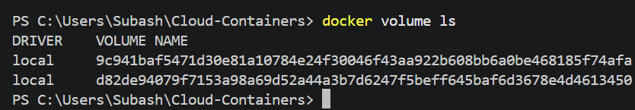
docker volume create mysql_data
3. Attach Volume to Container using Detach (-d) Environment Variables (-e) and attach new volume (-v) Flags.
docker run -d --name mysql-container -e MYSQL_ROOT_PASSWORD=my-secret-pw -e MYSQL_DATABASE=test_db -v mysql_data:/var/lib/mysql mysql:latest
4. Test Data Persistence
Step 4a: Add some data to the MySQL database
Logged into the running MySQL container's interactive shell using docker exec:
docker exec -it mysql-container mysql -u root -p
When prompted, enter the password you defined earlier (my-secret-pw).

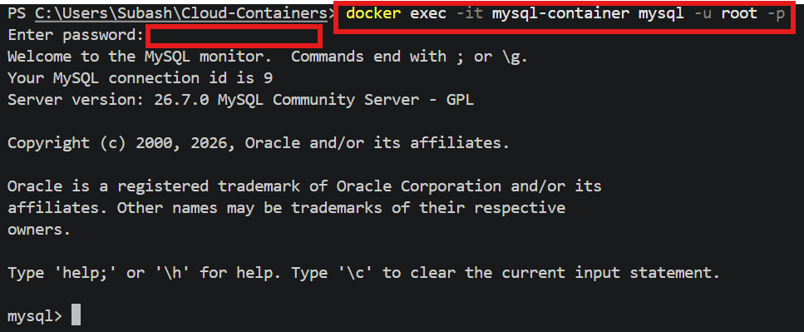
Once inside the MySQL prompt, verify the database exists, switch to it, and create a sample table with a row of data:
USE test_db;
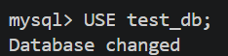
CREATE TABLE dummy_table (
id INT AUTO_INCREMENT PRIMARY KEY,
name VARCHAR(50)
);
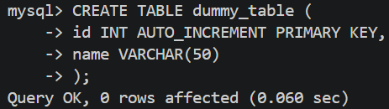
INSERT INTO dummy_table (name) VALUES ('Docker Persistence Test');
SELECT * FROM dummy_table;
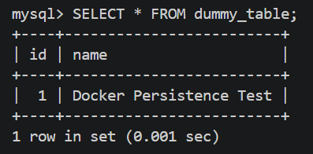
exit;
Step 4b: Remove the container
Stop and completely delete the container to prove that the data is decoupled from the container's lifecycle:
docker stop mysql-container
docker rm mysql-container
Step 4c: Run a new container with the same volume
Spin up a completely new container named mysql-container-new while mounting the identical mysql_data volume:
docker run -d --name mysql-container-new -e MYSQL_ROOT_PASSWORD=my-secret-pw -v mysql_data:/var/lib/mysql mysql:latest
Step 4d: Verify that data persists
Logged into new container to ensure the database schema and table rows are still intact:
docker exec -it mysql-container-new mysql -u root -p
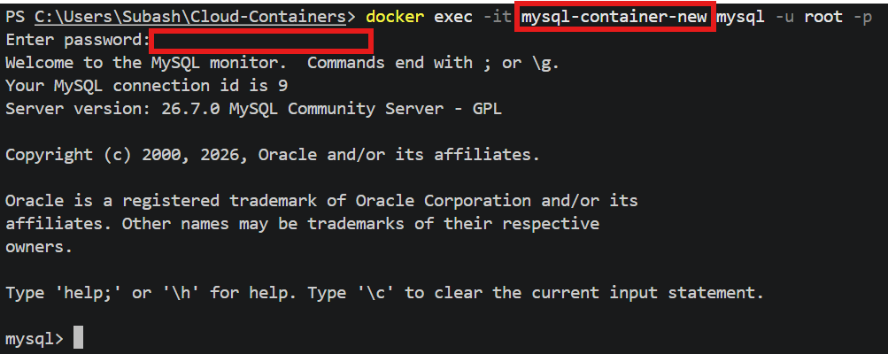
USE test_db;
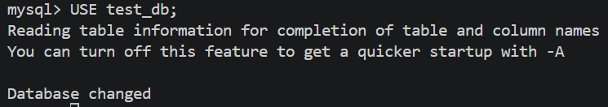
SELECT * FROM dummy_table;
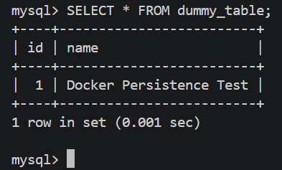
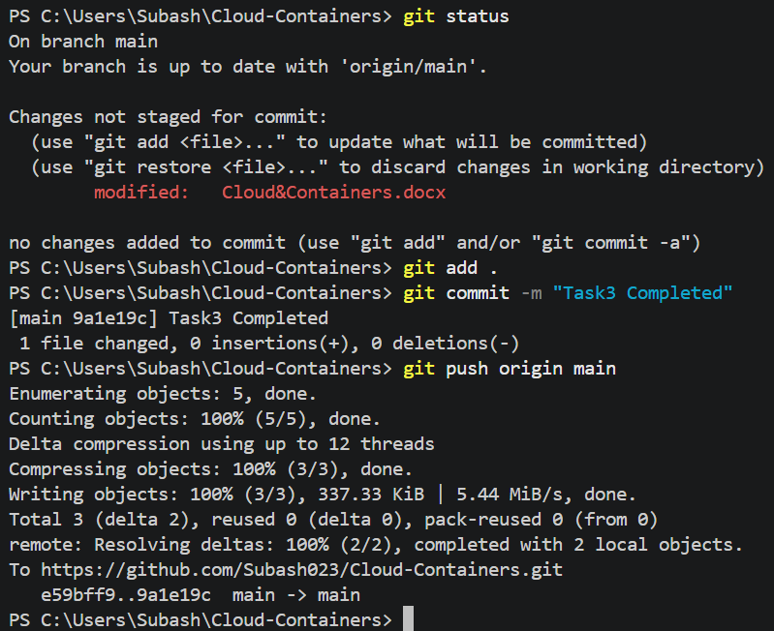

Task 4
Step 1: Create a Custom Bridge Network
Created a user-defined bridge network named my_custom_network:
docker network create --driver bridge my_custom_network

Step 2 & 3: Deploy and Configure the Containers
1. The Flask Application (app.py)
Configured Flask app initialization to establish a connection to Redis using the host parameter set as the container name (redis):
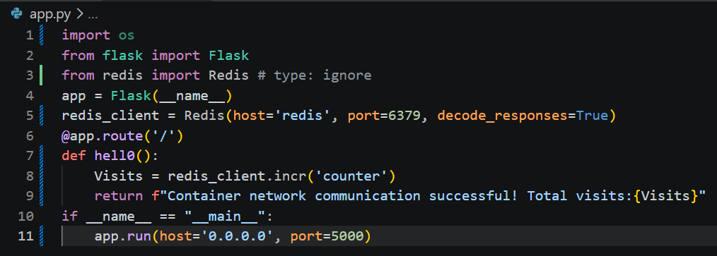
2. The Dockerfile for Flask
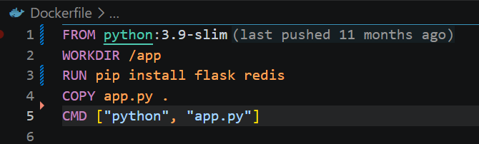
Build your Flask image locally:
docker build -t my-flask-app .
3. Spin up the Containers on the Network
First, deployed the Redis container attached to the custom network using --name redis:
docker run -d --name redis --network my_custom_network redis:alpine
Next, deployed Flask container attached to the same network, exposing port 5000 to the host machine:
docker run -d --name flask_app --network my_custom_network -p 5000:5000 my-flask-app
Step 4: Test Network Communication
Verified that the communication bridge functions properly by sending an HTTP request to the Flask server:
curl http://localhost:5000
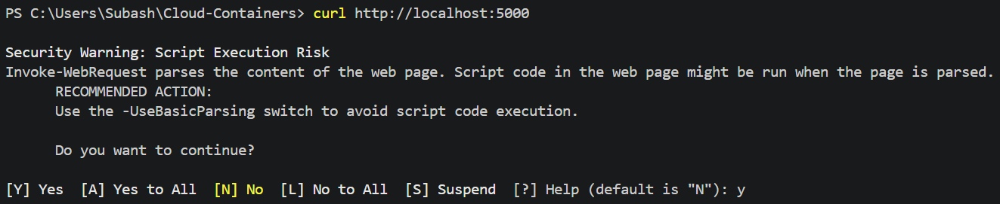
Expected Output:
Container network communication successful! Total visits: 1
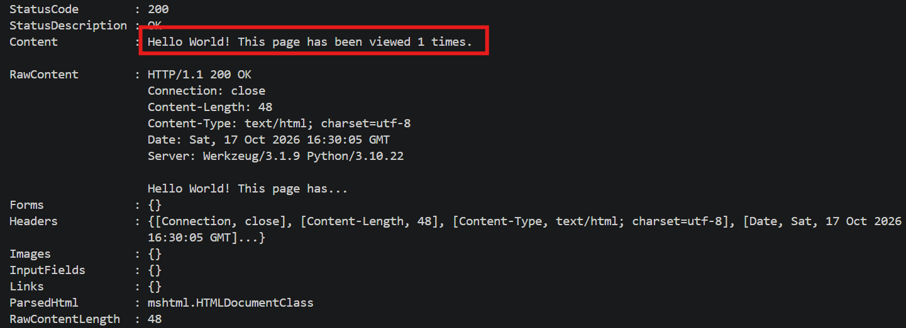
After run the curl command a second time, the visits will increment to 2, proving live read/write capability to the Redis container database over the internal network.
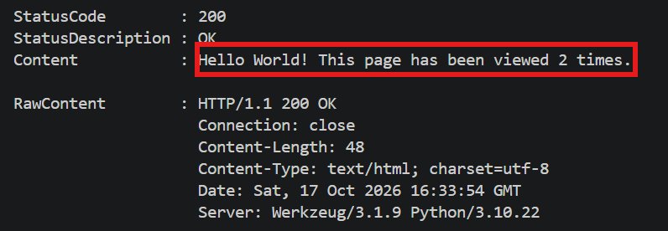

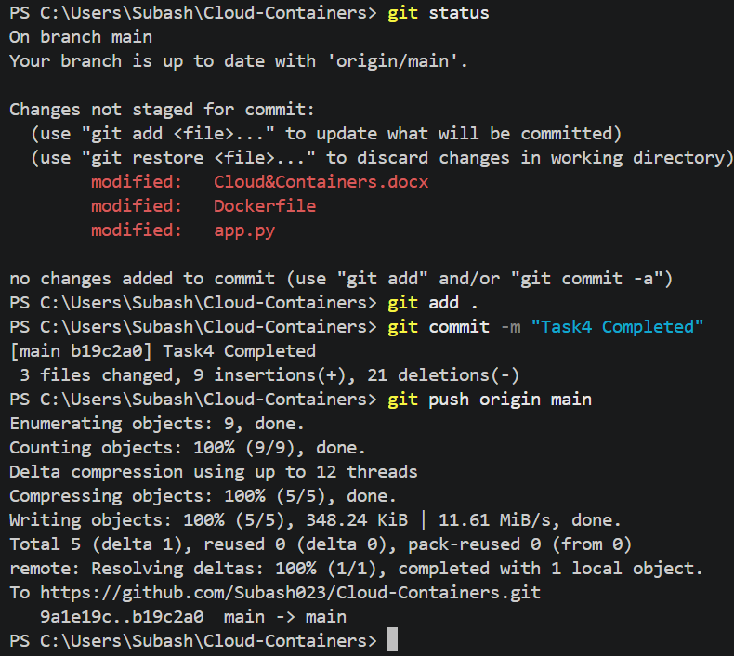

Task 5
1. Create Multiple Bridge Networks
Run the following commands to create network-1 and network-2:
a. Created the first custom bridge network
docker network create network-1
b. Create the second custom bridge network
docker network create network-2

To verify they were created successfully by listing your Docker networks:
docker network ls
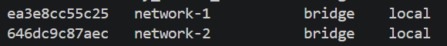
2. Deploy Containers in Different Networks
a. Deploy container-1 inside network-1
docker run -d --name container-1 --network network-1 alpine sleep 3600
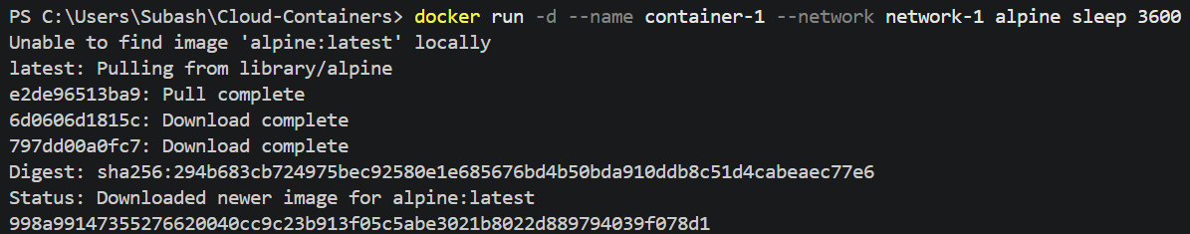
b. Deploy container-2 inside network-2
docker run -d --name container-2 --network network-2 alpine sleep 3600
3. Test Network Isolation
Step A: Get the IP address of container-2
Because they are on different networks, container-1 cannot resolve the hostname "container-2". We need to fetch container-2's internal IP address first:
docker inspect -f '{{range .NetworkSettings.Networks}}{{.IPAddress}}{{end}}' container-2
output IP is 172.23.0.2
Step B: Attempt to ping container-2 from container-1
Used docker exec to jump inside container-1 and attempt to send 3 ping packets to container-2's IP address
docker exec -it container-1 ping -c 3 172.23.0.2
Expected Result
The ping will fail completely, resulting in a 100% packet loss or hanging until it times out.
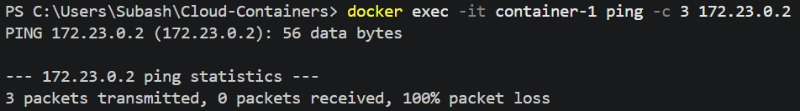
This confirms that container-1 and container-2 are successfully isolated from one another.
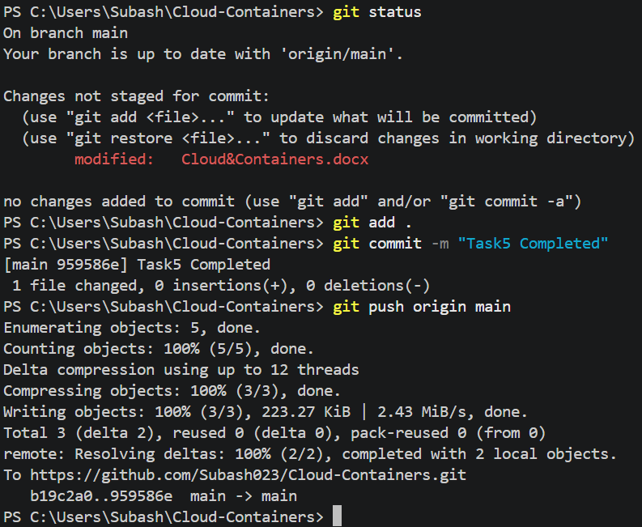

Task 6
1. Create the Node.js Application
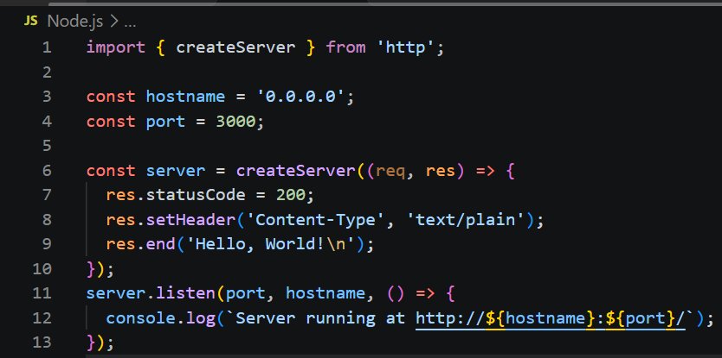
2. Create a Multi-Stage Dockerfile
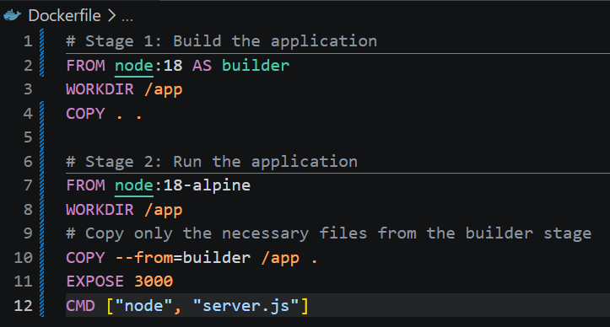
3. Build and Run the Docker Image
Opened the terminal or command prompt in the directory containing the files and execute the following commands.
- Build the Docker image:
docker build -t node-multi-stage .
- Run the container:
docker run -d -p 3000:3000 --name node-app node-multi-stage
4. Test the Application
- Opened the web browser.
- Navigate to http://localhost:3000.
- I can see the text "Hello, World!" displayed on the screen.


