**E-Commerce Sales Analysis Using SQL & Power BI**

**Project Objective:**

To analyze e-commerce customer behavior and product purchases using structured data from a Kaggle dataset. The goal was to extract insights from customer demographics and basket-level transaction data using **SQL** for data processing and **Power BI** for data visualization.

**Tools Used:**

* **MySQL Workbench**: Database design, data modeling, and SQL queries
* **Power BI Desktop**: Visual analytics and dashboard creation
* **VS Code**: Data review and potential script handling
* **Dataset**: [Kaggle – E-Commerce Sales Dataset](https://www.kaggle.com/datasets/berkayalan/ecommerce-sales-dataset)

Step 1: **Create Your MySQL Database and Tables**

Create Tables:

Step 2: **Import Data into MySQL**

MySQL Workbench → Table Data Import Wizard

Step 3: **SQL Query Ideas for Analysis**

1. Customer Demographics Summary

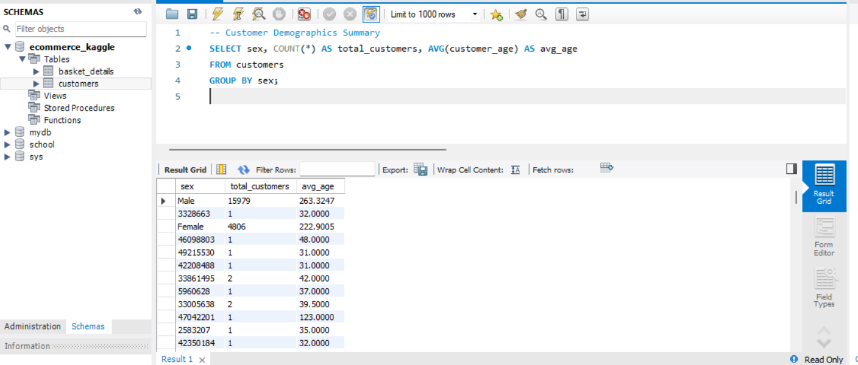

1. Monthly Production Basket Count

1. Top 10 Most Purchased Products

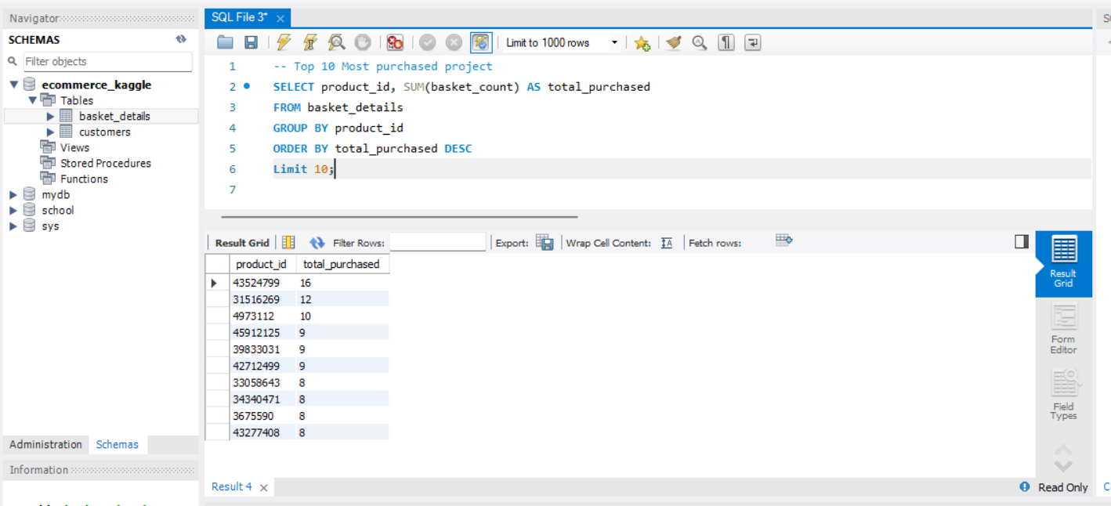

1. Age Group Purchase Patterns

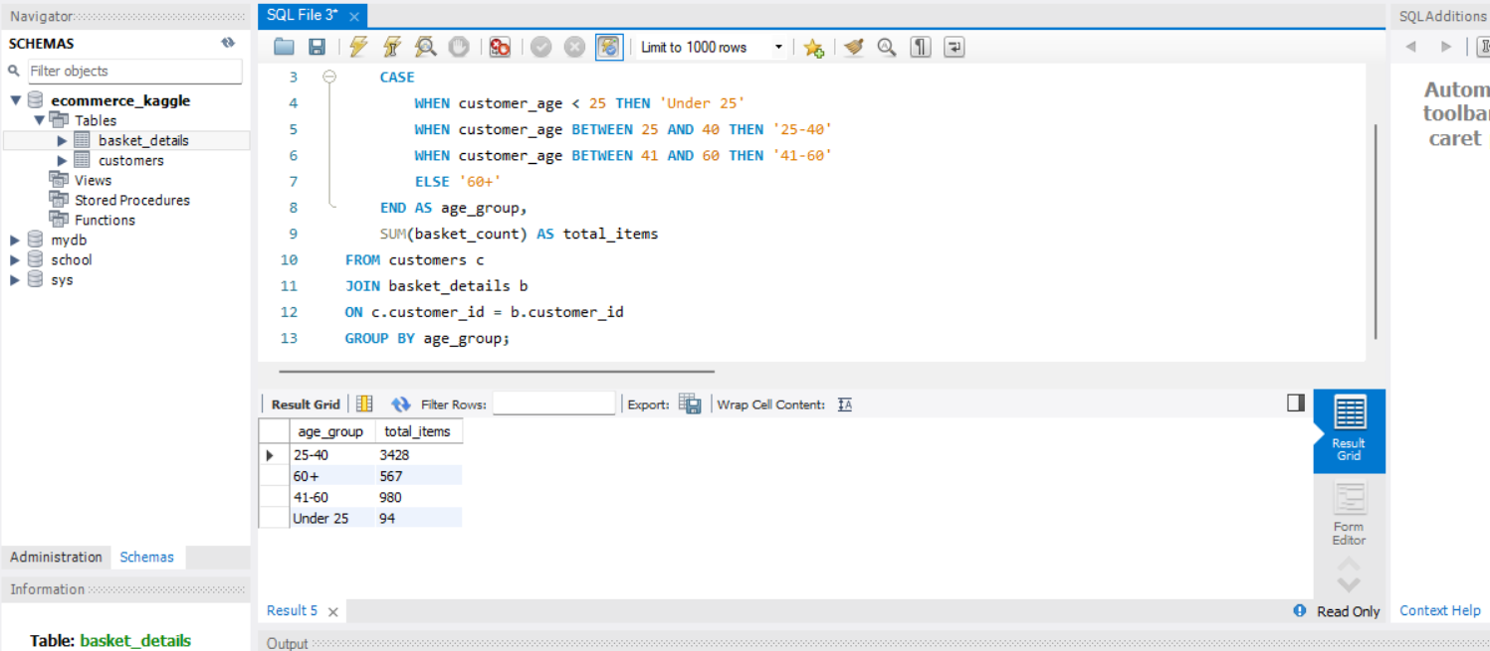

1. Returning vs. New Customers (Tenure-based)

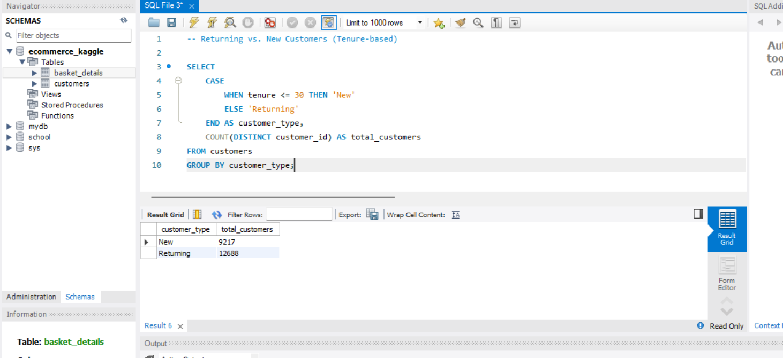

**E-Commerce Sales Analysis SQL Project Visualization Using Power BI**

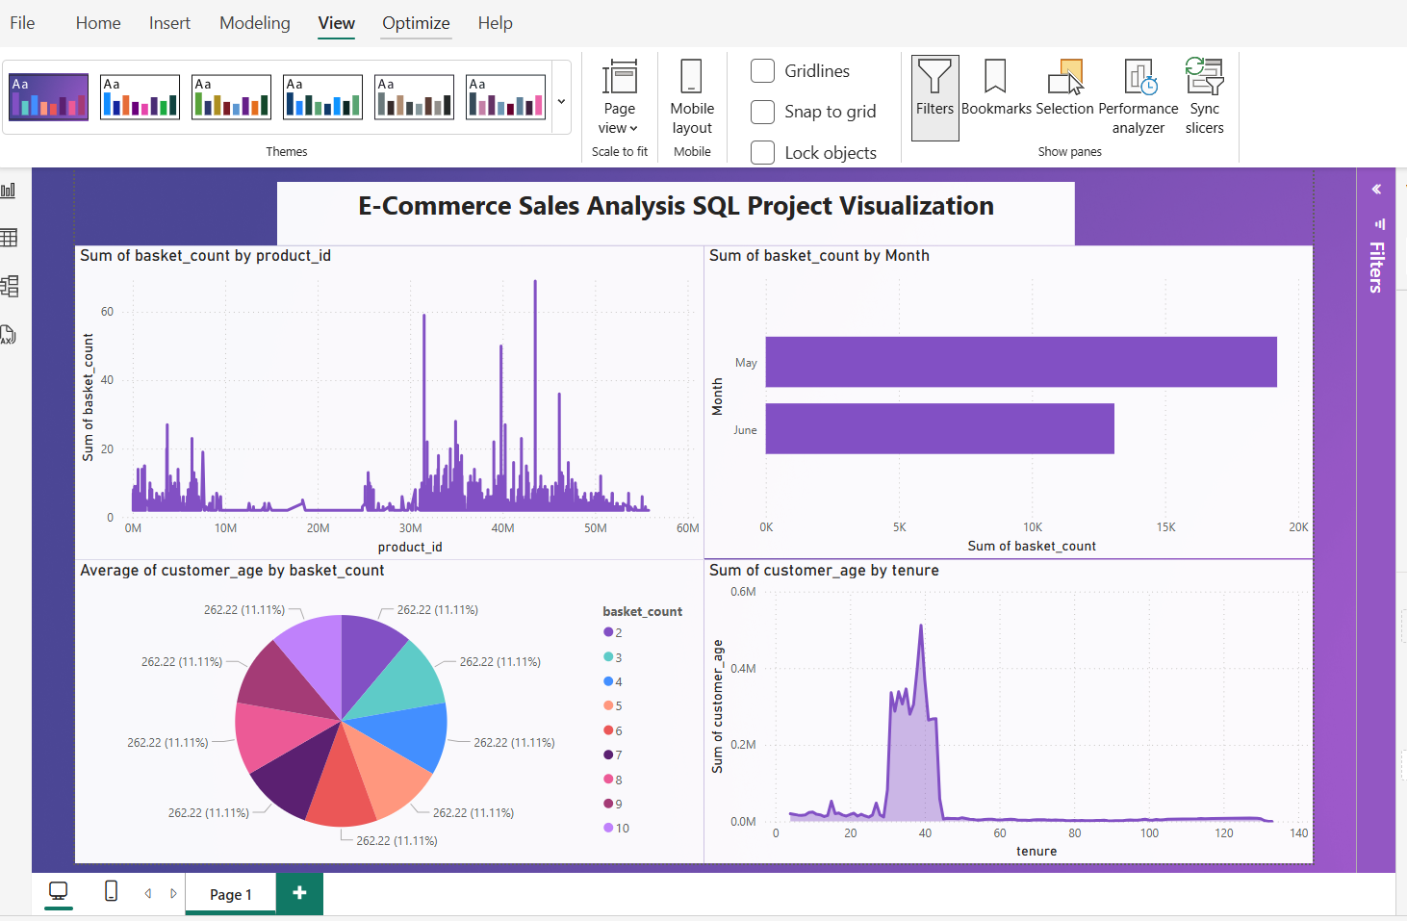

Conclusion