**PHASE 5: DISASTER RECOVERY WITH IBM VIRTUAL SERVERS.**

**Objective:** Implement a comprehensive disaster recovery plan to ensure the availability and continuity of critical systems and data in the event of unforeseen disasters or disruptions.

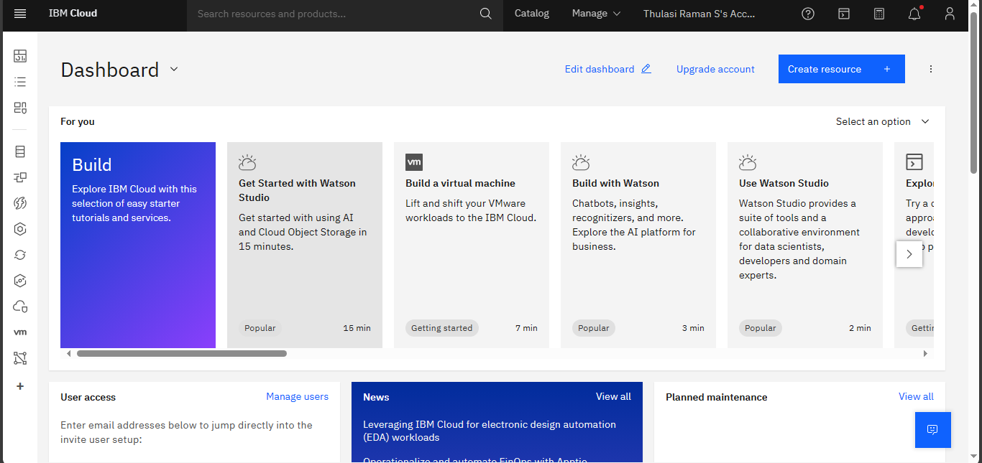

**Key Tasks and Activities:**

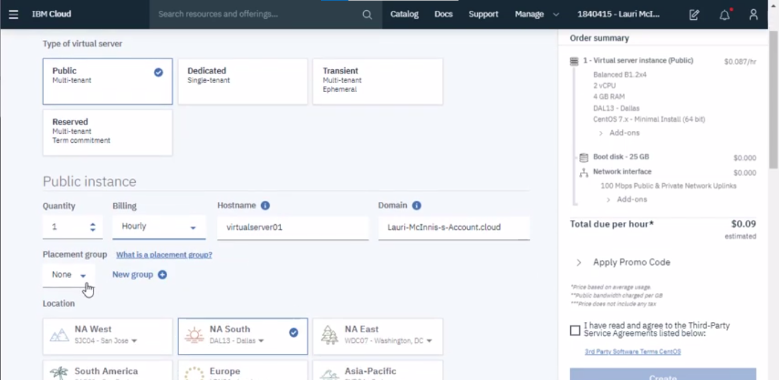

1. **Risk Assessment and Impact Analysis:**
   * Identify potential risks and threats to your organization's IT infrastructure.
   * Evaluate the impact of these risks on critical systems and data.
   * Prioritize risks based on severity and likelihood.
2. **Define RTO and RPO:**
   * Determine Recovery Time Objectives (RTO) and Recovery Point Objectives (RPO) for different systems and applications.
   * RTO: The maximum acceptable downtime for a system or application.
   * RPO: The acceptable data loss (time interval) in case of a disaster.
3. **Asset Inventory:**
   * Create an inventory of all IT assets, including servers, databases, applications, and data storage locations.
4. **Select Disaster Recovery Strategies:**
   * Choose appropriate disaster recovery strategies for different assets based on RTO and RPO requirements.
   * Strategies may include data backup, replication, virtualization, or cloud-based solutions.
5. **Infrastructure Configuration:**
   * Set up and configure backup and recovery infrastructure.
   * This includes the provisioning of secondary servers or cloud resources, data replication, and network configurations.
6. **Data Replication and Backup:**
   * Implement data replication mechanisms to ensure real-time or periodic synchronization of data between primary and secondary locations.
   * Perform regular backups of critical data to offsite locations.

**Diagram:**

**+-------------------+ +-------------------+**

**| Primary Data | | Secondary Data |**

**| Center Location:| | Center Location: |**

**| Data Center A | | Data Center B |**

**+-------------------+ +-------------------+**

**| Data Replication | | Data Replication |**

**| (Real-time) | | (Scheduled) |**

**+-------------------+ +-------------------+**

1. **Testing and Validation:**
   * Conduct periodic disaster recovery drills and tests to validate the effectiveness of the recovery plan.
   * Analyze and document the outcomes of these tests and make necessary adjustments.

**Examples of Testing And Validation:**

**+---------------------------------------+**

**| Disaster Recovery Test Timeline |**

**+---------------------------------------+**

**| Month | Test Type | Outcome |**

**+-------+-----------+-----------------+**

**| Jan | Planned | Successful |**

**| Apr | Surprise | Partial Success |**

**| Jul | Planned | Successful |**

**| Oct | Surprise | Failed |**

**+-------+-----------+-----------------+**

1. **Documentation and Runbooks:**
   * Create comprehensive documentation that includes the disaster recovery plan, configurations, procedures, and contact information.
   * Develop runbooks that provide step-by-step guidance during recovery efforts.
2. **Training and Awareness:**
   * Train IT staff in disaster recovery procedures and ensure they are well-versed in the documented processes.
   * Promote awareness among employees regarding disaster recovery protocols and their role in the recovery process.
3. **Communication Plan:**
   * Establish a clear communication plan that outlines how to notify stakeholders, employees, and customers in case of a disaster.
   * Ensure effective communication channels are in place.
4. **Legal and Compliance Considerations:**
   * Ensure that the disaster recovery plan complies with industry regulations and legal requirements.
   * Address data protection and privacy concerns, especially in highly regulated sectors.
5. **Monitoring and Alerting:**
   * Set up continuous monitoring systems for servers, networks, and data replication processes.
   * Configure alerting systems to notify IT teams of any anomalies or failures in real-time.
6. **Regular Updates and Improvements:**
   * Continuously review and update the disaster recovery plan to accommodate changes in infrastructure, applications, and business needs.
   * Stay informed about emerging threats and adapt the plan accordingly.
7. **Automation and Orchestration:**
   * Explore automation and orchestration tools to streamline disaster recovery processes and reduce RTO.
8. **Third-Party Disaster Recovery Services:**
   * Consider collaborating with third-party disaster recovery service providers for additional expertise and redundancy.
9. **Cost Management:**
   * Monitor and optimize resource allocation to balance cost-effectiveness with disaster recovery resilience.\

**Flowchart With Decision Points:**

**Start**

|

|--> Risk Assessment and Impact Analysis

| |

| |--> Identify Risks and Threats

| |

| |--> Evaluate Impact on Virtual Servers

| |

| |--> Prioritize Risks

|

|--> Define RTO and RPO

| |

| |--> Determine Recovery Time Objectives (RTO)

| |

| |--> Determine Recovery Point Objectives (RPO)

|

|--> Asset Inventory

| |

| |--> Create Inventory of Virtual Servers

| |

| |--> Document Configurations and Dependencies

|

|--> Disaster Recovery Strategies

| |

| |--> Choose Appropriate Strategies

| |

| |--> Implement Data Backup and Replication

|

|--> Configuration of IBM Virtual Servers

| |

| |--> Configure Primary Virtual Servers

| |

| |--> Configure Secondary Virtual Servers

|

|--> Data Replication and Backup

| |

| |--> Implement Data Replication Mechanisms

| |

| |--> Establish Backup Processes

|

|--> Testing and Validation

| |

| |--> Conduct Disaster Recovery Tests

| |

| |--> Analyze Test Outcomes

|

|--> Documentation and Runbooks

| |

| |--> Create Comprehensive Documentation

| |

| |--> Develop Runbooks

|

|--> Training and Awareness

| |

| |--> Train IT Staff

| |

| |--> Promote Awareness

|

|--> Communication Plan

| |

| |--> Establish Communication Plan

| |

| |--> Ensure Effective Communication Channels

|

|--> Monitoring and Alerting

| |

| |--> Set Up Continuous Monitoring

| |

| |--> Configure Alerting Systems

|

|--> Regular Updates and Improvements

| |

| |--> Continuously Review and Update the Plan

|

|--> Automation and Orchestration

| |

| |--> Explore Automation Tools

|

|--> Third-Party Disaster Recovery Services

| |

| |--> Consider Third-Party Partnerships

|

|--> Cost Management

| |

| |--> Monitor and Optimize Resource Allocation

|

**End**

**Conclusion:** This phase focuses on the implementation of a disaster recovery plan, from assessing risks to configuring infrastructure, conducting tests, and ensuring ongoing compliance. By following these steps, organizations can better prepare for unexpected disasters and maintain business continuity.